DIGITAL FOOTPRINT INVESTIGATION REPORT
Target Organization: Pixxel
Prepared By: Muppala Pooja

Executive Summary
This report presents an Open Source Intelligence (OSINT) assessment of Pixxel. The objective was to identify and analyze the organization's digital footprint using only publicly available information. The investigation focused on Organization Footprint, Personal Footprints, Metadata and Online Identity.

Reason for Selecting Pixxel
Pixxel was selected because it is a leading Indian space technology startup with a rich and transparent online presence. The company publicly shares information regarding its products, leadership, technology, company culture and professional identity, making it an ideal case study for digital footprint analysis.

1. Organization Footprint
Evidence: Homepage and Products pages.
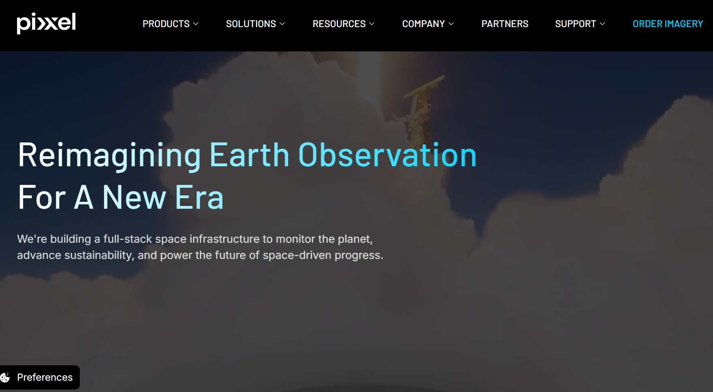
The official website reveals the company's mission, products, services, navigation structure, support resources and branding. Public information includes the company logo, mission statement, products, solutions, resources and support.
Analysis
The homepage demonstrates that Pixxel maintains an organized digital presence. Important organizational information such as products, services, support resources, and company details are publicly accessible. The "Seeing the Unseen" section explains Pixxel's hyperspectral imaging technology and Aurora Earth Observation Studio, showing the company's technical capabilities.
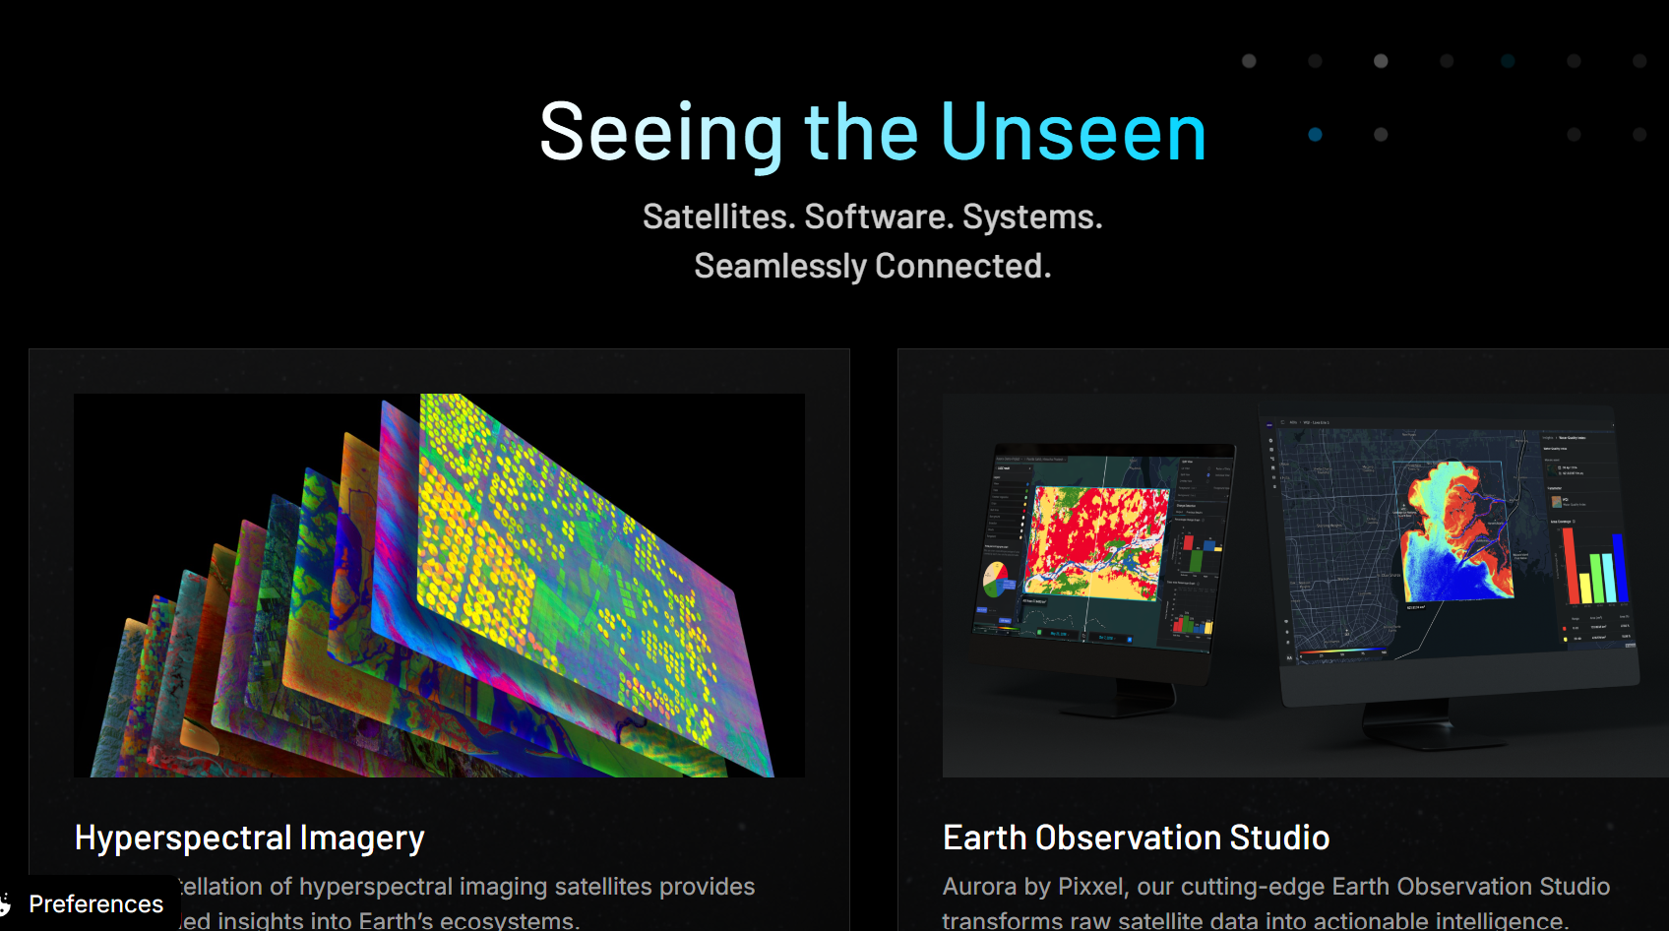
Analyst Observation
Pixxel maintains a strong organization footprint by making information about its business, technology, and services publicly available, allowing stakeholders to understand its operations.

2. Personal Footprints
Evidence: Team page.

The team page demonstrates Pixxel's culture, expertise and innovation. Public information about founders and leadership can be verified through the official website and LinkedIn.
Analyst Observation
The Team page demonstrates transparency by showcasing the organization's people and work culture, which contributes to Pixxel's personal digital footprint.

3. Metadata
Relation to Digital Footprint
Metadata is hidden information stored within digital documents, images, and files.
During this investigation, no publicly downloadable document containing useful metadata was identified from the collected evidence.
Instead, the investigation focused on visible metadata within the website itself.

4. Online Identity
Evidence: Official LinkedIn profile.
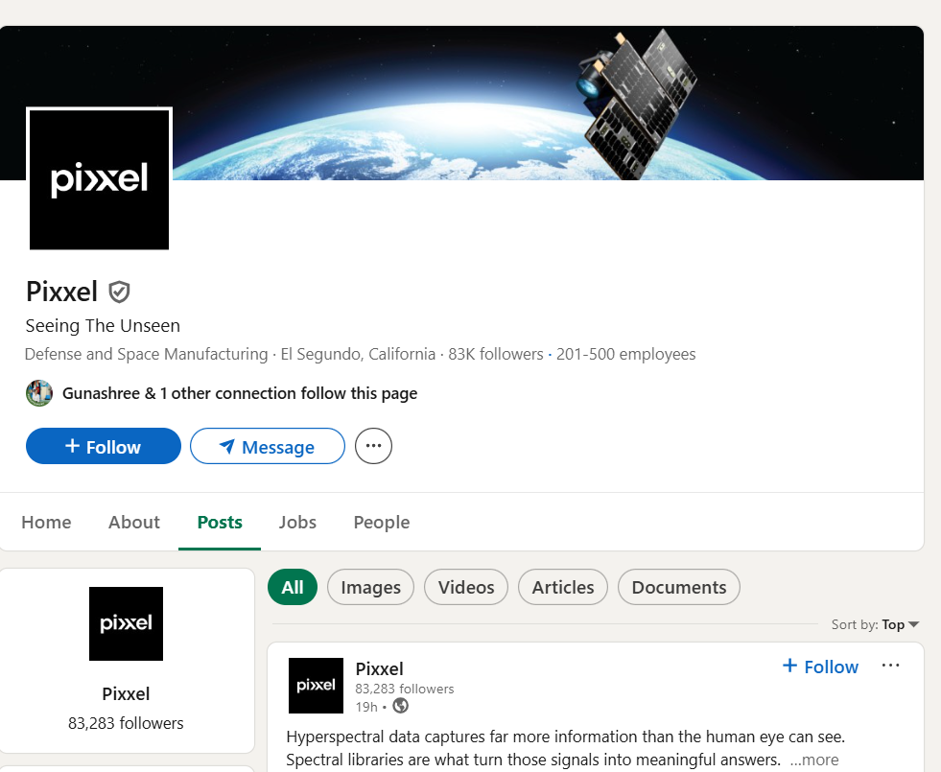
The LinkedIn page contains a verified profile, official logo, employee count, followers, industry classification and company updates. Branding matches the official website.
Analysis
The LinkedIn profile uses the same branding, logo, slogan ("Seeing The Unseen"), and imagery as the official website. This consistency confirms the authenticity of the organization's online identity.
The company also regularly publishes updates regarding products, satellite launches, achievements, and hiring opportunities.
Analyst Observation
Pixxel maintains a professional online identity by ensuring consistency across its official website and LinkedIn profile. This enhances trust and makes verification easier during OSINT investigations.

Overall Analyst Assessment
Pixxel demonstrates a mature and professionally managed digital footprint. The organization provides sufficient public information for verification while avoiding unnecessary exposure of sensitive information. The consistency between the official website, products, team page and LinkedIn profile indicates strong digital governance and supports the use of Pixxel as a model case for OSINT investigations.
Final Conclusion
The investigation demonstrates that Pixxel has a strong, well-managed digital footprint. Its official website clearly presents organizational information, products, and mission; the Team page highlights its people and culture; the LinkedIn profile establishes a consistent and verifiable online identity; and the absence of publicly exposed document metadata reflects a cautious approach to information sharing.
Overall, Pixxel is a suitable startup for digital footprint analysis because it offers sufficient public information to verify organizational identity and activities while demonstrating good information management practices. This makes it an ideal case study for applying OSINT techniques to understand Personal Footprints, Organization Footprints, Metadata, and Online Identity using only publicly available information.

Evidence Collected
Figure | Evidence | Purpose
Figure 1 | Homepage | Organization Footprint
Figure 2 | Products & Solutions | Organization Footprint
Figure 3 | Team Page | Personal Footprints
Figure 4 | LinkedIn | Online Identity
Insert the four screenshots below the corresponding figure numbers.

