INTERNET ARCHIVES PRACTICAL REPORT
Day 5 – Compare Three Archived Websites
Prepared By: Muppala Pooja

1. Objective
To compare archived and current versions of websites using Internet archive techniques and understand how historical web data supports OSINT investigations.

2. Theory
Internet archives preserve historical versions of webpages. The Wayback Machine stores snapshots from different dates, cached pages provide recently indexed copies, deleted websites may still be recovered from archives, and historical analysis compares past and present versions to identify changes in content, branding, products, and business strategy.

3. Practical Investigation

OpenAI
Archived Version (2023): Observed the historical homepage using the Wayback Machine.

OpenAI Homepage (Archived Version – 2023)
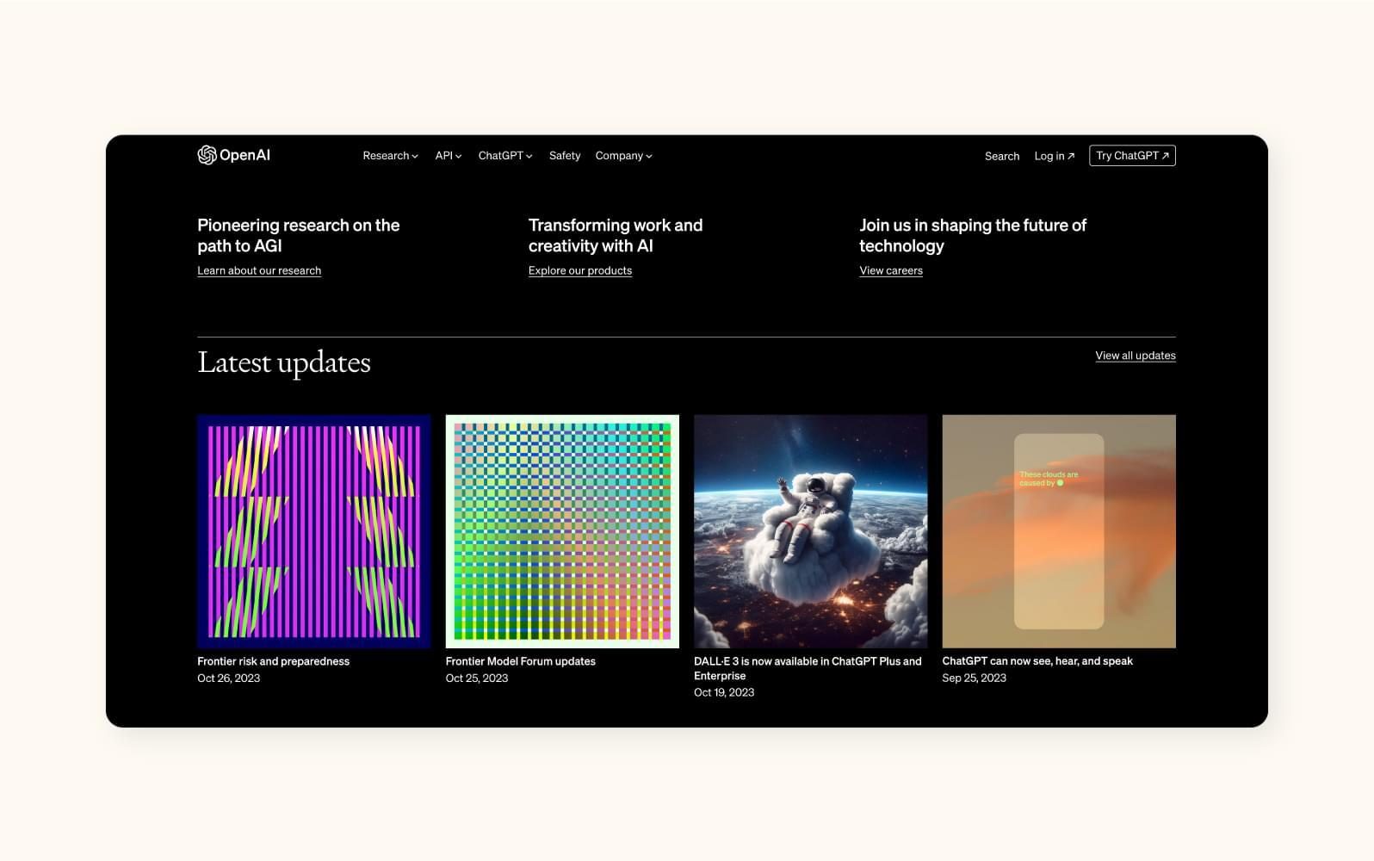

Current Version: Compared the live homepage to identify design, navigation, product, and branding changes.
OpenAI Homepage (Current Version – 2026)
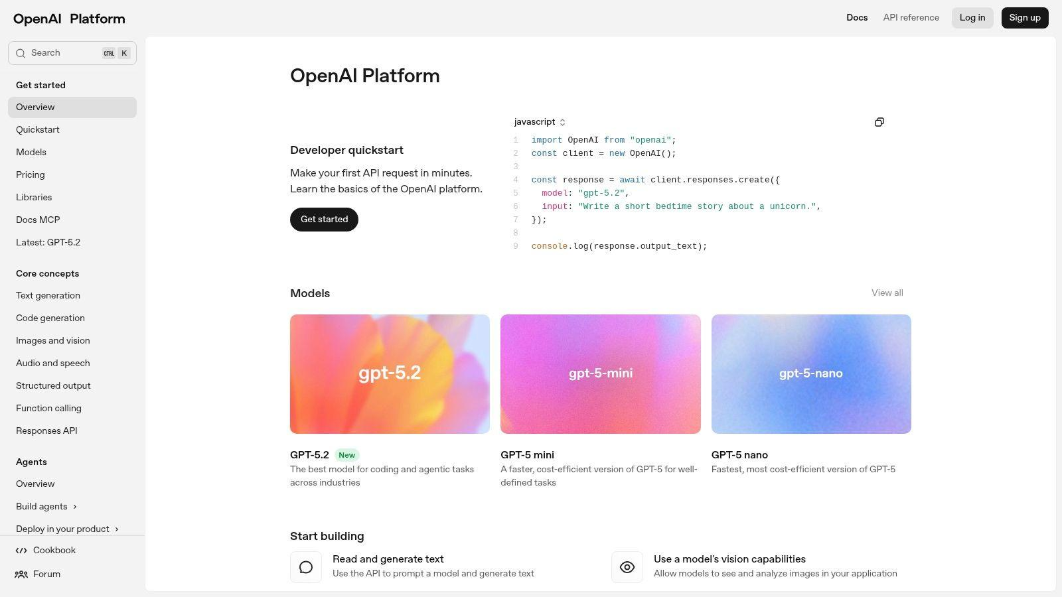

Summary:
Wayback Machine provided historical evidence, cached pages help recover recent changes, archived copies preserve removed pages, and historical analysis revealed the evolution of the website.

Netflix
Archived Version (2016): Observed the historical homepage using the Wayback Machine.
Netflix Homepage (Archived Version – 2016)


Current Version: Compared the live homepage to identify design, navigation, product, and branding changes.
Netflix Homepage (Current Version)
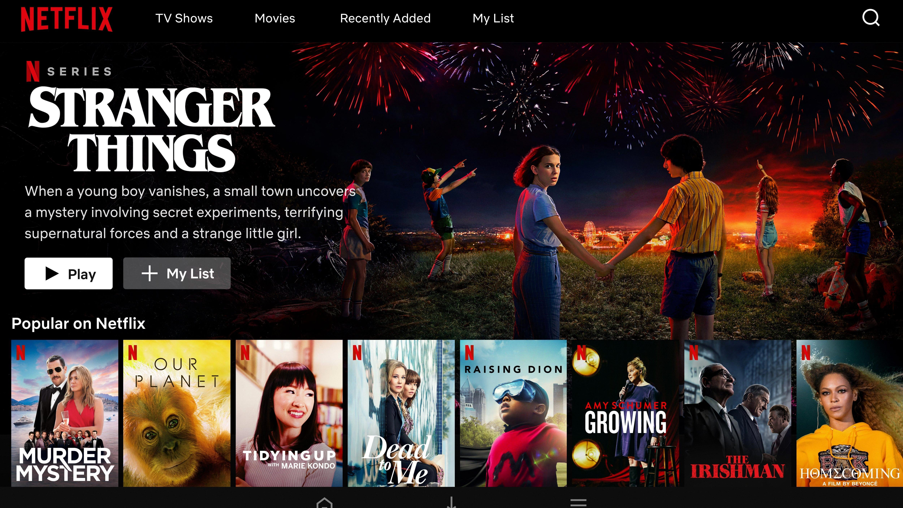

Summary: Wayback Machine provided historical evidence, cached pages help recover recent changes, archived copies preserve removed pages, and historical analysis revealed the evolution of the website.

Microsoft
Archived Version (2012): Observed the historical homepage using the Wayback Machine.
Microsoft Homepage (Archived Version – 2012)
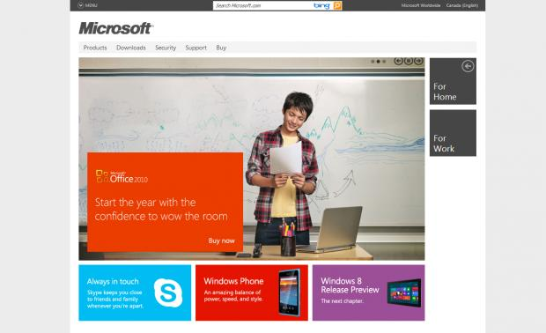
Current Version: Compared the live homepage to identify design, navigation, product, and branding changes.
Microsoft Homepage (Current Version)
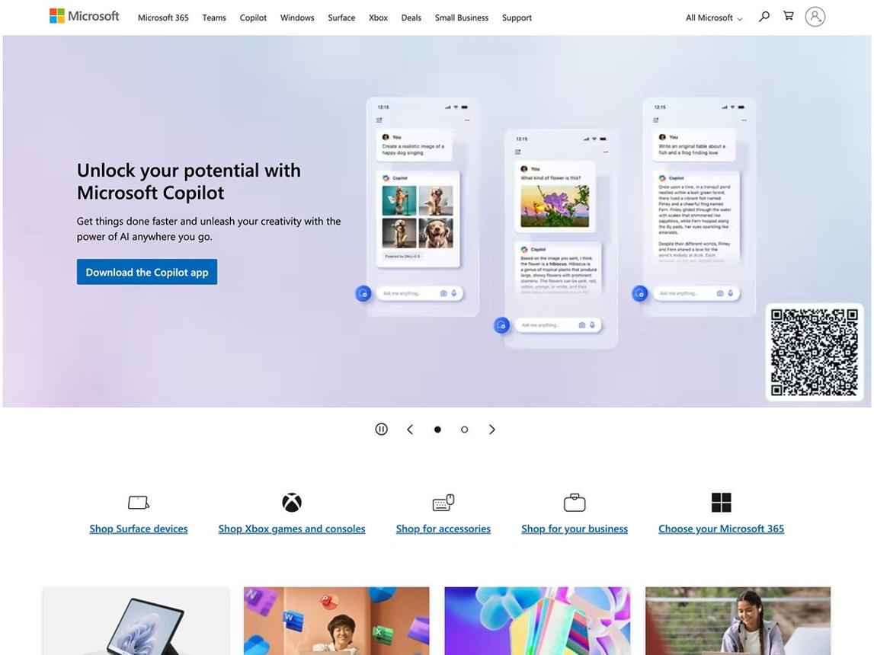
Summary: Wayback Machine provided historical evidence, cached pages help recover recent changes, archived copies preserve removed pages, and historical analysis revealed the evolution of the website.

4. Comparative Analysis

Website | Archived | Current | Analyst Observation
OpenAI | Research focus (2023) | AI ecosystem (2026) | Transitioned from a research-centric organization into a full AI ecosystem offering products, APIs, and enterprise solutions. This reflects rapid expansion and commercialization of AI.
Netflix | Basic UI (2016) | Personalized UI (2026) | Shifted from a simple streaming interface to a highly personalized experience driven by recommendation algorithms, data analytics, and global content diversification.
Microsoft | Windows/Office (2012) | AI & Cloud (2026) | Evolved from a software-first company into a cloud and AI powerhouse. Strategic transformation aligns with industry trends in enterprise services, cybersecurity, and intelligent platforms.

5. Analyst Observations

OpenAI: Expansion signals the commercialization of AI research, with implications for both innovation and regulation.
Netflix: Personalization demonstrates the power of data-driven UX, influencing user retention and global market penetration.
Microsoft: Cloud and AI adoption reflects a pivot toward resilience, scalability, and dominance in enterprise ecosystems.

6. Conclusion
The investigation showed that Internet archive technologies are valuable for OSINT because they preserve historical evidence, recover deleted information, and help investigators compare website evolution over time.

