SEARCH INTELLIGENCE QUERY LIBRARY
SEARCH INTELLIGENCE QUERY LIBRARY
A Curated Repository of Google Dork Queries for Open-Source Intelligence (OSINT)
Prepared By: Muppala Pooja

Table of Contents
1. Executive Summary
2. Search Operators
3. Modules M-01 to M-05
4. Analyst Observations
5. Conclusion

Executive Summary
This repository organizes fifty advanced Google Dork queries into operational modules for locating publicly indexed information from trusted domains. The library supports repeatable OSINT research, academic investigations, policy analysis, and structured data discovery.

Operator Breakdown
Operator | Purpose | Example
site: | Limit results to a domain | site:.gov
filetype: | Retrieve specific document types | filetype:pdf
" " | Exact phrase matching | "annual report"
intitle: | Search page titles | intitle:policy
inurl: | Search URLs | inurl:report

🔍 M-01 PDF Documents
Module Overview
This module focuses on discovering publicly available PDF documents hosted by trusted organizations including government agencies, universities, nonprofit organizations, and defense institutions. PDF files often contain comprehensive reports, policy documents, manuals, technical specifications, and research publications that are not easily accessible through conventional keyword searches.
Module M-01 – PDF Documents
ID | Target | Google Dork | Domain | Type | Expected Output
GD-001 | Annual Reports | filetype:pdf site:.gov "annual report" | .gov | PDF | Government Annual Reports
GD-002 | Defense Strategy | filetype:pdf site:.mil "defense strategy" | .mil | PDF | Defense Publications
GD-003 | Lecture Notes | filetype:pdf site:.edu "lecture notes" | .edu | PDF | Academic Notes
GD-004 | Compliance Manual | filetype:pdf site:.org "compliance manual" | .org | PDF | Manuals
GD-005 | Research Findings | filetype:pdf site:.org "research findings" | .org | PDF | Research
GD-006 | Policy Framework | filetype:pdf site:.gov "policy framework" | .gov | PDF | Policies
GD-007 | Syllabus | filetype:pdf site:.edu syllabus | .edu | PDF | Syllabus
GD-008 | Case Study | filetype:pdf site:.org "case study" | .org | PDF | Case Studies
GD-009 | Public Health Report | filetype:pdf site:.gov "public health report" | .gov | PDF | Health Reports
GD-010 | Project Report | filetype:pdf site:.edu "project report" | .edu | PDF | Projects

🔍 M-02 Excel Datasets
- Useful for statistical analysis and data visualization.
- Supports structured research using spreadsheets.
Module M-02 – Excel Sheets
ID | Target | Google Dork | Domain | Type | Expected Output
GD-011 | Census Data | filetype:xls site:.gov "census data" | .gov | XLS | Dataset
GD-012 | Audit Report | filetype:xlsx site:.org "audit report" | .org | XLSX | Audit
GD-013 | Survey Results | filetype:xls site:.edu "survey results" | .edu | XLS | Survey
GD-014 | Health Statistics | filetype:xlsx site:.gov "health statistics" | .gov | XLSX | Statistics
GD-015 | Transport Logs | filetype:xls site:.gov "transport logs" | .gov | XLS | Logs
GD-016 | Budget Allocation | filetype:xlsx site:.gov "budget allocation" | .gov | XLSX | Budget
GD-017 | Exam Marks | filetype:xls site:.edu "exam marks" | .edu | XLS | Marks
GD-018 | Financial Data | filetype:xlsx site:.org "financial data" | .org | XLSX | Finance
GD-019 | Crime Statistics | filetype:xls site:.gov "crime statistics" | .gov | XLS | Crime
GD-020 | Student Records | filetype:xlsx site:.edu "student records" | .edu | XLSX | Records

🔍 M-03 Research Papers
- Focuses on scholarly papers, theses, and technical reports.
- Valuable for literature reviews and innovation research
ID | Target | Google Dork | Domain | Type | Expected Output
GD-021 | Artificial Intelligence | filetype:pdf site:.edu "artificial intelligence" | .edu | PDF | AI
GD-022 | Cybersecurity | filetype:pdf site:.edu "cybersecurity" | .edu | PDF | Cyber
GD-023 | Clinical Study | filetype:pdf site:.edu "clinical study" | .edu | PDF | Clinical
GD-024 | Climate Change | filetype:pdf site:.edu "climate change" | .edu | PDF | Climate
GD-025 | Defense Technology | filetype:pdf site:.edu "defense technology" | .edu | PDF | Defense
GD-026 | Machine Learning | filetype:pdf site:.edu "machine learning" | .edu | PDF | ML
GD-027 | Data Science | filetype:pdf site:.edu "data science" | .edu | PDF | DS
GD-028 | Neural Networks | filetype:pdf site:.edu "neural networks" | .edu | PDF | NN
GD-029 | Quantum Computing | filetype:pdf site:.edu "quantum computing" | .edu | PDF | Quantum
GD-030 | Robotics Research | filetype:pdf site:.edu "robotics research" | .edu | PDF | Robotics

🔍 M-04 Government Documents
- Targets policy documents, budgets, and legal publications.
- Supports governance and public administration research.
ID | Target | Google Dork | Domain | Type | Expected Output
GD-031 | Policy Document | filetype:pdf site:.gov "policy document" | .gov | PDF | Policy
GD-032 | Budget | filetype:xls site:.gov "budget" | .gov | XLS | Budget
GD-033 | Court Ruling | filetype:pdf site:.gov "court ruling" | .gov | PDF | Legal
GD-034 | Parliamentary Report | filetype:pdf site:.gov "parliamentary report" | .gov | PDF | Parliament
GD-035 | Election Statistics | filetype:xls site:.gov "election statistics" | .gov | XLS | Election
GD-036 | Environmental Policy | filetype:pdf site:.gov "environmental policy" | .gov | PDF | Environment
GD-037 | Transport Policy | filetype:pdf site:.gov "transport policy" | .gov | PDF | Transport
GD-038 | Education Policy | filetype:pdf site:.gov "education policy" | .gov | PDF | Education
GD-039 | Foreign Affairs | filetype:pdf site:.gov "foreign affairs report" | .gov | PDF | Foreign Affairs
GD-040 | Public Safety | filetype:pdf site:.gov "public safety report" | .gov | PDF | Safety

🔍 M-05 Advanced Queries
- Designed for locating draft reports, technical specifications, and specialized documents.
- Useful for advanced OSINT investigations.
ID | Target | Google Dork | Domain | Type | Expected Output
GD-041 | Confidential | filetype:pdf site:.gov "confidential" | .gov | PDF | Sensitive
GD-042 | Restricted | filetype:xls site:.edu "restricted" | .edu | XLS | Restricted
GD-043 | Internal Use | filetype:pdf site:.org "internal use only" | .org | PDF | Internal
GD-044 | Classified | filetype:pdf site:.mil "classified" | .mil | PDF | Military
GD-045 | Draft Report | filetype:pdf site:.gov "draft report" | .gov | PDF | Draft
GD-046 | Raw Data | filetype:xls site:.gov "raw data" | .gov | XLS | Raw
GD-047 | Working Paper | filetype:pdf site:.edu "working paper" | .edu | PDF | Working
GD-048 | Evaluation Report | filetype:pdf site:.org "evaluation report" | .org | PDF | Evaluation
GD-049 | Technical Specification | filetype:pdf site:.gov "technical specification" | .gov | PDF | Specs
GD-050 | Dissertation | filetype:pdf site:.edu "dissertation" | .edu | PDF | Dissertation

📊 Visualization Summary
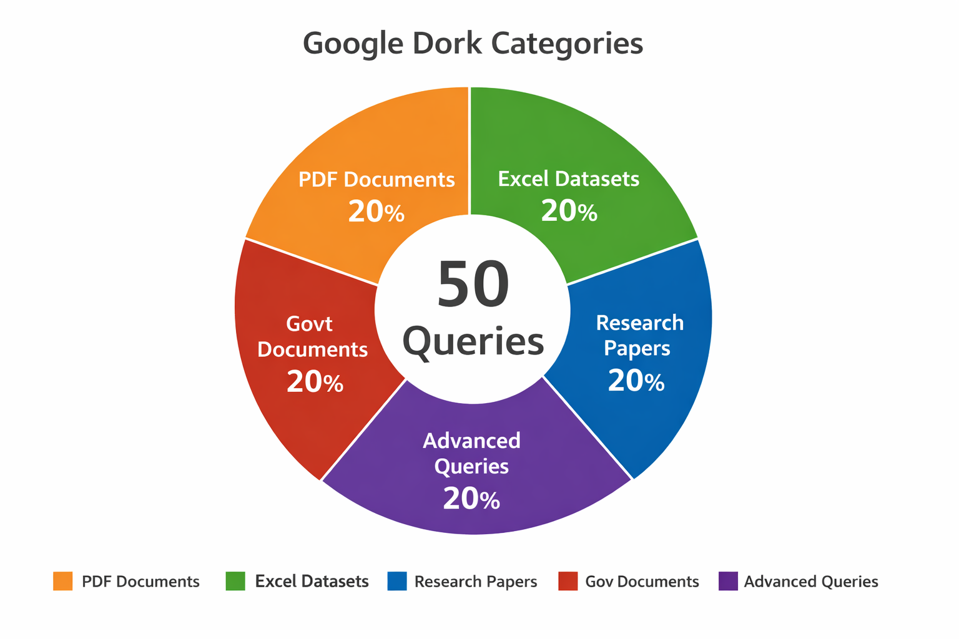
The pie chart provides a clear visual overview of how the 50 Google Dork queries are distributed across five categories — PDF Documents, Excel Datasets, Research Papers, Government Documents, and Advanced Queries. Each segment represents 20% of the total, showing a balanced focus across all modules. This visual helps readers quickly understand the scope and structure of the query library, emphasizing its comprehensive coverage for open-source intelligence research.
📌 Analyst Observation 01 Using .gov websites helps find official government documents and reduces unrelated search results. This increases the chances of getting accurate and trustworthy information.
📌Analyst Observation 02 Combining filetype:pdf with exact phrases (using quotation marks) helps Google find the specific documents you need instead of showing general web pages. This makes the search more accurate.
📌 Analyst Observation 03 Using exact keywords along with trusted domains such as .gov, .edu, and .org produces more relevant and consistent search results, making it easier to find reliable information.

Conclusion
This Search Intelligence Query Library serves as a structured repository of advanced Google search operators for discovering publicly available information across government, academic, and organizational domains. By organizing queries into operational modules and documenting their intended use, the repository supports efficient, repeatable, and targeted information retrieval for OSINT investigations, academic research, and data collection activities.

