class Test {
public static void main(String[] args) {
System.out.println("Hello Java");
}
}
Meaning of Each Keyword and Part
- class
The class keyword is used to declare a class in Java.
- public
public is an access modifier.
It means the method can be accessed from anywhere.
- static
static means the method belongs to the class rather than an object.
Because main() is static, JVM can call it without creating an object of the class.
- void
void is the return type of the method.
It means the main() method does not return any value.
- main()
The main() method is the entry point of a Java program.
JVM starts program execution from this method.
- String[] args
String[] args is used to receive command-line arguments.
It is an array of strings passed while running the program.
- System.out.println()
Used to print output on the console.
- Breakdown:
  - System → a predefined class in Java
  - out → a static object of the PrintStream class inside the System class.
  - println() → a method of the PrintStream class used to print data on the console.
Notes
- Arguments are separated by spaces.
- All command-line arguments are stored as strings in String[] args.
- If arguments contain spaces, use quotes:

Valid Java main() method signature
- public static void main(String[] args)
- public static void main(String []args)
- public static void main(String args[])
- public static void main(String... args) // Varargs is also valid
- static public void main(String[] args)
- public static final void main(String[] args)
- final public static void main(String[] args)
- final static public void main(String[] args)
- final strictfp public static void main(String[] args)
NOTE:-
A Java class can contain any number of main() methods using method overloading.
But only one specific signature is recognized by the JVM as the program entry point:
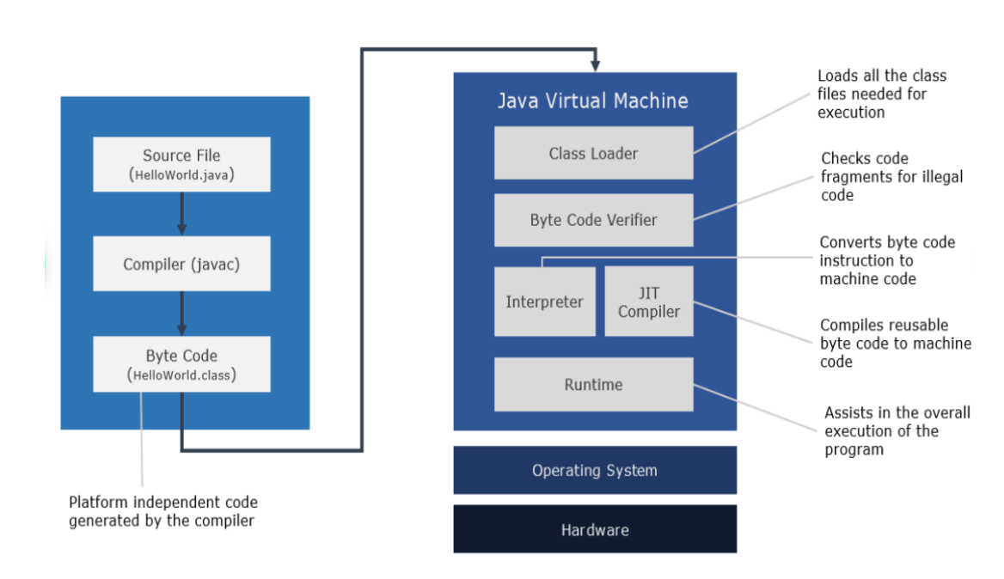
At Compile Time:
The Java source file (.java) is compiled by the Java compiler (javac).
Java compiler converts the Java source code(.java) into bytecode (.class file).
This bytecode is platform-independent, and the compiler does not interact with the operating system.
At Runtime:
The following steps are performed:
1.ClassLoader
The ClassLoader loads these .class files into memory when they are needed at runtime.
It also manages linking between classes and ensures all dependencies are available.
2. Bytecode Verification
Before execution, the bytecode verifier checks the loaded code for safety and correctness:
- Prevents illegal memory access
- Ensures stack is used correctly
- Maintains type safety
This step protects the JVM from corrupted or malicious code.
3. Interpreter
The JVM interpreter executes bytecode line by line.
It is simple but slower in performance.
4. JIT Compiler (Just-In-Time) & JVM Runtime
The JVM uses the JIT compiler to convert frequently used bytecode into native machine code for faster execution.
The JVM also manages memory (heap, stack, garbage collection).
5. Hardware (CPU)
Finally, the generated native machine code is executed by the CPU and underlying hardware.
Java Variables
In Java, a variable is a named memory location used to store data that can change during program execution.
🔹 Java Variables (Explanation)
- A variable in Java is a named memory location used to store data that can change during program execution.
- A variable acts like a container that holds a value.
- The value stored inside the variable can be changed during program execution.
- Each variable has three main parts:
  - Type → what kind of data it stores (e.g., int, String)
  - Name → the identifier used to access it
  - Value → the actual data stored inside
🔹 Types of Variables in Java
- Local Variable – Declared inside a method, constructor, or block. Accessible only within that method/block.
- Instance Variable –Declared inside a class but outside methods. Belongs to an object (instance) of the class. Each object gets its own copy.
- Static Variable – Declared using the static keyword. Shared among all objects of the class. Memory is allocated only once.
🔹 General Syntax for Declaring a Variable
<data_type> <variable_name>;
🔹 Syntax for Declaring and Initializing a Variable
<data_type> <variable_name> = <value>;
🔹 IDENTIFIER in Java
In Java, an identifier is the name given to a variable, method, or class to uniquely identify it.
🔹 Rules for Identifiers in Java
- It can contain alphanumeric characters (a–z, A–Z, 0–9), underscore (_), and dollar sign ($).
- It should not start with a digit (0–9).
- It should not contain spaces.
- It should not be a Java keyword (like int, class, public, etc.).
- It is case-sensitive (e.g., name and Name are different).
- It has no length restriction.
Java Identifier Naming Conventions (Best Practices):
Class & Interface names → PascalCase (e.g., StudentDetails)
Variables & methods → camelCase (e.g., firstName, calculateSum())
Constants → UPPER_CASE_WITH_UNDERSCORES (e.g., MAX_VALUE)
Package names → lowercase with dots (e.g., com.example.utils)
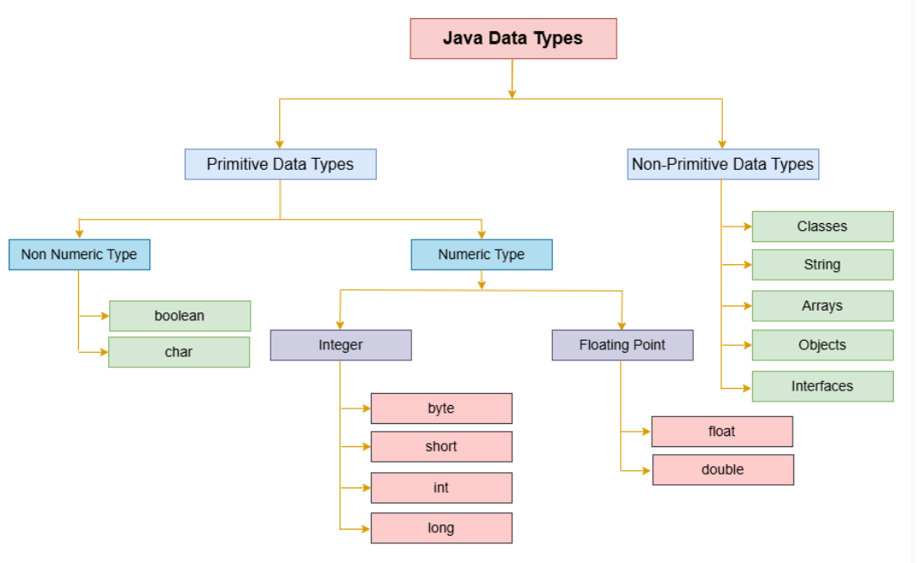
🔹 Java Data Types
A data type in Java specifies:
- what kind of value a variable can store
- and how much memory is required to store that value.
They are classified into primitive and non-primitive.
🔹 1. Primitive Data Types
These are the basic built-in data types in Java.
They store simple values directly in memory.
byte:
A byte is a small integer type that takes 1 byte (8 bits) of memory.
It can store values from -2⁷ to (2⁷ - 1) → -128 to 127
Example: byte smallNumber = 100;
short:
A short is a slightly larger integer type that takes 2 bytes (16 bits) of memory.
It can store values from -2¹⁵ to (2¹⁵ - 1) → -32,768 to 32,767.
Example: short mediumNumber = 20000;
int:
An int is the most commonly used integer type in Java, taking 4 bytes (32 bits) of memory.
It can store values from -2³¹ to (2³¹ - 1) → -2,147,483,648 to 2,147,483,647.
Example: int number = 123456;
long:
A long is used when larger integer values are needed, taking 8 bytes (64 bits) of memory.
It can store values from -2⁶³ to (2⁶³ - 1) → -9,223,372,036,854,775,808 to 9,223,372,036,854,775,807.
A long value must be suffixed with L.
Example: long largeNumber = 9223372036854775807L;
float:
A float is used for storing decimal numbers (floating-point) with 4 bytes (32 bits) of memory.
It can represent values approximately between ±(2⁻¹²⁶) to ±(2¹²⁷ - 1).
A float value must be suffixed with f.
Precision: ~6-7 decimal digits
Example: float decimalNumber = 3.14f;
double:
double is used to store decimal numbers with double precision.
It uses 8 bytes (64 bits) of memory.
Precision: ~15-16 decimal digits
Example: double e = 3.141592653589793;
char:
A char is used to store a single Unicode character and takes 2 bytes (16 bits) of memory.
It follows the Unicode system.
It can store Unicode characters, ranging from 0 to 65,535.
Example: char letter = 'A';
boolean:
A boolean is used to store only two possible values: true or false.
It takes 1 bit of memory but is often stored as 1 byte for memory alignment.
Example: boolean isJavaFun = true;
2. Non-Primitive Data Types
These store references (addresses) to objects, not raw values.
These include:
String (String name = "Java";)
Arrays (int[] arr = {1, 2, 3};)
Classes (User-defined objects)
Interfaces & Enums
🔥 Quick Memory Trick
Primitive = value stored directly
Non-primitive = reference to object
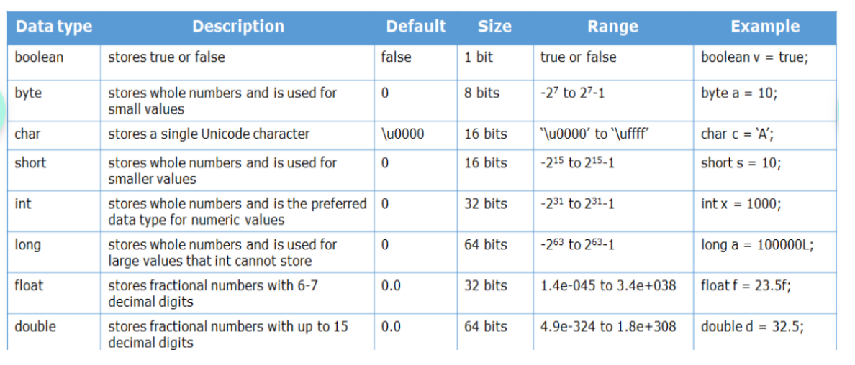
Type Casting in Java
Type casting is the process of converting a value from one data type to another data type.
Java supports two types of type casting:
- Implicit Type Casting (Widening)
Implicit type casting is also known as:
- Automatic Casting
- Widening Conversion
In this type of casting, a smaller data type is converted into a larger data type automatically.
Conversion Flow:
byte → short → int → long → float → double
Example: int num = 100;
double value = num;
Why is it automatic?
Because there is no risk of data loss.
- Explicit Type Casting (Narrowing)
Explicit type casting is also known as:
- Manual Casting
- Narrowing Conversion
In this type of casting, a larger data type is converted into a smaller data type manually.
Conversion Flow:
double → float → long → int → short → byte
Example: double price = 99.99;
int amount = (int) price;
Why is it manual?
Because there is a possibility of data loss.
Example: 99.99 becomes 99
Important Notes
- Widening Casting
  - Safe conversion
  - Performed automatically by Java
- Narrowing Casting
  - Unsafe conversion
  - Must be done manually using ()
- Explicit casting may:
  - Lose decimal values
  - Cause overflow problems
✅ Java Operators
In Java, operators are special symbols used to perform operations on variables and values.
1. Arithmetic Operators
Used for mathematical operations:
- + Addition
- - Subtraction
- * Multiplication
- / Division (integer division removes decimals)
- % Modulus (remainder)
2. Relational (Comparison) Operators
Used to compare two values → returns boolean:
- == equal to
- != not equal to
- > greater than
- < less than
- >= greater than or equal
- <= less than or equal
3. Logical Operators
Used with boolean expressions:
- && Logical AND → true if both are true
- || Logical OR → true if any one is true
- ! Logical NOT → reverses boolean value
4. Assignment Operators
Used to assign values:
- = assign
- += add and assign
- -= subtract and assign
- *= multiply and assign
- /= divide and assign
- %= modulus and assign
5. Unary Operators
Operate on a single operand:
Basic:
- + unary plus
- - unary minus
- ++ increment
- -- decrement
Increment/Decrement Types:
- Pre-increment: ++a → increment first, then use
- Post-increment: a++ → use first, then increment
- Pre-decrement: --a
- Post-decrement: a--
Logical NOT:
- ! → reverses boolean value
Bitwise NOT:
- ~ → flips bits (NOT for integers, NOT boolean)
6. Bitwise Operators
Used for bit-level operations (integers only):
- & AND
- | OR
- ^ XOR
- ~ NOT
- << Left shift
- >> Right shift
- >>> Unsigned right shift
7. Ternary Operator
Shortcut for if-else:
condition ? expression1 : expression2;
condition ? value_if_true : value_if_false;
8. instanceof Operator
Checks object type:
object instanceof ClassName
✅ Java Keywords
- Java keywords are reserved words that have a predefined meaning in the Java language.
- keywords are used to define the structure and logic of a program.
- keywords cannot be used as identifiers such as variable names, class names, or method names.
- Keywords are case-sensitive
Java has:
- 51 reserved keywords
- plus several contextual keywords
- plus 3 reserved literals (true, false, null)

📚 Categories of Java Keywords
1. Data Type Keywords
Used to define variable types:
- byte, short, int, long, float, double, char, boolean

2. Control Flow Keywords
Used for decision making and loops:
- if, else, switch, case, default
- for, while, do
- break, continue, return, yield
3. Object-Oriented Keywords
Used in OOP concepts:
- class, interface, extends, implements
- new, this, super
3. Object-Oriented Keywords
Used in OOP concepts:
- class, interface, extends, implements
- new, this, super
4. Access Modifiers
Used to control access:
- public, private, protected
5. Exception Handling Keywords
Used for error handling:
- try, catch, finally, throw, throws
6. Package Keywords
Used for grouping classes:
- package, import
7. Non-access Modifiers
Used to define special behavior:
- static, final, abstract, synchronized, strictfp
- volatile, transient, native

8. Return Type Keyword
- void → indicates method returns no value
9. Boolean Literals
- true, false
10. Null Literal
- null → represents no object reference
11. Other Keywords
- enum → used to define a fixed set of constants.
- instanceof → used to check whether an object is an instance of a specific class or interface.
Control Statements in Java
Control statements in Java are used to control the flow of execution of a program.
Normally, statements in Java are executed sequentially from top to bottom. However, control statements allow us to change this flow of execution based on conditions, repetition, or jumps.
📚 Types of Control Statements in Java
Java control statements are divided into 3 main categories:
1. 🔀 Decision-Making Statements
Used to execute a block of code based on conditions.
Types:
- if statement
- switch statement
2. 🔁 Looping (Iteration) Statements
Used to execute a block of code repeatedly.
Types:
- for loop
- while loop
- do-while loop
- for-each loop
3. 🚀 Jump Statements
Used to transfer control of execution.
Types:
- break → exits loop/switch
- continue → skips current iteration
if Statement
An if statement in Java is used for decision-making.
Java, there are four types of if-statements given below.
1. Simple if statement
2. if-else statement
3. if-else-if ladder
4. Nested if-statement
Simple if
Executes a block of code only when the given condition evaluates to true.
if(condition){
// code to be executed
}
The condition must return a Boolean value: true or false.
if-else Statement
Executes one block of code when the given condition evaluates to true, otherwise executes another block of code.
if(condition){
// executed if condition is true
} else {
// executed if condition is false
}
if-else-if Ladder
Used to check multiple conditions one after another.
if(condition1){
// code //executes when condition 1 is true
} else if(condition2){
// code //executes when condition 2 is true
} else if(condition3){
// code //executes when condition 3 is true
} else {
// default code //executes when all the conditions are false
}
Nested if Statement
An if statement inside another if statement.
if(condition 1) {
statement 1; //executes when condition 1 is true
if(condition 2) {
statement 2; //executes when condition 2 is true
}
else{
statement 2; //executes when condition 2 is false
}
}
Switch Statement
- The switch statement is used to evaluate a variable or expression and match its value against multiple possible case values.
- If a match is found, the corresponding block of code is executed.
- It is similar to the if-else-if ladder statement.
- The switch statement works with: byte, short, int, char, long (with wrapper classes), enum, and String.
Syntax:
switch (expression) {
case value1:
// Code to execute if expression = = value1
break;
case value2:
// Code to execute if expression = = value2
break;
.
.
.
default:
// Code to execute if none of the cases match
}
expression: The variable or expression to be evaluated.
case: Each case represents a possible value of the expression.
break:
Stops execution of the switch block.
Prevents fall-through to the next case.
Without break, execution continues into the next case until a break statement, or the end of the switch block is reached.
default: Optional block that executes if none of the case values match.
Points to Remember:
1. There can be one or many case values in a switch statement.
2. The case value must be compatible with the switch expression type.
3. Case values must be constants or literals. Variables are not allowed.
4. Case values must be unique. Duplicate case values cause a compile-time error.
Loop Statements in Java
In Java, loops are used to execute a block of code repeatedly as long as a condition remains true
Java provides four main types of loops:
- Java while loop
- Java do-while loop
- Java for loop
- Java for-each loop
1. while loop
The while loop checks the condition first, and only if it is true, the loop body is executed.
while loop is used when the number of iterations is not fixed in advance.
Syntax:
while(condition){
//looping statements
}
2. do-while loop
The do-while loop executes the loop body first and then checks the condition.
This guarantees that the loop runs at least once, even if the condition is false.
do-while loop is used when at least one execution is required.
Syntax:
do
{ //statements
} while (condition);
3. for loop
A for loop in Java is used to repeatedly execute a block of code for a specific number of times.
The for loop is used when the number of iterations is already known.
It contains initialization, condition, and increment/decrement in a single line.
Use case: Fixed number of repetitions.
Syntax:
for(initialization, condition, increment/decrement) {
//block of statements
}
4. for-each loop
The for-each loop is an enhanced version of the traditional for loop in Java.
The for-each loop is used to iterate through arrays or collections easily.
Syntax:
for(data_type var : array_name/collection_name){
//statements
}
Java Break Statement
The break statement is used to terminate a loop immediately when it is encountered.
Once the loop is terminated, the program control moves to the next statement after the loop.
In the case of nested loops, the break statement terminates only the innermost loop, and control continues with the outer loop.
The break statement can be used in all types of loops such as:
- for loop
- while loop
- do-while loop
Java Continue Statement
The continue statement is used to skip the current iteration of a loop and move to the next iteration.
Java Comments
In Java, comments are statements in a program that are ignored by the compiler and interpreter.
Comments are lines which are skipped during execution of a program
They are used only for documentation and explanation purposes.

Types of Java Comments
There are three types of comments in Java.
- Single Line Comment
- Multi Line Comment
- Documentation Comment
1) Java Single Line Comment
The single-line comment is used to comment only one line of the code. It is the widely used and easiest way of commenting the statements.
//This is single line comment
2) Java Multi Line Comment
The multi-line comment is used to comment multiple lines of code.
/*
This
is
multi line
comment
*/
3) Java Documentation Comment
Documentation comments are used to generate official documentation using tools like Javadoc.
/**
* This is a documentation comment.
* It is used to describe classes, methods, or APIs.
*
* Author: Chiranjeevi
* Course: ATB11x
*/
Object-Oriented Programming (OOP)
Object-Oriented Programming (OOP) is a programming paradigm where programs are designed using classes and objects.
It focuses on organizing code in a way that models real-world entities.
Four Main OOP Principles in Java
1. Inheritance
When one class acquires all the properties and behaviors of another class, it is called inheritance.
In Java, inheritance is achieved using the extends keyword.
👉 Benefit: Code reusability.
2. Abstraction
Abstraction means hiding internal implementation details and showing only the essential features to the user.
It is achieved using:
- Abstract classes
- Interfaces
👉 Benefit: Reduces complexity.
3. Polymorphism
Polymorphism means one action, many forms.
It is achieved in two ways:
- Method Overloading (compile-time polymorphism)
- Method Overriding (run-time polymorphism)
👉 Benefit: Flexibility and extensibility.
4. Encapsulation
Encapsulation is the process of wrapping data (variables) and code (methods) together into a single unit (class) and restricting direct access to data.
Achieved using private variables + public getter/setter methods.
👉 Benefit: Data security and controlled access.
Key OOP Concepts in Java
Class
A class is a blueprint or template for creating objects.
It defines the state (data) and behavior (methods) of objects.
A class does not occupy memory until an object is created.
Class Terminology
State (same meaning):
- Properties
- Fields
- Attributes
- Data members
- Member variables
- Instance variables

Behavior refers to:
- Methods / Functions / Member methods / Instance methods
What a Class Can Contain
A Java class can contain:
- Fields (instance variables)
- Methods (instance methods)
- Constructors
- Static and instance blocks
- Nested classes and interfaces
Key Points About Class
- A class is a logical entity
- It does not consume memory until objects are created
- A single class can create multiple objects
- Each object is independent
Object
An object is a real-world entity that has:
- State (data)
- Behavior (functions)
The object is an instance of a class.
Key Points About Object
- Objects are created using the new keyword
- Memory is allocated at runtime in the heap
- Each object has its own copy of instance variables
- Objects communicate using methods
- The dot (.) operator is used to access variables and methods
Syntax of an Object
<class_name> variable=new <class_name>();
Anonymous Object
An anonymous object in Java is an object that is created without storing its reference in a variable. It is used only once, immediately at the time of creation.

Ways to Initialize Objects in Java
- By reference variable
- By method
- By constructor
Memory Concept
- Objects are stored in Heap memory
- References are stored in Stack memory
What is a Java Method?
A method in Java is a block of code that performs a specific task.
A method is a collection of statements grouped together to perform a certain task.
A method is written once and can be used many times.
A method can be called multiple times from different parts of a program.
In Java, every method must be defined inside a class.
They improve:
- Code reusability
- Readability
- Maintainability
Syntax of a Java Method
access_modifier return_type method_name(parameter_list)
{
// Method body (code to be executed)
return value; // Optional (only if return type is not void)
}
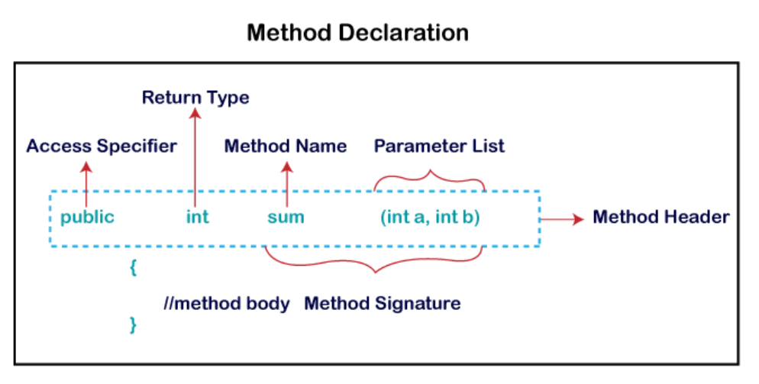
Components of a Method
1. Access Modifier
Defines the accessibility of the method.
- public → Accessible from anywhere.
- private → Accessible only within the same class.
- protected → Accessible within the same package and by subclasses.
- default (no modifier) → Accessible only within the same package.
2. Return Type
Specifies the type of value returned by the method.
- Use void if the method does not return anything.
- Use data types like int, double, String, etc., if the method returns a value.
3. Method Name
Used to identify the method.
- Should follow Java naming conventions.
- Usually written in camelCase.
4. Parameter List
A list of input values accepted by the method.
- Parameters are separated by commas.
- Enclosed within parentheses ().
- Parameters are optional.
5. Method Body
Contains the logic or statements executed by the method.
It is enclosed within curly braces {}.
Method Signature
A method signature consists of:
- Method name
- Parameter list
Types of Methods
1. Predefined Methods
Methods already available in Java libraries.
Also called built-in methods.
Example: System.out.println(), Math.sqrt(),Math.max(), Math.PI() etc..,
2. User-Defined Methods
Methods created by programmers to perform certain tasks.
Static Method
A static method belongs to the class rather than an object of the class.
Features:
- Can be called without creating an object.
- Invoked using the class name.
Instance Methods (Non-static Methods)
Require object creation.
Methods Based on Parameters and Return Type
Method Without Parameters and Without Return Type
Method Without Parameters and With Return Type
Method With Parameters and With Return Type
Method With Parameters and Without Return Type
Constructors in Java
A constructor in Java is a special type of method used to initialize objects.
When an object of a class is created, the constructor is automatically called to initialize the instance variables of that object.
Rule: If no constructor is defined in a class, the Java compiler automatically provides a default constructor.
Note: We can use access modifiers while declaring a constructor. It controls the object creation.
A constructor may be private, protected, public or default.
Important Points About Constructors
- A constructor must have the same name as the class.
- A constructor does not have a return type, not even void.
- Constructors can be overloaded (multiple constructors with different parameter lists).

Types of Constructors in Java
1. Default Constructor (No-Argument Constructor)
A constructor that does not take any parameters. (or)
A constructor with no parameters.
2. Parameterized Constructor
A constructor that accepts parameters.
3. Copy Constructor
A copy constructor creates a new object by copying the values of an existing object of the same class.
Java does not provide a built-in copy constructor like C++, but we can create one manually.
Constructor Overloading
Constructor overloading means defining multiple constructors in the same class with different parameter lists. This provides multiple ways to create objects.
The constructors must differ in:
- Number of parameters, or
- Type of parameters, or
- Order of parameters
A Java constructor cannot be declared as:
- abstract
- static
- final
- synchronized
because constructors are special members used only for object initialization.
this Keyword in Java
In Java, this is a reference variable that refers to the current object of a class.
this is used to access instance variables, methods, and constructors of the current object.
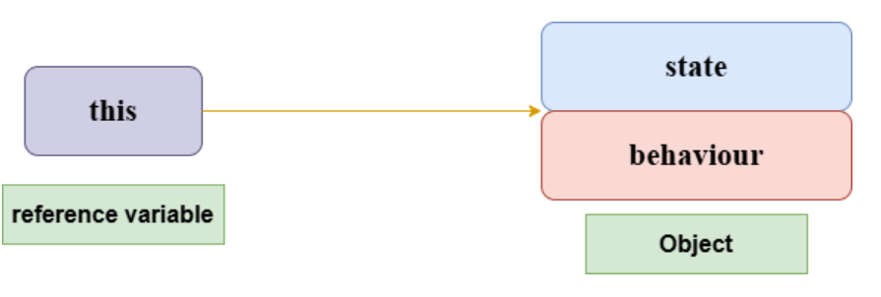
Usage of Java this keyword
1. this can be used to refer current class instance variable.
2. this() can be used to invoke current class constructor (constructor chaining).
3. this can be used to invoke current class method (implicitly)
4. this can be passed as an argument in the method call.
5. this can be passed as argument in the constructor call.
6. this can be used to return the current class instance from the method.
🔥 Key Rule Summary
- this → refers to current object
- this() → calls another constructor
- Must be first statement when used in constructor
- It cannot be used in a static context because static methods do not belong to objects.
Static Keyword in Java
The static keyword in Java is mainly used for memory management.
It is used when a member belongs to the class itself rather than to any specific object.
In general, static members are shared among all objects of a class
When something is declared static, it means:
- It belongs to the class, not objects
- Only one copy exists in memory
- It is shared by all objects
- It can be accessed without creating an object
You can use static with:
- Variables (static variables)
- Methods (static methods)
- Blocks (static block)
- Nested classes (static nested class)
1. Static Variable (Class Variable)
A variable declared with static is called a static variable.
- It is shared by all objects of the class.
- Memory allocated only once when class is loaded
- It is used for common properties (not unique to objects), such as:
  - Company name of employees
  - College name of students
2. Static Method (Class Method)
A method declared with static is called a static method.
- It belongs to the class, not to objects.
- It can be called without creating an object.
- It can access only static variables and other static methods.

Why is the main() method static?
The main() method is static because:
- JVM can call it without creating an object
- If it were non-static, JVM would first need to create an object, causing unnecessary memory usage
3. Static Block
A static block is used for initializing static variables.
- It runs once when the class is loaded
- It executes before the main method
- Multiple static blocks are executed in the order they appear
Important Note
- Static methods and static blocks cannot directly access instance members
- Cannot use this or super keywords
4. Static Nested Class
A static nested class is a class defined inside another class using the static keyword.
It is a member of the outer class, but it behaves like a separate top-level class.
Key idea
A static nested class does not need an object of the outer class to be created.
Main characteristics
A static nested class:
✔ Is declared inside another class using static
✔ Can be instantiated without creating an outer class object
✔ Can access only static members of the outer class directly
✔ Cannot access instance (non-static) members of the outer class
✔ Is used for logical grouping and better encapsulation
Inheritance in Java
Inheritance is an OOP (Object-Oriented Programming) feature where one class acquires the properties and behaviors of another class.
- The existing class is called the Parent / Superclass / Base class
- The new class is called the Child / Subclass / Derived class
Inheritance represents an IS-A relationship (parent-child relationship).
When a class inherits another class:
- It can reuse the fields and methods of the parent class.
- It can also add its own new fields and methods.
Why Inheritance is Used
Inheritance provides:
- Code Reusability
- Method Reuse
- Extensibility
- Runtime Polymorphism
- Better code organization
Types of Classes
Super Class / Parent Class
Superclass is a class whose features are inherited by another class.
It is also called a base class or a parent class.
Sub Class / Child Class
Subclass is a class that inherits another class.
It is also called a derived class, extended class, or child class.
Java uses the keyword: extends
Syntax:
class Subclass-name extends Superclass-name
{
//methods and fields
}
Types of Inheritance in Java
1. Single Inheritance
One child class inherits from one parent class.
2. Multilevel Inheritance
A class inherits from another child class.
3. Hierarchical Inheritance
Multiple child classes inherit from one parent class.
4. Multiple Inheritance
Java does not support multiple inheritance using classes.
Suppose there are three classes: A, B, and C.
If class C inherits both A and B, and both A and B contain a method with the same name, then Java becomes confused about which method should be inherited. This situation is called the Diamond Problem..
Java supports multiple inheritance through interfaces.
5. Hybrid Inheritance
Hybrid inheritance is a combination of two or more types of inheritance.
Java does not support hybrid inheritance using classes because Java does not support multiple inheritance with classes. However, hybrid inheritance can be achieved using interfaces.
Hybrid inheritance can be achieved using combinations such as:
- Single and Multiple Inheritance (achieved through interfaces)
- Multilevel and Hierarchical Inheritance
- Hierarchical and Single Inheritance
- Multiple and Multilevel Inheritance
👉 Constructor Chaining
When a child class object is created:
- Parent constructor runs first
- Then child constructor runs
Java automatically calls parent constructor using: super();
Aggregation in Java
Aggregation is a HAS-A relationship.
One class contains a reference to another class, but both classes can exist independently.
One Object uses another object but does not own it completely.
Key Points of Aggregation
- It represents a HAS-A relationship
- It is a weak association
- Objects are independent
- Helps in code reusability
- Implemented using reference variables
Polymorphism in Java
The word polymorphism comes from two Greek words:
- Poly → many
- Morphs → forms
So, polymorphism means many forms.
In Java, polymorphism allows the same method name or object to behave differently depending on the situation.

Types of Polymorphism in Java
1. Compile-Time Polymorphism
In this type, the compiler decides which method to call during compilation.
- Also called static polymorphism
- It is achieved by method overloading.
2. Runtime Polymorphism
In this type, the decision about which method to execute happens during runtime.
- Also called dynamic polymorphism.
- It is achieved by method overriding.
Advantages of Polymorphism
- Improves code reusability
- Makes code flexible and maintainable
- Allows one interface for multiple implementations
- Supports dynamic method dispatch
Method Overloading in Java
Method overloading means creating multiple methods with the same name but with different parameters in the same class.
Methods can be overloaded by changing:
- Number of parameters
- Type of parameters
- Order of parameters
Method overloading is not possible by changing only the return type of the method.
It is an example of compile-time polymorphism.
Advantages
- Improves readability
- Increases code reusability
- Provides flexibility
Method Overriding in Java
Method overriding happens when a subclass provides its own implementation of a method that is already defined in its superclass.
In simple terms:
Same method name + same parameters in child class = overriding
It is used to achieve runtime polymorphism (dynamic method dispatch)
📌 Rules of Method Overriding
The method in the child class must:
- Have the same name as the parent class method.
- Have the same parameters (same method signature)
- Have the same return type, or a covariant return type (a subtype is allowed)
- Have access modifier equal or less restrictive than the parent method (but not more restrictive)
There must be an IS-A relationship (inheritance between classes)
What Cannot Be Overridden
- static methods → they are hidden, not overridden (method hiding)
- final methods → cannot be changed
- private methods → not inherited, so they cannot be overridden
🔹1. static methods → Method Hiding
Not overridden
Decided at compile time
Depends on reference type, not object
🔹 2. final methods → Cannot be changed
Child class cannot override it
Always uses parent implementation
🔹 3. private methods → Not inherited
Child class cannot see it
You can create a same method name, but it is NOT overriding
Super Keyword in Java
In Java, the super keyword refers to the immediate parent class object.
It is mainly used in inheritance to access parent class members when they are hidden or overridden in the child class.
Whenever an object of a subclass is created, an object of its parent class is also created automatically. The super keyword refers to that parent class object.
Uses of super in Java
The super keyword is used for:
- Accessing parent class variables
- Invoking parent class methods
- Invoking parent class constructors
- Resolving ambiguity in inheritance
Important Notes
- super() is automatically added by the Java compiler if you do not explicitly write super() or this() in the constructor.
- When calling the parent constructor, super() must be the first line inside the child constructor.
- super refers only to the immediate parent class.
- super() calls the parent constructor.
- super cannot be used in static methods or static blocks.
- Helps access overridden methods and hidden variables.
- super.methodName() is used to call the parent class method when it is overridden in the child class.
- super.variableName is used to access the parent class variable when both parent and child have the same variable name.
- If a method is not overridden in the child class, the parent class method is automatically called, so using super is not needed.
- super() and this() cannot be used together in the same constructor because both must be the first statement.
Abstraction in Java
Abstraction means hiding implementation details and showing only the essential features to the user.
It focuses on what an object does instead of how it does it.
Ways to Achieve Abstraction in Java
- Abstract Class (0% to 100% abstraction)
- Interface (traditionally 100% abstraction)
Since Java 8, interfaces can also contain implemented methods (default and static methods), so they are no longer strictly 100% abstract.
Why Abstraction is Important
- To reduce complexity
- To improve security
- To achieve loose coupling
- To improve maintainability
Abstract Class
An abstract class is a class declared with the abstract keyword.
It can contain:
- Abstract methods (methods without body)
- Concrete methods (methods with body)
An abstract class cannot be instantiated (you cannot create objects of it directly).

Points to Remember
- If a class contains at least one abstract method, the class must be declared as abstract.
- An abstract class may or may not contain abstract methods.
- It can contain:
- Abstract methods
- Non-abstract (concrete) methods
- Constructors
- Static methods (including the main() method)
- Instance variables
- Final methods
- Private methods
- A subclass extending an abstract class must implement all abstract methods; otherwise, the subclass must also be declared abstract.
Advantages of Abstract Class
- Provides partial abstraction.
- Helps achieve code reusability.
- Allows common functionality to be defined in one place.
- Useful when multiple related classes share common behaviour.
Abstract Method in Java
An abstract method is a method declared with the abstract keyword and without a method body (implementation).
It must be declared inside an abstract class or an interface.
Syntax
abstract returnType methodName();
Example
abstract void printStatus();
Interface in Java
An interface in Java is a blueprint of a class that defines what a class should do, but not how it should do it.
An interface contains:
- Abstract methods (methods without a body)
- Constants (public static final variables)
- Default methods (with body)
- Static methods
- Private methods (Java 9+)
Syntax of Interface
interface <interface_name> {
// declare constant fields
// declare abstract methods
}
Key Points about Interfaces
- An interface represents an IS-A relationship.
- An interface cannot be instantiated, similar to an abstract class.
- It is declared using the interface keyword.
- Interfaces were traditionally used to achieve 100% abstraction before Java 8.
- All methods in an interface are implicitly: public and abstract
- All variables in an interface are implicitly: public static and final
- A class implementing an interface must implement all abstract methods; otherwise, the class must be declared abstract.
- A class can:
  - extend only one class
  - implement multiple interfaces
- Since Java 8:
  - interfaces can contain default and static methods.
- Since Java 9:
  - interfaces can contain private methods and private static methods
- So now, not all methods in an interface are abstract.
Why Use Interfaces in Java?
1. To Achieve Abstraction
Interfaces hide implementation details and show only functionality.
2. To Support Multiple Inheritance
Java does not support multiple inheritance with classes, but it supports multiple inheritance through interfaces.
3. To Achieve Loose Coupling
Interfaces reduce dependency between classes, making programs more flexible, maintainable, and scalable.
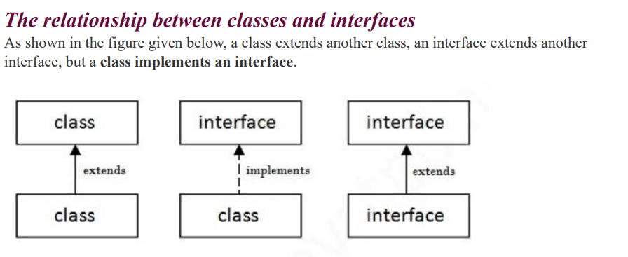
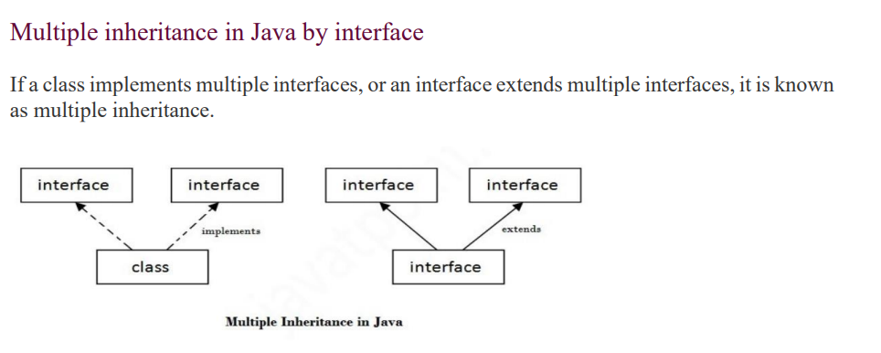
Java Package
In Java, a package is simply a way to group related classes, interfaces, and sub-packages together, so your code stays organized, reusable, and easier to maintain—especially in large projects.
Think of a package like a folder in a file system:
- Classes = files
- Packages = folders containing those files
A package is a namespace that organizes Java code.
So instead of having thousands of classes in one place, Java groups them into packages.
How to create a package
The package declaration must be the first statement in a Java file.
package packageName;
How to use a package
Import specific class: - import package_name.ClassName;
Import whole package: - import package_name.*;
Using fully qualified name
You can use a class without importing the package by using its fully qualified name.
package_name.ClassName obj = new package_name.ClassName();
- Only that specific class is accessed
- There is no need to use import
This approach is generally used when two packages contain classes with the same name
Note: If you import a package, its sub-packages are not imported automatically.
Types of packages in Java
1. Built-in Packages
These are already provided by Java and ready to use.
Some commonly used ones:
- java.lang:- Core language features (String, Math, System). Automatically imported.
- java.util:- Data structures and utilities like List, Map, ArrayList.
- java.io: -Input/output operations like file reading and writing.
- java.net: -Networking (URLs, sockets, connections).
- java.awt: -GUI components (buttons, windows, layouts).
- java.applet:-(Older) support for applets.
2. User-defined Packages
Packages created by developers.
Why Java uses packages
Packages solve a few common problems:
- Organization: Keeps related code together (like all utility classes in one place)
- Name conflicts: You can have two classes with the same name in different packages
- Access control: Packages help control visibility using access modifiers
- Reusability: Code can be reused across multiple projects easily
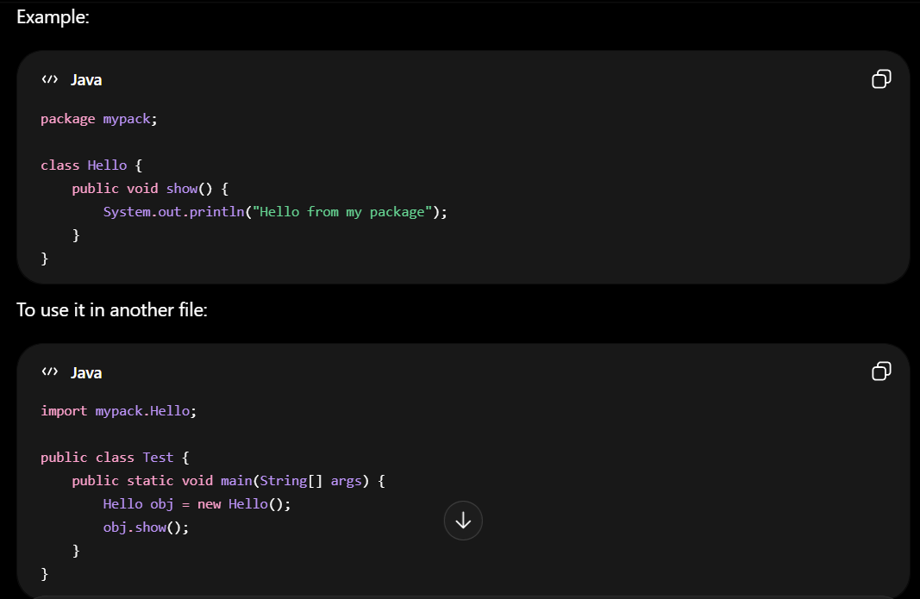
Access Modifiers in Java
Access modifiers in Java define the visibility or accessibility of classes, variables, methods, and constructors.
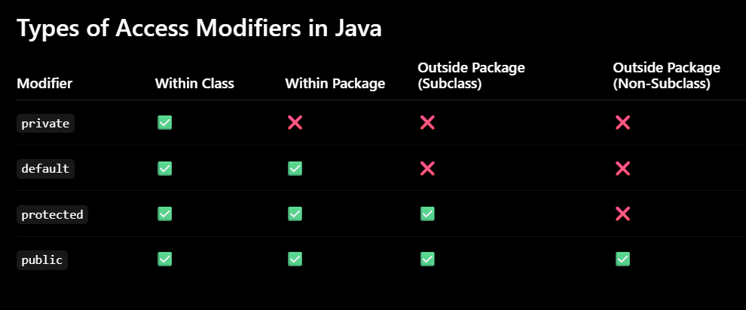
1. private Access Modifier
- Accessible only within the same class.
- Cannot be accessed outside the class.
2. Default Access Modifier
- No keyword is used.
- Accessible only within the same package.
- Cannot be accessed outside the package.
3. protected Access Modifier
- Accessible within the same package.
- Accessible outside the package through inheritance (child class).
4. public Access Modifier
- Accessible from anywhere in the program.
- Can be accessed within class, package, subclass, and outside package.
Important Points
- private is the most restricted access modifier.
- public is the least restricted access modifier.
- If no modifier is specified, Java uses the default access modifier.
- Top-level classes can only be public or default.

Note:- In Java, a top-level class cannot be declared as private or protected.
Only these access modifiers are allowed for a top-level class:
- public
- default (no modifier)
private and protected are allowed only for nested classes (classes declared inside another class).
Encapsulation in Java
Encapsulation is the process of wrapping data (variables) and code (methods) together into a single unit called a class, and restricting direct access to the data.
Encapsulation = Data Hiding + Controlled Access
In Java, encapsulation is achieved by:
- Declaring variables as private
- Providing public getter and setter methods to access and update the data
Why Encapsulation is Important
Encapsulation provides:
- Data Hiding → Protects data from direct modification
- Controlled Access → Controls how data is accessed or updated
- Flexibility → Validation logic can be added easily in setter methods
- Maintainability → Makes code cleaner and more modular
- Reusability → Encapsulated classes are easier to reuse
Simple Real-Life Example
Think of an ATM machine:
- You cannot directly access the bank balance variable
- You interact through methods like:
  - withdraw()
  - deposit()
  - checkBalance()
This is encapsulation.
How Encapsulation Works
- Variables are declared as private
- Direct access from outside the class is restricted
- Getter methods are used to read values
- Setter methods are used to modify values safely
This provides controlled access to data.

Instance Initializer Block in Java
An Instance Initializer Block (IIB) is a block of code inside a class that is used to initialize instance variables.
It runs every time an object is created, before the constructor body executes.
It is mainly used when:
- Multiple constructors need the same initialization logic.
- Initialization requires loops, try/catch, or multi-line logic.
- You want to avoid duplicating code in every constructor.
Execution Order During Object Creation
When an object is created in Java, the execution happens in this order:
- Memory is allocated for the object
- Instance variables are initialized
- Parent class constructor is called (super())
- Instance Initializer Blocks (IIBs) are executed
- Constructor body is executed
Important Note
The constructor does not execute first. Java automatically inserts super() as the first statement of every constructor (if not written explicitly).
So, the Instance Initializer Block executes after the parent constructor call(super()) and before the constructor body.
Multiple IIBs
Java allows multiple Instance Initializer Blocks in the same class.
They execute in the same order in which they appear in the class.
Inheritance and IIB Execution Order
If both superclass and subclass contain IIBs, the execution order is:
- Superclass instance variables initialized
- Superclass IIB executed
- Superclass constructor executed
- Subclass instance variables initialized
- Subclass IIB executed
- Subclass constructor executed

Overall Java Initialization Order
Java follows this general execution order:
- Static blocks → executed only once when the class is loaded
- Instance Initializer Blocks (IIBs) → executed every time an object is created
- Constructors → executed after IIBs
- Parent class initialization happens before child class initialization
Final Keyword in Java
The final keyword in Java can be used with:
- Variables
- Methods
- Classes
It is used to restrict modification.
1. Final Variable
A final variable cannot be reassigned once it is initialized.
It acts like a constant.
2. Blank Final Variable
A final variable that is declared but not initialized at the time of declaration is called a blank final variable (or uninitialized final variable).
It must be initialized inside the constructor.
3. Static Blank Final Variable
A static final variable that is not initialized at the time of declaration is called a static blank final variable.
It must be initialized inside a static block.
4. Final Method
A final method cannot be overridden by subclasses.
final prevents overriding, but not overloading.
5. Final Class
A final class cannot be inherited.
6. Final Reference Variable
For objects, final prevents changing the reference, not the object contents.

Java Arrays
In Java, an array is a collection of elements of the same data type stored in contiguous memory locations.
Instead of creating many variables: int a = 10, b = 20, c = 30;
you can use an array: int[] numbers = {10, 20, 30};
Features of Arrays
- Store multiple values using a single variable.
- Elements must be of the same data type.
- Array size is fixed after creation.
- Faster access using index values.
Characteristics of Arrays
- Stores same type of data
- Fixed size
- Elements stored in contiguous memory
- Index starts from 0
Types of Arrays in Java
- Single Dimensional Array - Stores elements in one row.
- Multidimensional Array - Stores data in rows and columns.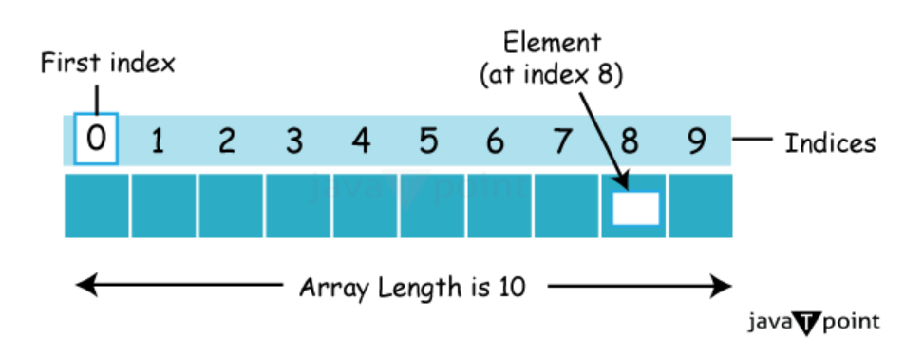
Syntax to Declare an Array
All three declarations are valid:
dataType[] arr;
dataType []arr;
dataType arr[];
Example:
int[] value;
int []value2;
int value3[];

Array Instantiation
Memory allocation for the array:
arr = new dataType[size];
Example:
value = new int[3];
Declaration + Instantiation
dataType[] arr = new dataType[size];
Example:
int[] value = new int[3];
Declaration + Instantiation + Initialization
dataType[] arrayName = { elementsOfArraySeparatedByComma};
Example:
int[] value = {11, 13, 17, 19};
Initializing Array Elements Individually
arrayName[index] = value;
Example:
int[] value = new int[3];
value[0] = 100;
value[1] = 200;
value[2] = 300;
Reference Type Array
Arrays can also store objects.
Example:
Bank[] bank = {new Bank(), new Bank()};
Length of an Array
Use the length attribute to get the array size.
Example:
int[] arr = {10, 20, 30, 40};
System.out.println(arr.length); // 4
Passing Array to a Method
Arrays can be passed to methods.
Anonymous Array
Java supports anonymous arrays.
Different ways of declaring arrays
int[] value1;
int []value2;
int value3[]; // DECLARATION
Instantiation
value3 = new int[5];
Declaration and Instantiation together
int[] value4 = new int[5];
Initialization of array elements
value4[0] = 10;
value4[1] = 34;
value4[2] = 67;
// and so on
Initializing an already instantiated array
value3 = new int[]{10, 76, 98, 76, 42};
Declaration, Instantiation and Initialization together
int[] value5 = {10, 76, 98, 76, 42};

Multidimensional Array (Two-Dimensional Array)
A multidimensional array (two-dimensional array) in Java is an array of arrays, where each element of the main array is itself an array.
It is used to store data in a table-like structure with rows and columns.
Syntax to Declare a Multidimensional Array
dataType[][] arrayRefVar;
dataType [][]arrayRefVar;
dataType arrayRefVar[][];
datatype[] []arrayRefVar;
dataType []arrayRefVar[];
Declaration + Instantiation of 2D Array
Syntax: dataType[][] arrayName = new dataType[rows][columns];
Example: int[][] arr = new int[3][4]; // 3 rows, 4 columns
Note: The number of rows is mandatory, but the number of columns is optional in some cases (especially jagged arrays).
1. Different ways of declaration
All the following are valid ways to declare a 2D array:
int[][] a;
int[] [] b;
int [][] c;
int [] d[];
int e[][];
2. Instantiation (memory allocation)
e = new int[3][2]; // 3 rows, 2 columns
3. Declaration + Instantiation together
int[][] f = new int[4][3];
4. Declaration + Instantiation + Initialization
int[][] g={{29,21},{24,23},{26,22}};
5. Initializing an already instantiated array
f=new int[][] {{29,21},{24,23},{26,22}};
👉 This replaces the previous content of f.
6. Manual element-wise initialization
int[][] arr = new int[3][3];
arr[0][0] = 1;
arr[0][1] = 2;
arr[0][2] = 3;
arr[1][0] = 4;
arr[1][1] = 5;
// and so on...
✔️ Key Idea to Remember
- Declaration → tells Java the variable is a 2D array
- Instantiation → allocates memory (new)
- Initialization → assigns values
Jagged Array in Java
A jagged array is a 2D array where each row can have different number of columns.
👉 In simple terms: rows are fixed, but columns vary.
Key idea
- Normal 2D array → every row has same number of columns
- Jagged array → each row can have different number of columns
Java Strings
In Java, a String is an object that represents a sequence of characters.
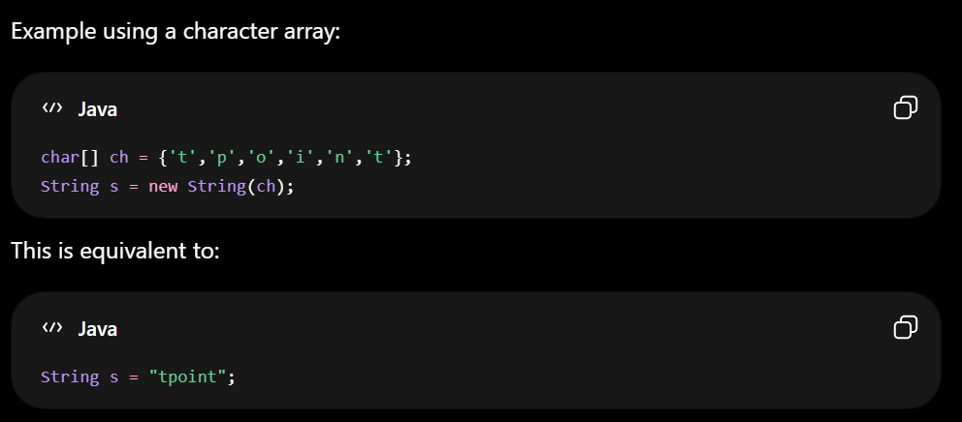
Features of Java String
- Strings are objects of the java.lang.String class.
- Strings are immutable (cannot be changed after creation).
- Java provides many built-in methods for string operations.
- String class implements Serializable, Comparable and CharSequence interfaces.
CharSequence Interface
The CharSequence interface represents a readable sequence of characters.
Classes implementing it:
- String
- StringBuffer
- StringBuilder
This means strings in Java can be handled using these classes.
Immutability of String
The Java String is immutable which means it cannot be changed. Whenever we change any string, a new instance is created.
Ways to Create String Objects in Java
There are two ways to create a String object in Java:
- By String Literal
- By new Keyword

1) String Literal
A Java String literal is created using double quotes.
When a string literal is created, the JVM checks the String Constant Pool (SCP).
- If the string already exists in the pool, JVM returns the reference of the existing object.
- If it does not exist, JVM creates a new object in the pool.
Example
String s1 = "Welcome";
String s2 = "Welcome";
System.out.println(s1 = = s2); // = = checks reference equality
Output: true
Here:
- "Welcome" already exists after creating s1
- s2 does not create a new object
- Both s1 and s2 point to the same memory location
Reason: Both references point to the same pooled object
String Constant Pool
The String Constant Pool is a special memory area inside the Heap memory where Java stores string literals.
Advantages:
- Saves memory
- Improves performance by reusing existing objects
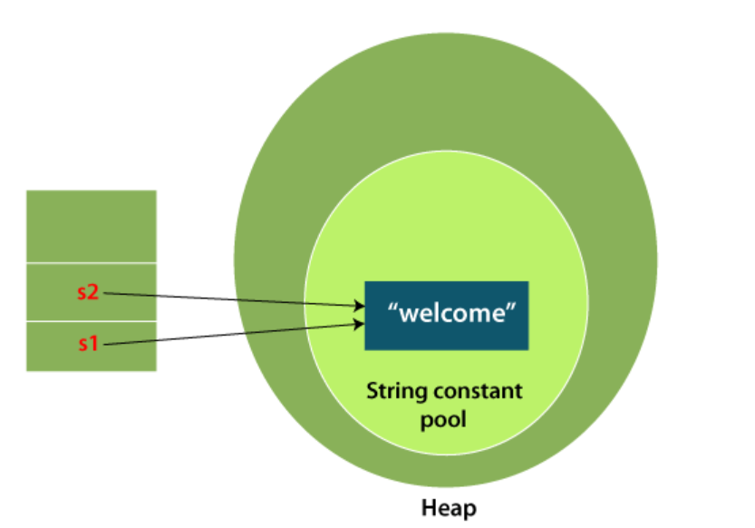

2) By new Keyword
When a String is created using the new keyword:
String s = new String("Welcome");
JVM performs two actions:
- Creates the string literal "Welcome" in the String Constant Pool (if not already present)
- Creates a new String object separately in Heap memory
Thus, a new memory allocation always happens.
Example
String s1 = new String("Welcome");
String s2 = new String("Welcome");
System.out.println(s1 = = s2);
Output: false
Reason: s1 and s2 refer to different objects in heap memory
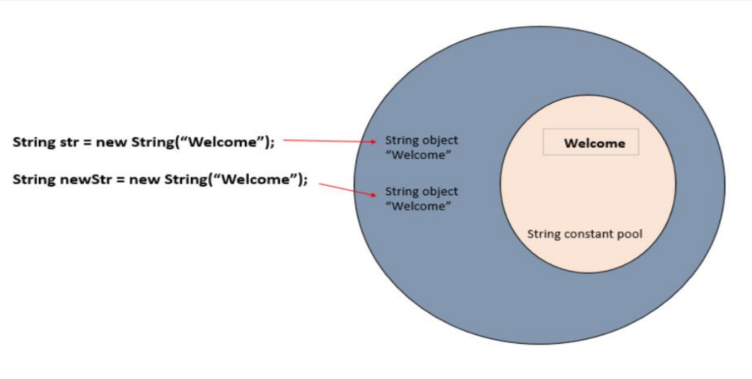
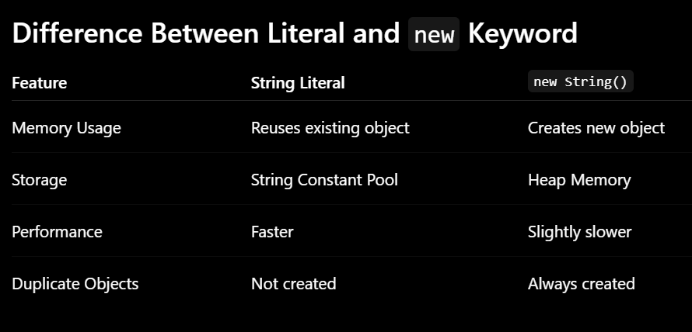
Commonly Used Java String Methods
Method | Description
length() | Returns the length of the string
charAt(int index) | Returns character at specified index
substring(int beginIndex) | Returns substring from given index
substring(int beginIndex, int endIndex) | Returns substring between indexes
concat(String str) | Joins two strings
equals(Object obj) | Compares two strings
equalsIgnoreCase(String str) | Compares strings ignoring case
compareTo(String str) | Lexicographically compares strings
compareToIgnoreCase(String str) | Comparison ignoring case
toUpperCase() | Converts string to uppercase
toLowerCase() | Converts string to lowercase
trim() | Removes leading and trailing spaces
strip() | Removes whitespace (Java 11+)
replace(char old, char new) | Replaces characters
replace(CharSequence old, CharSequence new) | Replaces text
replaceAll(String regex, String replacement) | Replaces using regex
replaceFirst(String regex, String replacement) | Replaces first matching text
contains(CharSequence s) | Checks if string contains text
startsWith(String prefix) | Checks beginning of string
endsWith(String suffix) | Checks ending of string
indexOf(int ch) | Returns first occurrence index
indexOf(String str) | Returns first occurrence of substring
lastIndexOf(int ch) | Returns last occurrence index
lastIndexOf(String str) | Returns last occurrence of substring
isEmpty() | Checks if string is empty
isBlank() | Checks if string contains only spaces (Java 11+)
split(String regex) | Splits string into array
split(String regex, int limit) | Splits with limit
join(CharSequence delimiter, elements) | Joins strings using delimiter
valueOf() | Converts data into string
toCharArray() | Converts string into character array
getBytes() | Converts string into byte array
intern() | Returns pooled string
matches(String regex) | Checks regex match
repeat(int count) | Repeats string (Java 11+)
codePointAt(int index) | Returns Unicode value
codePointBefore(int index) | Returns Unicode before index
codePointCount(int begin, int end) | Counts Unicode points
contentEquals(CharSequence cs) | Compares with character sequence
copyValueOf(char[] data) | Creates string from char array
format(String format, Object... args) | Formats string
indent(int n) | Adds indentation (Java 12+)
lines() | Returns stream of lines
regionMatches() | Compares specific regions
subSequence(int start, int end) | Returns character subsequence
stripLeading() | Removes leading spaces
stripTrailing() | Removes trailing spaces
translateEscapes() | Translates escape sequences
hashCode() | Returns hash code
toString() | Returns string itself
chars() | Returns stream of characters
codePoints() | Returns stream of Unicode points

Static Methods in String Class
Static Method | Description
String.valueOf() | Converts values to String
String.format() | Returns formatted string
String.join() | Joins strings
String.copyValueOf() | Converts char array to string

Java 11+ String Methods
Method | Description
isBlank() | Checks blank string
lines() | Returns lines stream
repeat() | Repeats string
strip() | Removes spaces
stripLeading() | Removes leading spaces
stripTrailing() | Removes trailing spaces
StringBuffer Class in Java
The StringBuffer class in Java is used to create mutable (modifiable) strings.
Unlike String objects, StringBuffer objects can be changed after creation without creating a new object.
Java StringBuffer class is thread-safe, meaning multiple threads cannot access and modify it simultaneously in an unsafe manner.
StringBuffer is thread-safe because its methods are synchronized. So, it is safer in multithreaded environments.
It is slightly slower than StringBuilder because of synchronization.
The StringBuffer class provides multiple constructors to create mutable string objects with different initial states and capacities.
1. StringBuffer()
This constructor creates an empty StringBuffer object with a default initial capacity of 16 characters.
Syntax: StringBuffer sb = new StringBuffer();
2. StringBuffer(String str)
This constructor creates a StringBuffer object initialized with the specified string.
Syntax: StringBuffer sb = new StringBuffer("Hello");

3. StringBuffer(int capacity)
This constructor creates an empty StringBuffer object with the specified initial capacity.
Syntax: StringBuffer sb = new StringBuffer(50);
Common Methods of StringBuffer
Method | Description
append() | Adds text at the end
insert() | Inserts text at a specified position
replace() | Replaces characters
delete() | Removes characters
reverse() | Reverses the string
capacity() | Returns current capacity
length() | Returns string length
charAt() | Returns character
setCharAt() | Changes character

StringBuilder Class in Java
The StringBuilder class in Java is used to create mutable (modifiable) strings.
Like StringBuffer, it allows modification of strings without creating new objects.
Java StringBuilder class is not thread-safe, meaning multiple threads can access and modify it simultaneously in an unsafe manner.
StringBuilder is not synchronized, so it is faster than StringBuffer.
It is mainly used in single-threaded environments where high performance is required.
The StringBuilder class provides multiple constructors to create mutable string objects with different initial states and capacities.
1. StringBuilder()
This constructor creates an empty StringBuilder object with a default initial capacity of 16 characters.
Syntax: StringBuilder sb = new StringBuilder();
2. StringBuilder(String str)
This constructor creates a StringBuilder object initialized with the specified string.
Syntax: StringBuilder sb = new StringBuilder("Hello");

3. StringBuilder(int capacity)
This constructor creates an empty StringBuilder object with the specified initial capacity.
Syntax: StringBuilder sb = new StringBuilder(50);
Common Methods of StringBuilder
Method | Description
append() | Adds text at the end
insert() | Inserts text at a specified position
replace() | Replaces characters
delete() | Removes characters
reverse() | Reverses the string
capacity() | Returns current capacity
length() | Returns string length
charAt() | Returns character
setCharAt() | Changes character

Key Summary
- String → fixed (immutable)
- StringBuffer → safe + slow (thread-safe)
- StringBuilder → fast + unsafe (no synchronization)
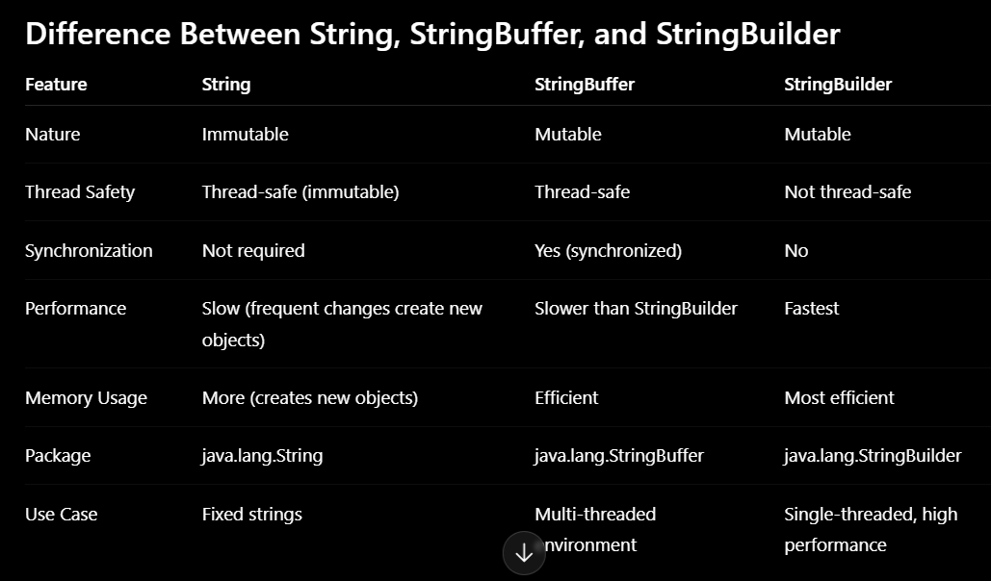
Exception Handling in Java
An exception in Java is an unexpected event that occurs during program execution and disrupts the normal flow of a program.
Simply put, an exception is an object that is thrown at runtime when an error occurs.
Exception handling is a mechanism used to handle runtime errors so that the normal flow of the program can continue.
Example:
If a program has 10 statements and an error occurs at statement 5:
- Without handling → statements 6 to 10 will NOT run
- With exception handling → program handles the error and continues execution
Java Exception Hierarchy
The root class of Java’s exception hierarchy is java.lang.Throwable.
It has two main subclasses:
- Exception
- Error
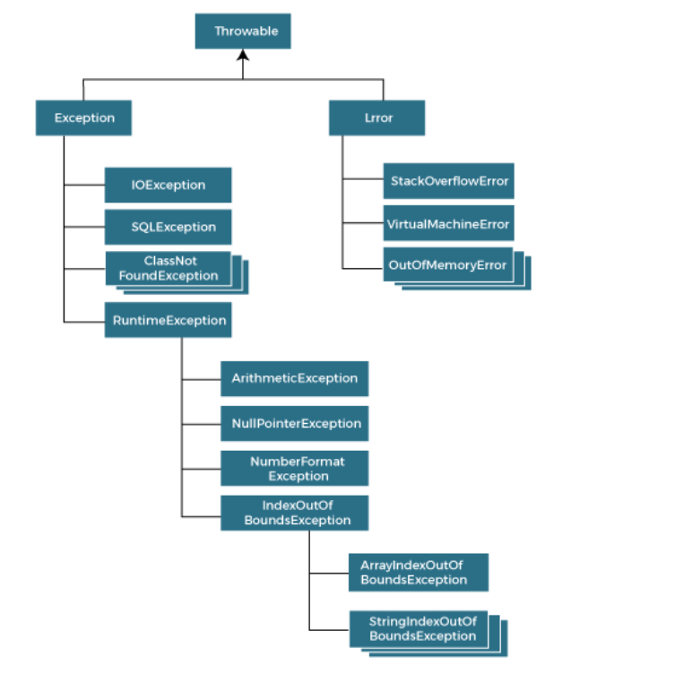
Types of Exceptions in Java
1. Checked Exceptions
- Exceptions checked at compile time by the compiler.
- Must be handled using try-catch or declared using throws
- All exceptions except RuntimeException are checked exceptions.
- Examples:
  - SQLException
  - IOException
2. Unchecked Exceptions
- Exceptions occur at runtime and are not checked during compilation.
- Usually caused by programming mistakes
- Examples:
- ArithmeticException
- NullPointerException
- IndexOutOfBoundsException
Key Points
- All exceptions inherit from the Exception class, which is a subclass of Throwable.
- The Exception class is the superclass of all exception types in Java.
Exception Output (Stack Trace)
- When an exception occurs, Java prints a stack trace.
- It includes:
  - Type of exception
  - Error message
  - Method call sequence
  - Line number where the exception occurred
This information is useful for debugging.
Exception Handling Mechanism
Java uses three main blocks:
1. try block
- The try block contains code that may generate an exception
- Must be followed by one or more catch blocks or a finally block

2. catch block
- Used to handle specific exceptions.
- Each catch block handles a particular type of exception.
3. finally block
- Executes always (whether exception occurs or not).
- Used for cleanup (closing files, database connections, etc.)
Best Practice
- Always catch specific exceptions first, and more general exceptions later.
try-catch Block Syntax
The syntax to handle an expectation using try-catch block is:
try {
// Code that may throw an exception
} catch (ExceptionType e) {
// Code to handle the exception
}

Handling Multiple Exceptions
Syntax
Here is the syntax to handle multiple exceptions:
try {
// Code that may throw an exception
} catch (IOException e) {
// Handle IOException
} catch (NumberFormatException e) {
// Handle NumberFormatException
} catch (Exception e) {
// Handle any other exceptions
}
Nested try Block
A nested try block is a try block inside another try block.
- If inner try does not handle the exception,
- Outer catch block is checked.

The finally Block
Syntax
Here is the syntax to use finally block along with the try-catch block:
try {
// Code that may throw an exception
} catch (Exception e) {
// Exception handling code
} finally {
// Cleanup code
}

Important Rules:
- If an exception occurs in the try block, remaining code inside it is skipped
- The matching catch block is executed
- If no exception occurs, catch blocks are ignored
- Catch blocks must be ordered from specific → general
- Only one finally block is allowed per try
- After handling, execution continues after the try-catch block
Ordering of catch Blocks
- Catch blocks must be arranged from most specific to most general.
- A catch block for Exception should always be last, as it can handle all exceptions.
Exception Handling in Methods
If an exception occurs in a method, it can be handled in two ways:
- Handle it inside the method using try-catch.
- Or propagate it to be handled by the caller.
throw Keyword
Used to explicitly throw an exception.
- Can throw both checked and unchecked exceptions
- Used for custom exceptions
throws Keyword
Used to declare exceptions in a method signature.
- Indicates that a method may throw exceptions
- Caller must handle or declare it again
Rule: If you call a method that uses throws, you must:
- Handle it using try-catch OR
- Declare it again using throws

Important Rules of Exception Handling
- A try block must be followed by at least one catch or finally block
- Multiple catch blocks are allowed
- Generic Exception catch must be last
- finally block is optional but always executes
- Exceptions can be thrown explicitly using throw
- Checked exceptions must be handled or declared
- User-defined exceptions must extend Exception
Object class in Java
The Object class is the root (topmost) class in Java.
Every class in Java directly or indirectly inherits from Object.
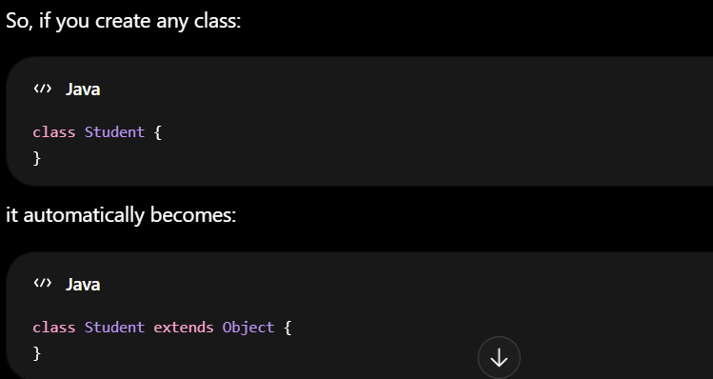
The Object class is defined in the package: java.lang.Object
It provides common behavior that all Java objects can use.
Creating an Object of Object Class
Object obj = new Object();
This creates a generic object.
Constructor Detail
The constructor of the Object class has no parameters and initializes a new instance of the object.

Syntax
public Object() {
// default constructor }
Important Methods of Object Class
The most commonly used methods are:
Method | Purpose
toString() | Converts object to string
equals() | Compares objects
hashCode() | Returns hash value
getClass() | Returns runtime class
clone() | Creates copy of object
finalize() | Cleanup before garbage collection
wait() | Thread waiting
notify() | Wakes waiting thread
notifyAll() | Wakes all waiting threads
Wrapper classes in Java
Wrapper classes in Java are used to convert primitive data types into objects.
Java provides a wrapper class for each primitive data type in the java.lang package.
Java collections and many APIs work only with objects, not primitive types.
Primitive Types and Wrapper Classes
Primitive Type | Wrapper Class
boolean | Boolean
char | Character
byte | Byte
short | Short
int | Integer
long | Long
float | Float
double | Double

Autoboxing
Automatic conversion of a primitive type into its wrapper object is called autoboxing.
Java automatically converts:
Primitive → Wrapper Object
Unboxing
Automatic conversion of a wrapper object into its primitive type is called unboxing.
Java automatically converts:
Wrapper Object → Primitive
Manual Conversion (Before Java 5)
Before autoboxing was introduced, conversion was manual.
Primitive to Object
int a = 10;
Integer obj = Integer.valueOf(a);
Object to Primitive
Integer obj = new Integer(10);
int a = obj.intValue();
Important Wrapper Class Methods
1. valueOf()
Converts primitive or string into wrapper object.
Integer obj = Integer.valueOf(100);
2. parseInt()
Converts string into primitive.
int num = Integer.parseInt("200");
3. toString()
Converts value into string.
Integer num = 50;
String str = num.toString();

Java Collections Framework
The Java Collections Framework (JCF) is a set of classes and interfaces used to store and manage groups of objects efficiently.
Instead of handling individual variables separately, collections allow multiple objects to be managed as a single unit.
Advantages of Collections
Collections provide built-in methods for:
- Adding elements
- Removing elements
- Searching data
- Sorting data
- Updating data
What is a Collection?
A Collection represents a group of objects.
It is used when you want to:
- Store multiple values together
- Perform operations on data easily
- Manage data dynamically
Main Components of Collection Framework
1. Interfaces
Interfaces define the structure and behavior of collections.
Important interfaces: List, Set, Queue, Deque, Map
2. Classes
Classes implement the interfaces.
Important classes: ArrayList, LinkedList, Vector, PriorityQueue, HashSet, LinkedHashSet, TreeSet, HashMap
3. Algorithms
The framework also provides algorithms for: Sorting, Searching, Reversing, Shuffling
These algorithms are available through the Collections class.

Iterable
|
Collection
├── List
│ ├── ArrayList
│ ├── LinkedList
│ └── Vector
│
├── Set
│ ├── HashSet
│ ├── LinkedHashSet
│ └── TreeSet
│
└── Queue
├── PriorityQueue
└── Deque

Map (Separate Hierarchy)
├── HashMap
├── TreeMap
└── LinkedHashMap
Collection Interface
The Collection interface is the root interface of the Collection Framework.
All collection classes implement this interface directly or indirectly.
Common methods: add(), remove(), contains(), size(), clear()
Iterable Interface in Java
The Iterable interface is the root interface for traversing collections.
It allows objects to be accessed one by one using an Iterator.
Since Collection extends Iterable, all collection classes automatically become iterable.
The Iterable interface contains only one abstract method:
Iterator<T> iterator()
It returns an iterator over elements of type T.
Iterator Interface in Java
The Iterator interface is used to traverse elements of a collection one by one.
It belongs to the java.util package.
Features
- Moves only in forward direction
- Also provides methods to remove elements while iterating.
- Works with most collection classes
Methods of Iterator Interface
Method | Description
hasNext() | Returns true if next element exists
next() | Returns the next element
remove() | Removes current element
Creating an Iterator
The iterator() method of the collection interface returns an iterator object.
Syntax Iterator<dataType> iteratorName = collection.iterator();
List Interface
A List: Ordered collection of elements. It allows:
- Duplicate values
- Null elements
- Supports index-based access
- Maintains insertion order
The List interface is available in the java.util package and extends the Collection interface.
Common List Classes
- ArrayList Fast reading/access & Dynamic arrays
- LinkedList Efficient insertion/deletion
- Vector Synchronized dynamic array
To instantiate the List interface, we must use:
- List <data-type> list1= new ArrayList();
- List <data-type> list2 = new LinkedList();
- List <data-type> list3 = new Vector();
- List <data-type> list4 = new Stack();
List interface provides a ListIterator that allows traversal of elements in both forward and backward directions
Java ArrayList
ArrayList is a resizable (dynamic) array
It allows you to store elements dynamically without worrying about the initial size.
ArrayList belongs to the java.util package and is commonly used when you need a flexible collection to store data.
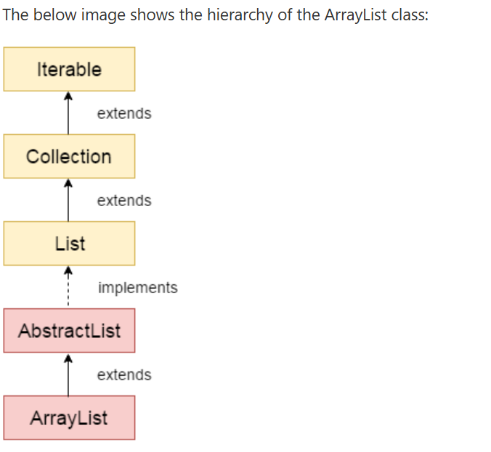
Constructors of Java ArrayList
The ArrayList class provides different constructors to create objects in different ways.
Constructor | Description
ArrayList() | Creates an empty ArrayList with default capacity
ArrayList(Collection<? extends E> c) | Creates an ArrayList containing elements from another collection
ArrayList(int initialCapacity) | Creates an ArrayList with the specified initial capacity
Java LinkedList
Java LinkedList is used to store and manage a collection of data where frequent insertion and deletion of elements are required.
Java LinkedList is a class that implements a doubly linked list data structure.
Unlike arrays, LinkedList does not store elements in continuous memory. Instead, it stores elements as nodes, where each node contains:
- The actual data
- A reference to the next node
- A reference to the previous node
Because of this structure, insertion and deletion become faster compared to arrays.
The LinkedList class:
- Extends the AbstractList class
- Implements the List and Deque interfaces
LinkedList can be used in multiple ways such as:
- List
- Stack
- Queue
Common Methods of LinkedList
Method | Description
add() | Adds an element
addFirst() | Adds element at beginning
addLast() | Adds element at end
remove() | Removes element
removeFirst() | Removes first element
removeLast() | Removes last element
get() | Returns element at index
getFirst() | Returns first element
getLast() | Returns last element
size() | Returns number of elements
clear() | Removes all elements

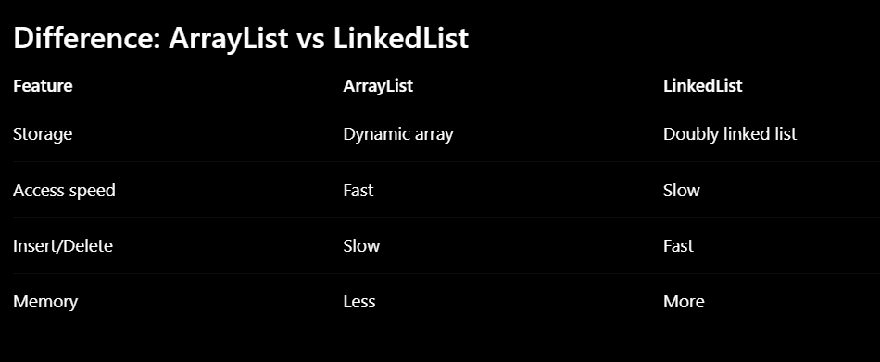
Set Interface
A List allows duplicate elements and maintains insertion order, whereas a Set does not allow duplicate elements and may not maintain any order (in case of HashSet).
A Set:
- Does NOT allow duplicates (Stores unique values)
- Not index-based
Types
- HashSet No duplicates & No insertion order (elements may appear in random order)
- LinkedHashSet No duplicates & Maintains insertion order
- TreeSet Stores sorted data & No duplicates (Uses Red-Black Tree)
Important Features of HashSet
- Does NOT allow duplicates
- Allows one null value
- Unordered collection (No insertion order)
- Fast insertion and searching
- Internally uses hashing
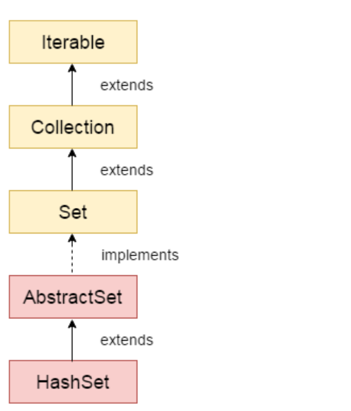
Java LinkedHashSet is a class that:
- Extends HashSet
- Implements the Set interface
- Internally uses both:
  - Hash Table → for fast searching
  - Linked List → for maintaining insertion order
- LinkedHashSet permits one null element.
Java TreeSet Class
Java TreeSet is used to store unique elements in sorted (ascending) order.
It internally uses a:
- Red-Black Tree (Self-balancing Binary Search Tree)
Because of this, elements are always stored in ascending order.
Does Not Allow Null Values TreeSet throws NullPointerException if null is inserted.
TreeSet compares elements for sorting, null cannot be compared.
TreeSet allows only those elements that are comparable (i.e., implement the Comparable interface).

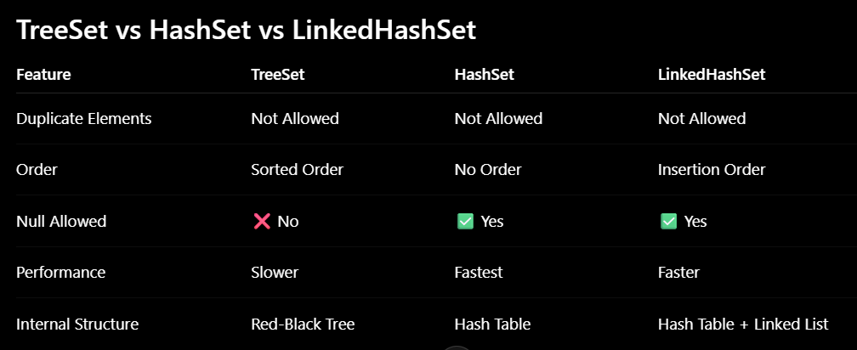
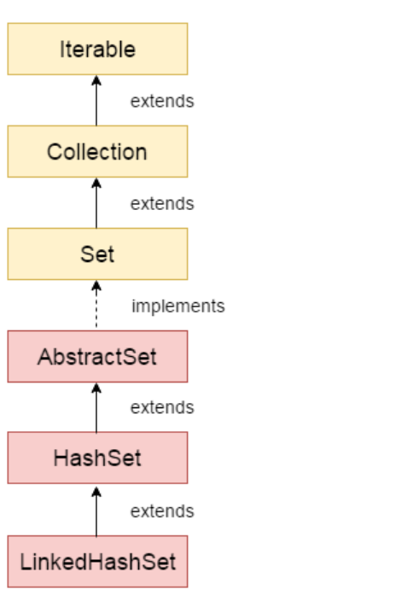
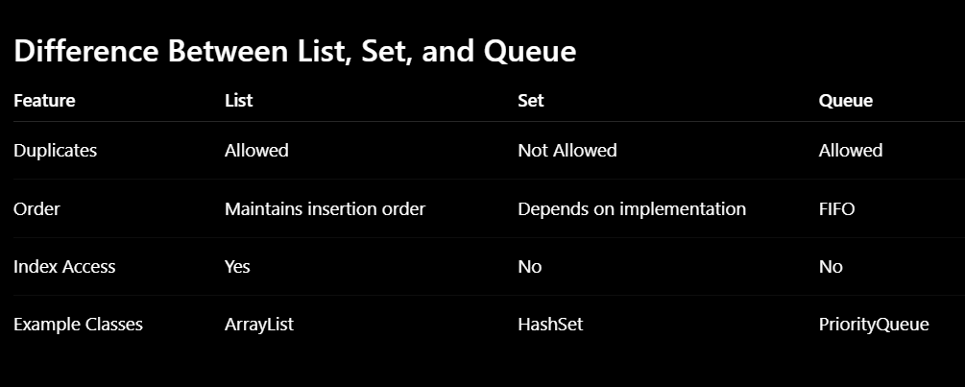
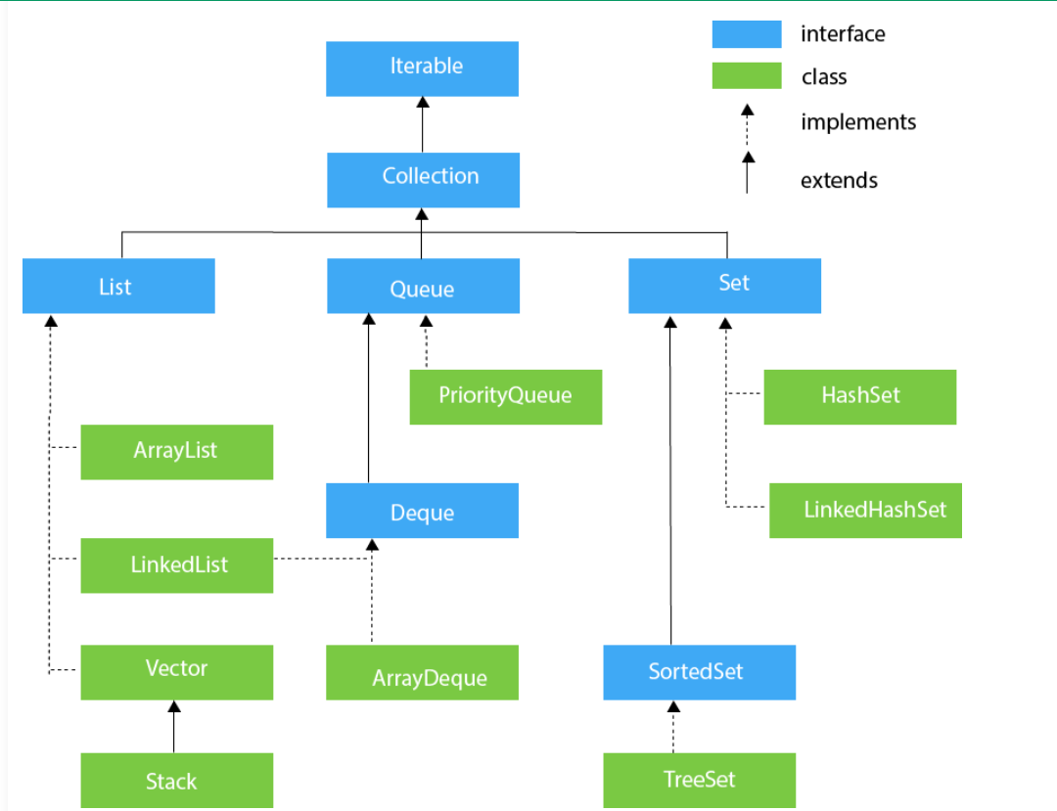
Java Map Interface
- Java Map Interface is used to store data in the form of key-value pairs.
- It allows data to be stored and accessed using a key.
- The Map interface is part of the java.util package.
- A Map stores data as: Key → Value pairs
Basic Syntax
Map<KeyType, ValueType> map = new HashMap< >();
Example: Map<String, Integer> ageMap = new HashMap< >();
- Key → String
- Value → Integer
Features of the Map Interface
- Each key must be unique.
- Duplicate keys are not allowed.
- A key maps to exactly one value.
- Values can be duplicated.
- A Map is mainly used for fast searching using a unique key.
- Different types of objects can be stored as keys and values.
- A Map works like a dictionary, where each key is associated with a value.
- A Map can contain null keys and null values, depending on the implementation.
    - HashMap allows one null key and multiple null values.
    - Hashtable does not allow null keys or null values.
- The Map interface is separate from the Collection interface hierarchy.
Most Common Map Implementations
Class | Features
HashMap | Fast, unordered
LinkedHashMap | Maintains insertion order
TreeMap | Sorted by keys
Hashtable | Thread-safe, old class
Java HashMap
Java HashMap class implements the Map interface and is used to store key-value pairs.
Each key must be unique, and if a duplicate key is inserted, the old value is replaced with the new value.
HashMap is part of the java.util package and allows one null key and multiple null values.
It extends the AbstractMap class and implements the Map interface.
Here is the syntax: HashMap<K,V> map = new HashMap<K,V>();
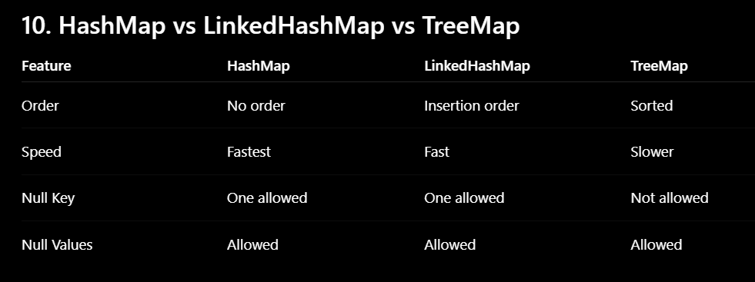
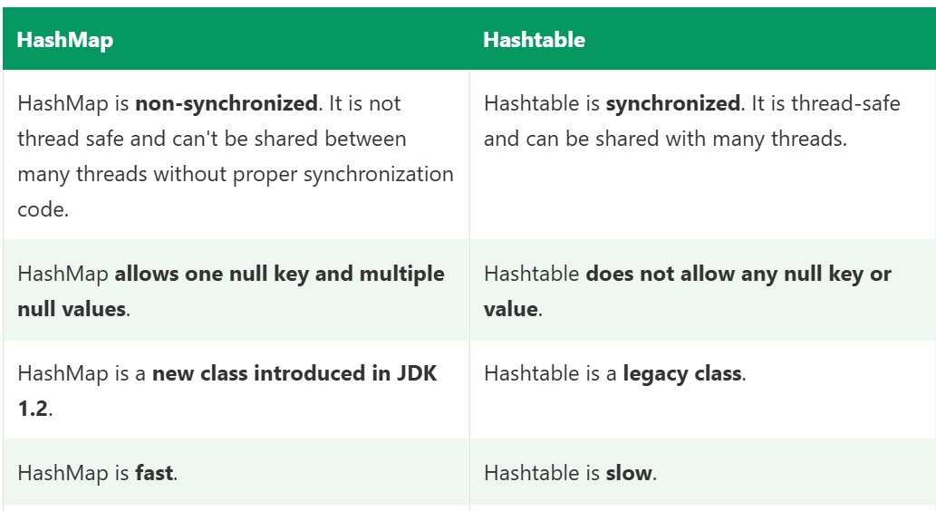

Queue Interface
Queue interface belongs to the java.util package and is a part of the Java Collections Framework.
A queue follows the FIFO (First-In-First-Out) principle, meaning the first element added to the queue is the first one to be removed.
- Elements are inserted at the rear (end) of the queue.
- Elements are removed from the front of the queue.
- A real-world example is a line at a bank, where the person who arrives first is served first.
The Queue interface is implemented by several classes, including LinkedList, PriorityQueue, and ArrayDeque.
Features of Queue
- Maintains the order of elements.
- Generally follows the FIFO principle.
- Supports insertion and deletion at opposite ends.
- Commonly used in scheduling, buffering, and task management operations.
- Allows duplicate elements (depending on the implementation).
Common Classes Implementing Queue
PriorityQueue Stores elements according to their priority rather than insertion order.
LinkedList Provides a standard FIFO queue implementation.
ArrayDeque Implements a double-ended queue (Deque) with efficient insertion and deletion at both ends.
Functional Interfaces in Java
A Functional Interface is an interface that contains exactly one abstract method. It is also known as a Single Abstract Method (SAM) Interface and is primarily used to support lambda expressions and functional programming features introduced in Java 8.
🔹 Key Characteristics
- Single Abstract Method (SAM)
A functional interface must have only one abstract method.
- Can have multiple default or static methods
A functional interface may contain multiple default and static methods.
These methods do not affect its functional interface status.
- Annotated with @FunctionalInterface (optional but recommended)
This annotation tells the compiler to enforce the rule.
Built-in Functional Interfaces
Java provides many ready-to-use functional interfaces in the package java.util.function:
- Predicate<T> → takes input, returns boolean
- Function<T, R> → takes input, returns output
- Consumer<T> → takes input, returns nothing
- Supplier<T> → returns a value, no input

Java Lambda Expressions
A lambda expression is a feature introduced in Java 8 that provides a short and clear way to represent the implementation of a functional interface (an interface with a single abstract method).
With lambda expressions, there is no need to write separate classes or methods for implementation. Instead, you can write the implementation directly using an expression.
A lambda expression follows a simple syntax: (argument-list) -> {body}
A lambda expression consists of three main parts:
- Argument-list: It can be empty or contain one or more parameters
- Arrow (->): It connects the argument list with the body
- Body: It contains the logic (expressions or statements)
No Parameter Syntax
() -> { //Body of no parameter lambda }
One Parameter Syntax
(p1) -> { //Body of single parameter lambda }
Two Parameter Syntax
(p1,p2) -> { //Body of multiple parameter lambda }
Function Reference (Method Reference)
A method reference is a shorter way to refer to a method using :: operator. It is used in place of lambda expressions when the method already exists.
Here is the syntax for function reference:
ClassName::methodName
Example:
System.out::println
Here, instead of writing a lambda expression, we directly refer to the println method.
Java Stream API
Java Streams (Java Stream API) were introduced in Java 8 to process collections in a functional, readable, and declarative way.
A Stream is:
- A sequence of elements (not a data structure)
- Used to process data from collections, arrays, or I/O
- Does NOT store data
- Does NOT modify the original collection
- Intermediate operations (like filter, map, etc.) are lazy and return another Stream, so you can chain them together.
- A terminal operation (like collect, forEach, count) ends the stream and gives the final result.
- Enables pipeline processing
👉 Think of it like a pipeline:
Source → Intermediate Operations → Terminal Operation → Result
Different Operations On Streams
There are two types of Operations in Streams:
1. Intermediate Operations
These operations:
- Transform a stream into another stream
- Intermediate operations are lazy, meaning they execute only when a terminal operation is invoked.
- Can be chained together
Common Intermediate Operations:
- map(Function<T, R>): Transforms each element of the Stream into another form using the provided function.
- filter(Predicate<T>): Selects elements from the Stream based on a specified condition.
- flatMap(Function<T, Stream<R>>): Transforms each element into zero or more elements by applying a function that returns a stream for each element.
- distinct(): Removes duplicate elements from the Stream.
- sorted(): Sorts the elements of the Stream.
- limit(long n): Truncates the Stream to be no longer than the specified size.
- skip(long n): Skips the first n elements of the Stream.
- peek(Consumer<T>): Performs a specified action on each element of the Stream without consuming the elements.
2. Terminal Operations
Terminal operations are the operations that produce the final result from a stream and end the stream processing. These operations trigger the execution of all intermediate operations.
Common Terminal Operations:
- forEach(Consumer<T>): Acts as each element of the Stream.
- collect(Collector<T, A, R>): Reduces the elements of the Stream into a mutable result container, such as a list or a map.
- reduce(BinaryOperator<T>): Reduces the elements of the Stream to a single value using an associative accumulation function.
- count(): Returns the count of elements in the Stream.
- anyMatch(Predicate<T>): Returns true if any element of the Stream matches the given predicate.
- allMatch(Predicate<T>): Returns true if all elements of the Stream match the given predicate.
- noneMatch(Predicate<T>): Returns true if no elements of the Stream match the given predicate.
- findFirst(): Returns an Optional describing the first element of the Stream, or an empty Optional if the Stream is empty.
- findAny(): Returns an Optional describing some element of the Stream, or an empty Optional if the Stream is empty.
Java Collections Class
The Java Collections class is a utility class in the java.util package that provides static methods for working with collection objects such as List, Set, and Map.
It is different from the Collection interface:
- Collection → Root interface of the collection framework.
- Collections → Utility class containing helper methods.
Comparable Interface in Java
The Comparable interface in Java is used to define the natural ordering of objects.
It allows objects of a class to be compared and sorted automatically.
The Comparable interface belongs to the java.lang package and contains a single method called compareTo(). This method compares the current object with another object of the same type and determines their order.
When a class implements the Comparable interface, it defines the rule for ordering its objects. This ordering is known as the natural ordering of the class.
Examples of Natural Ordering
- Numbers are sorted in ascending order (1, 2, 3, ...).
- Strings are sorted alphabetically (A, B, C, ...).
- Custom objects can be sorted based on attributes such as age, salary, roll number, or name.
Steps to Use Comparable
To make a class sortable using Comparable, follow these steps:
- Implement the Comparable<T> interface.
- Override the compareTo() method.
- Write the comparison logic inside the compareTo() method.
The syntax of the method is as follows:
- public int compareTo(Object obj)
Here,
- It returns a positive integer if the current object is greater.
- It returns a negative integer if the current object is smaller.
- It returns zero if both objects are equal.
Java Comparator Interface
- Comparator interface is used to define custom sorting logic for objects.
- Comparator allows you to create multiple sorting strategies without modifying the original class.
- It provides methods like compare() and equals() to define custom sorting logic.
public interface Comparator<T> {
int compare(T o1, T o2);
}
Rules:
Return value | Meaning
< 0 | o1 comes before o2
> 0 | o1 comes after o2
= 0 | both equal

