Dashboard Design
![Dashboard]
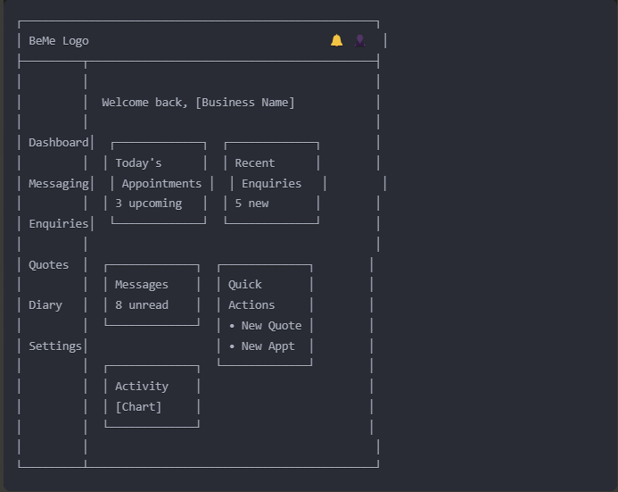

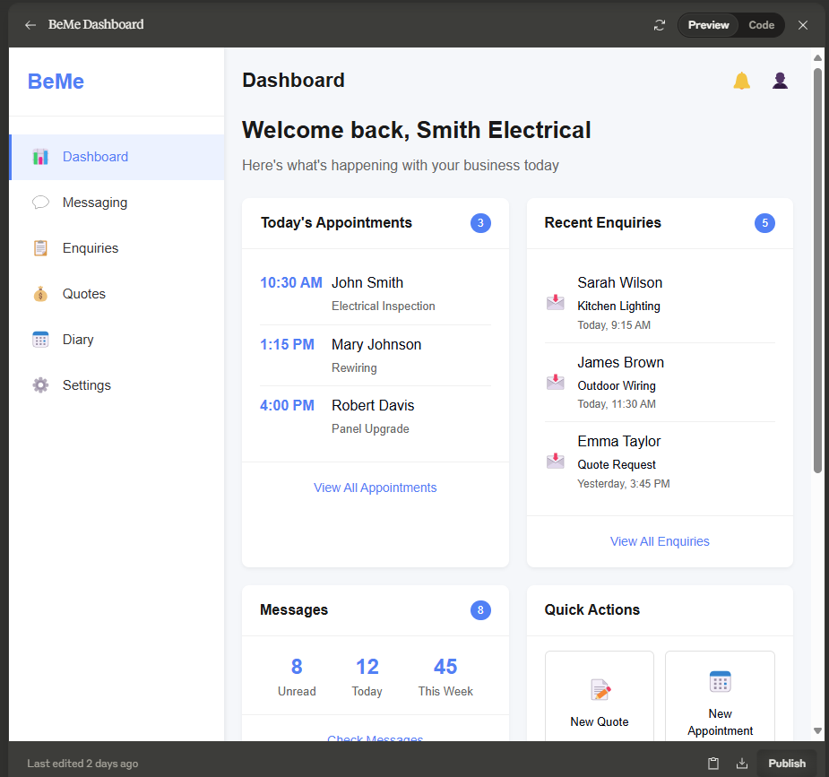

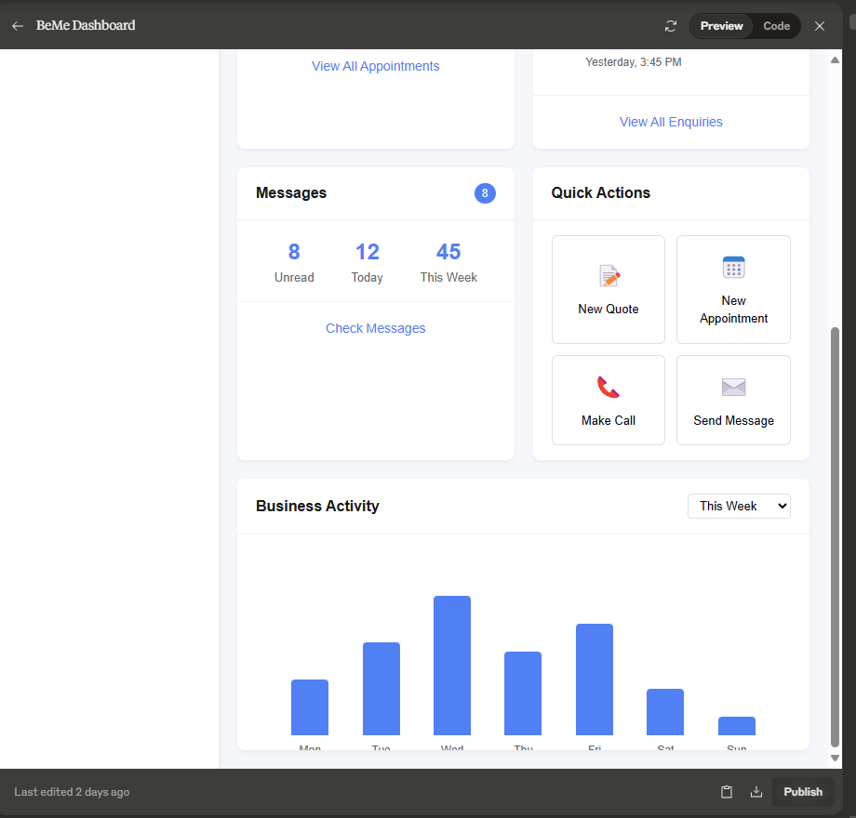

import React from 'react';

const Dashboard = () => {
// Sample data
const appointments = [
{ id: 1, customer: 'John Smith', time: '10:30 AM', service: 'Electrical Inspection' },
{ id: 2, customer: 'Mary Johnson', time: '1:15 PM', service: 'Rewiring' },
{ id: 3, customer: 'Robert Davis', time: '4:00 PM', service: 'Panel Upgrade' }
];

const enquiries = [
{ id: 101, customer: 'Sarah Wilson', subject: 'Kitchen Lighting', date: 'Today, 9:15 AM' },
{ id: 102, customer: 'James Brown', subject: 'Outdoor Wiring', date: 'Today, 11:30 AM' },
{ id: 103, customer: 'Emma Taylor', subject: 'Quote Request', date: 'Yesterday, 3:45 PM' },
{ id: 104, customer: 'Michael Lee', subject: 'Emergency Call', date: 'Yesterday, 8:20 PM' },
{ id: 105, customer: 'Jennifer White', subject: 'Home Inspection', date: 'Mar 20, 10:05 AM' }
];

return (
<div className="app-container">
{/* Sidebar */}
<div className="sidebar">
<div className="logo-container">
<div className="logo">BeMe</div>
</div>
<div className="sidebar-menu">
<div className="menu-item active">
<div className="menu-icon">📊</div>
<div className="menu-text">Dashboard</div>
</div>
<div className="menu-item">
<div className="menu-icon">💬</div>
<div className="menu-text">Messaging</div>
</div>
<div className="menu-item">
<div className="menu-icon">📋</div>
<div className="menu-text">Enquiries</div>
</div>
<div className="menu-item">
<div className="menu-icon">💰</div>
<div className="menu-text">Quotes</div>
</div>
<div className="menu-item">
<div className="menu-icon">📅</div>
<div className="menu-text">Diary</div>
</div>
<div className="menu-item">
<div className="menu-icon">⚙️</div>
<div className="menu-text">Settings</div>
</div>
</div>
</div>

{/* Main Content */}
<div className="main-content">
{/* Header */}
<div className="header">
<div className="page-title">Dashboard</div>
<div className="header-actions">
<div className="notification-icon">🔔</div>
<div className="user-profile">👤</div>
</div>
</div>

{/* Welcome Section */}
<div className="welcome-section">
<h1>Welcome back, Smith Electrical</h1>
<p>Here's what's happening with your business today</p>
</div>

{/* Dashboard Widgets */}
<div className="dashboard-widgets">
{/* Row 1 */}
<div className="widget-row">
{/* Appointments Widget */}
<div className="widget">
<div className="widget-header">
<h2>Today's Appointments</h2>
<span className="widget-badge">{appointments.length}</span>
</div>
<div className="widget-content">
{appointments.map(appointment => (
<div key={appointment.id} className="appointment-item">
<div className="appointment-time">{appointment.time}</div>
<div className="appointment-details">
<div className="customer-name">{appointment.customer}</div>
<div className="service-type">{appointment.service}</div>
</div>
</div>
))}
</div>
<div className="widget-footer">
<button className="view-all-btn">View All Appointments</button>
</div>
</div>

{/* Recent Enquiries Widget */}
<div className="widget">
<div className="widget-header">
<h2>Recent Enquiries</h2>
<span className="widget-badge">{enquiries.length}</span>
</div>
<div className="widget-content">
{enquiries.slice(0, 3).map(enquiry => (
<div key={enquiry.id} className="enquiry-item">
<div className="enquiry-icon">📩</div>
<div className="enquiry-details">
<div className="customer-name">{enquiry.customer}</div>
<div className="enquiry-subject">{enquiry.subject}</div>
<div className="enquiry-date">{enquiry.date}</div>
</div>
</div>
))}
</div>
<div className="widget-footer">
<button className="view-all-btn">View All Enquiries</button>
</div>
</div>
</div>

{/* Row 2 */}
<div className="widget-row">
{/* Messages Widget */}
<div className="widget">
<div className="widget-header">
<h2>Messages</h2>
<span className="widget-badge">8</span>
</div>
<div className="widget-content">
<div className="message-stats">
<div className="stat-item">
<div className="stat-value">8</div>
<div className="stat-label">Unread</div>
</div>
<div className="stat-item">
<div className="stat-value">12</div>
<div className="stat-label">Today</div>
</div>
<div className="stat-item">
<div className="stat-value">45</div>
<div className="stat-label">This Week</div>
</div>
</div>
</div>
<div className="widget-footer">
<button className="action-btn">Check Messages</button>
</div>
</div>

{/* Quick Actions Widget */}
<div className="widget">
<div className="widget-header">
<h2>Quick Actions</h2>
</div>
<div className="widget-content">
<div className="quick-actions">
<button className="quick-action-btn">
<span className="action-icon">📝</span>
<span className="action-text">New Quote</span>
</button>
<button className="quick-action-btn">
<span className="action-icon">📅</span>
<span className="action-text">New Appointment</span>
</button>
<button className="quick-action-btn">
<span className="action-icon">📞</span>
<span className="action-text">Make Call</span>
</button>
<button className="quick-action-btn">
<span className="action-icon">✉️</span>
<span className="action-text">Send Message</span>
</button>
</div>
</div>
</div>
</div>

{/* Row 3 */}
<div className="widget-row">
{/* Activity Widget */}
<div className="widget full-width">
<div className="widget-header">
<h2>Business Activity</h2>
<div className="widget-actions">
<select className="period-selector">
<option>This Week</option>
<option>This Month</option>
<option>This Quarter</option>
</select>
</div>
</div>
<div className="widget-content">
<div className="activity-chart">
{/* Simplified chart representation */}
<div className="chart-container">
<div className="chart-bar" style={{ height: '30%' }}><span className="day-label">Mon</span></div>
<div className="chart-bar" style={{ height: '50%' }}><span className="day-label">Tue</span></div>
<div className="chart-bar" style={{ height: '75%' }}><span className="day-label">Wed</span></div>
<div className="chart-bar" style={{ height: '45%' }}><span className="day-label">Thu</span></div>
<div className="chart-bar" style={{ height: '60%' }}><span className="day-label">Fri</span></div>
<div className="chart-bar" style={{ height: '25%' }}><span className="day-label">Sat</span></div>
<div className="chart-bar" style={{ height: '10%' }}><span className="day-label">Sun</span></div>
</div>
</div>
</div>
</div>
</div>
</div>
</div>

<style jsx>{`
.app-container {
display: flex;
min-height: 100vh;
font-family: 'Inter', sans-serif;
background-color: #f5f7fa;
}

/* Sidebar styles */
.sidebar {
width: 240px;
background-color: white;
box-shadow: 2px 0 4px rgba(0, 0, 0, 0.05);
padding: 20px 0;
display: flex;
flex-direction: column;
}

.logo-container {
padding: 0 20px 20px;
border-bottom: 1px solid #f0f0f0;
margin-bottom: 20px;
}

.logo {
font-size: 24px;
font-weight: bold;
color: #3B82F6;
}

.sidebar-menu {
display: flex;
flex-direction: column;
flex-grow: 1;
}

.menu-item {
display: flex;
align-items: center;
padding: 12px 20px;
cursor: pointer;
transition: background-color 0.2s;
border-left: 3px solid transparent;
}

.menu-item:hover {
background-color: #f5f7fa;
}

.menu-item.active {
background-color: #ebf2ff;
border-left-color: #3B82F6;
}

.menu-icon {
margin-right: 12px;
font-size: 18px;
}

.menu-text {
font-size: 15px;
color: #333;
}

.menu-item.active .menu-text {
font-weight: 500;
color: #3B82F6;
}

/* Main content styles */
.main-content {
flex: 1;
padding: 20px;
overflow-y: auto;
}

.header {
display: flex;
justify-content: space-between;
align-items: center;
margin-bottom: 20px;
}

.page-title {
font-size: 22px;
font-weight: 600;
color: #1a1a1a;
}

.header-actions {
display: flex;
align-items: center;
}

.notification-icon, .user-profile {
font-size: 20px;
margin-left: 16px;
cursor: pointer;
}

.welcome-section {
margin-bottom: 24px;
}

.welcome-section h1 {
font-size: 26px;
font-weight: 600;
margin-bottom: 8px;
color: #1a1a1a;
}

.welcome-section p {
font-size: 16px;
color: #666;
}

.dashboard-widgets {
display: flex;
flex-direction: column;
gap: 20px;
}

.widget-row {
display: flex;
gap: 20px;
}

.widget {
background-color: white;
border-radius: 8px;
box-shadow: 0 2px 4px rgba(0, 0, 0, 0.05);
overflow: hidden;
flex: 1;
}

.widget.full-width {
width: 100%;
}

.widget-header {
display: flex;
justify-content: space-between;
align-items: center;
padding: 16px 20px;
border-bottom: 1px solid #f0f0f0;
}

.widget-header h2 {
font-size: 16px;
font-weight: 600;
color: #1a1a1a;
margin: 0;
}

.widget-badge {
background-color: #3B82F6;
color: white;
font-size: 12px;
font-weight: 500;
padding: 2px 8px;
border-radius: 12px;
}

.widget-content {
padding: 16px 20px;
}

.widget-footer {
padding: 12px 20px;
border-top: 1px solid #f0f0f0;
display: flex;
justify-content: center;
}

.view-all-btn, .action-btn {
background-color: transparent;
border: none;
color: #3B82F6;
font-size: 14px;
font-weight: 500;
cursor: pointer;
padding: 6px 12px;
border-radius: 4px;
transition: background-color 0.2s;
}

.view-all-btn:hover, .action-btn:hover {
background-color: #ebf2ff;
}

/* Appointment widget styles */
.appointment-item {
display: flex;
padding: 10px 0;
border-bottom: 1px solid #f0f0f0;
}

.appointment-item:last-child {
border-bottom: none;
}

.appointment-time {
font-weight: 600;
color: #3B82F6;
min-width: 80px;
}

.appointment-details {
flex: 1;
}

.customer-name {
font-weight: 500;
margin-bottom: 4px;
}

.service-type {
font-size: 13px;
color: #666;
}

/* Enquiry widget styles */
.enquiry-item {
display: flex;
align-items: center;
padding: 10px 0;
border-bottom: 1px solid #f0f0f0;
}

.enquiry-item:last-child {
border-bottom: none;
}

.enquiry-icon {
margin-right: 12px;
font-size: 18px;
}

.enquiry-details {
flex: 1;
}

.enquiry-subject {
font-size: 13px;
margin: 2px 0;
}

.enquiry-date {
font-size: 12px;
color: #666;
}

/* Message stats styles */
.message-stats {
display: flex;
justify-content: space-around;
}

.stat-item {
text-align: center;
}

.stat-value {
font-size: 24px;
font-weight: 600;
color: #3B82F6;
}

.stat-label {
font-size: 13px;
color: #666;
}

/* Quick actions styles */
.quick-actions {
display: grid;
grid-template-columns: 1fr 1fr;
gap: 12px;
}

.quick-action-btn {
display: flex;
flex-direction: column;
align-items: center;
justify-content: center;
padding: 16px;
border: 1px solid #e0e0e0;
border-radius: 6px;
background-color: white;
cursor: pointer;
transition: all 0.2s;
}

.quick-action-btn:hover {
background-color: #f8faff;
border-color: #3B82F6;
}

.action-icon {
font-size: 24px;
margin-bottom: 8px;
}

.action-text {
font-size: 13px;
font-weight: 500;
}

/* Activity chart styles */
.activity-chart {
height: 200px;
display: flex;
justify-content: center;
align-items: flex-end;
}

.period-selector {
padding: 4px 8px;
border: 1px solid #e0e0e0;
border-radius: 4px;
font-size: 13px;
}

.chart-container {
display: flex;
align-items: flex-end;
height: 100%;
width: 100%;
justify-content: space-around;
padding: 0 20px;
}

.chart-bar {
width: 40px;
background-color: #3B82F6;
border-radius: 4px 4px 0 0;
position: relative;
transition: height 0.3s;
}

.day-label {
position: absolute;
bottom: -25px;
left: 50%;
transform: translateX(-50%);
font-size: 12px;
color: #666;
}
`}</style>
</div>
);
};

export default Dashboard;
Last edited 2 days ago

