PACE INSTITUTE OF TECHNOLOGY AND SCIENCE

**FORMAT FOR PREPARING THE INTERNSHIP PROJECT REPORT**

The write-up should focus on the specific objectives of the project, the methodology used, and the major findings. Regarding title, instead of giving a general, topic-like title, be specific and emphasize the explicit nature of the work. The report should be brief, with the number of pages of the main content of the report being not be more than 30 pages *(Please consult with respective departments for specific instructions in this regard)*. Front matter, appendix, etc can be extra.

1. **ARRANGING THE CONTENTS:**

The sequence in which the project report material should be arranged and bound should be as follows:

* 1. Cover Page & Title Page
  2. Declaration by author(s)
  3. Abstract
  4. Table of Contents
  5. List of Symbols, Abbreviations and Nomenclature
  6. Chapters
  7. Appendices
  8. References

1. **PREPARATION FORMAT:** 
   1. **Cover Page & Title Page** – A specimen copy of the Cover page & Title page of the project report are given in **Appendix 1.**
   2. **Bonafide Certificate –** The Bonafide Certificate shall be in double line spacing Times New Roman using Font Style and Font Size 14, as per the format in **Appendix 2.** The certificate shall carry the supervisor‟ssignature.
   3. **Declaration by Author(s) –** see template in appendix 3
   4. **Abstract – Abstract** should be straight to the point; not too descriptive but fully informative. The following things should appear in the abstract. (a) the problem addressed, (b) its importance/novelty, (c) the approach adopted for solving the problem, highlighting novelty, if any, (d) the major results obtained, (e) and the major conclusion. The abstract does not have to be an entire summary of the project, but rather a concise summary of the scope and results of the project. It should inform a reader whether to read or not the full text, and also give a precise idea on what has been attempted. An abstract should be short, and limited to 1 page. Include key words (Font Style: Times New Roman and Font Size: 12, Spacing: Single)
   5. **Table of Contents –** The table of contents should list all material following it as well as any material which precedes it. The title page, Bonafide Certificate, and Declaration by Authors may not be included in the Table of Contents, but the page numbers of which are in lower case Roman numbers. The format of the table of contents is given in **Appendix 4**.
   6. **List of Symbols, Abbreviations and Nomenclature** –Standard symbols, abbreviations etc. should be used.
   7. **Chapters –** The main text will be divided into several chapters and each chapter may further be divided into sections and subsections. Chapters, sections, and subsections should be given appropriate titles. Tables and figures should be placed in the immediate vicinity of the first reference to them. Figure and table numbers should carry their chapter number. For example Fig. 4.2 is the second figure in the fourth chapter.

The following are suggested chapters and what they could contain. The division into chapters may vary from project to project. The important point is that the report should mainly contain the work accomplished in the project, with a small portion devoted to describing the problem addressed and how others have tackled this or similar problems. The report should be understandable to your classmates. It should have sufficient detail to enable the examiners to assess the validity of the approaches used and the results obtained.

**a)Introduction**

Introduction could contain the following. (a) brief statement of the problem, (b) importance/novelty of the problem, (c) related literature - how others have addressed this or similar problems and the relevant results they obtained (For example, “It has already been reported [**1**]……” OR “Jiang et al [**2**] reported that….” OR “It is known [**3**] that….” etc., where [1], [2], [3], should be detailed in the reference section as per the format given below), (d) scope of the project - precise idea on what is to be achieved in the work, (e) brief statements on what subsequent chapters contain.

* + - 1. **Approach Used**

This could be in one or more chapter. It should give the details of the approaches used by the student for arriving at results. The approach could be theoretical, computational, experimental, or a combination of these. The description should be detailed enough to enable someone else with the author's background to use the same approach and get the same results. Detailed part of the description, parameter values used, etc can be be presented in Appendices*.*

* + - 1. **Results and Discussion**

This could also be in one or more chapters. These chapters include the specific details of data generated and results obtained, in graphical and/or tabular form. Based on the analysis and interpretation of data and results, major findings should be pointed out unambiguously. It should be noted that the findings are to be summarized according to the significance to the stated objectives, and should complement the latter. Detailed aspects can be presented in Appendices.

* + - 1. **Conclusions and Recommendations**

Conclusions are to be drawn with reference to the previously stated objectives of the project. This should highlight the major results. Recommendations are often more important than conclusions. It is known to us how to do better only after we finish a project, i.e. after we obtain an appropriate experience. Particularly, students‟ experiments are hampered due to lack of experience, time, methods and equipment as well as insufficient attention to accuracy and details. Recommendations should be given for any further changes or work that would better accomplish the project objectives, or can extend them.

Note: It is very important to draw the figures and prepare the tables yourself. If any figure or table or data or result or opinion is not yours, cite relevant reference. If you do not cite reference in such cases, you will be regarded to have plagiarized/stolen the material. This could lead to punitive action.

* + 1. **Appendices** – Appendices may be provided to give supplementary information, which is included in the main text may serve as a distraction and cloud the central theme.

1. **TYPING INSTRUCTIONS**

The impression on the typed copies should be black in colour. One and a half spacing should be used for typing the text, and shall be typed in the Font style „Times NewRoman‟ and Font size 12, unless otherwise stated explicitly.

**APPENDIX 1**

# TITLE OF PROJECT

HOSPITAL MANAGEMENT SYSTEM

INTERNSHIP PROJECT REPORT

***by***

M.HARIKA

&

V.BHAVYA

## NAME OF THE CANDIDATE(S)

Roll Number(s):-22KQ1A6317

&

22KQ1A05G6

Department of CSE-R & CSE

PACE INSTITUTE OF TECHNOLOGY AND SCIENCES

Ongole

Month & Year

JUNE - 2024

**APPENDIX 2**

## BONAFIDE CERTIFICATE

This is to certify that this project report entitled  **HOSPITAL MANAGEMENT SYSTEM** submitted to **PACE Institute of Technology and Sciences**,is a bonafide record of work done by

V.BHAVYA AND M.HARIKA under my supervisionfrom  **07-06-2024 to**

10-06-2024

Signature

M.HARIKA

V.BHAVYA

Place :ONGOLE

Date :10-06-2024

APPENDIX 3

## Declaration by Author(s)

This is to declare that this report has been written by us. No part of the report is plagiarized from other sources. All information included from other sources have been duly acknowledged. We aver that if any part of the report is found to be plagiarized, we are shall take full responsibility for it.

V.BHAVYA

22KQ1A05G6

M.HARIKA

22KQ1A6317

Place :ONGOLE

Date:10-06-2024

### APPENDIX 4

### TABLE OF CONTENTS

**CHAPTER NO. TITLE PAGE NO.**

**ABSTRACT iii**

**CONTENTS xx**

1. **Introduction .......................................................................... 1**
2. **Abstract ................................................................................. 2**
3. **Methodology .......................................................................... 3**
4. **Result ...................................................................................... 4**
5. **Conclusion .............................................................................. 5**
6. **Future Work ........................................................................... 7**

# 1.Introduction

* Hospital Management System is a system enabling hospitals to manage information and data related to all aspects of healthcare – processes, providers, patients, and more, which in turn ensures that processes are completed swiftly and effectively. When one thinks of the various aspects and departments of a hospital, it becomes apparent that an HMS is critical.

2.ABSTRACT

Hospital Management System is an organized computerized system designed and programmed to deal with day-to-day operations and management of hospital activities. The program can look after inpatients, outpatients, records, database treatments, status illness, billings in the pharmacy, and labs. It also maintains hospital information such as ward id, doctors in charge, and department administering.

3.METHODOLOGY

* **Software:** 
  + HTML.
  + CSS.
  + CSS3
  + HTML5
  + JavaScript.
  + Bootstrap

4.RESULT

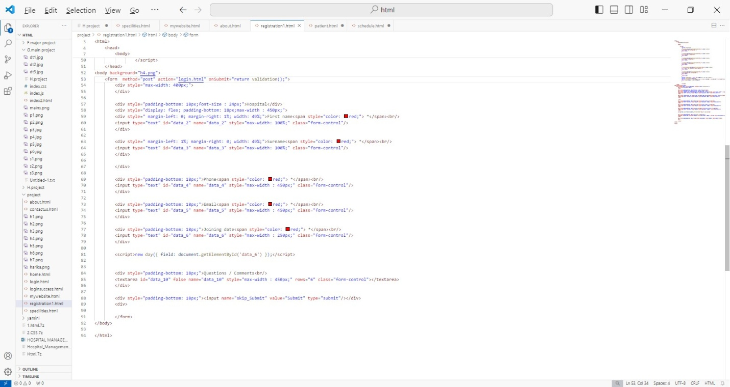

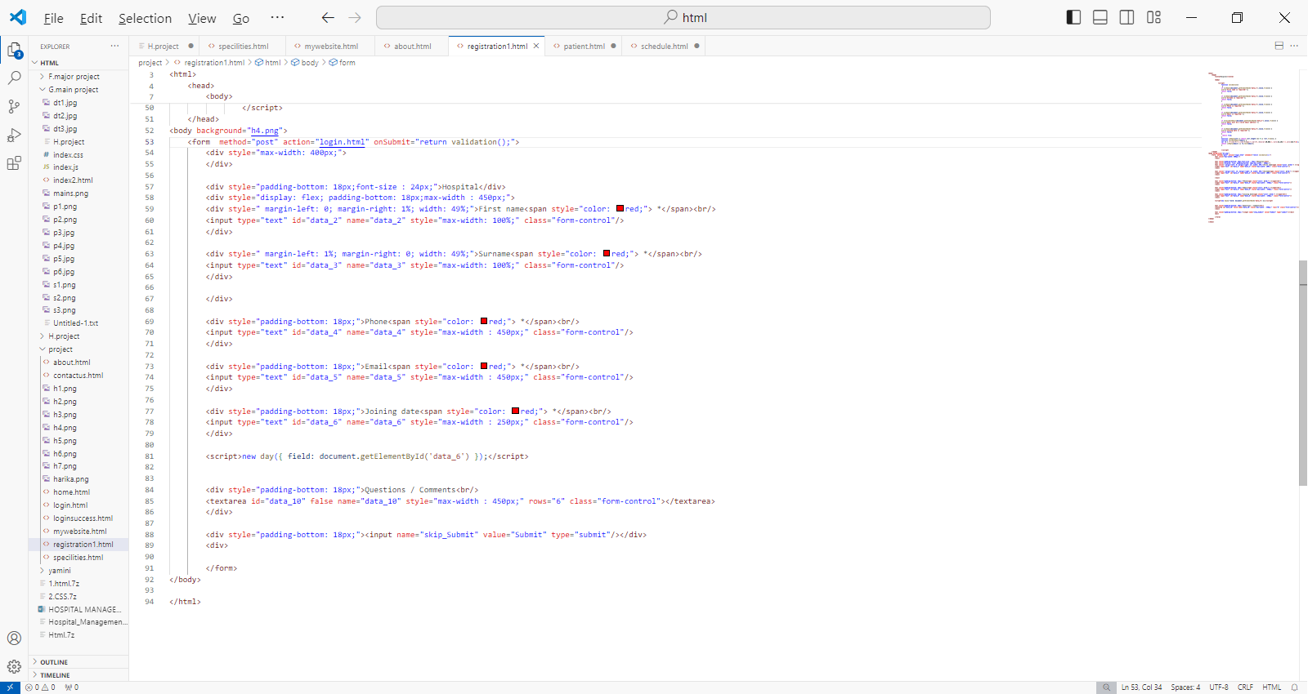

5.CONCLUSION

* The [Hospital Management System](https://www.karexpert.com/saas/hospital-information-management-system/?utm_source=Website%20Organic&utm_medium=https://www.bing.com/&referer=https://www.bing.com/&origin_referer=https://www.bing.com/) has today become an indispensable part of any hospital/clinic/healthcare facility. In order to create a differentiated, efficient, speedy, and thoughtful healthcare model, it would make sense to invest in a comprehensive HMS.

6.FUTURE WORK

* Currently it is not visible on the virtual world (Internet) due to some limitations of the project.
* In future it may be available to users.