**PUNJAB UNIVERSITY COLLEGE OF INFORMATION AND TECHNOLOGY**



**Report For Student Interest System**

Submitted to: **Syed Rizwan**

Submitted by: **Muqadas Arshad**

Roll No.: **BITF20M023**

Submission Date: **Dec-26-2023**

**Table Contents**

1. Introduction 3

**2.** Purpose of that System 3

3. Key Features 3

4. Technology 4

5. Application Flow 4

5.1 Workflow 4

5.2 Login Screen and Functionality 4

5.3 Register (sign up) Screen and Functionality 5

5.4 Dashboard Screen and Functionality 5

5.5 Add Student Screen and Functionality 5

5.6 Student List and Functionalities 6

5.7 Update Screen and Functionality 6

5.8 View Screen and Functionality 6

5.9 Delete Screen and Functionality 6

6. Conclusion 6

1. **Introduction**

The Student Interest System is a comprehensive web-based application designed to streamline and enhance the management of student data related to their academic interests. In an educational institution, understanding and categorizing the diverse interests of students can provide valuable insights for academic planning, student engagement, and resource allocation.

1. **Purpose of that System**

The primary purpose of the Student Interest System is to collect, store, and analyze data related to the interests of students enrolled in an educational institution. This system aims to facilitate efficient decision-making processes by providing administrators and educators with a clear understanding of the diverse interests and preferences of the student body.

1. **Key Features**

* **User Authentication:**

Secure sign-in and sign-up functionality to ensure authorized access to the system.

* **Dashboard:**
* Top 5 interests, Bottom 5 interests, and Distinct interests for quick insights.
* Provincial distribution, Submission chart, Age distribution, Department distribution, Degree distribution, Gender distribution.
* Activity Metrics: Last 30 days activity, Last 24 hours activity.
* Students Status Grid: Number of students currently studying, recently enrolled, about to graduate, and graduated.
* Most active hours, least active hours, and dead hours in the last 30 days.
* **Add Student Page:**

Intuitive form for entering student information including name, roll number, degree, department, date of birth, interest subject, start and end date, city, and gender.

* **Student List:**
* DataTable for viewing all students with action buttons for view, edit, and delete.
* Page navigation for easy browsing.
* Options for changing page size.
* Search
* **Logout:**

Secure log out functionality to ensure data privacy.

* **Chart and Visualization:**

Integration of charting libraries to provide graphical representations of interest data.

* **CRUD Operations:**

Comprehensive support for Create, Read, Update, and Delete operations for student records.

* **Activity Log:**

Real-time logging of user activities displayed on the dashboard.

1. **Technology**

The Student Interest System is built using modern web development technologies:

* **Frontend:** HTML, CSS, JavaScript, and Bootstrap for a responsive and user-friendly interface.
* **Backend:** Flask, a Python web framework, to handle server-side logic and database interactions.
* **Database:** MySQL workbench is employed to store and retrieve student data efficiently.
* **Visualization:** Integration of charting libraries, such as Chart.js, for graphical representation of interest data.

1. **Application Flow**
   1. **Workflow**

* Users log in securely with authentication credentials.
* If you are not register in this system then first register yourself.
* Data is entered and managed through the Add Student Page.
* The Dashboard provides a visual overview of key metrics and insights.
* CRUD operations are performed on the Student List.
* Users can log out securely.
  1. **Login Screen and Functionality**
* **Screen Design:**
* A clean and intuitive login form with fields for email and password.
* Responsive design for various devices.

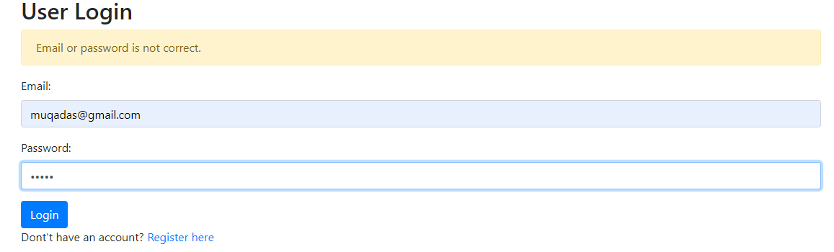

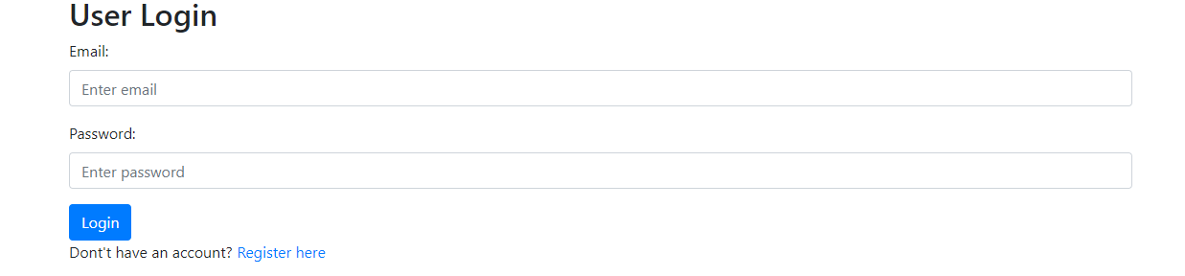

* **Functionality:**
* Users enter their credentials (email and password) and submit the form.
* The system securely authenticates the user.
* If the credentials are valid, the user is redirected to the dashboard.
* If the credentials are invalid, an appropriate error message is displayed.
  1. **Register (sign up) Screen and Functionality**
* **Screen Design:**
* A registration form with fields for username, email, password.
* Clear instructions on password requirements.

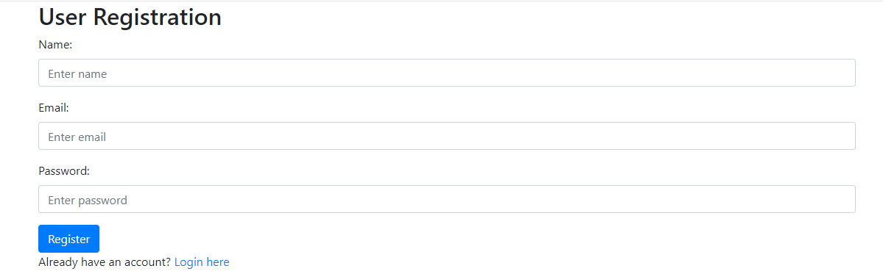

* **Functionality:**
* Users fill in the registration form and submit their information.
* The system validates the input and checks for existing accounts.
* If the registration is successful, the user is redirected to the login screen.
* If there are errors (e.g., duplicate username), appropriate error messages are displayed.
  1. **Dashboard Screen and Functionality**
* **Screen Design:**
* An aesthetically pleasing and informative dashboard providing a summarized view of the student interest system.
* Divided into various sections for different key features.

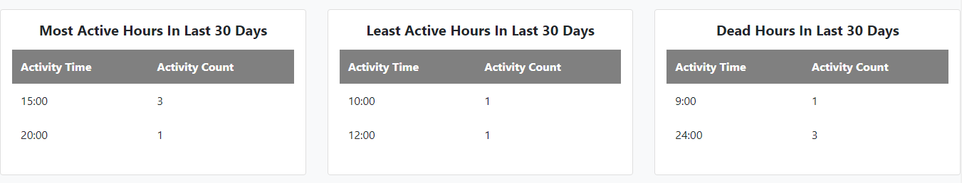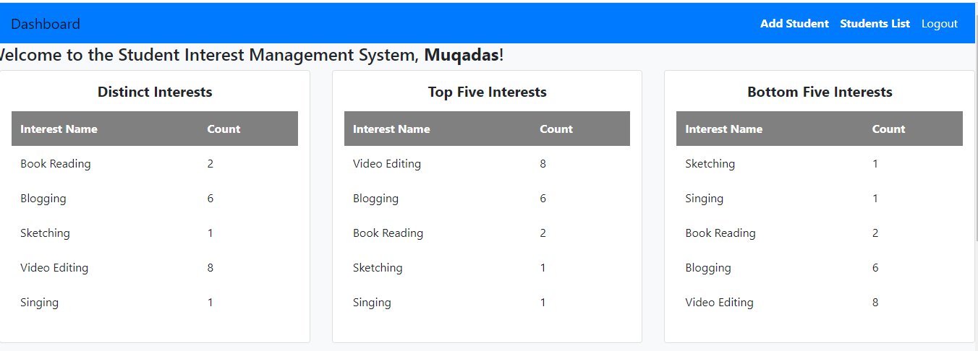

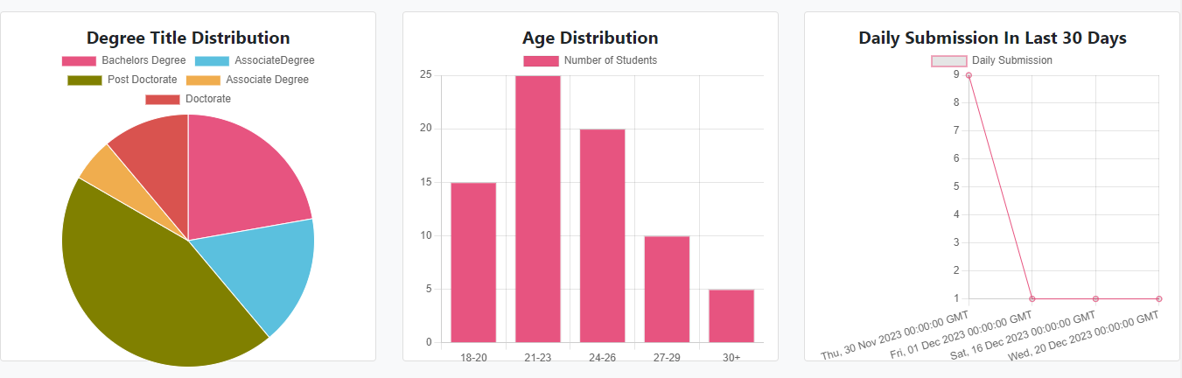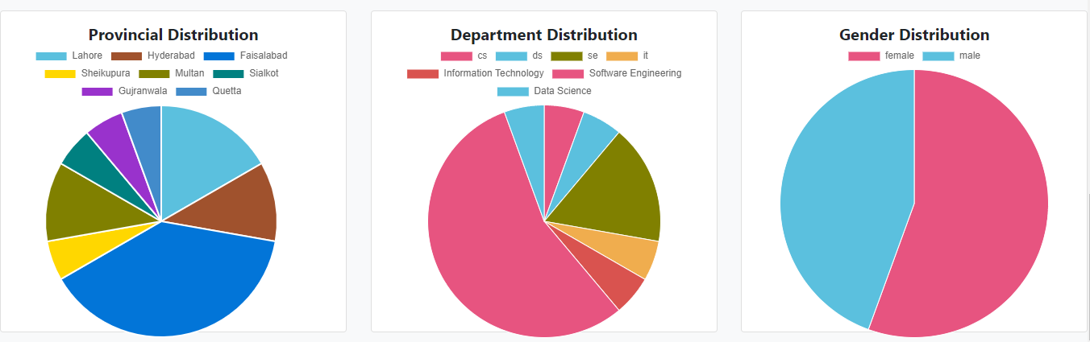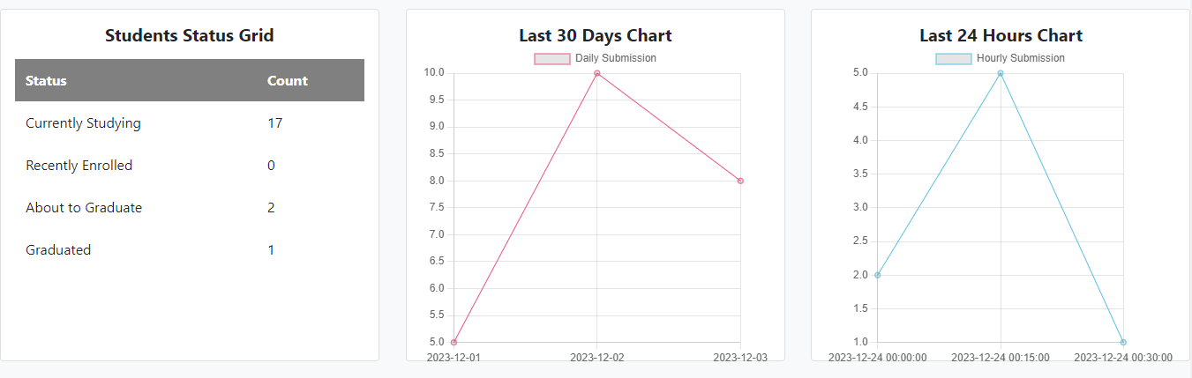

* **Functionality:**
* **User Authentication:**

Display the user's name and provide a logout option.

* **Top 5 Interests:**

Visual representation (e.g., bar chart or pie chart) of the top 5 student interests.

* **Bottom 5 Interests:**

Visual representation of the bottom 5 student interests.

* **Distinct Interests:**

Display the count of distinct interests.

* **Provincial Distribution:**

Map or chart showing the distribution of students across different provinces.

* **Submission Chart:**

Line chart showing the number of student submissions over the last 30 days.

* **Age Distribution:**

Chart or graph representing the age distribution of students.

* **Department Distribution:**

Chart showing the distribution of students across different departments.

* **Degree Distribution:**

Chart indicating the distribution of students based on their degree titles.

* **Gender Distribution:**

Chart displaying the gender distribution of students.

* **Last 30 Days Activity:**

Highlights the overall system activity over the last 30 days.

* **Last 24 Hours Activity:**

Provides insights into system activity within the last 24 hours.

* **Students Status Grid:**

Grid displaying the status of students, such as the number currently studying, recently enrolled, about to graduate, and graduated.

* **Most Active Hours in Last 30 Days:**

Displays the hours when the system experiences the highest activity.

* **Least Active Hours in Last 30 Days:**

Highlights the hours with the least system activity.

* **Dead Hours in Last 30 Days:**

Identifies time periods with minimal to no system activity.

* **Add Student Page:**

Link or button to navigate to the Add Student page.

* **Student List:**

Link or button to navigate to the Student List page.

* **Chart and Visualization:**

Option to view additional charts and visualizations for in-depth analysis.

* **Activity Log:**

A log capturing significant activities within the system.

* 1. **Add Student Screen and Functionality**
* **Screen Design:**
* A form with fields for student information (name, roll number, email, etc.).
* Dropdowns or input fields for selecting interests, department, degree, and gender.

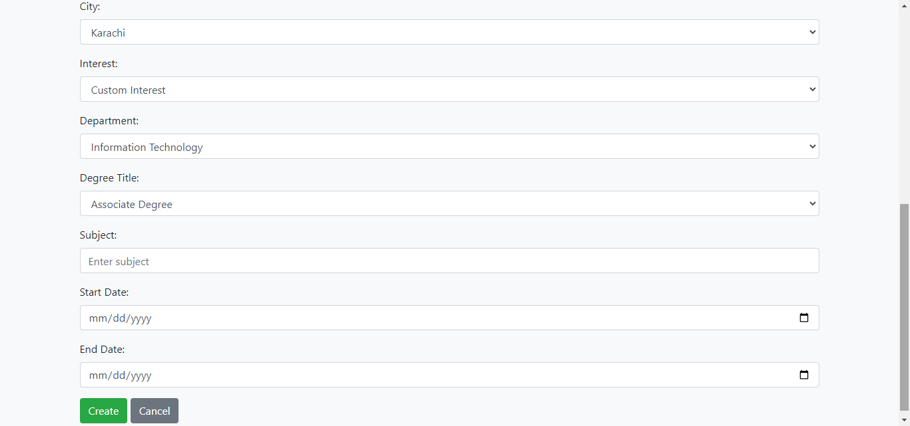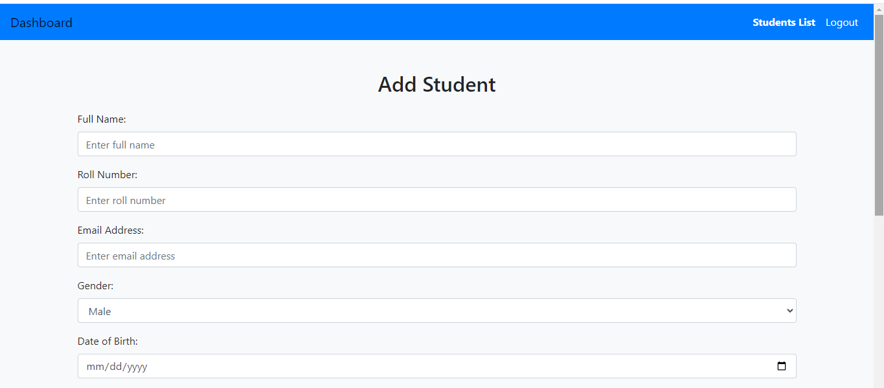

* **Functionality:**
* Users enter student information in the form.
* The system validates the data (e.g., ensuring required fields are filled).
* If the data is valid, it is added to the database.
* If the interest is custom, it is added to the interests table.
* Confirmation message or redirection to the student list page.
* If user click on cancel button then it redirection to the student list page.
  1. **Student List and Functionalities**
* **Screen Design:**
* A table displaying student records with columns for various details.
* Action buttons (View, Edit, Delete) in each row.

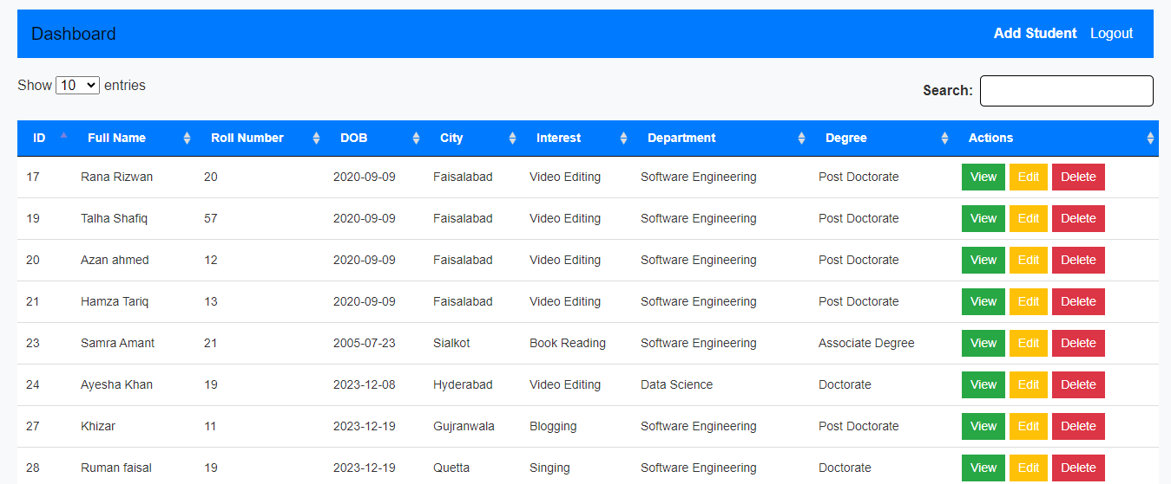

* **Functionality:**
* Pagination for easy navigation through the student list.
* Search functionality to find specific students.
* View: Detailed view of a student's information.
* Edit: Modify student details and update the database.
* Delete: Prompt for confirmation before deleting a student record.
  1. **Update Screen and Functionality**
* **Screen Design:**
* Similar to the Add Student screen but pre-filled with existing data.
* Users can modify the necessary fields.

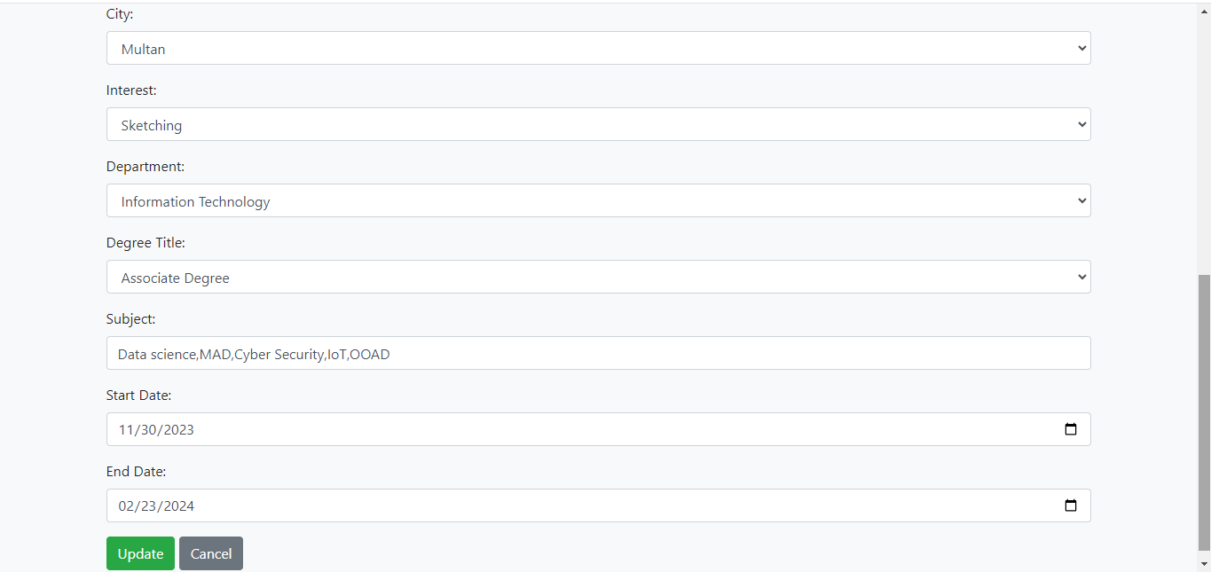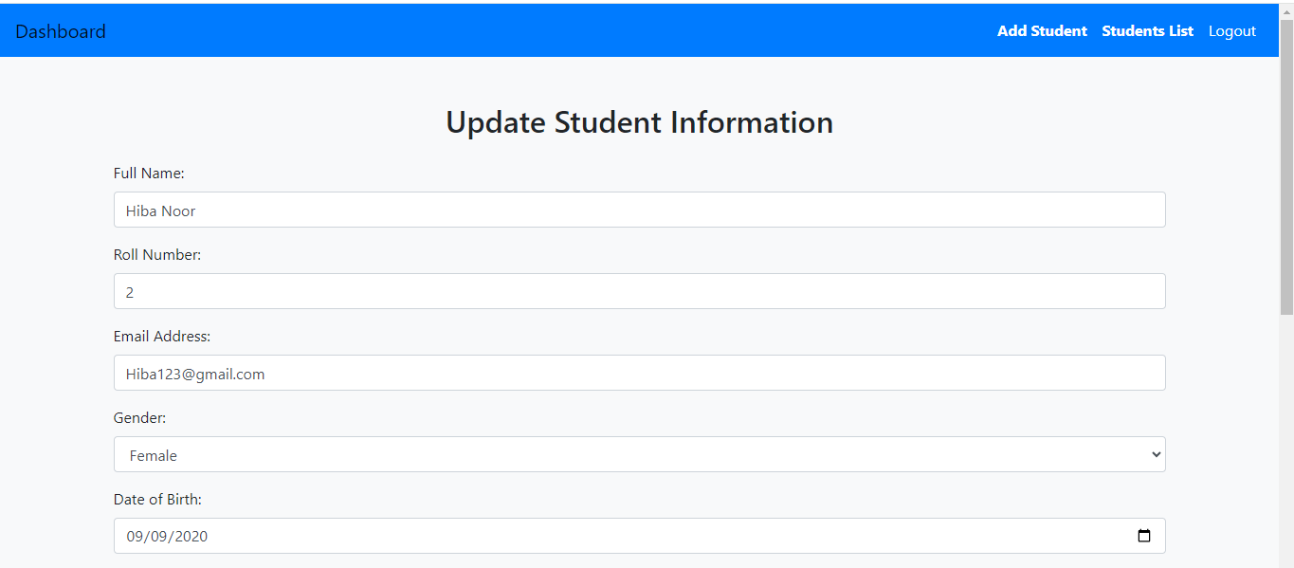

* **Functionality:**
* Users make changes to the student information.
* The system validates the modifications.
* If the data is valid, it is updated in the database.
* Confirmation message or redirection to the student list page.
  1. **View Screen and Functionality**
* **Screen Design:**
* A read-only view displaying detailed information about a specific student.
* All fields of the student record visible and well-formatted.

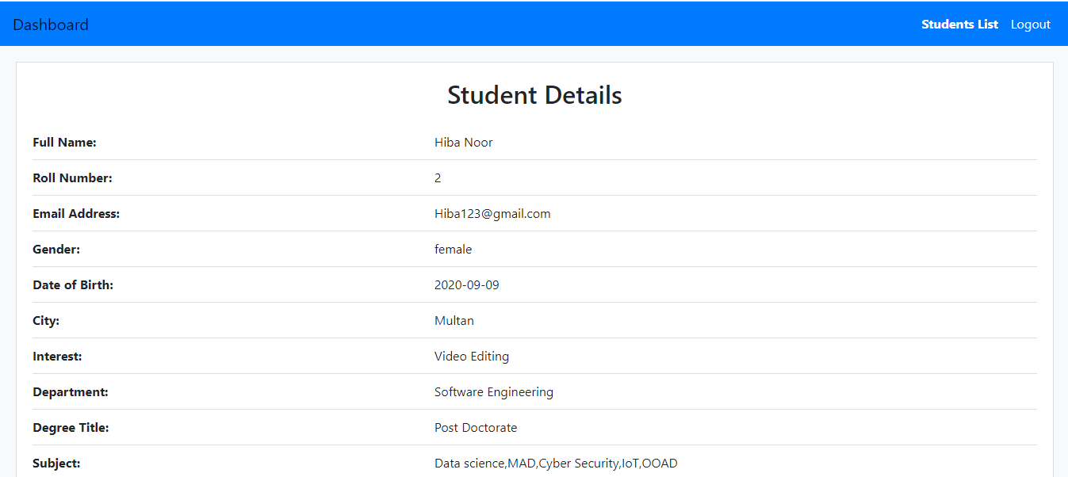

* **Functionality**:
* Accessed by clicking the "View" button on the Student List page.
* Users can see all details of the selected student.
* A back button to return to the Student List.
  1. **Delete Screen and Functionality**
* **Screen Design:**
* A confirmation screen with the student's information and a warning message.

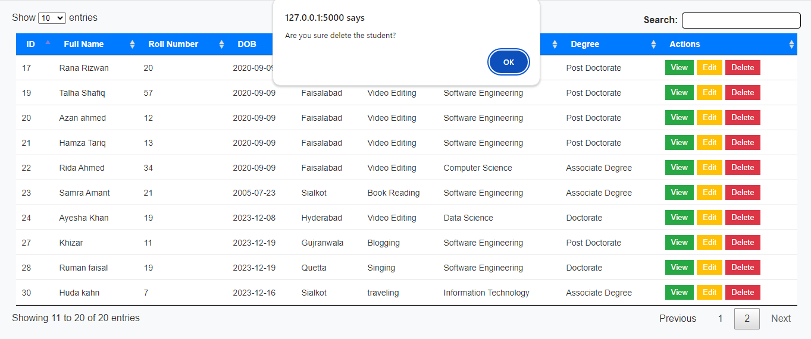

* **Functionality**:
* Accessed by clicking the "Delete" button on the Student List page.
* Displays a confirmation message asking if the user is sure about deleting the student.
* If confirmed, the student record is deleted from the database.
* If canceled, the user is redirected back to the Student List.

1. **Conclusion**

The Student Interest System, with its user-friendly interface and comprehensive features, serves as an indispensable tool for educational institutions. By leveraging technology to manage, analyze, and respond to student interest data, the system contributes to informed decision-making and a more tailored educational experience. Its adherence to data security, coupled with advanced visualization and reporting capabilities, positions it as a key asset for institutions aiming to stay responsive to the evolving needs of their student body.