
The University Of Azad Jammu & Kashmir,Muzaffarabad
Name: Muqaddas Kiani
Roll NO: 2024-SE-23
Course Code:CS-2203
Submission Date:4thMarch,2026
Course Title:Computer Networks
Instructor Name: Engr. Asma Javaid

Department Of Software Engineering
LAB TASK 1- Installation of Cisco Packet Tracer

Introduction
Cisco Packet Tracer is a network simulation tool used by students to design, configure, and troubleshoot network topologies in a virtual environment.

Phase 1: Downloading the Software

Step 1: Open Browser
- Open Google Chrome or any web browser.

Step 2: Visit Official Website
- Go to Cisco Networking Academy website.
- Log in using your registered email and password.
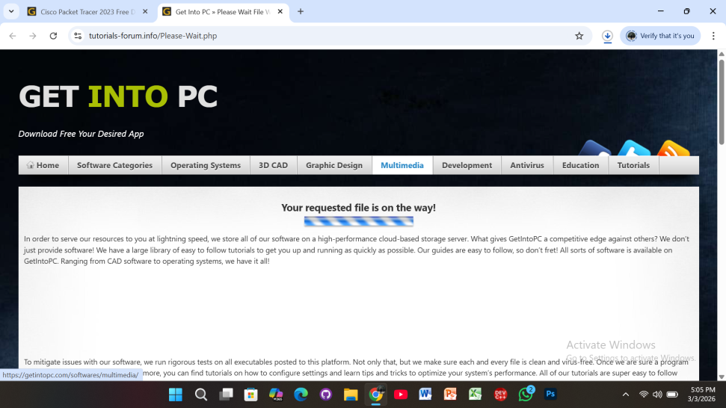

Step 3: Download File
- Go to Resources / Download Packet Tracer.
- Select Windows version (.exe file).
- Click Download.
- Wait for the file to download completely.
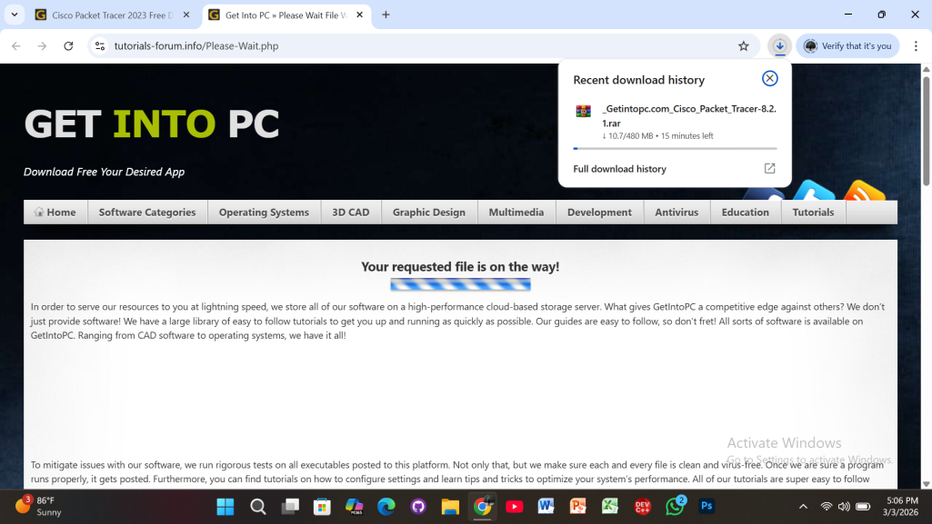

Phase 2: Installing the Software

Step 4: Open Downloaded File
- Go to Downloads folder.
- Double-click the downloaded PacketTracer.exe file.
- If User Account Control (UAC) appears, click Yes.
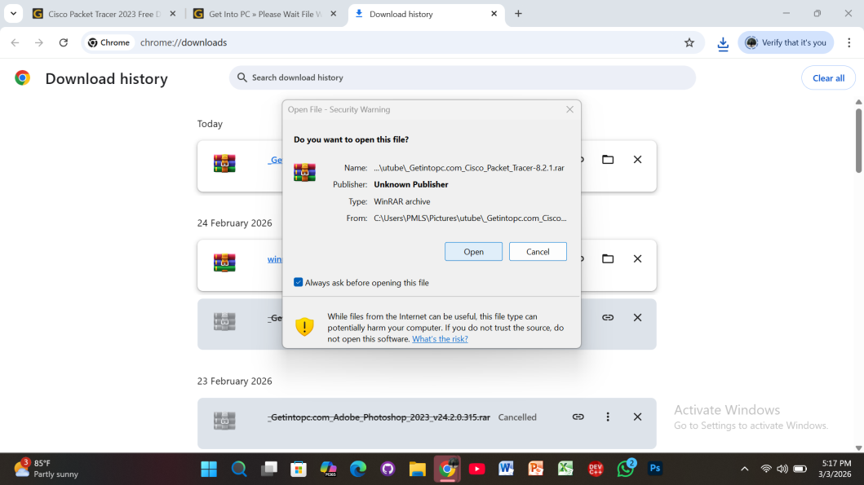

Step 5: Setup Wizard Starts
- The Setup Wizard window will appear.
- Click Next to continue.
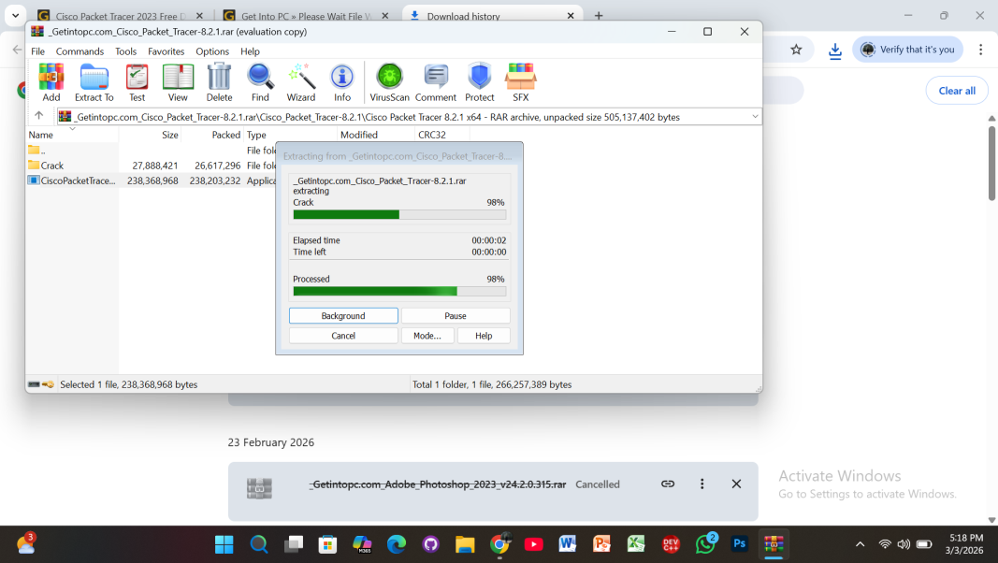

Step 6: License Agreement
- Select I accept the agreement.
- Click Next.
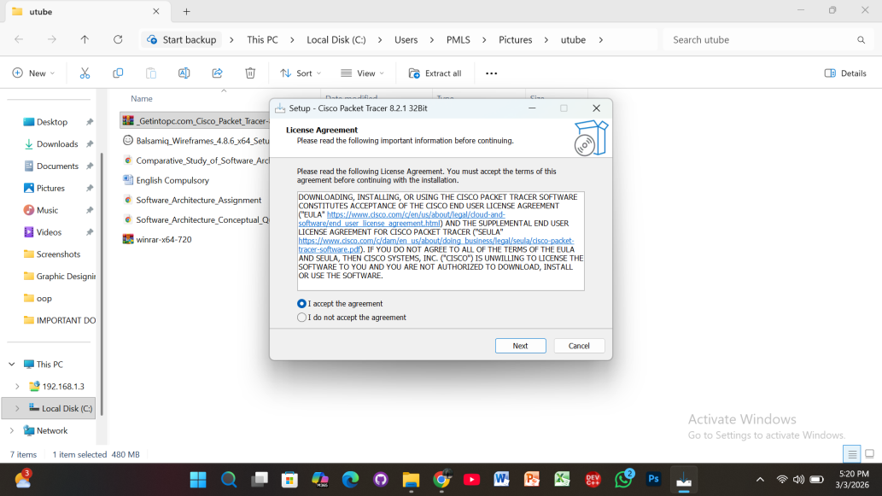

Step 7: Select Destination Location
- Choose installation folder.
- Default location is recommended.
- Click Next.

Step 8: Select Start Menu Folder
- Choose folder name (default is recommended).
- Click Next.
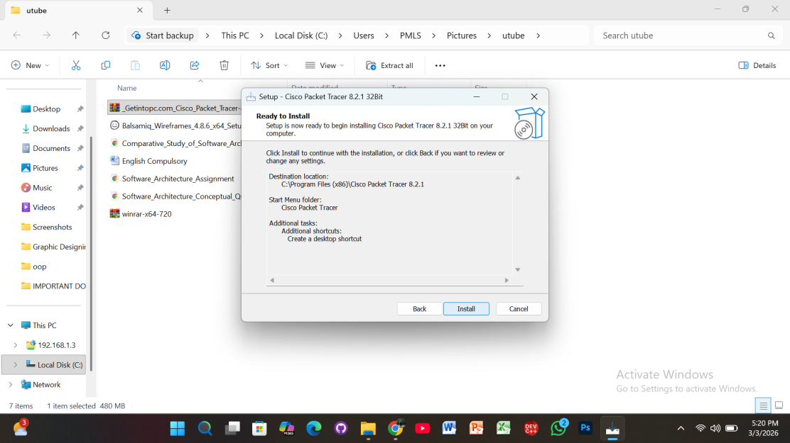

Step 9: Additional Tasks
- Select:
✔ Create Desktop Shortcut
✔ Create Quick Launch Shortcut (optional)
- Click Next.

Step 10: Ready to Install
- Review installation settings.
- Click Install.
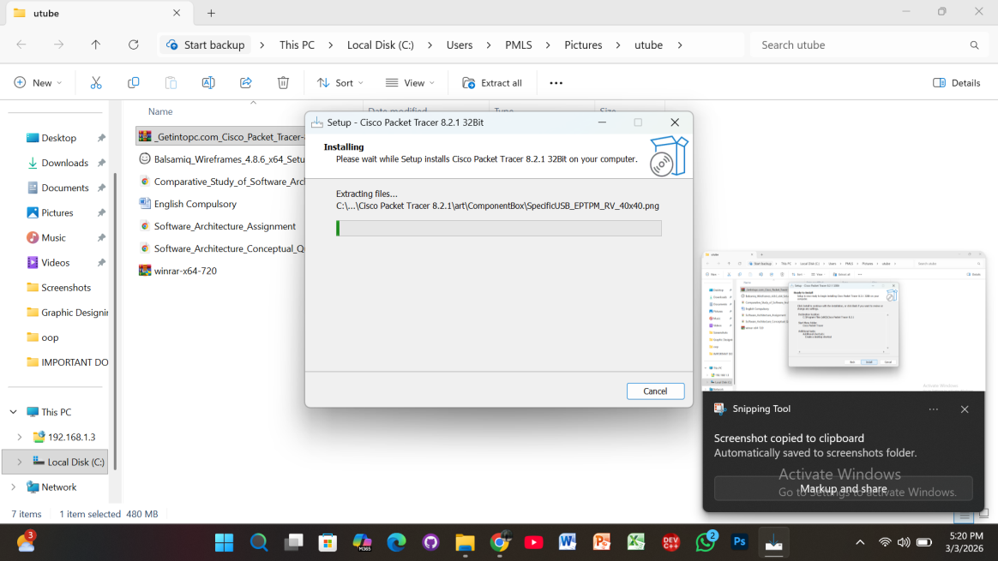

Step 11: Installing Process
- Wait while installation completes.
- Do not close the window.
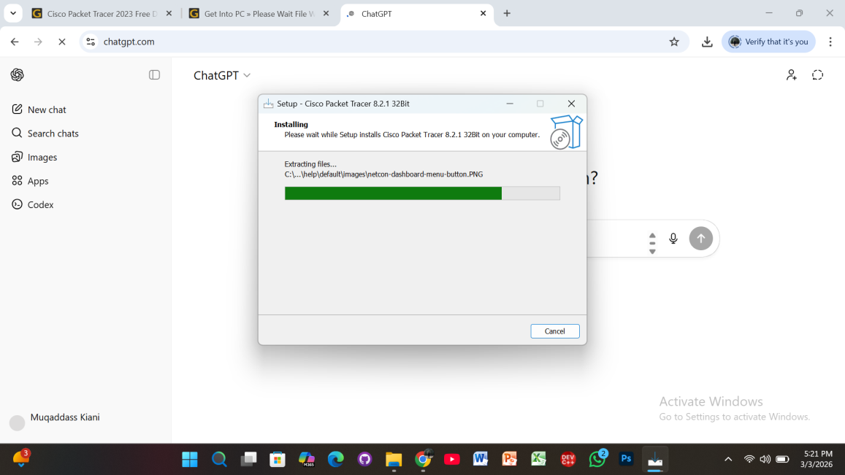

Step 12: Finish Installation
- Click Finish.
- Cisco Packet Tracer will launch automatically (if selected).
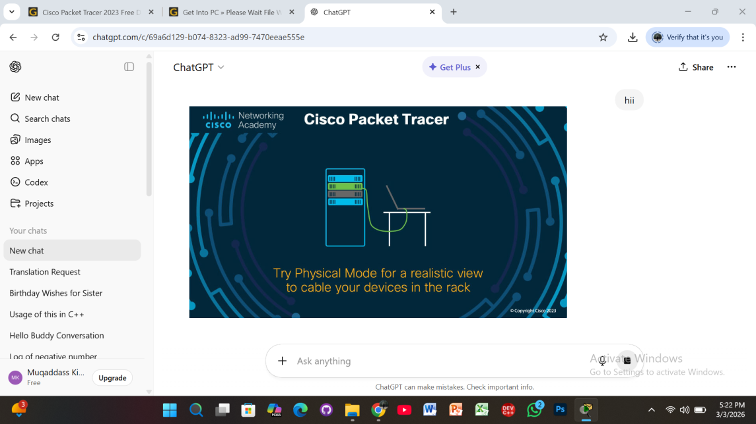

Phase 3: First-Time Login

Step 13: Login Screen Appears
You will see two login options:
- Networking Academy
- Skills For All
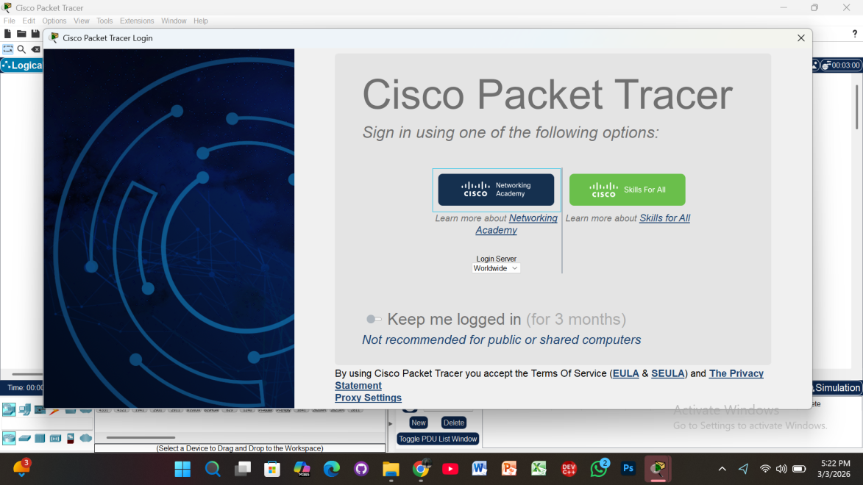

Step 14: Sign In
- Click your preferred option.
- Enter email and password.
- Click Login.
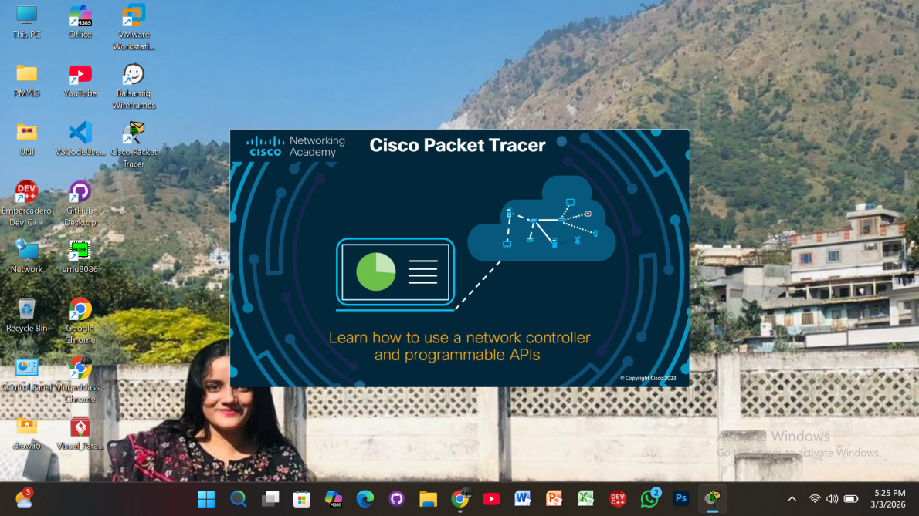

Installation Completed Successfully
Now Cisco Packet Tracer is ready to use.
