**PERSONAL BLOG ON CLOUD STATIC WEB APPS**

**PHASE 2 SUBMISSION DOCUMENT**

**Project : Personal Blog**

* **Team member : MD Muqbil Sinan.M**

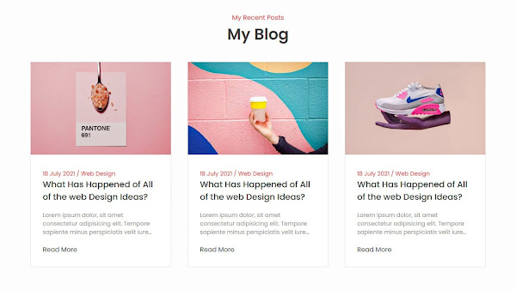

**Introduction**

Welcome to "My Personal blog," your personal gateway to the ethereal world of cloud computing. In this digital journal, we'll embark on a captivating journey through the boundless realms of the cloud, uncovering its mysteries, and embracing its transformative power.

The cloud has become the beating heart of the digital era, a catalyst for change that influences every facet of our lives. As we navigate the ever-evolving landscapes of technology, this blog aims to serve as your compass and guide through the intricate pathways of the digital skies.

Here I am sharing my personal blogs through posts.

#HTML Code

<!DOCTYPE html>

<html lang="en">

<head>

<meta charset="UTF-8">

<meta name="viewport" content="width=device-width, initial-scale=1.0, maximum-scale=1.0,user-scalable=no">

<title>My Personal Blog</title>

<link rel="stylesheet" href="style.css"/>

<link rel="stylesheet" href="#">

</head>

<body>

<section id="blog">

<div class="blog-heading">

<span>Recent Posts</span>

<h3>My Personal Blog</h3>

</div>

<div class="blog-container">

<div class="blog-box">

<div class="blog-img">

<img src="images/img.jpeg" alt="blog">

</div>

<div class="blog-text">

<span> Musician Store visit </span>

<a href="#" class="blog-title"> My personal blog</a>

<p>Lorem, ipsum dolor sit amet consectetur adipisicing elit. Aperiam, ipsum animi qui magni sequi sunt obcaecati quod dolor esse adipisci modi officiis nostrum quas, quae, vero unde? In, ipsa dolorem!</p>

<a href="#">Read More</a>

</div>

</div>

<div class="blog-box">

<div class="blog-img">

<img src="images/i.jpg" alt="blog">

</div>

<div class="blog-text">

<span> library</span>

<a href="#" class="blog-title">Gaining knowledge</a>

<p>Lorem, ipsum dolor sit amet consectetur adipisicing elit. Aperiam, ipsum animi qui magni sequi sunt obcaecati quod dolor esse adipisci modi officiis nostrum quas, quae, vero unde? In, ipsa dolorem!</p>

<a href="#">Read More</a>

</div>

</div>

</div>

</section>

</body>

</html>

#CSS coding

*{

margin: 0px;

padding: 0px;

font-family: poppins;

box-sizing: border-box;

background-color: bisque;

}

a{

text-decoration: none;

}

ul{

list-style: none;

}

body{

margin:0px;

padding: 0px;

font-family:poppins;

}

/* blog--------*/

#blog

{

display: flex;

justify-content: center;

align-items: center;

flex-direction:column;

padding: 5px;

border-bottom: 1px solid rgba(0,0,0,0);

}

.blog-heading span

{

color: red;

}

.blog-heading h3

{

font-size: 2.4rem;

color: #2b2b2b;

font-weight: 600;

}

.blog-container

{

display: flex;

justify-content: center;

align-items: center;

margin:5px 0px;

flex-wrap: wrap;

}

.blog-box

{

width: 350px;

background-color: aliceblue;

border: 1px solid white;

margin: 5px;

}

.blog-img

{

width: 100%;

height: auto;

}

.blog-img img

{

width: 100%;

height: 100%;

object-fit: cover;

object-position: center;

}

.blog-text

{

padding: 30px;

display: flex;

flex-direction: column;

}

.blog-text span

{

color: #3f3f3f ;

font-size: 0.9rem;

}

.blog-text.blog-title

{

font-size: 1.3rem;

font-weight: 500;

color: #272727;

}

.blog-text p{

color: #9b9b9b;

font-size: 0.9rem;

display: -webkit-box;

-webkit-line-clamp: 3;

-webkit-box-orient: vertical;

overflow: hidden;

text-overflow: ellipsis;

margin: 20px 0px;

}

.blog-text a{

color: #0f0f0f;

}

.blog-text a:hover{

color: red;

transition: all ease 0.3s;

}

