**PERSONAL BLOG ON CLOUD STATIC WEB APPS**

**PHASE 5 - Project Documentation & Submission**

**Project : Personal Blog**

**Team member : MD Muqbil Sinan.M**

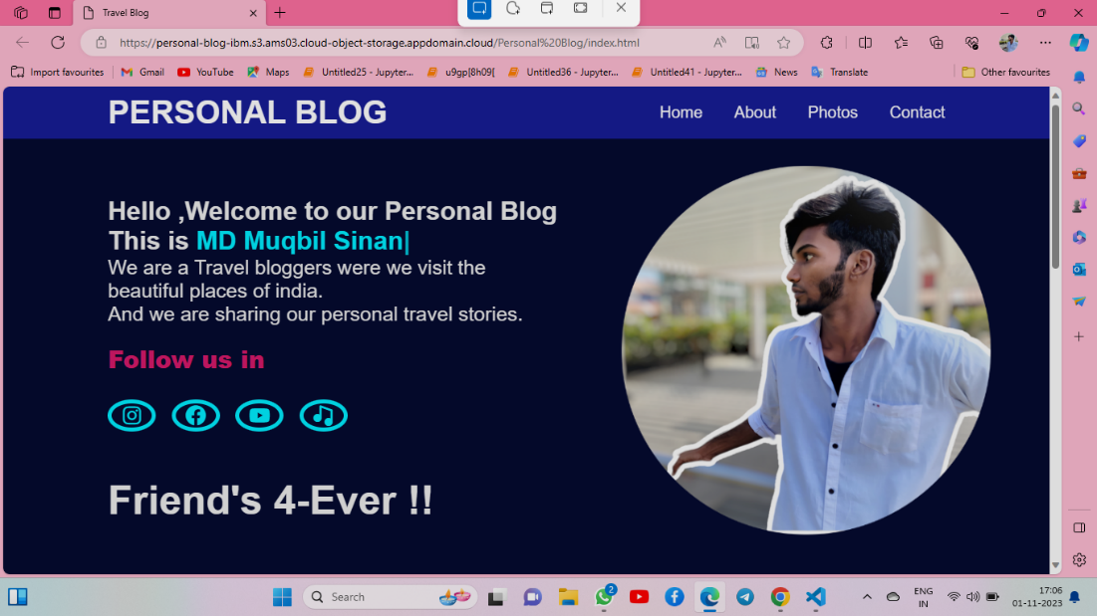

**Introduction**

Welcome to "My Personal blog," Hello ,Welcome to our Personal Blog .We are a Travel bloggers were we visit the beautiful places of india.And we are sharing our personal travel stories.The cloud has become the beating heart of the digital era, a catalyst for change that influences every facet of our lives. As we navigate the ever-evolving landscapes of technology, this blog aims to serve as your compass and guide through the intricate pathways of the digital skies.

**Here I am Developed a website for my Blog**

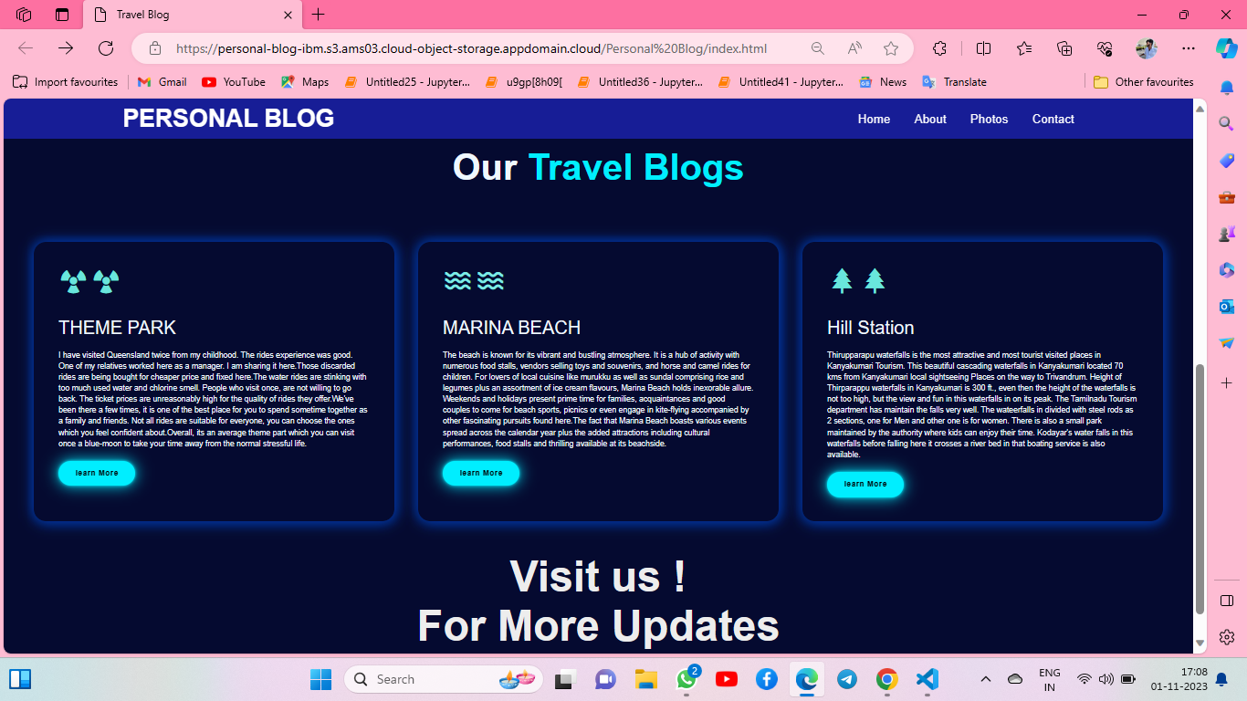

**IBM CLOUD :**

**Introduction to IBM Cloud Static Web Apps**

**Understand the importance of static websites in modern web development.**

**Explore the benefits of hosting your blog on IBM Cloud Static Web Apps.**

**Get an overview of the modules that will guide you through the entire process.**

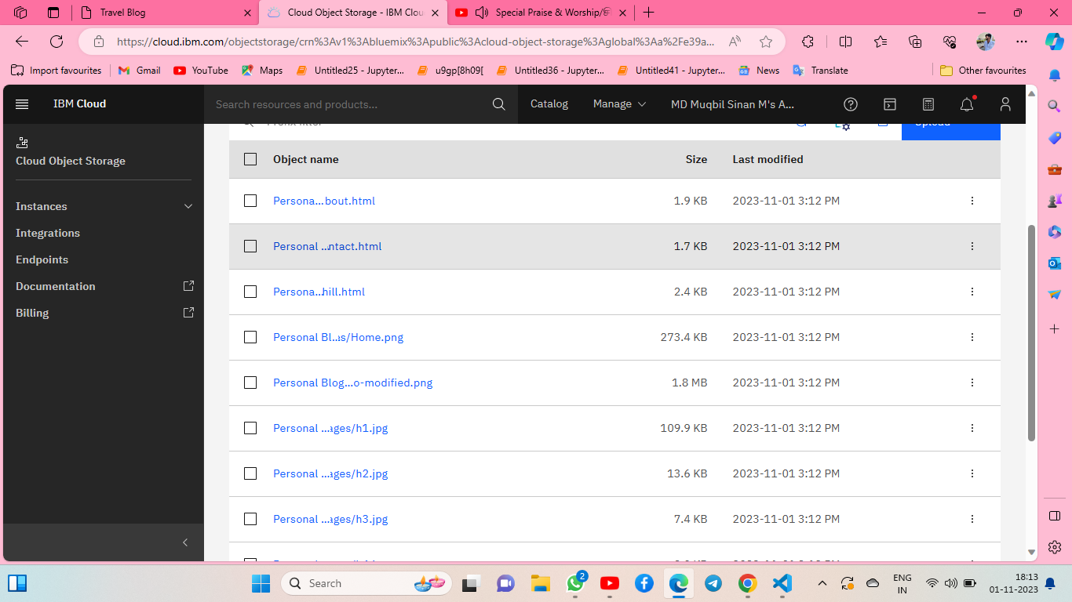

**Setting Up Your Development Environment**

Install and configure the necessary development tools, including VS Code and Git.

Create a new project directory and initialize a Git repository.

Set up a basic project structure for your personal blog.

**Creating and Organizing Content**

Plan your blog's content strategy.

Write and organize your blog posts using Markdown.

Utilize front matter for metadata and SEO optimization.

**Designing Your Blog**

Choose a responsive design framework for your blog.

Customize the design using HTML, CSS, and JavaScript.

Optimize your blog's layout for various screen sizes.

**Building a Deployment Pipeline**

Set up continuous integration and continuous deployment (CI/CD) using GitHub Actions.

Automate the deployment process from your Git repository to IBM Cloud Static Web Apps.

Ensure your blog is always up to date with the latest changes.

**Integrating Dynamic Features**

Enhance user engagement with interactive features such as comment sections and contact forms.

Explore serverless functions and APIs for dynamic content integration.

Implement social media sharing and analytics for better user interaction.

**Optimizing for Performance and Security**

Optimize your blog for speed and performance.

Implement security best practices to protect your website and user data.

Set up HTTPS and deploy your blog on a secure domain.

**Monitoring and Analytics**

Implement website analytics to track user behavior.

Set up error monitoring and logging for proactive issue detection.

Monitor the performance and growth of your blog using IBM Cloud services.

**Scaling Your Blog**

Explore strategies for scaling your blog as it gains popularity.

Consider monetization options and strategies for generating revenue.

Learn about advanced features and integrations to take your blog to the next level.

**Conclusion and Future Directions**

Recap the key takeaways from each module.

Discuss potential future enhancements and expansions for your personal blog.

Encourage continued learning and exploration in the world of web development.

By the end of this blog series, you will have the knowledge and skills to create, deploy, and maintain a personal blog on IBM Cloud Static Web Apps, setting you on the path to becoming a proficient web developer with a powerful online presence.

Github Link:----> <https://github.com/Enoch5J/Cloud-Application-Development/tree/main/Personal%20Blog>

**Instructions on how to deploy the blog using IBM Cloud Static Web Apps**

* **Monitor the Deployment:**
* Once the build and deployment process is initiated, you can monitor the progress and see the deployment logs in your IBM Cloud dashboard.
* **Access Your Deployed Blog:**
* Once the deployment is complete, you will receive a URL for your static web app. This is where your blog is hosted. You can access your blog by clicking on this URL.
* **Custom Domain (Optional):**
* If you want to use a custom domain for your blog, you can configure that in the Static Web Apps settings.
* **SSL and Security (Optional):**
* IBM Cloud Static Web Apps comes with built-in SSL support. You can configure SSL for your custom domain to secure your blog.
* **Scale and Monitor:**
* IBM Cloud provides tools for scaling your static web app and monitoring its performance and usage.