- Create one VPC, with 1 public subnet and 1 private subnet.
Created the VPC
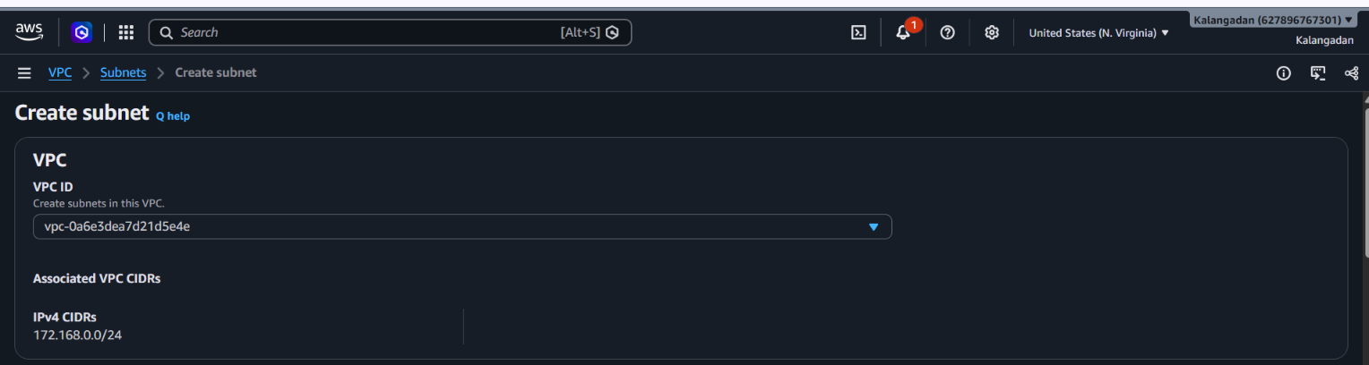
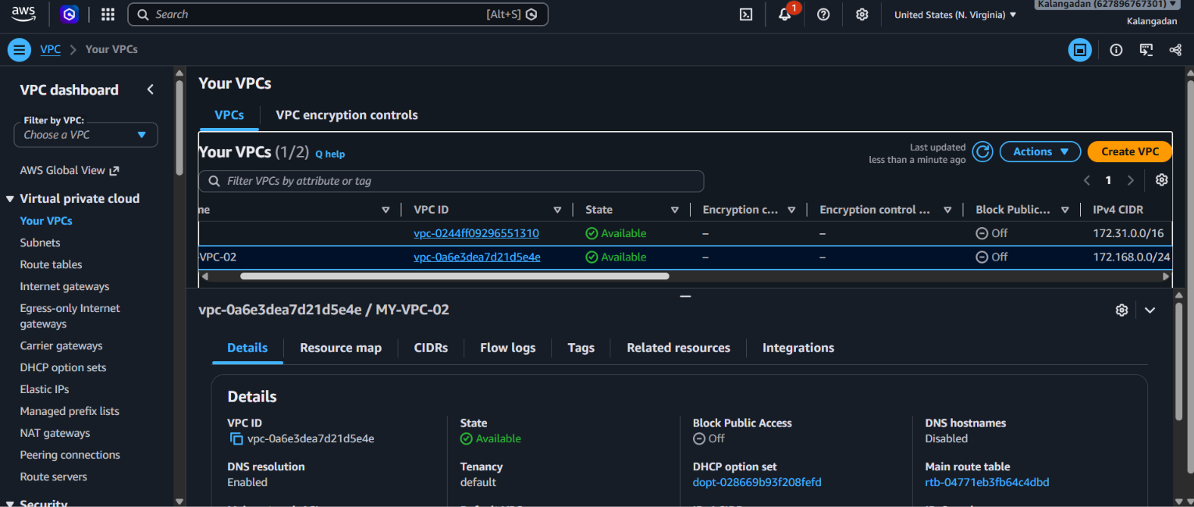
Creating the Public subnet
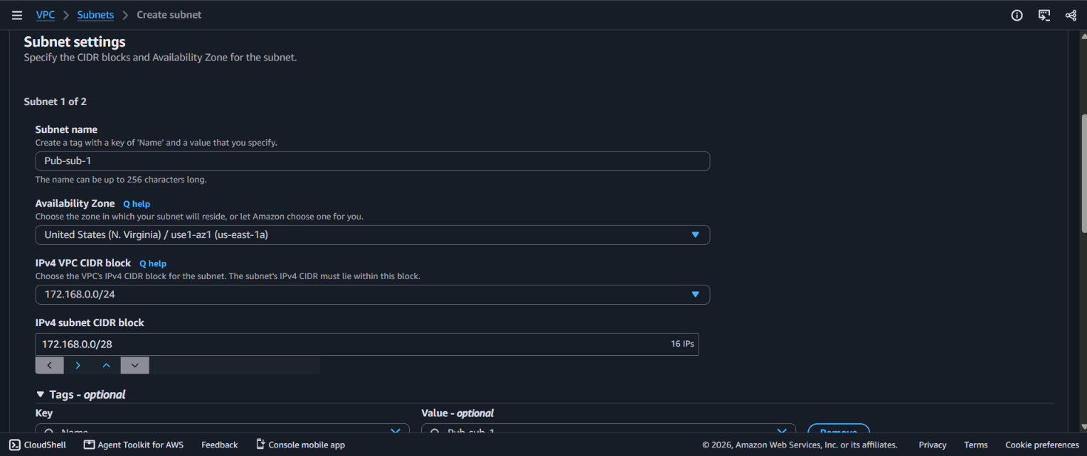

Created 2 subnets successfully
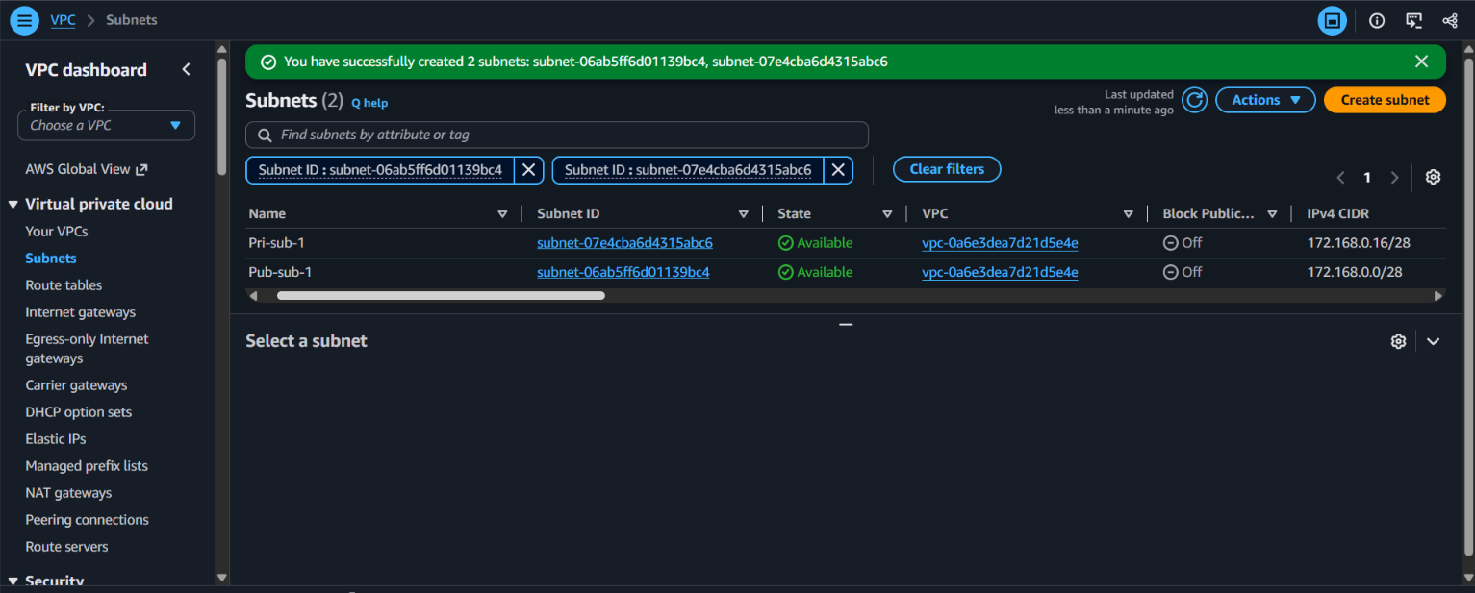

Created IGW for public subnet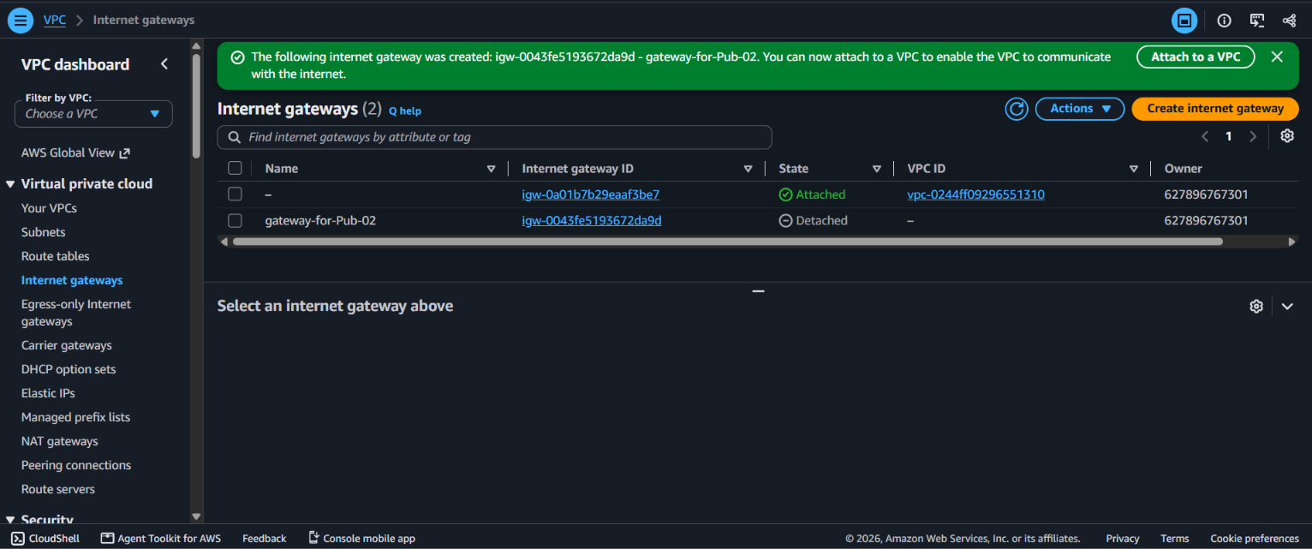
Attach this IGW to the PUB-SUB (in IGW actions)
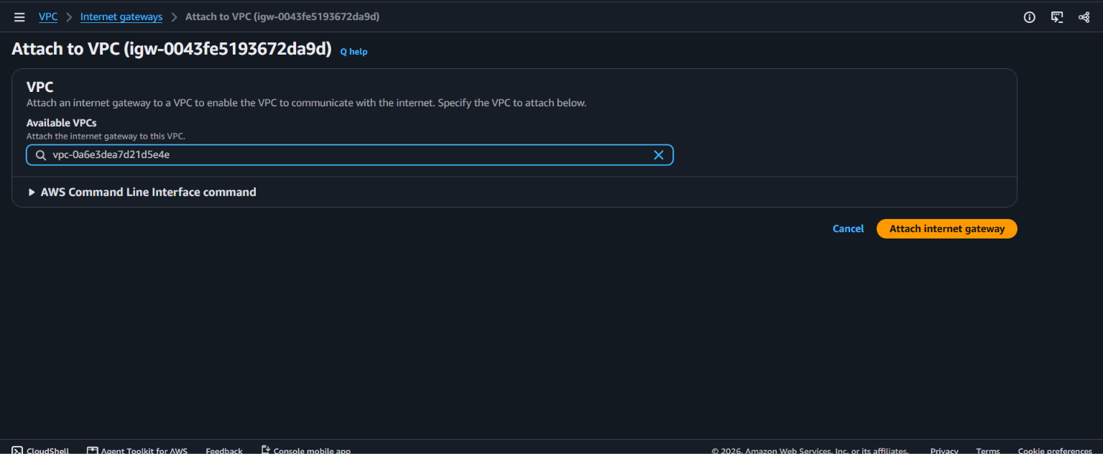
IGW Attached to the VPC
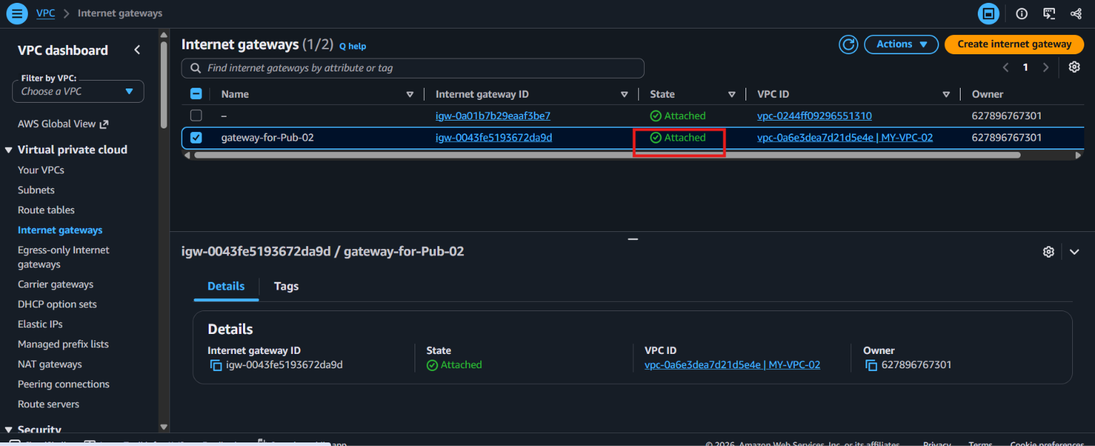
The benefit of doing this is that we can directly SSH (Secure Shell) into that instance from our laptop over the internet. If this setting is not enabled, the instance will only get a Private IP, and we won't be able to access it from outside.
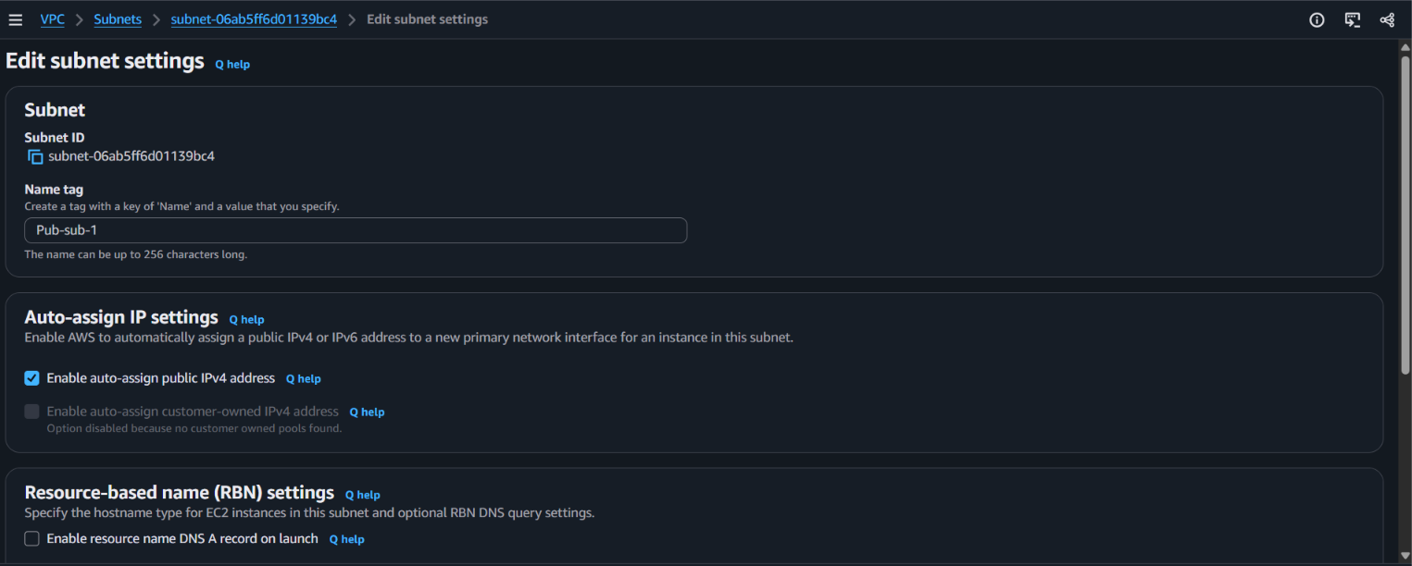
Creating a Pub-RT for the PUB-SUB
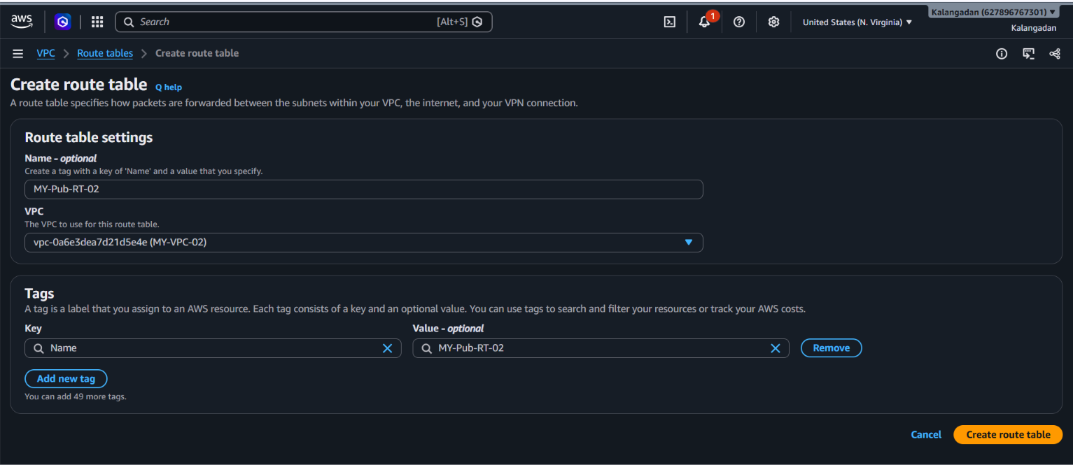
Connecting PUB-SUB & PUB-RT to the IGW
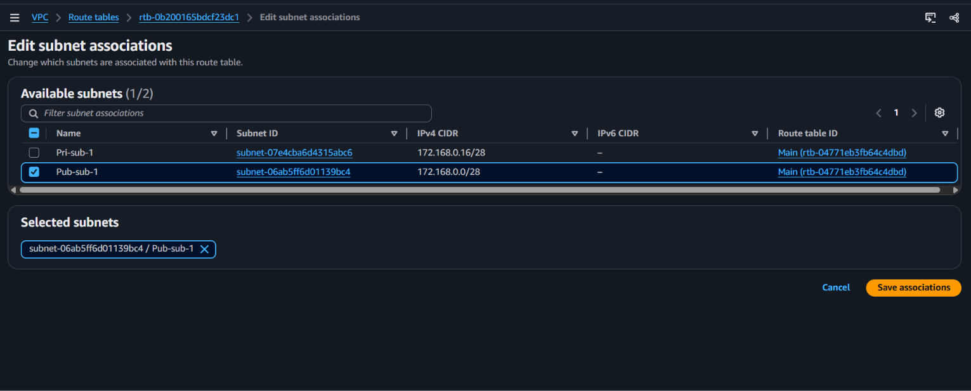connected to the subnet
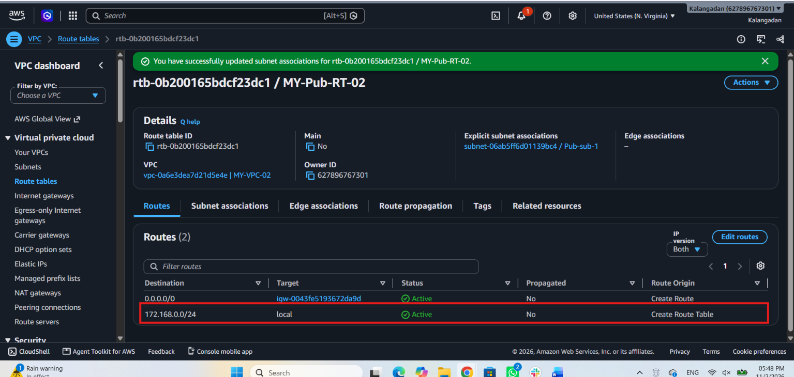
Creating the Private subnet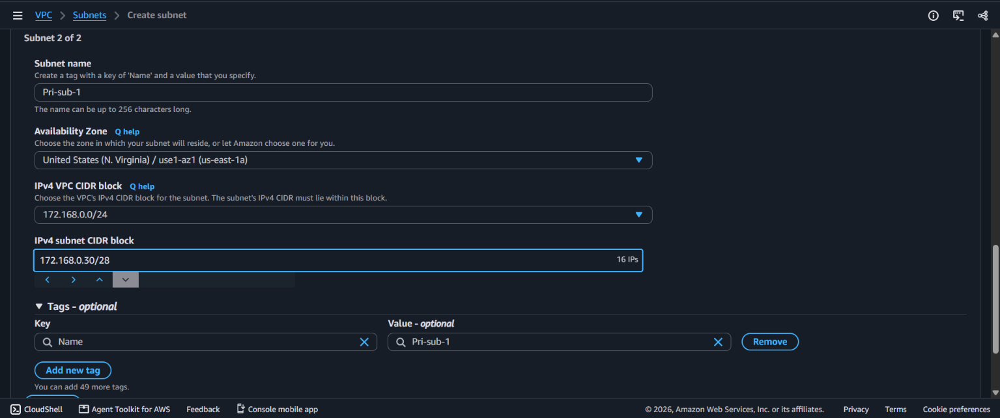

Creating a Pri-RT for the Pri-Sub
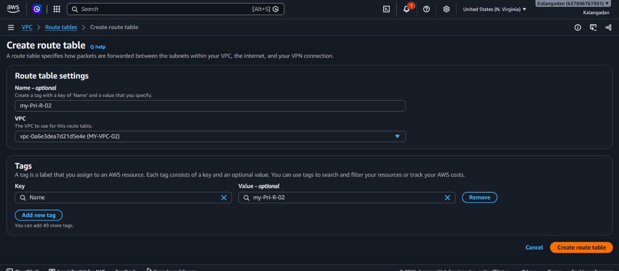
Connecting Pri-sub to the Pri-RT
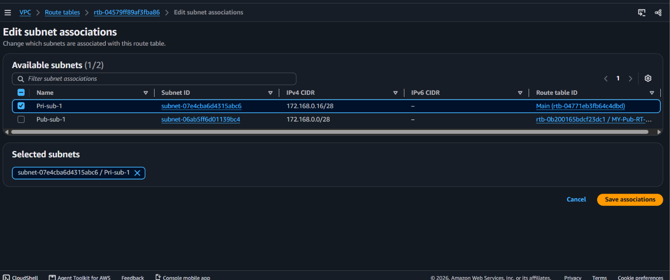

- Enable VPC peering for cross-region.
Peering connections > Create peering connection > name to peer connection > Create an instance & configured the SG > Ohio VPC ID added in the Virginia region > Accepted the peering request in the Ohio region > connected with the terminal (Ohio).
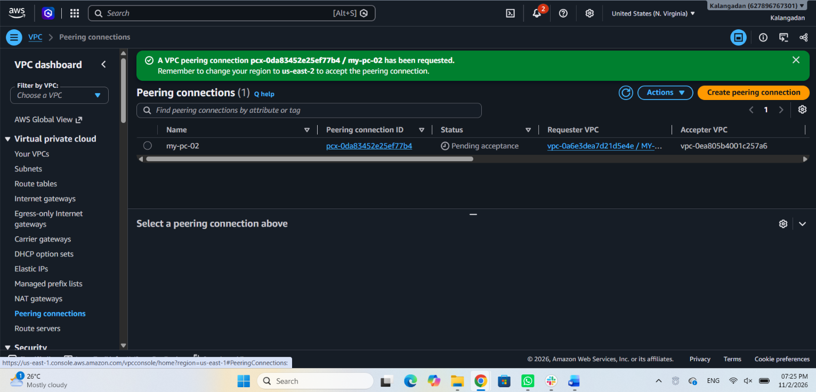
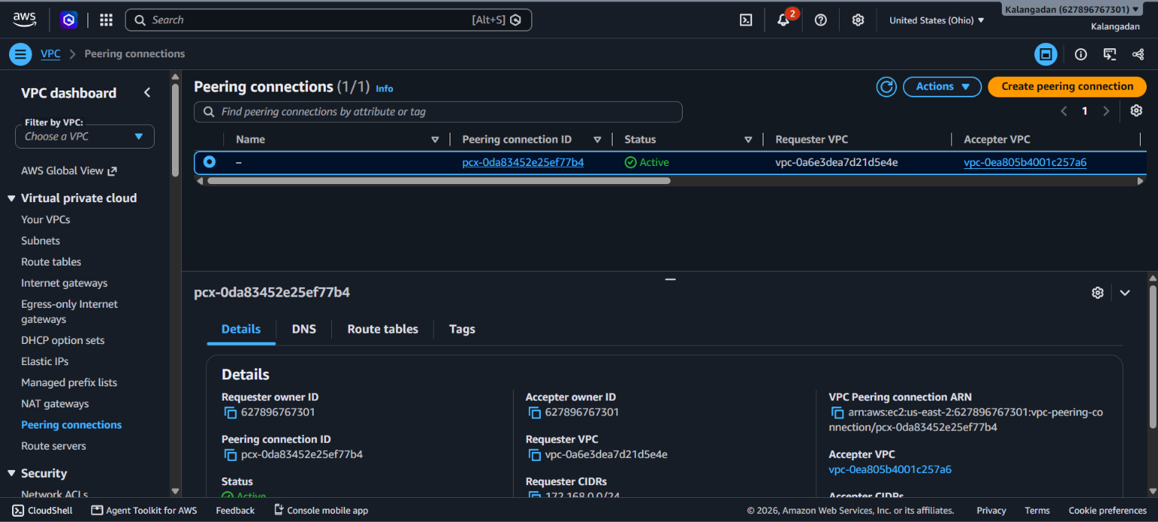

- Enable VPC peering for cross-account (you can collaborate with your friend to do this task).
Peering connections > Create peering connection > name to peering connection > select another account details > send the request .

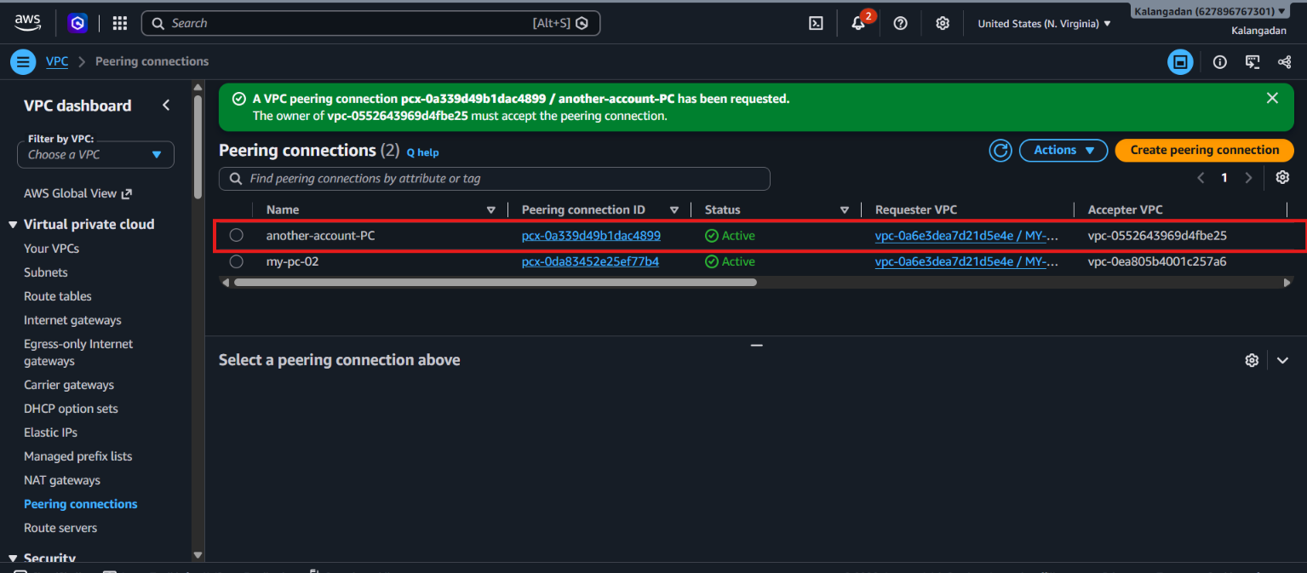
- Set up a VPC Transit Gateway.
VPC > Transit gateways > Create transit gateway > name the transit > keep ASN > transit gateway attachments > name the attachment > select created transit > VPC > select VPC & subnets IDs > create attachments >
Transit gateways
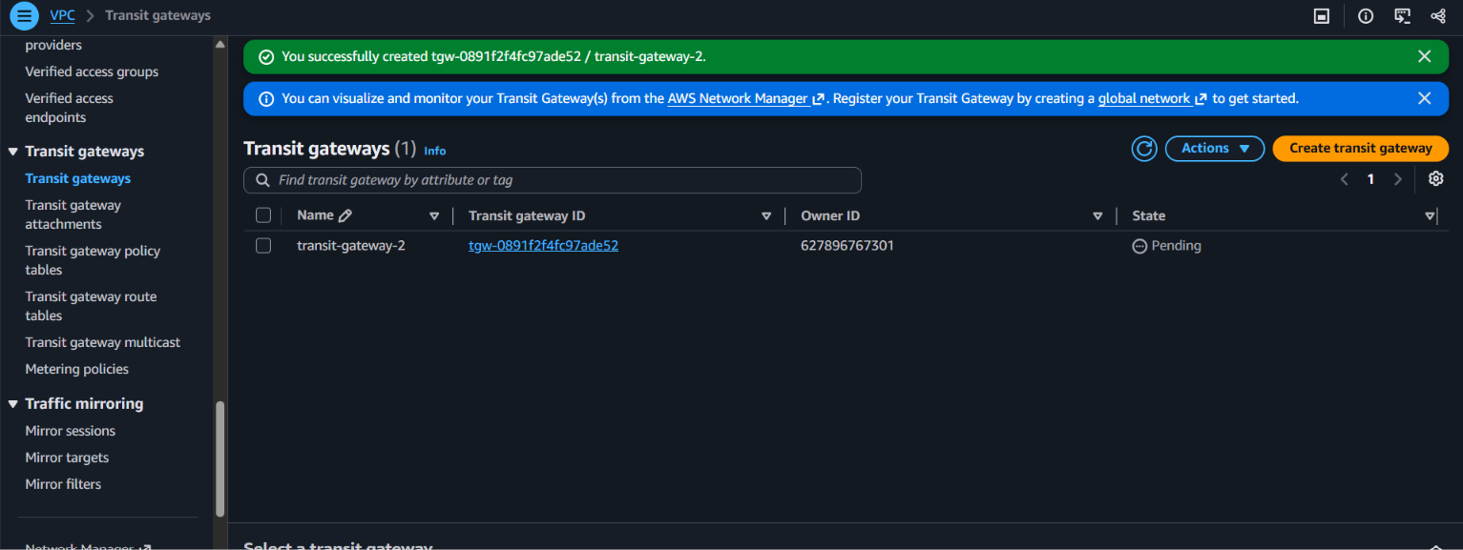
Transit gateway attachments 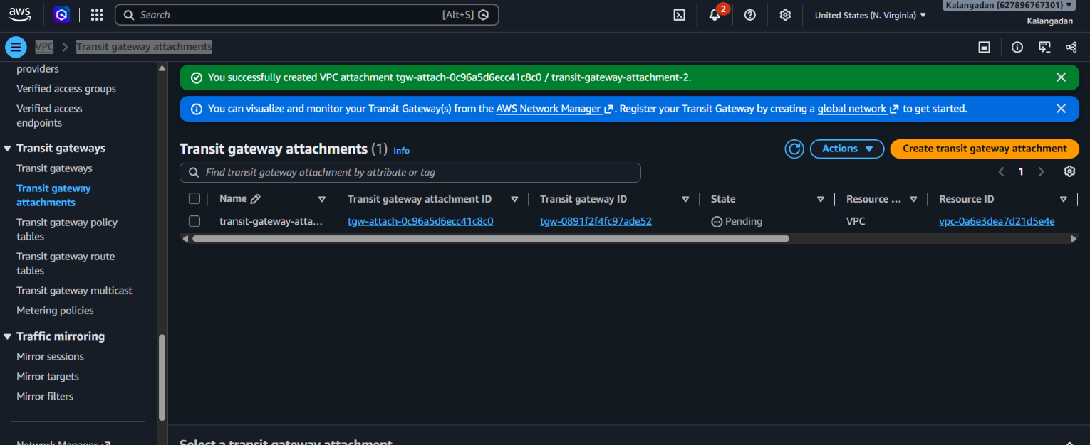
- Set up a VPC Endpoint.
End point > name the endpoint > type (aws services) > then search with the s3 > gateway > VPC > subnets > Full access > RT > Create endpoint.


