

BIT3208
Advanced Web Design and Development

Development Logbook

Student Name: Stephen Muriithi
Admission Number: BSCCS/2024/54461
Course: Computer Science – 2024 Sep Class
Unit Code: BIT3208
Unit Name: Advanced Web Design and Development
Lecturer: Michael Nyoro
Academic Year: 2026/ Semester 3.2

Project Title: Student Hostel Booking System
Technologies Used: PHP, MySQL, JavaScript, HTML/CSS
GitHub Repository: https://github.com/stephenmuriithi/hostel-booking

TABLE OF CONTENTS
Contents
No table of contents entries found.
Week 1: Local Environment Setup
Installation and Testing of Local Development Environment

Overview
This week marked the beginning of the Student Hostel Booking System project. The primary task was to install and configure a local web server environment using XAMPP, which provides Apache as the web server and MySQL as the database engine. Once installed, the goal was to verify that PHP scripts could execute correctly on the local machine and that a basic database connection could be established, forming the foundation for all subsequent development.
Evidence of Work
Fig 1: XAMPP Control Panel showing Apache and MySQL services running confirms the local server is active and ready for PHP execution.
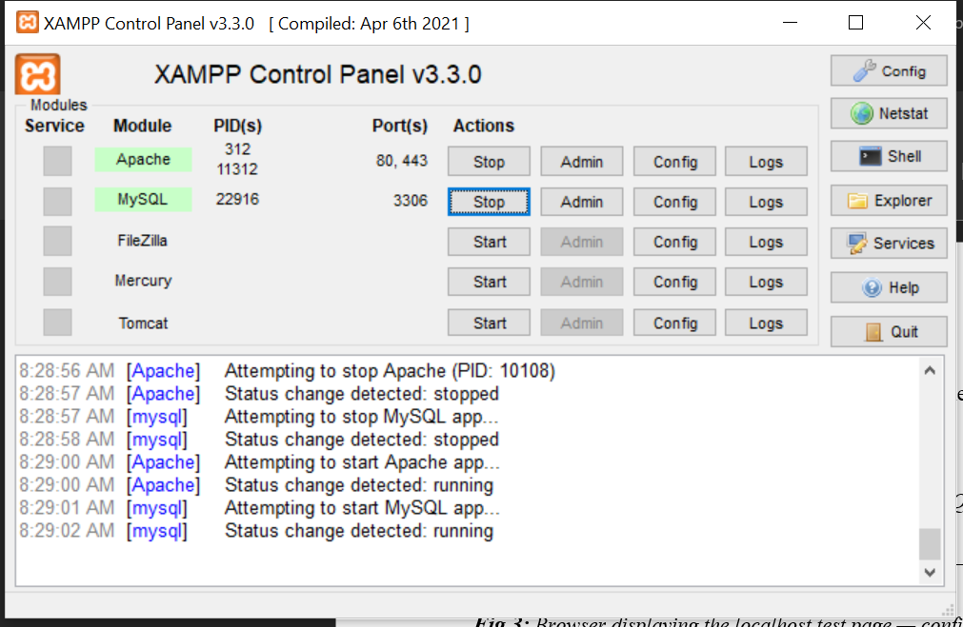
Figure 1:XAMPP Control Panel
Fig 2: phpMyAdmin interface at localhost/phpmyadmin confirms the database management layer is accessible and the hostel_db schema was created.
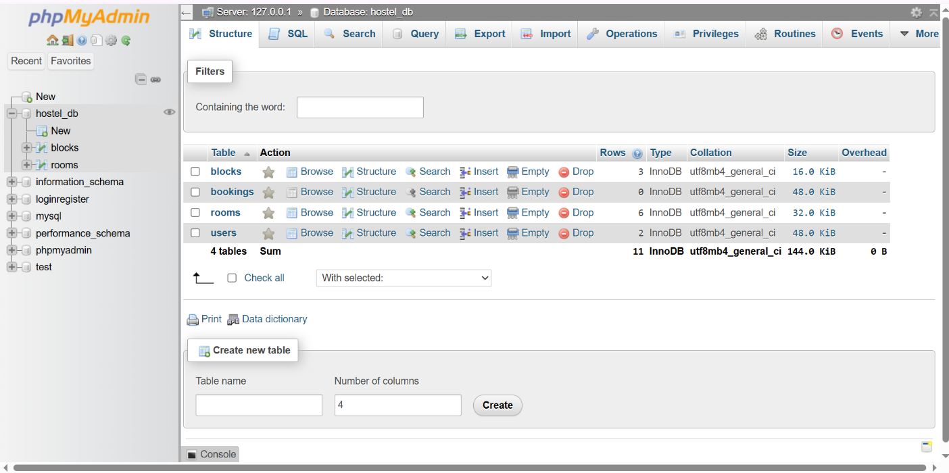
Figure 2:phpMyAdmin interface

Fig 3: Browser displaying the localhost test page confirms Apache is serving pages correctly on port 80.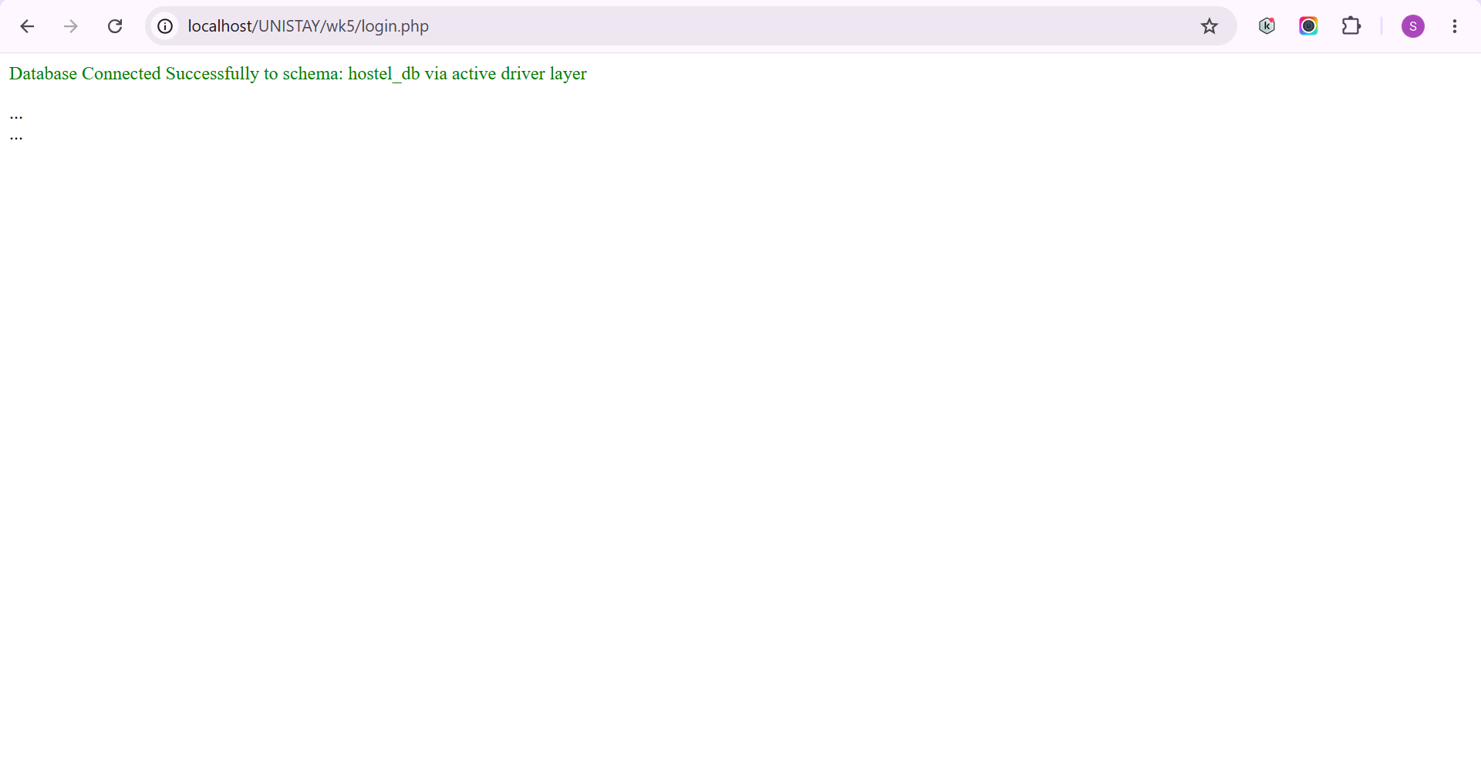
Figure 3:Browser test page

Fig 4: Hello World PHP page rendered at localhost/hostel-booking/index.php confirms PHP server-side execution is functioning.
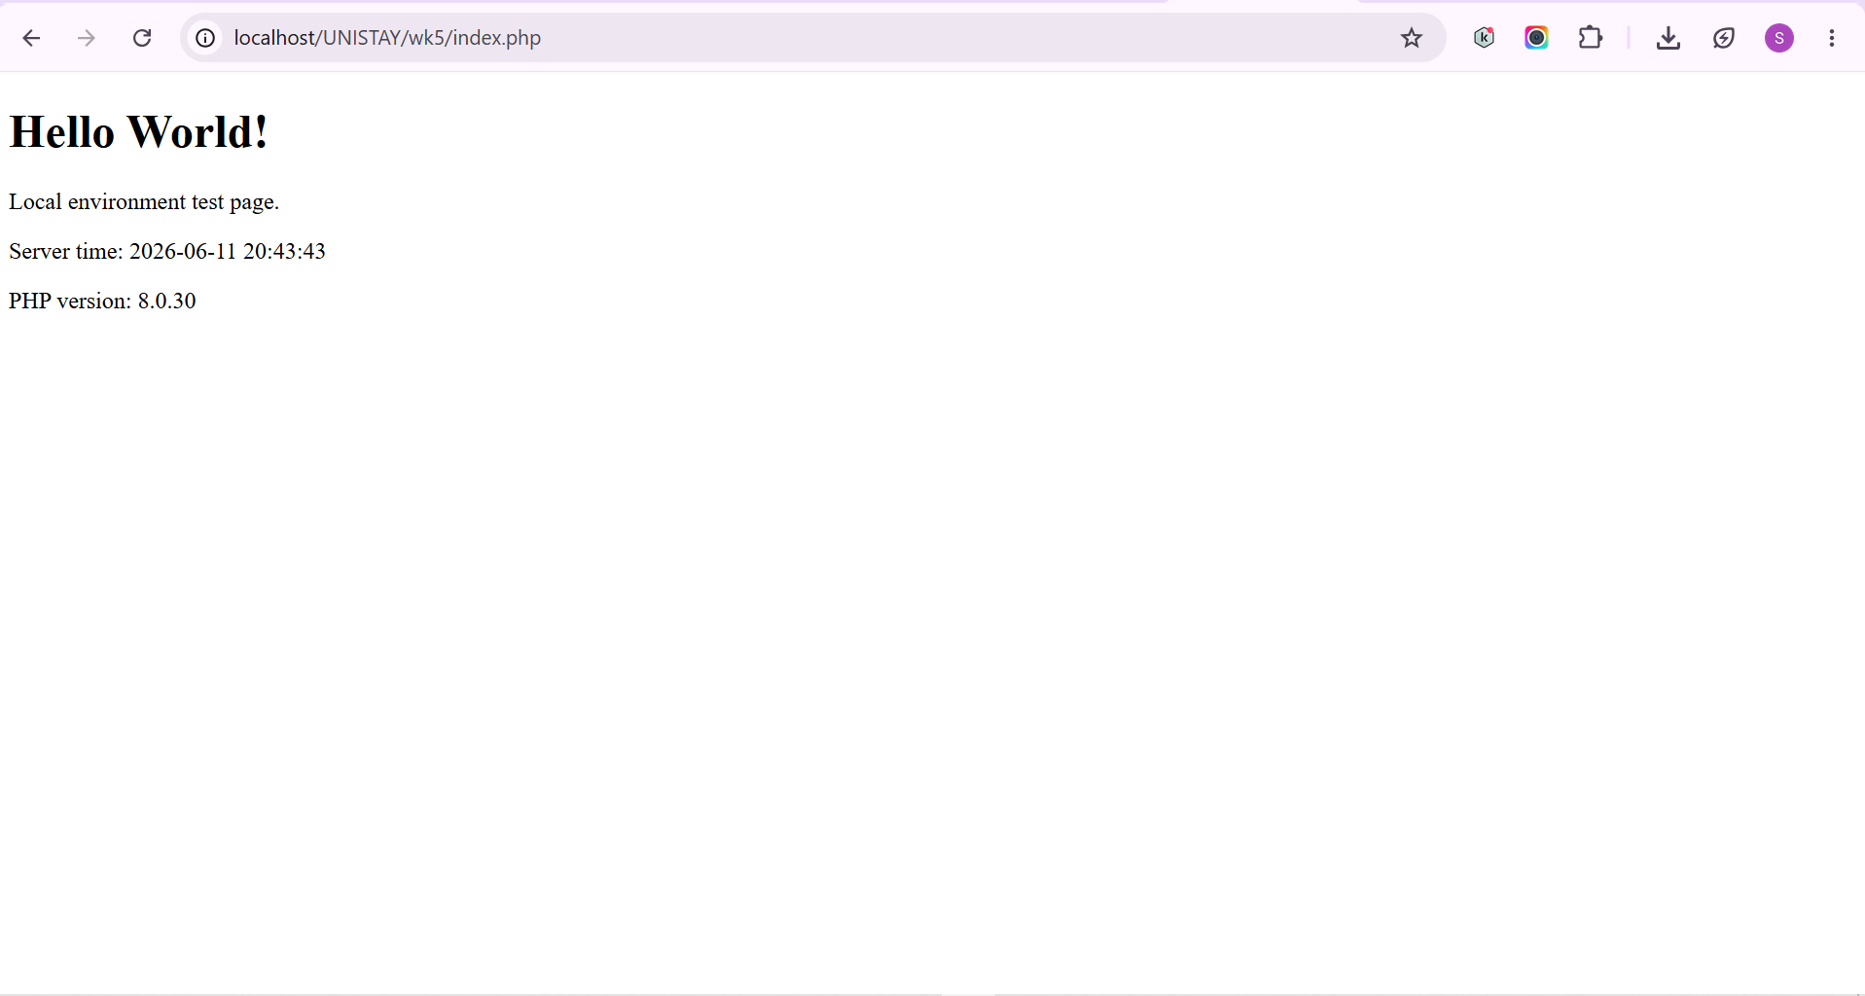
Figure 4:Local Environment Test Page
Fig 5: Blank page output from config/db.php a blank response with no errors confirms a successful silent PDO connection to MySQL.


Figure 5: Blank Page Output
Student Reflection
Setting up XAMPP taught me the distinction between client-side and server-side execution. HTML and JavaScript run in the browser, whereas PHP executes on the Apache server and only the output is sent to the client. The most important realisation this week was understanding the PDO connection string a blank page on db.php is actually a success message because it means no exceptions were thrown. I also organised the project directory with separate folders for config, assets, pages, and includes from the start to follow a professional development workflow.

Week 2: Wireframes and GUI Design
User Interface Planning and System Design

Overview
Before writing a single line of HTML, this week was devoted entirely to planning the visual and navigational structure of the system. Using Figma, I designed low-fidelity wireframes for all key screens of the hostel booking portal. This planning phase ensures that the final system has a logical user flow and that every screen serves a defined purpose, rather than developing pages randomly and linking them together afterwards.
Evidence of Work
Fig 1: Hand-drawn architecture diagram showing the three-tier structure: student browser (client), Apache/PHP (server layer), and MySQL (data layer).
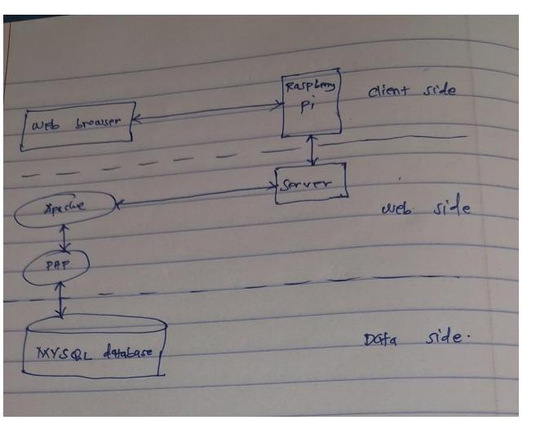
Figure 6: Hand-drawn architecture diagram

Fig 2: Figma wireframe for the student login and registration screen ,includes admission number, email, and password fields with role selection.
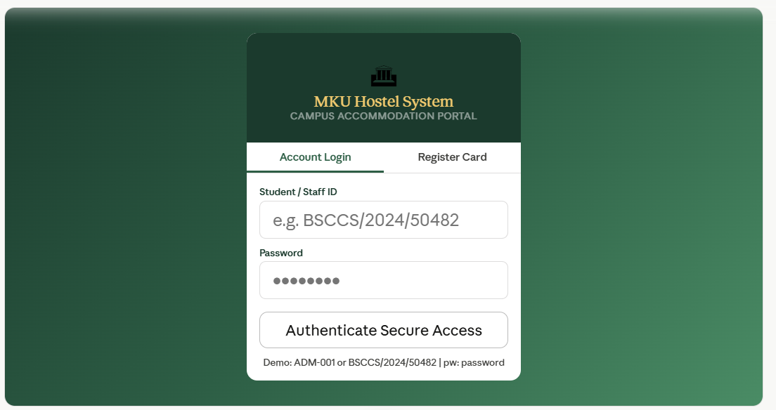
Figure 7:Figma wireframe
Fig 3: Figma wireframe for the room listing page ,shows filterable room cards with availability badges (Available, Occupied, Pending) and pricing.
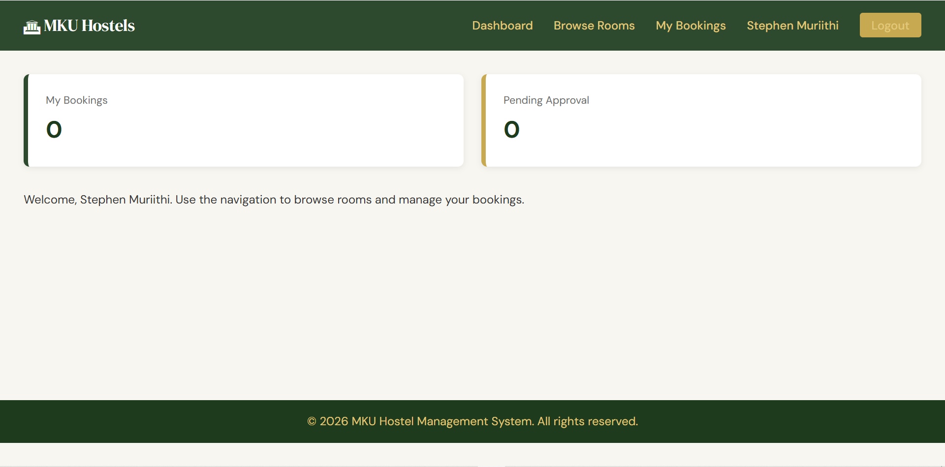
Figure 8: Figma wireframe

Fig 4: Figma wireframe for the booking form ,shows date pickers, room details, live fee preview section, and confirmation button.
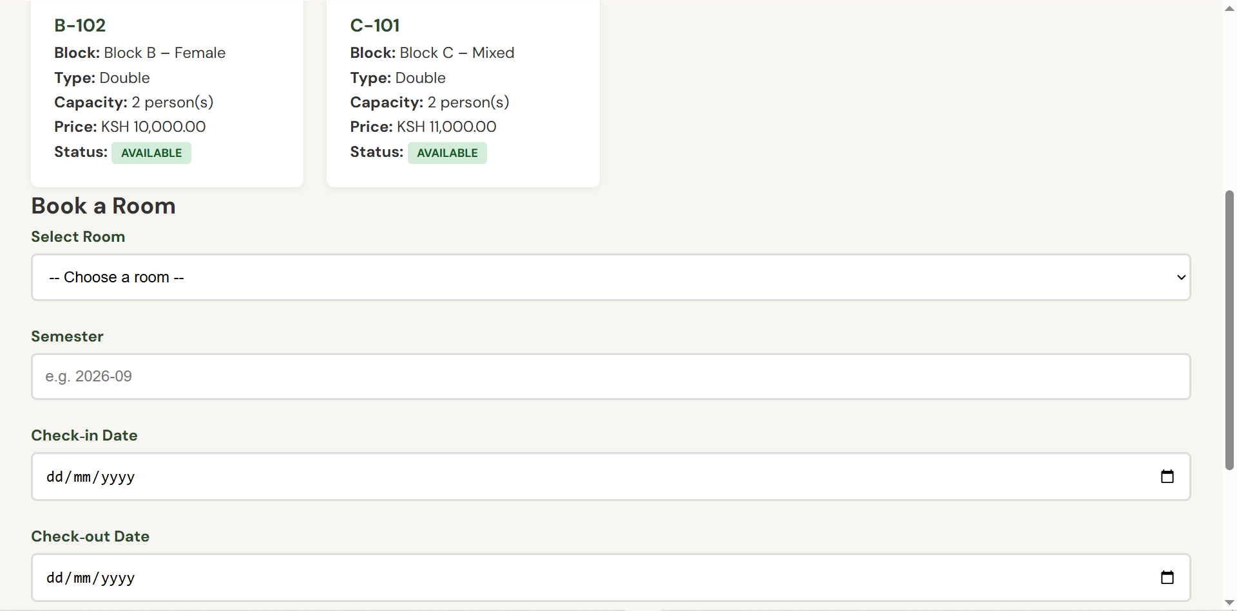
Figure 9: Figma wireframe
Fig 5: Figma wireframe for the admin dashboard which displays booking summary table, occupancy counters, and management action buttons. 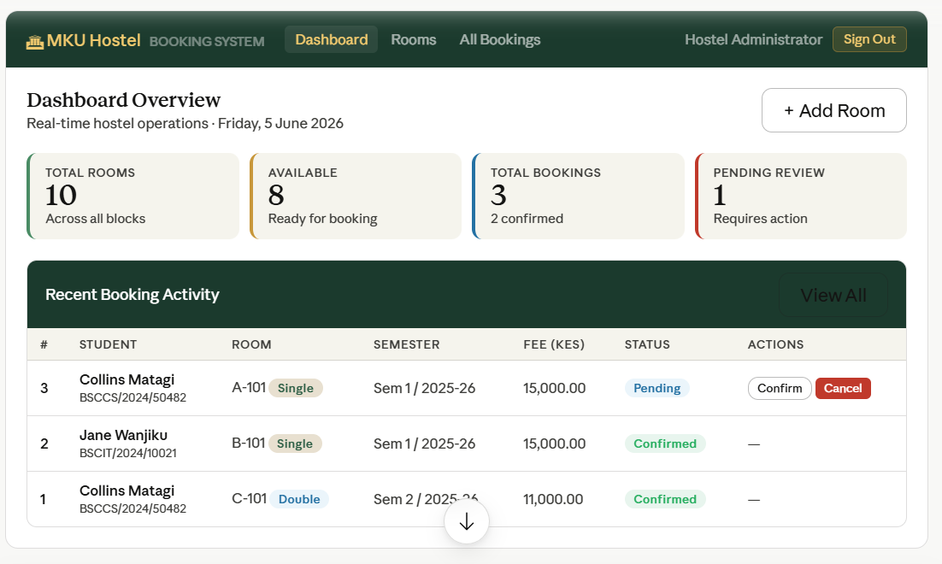
Figure 10:Figma wireframe
Student Reflection
Designing before coding revealed how many decisions need to be made about user experience before the first tag is written. I decided to place navigation on the left side of the dashboard to make it easier to add new modules later without redesigning the layout. The room listing page was designed with filter buttons at the top because hostel administrators need to quickly find specific rooms by block or type. The wireframes also helped me define exactly which database fields would be needed, making the schema design in Week 3 much more focused.
Week 3: JavaScript and PHP Basics
Frontend Interaction and Backend Foundations

Overview
This week introduced two parallel tracks of development. On the frontend, JavaScript was used to add client-side form validation to the booking form, preventing empty submissions before data ever reaches the server. On the backend, the MySQL database schema was written and the two core tables rooms and students were created with appropriate data types, constraints, and relationships. A reusable PDO connection bridge was also written in config/db.php.
Evidence of Work
Fig 1: JavaScript validation alert triggered on the booking form when a student attempts to submit without selecting a room : prevents null data reaching the PHP backend.
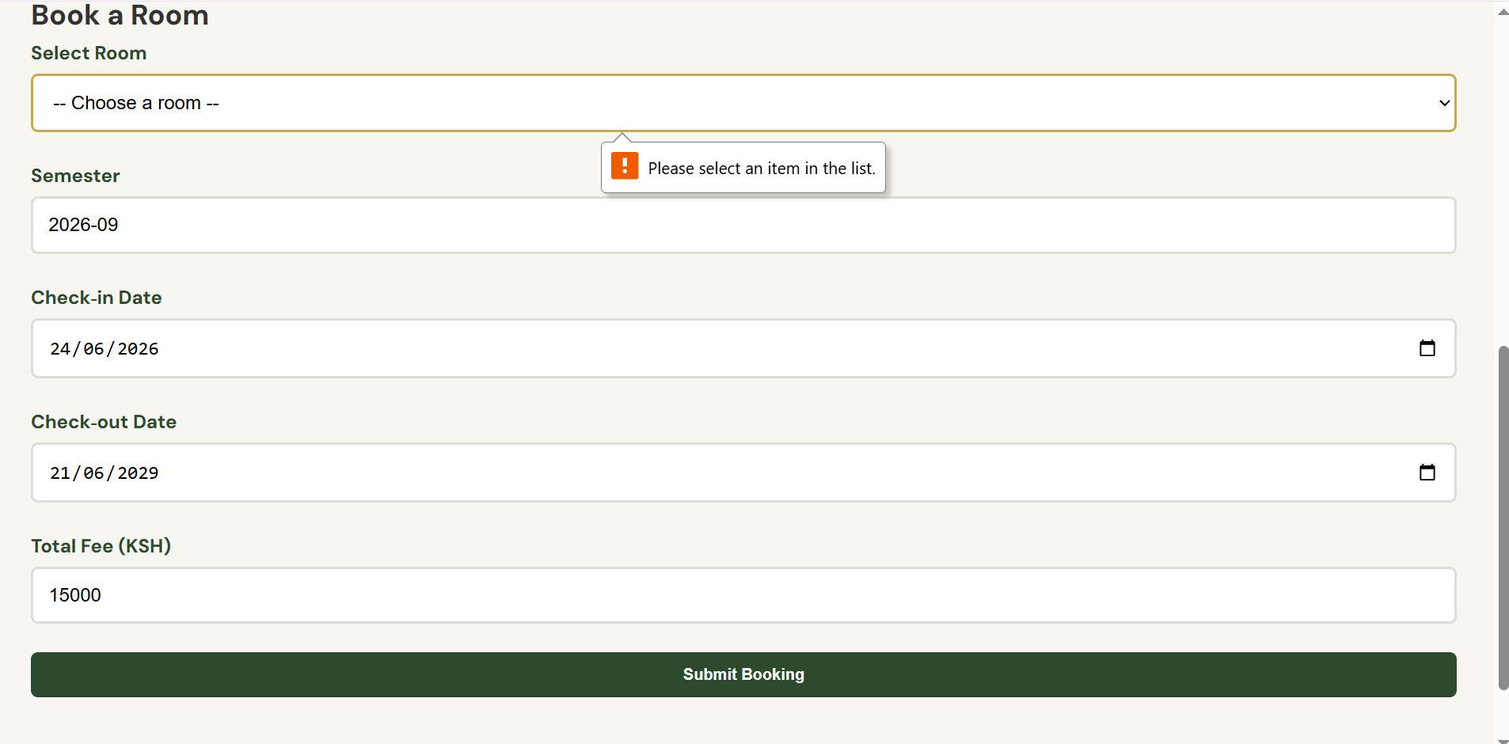
Figure 11:: JavaScript validation alert
Fig 2: Password strength checker in action on the registration form : gives live feedback as the user types, using DOM event listeners.
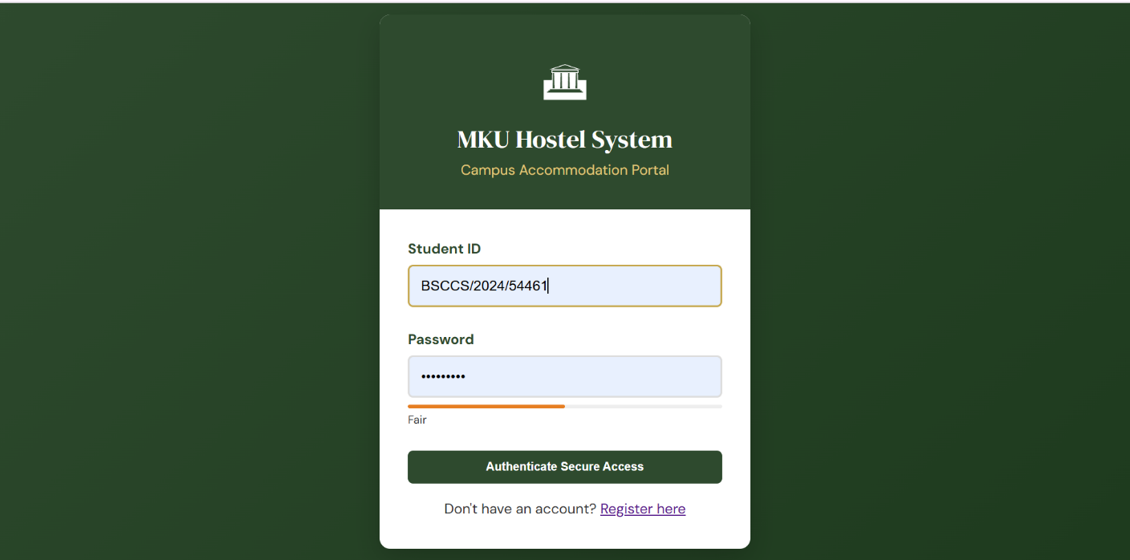
Figure 12:Password strength checker
Fig 3: phpMyAdmin showing the rooms table structure with columns: room_id, room_number, room_type, price_per_semester, capacity, status, floor, and block.
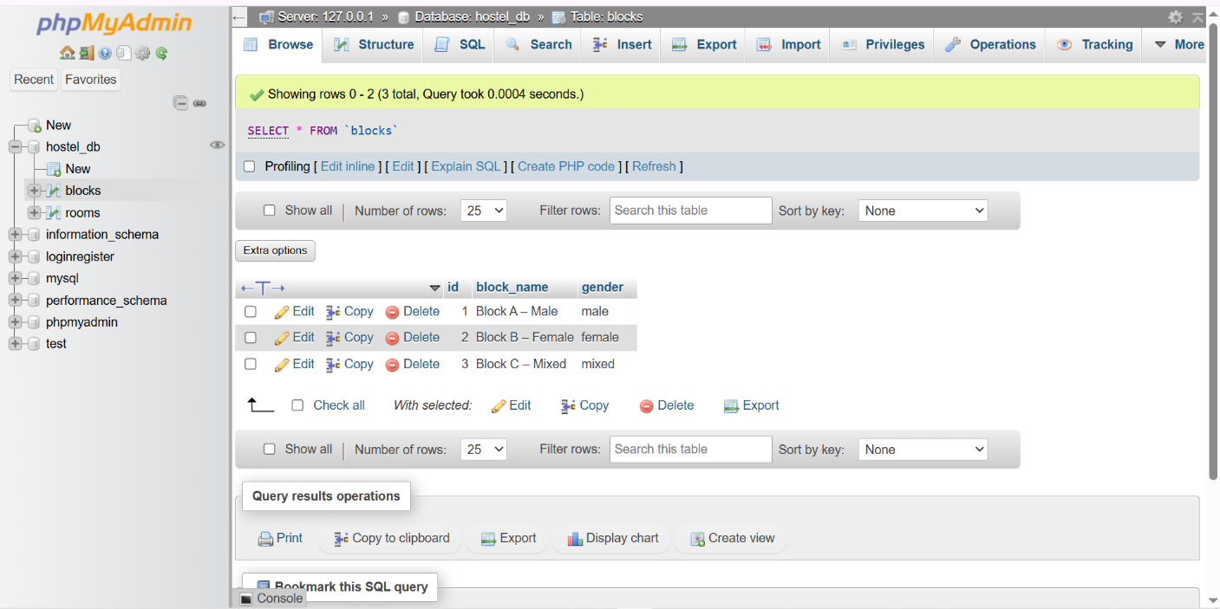
Figure 13: phpMyAdmin

Fig 4: phpMyAdmin showing the students table structure with hashed password field : confirms password_hash() is being used, not plain text storage.
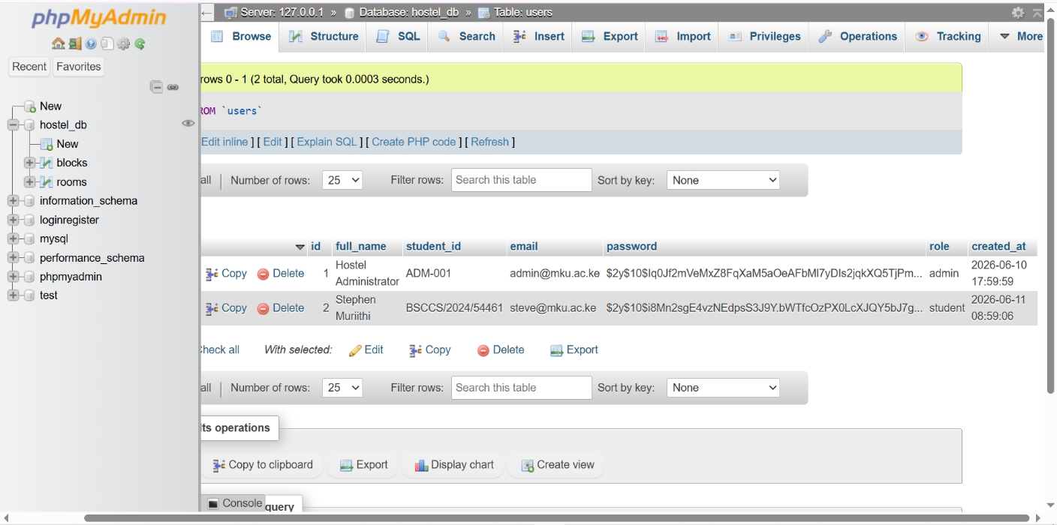
Figure 14:phpMyAdmin
Fig 5: Browser confirmation message from connection.php: "Database Connected Successfully to schema hostel_db via active driver layer."

Figure 15:Browser confirmation message
Student Reflection
The most important concept this week was understanding why both layers of validation matter. JavaScript validation improves the user experience by giving instant feedback without a page reload. However, it can be bypassed using browser developer tools or direct HTTP requests, which is why PHP must also validate every input on the server side. I also learned the difference between mysqli_connect() and PDO which supports prepared statements across multiple databases, making it the more professional and secure choice for this project
Week 4: Dynamic Backend Form Processing and System Authentication
Server-Side Components and Backend Development Foundations

Overview
Week 4 elevated the system from static wireframes and database tables into a functioning application with real user authentication. The focus was on implementing the full HTTP request-response cycle , a student fills the login form, the browser sends a POST request to login.php, PHP validates the credentials against the database using a parameterised query, and on success, a $_SESSION variable is set and the user is redirected to the dashboard. A critical file introduced this week was auth_check.php , a middleware gatekeeper that every protected page includes at the top to block unauthenticated access.
Evidence of Work
Fig 1: VS Code showing auth_check.php ,the file checks for $_SESSION['student_id'] and redirects to login with an error parameter if the session is not set.
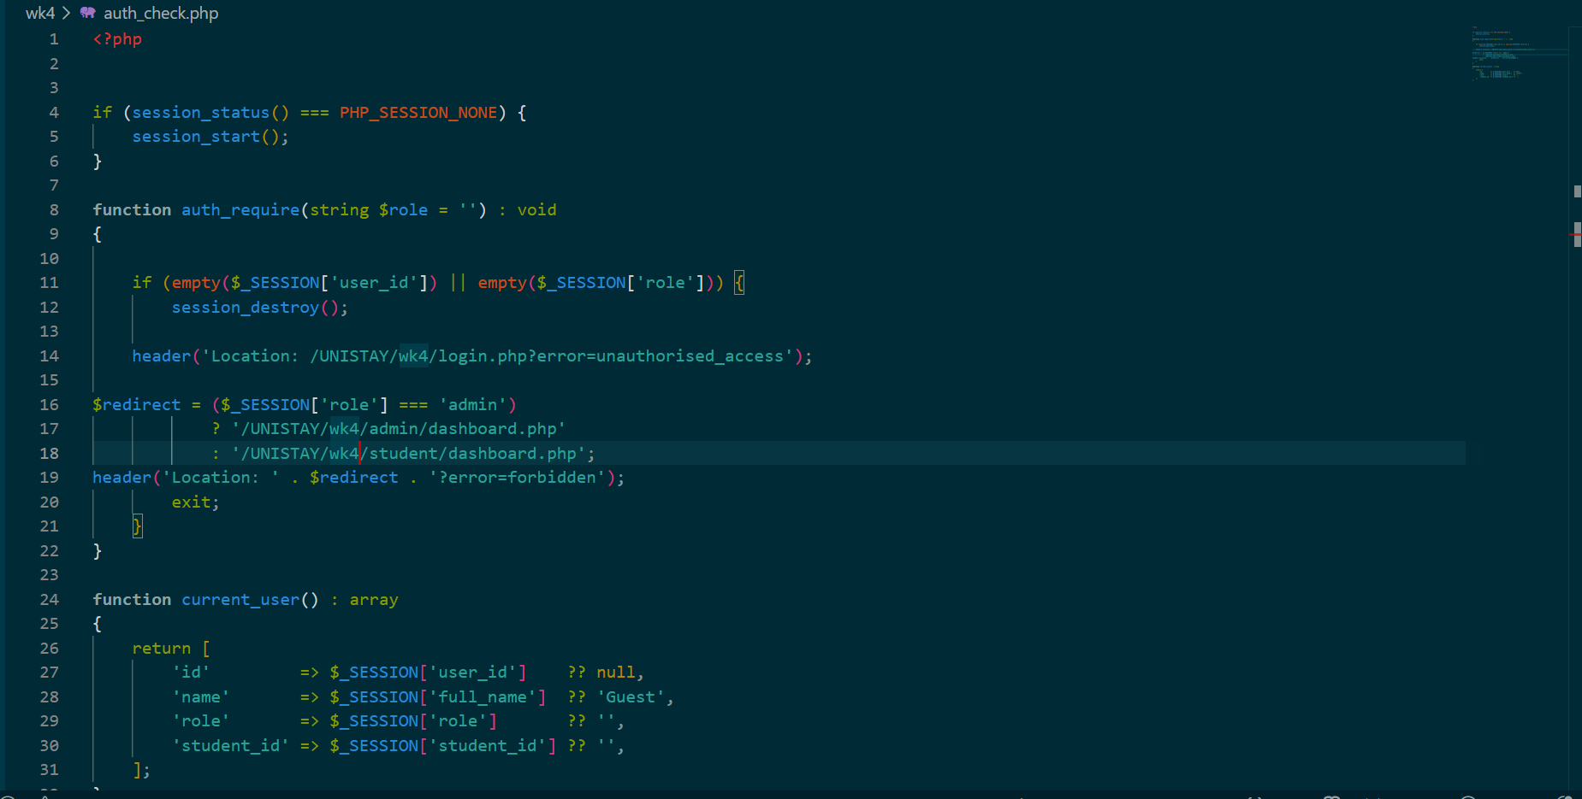
Figure 16:VS Code showing auth_check.php
Fig 2: login.php source code showing POST method handling, htmlspecialchars() sanitisation, and the parameterised PDO SELECT query for credential checking.
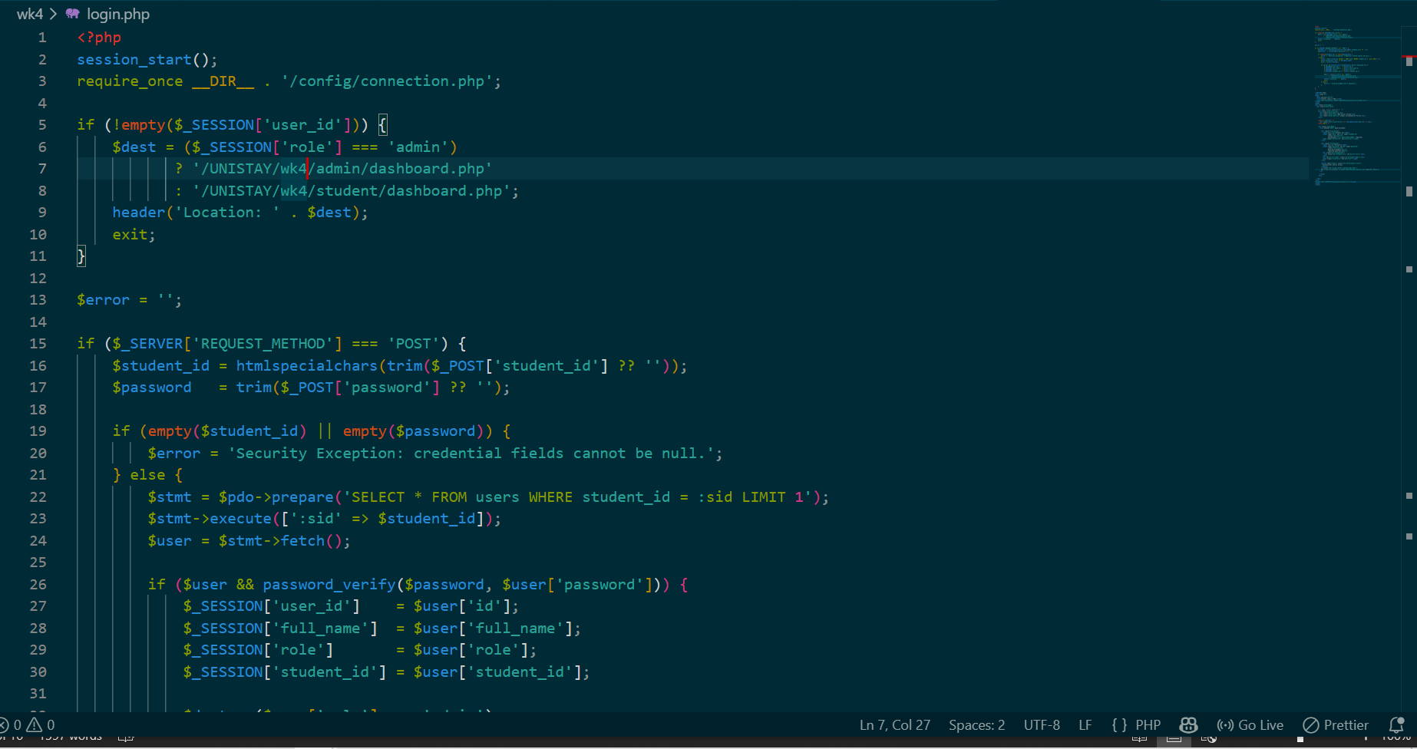
Figure 17:: login.php source code
Fig 3: Active login page rendered in the browser showing the Hostel Booking System gateway with room and password fields alongside the database connection status banner.

Figure 18:Active login page rendered
Fig 4: Successful redirect to the student dashboard after authentication , confirms that session tracking and the gatekeeper file are working correctly together.
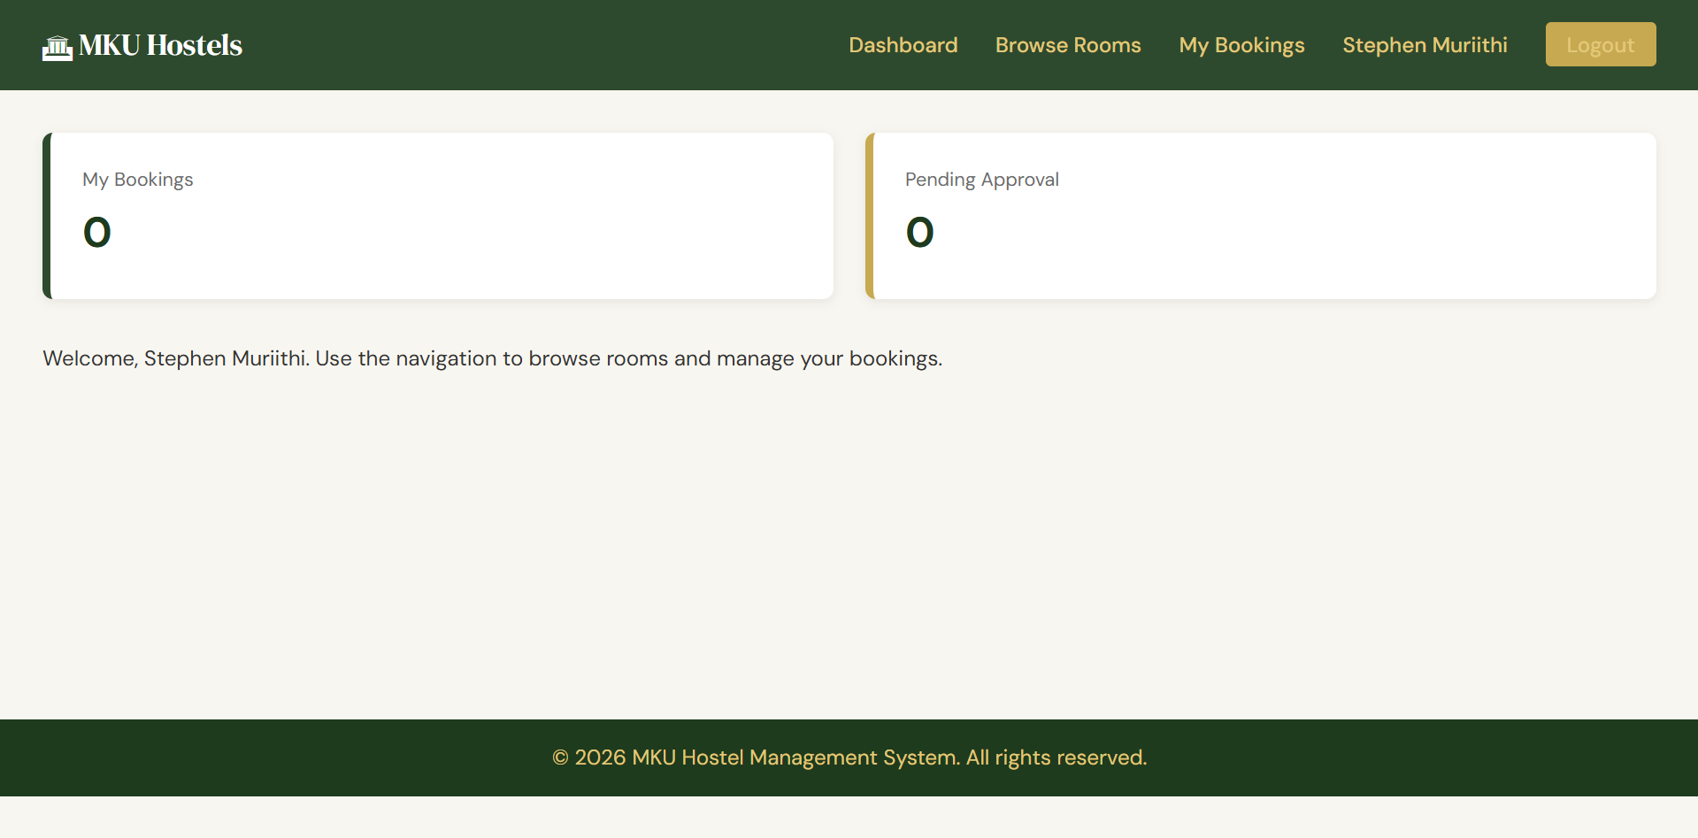
Figure 19:Successful redirect

Fig 5: Error state on the login page when incorrect credentials are entered , the PHP backend returns an error message without revealing whether the email or password was wrong.
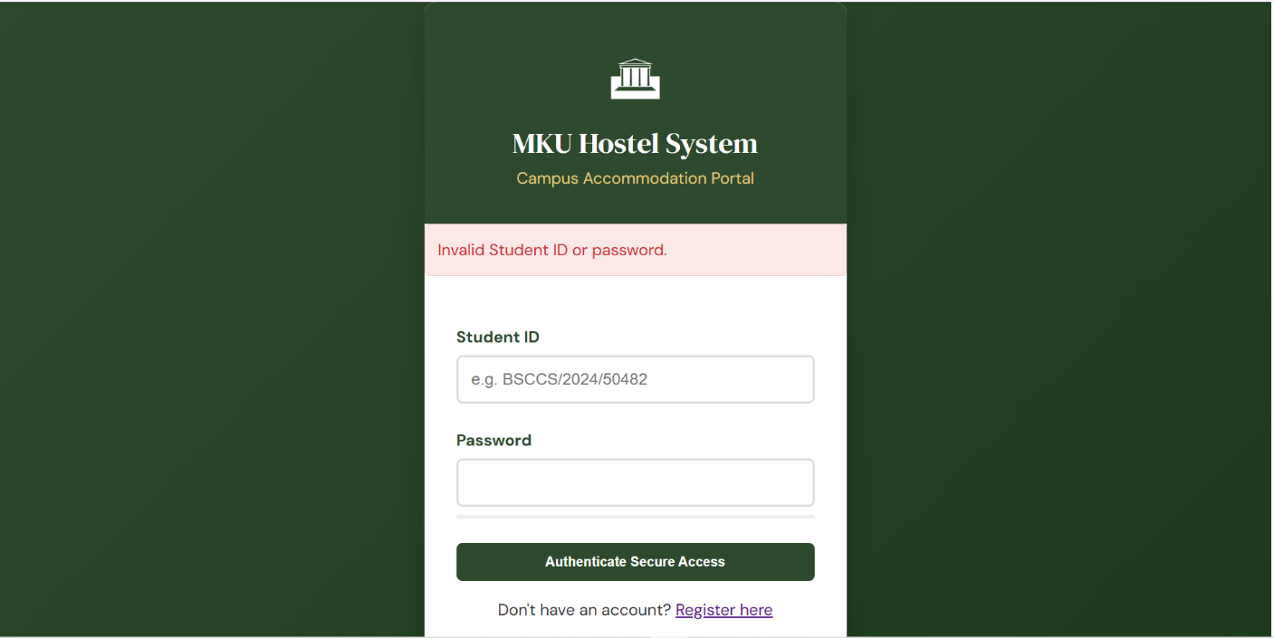
Figure 20:Error state
Student Reflection
The most significant learning from this week was recognising that authentication and authorisation are two separate concerns. Authentication confirms who the user is — the login form handles this. Authorisation controls what they can access , auth_check.php handles this by blocking direct URL access to protected pages. Without the gatekeeper file, any user could navigate directly to dashboard.php in their browser without ever logging in, completely bypassing the login system. I also practised using htmlspecialchars() on all POST inputs to neutralise potential cross-site scripting (XSS) characters before they are processed or displayed.
Week 5: Database Completion and CRUD System Integration
Database Components and Full CRUD Operations

Overview
This week completed the relational database schema by adding the bookings table with foreign keys linking it to both the students and rooms tables. Full CRUD mechanics were then implemented across the system: students can Create a booking, the dashboard Reads and displays all records, and the admin panel can Delete (cancel) a booking and automatically restore the room's availability status. A confirmation page was also built to show students a summary immediately after booking.
Evidence of Work
Fig 1: phpMyAdmin showing the bookings table with foreign key constraints to both rooms and students , confirms relational integrity is enforced at the database level.
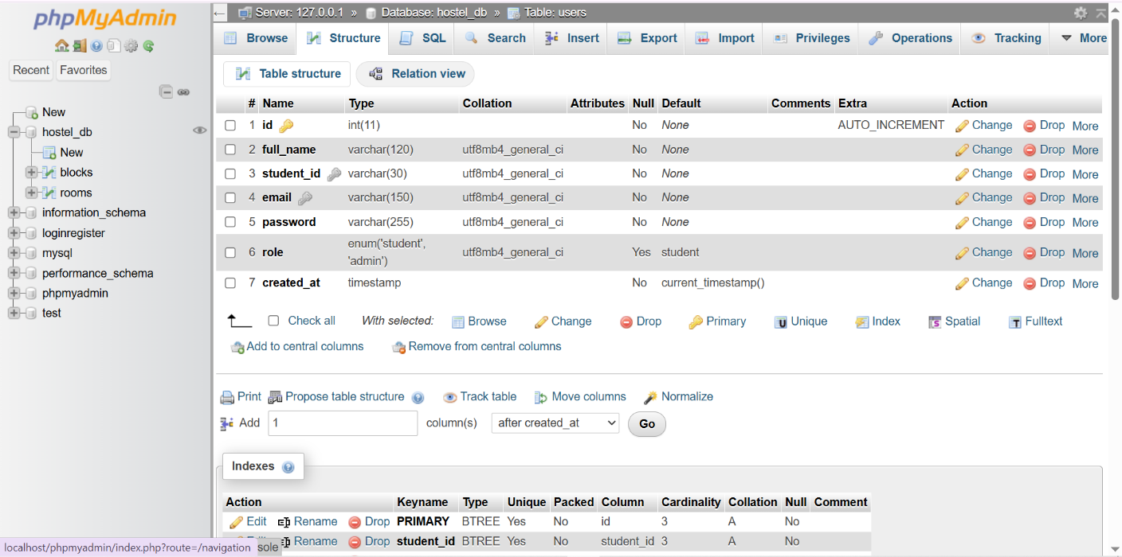
Figure 21: phpMyAdmin
Fig 2: The working booking form page in the browser , a student can select a room, choose dates, and submit to process_booking.php.

Figure 22:The working booking form
Fig 3: Booking confirmation page displaying booking reference, room number, check-in and check-out dates, and total fee r,endered after a successful INSERT.
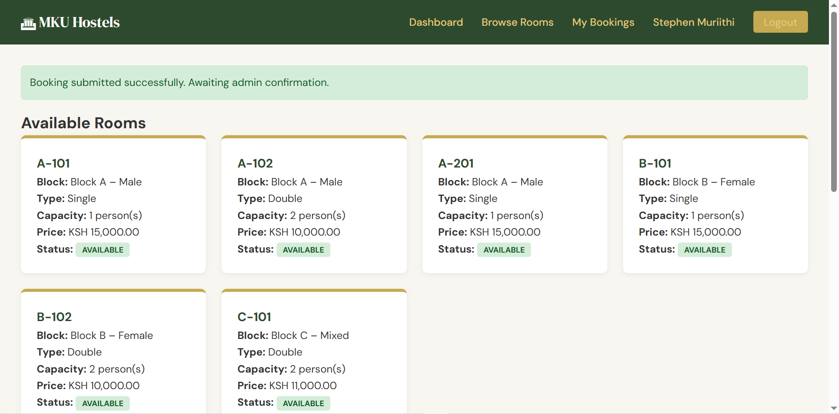
Figure 23: Booking Confirmation Page
Fig 4: Admin dashboard showing the live bookings table populated from the database, with student name, room number, dates, status, and a Cancel action link for each row.
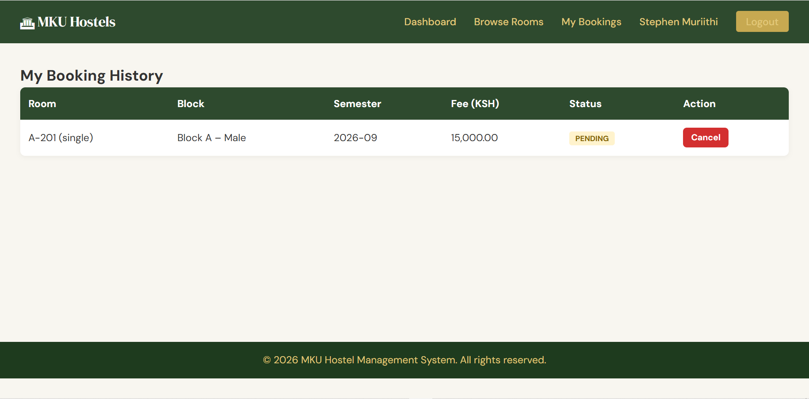
Figure 24: Live bookings check

Fig 5: phpMyAdmin showing the rooms table before and after a booking , the status column changes from 'available' to 'occupied' automatically when a booking is processed.
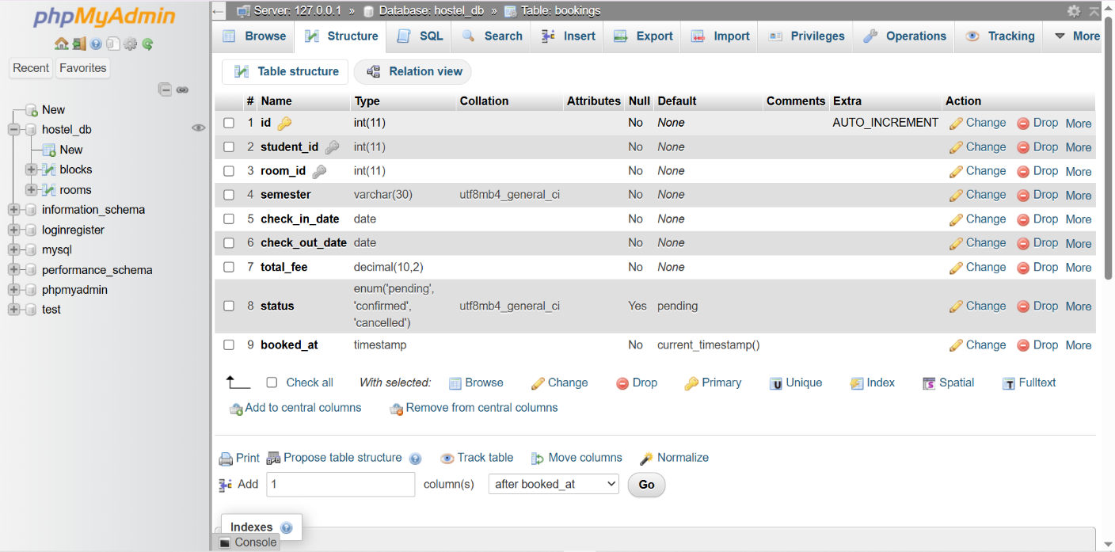
Figure 25: phpMyAdmin
Student Reflection
Implementing CRUD with real foreign key constraints revealed a problem I had not anticipated: when I first tried to insert a test booking, I received a SQLSTATE[23000] foreign key constraint violation because the room_id I used in the form did not exist in the rooms table. This taught me that the order of operations matters ,the database must contain valid rooms before any booking can reference them, and seed data must be inserted in the correct table order. Resolving this error deepened my understanding of referential integrity and why it exists: it prevents orphaned records that would break the application's data logic.

