**MORWELL CAMPUS**

***YEAR 7***

**The aim of the Year 7 program is to ensure a smooth transition from Primary School into Secondary School.  To assist this transition, Morwell Campus operates the majority of its Year 7 program from the Learning Centre.  All students meet at the centre in the morning for a combined form group where daily information is disseminated.**

**The Year 7 program is arranged to allow for a mix of individual class work and large group work.  Through our Team Time class, we address, and aim to build; resilience and emotional intelligence.  Students also complete the ‘Revved Up’ or ‘M Power’ programs.**

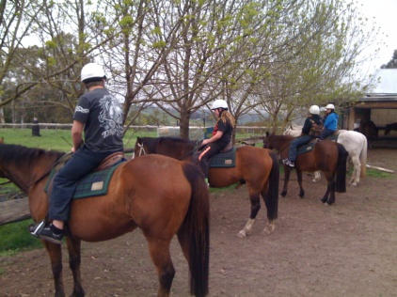 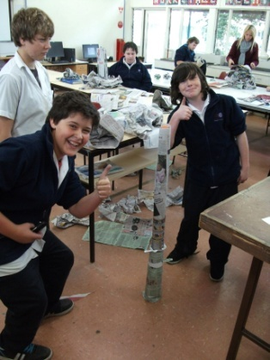 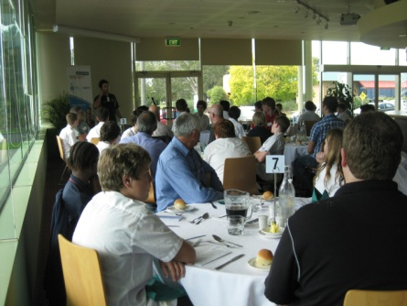

**2010 ACTIVITIES**

* **3 NIGHT CAMP AT CAMP COOLAMATONG**
* **ACMI EXHIBITION EXCURSIONS**
* **GIRLS GROUPS**
* **DEEP SEA PRESENTATION**
* **CHINESE ROADSHOW**
* **CIRCUS CHALLENGE**
* **MATHS ROADSHOW**
* **FUN RUN**