<https://www.tutorialspoint.com/execute_ksh_online.php>

# [KornShell - Set “-x” (debug) flag globally?](https://stackoverflow.com/questions/2273474/kornshell-set-x-debug-flag-globally)

<https://stackoverflow.com/questions/2273474/kornshell-set-x-debug-flag-globally>

<http://kornshell.com/doc/faq.html>

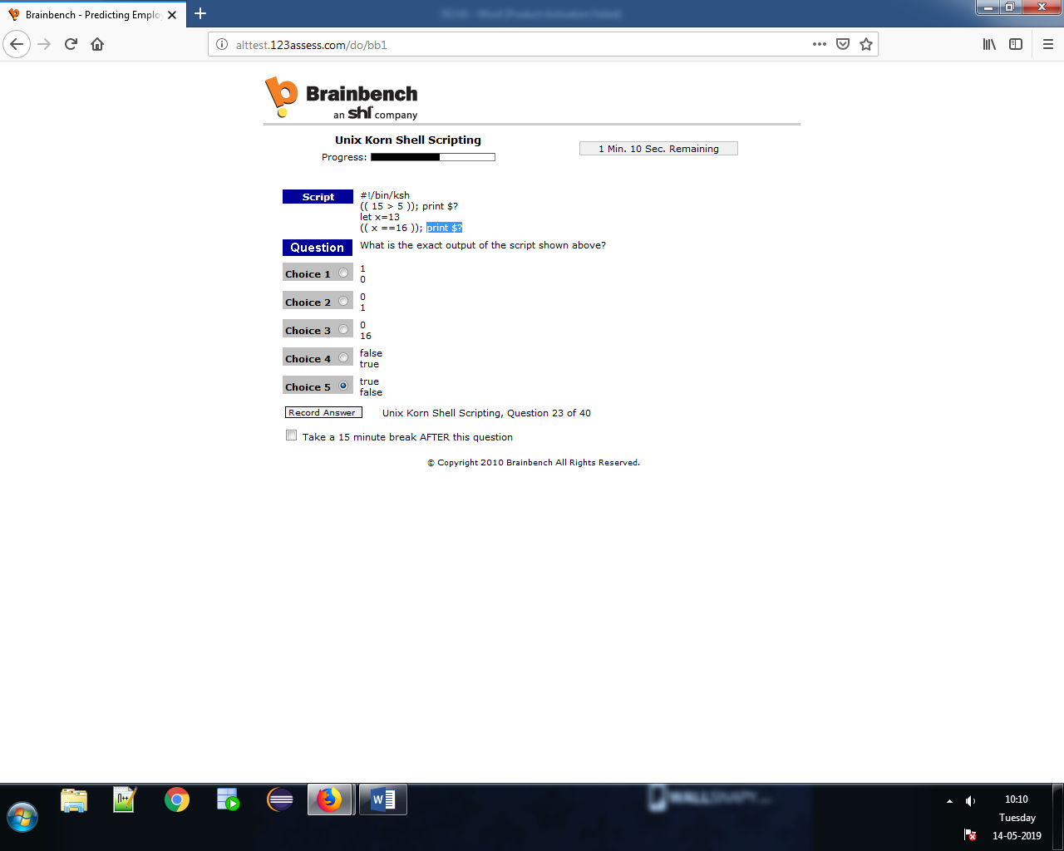

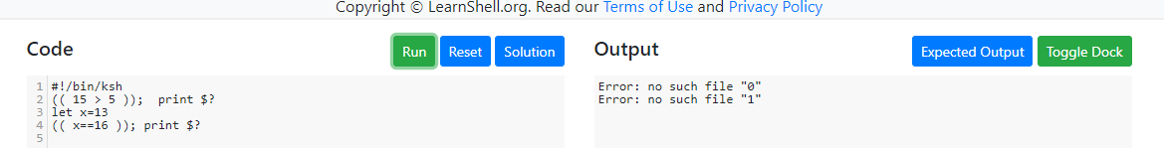

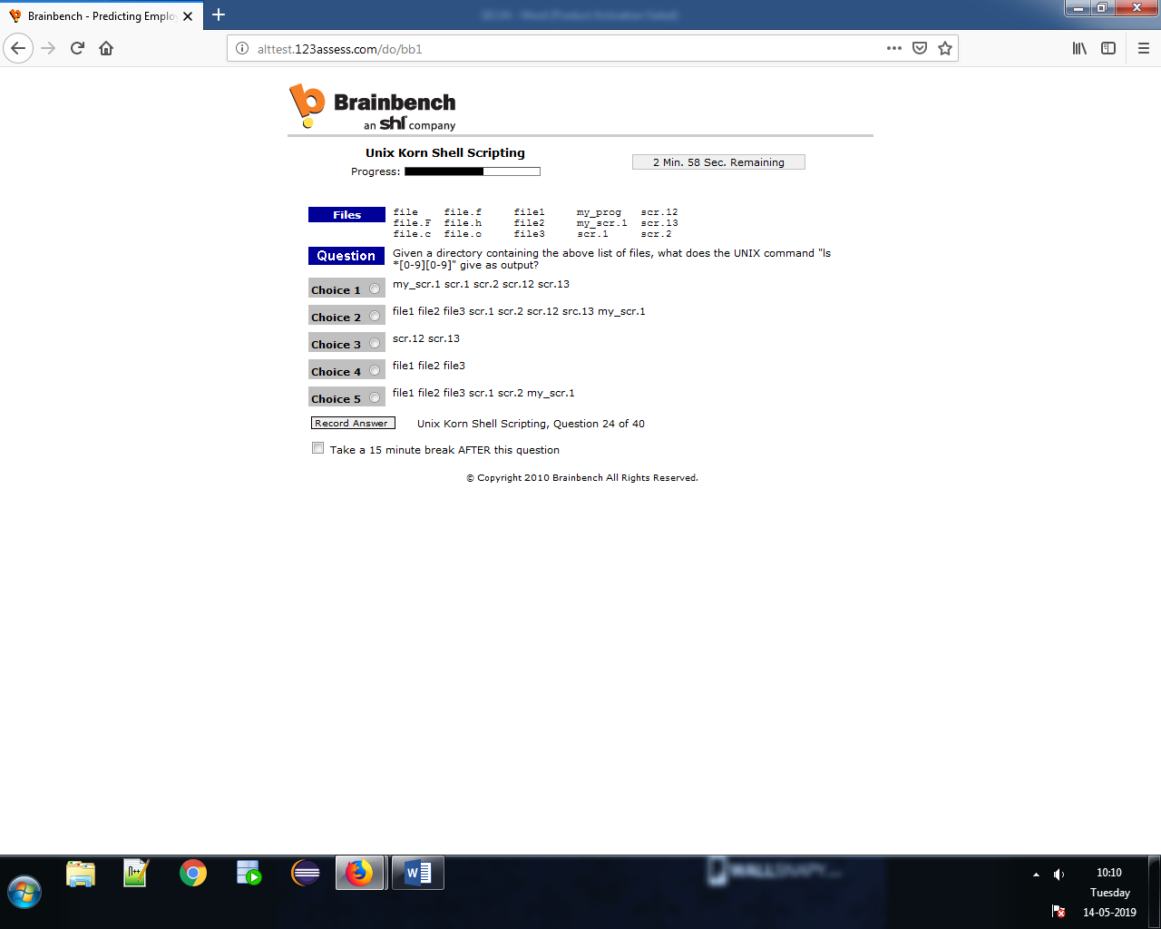

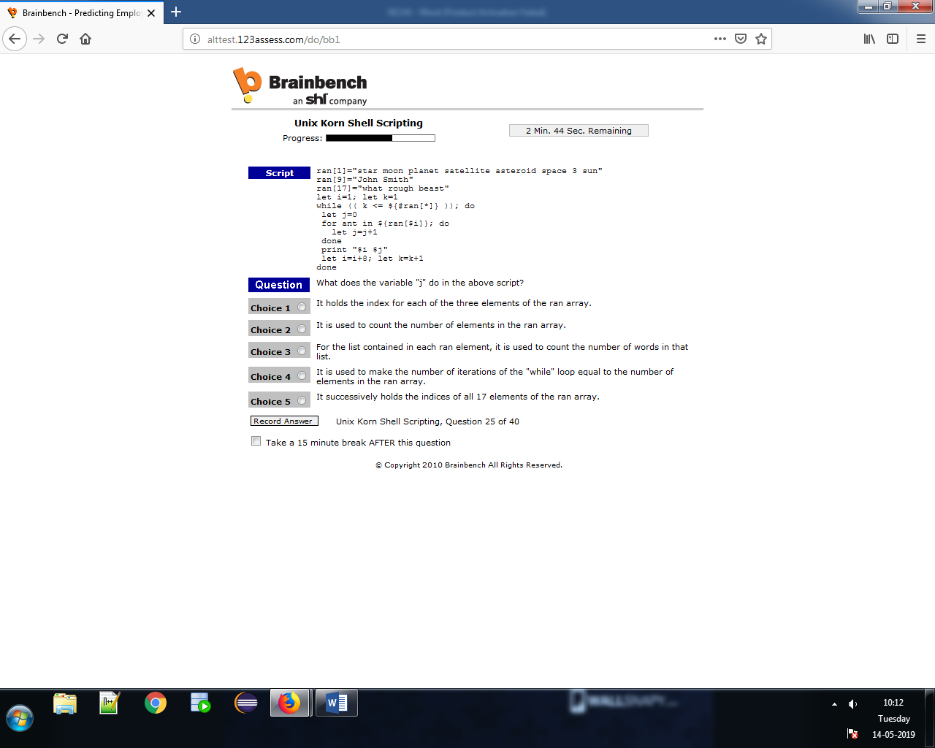

#!/bin/bash

ran[1]="star moon planet satellite asteroid space 3 sun"

ran[9]="John Smith"

ran[17]="what rough beast"

let i=l;let k=1

while (( k <= ${#ran[*]} )); do

let j=0

for ant in ${ran[$i]}; do

let j=j+1

print $j

done

print "$i $j"

let i=i+8; let k=k+1

done

**************santh*********  
#!/bin/ksh

ran[1]="star moon planet satellite asteroid space 3 sun"

ran[9]="John Smith"

ran[17]="what rough beast"

let i=1;let k=1

while (( k <= ${#ran[*]} )); do

let j=0

for ant in ${ran[$i]}; do

: '

let j=j+1

print $j

'

done

print "$i $j"

let i=i+8; let k=k+1

done

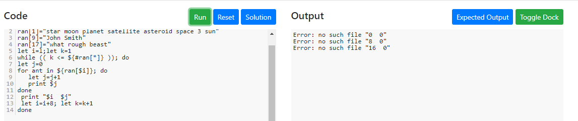

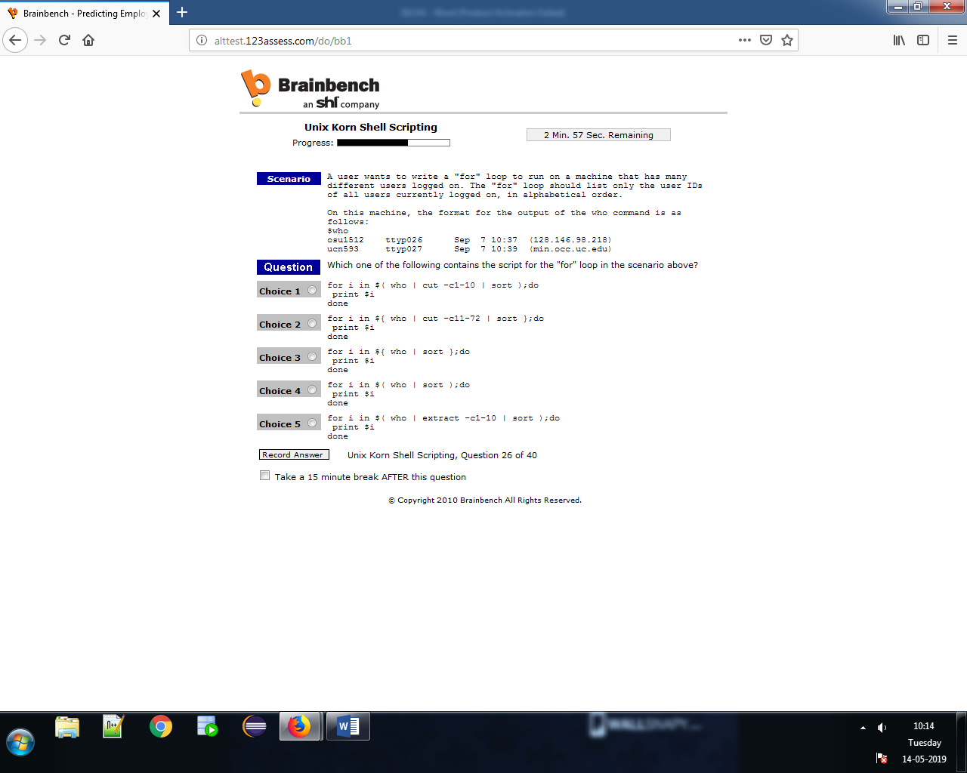

x='osu1512-ttyp026-sep7 10:37-128.146.98.218'

for i in $( echo $x | cut -c1-10 | sort); do

print $i

done

`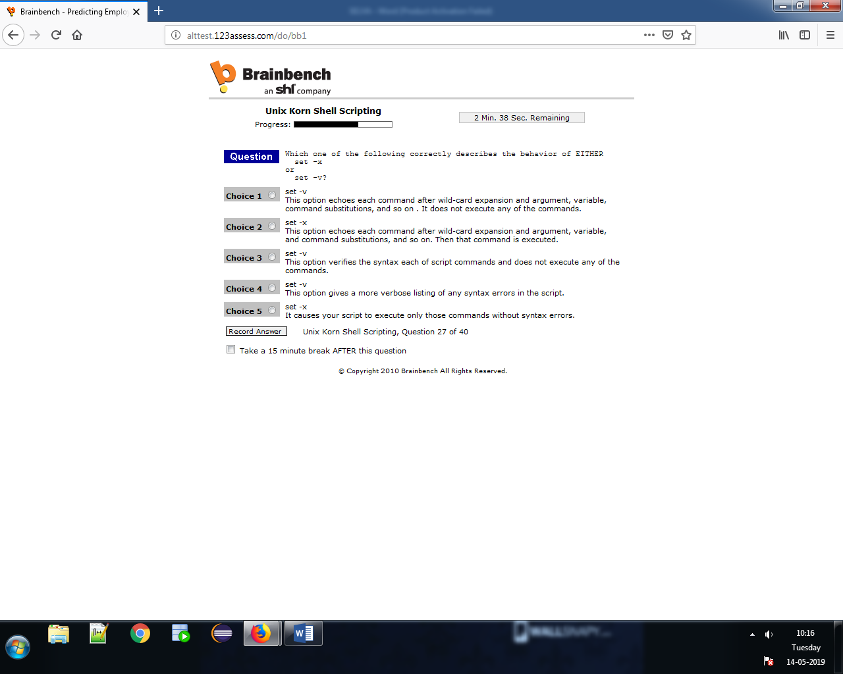

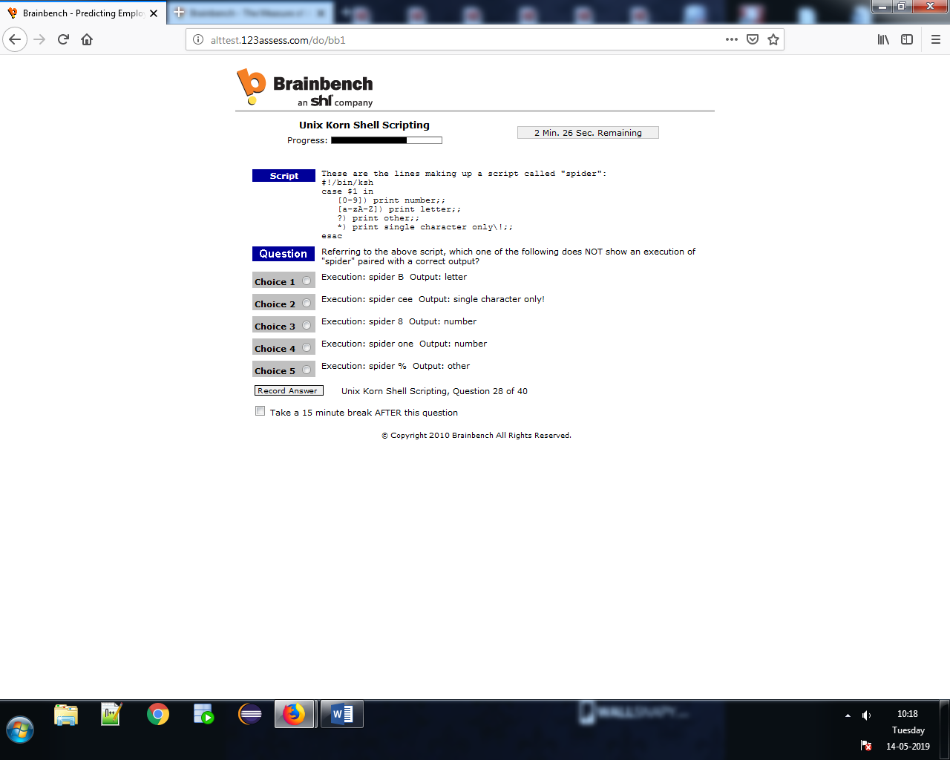

#!/bin/ksh

x=one

case $x in

[0-9]) print number;;

[a-zA-Z]) print letter;;

?) print other;;

*) print single character only\!;;

esac

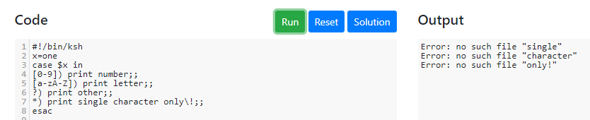

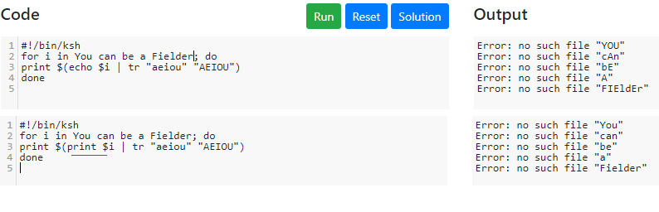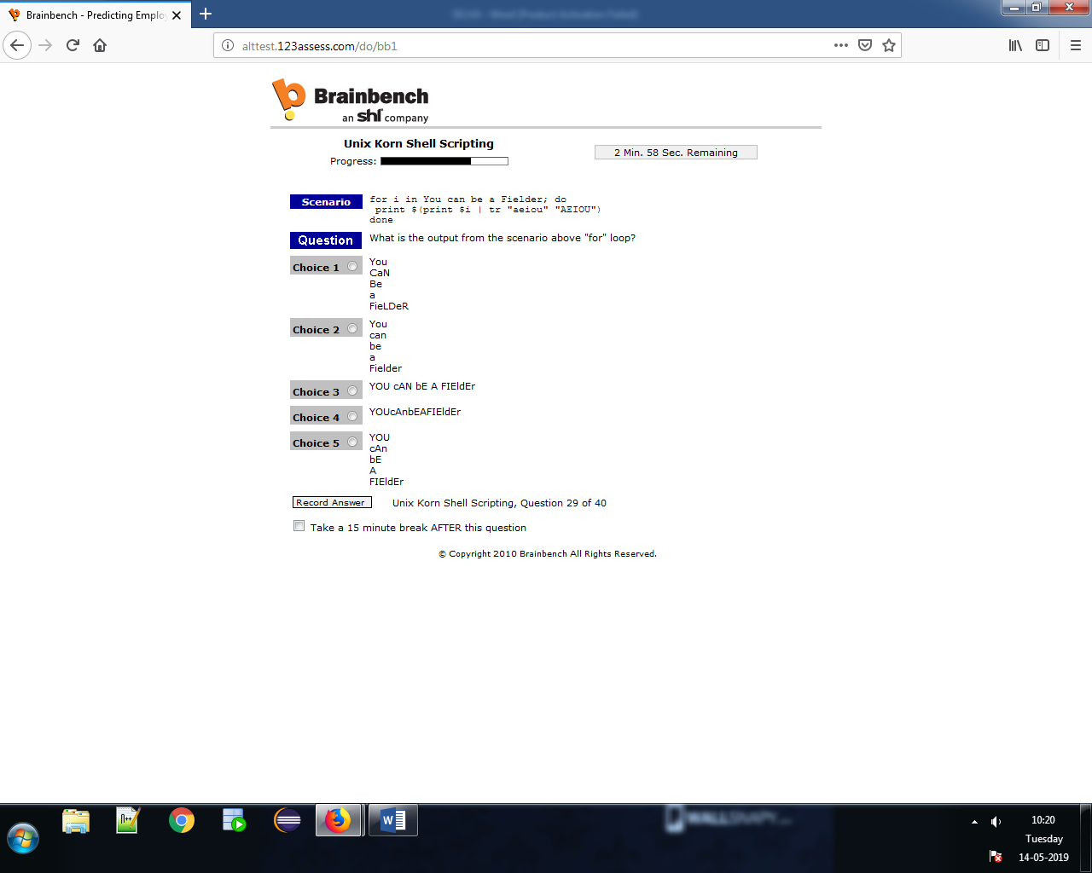

#!/bin/ksh

for i in You can be a Fielder; do

print $(print $i | tr "aeiou" "AEIOU")

done

#!/bin/ksh

for i in You can be a Fielder; do

print $(echo $i | tr "aeiou" "AEIOU")

done

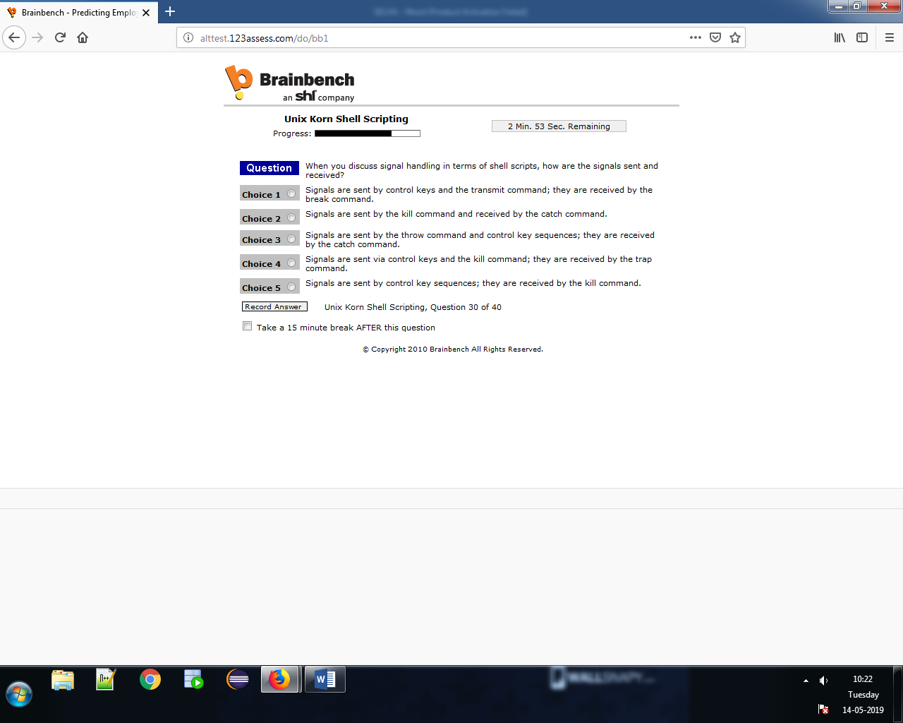

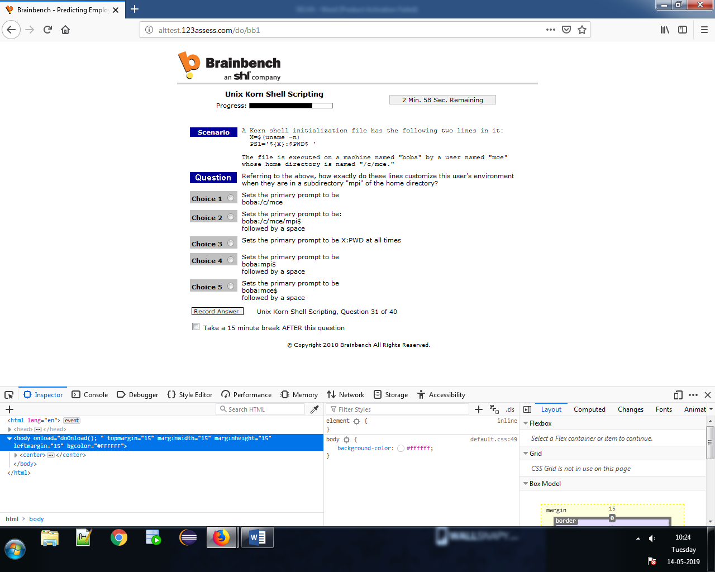

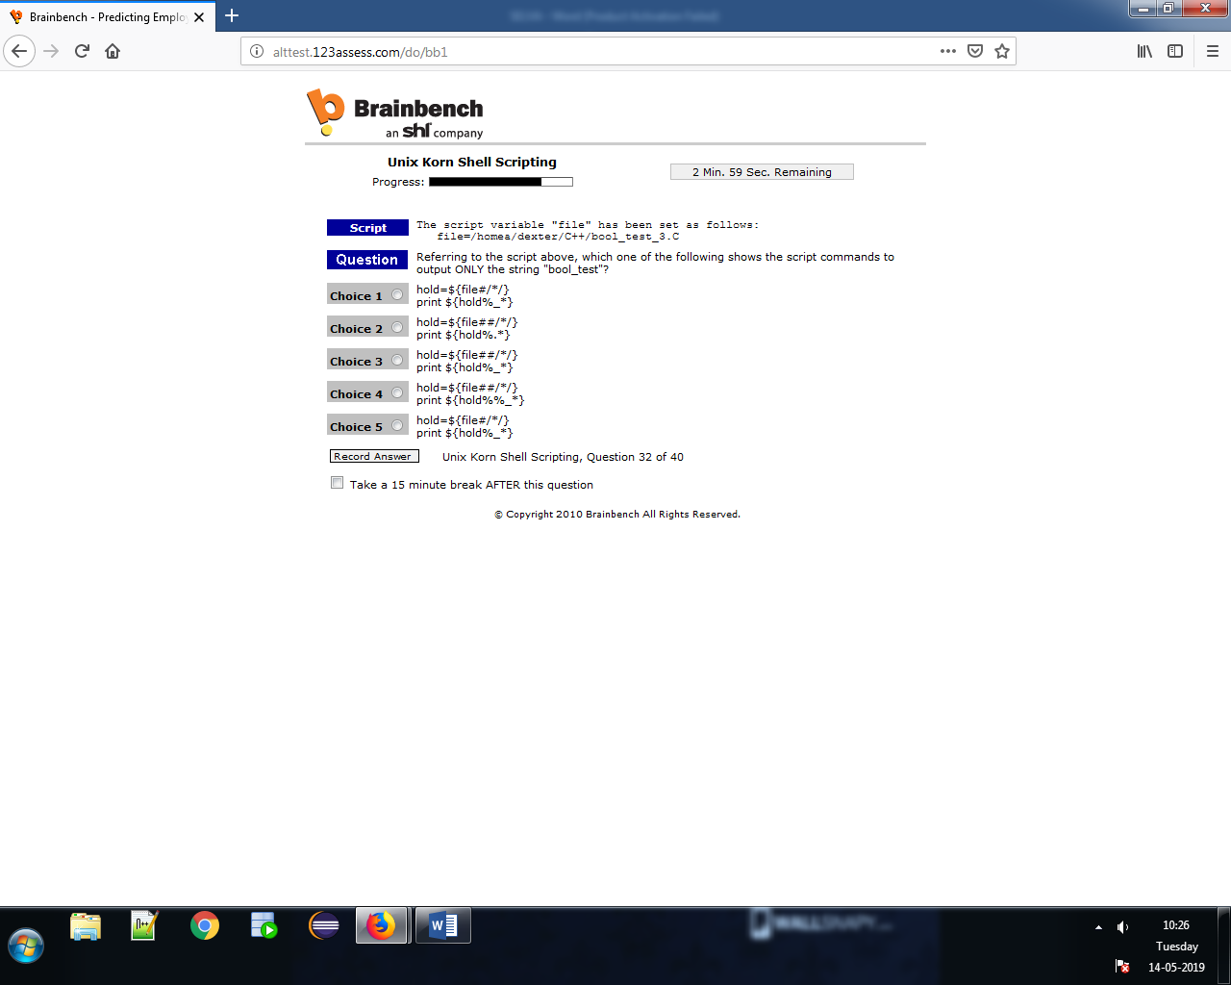

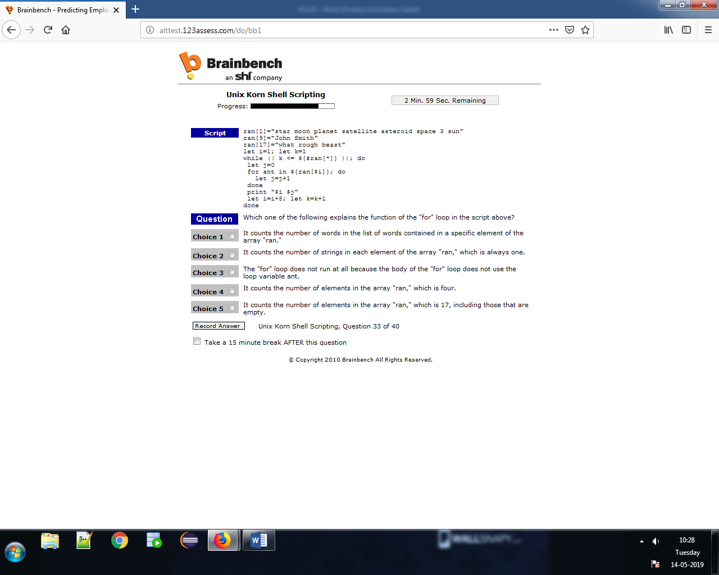

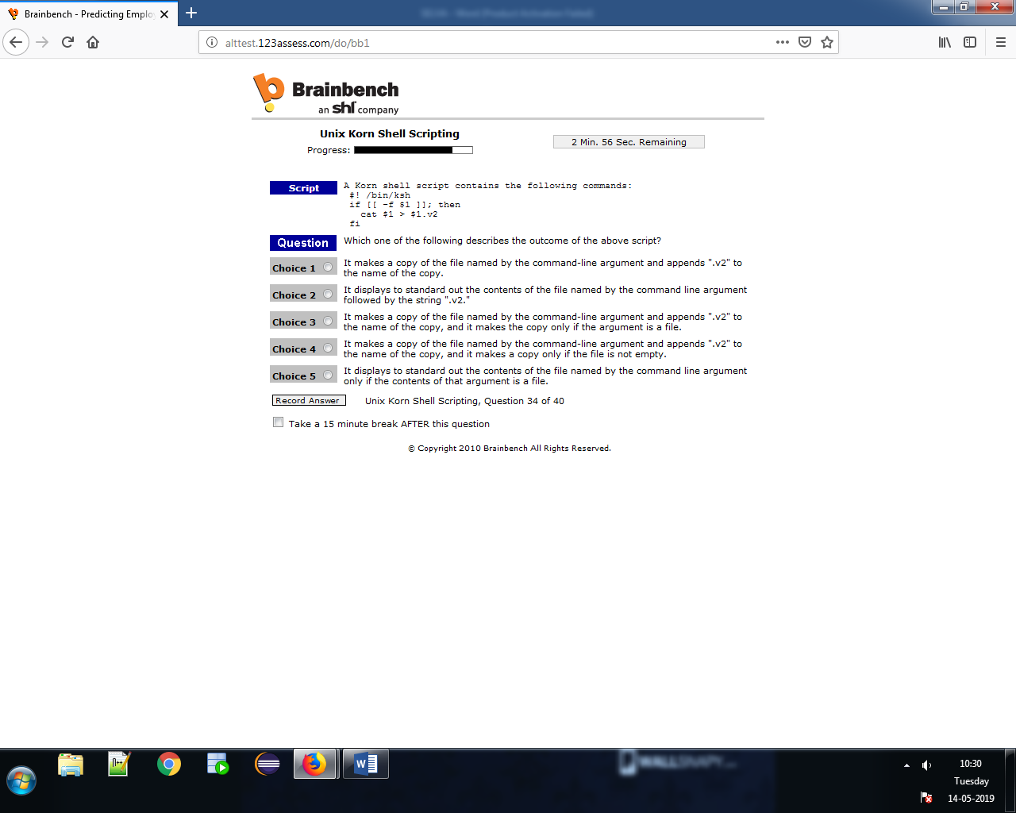

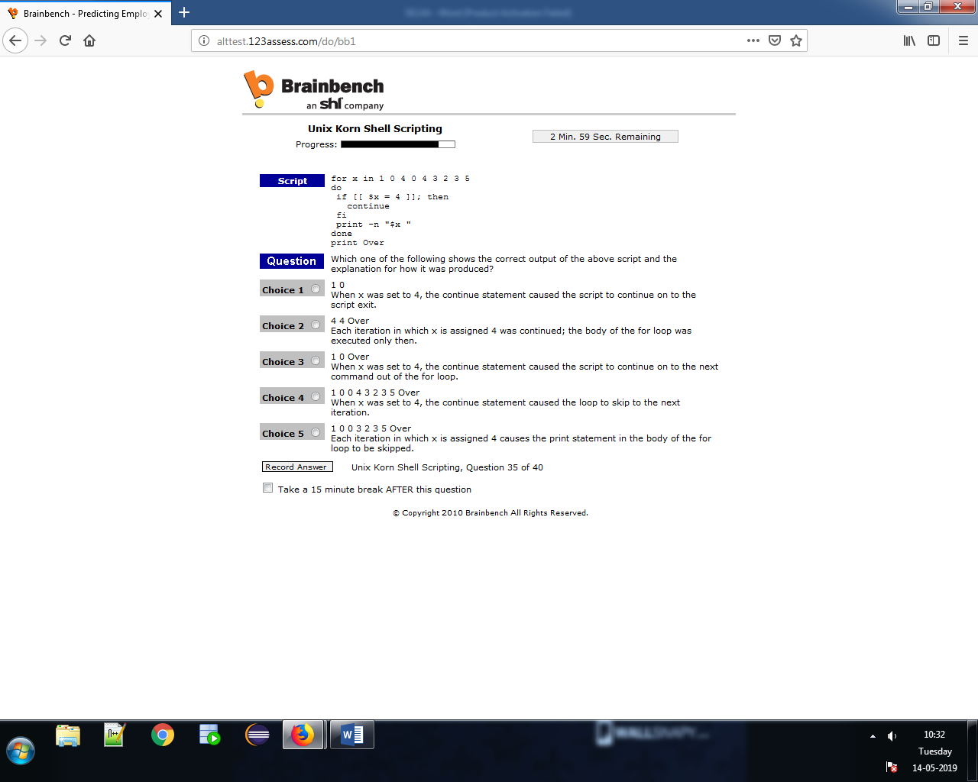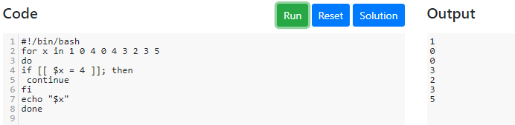

#!/bin/bash

for x in 1 0 4 0 4 3 2 3 5

do

if [[ $x = 4 ]]; then

continue

fi

echo "$x"

done

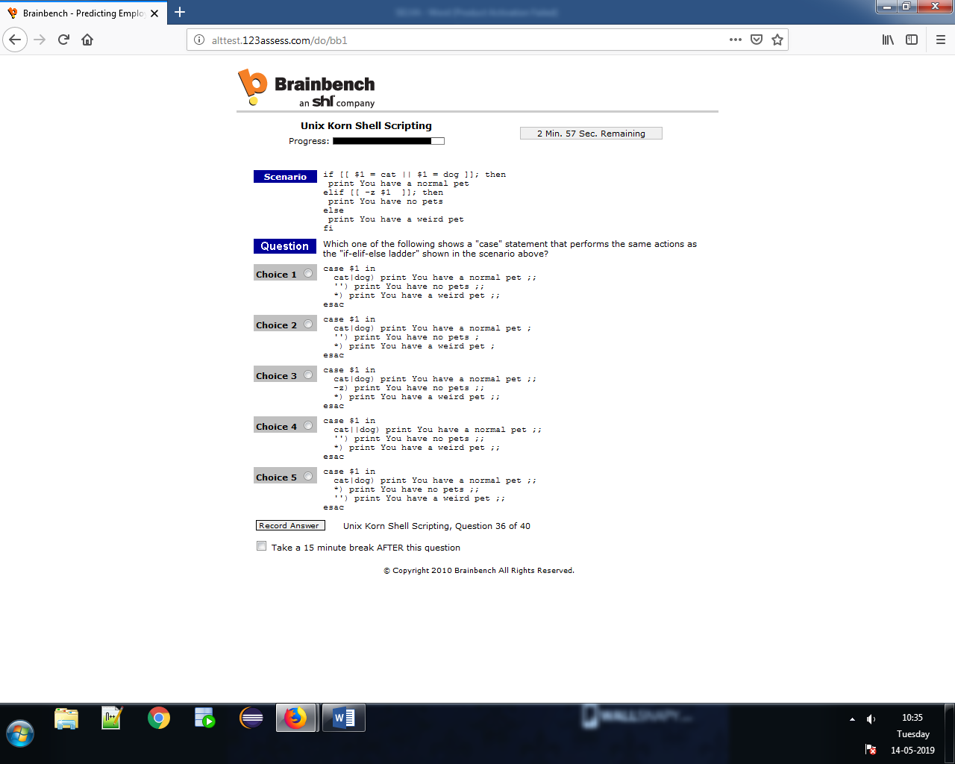

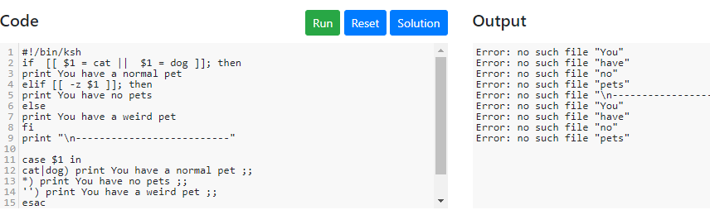

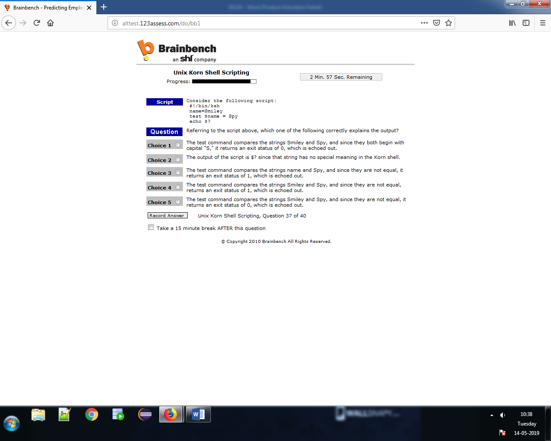  
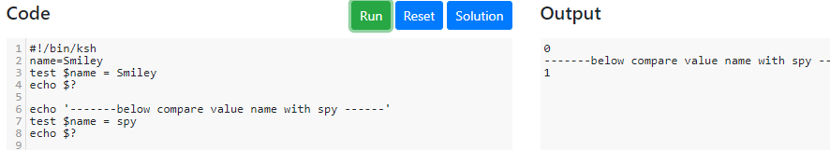

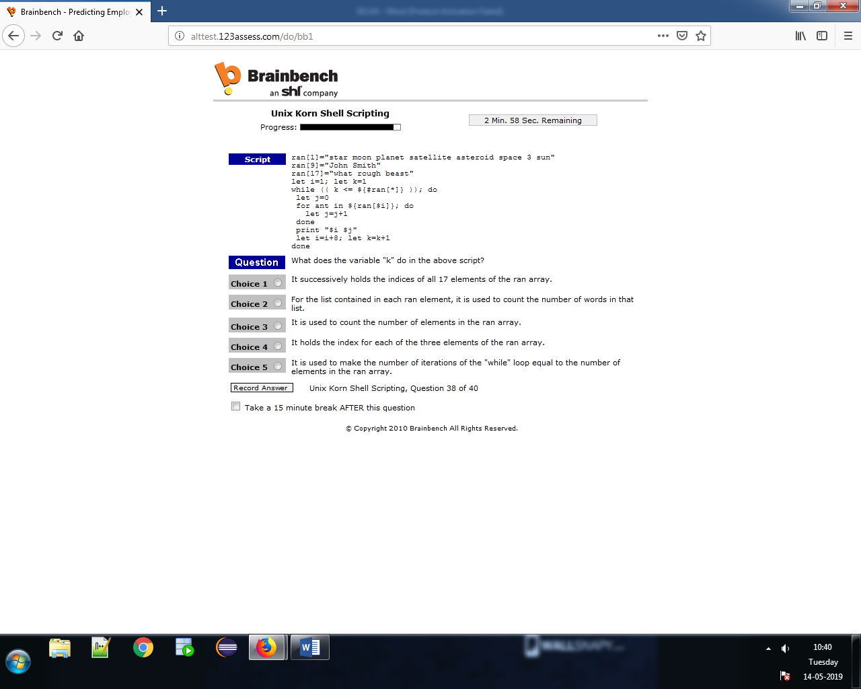

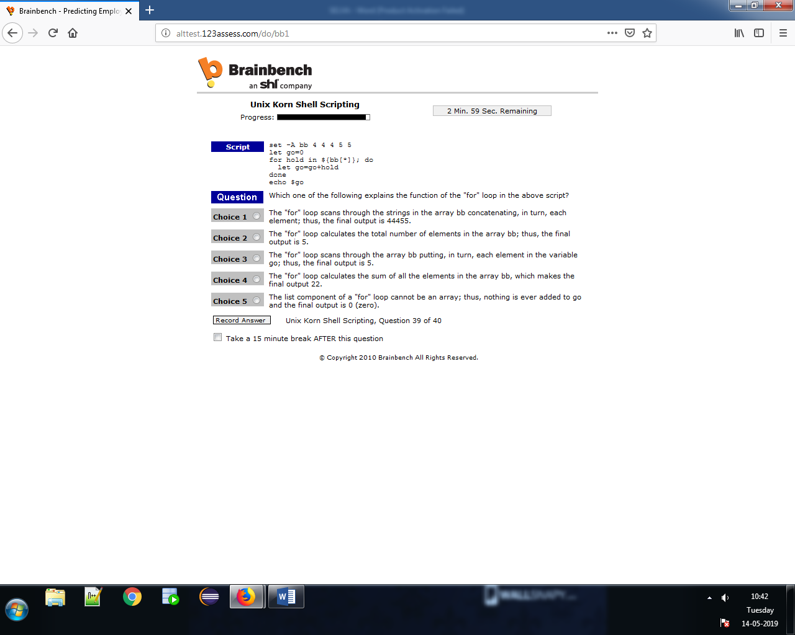

If you are using the ksh shell, here is the syntax of array initialization −

set -A array_name value1 value2 ... valuen

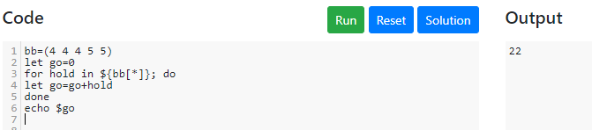

o/p foo

bar

my_array=(foo bar)

for i in "${my_array[@]}"; do echo "$i"; done

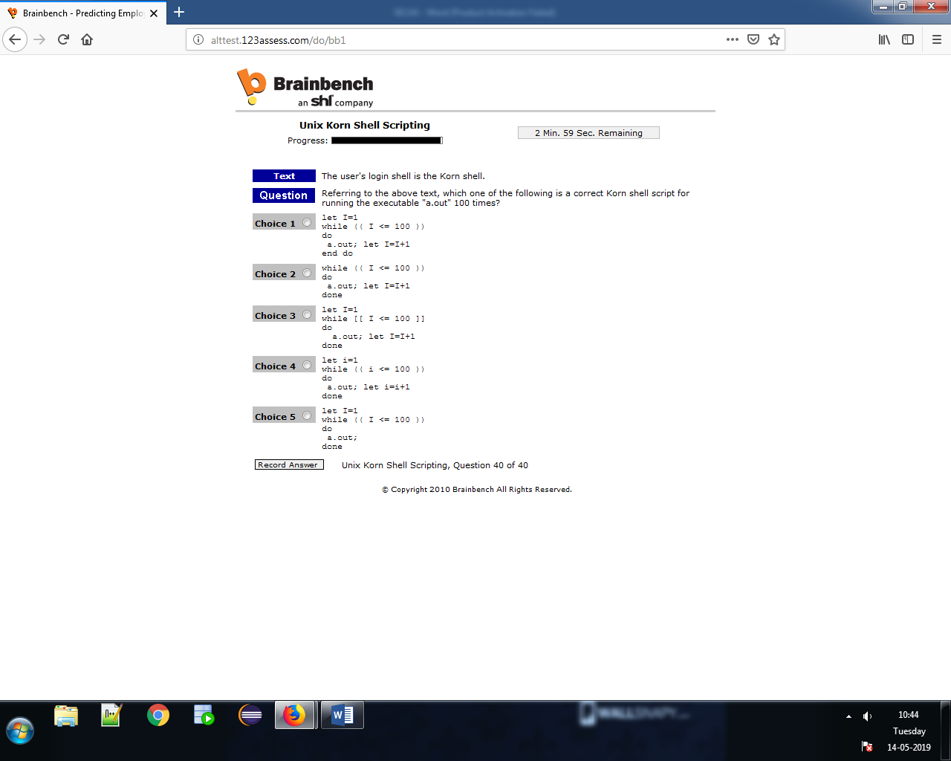

let i=1

while (( i <= 100 ))

do

a.out ; let i=i+1

done

#!/bin/ksh

(( 15>5 )); print $?

let x=13

(( x==16 )); print $?

X=$(uname -n)

PS1='${X}:$PWD$ '

let I=1

while (( I <= 100 ))

do

a.out

let I=I+1

done

let x=2+3 y=4+5

print $((x)) $((y))

print $((x*y)) \ $(($x*$y))

x=2+3 y=4+5

print $((x)) $((y))

print $((x*y)) \ $(($x*$y))

#!/bin/ksh

name=Smiley

test $name = Spy

echo $name

print $?