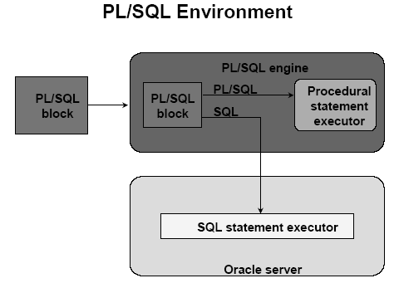

PL/SQL

Procedural Extension to SQL

Benefits of PL/SQL

- PL/SQL Block structure
  - Contain many blocks.
  - Blocks are nested within one another.
  - Blocks are PL/SQL program units like Procedures, Functions, Anonymous block.

- Modularity
  - Breaking down complex problem into set of manageable well defined logical modules.
  - Create reusable code in PL/SQL libraries which is shared between forms and reports

- Portability
U can run your program in any environment that supports Oracle Server.

- Identifiers
In PL/SQL we can use these identifiers to do the following
  - declare variables, cursors, constants, exceptions etc.,
  - declare variables of type scalar, reference, composite and LOB
  - declare variables dynamically(runtime)
- Procedural Language control structure
  - Execute a sequence of statements conditionally.
  - execute a sequence of statements iteratively
  - process multirow-query using cursors

- Errors.
Exception handlings are used to process errors.

PL/SQL Block Structure

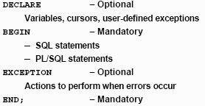

There are two types of blocks
- Ananonyms Block(un named block)
- Named block (functions , procedures)

Variables

Variables are used for temporary storage of data.

How to handle variables in PL/SQL
- Declare ane initialize variables in the declaration section
- Assign new values to variables in the executable section
- Pass values into PL/SQL blocks through parameters
- View results through output variables.

Types of variables:
- pl/sql variables
  - Scalar – all datatypes see in sql are scalar
  - Composite – composite has internal components,collection of different types of data. (table , record type)
  - Reference
  - LOB

- Non pl/sql variable → Bind and Host variables

Declare the variable – syntax

Identifier [constant ] datatype [not null]
[ := | default expr];

Examples :

Declare
V_hiredate date;
V_deptno number(2) not null := 10;
V_location varchar2(25) := ‘Atlanta’;
C_comm constant number := 1100;

Bind Variables

Bind variables are used to pass values in and out of sql and pl/sql during runtime.

How to declare

Variable <variable-name> datatype;

Print variable-name;

Example:

Sql> variable a number;

In plsql

Begin
Select (salary * 12) + nvl (comm.,0) into :a from emp where empno = 7394;
End;

Sql> print a

DBMS_OUTPUT.PUT_LINE() package is used to display the message or value as output .
For this we have set in sql prompt
Sql> set serveroutput on;

How to run the program :

  - Each statement should end with a semicolon.
  - / is used to run the program
  - Save the file in bin folder with .sql extension and give @filename.sql in sql prompt.

Condition of using select statements in pl/sql

- Select statement used in the pl/sql should return only one row.
- We cannot directly use the columns of table in select , for that we have to select the columns into some other variable and we have to use that variable.

Scope of VARIABLEs in the pl/sql

- There can be nested blocks also .
- A variable declared in that block becomes local to that block.
- We can also use the other blocks variables by
<outer>.variable-name;

Example:

<<outer>>
declare
a number(3) := 10;
b number(3) := 20;
begin
declare
a number(3) := 101;
b number(3) := 102;
begin
dbms_output.put_line('The value of a in inner block is = '||a);
dbms_output.put_line('The value of a in outer block is = '||outer.a);
end;
end;

How to write simple programs:

Example – 1:

Declare
Eno number(3);
Ename varchar2(25);
Dno number(3);
Sal number(8,2);
Begin
Eno := &eno;
Ename := ‘&ename’;
Dno := &dno;
Sal := &sal;
Dbms_output.put_line(‘ Employee details ‘);
Dbms_output.put_line(‘ ============ ‘);
Dbms_output.put_line(‘Employee Number : ‘ ||Eno);
Dbms_output.put_line(‘Employee Number : ‘ ||Ename);
Dbms_output.put_line(‘Employee Number : ‘ ||dno);
Dbms_output.put_line(‘Employee Number : ‘ ||sal);
End;

Example – 2 :

Declare
sno stu_mas.stno%type;
stu_rec stu_mas%rowtype;
Begin
sno := &sno;
Select * into stu_rec from stu_mas where stno = sno;
Dbms_output.put_line(' Student details ');
Dbms_output.put_line(' ============ ');
Dbms_output.put_line('Student Number : ' ||stu_rec.stno);
Dbms_output.put_line('Student Name : ' ||stu_rec.stname);
Dbms_output.put_line('Student Address : ' ||stu_rec.address);
End;

