Note1:

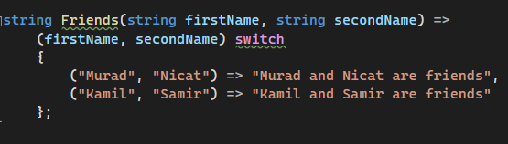

**Unity esas funksiyalar:**

Awake

OnEnable

Start

FixedUpdate

Update

LateUpdate

OnDisable

**Cotuine’den istifade:**

1. Basladarken StartCoroutine(Test());
2. Dayandararken StopCoroutine(Test());

