Text Processing
Motivation: Creating an AI which will post fun fake news in the telegram channel
Text Sources: Azerbaijani news telegram channels (SputnikAz, APA, DIM)
In order to collect the data I exported telegram chat history of the news and used a simple script for taking text out of JSON file exported (text_from_json_tg.py).
Then I used simple tokenization using regexes for deleting URLs and considering special cases for periods, comas, hyphens. The problem with this methods is that it will not takes words as “San Francisco” as a whole or will not see the unusual punctuation symbols.
Afterwards I checked the Heaps Law on my dataset and have got coefficients k = 0.0009 and b = 1.8585 and checked it with 70% of the dataset which gave quite an accurate result:
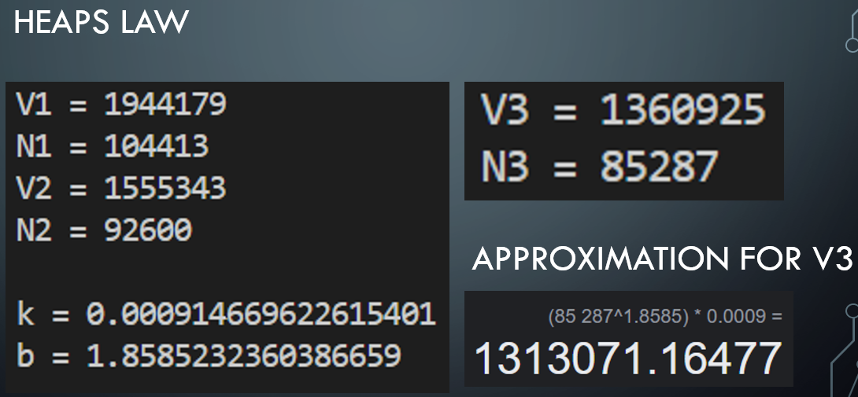
Then I used the Byte Pair Encoding which helped considering the words that are separated by a space. One of the examples from my corpus was name and surname “Ilham Aliyev” (bpe.py).
Talking about sentence segmentation algorithm, I couldn’t yet come up with a good idea and have written small regex for it (sentence_tokenizer.py).
For spelling checking I implemented Levenstein distance function and checked the given word with all the types in my dataset. (spelling_checker.py).
Then I created the confusion matrix and implemented the Weighted Levenstein distance algorithm and got better results with it (weight_spelling_checker.py).
Confusion matrix:
