step 1

after downloading a kernel extract it and then go inside the linux folder

create a new folder and name it hello (since we are making a hello world system call)

then go inside that folder

step 2

open the terminal in folder and make a c code file by typing gedit hello.c

and type the following code

#include <linux/kernel.h>

asmlinkage long sys_hello(void)

{

printk("Hello world\n");

return 0;

}

step 3

now create a makefile by typing makefile and put obj-y:=hello.o

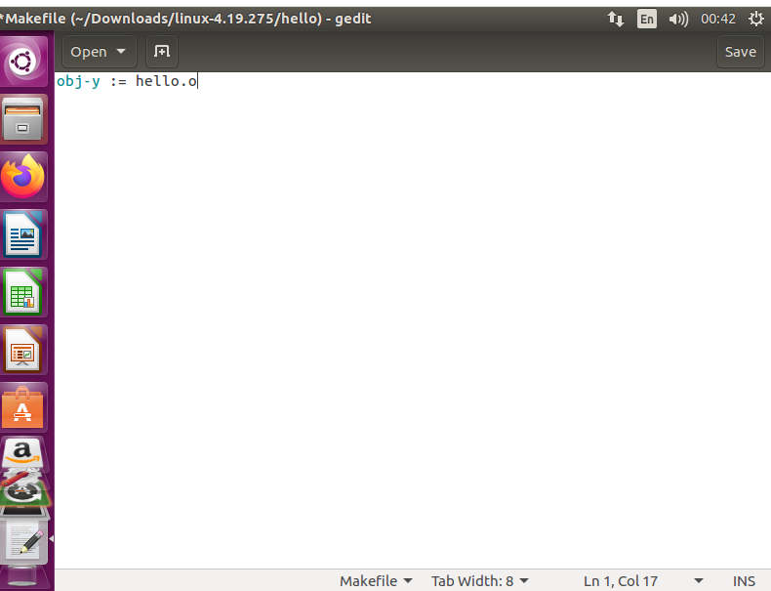

step4

go into the directory in /arch/x86/entry/syscalls/syscall_64.tbl.

and edit a system call

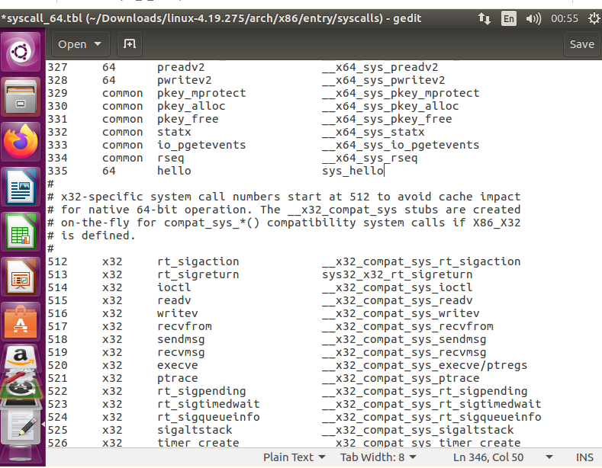

step5

type gedit include/linux/syscalls.h and paste the prototype of function hello in end of file

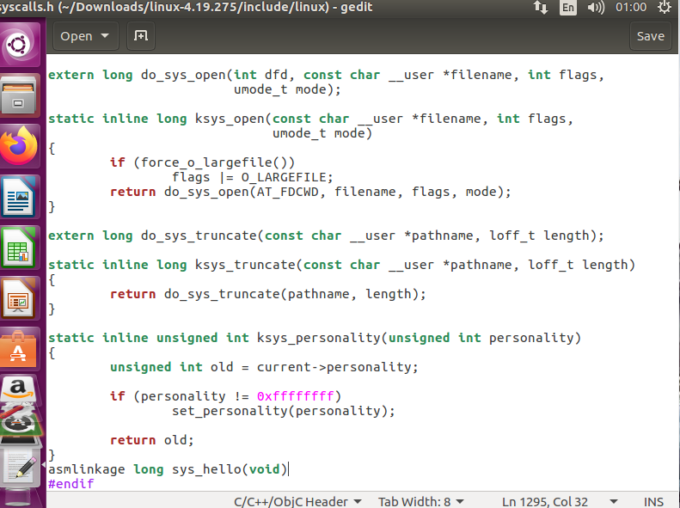

step6

changing version and editing hello system call type make file and edit extraversion=-213064

and edit hello/ after core-y

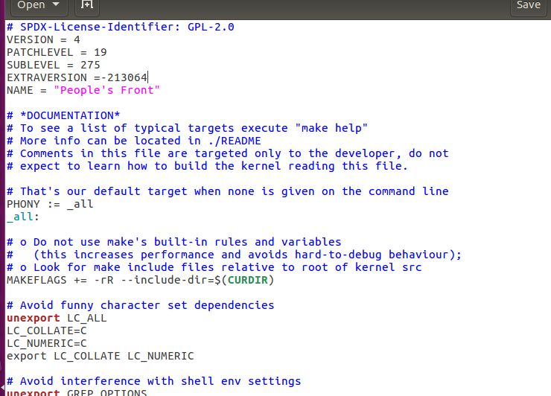

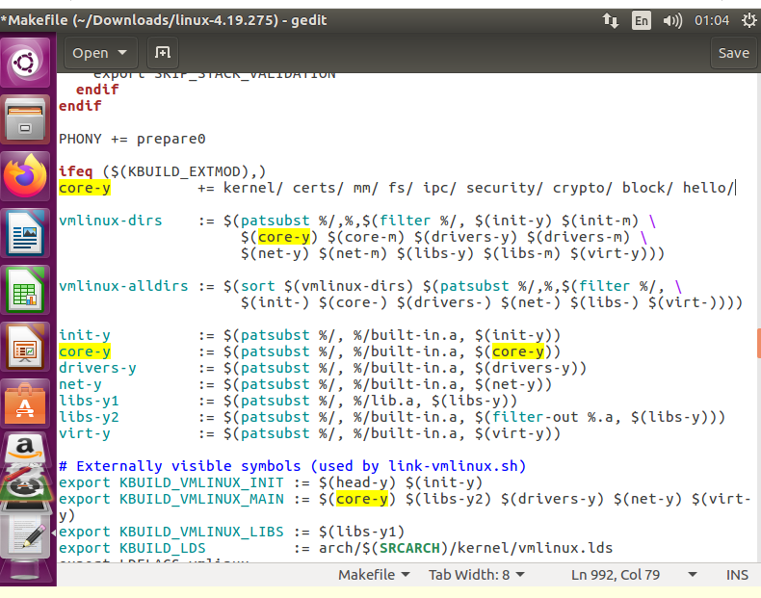

step7

type ls /boot |grep config

copy the config of current kernel into new one

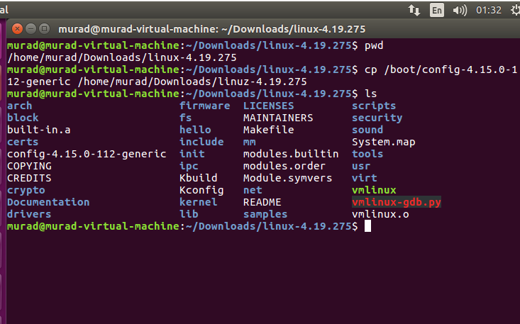

step 8

clean kernel by typing make clean -j2 and then type make -j2

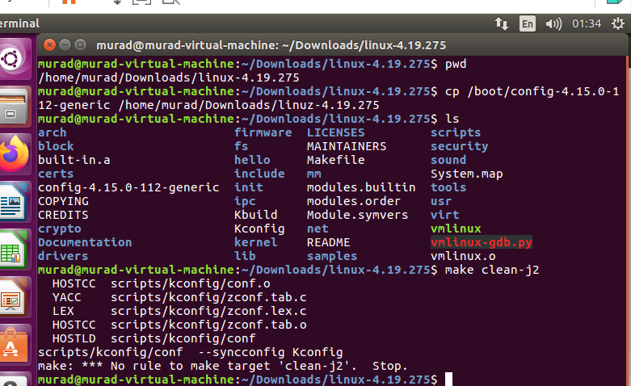

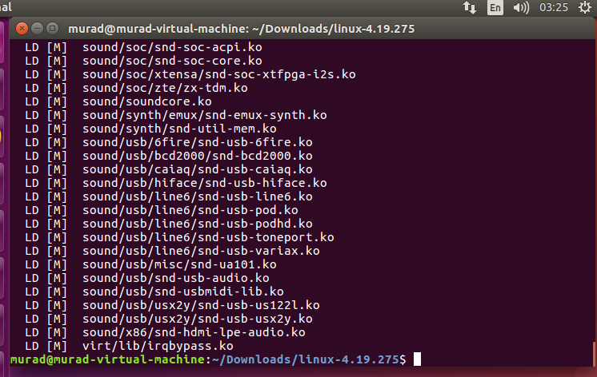

step 9

now we have to install kernel

type sudo make modules_install install

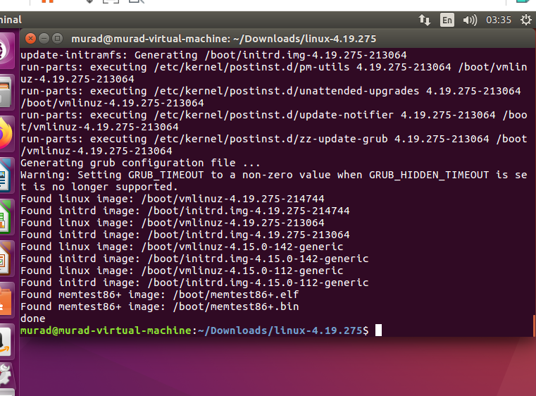

now restart by shutdown -r

step 10

enter uname -r in terminal

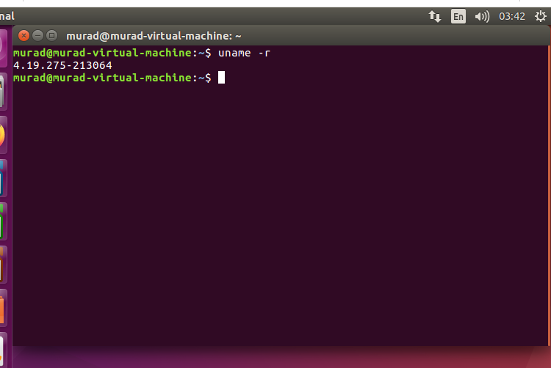

step 11

make a userspace file and type the following code in screenshot

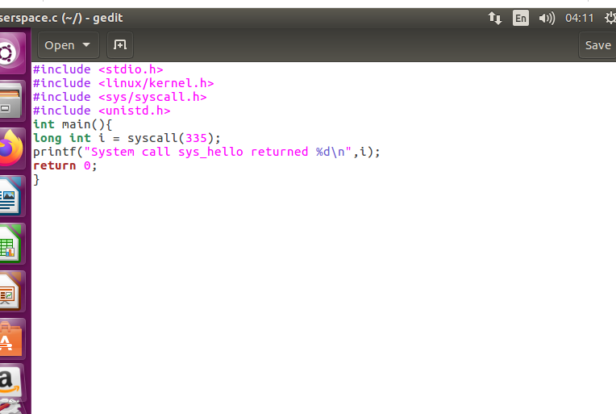

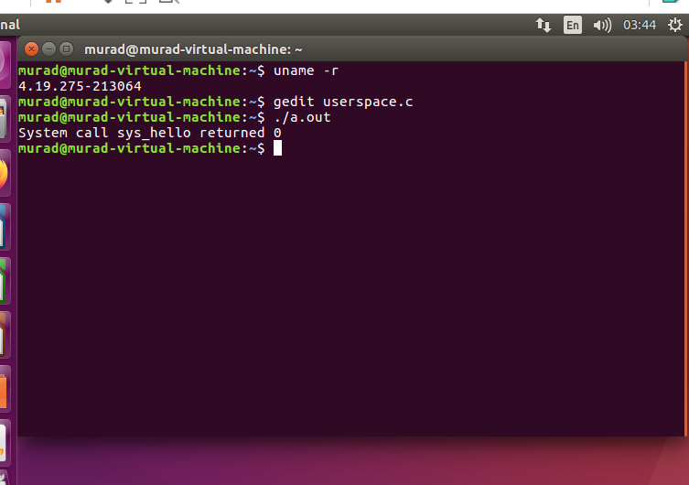

and here it is our hello world in the last screenshot after running dmesg command

