**OOP LAB 5 ASSIGNMENT SUBMISSION**

**Teacher: Ms. Abeer Gauher**

**NAME : Muhammad Murad**

**Roll no: 21k-3064**

**Section: BAI-2B**

**Question 1:**

package com.company;  
  
import java.util.Scanner;  
  
class Student{  
 String name;  
 int roll_no;  
 static String *uni_name*;  
 static int *counter* = 0;  
 static int setRoll_number()  
 {  
 *counter*++;  
 return *counter*;  
 }  
 Student(String name)  
 {  
 this.name = name;  
 }  
 public String getName()  
 {  
 return name;  
 }  
 public void setRoll_no( ) {  
 roll_no = *setRoll_number*();  
 }  
  
 public static void setUni_name(String uni_name) {  
 Student.*uni_name* = uni_name;  
 }  
  
 public int getRoll_no() {  
 return roll_no;  
 }  
  
 public static String getUni_name() {  
 return *uni_name*;  
 }  
 public void display()  
 {  
 System.*out*.print(getName() + "\t\t" + getRoll_no() + "\t\t" + *getUni_name*());  
  
 }  
}  
  
public class OOPLAB5_Q1 {  
 public static void main(String[] args) {  
 Scanner data = new Scanner(System.*in*);  
 Student[] obj = new Student[3];  
 for ( int i = 0; i < obj.length; i++ )  
 {  
 System.*out*.println("enter student name ");  
 obj[i] = new Student(data.nextLine());  
 obj[i].setRoll_no();  
 Student.*setUni_name*("FAST UNIVERSITY");  
 }  
 System.*out*.println(" Name \t Roll_no \t University ");  
 for(int i = 0; i < obj.length; i++)  
 {  
 obj[i].display();  
 System.*out*.println(" ");  
 }  
 }  
}

**Output:**

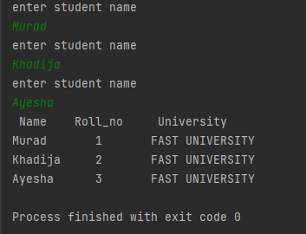

**Question 2:**

package com.company;  
  
import java.util.Scanner;  
  
class Car  
{  
 private String carName, engineNumber, color;  
 private int modelYear;  
 static int *carCount* = 0;  
  
 Car(String carName, String engineNumber, String color, int modelYear) {  
 this.carName = carName;  
 this.engineNumber = engineNumber;  
 this.color = color;  
 this.modelYear = modelYear;  
 }  
 Car()  
 {  
 *carCount*++;  
 }  
 public String getCarName() {  
 return carName;  
 }  
  
 public void setCarName(String carName) {  
 this.carName = carName;  
 }  
  
 public String getEngineNumber() {  
 return engineNumber;  
 }  
  
 public void setEngineNumber(String engineNumber) {  
 this.engineNumber = engineNumber;  
 }  
  
 public String getColor() {  
 return color;  
 }  
  
 public void setColor(String color) {  
 this.color = color;  
 }  
  
 public int getModelYear() {  
 return modelYear;  
 }  
  
 public void setModelYear(int modelYear) {  
 this.modelYear = modelYear;  
 }  
 public void display()  
 {  
 // System.out.println(" no of cars " + carCount);  
 System.*out*.print(getCarName() + "\t\t\t" + getEngineNumber() + "\t\t\t" + getModelYear() + "\t\t\t" + getColor());  
  
 }  
}  
public class OOPLAB5_Q2 {  
 public static void main(String[] args) {  
 Scanner sc = new Scanner(System.*in*);  
 Car obj = new Car(null, null, null, 0);  
 Car[] objs = new Car[3];  
 for(int i = 0; i < objs.length; i++)  
 {  
 objs[i] = new Car();  
 System.*out*.print("Car name: ");  
 objs[i].setCarName(sc.next());  
 System.*out*.print("Engine number: ");  
 objs[i].setEngineNumber(sc.next());  
 System.*out*.print("car color: ");  
 objs[i].setColor(sc.next());  
 System.*out*.print("Model year: ");  
 objs[i].setModelYear(sc.nextInt());  
 }  
 System.*out*.println(" ");  
 System.*out*.println(" No fo cars " + Car.*carCount*);  
 System.*out*.println(" Name of car \t Engine number \t Model year \t color ");  
 for (int i = 0; i < objs.length; i++)  
 {  
 objs[i].display();  
 System.*out*.print("\n");  
 }  
 }  
}

**Output:**

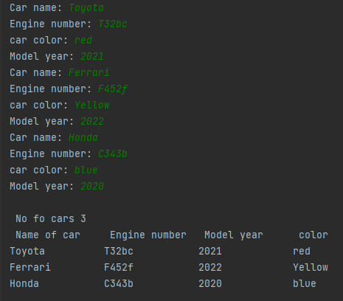

**Question no 3:**

package com.company;  
  
import java.util.Scanner;  
  
class AveragePrice  
{  
 float purchase;  
 Scanner sc = new Scanner(System.*in*);  
 public void setPurchase(AveragePrice[] purchase)  
 {  
 for(int i = 0; i < purchase.length; i++)  
 {  
 purchase[i] = new AveragePrice();  
 System.*out*.printf(" enter purchase %d: ", i+1);  
 purchase[i].purchase = sc.nextFloat();  
 }  
 }  
  
 public void getPurchase(AveragePrice[] obj ) {  
 System.*out*.println(" todays purchases are ");  
 for (int i = 0; i < obj.length; i++)  
 System.*out*.println(" " + obj[i].purchase);  
 }  
 public void getAveragePrice(AveragePrice[] obj ) {  
 float sum = 0;  
  
 for (int i = 0; i < obj.length; i++)  
 sum += obj[i].purchase;  
 System.*out*.println(" todays purchases' avg is " + (sum/ obj.length));  
 }  
}  
  
public class OOPLAB5_Q3 {  
 public static void main(String[] args) {  
 Scanner sc = new Scanner(System.*in*);  
 System.*out*.println(" enter the count of today's purchases ");  
 int n = sc.nextInt();  
 AveragePrice[] obj = new AveragePrice[n];  
 AveragePrice obj1 = new AveragePrice();  
 obj1.setPurchase(obj);  
 obj1.getPurchase(obj);  
 obj1.getAveragePrice(obj);  
  
 }  
}

**Output:**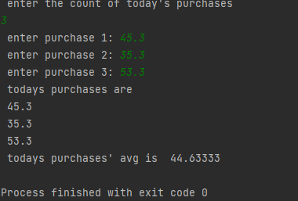

**Question 4:**

package com.company;  
  
import java.util.ArrayList;  
  
public class OOPLAB5_Q4 {  
 public static void main(String[] args) {  
 ArrayList<String> obj = new ArrayList<String>();  
 obj.add("c/c++");  
 obj.add("java");  
 obj.add("python");  
 obj.add("javascript");  
 obj.add("kotlin");  
 System.*out*.println(obj);  
 obj.set(0, "c++");  
 obj.remove(4);  
 System.*out*.println(obj);  
 }  
}

**Output:** 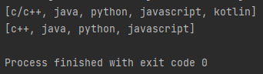

**Question 5:**

package com.company;  
import java.util.ArrayList;  
import java.util.Scanner;  
  
  
public class OOPLAB5_Q5 {  
 public static void main(String[] args) {  
 Scanner sc = new Scanner(System.*in*);  
 ArrayList <Integer> marks;  
 marks = new ArrayList<>();  
 int avg;  
 int sum = 0;  
 System.*out*.println("enter marks for student");  
 for (int i = 0; i < 5; i++) {  
 System.*out*.printf("Student%d: ", i+1);  
 marks.add(i, sc.nextInt());  
 }  
 System.*out*.println("before applying condition");  
 System.*out*.println(marks);  
 marks.removeIf(n -> (n < 50) );  
 System.*out*.println("after applying condition");  
 System.*out*.println(marks);  
  
 for(int i = 0; i < marks.size(); i++)  
 {  
 sum += marks.get(i);  
 }  
 avg = sum/marks.size();  
 System.*out*.println("average is " + avg);  
 }  
}

**Output:**

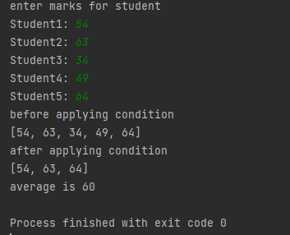

**Question 6:**

package com.company;  
  
import java.util.Scanner;  
class stationary  
{  
 int product_code;  
 float product_price;  
  
 stationary() {  
 }  
 public void setProduct_code(int p)  
 {  
 this.product_code = p;  
 }  
 public void setProduct_price(float p)  
 {  
 this.product_price = p;  
 }  
 public int getProduct_code()  
 {  
 return product_code;  
 }  
 public float getProduct_price()  
 {  
 return product_price;  
 }  
 public void billing (stationary[][] obj)  
 {  
  
 float total = 0;  
 System.*out*.println("Product code \t\t product price ");  
 for (int i = 0; i < obj.length; i++)  
 for (int j = 0; j < obj.length; j++) {  
 System.*out*.println(obj[i][j].getProduct_code() + "\t\t\t\t\t" + obj[i][j].getProduct_price());  
  
 total += obj[i][j].getProduct_price();  
  
 }  
 System.*out*.println("____________________________");  
 System.*out*.println("Total \t\t \t\t" + total);  
 }  
  
}  
  
public class OOPLAB5_Q6 {  
  
 public static void main(String[] args) {  
 Scanner sc = new Scanner(System.*in*);  
 System.*out*.println("enter no of products ");  
 int n = sc.nextInt();  
 stationary[][] obj = new stationary[2][1];  
 stationary obj1 = new stationary();  
 for (int i = 0; i < obj.length; i++)  
 {  
 for ( int j = 0; j < obj[i].length; j++)  
 {  
 obj[i][j] = new stationary();  
  
 System.*out*.println("enter product code ");  
 obj[i][j].setProduct_code(sc.nextInt());  
  
 System.*out*.println("enter the product price ");  
 obj[i][j].setProduct_price(sc.nextFloat());  
  
 }  
 }  
 obj1.billing(obj);  
 }  
}

**Output:**

