The activities in an automated process are determined by a program of instructions. In the simplest automated processes, the only instruction may be to maintain a certain controlled variable at a specified level, such as regulating the temperature in a heat treatment furnace. In more complex processes, a sequence of activities is required during the work cycle, and the order and details of each activity are defined by the program of instructions.
Действия в автоматизированном процессе определяются программой инструкций. В простейших автоматизированных процессах единственной инструкцией может быть поддержание определенной регулируемой переменной на заданном уровне, например регулирование температуры в печи для термообработки. В более сложных процессах требуется последовательность действий в течение рабочего цикла, а порядок и детали каждого действия определяются программой инструкций.

Each activity involves changes in one or more process parameters, such as changing the x coordinate position of a machine tool worktable, opening or closing a valve in a fluid flow system, or turning a motor on or off. Process parameters are inputs to the process. They may be continuous (continuously variable over a given range, such as the x-position of a worktable) or discrete (On or Off). Their values affect the outputs of the process, which are called process variables. Like process parameters, process variables can be continuous or discrete. Examples include the actual position of the machine worktable, the rotational speed of a motor shaft, or whether a warning light is on or off.
Каждое действие включает в себя изменение одного или нескольких параметров процесса, таких как изменение положения рабочего стола станка по координате x, открытие или закрытие клапана в системе подачи жидкости или включение или выключение двигателя. Параметры процесса являются входными данными для процесса. Они могут быть непрерывными (непрерывно изменяемыми в заданном диапазоне, например, положение x рабочего стола) или дискретными (включенными или выключенными). Их значения влияют на выходные данные процесса, которые называются переменными процесса. Как и параметры процесса, переменные процесса могут быть непрерывными или дискретными. Примеры включают фактическое положение рабочего стола станка, скорость вращения вала двигателя или то, включена или выключена сигнальная лампа.

The program of instructions specifies the changes in process parameters and when they should occur during the work cycle, and these changes determine the resulting values of the process variables. For example, in computer numerical control, the program of instructions is called a part program. The numerical control (NC) part program specifies the individual sequence of steps required to machine a given part, including worktable and cutter positions, cutting speeds, feeds, and other details of the operation.

In some automated processes, the work cycle program must contain instructions for making decisions or reacting to unexpected events during the work cycle. Examples of situations requiring this kind of capability include (1) variations in raw materials that require adjusting certain process parameters to compensate, (2) interactions and communications with human such as responding to requests for system status information, (3) safety monitoring requirements, and (4) equipment malfunctions.

The program of instructions is executed by a control system, the third basic component of an automated system. Two types of control system can be distinguished: closed loop and open loop.
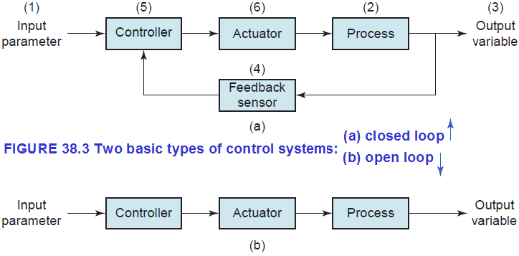

A closed loop system, also known as a feedback control system, is one in which the process variable of interest (output of the process) is compared with the corresponding process parameter (input to the process), and any difference between them is used to drive the output value into agreement with the input. Figure 38.3(a) shows the six elements of a closed loop system: (1) input parameter, (2) process, (3) output variable, (4) feedback sensor, (5) controller, and (6) actuator. The input parameter represents the desired value of the output variable. The process is the operation or activity being controlled; more specifically, the output variable is being controlled by the system. A sensor is used to measure the output variable and feed back its value to the controller, which compares output with input and makes the required adjustment to reduce any difference. The adjustment is made by means of one or more actuators, which are hardware devices that physically accomplish the control actions.

The other type of control system is an open loop system, presented in Figure 38.3(b).
As shown in the diagram, an open loop system executes the program of instructions without a feedback loop. No measurement of the output variable is made, so there is no comparison between output and input in an open loop system. In effect, the controller relies on the expectation that the actuator will have the intended effect on the output variable. Thus, there is always a risk in an open loop system that the actuator will not function properly or that its actuation will not have the expected effect on the output. On the other hand, the advantage of an open loop system is that its cost is less than a comparable closed loop system.

