AUTOMATION TECHNOLOGIES FOR MANUFACTURING SYSTEMS
Manufacturing systems include both automated and manually operated systems. The distinction between the two categories is not always clear, because many manufacturing systems consist of both automated and manual work elements (e.g., a machine tool that operates on a semiautomatic processing cycle but which must be loaded and unloaded each cycle by a human worker)..
A manufacturing system can be defined as a collection of integrated equipment and human resources that performs one or more processing and/or assembly operations on a starting work material, part, or set of parts. The integrated equipment consists of production machines, material handling and positioning devices, and computer systems. Human resources are required either full-time or part-time to keep the equipment operating. The position of the manufacturing systems in the larger production system is shown in Figure 38.1. As the diagram indicates, the manufacturing systems are located in the factory. They accomplish the value-added work on the part or product.

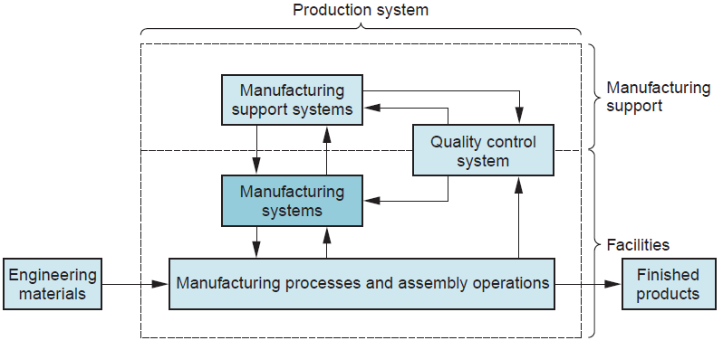
FIGURE 38.1 The position of the manufacturing systems in the larger production system.

Automation can be defined as the technology by which a process or procedure is performed without human assistance. Humans may be present as observers or even participants, but the process itself operates under its own self-direction. Automation is implemented by means of a control system that executes a program of instructions.
To automate a process, power is required to operate the control system and to drive the process itself.
Generally, an automated system consists of three basic components: (1) power, (2) a program of instructions, and (3) a control system to carry out the instructions. The relationship among these components is shown in Figure 38.2.
The form of power used in most automated systems is electrical. The advantages of electrical power include (1) it is widely available, (2) it can be readily converted to other forms of power such as mechanical, thermal, or hydraulic, (3) it can be used at very low power levels for functions such as signal processing, communication, data storage, and data processing, and (4) it can be stored in long-life batteries.

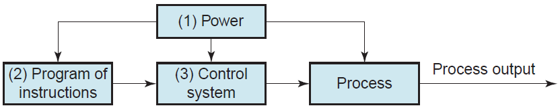

FIGURE 38.2 Elements of an automated system: (1) power, (2) program of instructions, and (3) control system.

In a manufacturing process, power is required to accomplish the activities associated with the particular process. Examples of these activities include (1) melting a metal in a casting operation, (2) driving the motions of a cutting tool relative to a workpiece in a machining operation, and (3) pressing and sintering parts in a powder metallurgy process.
Power is also used to accomplish any material handling activities needed in the process, such as loading and unloading parts, if these activities are not performed manually. Finally, power is used to operate the control system.

The activities in an automated process are determined by a program of instructions. In the simplest automated processes, the only instruction may be to maintain a certain controlled variable at a specified level, such as regulating the temperature in a heat treatment furnace. In more complex processes, a sequence of activities is required during the work cycle, and the order and details of each activity are defined by the program of instructions.
Each activity involves changes in one or more process parameters, such as changing the x coordinate position of a machine tool worktable, opening or closing a valve in a fluid flow system, or turning a motor on or off. Process parameters are inputs to the process. They may be continuous (continuously variable over a given range, such as the x-position of a worktable) or discrete (On or Off). Their values affect the outputs of the process, which are called process variables. Like process parameters, process variables can be continuous or discrete. Examples include the actual position of the machine worktable, the rotational speed of a motor shaft, or whether a warning light is on or off. The program of instructions specifies the changes in process parameters and when they should occur during the work cycle, and these changes determine the resulting values of the process variables. For example, in computer numerical control, the program of instructions is called a part program. The numerical control (NC) part program specifies the individual sequence of steps required to machine a given part, including worktable and cutter positions, cutting speeds, feeds, and other details of the operation.
In some automated processes, the work cycle program must contain instructions for making decisions or reacting to unexpected events during the work cycle. Examples of situations requiring this kind of capability include (1) variations in raw materials that require adjusting certain process parameters to compensate, (2) interactions and communications with human such as responding to requests for system status information, (3) safety monitoring requirements, and (4) equipment malfunctions.
The program of instructions is executed by a control system, the third basic component of an automated system. Two types of control system can be distinguished: closed loop and open loop.
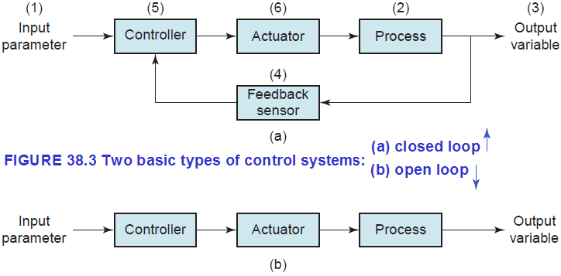
A closed loop system, also known as a feedback control system, is one in which the process variable of interest (output of the process) is compared with the corresponding process parameter (input to the process), and any difference between them is used to drive the output value into agreement with the input. Figure 38.3(a) shows the six elements of a closed loop system: (1) input parameter, (2) process, (3) output variable, (4) feedback sensor, (5) controller, and (6) actuator. The input parameter represents the desired value of the output variable. The process is the operation or activity being controlled; more specifically, the output variable is being controlled by the system. A sensor is used to measure the output variable and feed back its value to the controller, which compares output with input and makes the required adjustment to reduce any difference. The adjustment is made by means of one or more actuators, which are hardware devices that physically accomplish the control actions.
The other type of control system is an open loop system, presented in Figure 38.3(b).
As shown in the diagram, an open loop system executes the program of instructions without a feedback loop. No measurement of the output variable is made, so there is no comparison between output and input in an open loop system. In effect, the controller relies on the expectation that the actuator will have the intended effect on the output variable. Thus, there is always a risk in an open loop system that the actuator will not function properly or that its actuation will not have the expected effect on the output. On the other hand, the advantage of an open loop system is that its cost is less than a comparable closed loop system.

