# Задание №3 – трёхмерная графика

[X, Y] = meshgrid(0:.02:1);

z = x*2+Y>2;

mesh(X, Y, Z)

[X, Y] = meshgrid(-2:.01:2);

= exp (- ( (X. *2) . /2+(Y. 2) . /2)

mesh (X, Y, Z)

n=1;

[X, Y] = meshgrid(-2:0.01:2);

Z = N/2.*sin(2*pi.*X).*cos(1.5*pi.*X).*(1-X.*2).*Y.*X.*(1-Y);

mesh( X, Y, )

surface (X, Y, Z)

Y] = meshgrid(-2:2);

surface (X, Y, Z)

[X, Y] = meshgrid(-2:0.01:2);

shading flat

title('Flat Shading')

surface (X, Y, Z)

shading flat,

title (' Flat Shading');

surface(X,Y, Z);

shading interp

surf(X,Y, Z);

shading flat;

mesh( X, Y, );

shading flat;

shading interp

mesh ( x, Y, Z )

surface(X,Y, Z);

shading interp

surf(X,Y, Z);

shading flat;

mesh ( x, Y, );

shading flat;

shading interp

mesh ( x, Y, );

surf (X, Y, Z) ;

meshc (X, Y, Z)

colorbar

colorbar;

mesh (X, Y, Z)

colorbar;

contour 3 (X, Y, Z, 40)

contour (X, Y, 2, 20)

colorbar;

contourf(X, Y, 2, 20)

= contour (X, Y, Z);

clabel (C)

mesh( X, Y, 2 )

surf(X, Y, Z);colormap(jet); shading interp

clabel (C)

help colormap

b=1;

u = (-2:0.1:2)

v = [0:0.05*pi:2*pi];

z = a*u*cos (v)

x = b*u*sin(v) :

Y = c*u*ones (size (v) ) :

figure ('Color', 'w')

hS-mesh (X, Y, Z)

## 3,1

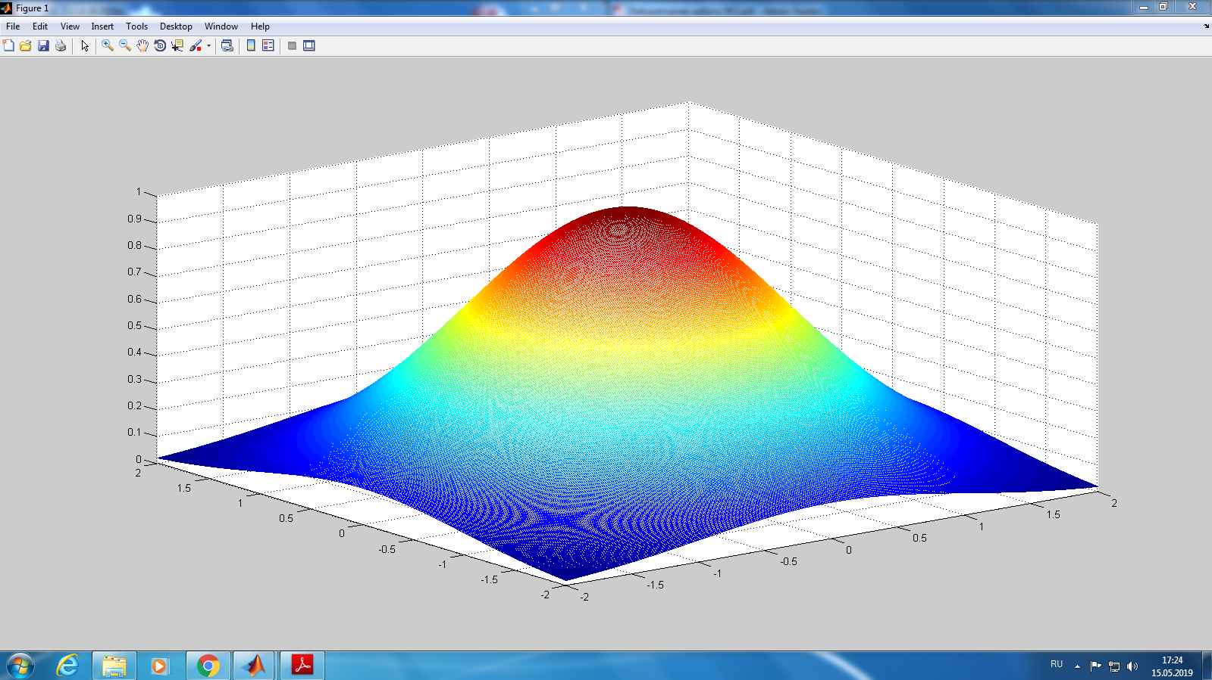

## 3,2

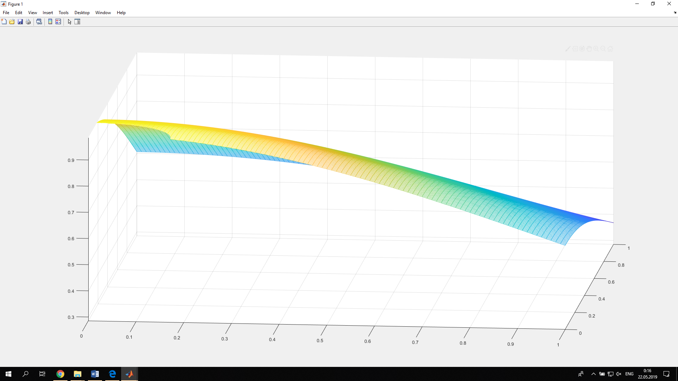

3,3

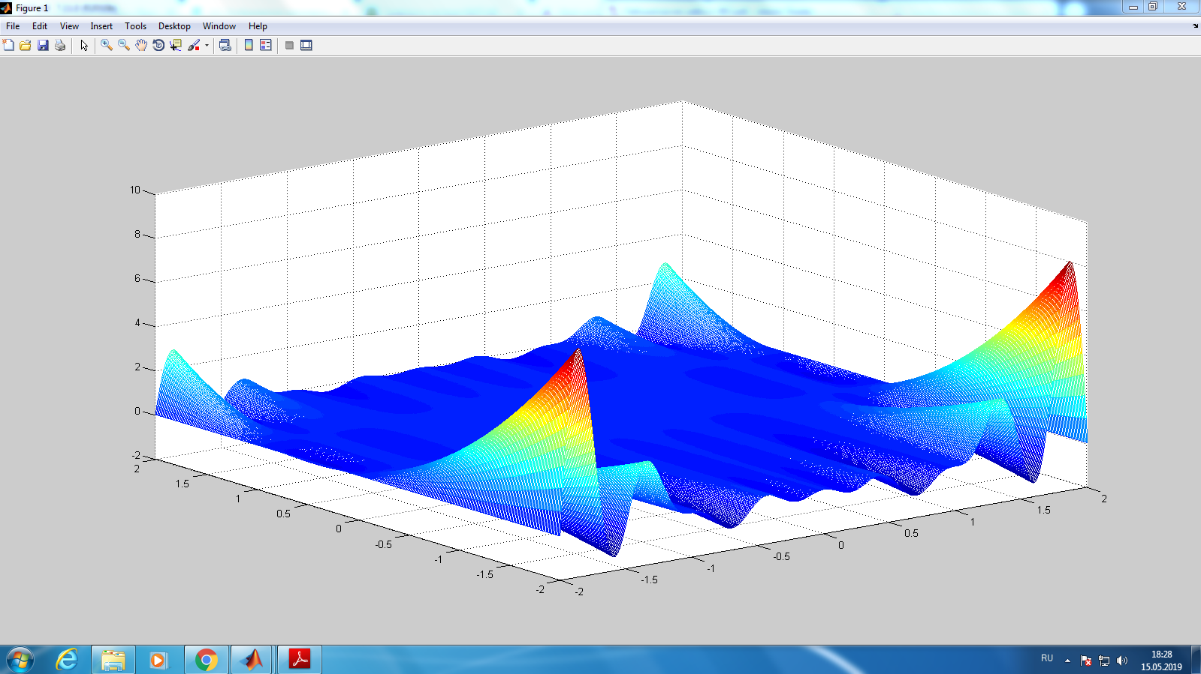

## 3.4

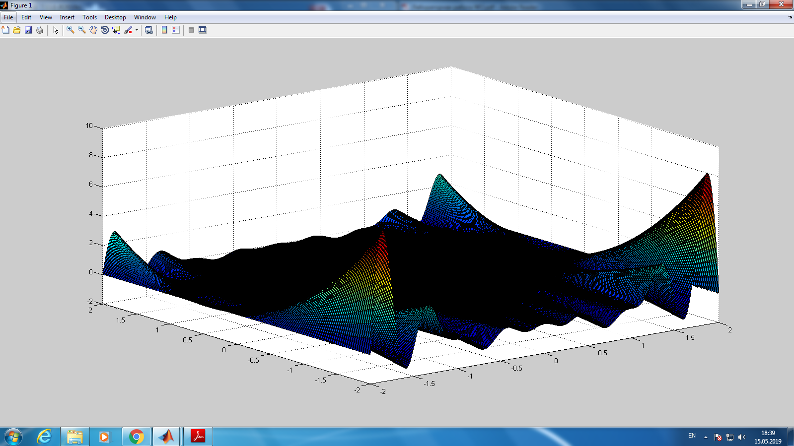

3.5

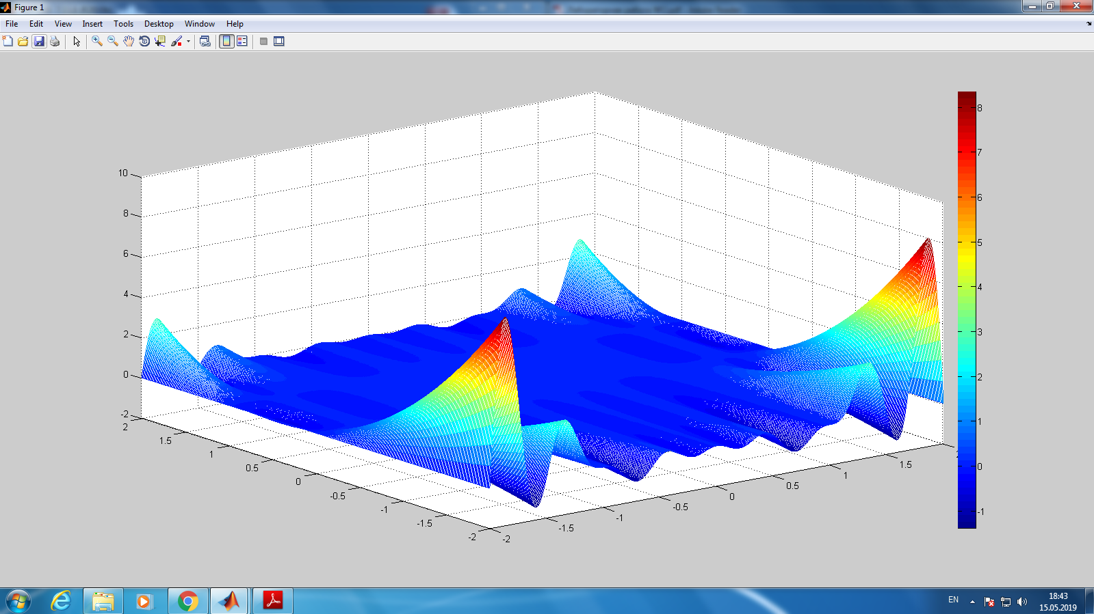

## 3.6

### meshc

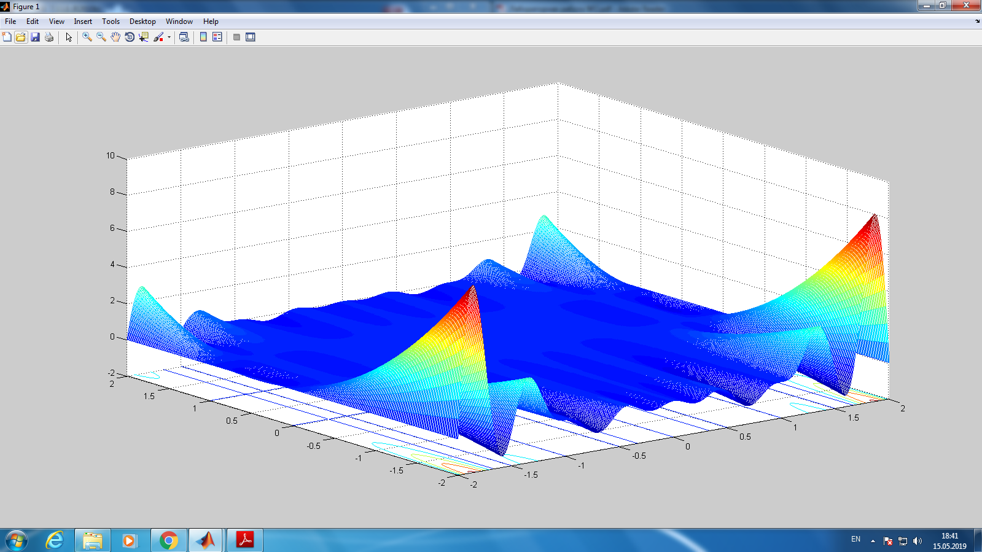

### surfc

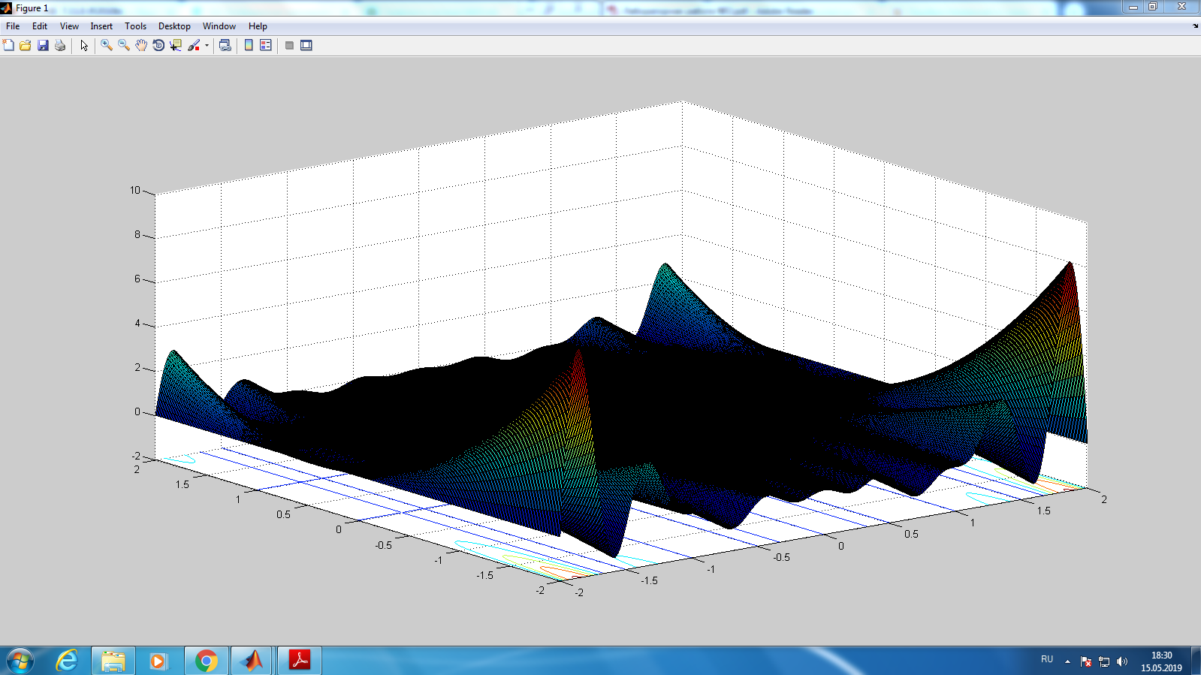

3.7

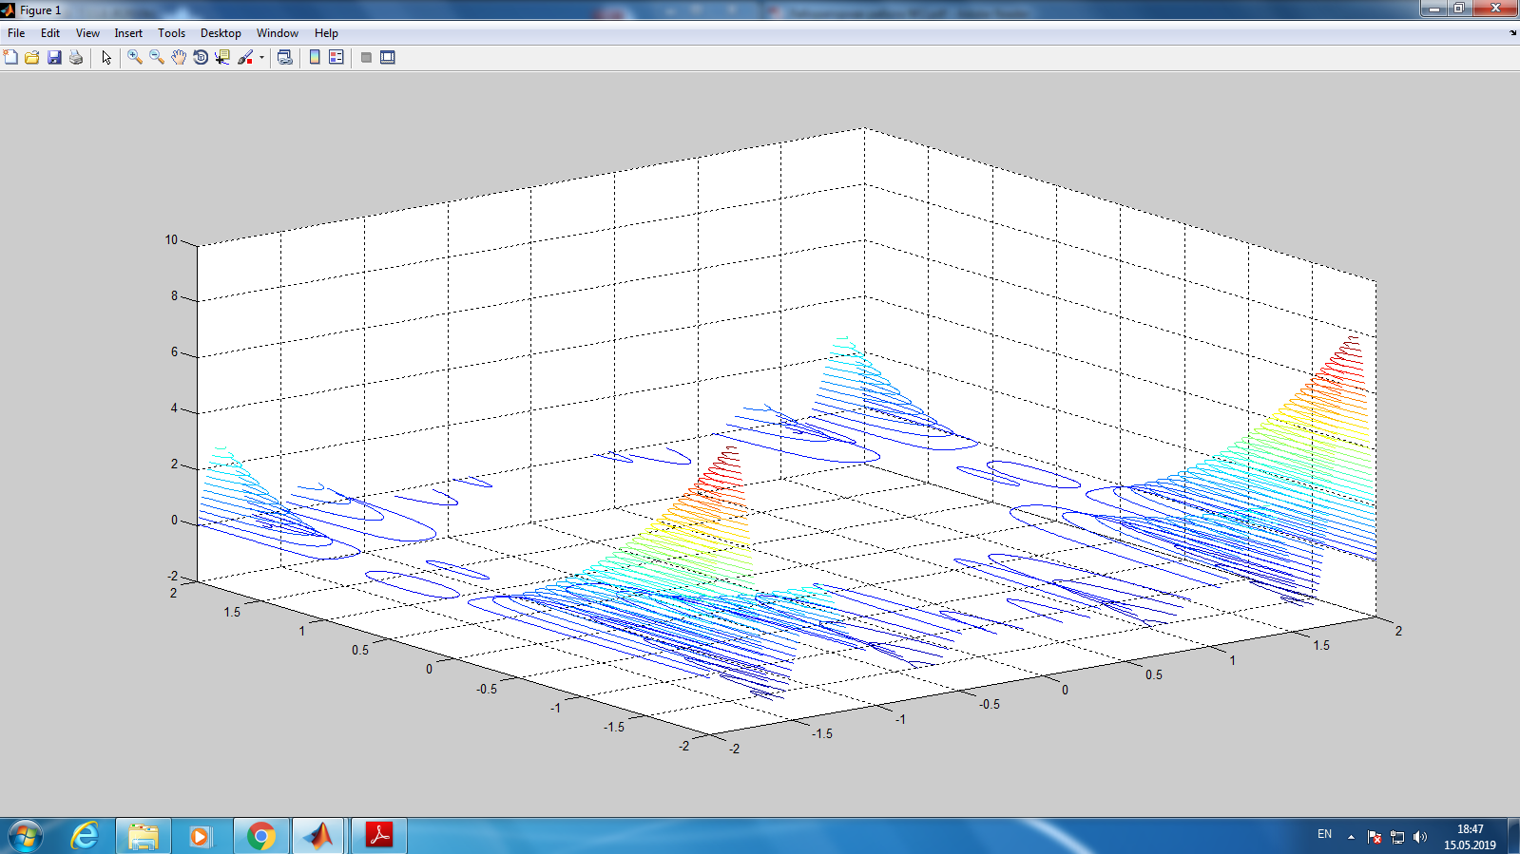

## 3.8

### contour

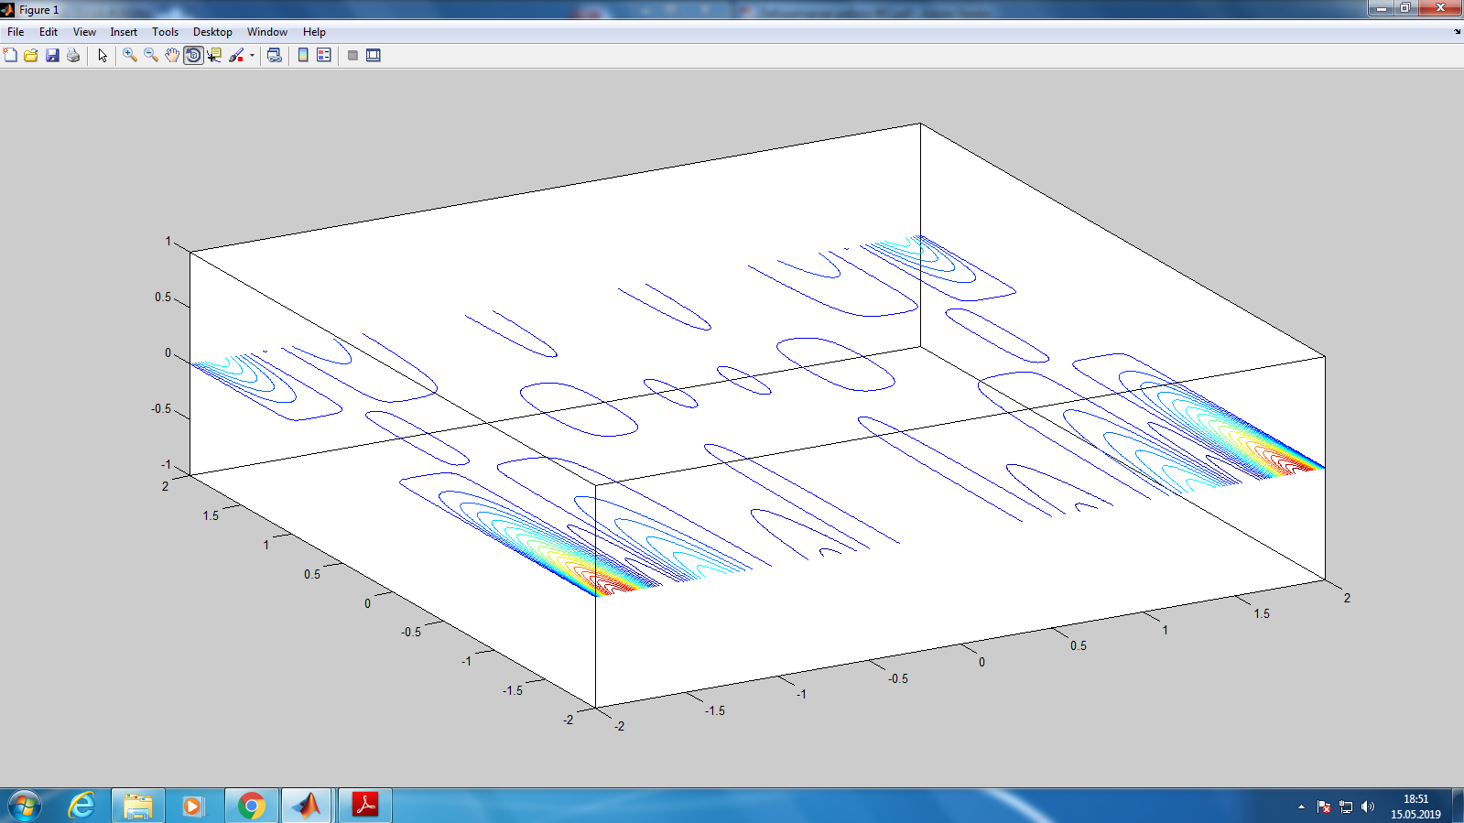

### Contour

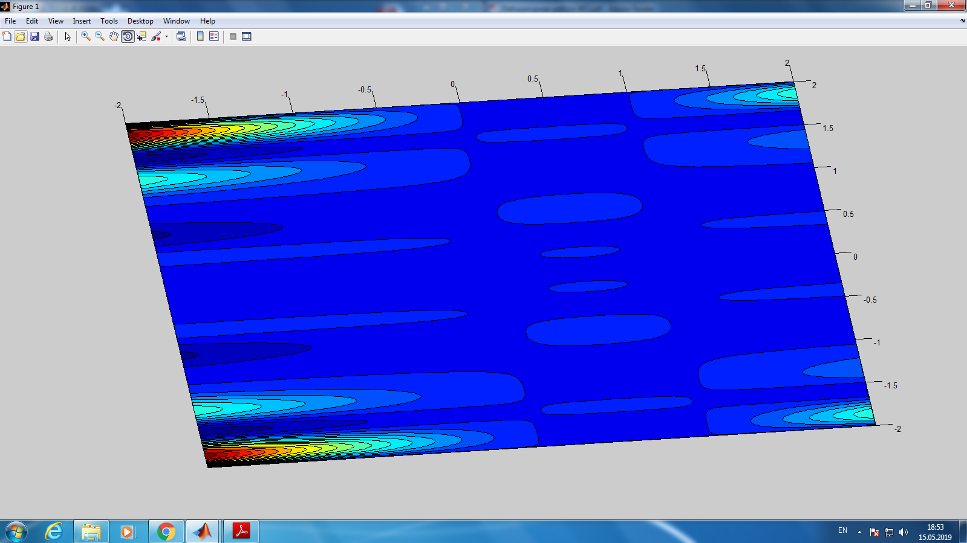

### Clabel

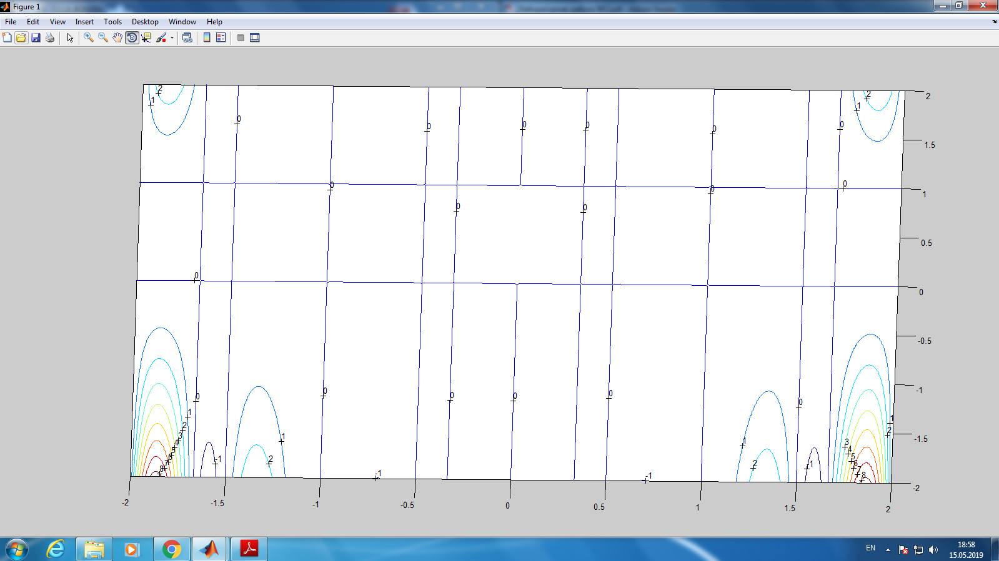

## 3.9

