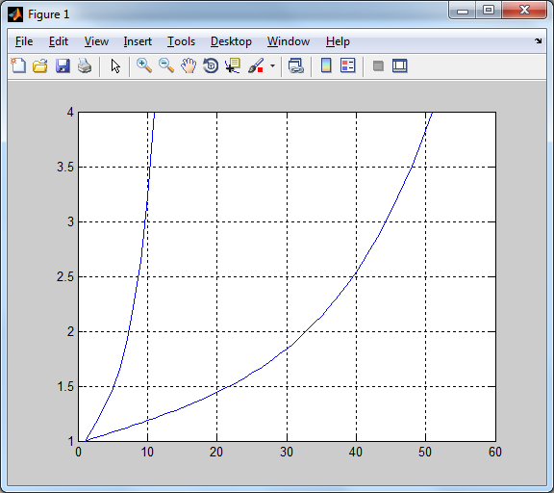

>> N = [0.1:0.1:1]

N =

Columns 1 through 8

0.1000 0.2000 0.3000 0.4000 0.5000 0.6000 0.7000 0.8000

Columns 9 through 10

0.9000 1.0000

>> A = COS( N +100)

??? Undefined function or method 'COS' for input arguments of type 'double'.

>> A = cos (N + 100)

A =

Columns 1 through 8

0.9086 0.9457 0.9734 0.9914 0.9995 0.9976 0.9857 0.9640

Columns 9 through 10

0.9327 0.8920

>> B = sqrt(b)/(N^3 +N^2 + 1)

??? Undefined function or variable 'b'.

>> B = sqrt(N)/(N^3 +N^2 + 1)

??? Error using ==> mpower

Inputs must be a scalar and a square matrix.

>> B = sqrt(N)/(N.^3 +N.^2 + 1)

B =

0.4050

>> C = ln(5N +2 )

??? C = ln(5N +2 )

|

Error: Unexpected MATLAB expression.

>> C= log(5.*N +2)

C =

Columns 1 through 8

0.9163 1.0986 1.2528 1.3863 1.5041 1.6094 1.7047 1.7918

Columns 9 through 10

1.8718 1.9459

>> B = sqrt(N)./(N.^3 +N.^2 + 1)

B =

Columns 1 through 8

0.3128 0.4267 0.4904 0.5167 0.5143 0.4915 0.4564 0.4156

Columns 9 through 10

0.3736 0.3333

>> M = A.^2 .*tg(B+C.^3)

??? Undefined function or method 'tg' for input arguments of type 'double'.

>> M = A.^2 .*tan(B+C.^3)

M =

Columns 1 through 8

1.5525 -4.8626 -0.7744 0.0387 0.9790 19.1286 -1.1575 -0.1076

Columns 9 through 10

0.6594 5.1829

>> N = [0.1:1:1]

N =

0.1000

>> N = [0.1:1:1];

>> A = A = cos (N + 100)

??? A = A = cos (N + 100)

|

Error: The expression to the left of the equals sign is not a valid target for an

assignment.

>> A = cos (N + 100)

A =

0.9086

>> B = sqrt(N)/(N.^3 +N.^2 + 1)

B =

0.3128

>> C= log(5.*N +2)

C =

0.9163

>> D = A.^2 .*tan(B+C.^3)

D =

1.5525

>> N = [0:0.1:1]

N =

Columns 1 through 8

0 0.1000 0.2000 0.3000 0.4000 0.5000 0.6000 0.7000

Columns 9 through 11

0.8000 0.9000 1.0000

>> M = [0:0.02:1]

M =

Columns 1 through 8

0 0.0200 0.0400 0.0600 0.0800 0.1000 0.1200 0.1400

Columns 9 through 16

0.1600 0.1800 0.2000 0.2200 0.2400 0.2600 0.2800 0.3000

Columns 17 through 24

0.3200 0.3400 0.3600 0.3800 0.4000 0.4200 0.4400 0.4600

Columns 25 through 32

0.4800 0.5000 0.5200 0.5400 0.5600 0.5800 0.6000 0.6200

Columns 33 through 40

0.6400 0.6600 0.6800 0.7000 0.7200 0.7400 0.7600 0.7800

Columns 41 through 48

0.8000 0.8200 0.8400 0.8600 0.8800 0.9000 0.9200 0.9400

Columns 49 through 51

0.9600 0.9800 1.0000

>> f1 = N.^5 +N.^3 +N +1

f1 =

Columns 1 through 8

1.0000 1.1010 1.2083 1.3294 1.4742 1.6563 1.8938 2.2111

Columns 9 through 11

2.6397 3.2195 4.0000

>> f1 = N.^5 +N.^3 +N +1 ;

>> f2 = M.^5 +M.^3 + M + 1;

>> axes(handles.axes1);

??? Undefined function or variable 'handles'.

>> plot(f1);

>> hold on;

>> grid on;

>> plot(f2);  


>>f3 = 10.^(-2) .*f1 .*sin(N);

>> plotyy ( N,f1)

??? Error using ==> plotyy at 36

Not enough input arguments.

>> plotyy (N,f1,N,f3)

>> plotyy (N,f1,N,f3)  
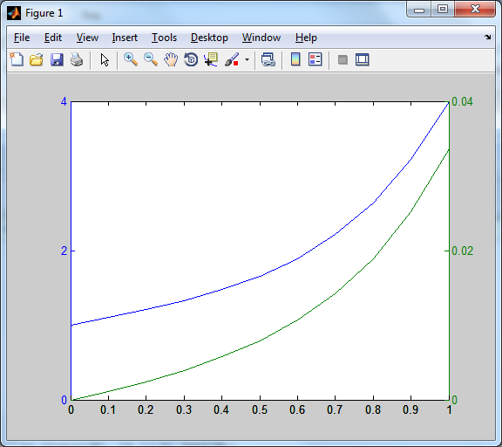  
  
  
  
plotyy (N,f1,N,f3,'loglog')  
/  
  
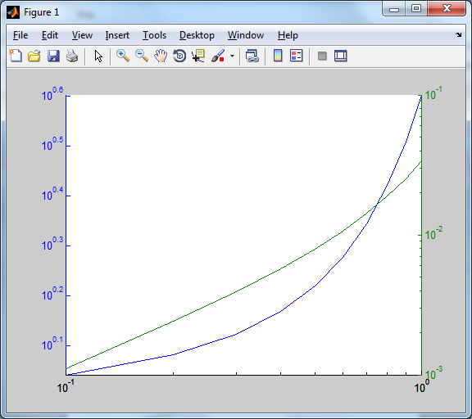

>> plotyy (N,f1,N,f3,@semilogx)  
  
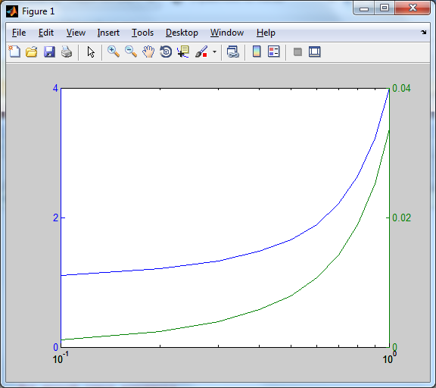  
  
>> plotyy (N,f1,N,f3,@semilogy)  
  
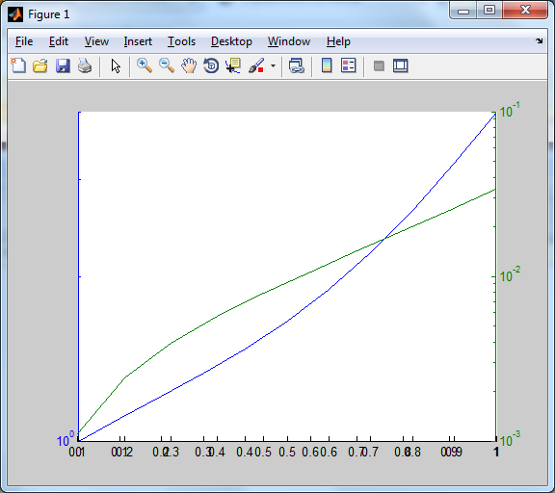  
  
>> J = [2 4 5 6 7 1; 2 6 7 5 3 2; 9 8 7 4 1 3; 7 6 5 8 9 8; 3 4 3 2 1 3]

J =

2 4 5 6 7 1

2 6 7 5 3 2

9 8 7 4 1 3

7 6 5 8 9 8

3 4 3 2 1 3

>> V = [2;4;6;5;3;7;6]

V =

2

4

6

5

3

7

6

>> V= [ 2:8]

V =

2 3 4 5 6 7 8

>> imagesc(A)

>> plot(J);

>> hold on;

>> grid on;

>> imagesc(J);

>> colrbar

??? Undefined function or variable 'colrbar'.

**НЕНУЖНО НЕНУЖНО НЕНУЖНО НЕНУЖНО НЕНУЖНО НЕНУЖНО НЕНУЖНО НЕНУЖНО НЕНУЖНО НЕНУЖНО НЕНУЖНО НЕНУЖНО НЕНУЖНО НЕНУЖНО НЕНУЖНО НЕНУЖНО НЕНУЖНО НЕНУЖНО**

>> colorbar>> imagesc(A)

>> plot(J);

>> hold on;

>> grid on;

>> imagesc(J);

>> colorbar  
  
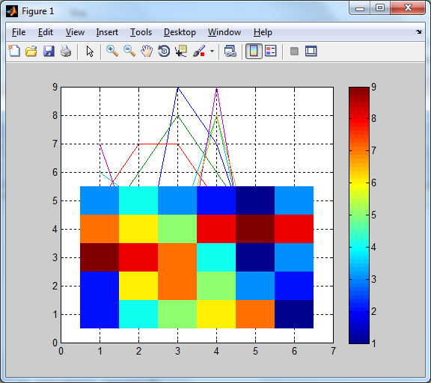  
  
  
  
  
  
  
  
  
  
  
  
  
  
  
  
  
  
  
  
  
>> plot(J)

>> colorbar  
  
  
  
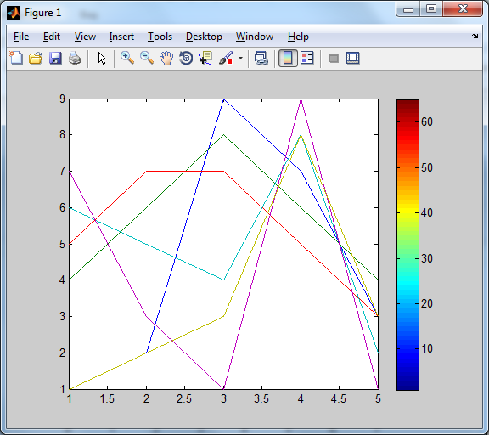  
  
  
  
  
  
  
  
  
  
  
  
  
  
  
  
>> plot(V)

>> hold on;

>> grid on;

>> imagesc(V);

>> colorbar  
  
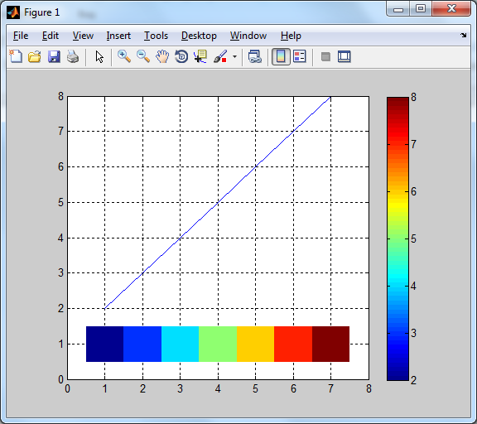

>> plot(V)

>> colorbar  
  
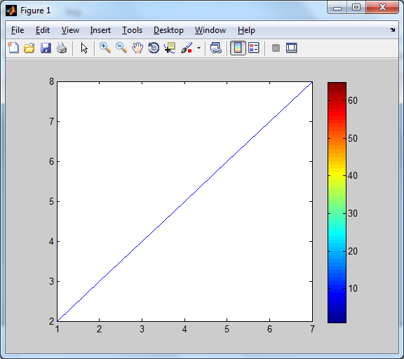  
  
  
  
**НЕНУЖНО НЕНУЖНО НЕНУЖНО НЕНУЖНО НЕНУЖНО НЕНУЖНО НЕНУЖНО НЕНУЖНО НЕНУЖНО НЕНУЖНО НЕНУЖНО НЕНУЖНО НЕНУЖНО НЕНУЖНО НЕНУЖНО НЕНУЖНО НЕНУЖНО НЕНУЖНО**

>> imagesc(V)

>> colorbar  
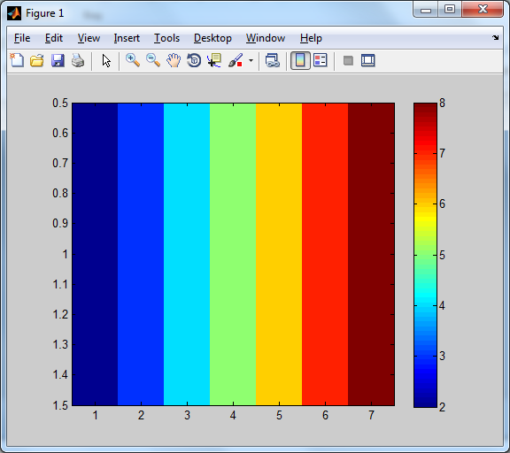

>> imagesc(J)

>> colorbar  
  
