1)x=0:0.1:5;

>> y1=6\*(1-exp(-x/0.1));

>> plot(y);

>> grid on

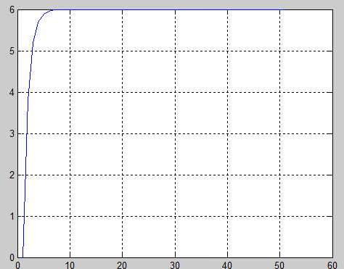

>> y2=6\*(1-exp(-x/0.5));

>> plot(y);

>> grid on

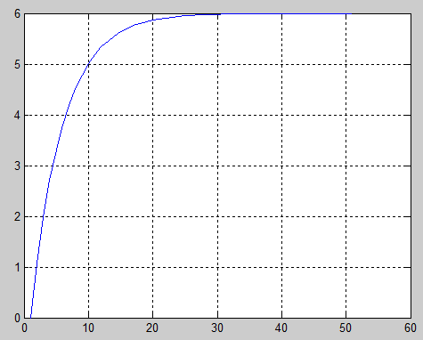

>> y3=6\*(1-exp(-x/1.2));

>> plot(y);

>> grid on

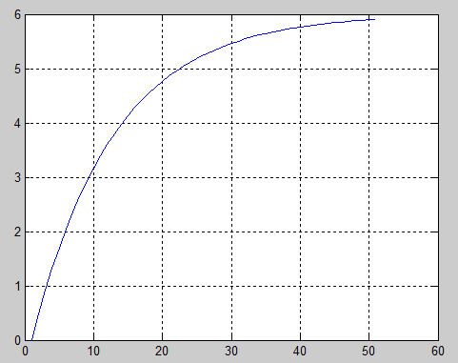

2) >> plot(x,y2,'m:+');

>> hold on

>> plot(x,y1,'r-.');

>> plot(x,y3,'g-.X');

>> grid on

>> text(0.5,5,'\leftarrow y1(x)');

>> text(1.05,4,'\leftarrow y2(x)');

>> text(1.05,3,'\leftarrow y3(x)');

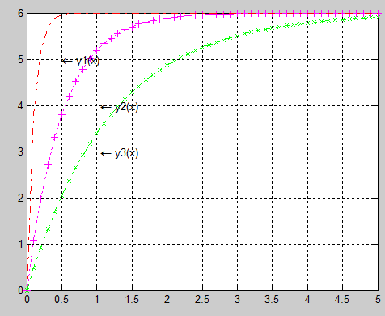

3) f1=exp((-0.1/0.5).\*x).\*sin((sqrt(1-0.1.\*0.1)/0.5.\*x).\*6.\*0.1)/(0.5.\*(sqrt(1-0.1)));

>> plot(f1);

>> grid on

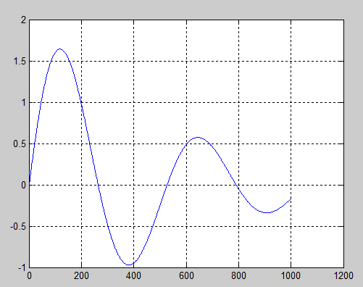

f2=exp((-0.5/0.5).\*x).\*sin((sqrt(1-0.5.\*0.5)/0.5.\*x).\*6.\*0.5)/(0.5.\*(sqrt(1-0.5)));

>> plot(f2);

>> grid on

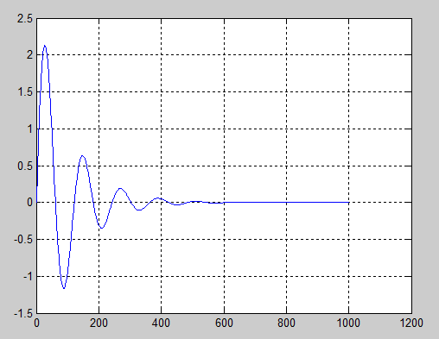

>> f3=exp((-2/0.5).\*x).\*sin(x.\*((1-2.\*2)^(0.5)/0.5)).\*1.\*2./(0.5.\*((1-2.\*2)^(0.5)));

>> plot(x,real(f3));

>> grid on

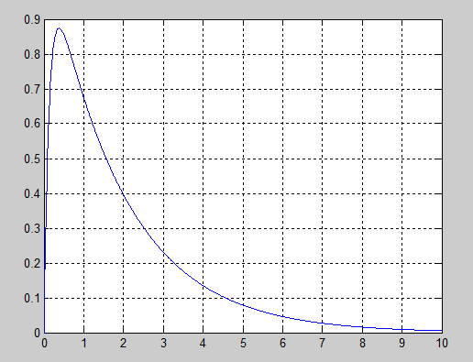

4>> plot(x,f2,'g--X');

>> hold on

>> plot(x,f1,'m-.');

>> plot(x,f3,'r-\*');

Warning: Imaginary parts of complex X and/or Y arguments ignored

>> grid on

>> text(2,1.5,'\leftarrow f1(x)');

>> text(1,2,'\leftarrow f1(x)');

>> text(1,0.7,'\leftarrow f3(x)');

