>> N=3

N =

3

>> C^2

ans =

Inf

>> C

C =

2.2844e+222

>> C=exp((N-1)^3)

C =

2.9810e+003

>> C^2

ans =

8.8861e+006

>> A=(cos(N))^2

A =

0.9801

>> B=(log(N)^2)

B =

1.2069

>> D=A-B

D =

-0.2269

>> (A^(2/9)-sqrt(B))/(C^2+D)^2

ans =

-1.3053e-015

>> (A^(2/9)+sqrt(B))/(C^2+D)^2

ans =

2.6521e-014

>> format long

>> ans

ans =

2.652068998778429e-014

Задание 2.1

>> N=7+8i

N =

7.000000000000000 + 8.000000000000000i

>> Nc=conj(N)

Nc =

7.000000000000000 - 8.000000000000000i

>> Nc^2

ans =

-1.500000000000000e+001 -1.120000000000000e+002i

>> format short

>> ans

ans =

-1.5000e+001 -1.1200e+002i

>> Pr=N\*Nc

Pr =

113

>> Ns=sin(N)+cos(N)

Ns =

2.1029e+003 +1.4445e+002i

Задание 2

A =

1 2 3

4 5 6

7 8 9

>> B=[10 20 30; 40 50 60; 70 80 90]

B =

10 20 30

40 50 60

70 80 90

>> A+B

ans =

11 22 33

44 55 66

77 88 99

>> A-B

ans =

-9 -18 -27

-36 -45 -54

-63 -72 -81

>> A\*B

ans =

300 360 420

660 810 960

1020 1260 1500

>> A'

ans =

1 4 7

2 5 8

3 6 9

>> B'

ans =

10 40 70

20 50 80

30 60 90

>> C=A+B\*i

C =

1.0000 +10.0000i 2.0000 +20.0000i 3.0000 +30.0000i

4.0000 +40.0000i 5.0000 +50.0000i 6.0000 +60.0000i

7.0000 +70.0000i 8.0000 +80.0000i 9.0000 +90.0000i

>> A^2

ans =

30 36 42

66 81 96

102 126 150

>> A\*A

ans =

30 36 42

66 81 96

102 126 150

>> A(1,:)\*B

ans =

300 360 420

>> B\*A(:,3)

ans =

420

960

1500

>> MS=[-1.2 -0.3 0.2; 0.5 2.1 1.3; -0.9 0.7 5.6]

MS =

-1.2000 -0.3000 0.2000

0.5000 2.1000 1.3000

-0.9000 0.7000 5.6000

>> MF=[1.32; 3.91; 5.4]

MF =

1.3200

3.9100

5.4000

>> MX=MS\MF

MX =

-1.4994

1.9197

0.4834

>> K=[A B; B' A']

K =

1 2 3 10 20 30

4 5 6 40 50 60

7 8 9 70 80 90

10 40 70 1 4 7

20 50 80 2 5 8

30 60 90 3 6 9

>> K(:,2)=[]

K =

1 3 10 20 30

4 6 40 50 60

7 9 70 80 90

10 70 1 4 7

20 80 2 5 8

30 90 3 6 9

>> K(3,:)=[]

K =

1 3 10 20 30

4 6 40 50 60

10 70 1 4 7

20 80 2 5 8

30 90 3 6 9

>> MC(5,8)=zeros

MC =

0 0 0 0 0 0 0 0

0 0 0 0 0 0 0 0

0 0 0 0 0 0 0 0

0 0 0 0 0 0 0 0

0 0 0 0 0 0 0 0

>> ME=eye(7,4)

ME =

1 0 0 0

0 1 0 0

0 0 1 0

0 0 0 1

0 0 0 0

0 0 0 0

0 0 0 0

>> ME=eye(5,5)

ME =

1 0 0 0 0

0 1 0 0 0

0 0 1 0 0

0 0 0 1 0

0 0 0 0 1

ME =

1 1 1 1 1

1 1 1 1 1

1 1 1 1 1

1 1 1 1 1

>> ME=ones(4,4)

ME =

1 1 1 1

1 1 1 1

1 1 1 1

1 1 1 1

>> ME=3.\*rand(4,5)

ME =

2.4925 0.8575 1.7035 2.3375 1.4082

1.7558 2.2716 0.2276 2.8020 0.0357

1.6492 2.2612 0.1619 0.3897 1.0114

2.7516 1.1413 1.5924 1.7065 0.4865

>> diag(K(1,:))

ans =

1 0 0 0 0

0 3 0 0 0

0 0 10 0 0

0 0 0 20 0

0 0 0 0 30

>> A+1

ans =

2 3 4

5 6 7

8 9 10

>> B+1

ans =

11 21 31

41 51 61

71 81 91

>> A\*2

ans =

2 4 6

8 10 12

14 16 18

>> B\*2

ans =

20 40 60

80 100 120

140 160 180

>> A-2

ans =

-1 0 1

2 3 4

5 6 7

>> B-2

ans =

8 18 28

38 48 58

68 78 88

>> A/2

ans =

0.5000 1.0000 1.5000

2.0000 2.5000 3.0000

3.5000 4.0000 4.5000

>> B/2

ans =

5 10 15

20 25 30

35 40 45

spy(K)

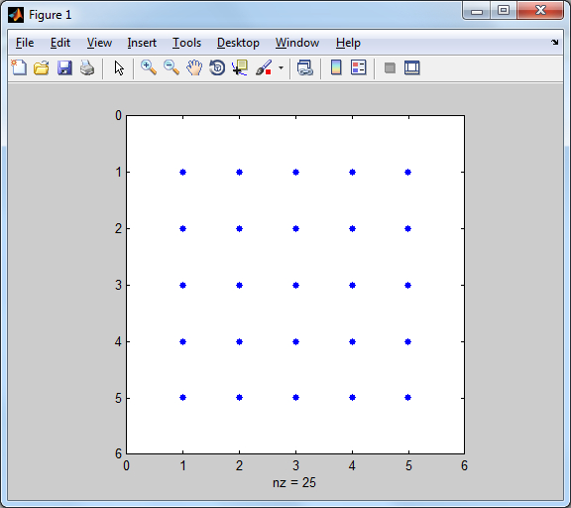

imagesc(K) 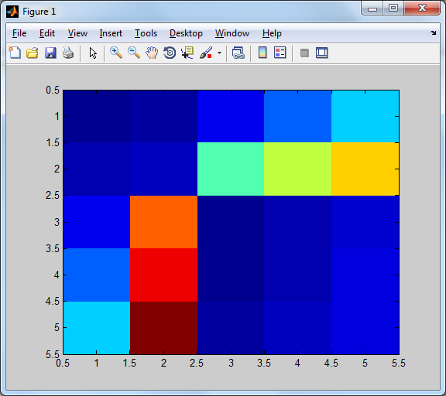

colorbar

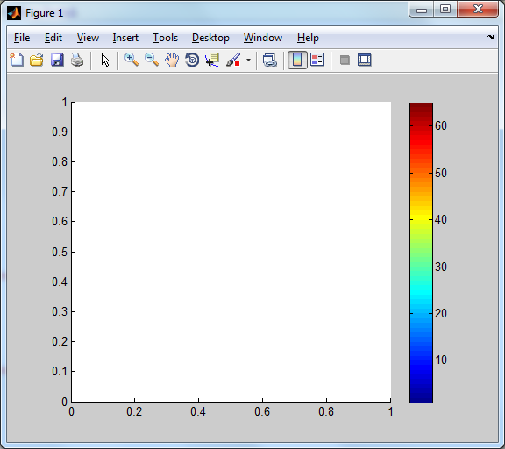

colormap(gray) 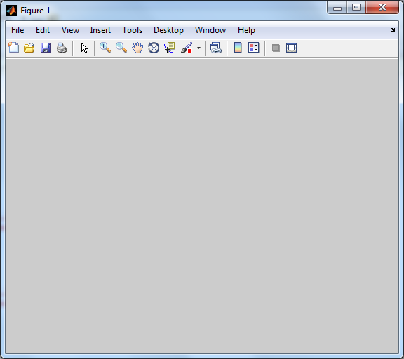

>> A=[1 0 -1; 1 0 1; 0 1 0]

A =

1 0 -1

1 0 1

0 1 0

>> R=[sqrt(2)/2 -sqrt(2)/2 0; sqrt(2)/2 sqrt(2)/2 0; 0 0 1]

R =

0.7071 -0.7071 0

0.7071 0.7071 0

0 0 1.0000

>> det(A)

ans =

-2

>> det(R)

ans =

1.0000

>> D=[1 0 0 0; 0 1 0 1; 0 0 0 0; 0 1 0 0]

D =

1 0 0 0

0 1 0 1

0 0 0 0

0 1 0 0

>> rank(D)

ans =

3

>> a=[1;1;3]

a =

1

1

3

>> b=[2;1;-1]

b =

2

1

-1

>> dot(a,b)

ans =

0

>> cross(a,b)

ans =

-4

7

-1

Задание 3

>> V2=[1;2;4]

V2 =

1

2

4

>> R12=[cos(pi/2) -sin(pi/2) 0; sin(pi/2) cos(pi/2) 0; 0 0 1]

R12 =

0.0000 -1.0000 0

1.0000 0.0000 0

0 0 1.0000

>> V1=R12\*V2

V1 =

-2.0000

1.0000

4.0000

Vn2 =

1.0000

1.5000

0

>> V1=R12\*Vn2

V1 =

-1.5000

1.0000

0

>> Vo1=[2;1;0]

Vo1 =

2

1

0

>> W=[0;0;1.5]

W =

0

0

1.5000

>> ra=[2;2;0]

ra =

2

2

0

>> rb=[1;0;0]

rb =

1

0

0

>> rc=[4;3.2;0]

rc =

4.0000

3.2000

0

Лаба 2

Задание 1.1

>> N = [0.1:0.1:1];

>> A=(cos(N)).^2

A =

Columns 1 through 7

0.9900 0.9605 0.9127 0.8484 0.7702 0.6812 0.5850

Columns 8 through 10

0.4854 0.3864 0.2919

>> B=(log(N).^2)

B =

Columns 1 through 7

5.3019 2.5903 1.4496 0.8396 0.4805 0.2609 0.1272

Columns 8 through 10

0.0498 0.0111 0

>> C=exp((N-1).^3)

C =

Columns 1 through 7

0.4824 0.5993 0.7096 0.8057 0.8825 0.9380 0.9734

Columns 8 through 10

0.9920 0.9990 1.0000

>> D=A-B

D =

Columns 1 through 7

-4.3119 -1.6298 -0.5369 0.0088 0.2897 0.4202 0.4578

Columns 8 through 10

0.4356 0.3753 0.2919

>> (A.^(2./9)-sqrt(B))./(C.^2+D).^2

ans =

Columns 1 through 7

-0.0784 -0.3830 -202.1165 0.1105 0.2194 0.2410 0.2689

Columns 8 through 10

0.3118 0.3734 0.4557

Задание 1.2

>> N = [0.1:1:1];

>> A=(cos(N)).^2

A =

0.9900

>> B=(log(N).^2)

B =

5.3019

>> C=exp((N-1).^3)

C =

0.4824

>> D=A-B

D =

-4.3119

>> (A.^(2./9)-sqrt(B))./(C.^2+D).^2

ans =

-0.0784

Задание 1.3

>> N = [0:0.1:1];

>> M = [0:0.02:1];

>> F1=N.^5+N.^3+N+1

F1 =

Columns 1 through 7

1.0000 1.1010 1.2083 1.3294 1.4742 1.6563 1.8938

Columns 8 through 11

2.2111 2.6397 3.2195 4.0000

>> F2=M.^5+M.^3+M+1

F2 =

Columns 1 through 7

1.0000 1.0200 1.0401 1.0602 1.0805 1.1010 1.1218

Columns 8 through 14

1.1428 1.1642 1.1860 1.2083 1.2312 1.2546 1.2788

Columns 15 through 21

1.3037 1.3294 1.3561 1.3838 1.4127 1.4428 1.4742

Columns 22 through 28

1.5072 1.5417 1.5779 1.6161 1.6563 1.6986 1.7434

Columns 29 through 35

1.7907 1.8407 1.8938 1.9499 2.0095 2.0727 2.1398

Columns 36 through 42

2.2111 2.2867 2.3671 2.4525 2.5433 2.6397 2.7421

Columns 43 through 49

2.8509 2.9665 3.0892 3.2195 3.3578 3.5045 3.6601

Columns 50 through 51

3.8251 4.0000

>> plot(F1);

>> hold on;

>> grid on;

>> plot (F2);

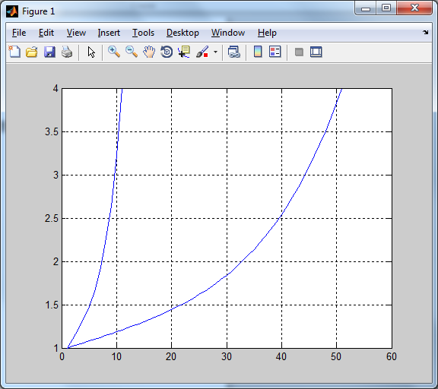

Задание 1.4

F3=10^-2.\*F1.\*sin(N)

F3 =

Columns 1 through 7

0 0.0011 0.0024 0.0039 0.0057 0.0079 0.0107

Columns 8 through 11

0.0142 0.0189 0.0252 0.0337

>> plotyy(N,F1,N,F3)

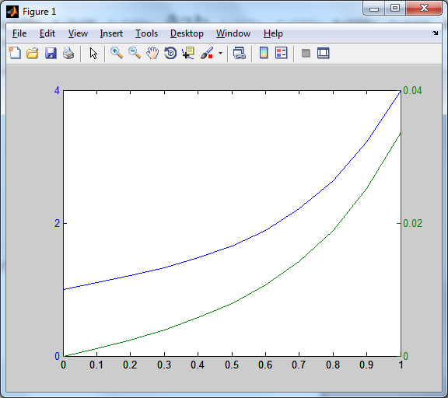

Задание 1.5

>>plotyy(N,F1,N,F3,@loglog) 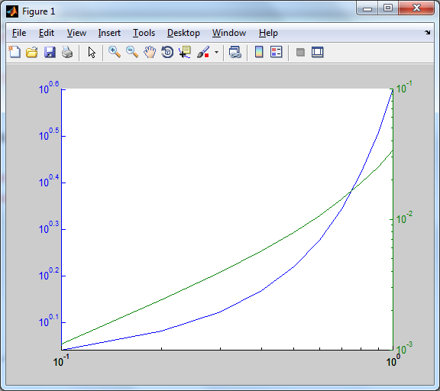

>> plotyy(N,F1,N,F3,@semilogx)

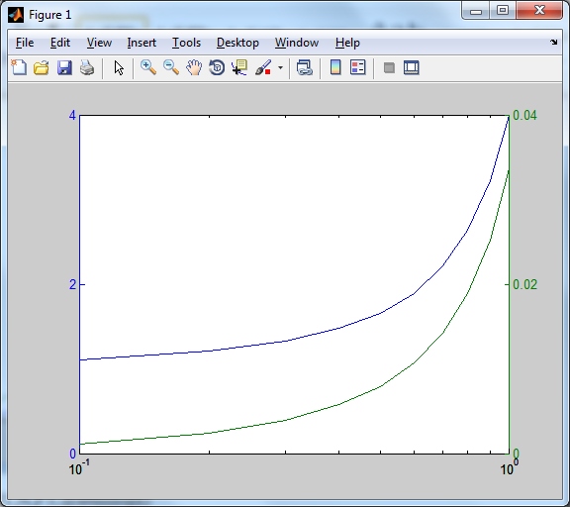

>> plotyy(N,F1,N,F3,@semilogy)

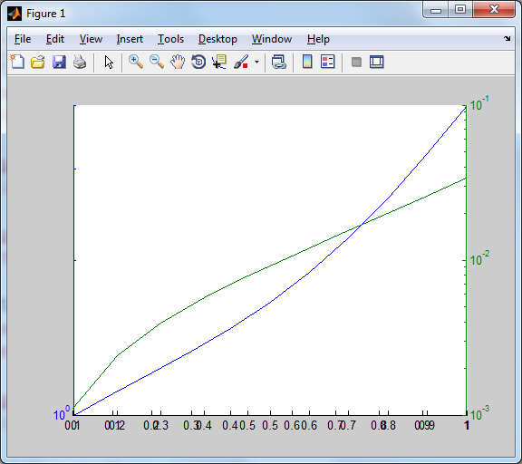

Задание 1.6

>> plot(D)

>> hold on;

>> grid on;

>> imagesc(D)

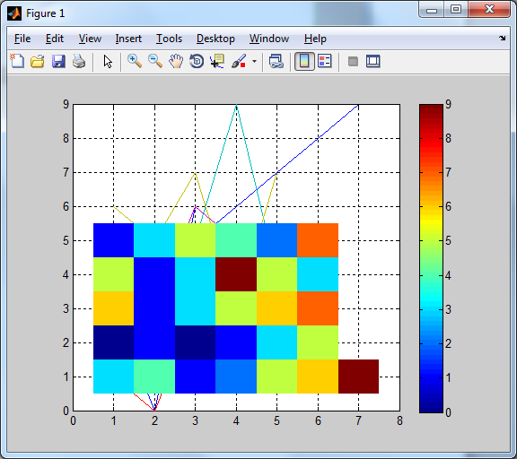 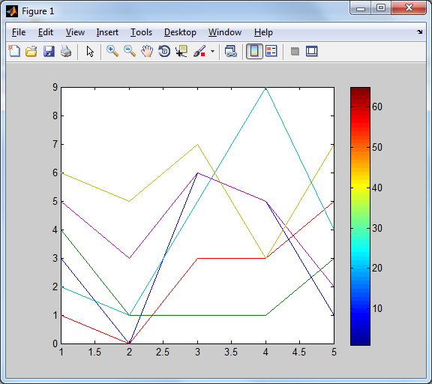

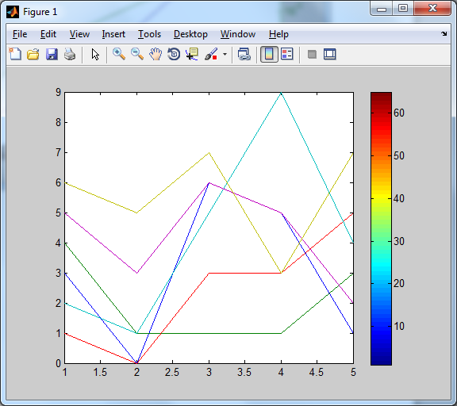

>> plot(V)

>> hold on;

>> grid on;

>> imagesc(V)

>> colorbar

