|  |  |
| --- | --- |
| **DOCUMENT RULES:** | |
| **Task Number / Name:** | **Task3 / Setting up Kubernetes on AWS (Amazon)** |
| **Task name & column name should be written:** | **Bold (CTRL+B)** |
| **Commands should be written in the after # sign:** | *Italic (CTRL+I) #hostname* |
| **Output photo should be cropped or compressed:**  **Photo could be more than one:**  **If you need extra lines, add the line next after it:** | ***Description photo should be with title bar (CTRL + I + B)*** |
| **All other text should be written:** | Standard |
| **Font name and text size:** | Calibri and 9 |
| **Group name:** | Dev_ops_ |
| **Student name and surname:** | Murad Abbaszade |
| **E-mail:** | [muradabbaszade6@gmail.com](mailto:muradabbaszade6@gmail.com) |
| **WhatsApp number:** | **+994703664205** |

|  |  |  |
| --- | --- | --- |
| **#** | **Task names** | **Command steps and outputs** |
| **1** | 1. **Lab requirements:**   **-We need Ubuntu VM on Desktop Hypervisor with Snapshoot**  **- MobaXterm terminal Client software should access to guest VM** | Ubuntu 18.04 Bionic Beaver mini.iso |
| **2** | 1. **Check status of firewall and take screenshot of the CLI output.** 2. **If firewall is not installed left it as have.** 3. **Give permanent SSH access from.** 4. **SSH virtual port is 22. If SSH server is not installed, please install it.** 5. **To be check connectivity use commands.** 6. **Update the system and application.** | **For instance: start**, **stop**, **enable**, **disable, status**  *# firewall-cmd –state*  #*ping x.x.x.x*  *#telnet x.x.x.x 22*  *#sudo apt-get update* |
| **3** | **Go to this site and start to install**  *-on the Linux, macOS, and Windows*  *Note: try to install on windows too* | [**https://github.com/kubernetes/kops/blob/master/docs/install.md**](https://github.com/kubernetes/kops/blob/master/docs/install.md) |
| **3.1** | **Installing kOps (Binaries)**  *-Step 1 install kops on the VM* | **From Github:**  *# curl -Lo kops https://github.com/kubernetes/kops/releases/download/$(curl -s https://api.github.com/repos/kubernetes/kops/releases/latest | grep tag_name | cut -d '"' -f 4)/kops-darwin-amd64* |
| *#chmod +x ./kops* |
| *#sudo mv ./kops /usr/local/bin/* |
| **3.2** | Installing Other Dependencies-Step 2 install pip*-Python-pip allow to use AWS command line utility**-Python-pip allow to install AWS* | **From the official kubernetes kubectl release:**  *# curl -Lo kubectl https://storage.googleapis.com/kubernetes-release/release/$(curl -s https://storage.googleapis.com/kubernetes-release/release/stable.txt)/bin/darwin/amd64/kubectl* |
| *#chmod +x ./kubectl* |
| *#sudo mv ./kubectl /usr/local/bin/kubectl* |
| **3.3** | Install pip tool | *# sudo apt install python-pip* |
| **3.4** | **Installing AWS CLI Tools**  *-AWS CLI is utility managing* | **The officially supported way of installing the tool is with pip:**  *#pip install awscli* |

|  |  |
| --- | --- |
| **DOCUMENT RULES:** | |
| **Task Number / Name:** | **Task4 / Preparing AWS for kops install** |
| **Task name & column name should be written:** | **Bold (CTRL+B)** |
| **Commands should be written in the after # sign:** | *Italic (CTRL+I) #hostname* |
| **Output photo should be cropped or compressed:**  **Photo could be more than one:**  **If you need extra lines, add the line next after it:** | ***Description photo should be with title bar (CTRL + I + B)***   |
| **All other text should be written:** | Standard |
| **Font name and text size:** | Calibri and 9 |
| **Group name:** | Dev_ops_ |
| **Student name and surname:** | Murad Abbaszade |
| **E-mail:** | [muradabbaszade6@gmail.com](mailto:muradabbaszade6@gmail.com) |
| **WhatsApp number:** | **+994703664205** |

|  |  |  |
| --- | --- | --- |
| **#** | **Task names** | **Command steps and outputs** |
| **4.1** | **Register or login Amazon** [*https://signin.aws.amazon.com*](https://signin.aws.amazon.com) |  |
| **4.2** | **Login page** |  |
| **4.3** | **Console Home** |  |
| **4.4** | **You must create new account in the IAM Menu**  *(IAM) stand Identity and access management* | **Search for IAM in the Services -> click** |
| **4.5** | **Users menu -> Add user -> give user name as “Kops” -> click next permission button** |  |
| **4.6** | **Select -> Attach existing permission -> check box AdministratorAccess -> next tag** |  |
| **4.7** | **Skip this “Add tags” and click next: Review** |  |
| **4.8** | **Review it-> Click “Create user” button -> go ahead** |  |
| **4.9** | **Access key and Secret key will needed on AWS CLI** |  |
| **5.1** | **Login in mobaXterm and configure aws using commands below** | *# aws configure*  *AWS Access key ID [none] : “access key” -> hit enter*  *AWS Secret Access Key [None]: “Secret access key” -> hit enter*  *Default region name [None]: -left it default hit enter*  *Default output format [None]: -left it default hit enter* |
| **5.2** | **After AWS installation these files created in .aws** | *# ls -ahl ~/.aws/*  total 16K  drwxrwxr-x 2 **rahim** **rahim** 4.0K Jun 8 00:31 .  drwxr-xr-x 8 **rahim** **rahim** 4.0K Jun 8 00:31 ..  -rw------- 1 **rahim** **rahim** 10 Jun 8 00:33 config  -rw------- 1 **rahim** **rahim** 116 Jun 8 00:33 credentials |
| **6.1** | **(Object storage like Google Drive or Drop Box)**  **Create new bucket** |  |
| **6.2** | **In the AWS Portal go S3 menu ->**  **Create new bucket** |  |
| **6.3** | **If you can’t select AWS Region try this link, please**  [**https://www.cloudping.info/**](https://www.cloudping.info/) | **Bucket name:** *Kops-state-ADNSU01*  *Object Ownership-ACLs disabled*  **Block Public Access settings for this bucket -** Block *all* public access  **Bucket Versioning** – Disable  **Server-side encryption –** Disable  **> Create Bucket buton** |
| **6.4** | **Then go DNS (Route 53)**  **This is DNS management tool**  **Route 53 -> Hosted zones -> Create hosted zone menu** |  |
| **6.5** | **These records will be used in your own public DNS server.** |  |
| **6.6** | **My own public DNS server console**  **Temporary I am using modernhospital.az and I added 4 NS DNS records**  **Kubernetes as a host** | Temporary DNS records  kubernetes.modernhospital.az  TTL 172800  ns-1312.awsdns-36.org.  ns-526.awsdns-01.net.  ns-347.awsdns-43.com.  ns-1630.awsdns-11.co.uk. |
|  |  |  |

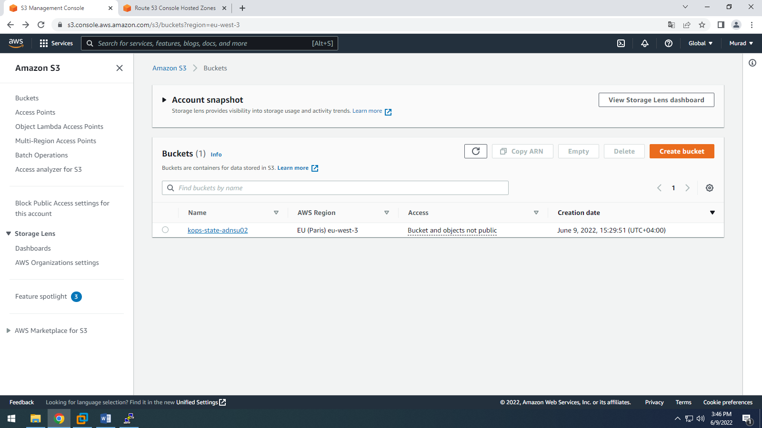

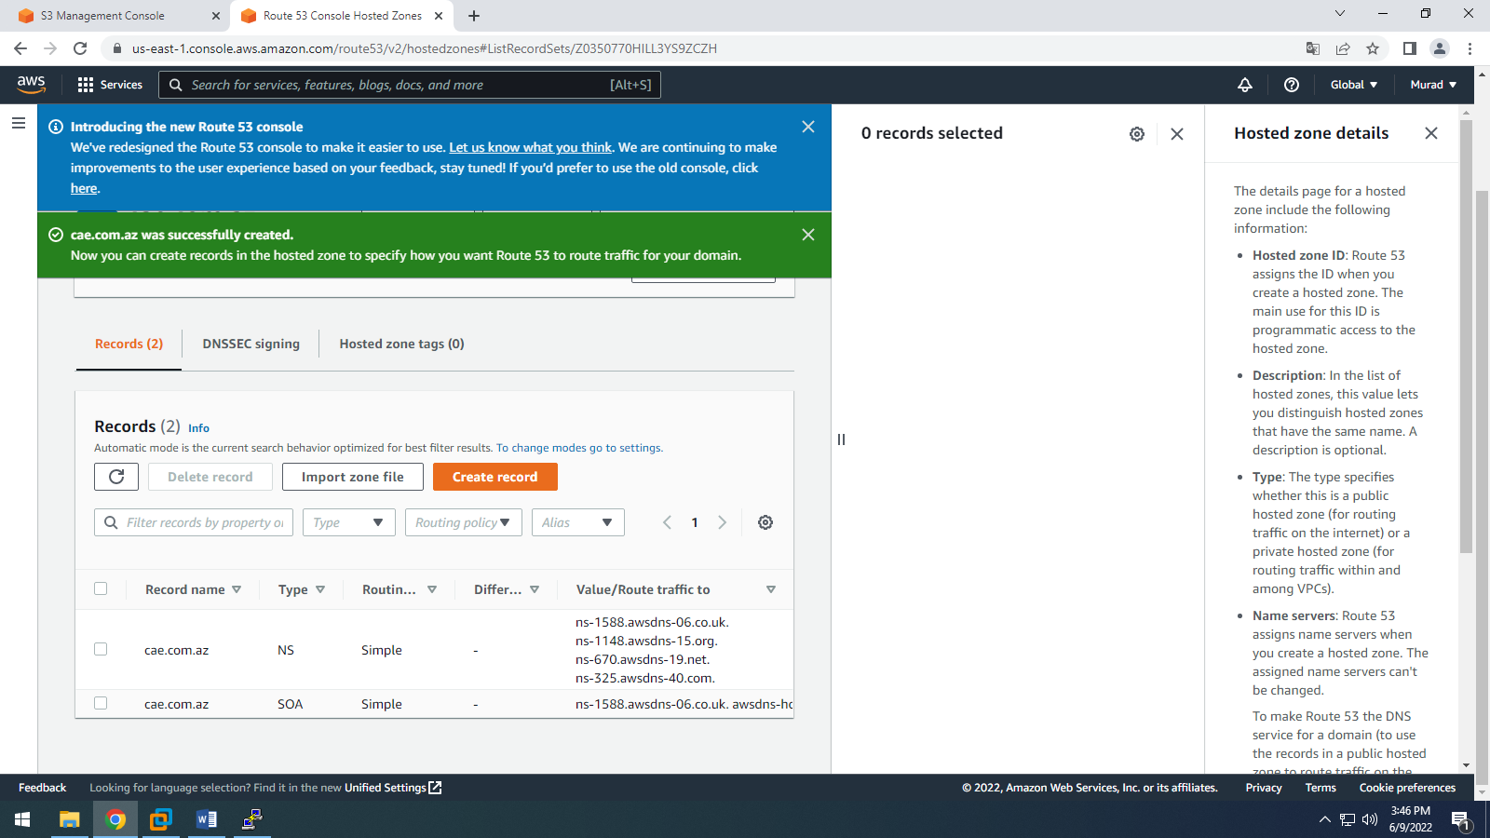

|  |  |
| --- | --- |
| **DOCUMENT RULES:** | |
| **Task Number / Name:** | **Task5 / DNS Troubleshooting** |
| **Task name & column name should be written:** | **Bold (CTRL+B)** |
| **Commands should be written in the after # sign:** | *Italic (CTRL+I) #hostname* |
| **Output photo should be cropped or compressed:**  **Photo could be more than one:**  **If you need extra lines, add the line next after it:** | ***Description photo should be with title bar (CTRL + I + B)***   |
| **All other text should be written:** | Standard |
| **Font name and text size:** | Calibri and 9 |
| **Group name:** | Dev_ops_ |
| **Student name and surname:** | Murad Abbaszade |
| **E-mail:** | [muradabbaszade6@gmail.com](mailto:muradabbaszade6@gmail.com) |
| **WhatsApp number:** | **+994703664205** |

|  |  |  |
| --- | --- | --- |
| **#** | **Task names** | **Command steps and outputs** |
| **1** | **For DNS Troubleshooting go to the Linux Guest VM and install Ubuntu Linux DNS tools** | *#* *sudo apt install bind9* |
| **2** | **Add some records in the DNS Host file in the Guest VM.**  **If you resolve the Kubernetes.modernhospital.az it show you Amazon name server Route 53.**  **These records are same as Hosted Zone Records** | # host -t NS Kubernetes.modernhospital.az – hit enter and result mus be below |
| **3** | **If you accidentally will create main name of the whole domain name modernhospital.az there will no problem because Hostgator still responsible for root domain.** | Look whois command |
| **4** | **Some helpful commands install it please** | # sudo apt install whois  # whois modernhospital.az |
| **5** | **Please learn all DNS rules about AWS from outsource** |  |
| **6** | **If you will create main domain name modernhospital.az although it is not impact your ns routing and then add kubernetes’s records to root domain inside of the AWS** | You can delete Kubernetes.modernhopsital.az record and keep modernhospital.az records it will also works. |
| **7** | **Keep in mind**   1. **This is cluster name as DNS name** 2. **You have API.kubernetes.modernhospital.az or api.modernhopsital.az** |  |
| **8** | **As a result you will check it again** | # host -t NS Kubernetes.modernhospital.az – hit enter to see correct route 53 zone |
| **9** | **DNS changes takes 30 minutes to propagate changes.** |  |

|  |  |
| --- | --- |
| **DOCUMENT RULES:** | |
| **Task Number / Name:** | **Task6 / Cluster setup on AWS using kops** |
| **Task name & column name should be written:** | **Bold (CTRL+B)** |
| **Commands should be written in the after # sign:** | *Italic (CTRL+I) #hostname* |
| **Output photo should be cropped or compressed:**  **Photo could be more than one:**  **If you need extra lines, add the line next after it:** | ***Description photo should be with title bar (CTRL + I + B)***   |
| **All other text should be written:** | Standard |
| **Font name and text size:** | Calibri and 9 |
| **Group name:** | Dev_ops_ |
| **Student name and surname:** | Murad Abbaszade |
| **E-mail:** | [muradabbaszade6@gmail.com](mailto:muradabbaszade6@gmail.com) |
| **WhatsApp number:** | **+994703664205** |

|  |  |  |
| --- | --- | --- |
| **#** | **Task names** | **Command steps and outputs** |
| **1.1** | **Log in ubuntu-(bionic)/xenial in Guest VM** |  |
| **1.2** | **Before submitting the cluster check Kubernetes latest version using link**  **Which command shows version / edition** | [*https://kubernetes.io/docs/tasks/tools/install-kubectl-linux/*](https://kubernetes.io/docs/tasks/tools/install-kubectl-linux/) |
| **1.3** | **Start Kubernetes** | *#kubectl -> hit enter* |
| **2.0** | **Before creating cluster, you must create ssh key**  **id_rsa – is private key**  **rsa.pub – is public key** | *#ssh-keygen -f .ssh/id_rsa -> hit enter*  *#cat .ssh/id_rsa.pub ->Hit enter*  *\*\*generated key will be uploaded to our instances\*\** |
|  |  |  |