Ansible(101)

apt install -y python3-pip && mkdir -p /opt/kata-materials && cd /opt/kata-materials && git clone --depth 1 https://github.com/irixjp/katacoda-scenarios.git . && pip install virtualenv && virtualenv ansible && source /opt/kata-materials/ansible/bin/activate && cd tools && bash ./kata_setup.sh && cd ~/

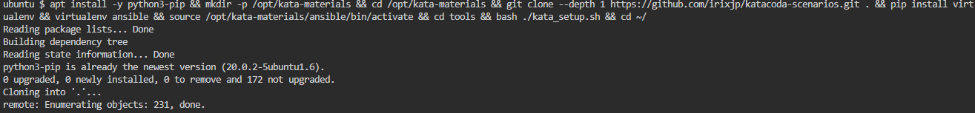

Environment Overview

In this exercise, we will use an environment built as follows. Three servers, node-1 , node-2 , and node-3 , are running, and we will use Ansible to perform various automated operations on them.

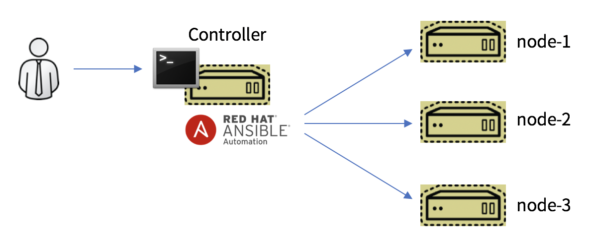

First, please run the following command. This is using Ansible to check the disk usage of the three exercise nodes.

cd ~/

ansible all -m shell -a 'df -h'

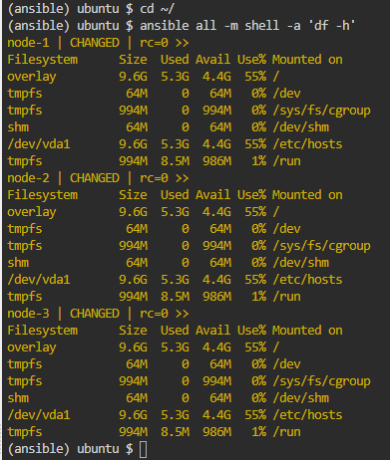

ansible --version

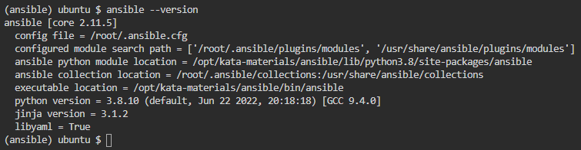

If you run the ansible command with the --version option, it will output some basic information about the execution environment. This includes the version and the Python version you are using. Here we will focus on the following line.

* config file = /root/.ansible.cfg

cat ~/.ansible.cfg

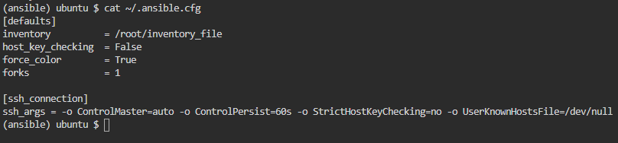

cat ~/inventory_file

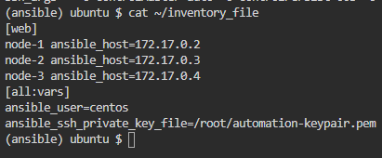

ansible web -i ~/inventory_file -m ping -o



ansible web -m ping -o



ansible node-1 -m ping -o



ansible node-1,node-3 -m ping -o



ansible all -m ping -o



ansible web --list-hosts

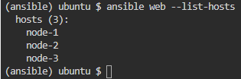

ansible node-2 --list-hosts

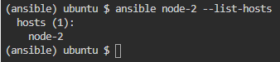

ansible all -u centos --private-key ~/aitac-automation-keypair.pem -m ping

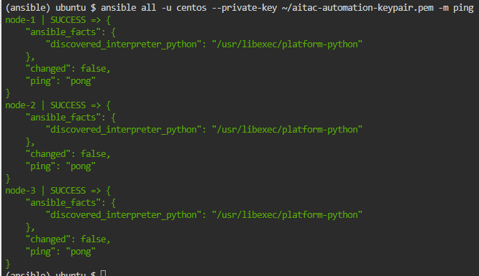

* -u centos : Specify the user name to use for login.
* --private-key : Specify the private key to use for login.

ansible-doc -l

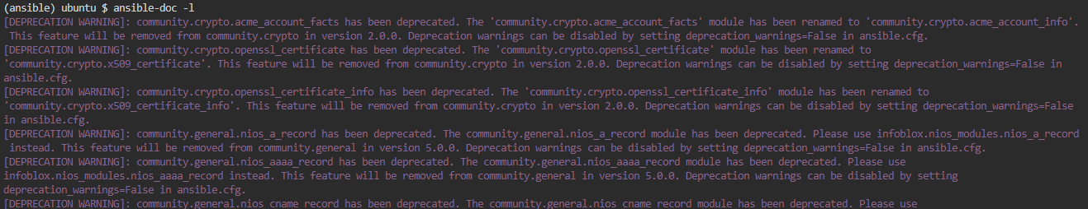

ansible-doc dnf

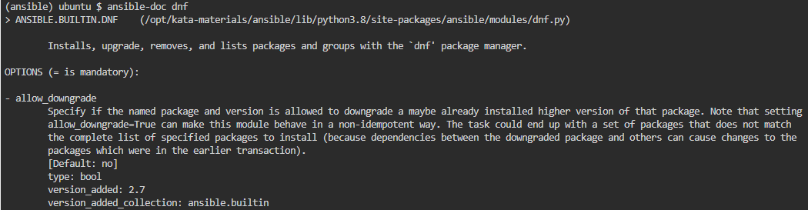

ansible all -m ping

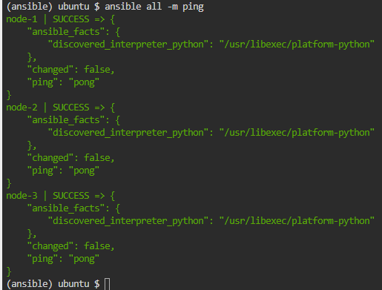

ansible all -m shell -a 'hostname'

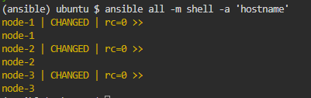

ansible all -m shell -a 'uname -a'

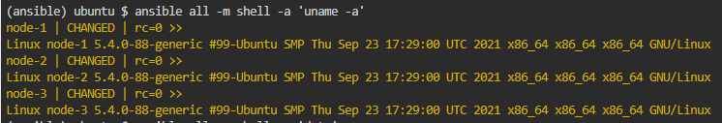

ansible all -m shell -a 'date'

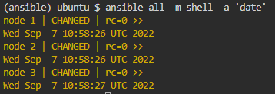

ansible all -m shell -a 'df -h'

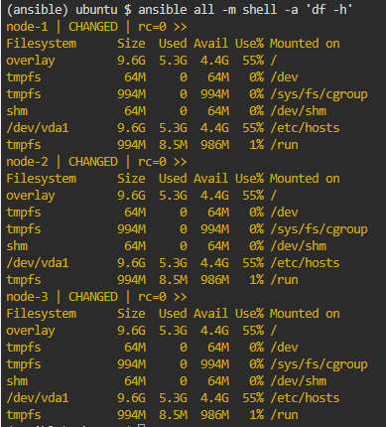

ansible all -m shell -a 'rpm -qa |grep bash'

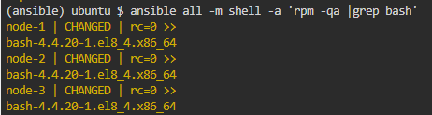

ansible node-1 -b -m dnf -a 'name=screen state=latest'

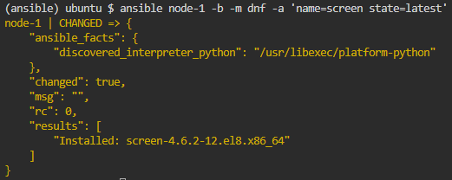

ansible node-1 -m shell -a 'which screen'



Ansible(102)

apt install -y python3-pip && mkdir -p /opt/kata-materials && cd /opt/kata-materials && git clone --depth 1 https://github.com/irixjp/katacoda-scenarios.git . && pip install virtualenv && virtualenv ansible && source /opt/kata-materials/ansible/bin/activate && cd tools && bash ./kata_setup.sh && cd ~/

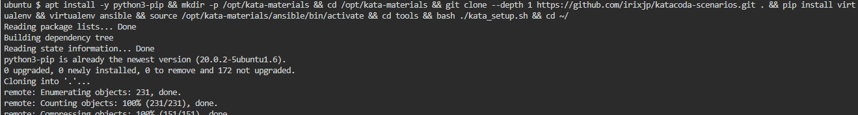

Please edit ~/working/vars_debug_playbook.yml as follows.

---

- hosts: node-1

gather_facts: no

tasks:

- name: print all variables

debug:

var: vars

- name: get one variable

debug:

msg: "This value is {{ vars.ansible_version.full }}"

cd ~/working

ansible-playbook vars_debug_playbook.yml

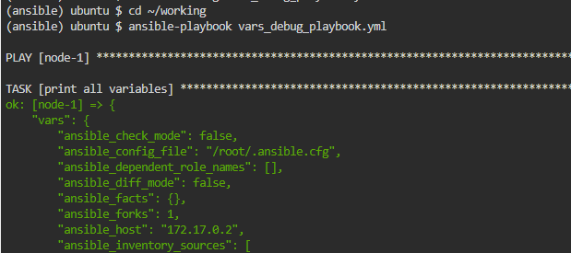

Please edit ~/working/vars_play_playbook.yml as follows.

---

- hosts: node-1

gather_facts: no

vars:

play_vars:

- order: 1st word

value: ansible

- order: 2nd word

value: is

- order: 3rd word

value: fine

tasks:

- name: print play_vars

debug:

var: play_vars

- name: access to the array

debug:

msg: "{{ play_vars[1].order }}"

- name: join variables

debug:

msg: "{{ play_vars[0].value}} {{ play_vars[1].value }} {{ play_vars[2].value

}}"

cd ~/working

ansible-playbook vars_play_playbook.yml

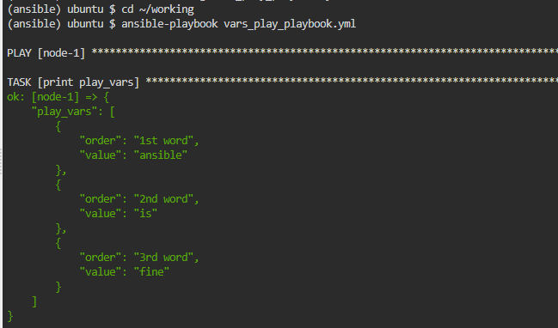

Let's edit ~/working/vars_task_playbook.yml as follows.

---

- hosts: node-1

gather_facts: no

vars:

task_vars: 100

tasks:

- name: print task_vars 1

debug:

var: task_vars

- name: override task_vars

debug:

var: task_vars

vars:

task_vars: 20

- name: print task_vars 2

debug:

var: task_vars

ansible-playbook vars_task_playbook.yml

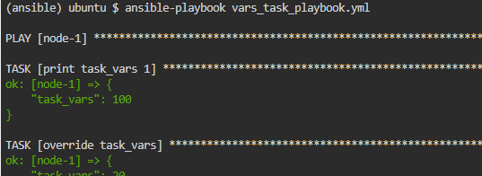

ansible-playbook vars_task_playbook.yml -e 'task_vars=50'

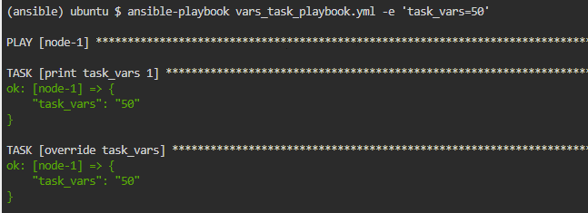

### **~/working/group_vars/all.yml**

Let's define the group variables.

---

vars_by_group_vars: 1000

### **~/working/host_vars/node-1.yml**

Define the host variables for node-1.

---

vars_by_host_vars: 111

### **~/working/host_vars/node-2.yml**

Define the host variables for node-2.

---

vars_by_host_vars: 222

### **~/working/host_vars/node-3.yml**

Define the host variables for node-3.

---

vars_by_host_vars: 333

### **~/working/vars_host_group_playbook.yml**

Let's create a playbook that uses these variables.

---

- hosts: all

gather_facts: no

tasks:

- name: print group_vars

debug:

var: vars_by_group_vars

- name: print host vars

debug:

var: vars_by_host_vars

- name: vars_by_group_vars + vars_by_host_vars

set_fact:

cal_result: "{{ vars_by_group_vars + vars_by_host_vars }}"

- name: print cal_vars

debug:

var: cal_result

Edit ~/working/loop_playbook.yml as follows.

---

- name: add users by loop

hosts: node-1

become: yes

vars:

user_list:

- apple

- orange

- pineapple

tasks:

- name: add a user

user:

name: "{{ item }}"

state: present

loop: "{{ user_list }}"

cd ~/working

ansible-playbook loop_playbook.yml

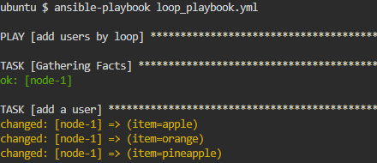

ansible node-1 -b -m shell -a 'cat /etc/passwd'

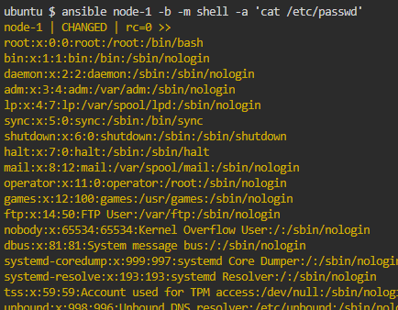

ansible-playbook loop_playbook.yml

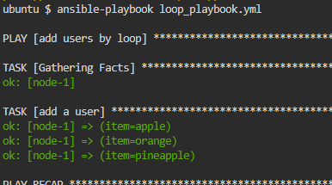

Let's write the following ~/working/when_playbook.yml .

---

- name: start httpd if it's stopped

hosts: node-1

become: yes

tasks:

- name: install httpd

yum:

name: httpd

state: latest

- name: check httpd processes is running

shell: ps -ef |grep http[d]

register: ret

ignore_errors: yes

changed_when: no

- name: print return value

debug:

var: ret

- name: start httpd (httpd is stopped)

service:

name: httpd

state: started

when:

ansible-playbook when_playbook.yml

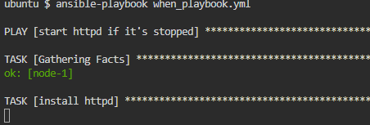

ansible-playbook when_playbook.yml

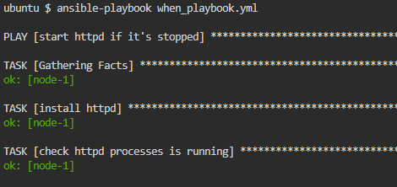

ansible node-1 -m fetch -a 'src=/etc/httpd/conf/httpd.conf dest=files/httpd.conf flat=yes'

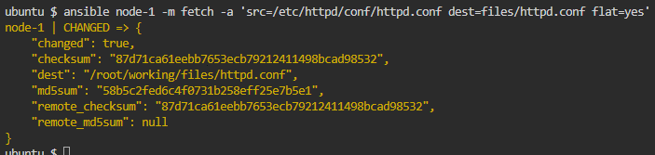

Edit ~/working/handler_playbook.yml as follows:

---

- name: restart httpd if httpd.conf is changed

hosts: node-1

become: yes

tasks:

- name: Copy Apache configuration file

copy:

src: files/httpd.conf

dest: /etc/httpd/conf/

notify:

- restart_apache

handlers:

- name: restart_apache

service:

name: httpd

state: restarted

ansible-playbook handler_playbook.yml

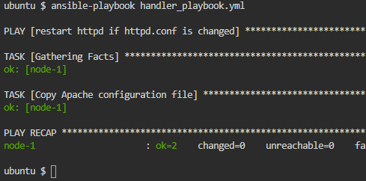

Edit the ~/working/block_playbook.yml

---

- name: using block statement

hosts: node-1

become: yes

tasks:

- name: Install, configure, and start Apache

block:

- name: install httpd

yum:

name: httpd

state: latest

- name: start & enabled httpd

service:

name: httpd

state: started

enabled: yes

- name: copy index.html

copy:

src: files/index.html

dest: /var/www/html/

when:

ansible-playbook block_playbook.yml -e 'exec_block=no'

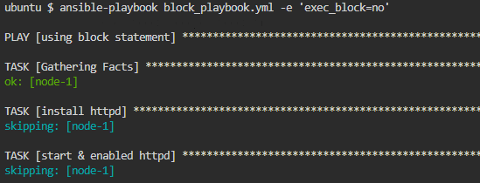

ansible-playbook block_playbook.yml -e 'exec_block=yes'

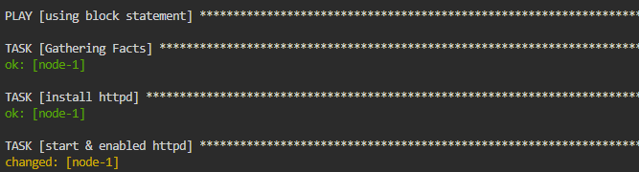

Create ~/working/rescue_playbook.yml as follows.

---

- name: using block, rescue, always statement

hosts: node-1

become: yes

tasks:

- block:

- name: block task

debug:

msg: "message from block"

- name: check error flag in block

assert:

that:

- error_flag == 'no'

rescue:

- name: rescue task

debug:

msg: "message from rescue"

- name: check error flag in rescue

assert:

that:

- error_flag == 'no'

always:

- name: always task

debug:

ansible-playbook rescue_playbook.yml -e 'error_flag=no'

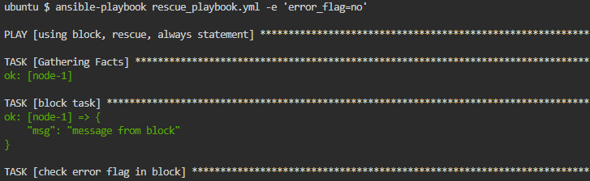

ansible-playbook rescue_playbook.yml -e 'error_flag=yes'

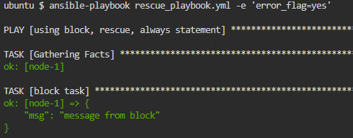

Please create a file ~/working/templates/index.html.j2 and edit its contents to be as follows. This file will be the jinja2 template file.

<html><body>

<h1>This server is running on {{ inventory_hostname }}.</h1>

{% if LANG == "JP" %}

Konnichiwa!

{% else %}

Hello!

{% endif %}

</body></html>

~/working/template_playbook.yml and try to run the template. Please edit template_playbook.yml as follows.

---

- name: using template

hosts: web

become: yes

tasks:

- name: install httpd

yum:

name: httpd

state: latest

- name: start & enabled httpd

service:

name: httpd

state: started

enabled: yes

- name: Put index.html from template

template:

src: templates/index.html.j2

dest: /var/www/html/index.html

cd ~/working

ansible-playbook template_playbook.yml -e 'LANG=JP'

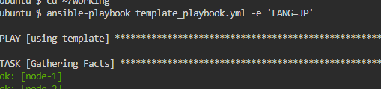

ansible web -m uri -a 'url=http://localhost/ return_content=yes'

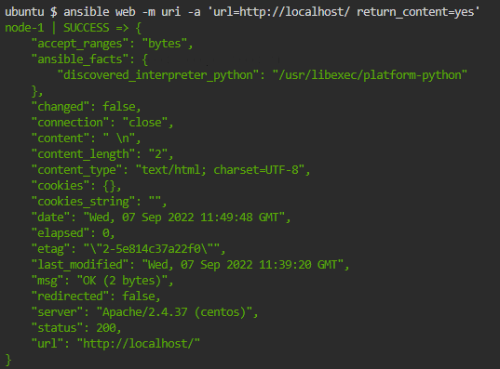

ansible-playbook template_playbook.yml -e 'LANG=EN'

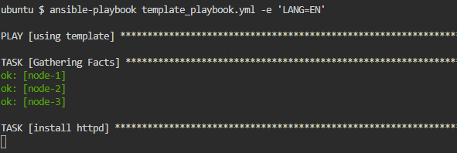

ansible web -m uri -a 'url=http://localhost/ return_content=yes'

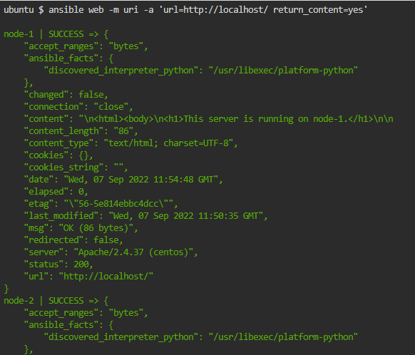

ansible node-1 -m debug -a 'msg={{ hoge | default("abc") }}'

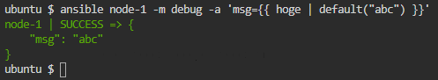

ansible node-1 -e 'str=abc' -m debug -a 'msg="{{ str | upper }}"'

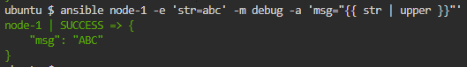

ansible node-1 -m debug -a 'msg="{{ [5, 1, 10] | min }}"'



ansible node-1 -m debug -a 'msg="{{ [5, 1, 10] | max }}"'

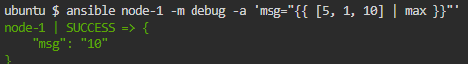

Ansible(103)

apt install -y python3-pip && mkdir -p /opt/kata-materials && cd /opt/kata-materials && git clone --depth 1 https://github.com/irixjp/katacoda-scenarios.git . && pip install virtualenv && virtualenv ansible && source /opt/kata-materials/ansible/bin/activate && cd tools && bash ./kata_setup.sh && cd ~/

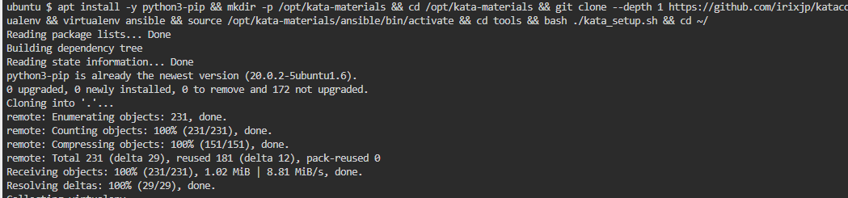

Edit ~/working/roles/web_setup/tasks/main.yml

---

- name: install httpd

yum:

name: httpd

state: latest

- name: start & enabled httpd

service:

name: httpd

state: started

enabled: yes

- name: Put index.html from template

template:

src: index.html.j2

dest: /var/www/html/index.html

- name: Copy Apache configuration file

copy:

src: httpd.conf

dest: /etc/httpd/conf/

notify:

- restart_apache

Edit ~/working/roles/web_setup/handlers/main.yml

---

- name: restart_apache

service:

name: httpd

state: restarted

Edit ~/working/roles/web_setup/defaults/main.yml

---

LANG: JP

Edit ~/working/roles/web_setup/templates/index.html.j2

<html><body>

<h1>This server is running on {{ inventory_hostname }}.</h1>

{% if LANG == "JP" %}

Konnichiwa!

{% else %}

Hello!

{% endif %}

</body></html>

cd ~/working/roles/web_setup

ansible node-1 -b -m yum -a 'name=httpd state=latest'

ansible node-1 -m fetch -a 'src=/etc/httpd/conf/httpd.conf dest=files/httpd.conf flat=yes'

Verify that the file has been retrieved.

ls -l files/

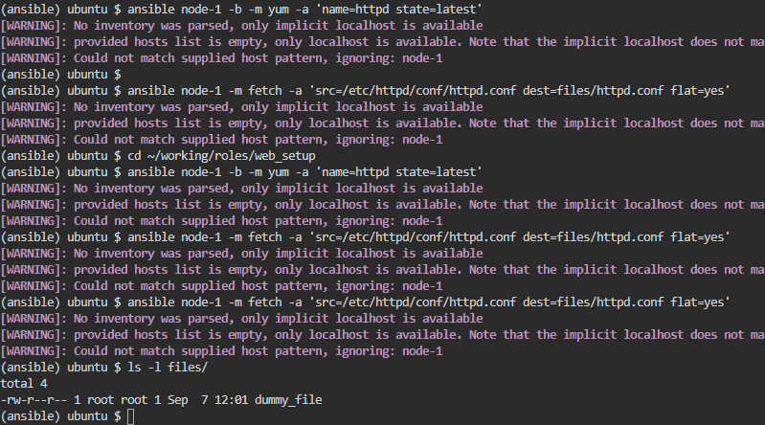

Edit ~/working/role_playbook.yml

Create a playbook that actually calls the role.

---

- name: using role

hosts: web

become: yes

tasks:

- import_role:

name: web_setup

Next, create a ~/working/galaxy_playbook.yml that uses this role.

---

- name: using galaxy

hosts: node-1

tasks:

- import_role:

name: irixjp.role_example_hello

- import_role:

name: irixjp.role_example_uptime

ansible-galaxy collection list

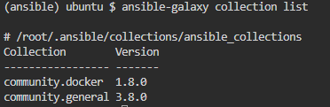

ansible-galaxy collection install cisco.ios

ansible-galaxy collection list

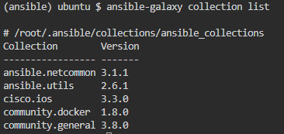

ansible-doc -l | wc -l

ls -alF ~/.ansible/collections/ansible_collections/

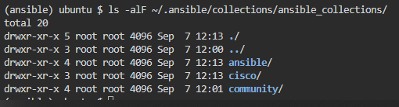

rm -rf ~/.ansible/collections/ansible_collections/{ansible,cisco}

ls -alF ~/.ansible/collections/ansible_collections/

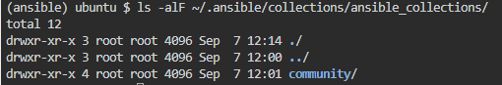

ansible-galaxy collection list

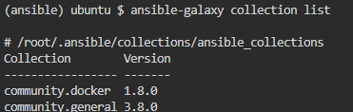

ansible-doc -l | wc –l

ansible-galaxy collection install cisco.ios:2.3.1 `

ansible-galaxy collection list

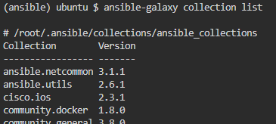

Please edit ~/working/collections/requirements.yml as follows.

---

collections:

- name: irixjp.sample_collection_hello

version: 1.0.0

cd ~/working

ansible-galaxy collection install -r collections/requirements.yml

ansible-galaxy collection list

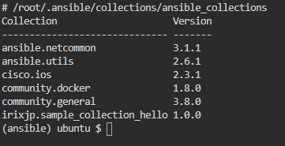

Edit ~/working/collection_playbook.yml as follows.

---

- name: using collection

hosts: node-1

tasks:

- import_role:

name: irixjp.sample_collection_hello.hello

- import_role:

name: irixjp.sample_collection_hello.uptime

- name: get locale

irixjp.sample_collection_hello.sample_get_locale:

register: ret

- debug: var=ret

ansible-playbook collection_playbook.yml

Ansible(104)

apt install -y python3-pip && mkdir -p /opt/kata-materials && cd /opt/kata-materials && git clone --depth 1 https://github.com/irixjp/katacoda-scenarios.git . && pip install virtualenv && virtualenv ansible && source /opt/kata-materials/ansible/bin/activate && cd tools && bash ./kata_setup.sh && cd ~/

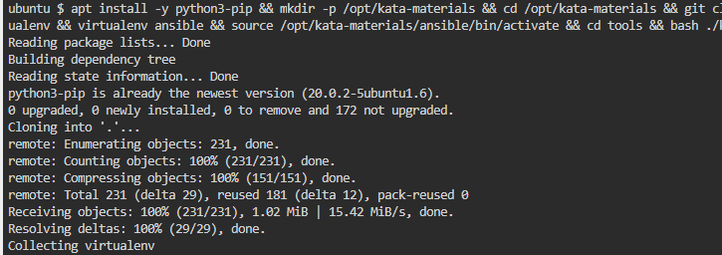

cd ~/working

ansible-playbook lint_ok_playbook.yml

ansible-playbook lint_ng_playbook.yml

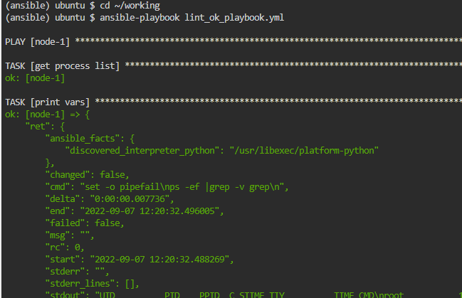

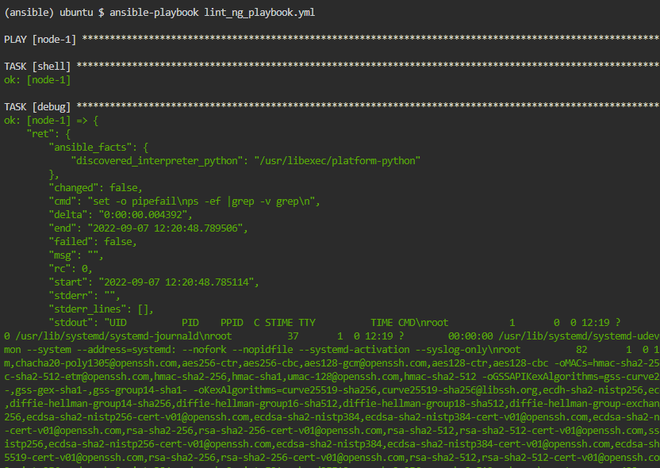

ansible-lint lint_ok_playbook.yml

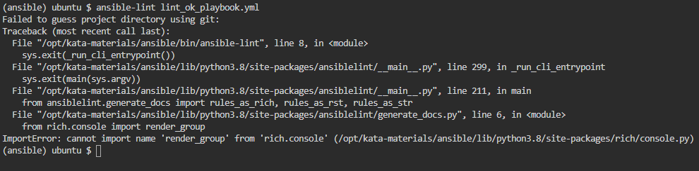

ansible-lint lint_ng_playbook.yml

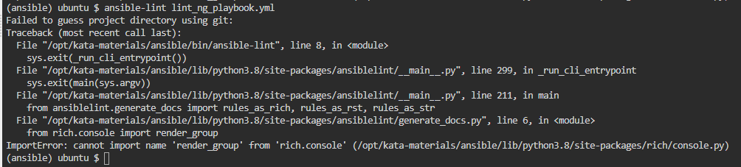

ansible-lint -L

ansible-lint –T

ansible node-1 -b -m yum -a 'name=httpd state=present'

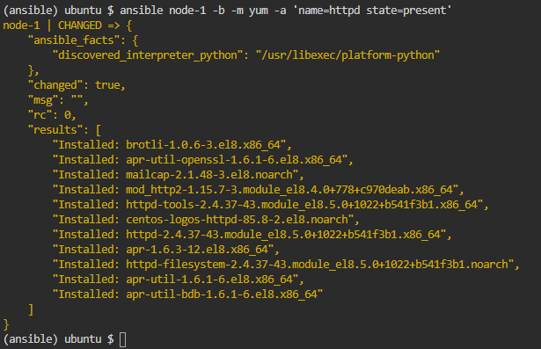

ansible node-1 -b -m systemd -a 'name=httpd state=started enabled=yes'

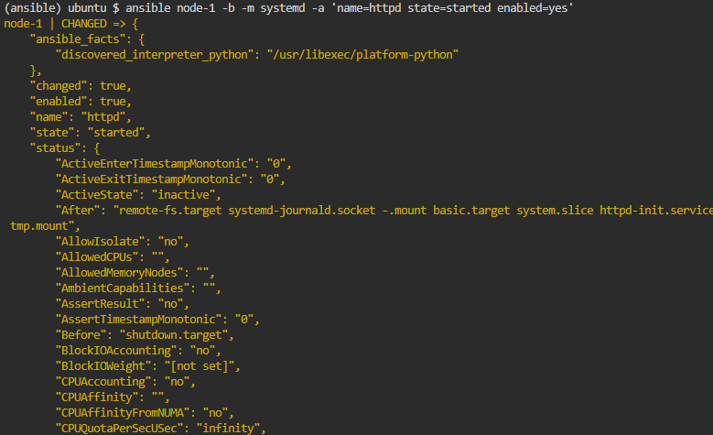

Edit the file ~/working/testing_assert_playbook.yml as follows.

---

- name: Test with assert

hosts: node-1

become: yes

gather_facts: no

tasks:

- ignore_errors: yes

block:

- name: Is httpd package installed?

shell: yum list installed | grep -e '^httpd\.'

register: ret_httpd_pkg

- name: check httpd processes is running

shell: ps -ef |grep http[d]

register: ret_httpd_proc

- name: Is httpd service enabled?

shell: systemctl is-enabled httpd

register: ret_httpd_enabled

- block:

- name: Assert results

assert:

that:

- ret_httpd_pkg.rc == 0

- ret_httpd_proc.rc == 0

- ret_httpd_enabled.rc == 0

cd ~/working

ansible-playbook testing_assert_playbook.yml

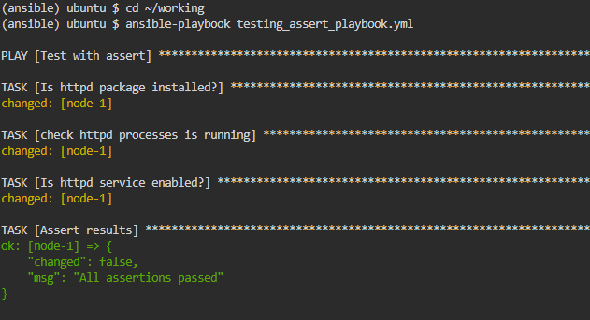

ansible node-1 -b -m systemd -a 'name=httpd state=stopped enabled=yes'

ansible-playbook testing_assert_playbook.yml

ansible node-1 -b -m systemd -a 'name=httpd state=started enabled=yes'

ansible-playbook testing_assert_playbook.yml

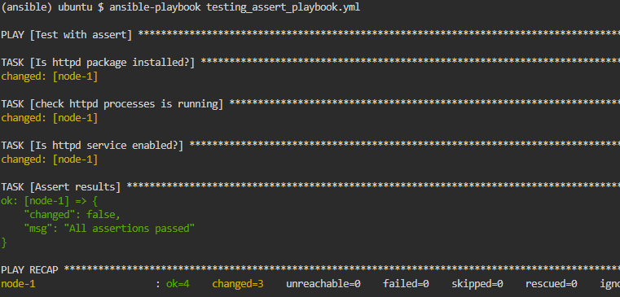

ansible node-1 -b -m systemd -a 'name=httpd state=stopped enabled=yes'

ansible-playbook testing_assert_playbook.yml

Create the file ~/working/reporting_playbook.yml as following.

---

- name: Report with Ansible

hosts: web

gather_facts: true

tasks:

- name: build report

copy:

content: |

# Server Configuration Reports: {{ inventory_hostname }}

---

| name | value |

| ---- | ------ |

{% for key, value in ansible_default_ipv4.items() %}

| {{ key }} | {{ value }} |

{% endfor %}

dest: /tmp/setting_report_{{ inventory_hostname }}.md

delegate_to: localhost

- name: concatenate reports

assemble:

src: /tmp

regexp: 'setting\_report\_*'

dest: setting_report.md

delimiter: "\n"

run_once: true

delegate_to: localhost

cd ~/working

ansible-playbook reporting_playbook.yml

