Docker

 Check docker version docker version / docker version | less

How many containers running : docker ps -a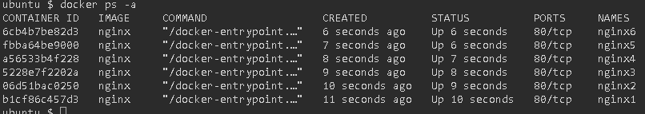

How many docker network configured

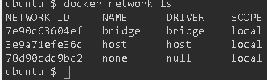

Docker pull image

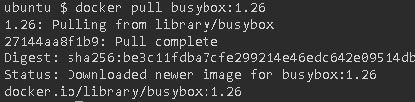

##### Docker Version



##### Docker help



##### Create image of NGINX in using centos image

##### Docker build .

##### 

##### Docker build –f /tmp/task3/Dockerfile .

##### 

##### Docker build –t my-nginx-centos:7

##### 