**CloudNative & Crossplane**

K8s-configuration

Kubernetes natively supports 2 resources geared towards storing configuration consumed by pods. Both configuration types required data to be represented in a *key:value* pair format.

* *Config Maps*: use to store non-confidential data
* *Secrets*: use to store confidential data (tokens, SSH keys, passwords, certificates, etc)

## Config Maps

k apply -f <https://raw.githubusercontent.com/Piotr1215/dca-exercises/master/k8s/configuration/1-create-configmap.yaml>



k apply -f <https://raw.githubusercontent.com/Piotr1215/dca-exercises/master/k8s/configuration/4-Create-deployment.yaml>



POD=$(kubectl get pods -n default | grep "nginx-test" | awk '{print $1}')



kubectl describe po $POD | grep Volumes: -A 9

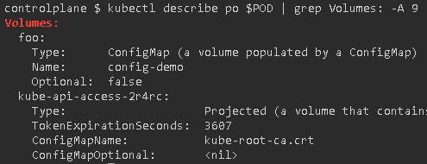

kubectl exec -it $POD – sh

cd /etc/foo ; ls ; cat api.properties ; cat deployment_env ; echo""

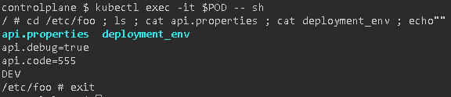

## Secrets

apply -f <https://raw.githubusercontent.com/Piotr1215/dca-exercises/master/k8s/configuration/3-create-secret-encoded.yaml>



k apply -f <https://raw.githubusercontent.com/Piotr1215/dca-exercises/master/k8s/configuration/5-create-deployment-secret.yaml>



k get secret

k describe secrets mysecret-encoded

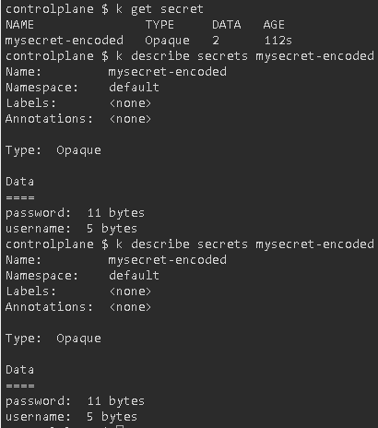

export POD=$(kubectl get pods -n default | grep "nginx-test" | awk '{print $1}')

kubectl describe po $POD | grep Volumes: -A 9

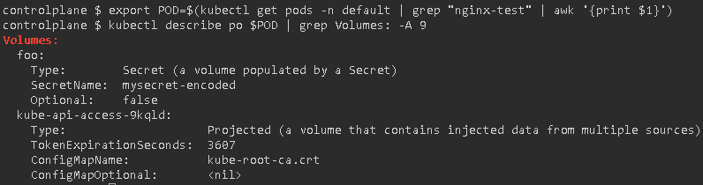

k exec -it $POD – sh

cd /etc/foo/

cat password

echo ""

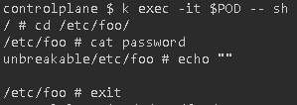

kubectl get secrets mysecret-encoded -n default -o jsonpath='{@.data.password}'| base64 --decode && echo



## Config Update

k apply -f <https://raw.githubusercontent.com/Piotr1215/dca-exercises/master/k8s/configuration/1-create-configmap.yaml>



k apply -f <https://raw.githubusercontent.com/Piotr1215/dca-exercises/master/k8s/configuration/4-Create-deployment.yaml>



export POD=$(kubectl get pods -n default | grep "nginx-test" | awk '{print $1}')

k exec -it $POD – sh

cd /etc/foo/

cat api.properties

cat deployment_env

echo ""

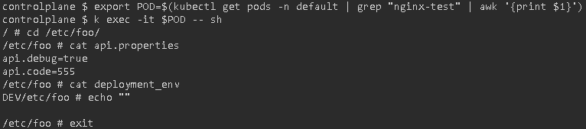

# K8s-deployments

## Cluster Setup

scp -pr .kube [root@node01:/root/.kube](mailto:root@node01:/root/.kube)

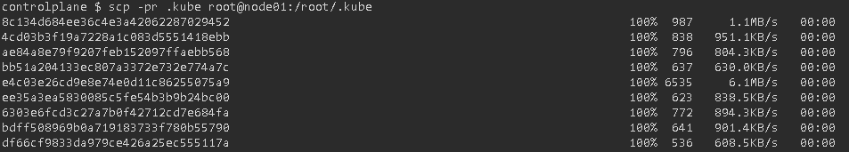

kubectl wait node --all --for=condition=Ready --timeout=3m****

kubectl get pods -n kube-system

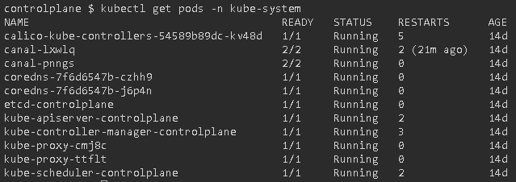

alias k=kubectl

kubectl cluster-info

kubectl version –short

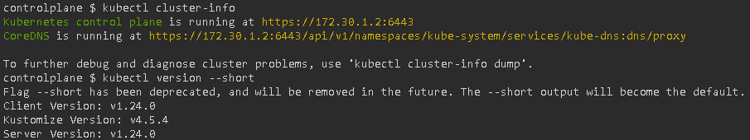

## Configuration

# K8s-jobs