Parts

Mounts
- 1201 Series Quad Block Pattern Mount (43-2)
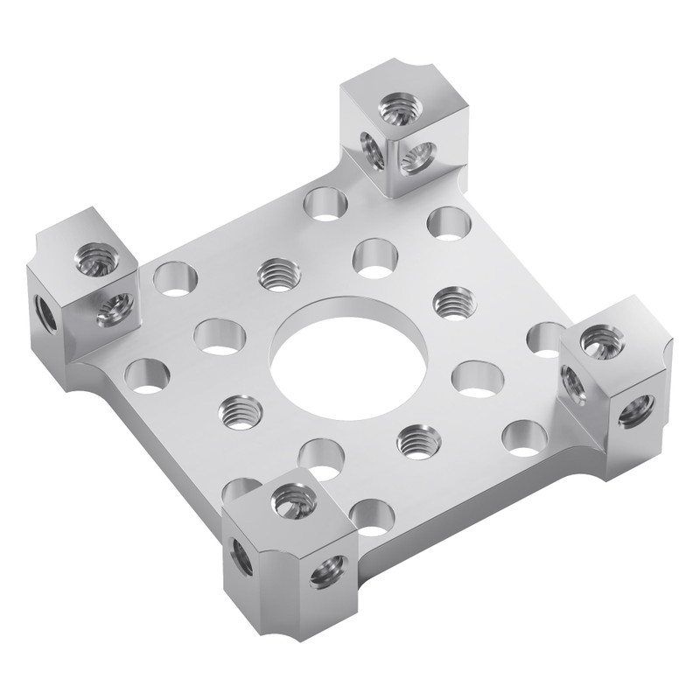

Brackets
- 1108-0001-0002 Flat Pattern Bracket (1-2)

Plates
- 2803-0039-0007 Stainless Steel Threaded Plate

Spacers
- 1522 Series 8mm ID Spacer (10mm OD, 9mm Length)
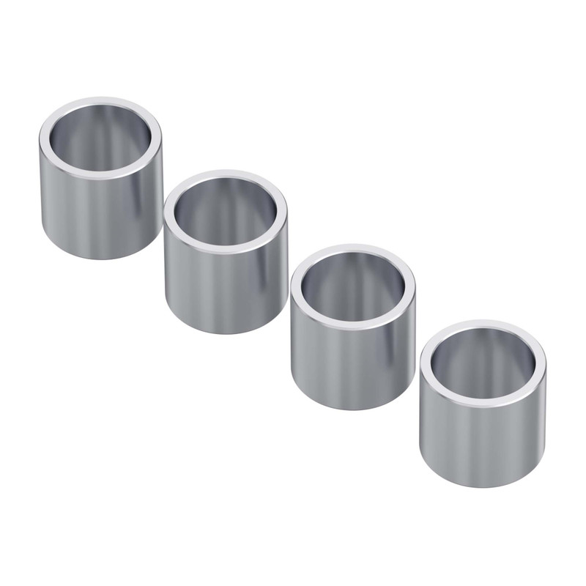

Gears
- 8mm REX™ Pinion Gears
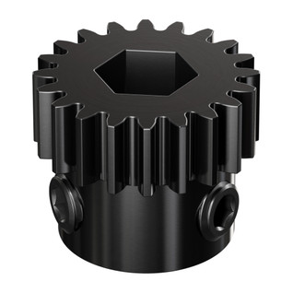
If your build is going to take a beating, consider 8mm REX™. These gears are constructed of hardened steel and mount with two set screws for excellent hold on 8mm REX™ shafting.
- Clamping Steel Miter Gear (8mm REX™ Bore, 24 Tooth, MOD 1)
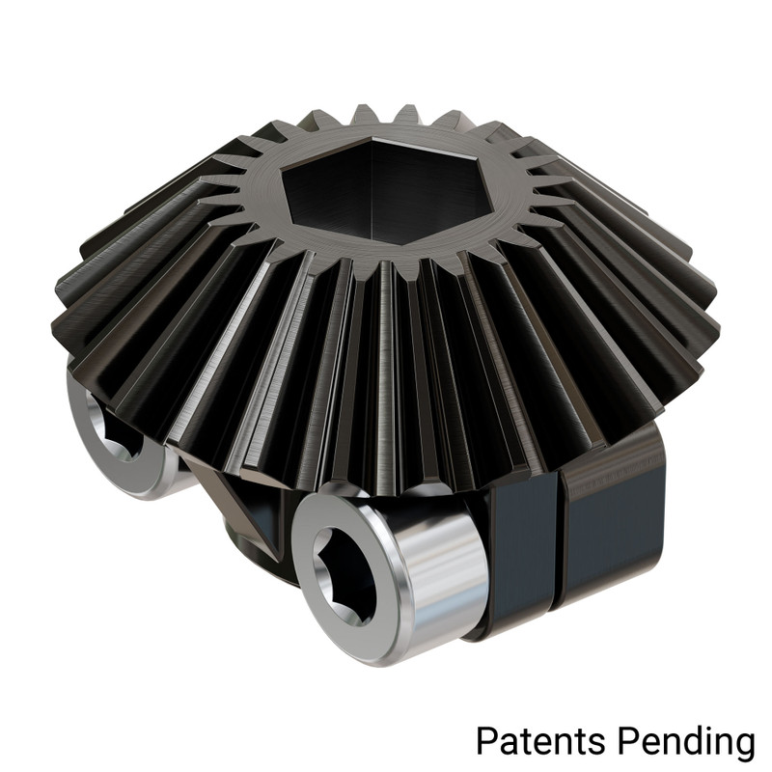

Sprockets
- 3307 Series 8mm Pitch Steel Set-Screw Sprocket (8mm REX™ Bore, 10 Tooth)
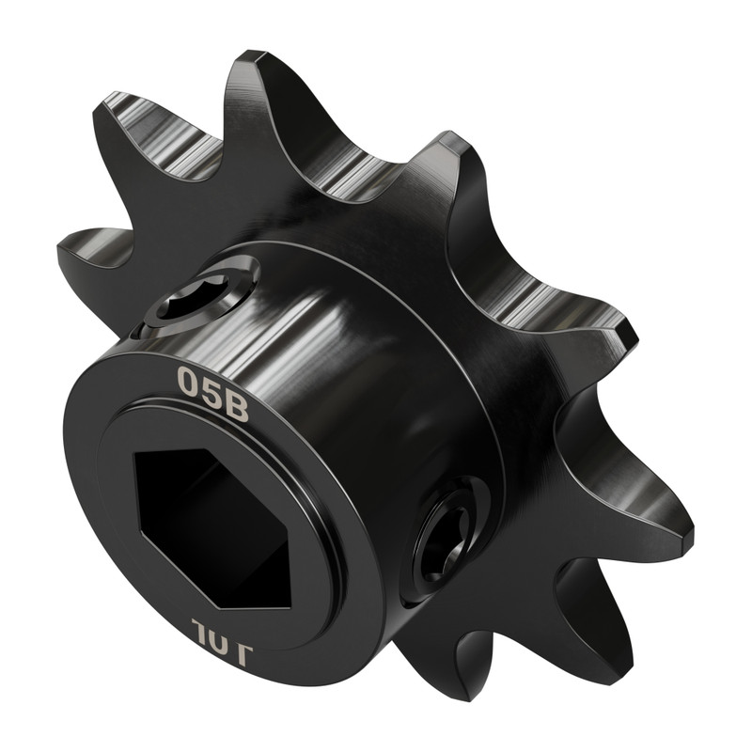

Shafts
- 2106 Series 8mm REX™ Stainless Steel Shafting
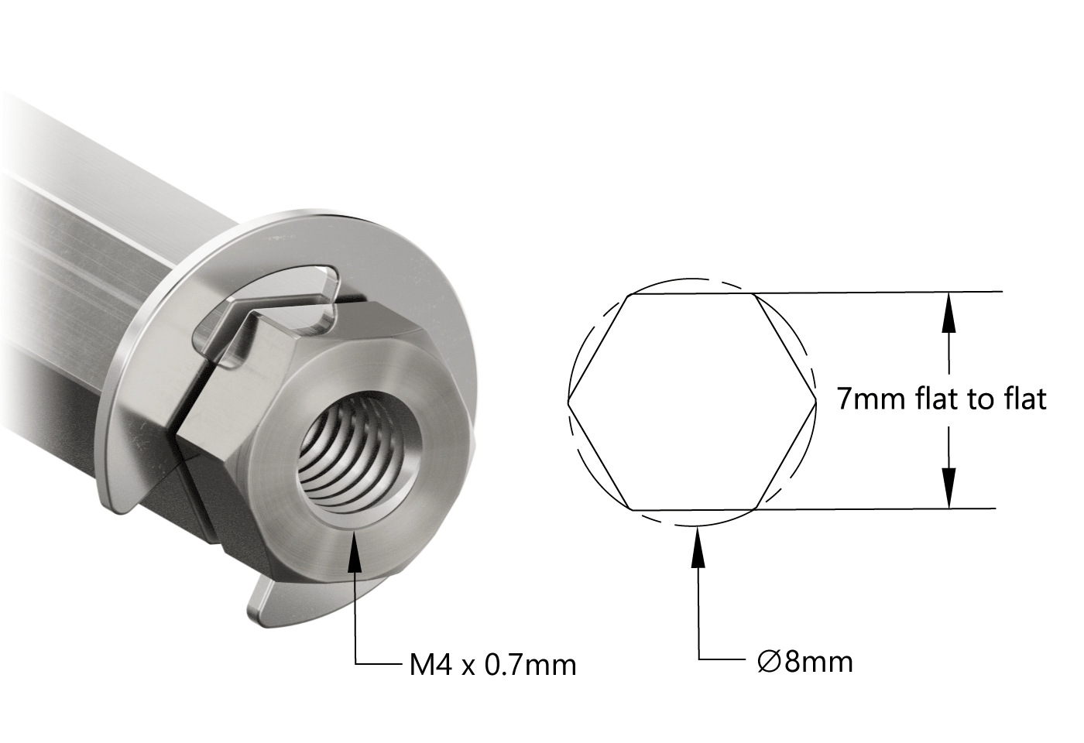
These 8mm REX™ Shafts have been tricked out with features that make them the go-to in many situations. The addition of an E-clip negates the need for a collar to hold bearings in place, and the threaded ends are an excellent addition for use as dead axles and super strong standoffs.
- Shouldered 8mm REX™ Hub-Shaft (20mm Hub Offset)
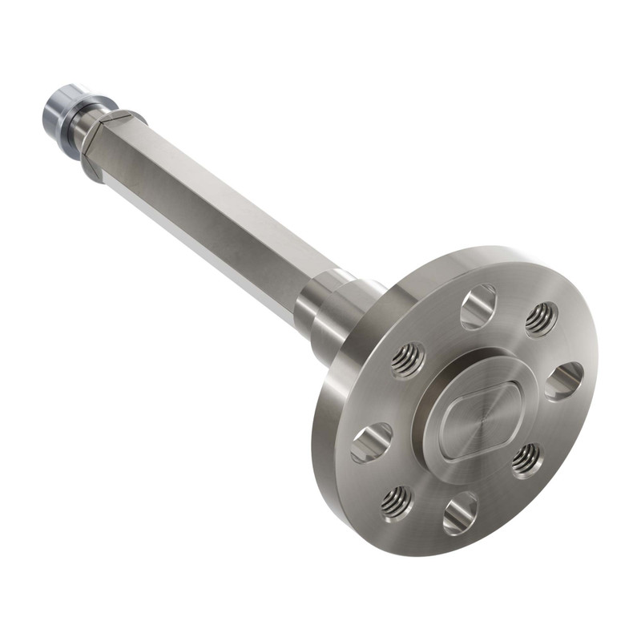
- 8mm Shaft (Stainless Steel, 25mm Length)
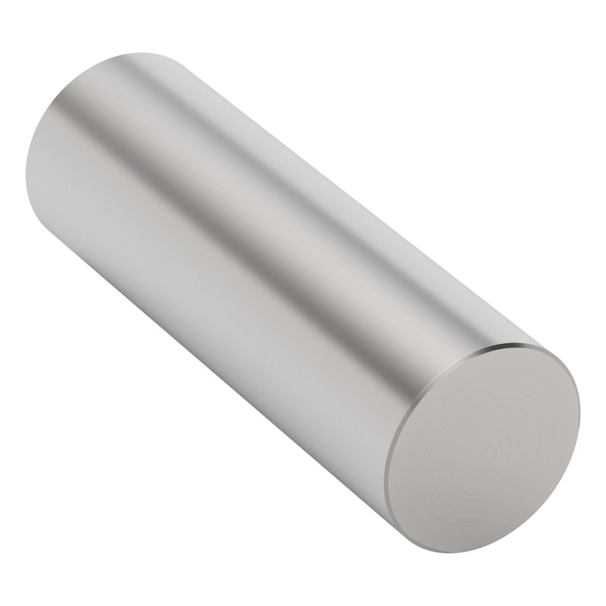

U-Channels
- 1121-0002-0072 Low-Side U-Channel (2 Hole, 72mm Length)
- 1121-0004-0120 Low-Side U-Channel (4 Hole, 120mm Length)
- 1120-0003-0096 U-Channel (3 Hole, 96mm Length)

Screws
- Premium M4 Socket Head Thread-Locking Screw (8mm Length)
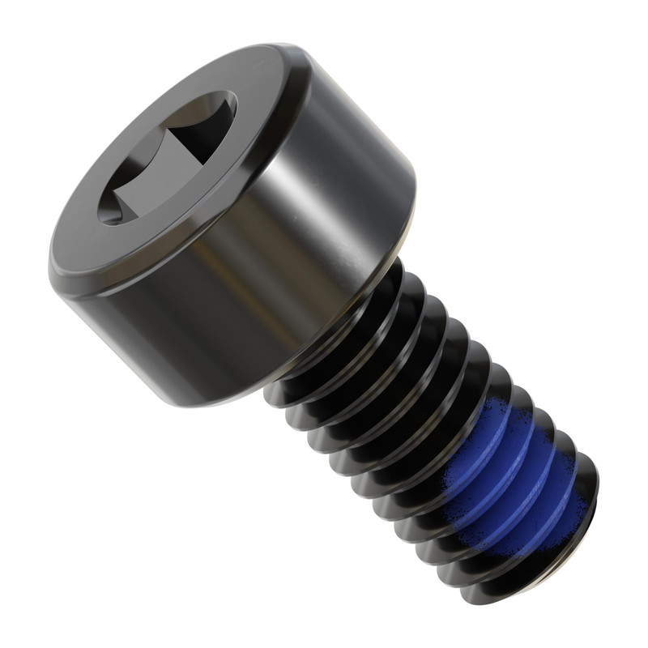

Shims
- 2807 Series Stainless Steel Shim (8mm ID x 11mm OD, 0.50mm Thickness)
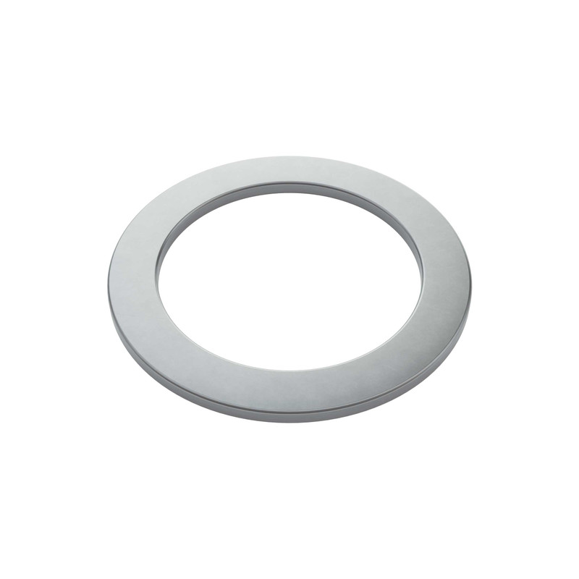

Ball Bearing
Bearings aid in creating low-friction motion assemblies. Many different styles are available, each with its own strong point.
- 1611 Series Flanged Ball Bearing (8mm REX™ ID x 14mm OD, 5mm Thickness)
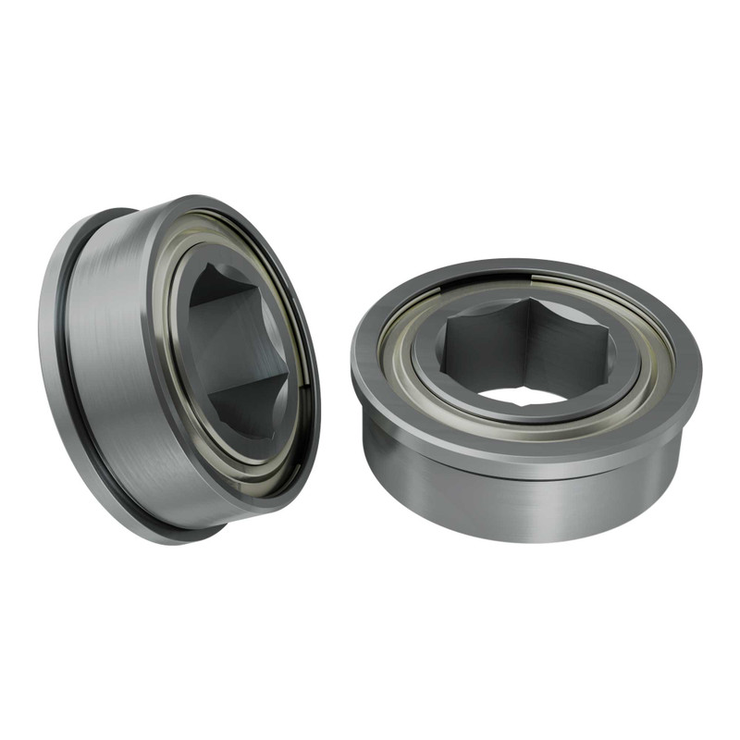
- 8mm REX™ Bore Flat Pillow Block (16mm x 32mm Mounting Pattern)
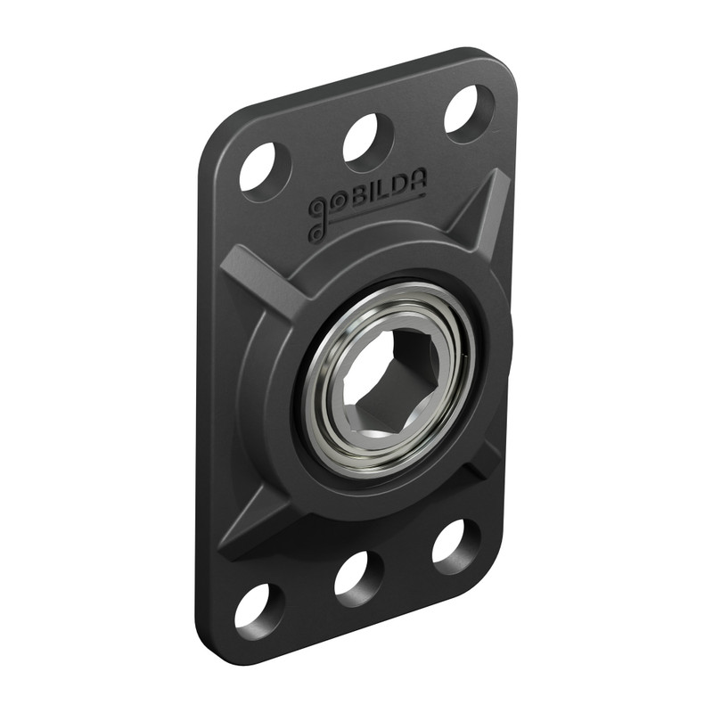
- Dual-Bearing Pillow Block (8mm REX™ Bore)
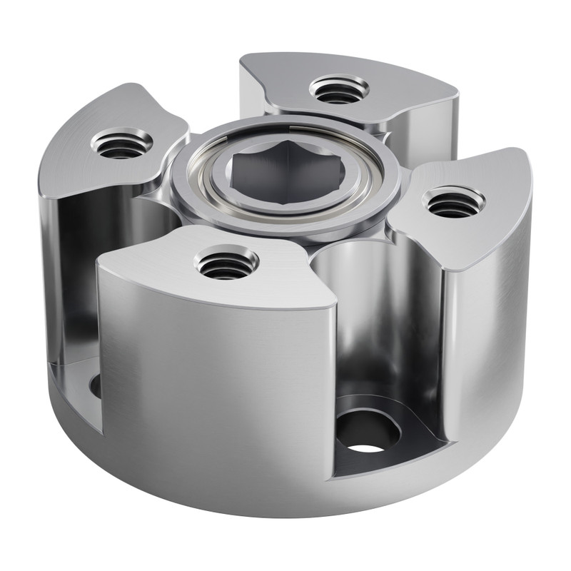
- 8mm REX™ Bore 2-Side, 1-Post Pillow Block (43mm Width)
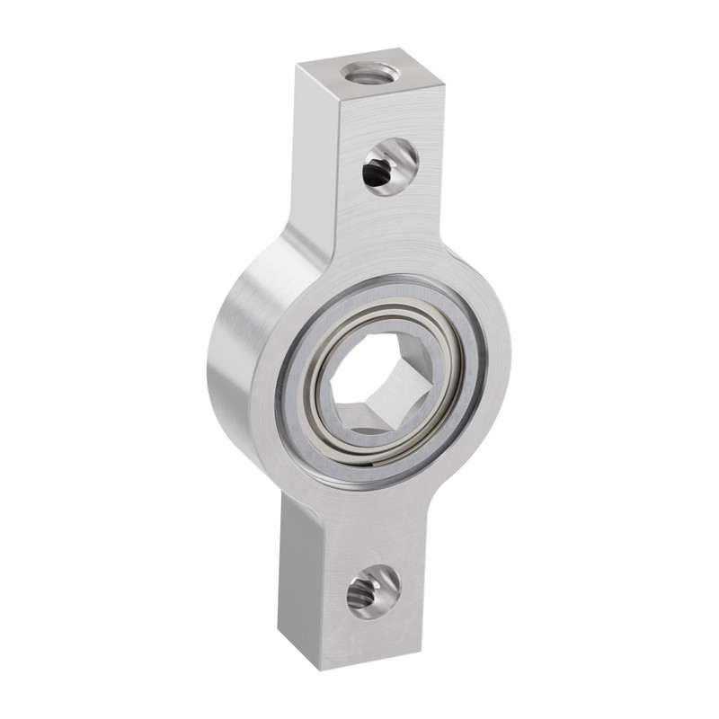
- 8mm ID Thrust Ball Bearing (15.5mm OD, 5mm Thickness)
Our 8mm thrust bearings can be used with 8mm diameter shafting and 8mm lead screws in order to isolate an axial load from other areas of your assembly.
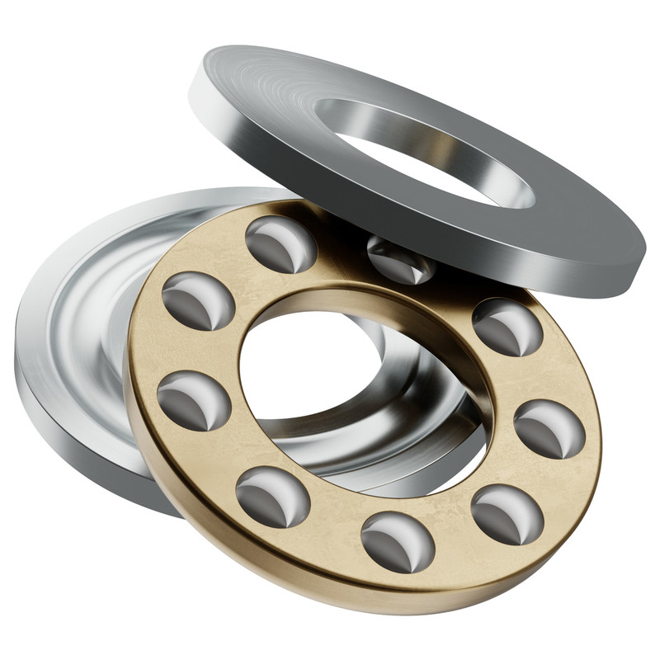

Hubs
Hubs play the critical role of transferring motion from a shaft to the next component in the drivetrain—whether that be a gear, pulley, wheel or arm. Different hub styles each have their strong points, from brute holding force, to attachments options, to weight savings.

Set-Screw Hubs (16mm Pattern)
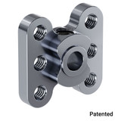
These hubs have a compact form factor to minimize rotating mass. Their near-perfect balance means they excel in high-speed applications. While they have the standard 16mm pattern, they also boast two additional holes, which measure 16mm straight across the center bore and unlock mounting possibilities with beams.

Classic Clamping Hubs
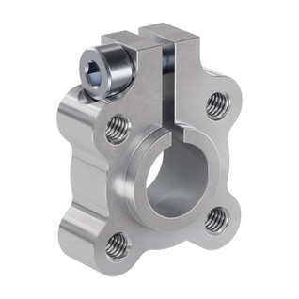
Clamping hubs provide a non-marring solution for fastening parts onto an axle or shaft. When the M4 pinch bolt is tightened, it locks on the shaft ensuring your rotating components do not move or come loose. The 14mm protrusion on one of the faces offers a centering mechanism for mating components which have a 14mm bore.

Sonic Hubs
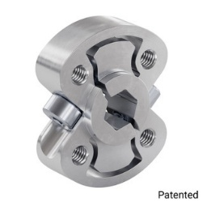
Sonic Hubs are more balanced than set screw hubs while retaining just as much clearance. Make them your go-to hub for high speed applications, and you can leave your concerns about marred shafts or lost set-screws behind! The pattern holes for fastening components, as well as the clamping mechanism to hold the hub onto a shaft, are completely isolated from one another. This means you can tighten the dual pinch bolts to clamp down on a shaft without distorting the holes you use to mount components to the hub. You can likewise fasten the hub to a gear, sprocket, pulley or wheel prior to tightening onto a shaft, since the clamping mechanism is able to function regardless of what the hub is connected to. Since the Sonic Hub clamping mechanism pulls in toward the center, the hub can fit in recesses and clear where a 1301 Series Clamping Hub cannot. 1309-0016-1006 Sonic Hub (6mm D-Bore)

Hyper Hubs (16mm Pattern)

Metric (1313 Series)
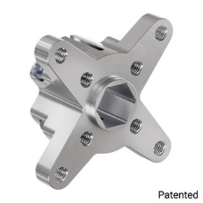

Metric (1310 Series)
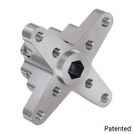

Metric (1315 Series)
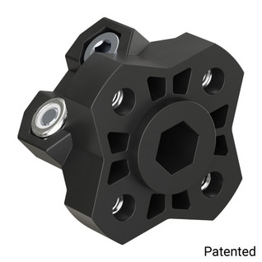
The Hyper Hub design is both balanced, and heavy duty. The increased barrel length of the Hyper hub, as compared to a standard clamping hub, provides more shaft-to-bore surface contact for a super tight hold. This length not only increases holding power, but also provides more support to battle heavy radial loads. Similar to a Sonic Hub, a Hyper Hub is able to fit in areas where a standard clamping hub might run into clearance issues

25 Tooth Spline Servo Hubs
- 1910 Series Servo Hub Shaft (25 Tooth Spline, 8mm Shaft Diameter, 16mm Length)
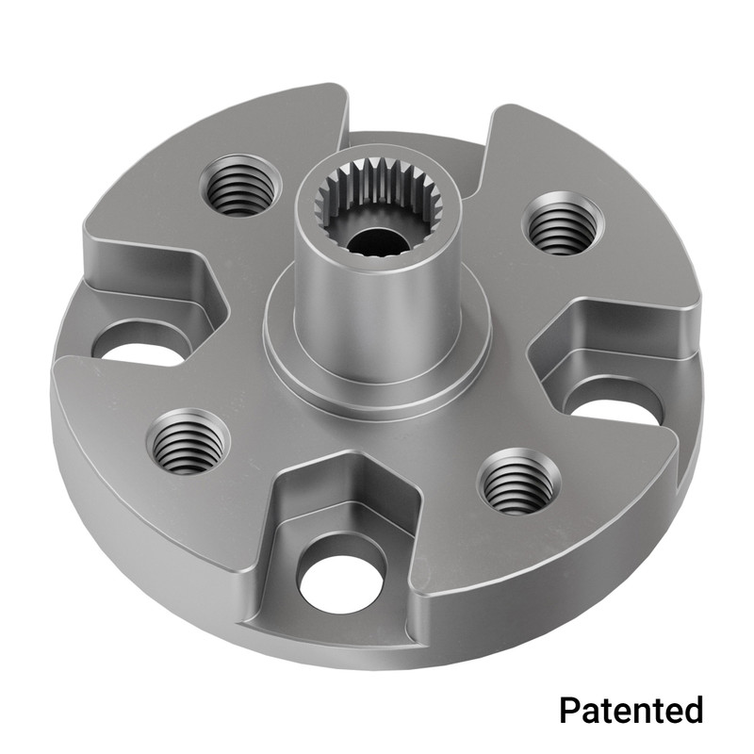
- 1906 Series Low-Profile Servo Hub (25 Tooth Spline, 32mm Diameter)
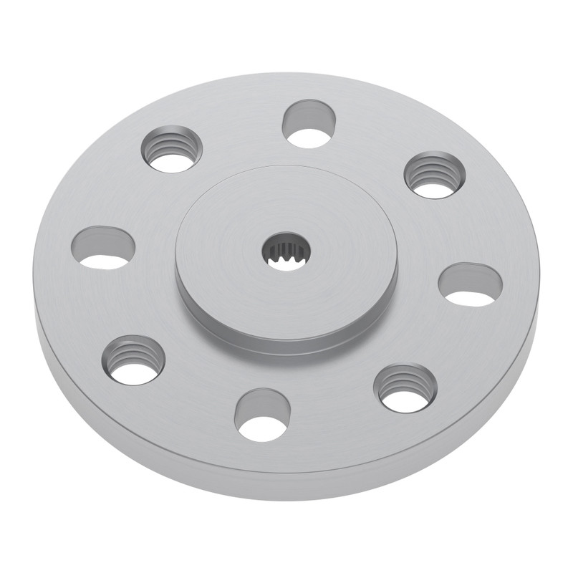
- 1908 Series Servo Hub (25 Tooth Spline, 32mm Diameter)
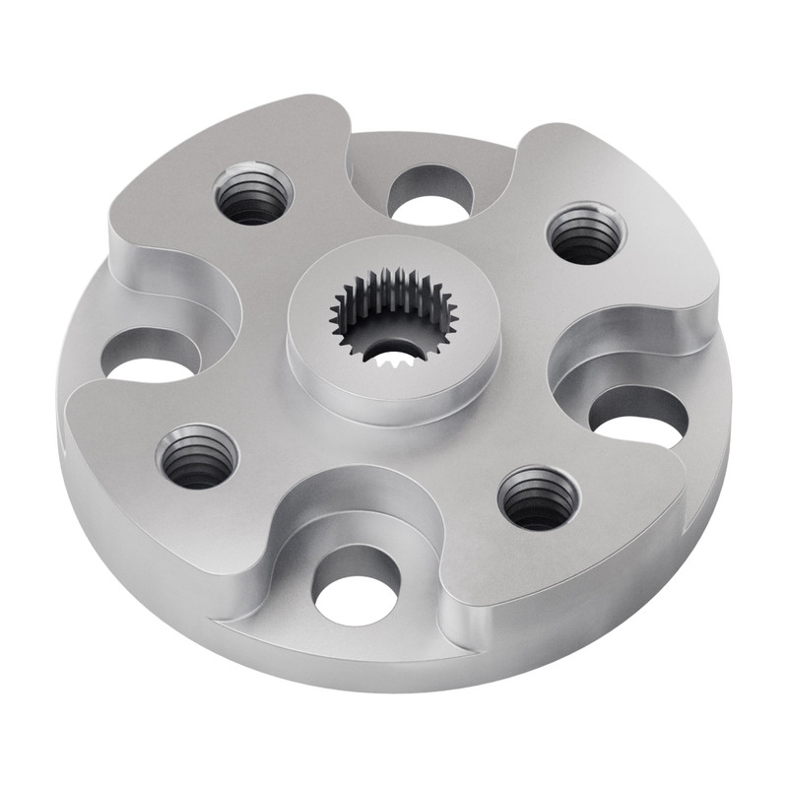
- 1910 Series Servo Hub Shaft (25 Tooth Spline, 10mm Shaft Diameter, 33mm Length)
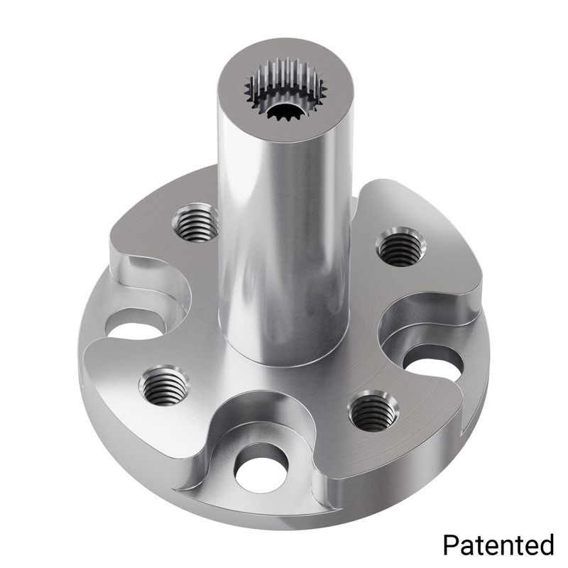

Round Bore Hubs
- 8mm Round Bore Hubs
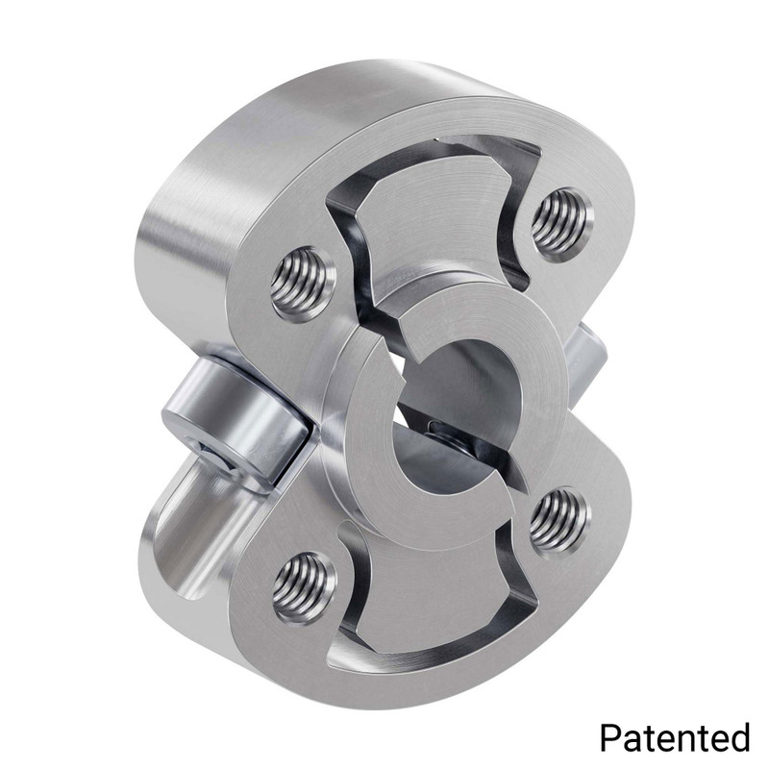
- 1310 Series Hyper Hub (8mm Bore)

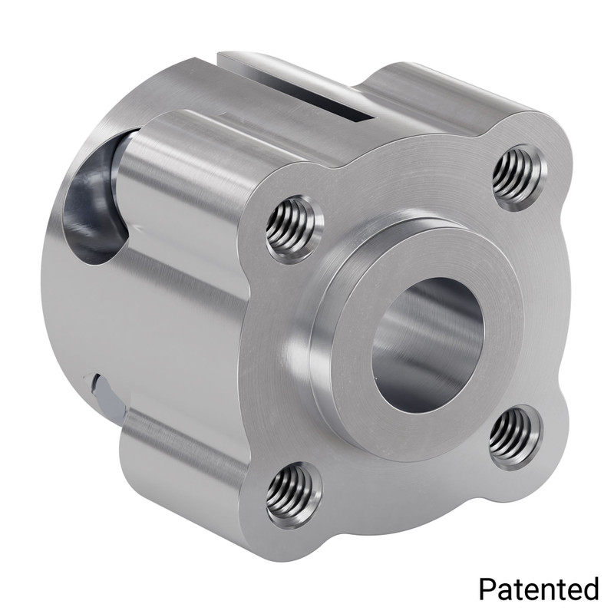

Timing Belt Pulleys

5mm HTD Timing Pulleys
- 3417 Series 5mm HTD Pitch Set-Screw Pinion Timing Belt Pulley (8mm REX™ Bore, 16 Tooth
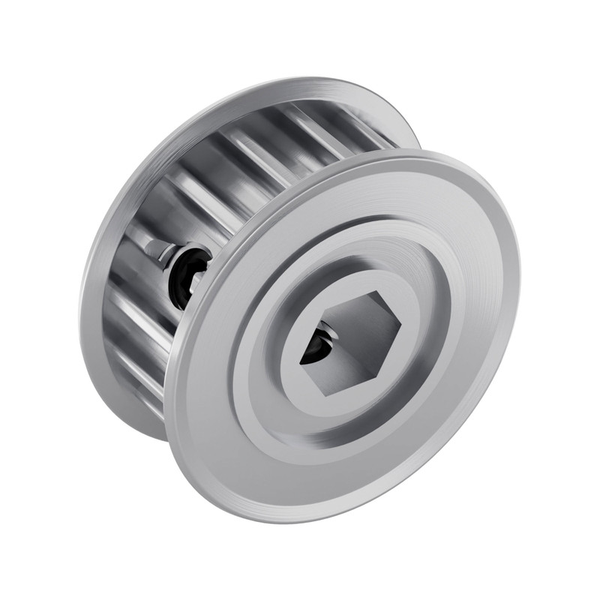
- Dual Belt, 5mm HTD Pitch, Set-Screw Pinion Timing Belt Pulley (8mm REX Bore, 16 Tooth)
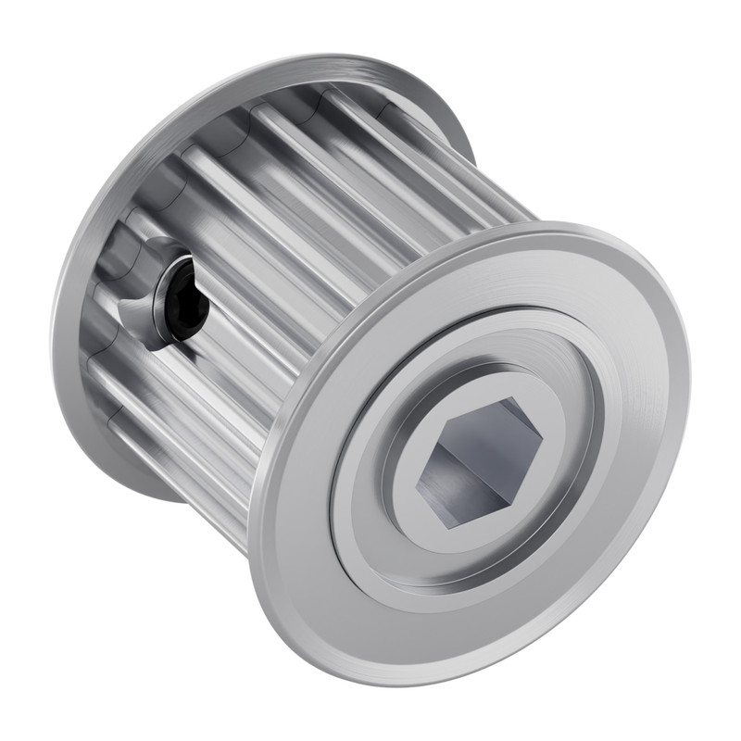
- 3417 Series 5mm HTD Pitch Set-Screw Pinion Timing Belt Pulley (8mm REX™ Bore, 24 Tooth)
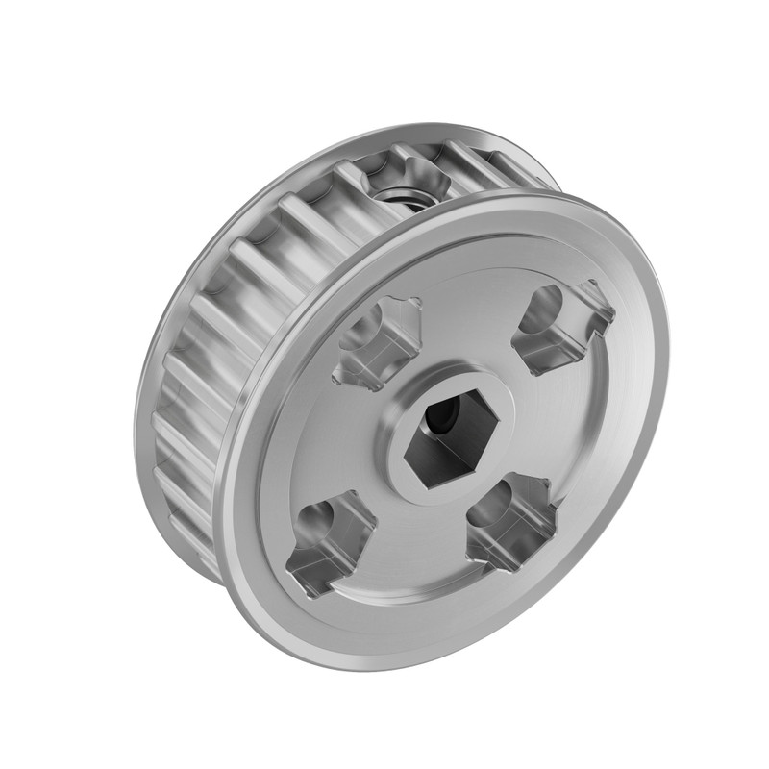

Collars
The primary use of collars is to restrict axial motion of a shaft mounted in bearings.
- Polycarbonate Clamping Collar (8mm REX™ Bore)
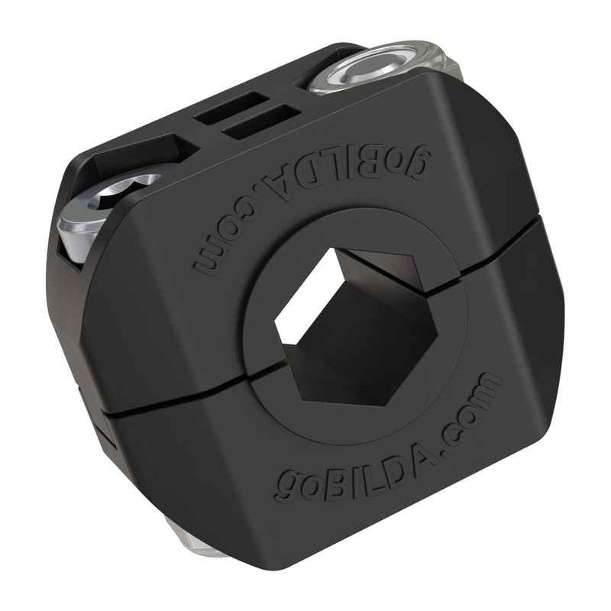
- 2910 Series Aluminum Clamping Collar (8mm REX™ ID x 20mm OD, 9mm Length)
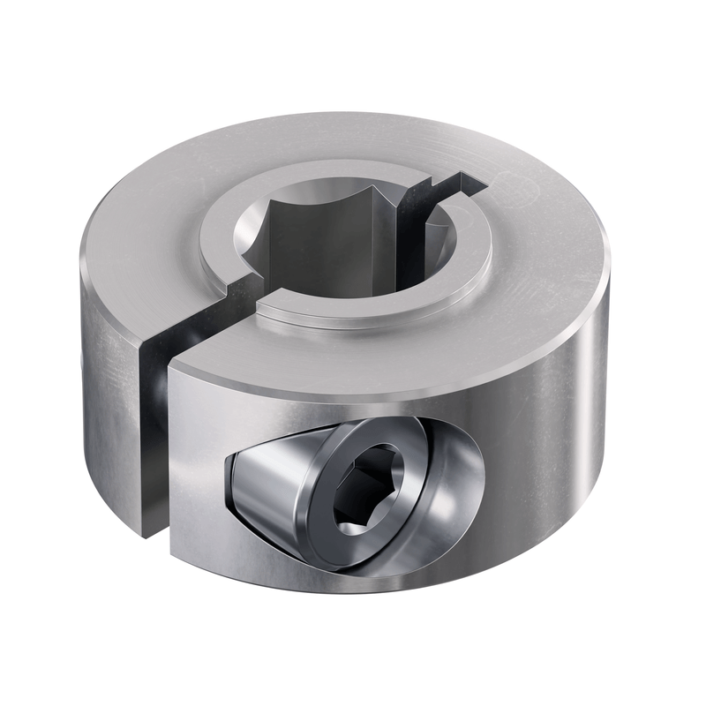
- 2920 Series Steel Set-Screw Collar (8mm REX™ Bore) - 2 Pack
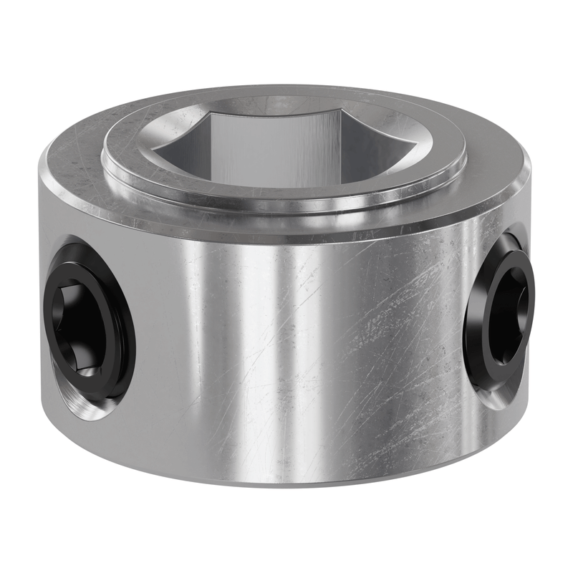

Couplers
Couplers fix two shafts together while creating concentricity.

8mm REX™ Bore Couplers
- 4007 Series Hyper Coupler (8mm Round Bore to 8mm REX™ Bore)
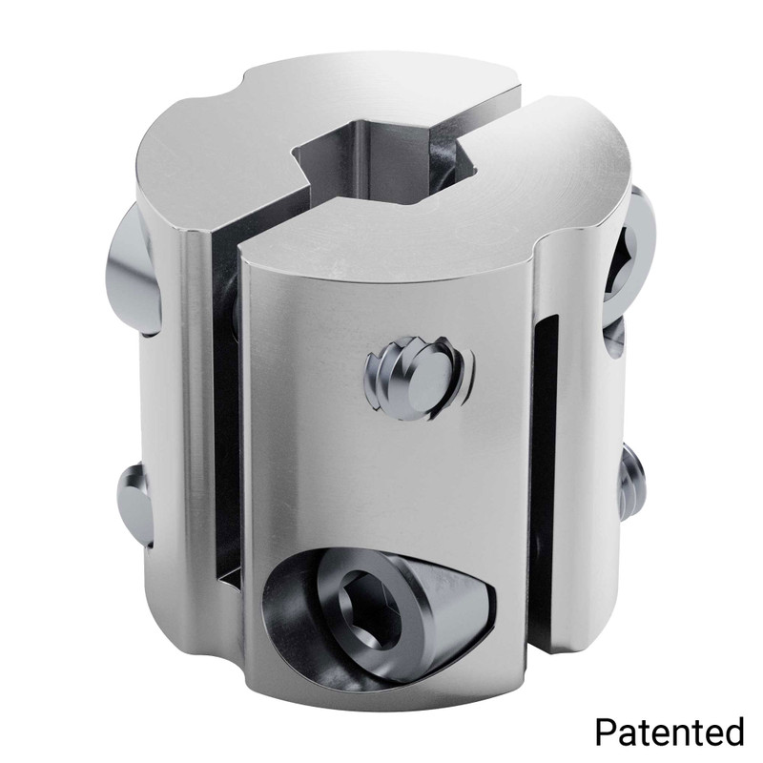
- Clamping Shaft Couplers
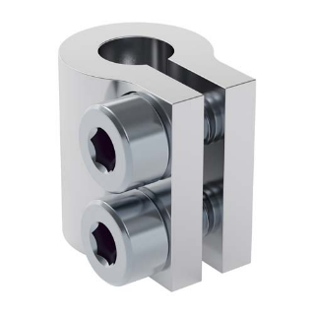
These couplers are compact and create a solid connection between two shafts. The pinch bolts are M4 and accept a 3mm hex key.

Wheels
- GripForce™ Mecanum Wheel Set (Ø104mm, 40A Durometer Rollers)
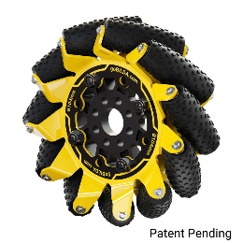

Wiring
- 2-Pos JST VH [MH-FC] to 3.5mm Bullet [MH-FC] Adaptor
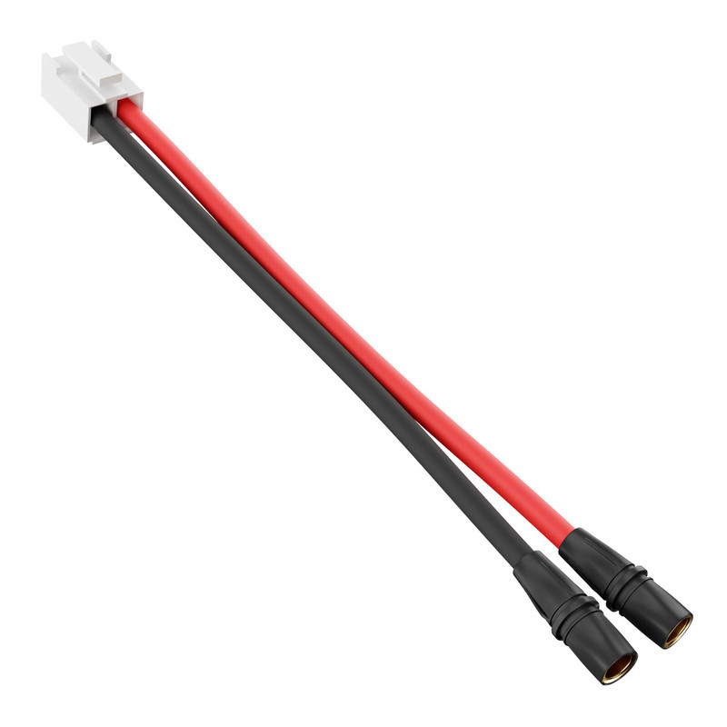
- 4-Pos JST PH [MH-FC] to 4-Pos JST XH [MH-FC] Adaptor
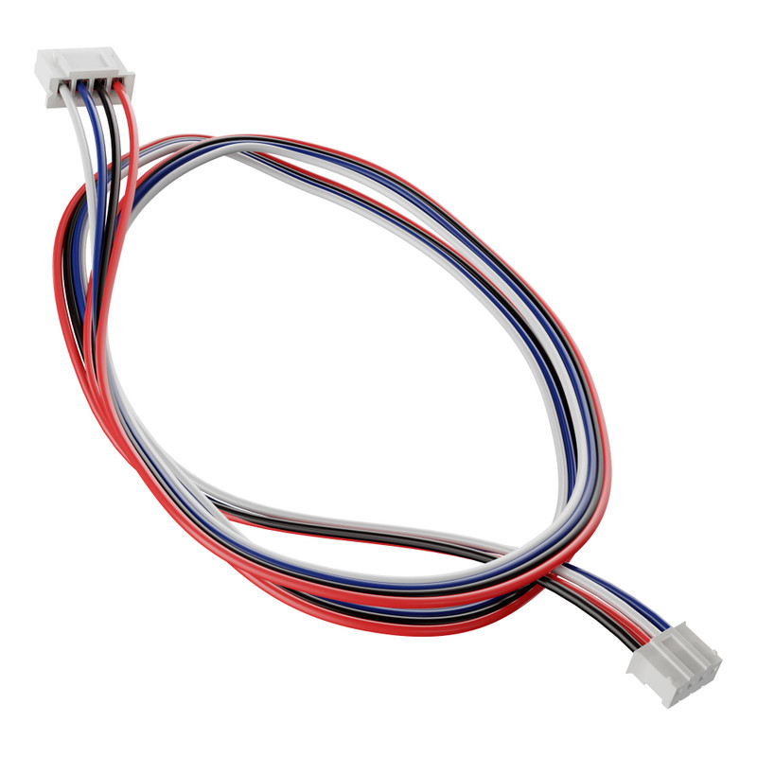

Motors
- 5203 Series Yellow Jacket Planetary Gear Motor (19.2:1 Ratio, 24mm Length 8mm REX™ Shaft, 312 RPM, 3.3 - 5V Encoder)
