External Modulation of Geomagnetic Secular Variation:
A Hypothesis on Solar Wind Coupling,
The May 2024 Storm, and the Tesla Circuit
Author: Murad Tulunay
B.Sc. Computer Engineering, Istanbul Technical University
Date: February 2026
Contact: murad.tulunay@gmail.com
DOI: To be assigned upon Zenodo publication
Repository: To be assigned upon GitHub publication

Abstract
Standard geodynamo models attribute geomagnetic jerks and pole drift primarily to hydromagnetic waves in the Earth’s core (e.g., Aubert & Finlay, 2019; Aubert et al., 2022). However, this paper proposes a “Solar-Atmospheric Steering Hypothesis.” We argue that the interaction between Solar Wind dynamic pressure and ionospheric asymmetry acts as a significant vector component in biasing the apparent position of the Magnetic North Pole.
Utilizing data from the May 2024 superstorm (Dst ≈ −412 nT; Sym-H < −500 nT) and drawing historical inspiration from Nikola Tesla’s early circuit-like framing of the Earth-atmosphere system, we propose that external forcing can modulate secular drift. We define a falsification test comparing Earth (active dynamo) with Mars (induced magnetosphere) to isolate this external vector, using spherical harmonic decomposition to separate internal and external field contributions.
Strong-form note: The author’s original intuition is that external electrodynamics may play a more dominant role than currently accepted. Even falsification of this strong claim would yield valuable quantitative bounds on external contributions to geomagnetic variability.

1. Introduction
While the internal geodynamo generates Earth’s bulk magnetic field, the precise mechanism behind rapid impulses (jerk-like signatures) and the accelerated drift towards Siberia remains a subject of complex modeling. The question of whether geomagnetic jerks are external or internal in origin has been debated since the 1980s (Alldredge, 1984; Mandea et al., 2010). Some authors have proposed Solar Wind Induced Electric Dynamo (SWIED) frameworks suggesting external coupling (see discussion in Chambodut et al., 2005). Recent work by Aubert et al. (2022) successfully modeled jerks via rapid hydromagnetic waves within the core, but the external contribution to observed rapid impulses remains incompletely quantified.
We revisit external coupling via modern space weather data, proposing that the magnetosphere is not merely a passive shield but an active external current system driven by solar wind momentum. The 2025 World Magnetic Model (WMM2025) confirms that the North Magnetic Pole continues its unprecedented drift toward Siberia at ~35 km/year (NOAA/NCEI, 2025), and scientists acknowledge the underlying cause is not fully explained.

2. Historical Inspiration: The Tesla Connection
Nikola Tesla conceptualized the Earth and its atmosphere as a massive conductive system in the context of wireless transmission. While his specific engineering goal differs from modern atmospheric electricity, the Global Electric Circuit (GEC) is an established concept in atmospheric science.
Hypothesis extension: We posit that this global circuit is naturally “pumped” by the Solar Wind. The variable dynamic pressure of the wind is modeled as:
Pdyn = ρ v² ≈ n mp v²
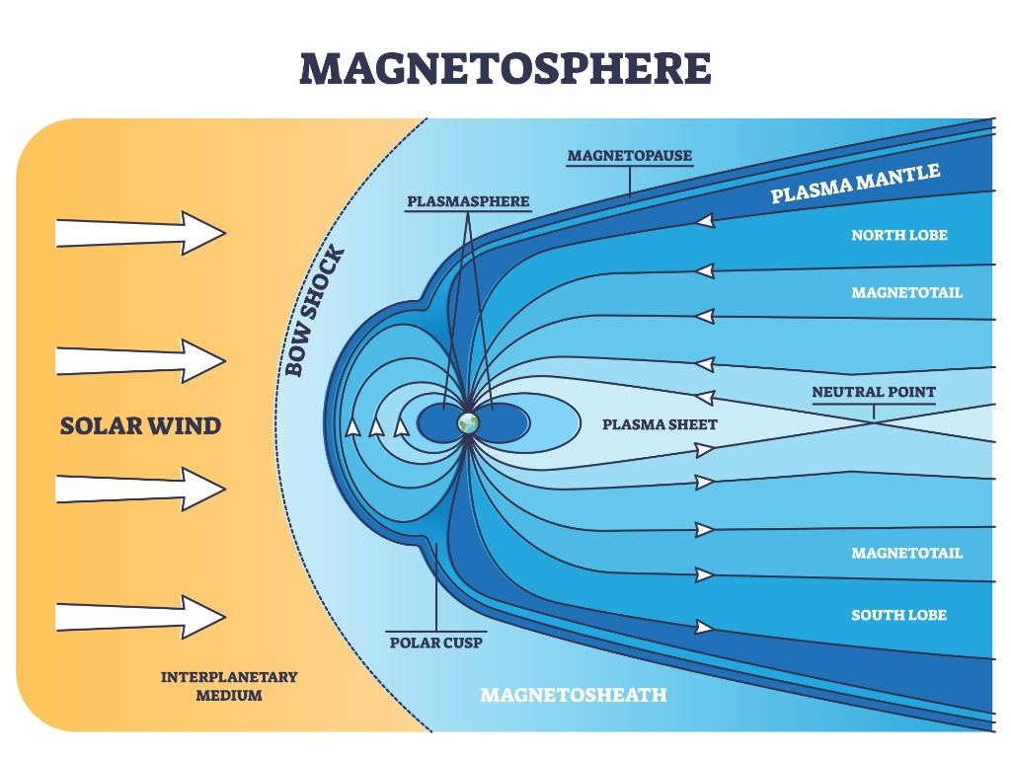
Figure 1. Conceptual view of the solar wind interaction with Earth’s magnetosphere, illustrating the bow shock and magnetopause.
This creates potential differences across day/night ionospheric conductivity asymmetry, driving currents that do not just dissipate but actively modulate the geomagnetic vector observed on the surface.

3. The Hypothesis: Modulation vs. Generation
Main claim: The Solar Wind applies a continuous external bias (steering effect) on geomagnetic field lines via magnetosphere–ionosphere current systems.
The Mars counter-point: Mars possesses an ionosphere but lacks a global dipole field. This confirms that the ionosphere alone cannot generate a planetary dipole (refuting a purely external generation model). Mars provides a boundary condition for generation, not for the modulation of an existing dynamo field. However, Mars exhibits strong induced fields, proving the capacity of external currents to create magnetic structures.
Earth application: On Earth, this external effect is superimposed on the internal dynamo. During solar quiet, it is minor. During solar maximum and strong storms, it can become a significant vector in short-term pole-path deviations.

4. Evidence: The May 2024 Superstorm
Analyzing the event of May 10–12, 2024:
- Data: The Dst index reached approximately −412 to −427 nT (depending on dataset), while the Sym-H index dropped below −500 nT (WDC for Geomagnetism, Kyoto).
- Impact: The magnetopause was compressed to approximately 5.04 RE during the storm (Hayakawa et al., 2024). High-latitude declination deviations exceeded 15° during subsequent G4/G5 storms in October 2024 (WMM2025 Report).
- A geomagnetic jerk in late 2023–2024: The 2025 State of the Geomagnetic Field Report identifies a jerk event between late 2023 and early 2024, most visible in the Pacific region and across Australia.
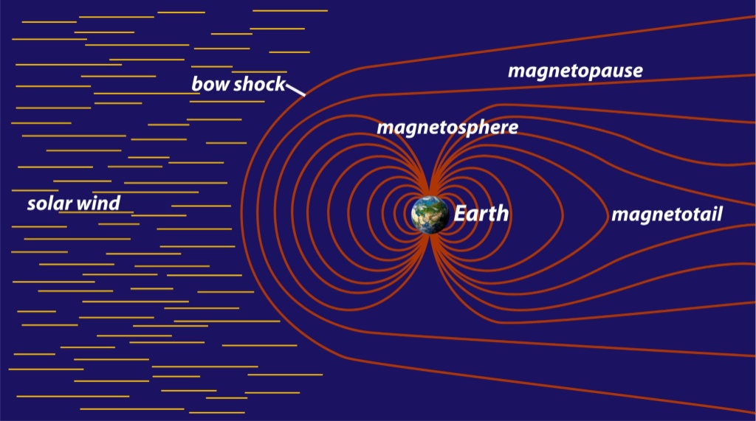
Figure 2. Magnetosphere structure highlighting the magnetopause boundary and magnetotail configuration under solar wind forcing.
- Definition: ‘Apparent deviation’ refers to pole-path estimates derived from external-field-sensitive components of the local field vector, distinct from deep crustal/core motion.

5. Methodology
We modeled the magnetopause standoff distance using Chapman-Ferraro-style pressure balance scaling under variable Solar Wind velocity (~400–1500 km/s) and density ranges representative of quiet to extreme conditions, to estimate the theoretical surface perturbation ΔB imposed on the observed geomagnetic vector.
For validation, the analysis plan is to use ESA Swarm-based field models (and/or ground observatory data) to separate internal and external coefficients via Spherical Harmonic Analysis (SHA), then quantify how much short-term vector variability aligns with solar wind driving during rapid-impulse intervals.
Python simulation code is available in the associated GitHub repository.

6. Results: Perturbation Analysis
The simulation indicates that external pressure variations create significant surface perturbations. The table below summarizes estimated ΔB values under different solar wind regimes:
Quiet | 400 km/s | ~1.3 nPa | ~20–30 nT | Minor diurnal variation
Storm (G4/G5) | 800 km/s | ~53 nPa | ~100–300 nT | Significant jerk-like signature
Extreme (Carrington) | 1500 km/s | ~375 nPa | >1000 nT | Major vector deviation
May 2024 actual | ~800–1000 km/s | >100 nPa (est.) | Dst ≈ −412 nT | Magnetopause at 5.04 Rₑ
Table 1. Estimated surface perturbations under different solar wind regimes. ‘Equivalent Effect’ refers to the apparent deviation in external-field-sensitive indices, not crustal displacement. May 2024 row uses observed data from Hayakawa et al. (2024).
These results suggest that during extreme events, external forcing produces perturbations comparable to the magnitude of geomagnetic jerks, supporting the hypothesis that at least some component of rapid pole-path deviations may be externally driven.

7. Discussion: The Siberian Drift Anomaly
The 2025 WMM update confirms the North Magnetic Pole has drifted over 2,200 km from Canada toward Siberia. The drift accelerated from ~15 km/year to ~55 km/year around 1990, then decelerated to ~35 km/year by 2025 (NOAA/NCEI, 2025). Scientists attribute this to a “tug-of-war” between magnetic flux lobes beneath Canada and Siberia, with the Siberian lobe gaining dominance.
Speculative working hypothesis: If the Solar System is traversing a region of the Local Interstellar Cloud (LIC) with varying plasma density, the baseline dynamic pressure on the magnetosphere could shift secularly. This would create a sustained bias in external modulation, potentially contributing to the drift. This remains highly speculative and requires independent verification from heliospheric boundary missions (e.g., IBEX data).

8. Conclusion & Call for Investigation
This is a falsifiable proposition. We invite the scientific community to test this hypothesis by decomposing internal/external field coefficients via Spherical Harmonic Analysis (SHA) using ESA Swarm data, specifically during rapid impulse events and major storms.
Proposed Test Plan:
- Test A (Pressure–Jerk Correlation): Correlate OMNIWeb Solar Wind dynamic pressure data with historical geomagnetic jerk events. Prediction: If valid, rapid-impulse events must correspond to specific thresholds in solar wind momentum transfer.
- Test B (Asymmetry Vector Analysis): Use Swarm A/B/C vector data to separate internal (Bint) and external (Bext) harmonics. Prediction: The magnetic pole’s daily wander ellipse is a function of ionospheric conductivity gradient.
- Test C (Mars Control): Compare Earth’s external field response to Mars’s induced magnetic environment during equivalent solar events. If Mars shows proportionally similar induced-field structures, this supports the external coupling mechanism.
If confirmed, this supports a coupled system view where Earth’s observed magnetic behavior is a function of both the core and the heliosphere. If falsified, the same workflow will provide quantitative upper bounds on external contributions to apparent pole-path variability. Even a negative result would be valuable.

Appendix A: Order-of-Magnitude Scale Calculation
To address the feasibility of ionospheric field generation versus modulation, we present the following scale analysis:
Model: Treat the ionosphere as an equivalent single-turn current loop at radius R ≈ 6.37 × 10⁶ m. The magnetic field at the center of such a loop is:
B ≈ μ0I / (2R)
Required current for full field: To reproduce the typical surface field magnitude B ~ 50 μT:
I ≈ 2RB / μ0 ≈ 2 × 6.37 × 10⁶ × 50 × 10⁻⁶ / (4π × 10⁻⁷) ≈ 5 × 10⁸ A
This yields approximately 0.5 GigaAmperes — orders of magnitude larger than typical large-scale ionospheric current systems.
Observed ionospheric currents: The Sq (solar quiet) current system and equatorial electrojet carry currents on the order of 10⁵–10⁶ A.
Current | ~500,000,000 A (0.5 GA) | ~100,000–1,000,000 A
Field contribution | ~50,000 nT (100%) | ~10–100 nT (~0.02–0.2%)
During extreme storm | — | ~100–1000+ nT (~0.2–2%)
Table A1. Scale comparison: ionospheric current capacity vs. full field requirement.
Conclusion: The ionosphere cannot generate the main geomagnetic field. However, it is perfectly scaled to provide the perturbations (ΔB ~ tens to hundreds of nT) observed during geomagnetic jerks, diurnal variations, and storm-time disturbances. This is the physical basis for the “modulation, not generation” framework of this hypothesis.
Caveat on the strong hypothesis: The author acknowledges this magnitude gap. The strong-form claim (external dominance) would require either: (a) a multi-layer, multi-turn equivalent current system with energy budgets not yet fully quantified, or (b) a fundamental revision of how external coupling is modeled. We present the modulation framework as the testable, conservative version, while keeping the strong form as a motivation for deeper investigation.

References
1. Alldredge, L. R. (1984). A discussion of impulses and jerks in the geomagnetic field. Journal of Geophysical Research, 89, 4403–4412.
2. Aubert, J., & Finlay, C. C. (2019). Geomagnetic jerks and rapid hydromagnetic waves focusing at Earth’s core surface. Nature Geoscience, 12, 393–398. https://doi.org/10.1038/s41561-019-0355-1
3. Aubert, J., Livermore, P. W., Finlay, C. C., Fournier, A., & Gillet, N. (2022). A taxonomy of simulated geomagnetic jerks. Geophysical Journal International, 231(1), 650–672. https://doi.org/10.1093/gji/ggac212
4. Chambodut, A., et al. (2005). Geomagnetic jerks from the Earth’s surface to the top of the core. Earth, Planets and Space, 57, 551–559.
5. Hayakawa, H., et al. (2024). The Solar and Geomagnetic Storms in May 2024: A Flash Data Report. The Astrophysical Journal, 979, 49. https://doi.org/10.3847/1538-4357/ad9335
6. Mandea, M., Holme, R., Pais, A., Pinheiro, K., Jackson, A., & Verbanac, G. (2010). Geomagnetic jerks: rapid core field variations and core dynamics. Space Science Reviews, 155, 147–175.
7. NOAA/NCEI & British Geological Survey. (2025). World Magnetic Model 2025 (WMM2025). https://www.ncei.noaa.gov/products/world-magnetic-model
8. Tesla Science Center at Wardenclyffe. Tesla’s Wireless Power and the Wardenclyffe Tower. https://teslasciencecenter.org/teslas-wireless-power/
9. WDC for Geomagnetism, Kyoto University. (2024). Dst and SYM-H index data. https://wdc.kugi.kyoto-u.ac.jp/

Acknowledgements
The conceptual framework for this hypothesis was developed by Murad Tulunay, with the assistance of AI research tools (Anthropic Claude, OpenAI ChatGPT, and Google Gemini) for data synthesis, simulation logic, literature review, and document drafting. Responsibility for all claims and interpretation remains with the author.
Dedicated to the engineering intuition of Nikola Tesla, and to every curious mind that asks “what if?”
AI Disclosure: This work was developed using large language models (Claude by Anthropic, ChatGPT by OpenAI, Gemini by Google) as research and drafting tools. The AI systems assisted with literature synthesis, simulation design, mathematical verification, and document formatting. All conceptual claims, hypotheses, and scientific interpretations are the responsibility of the human author.

