|  |  |  |
| --- | --- | --- |
|  | National University  of Computer and Emerging Sciences  Chiniot-Faisalabad Campus |  |

**CS3004-Software Design and Analysis**

**Project Phase III**

**FALL 2023**

|  |
| --- |
|  |

**MURAD HAMEED**

**21F-9087**

**BCS-5A**

**Submitted To**

“Dr. Sajid Anwer”

Contents

Vision Document 3

**Problem:** 3

**Overview/Scope:** 3

**Functional Requirements:** 4

**Non-Functional Requirements:** 5

System narrative: 5

• ***Identify key concepts:*** 6

Data 7

Function 7

Stakeholders 7

Hardware 7

System 7

Abstract 7

User’s listening pattern 7

Search playlist 7

Users 7

Mobile phone 7

Create playlist 7

MusicVerse company 7

Laptops 7

User preference 7

Edit playlist 7

PCs 7

Display the lyrics 7

Individualized songs selection 7

Make recommendation 7

Friends activity 7

Private mode 7

Premium 7

Record music labels 7

• ***Identify components for architecture:*** 7

Architectural Style: 8

Use Case Diagram: 9

Expended Use Case: 10

Domain Model: 23

Class Diagram: 23

System sequence diagram: 23

• Create account 24

• Login 24

• Discover music: 26

• Create edit playlist: 27

• Check history: 28

• Play on different devices: 29

• Friends activity: 30

• Shuffle playlist: 30

• Search songs: 31

• Premium: 31

• Display lyrics: 32

• Private mode: 32

Sequence diagram: 32

Activity diagram: 34

State machine: 34

Data Flow Diagram: 35

Component diagram: 37

Package diagram: 38

Deployment diagram: 39

# Vision Document

## **Problem:**

After doing research, I recognized that one of the key challenges in the music streaming industry is providing a smooth and personalized experience for users. Users need to navigate multiple websites and services to find the music they want. Despite the growing number of music streaming platforms available, many still struggle with slow loading times, limited content discovery options, and an overall messy user interface. These discomfort points can make it difficult for users to find the music they want and enjoy the experience of listening to it.

## **Overview/Scope:**

The scope of MusicVerse is to develop and maintain a user-friendly streaming platform that provides users with access to almost every song and personalized music recommendations. We will create a platform that is secure, and innovative, offering users a trustworthy, valuable streaming experience. We will focus on performance and reliability to ensure the platform that can support the ever-expanding user experiences. We will also try to provide users with an enjoyable experience through our platform by continuing to add new features and improve existing ones.

Additionally, our platform will provide users with the capability to create and share playlists with friends, discover new music through personalized recommendations, and even connect with their favorite artists and bands. We will develop our platform to be available from all types of devices (Smartphones, Computers, etc. ), so users can access their music on the move. Moreover, the platform will prioritize the protection of user data and privacy. User data will be collected, stored, and used in a secure and transparent manner, obeying the highest guidelines of data privacy and security.

The scope of MusicVerse will continue to evolve as the platform grows and expands. However, these key areas will serve as the basis for the vision of MusicVerse as a comprehensive and user-friendly music streaming platform.

## **Functional Requirements:**

|  |  |
| --- | --- |
| SR NO | FUNCTIONAL REQUIREMENTS |
| FR 1 | The system must allow the user to create new account or login with Google/Facebook account |
| FR 2 | The system must allow the user to discover music and will offer an algorithmically created playlist that is specifically designed for the user. |
| FR 3 | The system must allow the user to create playlist, and can add remove and arrange the songs in the playlist |
| FR 4 | The system must create the mix playlist for the on the basis of recent songs, genre they liked or listened |
| FR 5 | The system must allow the user to check history of the previously listened songs |
| FR 6 | The system must allow the user to play their music on different devices and allow to control the music from device to the other over the same account |
| FR 7 | The system must allow the user to view friends activity and allow them to see what they are listening to |
| FR 8 | The system must display the lyrics of the songs that are being synchronized with the song when listened |
| FR 9 | The system must allow the user to search songs, artists and their albums |
| FR 10 | The system must allow the user to shuffle the playlist ,mix playlist and albums |
| FR 11 | The system must allow the set their profile to private mode where friends not able to see the user’s activity |
| FR 12 | The system must allow the user to sign up for the premium package where user can have unlimited skips to the songs and add-free |

## **Non-Functional Requirements:**

|  |  |
| --- | --- |
| SR NO | NON-FUNCTIONAL REQUIREMENTS |
| NF1 | The system should not delay on any network (Low Latency) |
| NF2 | The system should be available 24/7 (Availability) |
| NF3 | The system should response the user within seconds (Good Performance) |
| NF4 | The system should be easy to use and easy to learn for the user (Usability) |
| NF5 | The system should support all the operating systems and should have a web version (Compatibility) |
| NF6 | The system should be reliable |

# System narrative:

The goal of MusicVerse is to support the platform’s purpose of giving users a smooth and customized music streaming experience. It is based on a number of essential elements that come together to give users access to music and other audio content.

The user interface, which is the core of MusicVerse, is in charge of giving consumers access to the platform's services and content. With features like search, playlists, and personalized suggestions that are catered to each user's listening preferences, the user interface is made to be simple and user-friendly. The software lets users make playlists and shuffle, remove, and add songs to them. The platform lets the user view a history of the music they’ve previously listened to, when a music is being listened to, the system displays the lyrics of the corresponding song.

The software lets users view their friends' activities and see what they are listening to. The software helps users to set their profiles to private mode so that friends cannot view their activity. The software must enable users to register to the premium plan, which includes unlimited skips to songs and add-free listening. The system allow the user to play their music on different devices such as mobile phone, laptops and PCs etc. System shall allow to control the music from device to the other over the same account, and can run on different operating systems including IOS, ANDROID AND WINDOWS.

The recommendation system, which is in charge of offering customers individualized song selections, is yet another critical aspect of MusicVerse. To make recommendations for new artists, songs, and playlists that are customized to each user's preferences, the recommendation engine uses advanced algorithms to analyze users' listening patterns as well as information from record companies and other sources.

Another critical aspect of MusicVerse is its content delivery network. Regardless of the user’s location or the device they are using to access the site, the content delivery network is in charge of getting music and other audio content to them. Even when they're on the road or utilizing a slow connection, consumers can get high-quality music because to the content delivery network.

Last but not least, a cutting-edge data infrastructure that gathers and examines massive amounts of information about user’s listening patterns as well as information from record labels and other content sources. The recommendation engine as well as other features like playlists and social sharing are powered by this data.

In general, MusicVerse is made to offer users a seamless and customized music listening experience. Users of the platform can access high-quality audio content because of the platform's user-friendly interface, smart recommendation engine, content delivery network, and data infrastructure, which also opens the way for future developments in the music streaming industry.

## ***Identify key concepts:***

* + - * **Search playlist**
      * **User interface**
      * **User preference**
      * **Make playlist, shuffle, add and remove**
      * **Display the lyrics**
      * **Users individualized** **songs selection**
      * **Make recommendations**
      * **Record user’s listening patterns**
      * **Information from record music labels and other resources**
      * **View friend’s activity**
      * **Private mode**
      * **Premium (unlimited skips and ad free)**

|  |  |  |  |  |  |  |  |
| --- | --- | --- | --- | --- | --- | --- | --- |
| Data | Function | Stakeholders | Hardware | System | Abstract | | |
| User’s listening pattern | Search playlist | Users | Mobile phone |  | |  |
|  | Create playlist | MusicVerse company | Laptops |  | |  |
| User preference | Edit playlist |  | PCs |  | |  |
|  | Display the lyrics |  |  |  | |  |
|  | Individualized songs selection |  |  |  | |  |
|  | Make recommendation |  |  |  | |  |
|  | Friends activity |  |  |  | |  |
|  | Private mode |  |  |  | |  |
|  | Premium |  |  |  | |  |
|  | Record music labels |  |  |  | |  |

## ***Identify components for architecture:***

* + - * + **User interface:**  Users can access the platform's services and content through the user interface, which is the main part of the architecture. It has features like search, playlists, and personalized recommendations.
        + **Data infrastructure:** The data infrastructure is an advanced system that collects and analyzes a vast quantity of data about user’s listening habits as well as data from record labels and other content sources. It drives the playlists, social sharing, and recommendation engine.
        + **Recommendation engine:** A key component that gives customers personalized song choices. It analyzes user’s listening habits as well as data from music labels and other sources using efficient algorithms.
        + **Premium plan:** Users can sign up for the premium plan through the premium plan component, which offers add-free listening and unlimited song skips.
        + **Friend’s activity:** Users can set their profiles to private mode so that friends cannot access their activity using the friend’s activity component, which also allows them to view their friends' activities and see what they are listening to.
        + **Artist profile:** Artist can upload their albums, songs and get their monthly/daily listeners.
        + **Songs Albums:**  Songs album consist of the songs that being uploaded by the artist, user can search them by album name, song name or artist name.
        + **Search songs:**  User can search the song by album name, song name or artist name.
        + **Create playlist:** User can create the playlist by adding their favorite songs, user can further add, remove and shuffle songs in the playlist
        + **Like songs:** Users can click "Like" on a song they like to add it to the liked songs playlist or category.
        + **Display lyrics:** It display the lyrics of the songs that are being synchronized with the song when listened
        + **Database:** It will store the user information like the user’s preference of the songs, keep track of user listening pattern and store the recorded music label.
        + **User profile:**  User can login and can search for songs, listen to playlist and discover new artist from the recommendation and can listen to “made for you” playlist
        + **Authenticate:** User can sign up to the application using the Google account, Facebook and can create their own account on MusicVerse.

# Architectural Style:

We chose **N-tier architecture** because it seems like MusicVerse likely uses a multi-tier architecture, where the application is divided into separate logical layers or tiers, each responsible for a specific set of functionalities. This allows for better separation of concerns, scalability, and maintainability.

Following are those layers:

* **Presentation Layer:** This layer represents the user interfaces of MusicVerse, such as web or mobile apps, and is responsible for displaying the music content, handling user interactions, and providing a smooth user experience.
* **Application Layer:** This layer contains the business logic of MusicVerse and handles functionalities such as user authentication, playlist creation, music recommendation algorithms, and social features like viewing friends' activities.
* **Services Layer:** This layer includes various services that provide specific functionalities, such as a music recommendation service, a playlist management service, a user profile service, and a payment service for premium subscriptions.
* **Data Storage Layer:** This layer consists of databases or data services that store music metadata, user profiles, playlists, listening history, and other relevant data.
* **External Services:** MusicVerse may also interact with external services, such as music licensing providers, payment gateways, social media platforms (for friend activities), and other third-party services for additional functionalities.

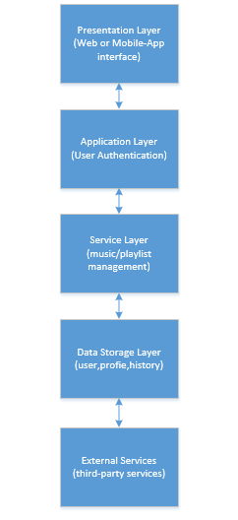

# Use Case Diagram:

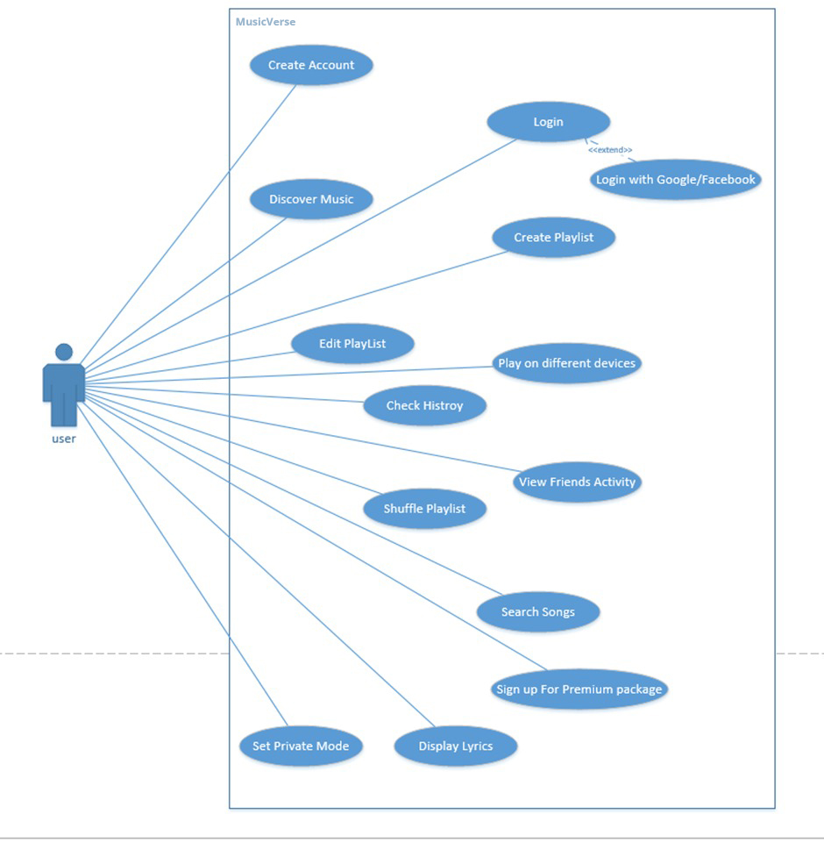

# Expended Use Case:

|  |  |  |
| --- | --- | --- |
| No. | Section | Content/Explanation |
| 1 | Designation | Sp-01 |
| 2 | Name | Create account |
| 3 | Authors | Murad Hameed |
| 4 | Priority | 9 |
| 5 | Criticality | High |
| 6 | Source | David Ng |
| 7 | Person responsible | Murad Hameed |
| 8 | Description | This use case will allow the user to create account by entering the email and setting the password and confirm details for account or using google and Facebook account |
| 9 | Trigger Event | The user wants to sign up to use MusicVerse so that he/she can listen to their favorite artist |
| 10 | Actors | Users |
| 11 | Preconditions | The user must have internet connection |
| 12 | Post-conditions | The user must enter the MusicVerse application or website |
| 13 | Result | The user will search, create playlist, like songs, add friends, watch friend’s activity, view lyrics, and buy premium. |
| 14 | Main Scenario | 1. The user will click to start now button to start creating account 2. The user will click on sign up for MusicVerse 3. The user will enter the email (any domain) 4. The user will confirm email 5. The user will set the password for the account 6. The user enter the profile name 7. The user will enter the date of birth 8. The user will select the gender 9. The user will select of agree the sharing registration data 10. The user will then click on the sign up button |
| 15 | Alternative Scenario | 3a. Without create separate account he can also sign up using google and Facebook account. |
| 16 | Exception scenario | If the confirming email doesn’t similar to the email written before so it will give error message  If the password is shorter than 8 characters the it will give error message |
| 17 | Quality |  |

|  |  |  |
| --- | --- | --- |
| No. | Section | Content/Explanation |
| 1 | Designation | Sp-02 |
| 2 | Name | Login |
| 3 | Authors | Murad Hameed |
| 4 | Priority | 9 |
| 5 | Criticality | High |
| 6 | Source | David Ng |
| 7 | Person responsible | Murad Hameed |
| 8 | Description | This use case will allow the user to login the MusicVerse using google, Facebook and apple account |
| 9 | Trigger Event | The user wants to sign up to use MusicVerse so that he/she can listen to their favorite artist |
| 10 | Actors | Users |
| 11 | Preconditions | The user must have internet connection  The user must have the account already created |
| 12 | Post-conditions | The user must enter the MusicVerse application or website |
| 13 | Result | The user will search, create playlist, like songs, add friends, watch friend’s activity, view lyrics, and buy premium. |
| 14 | Main Scenario | 1. The user will click on the login option (google, facebook or apple) 2. The user will select his/her account |
| 15 | Alternative Scenario | 1a. The user can also login to MusicVerse created account by entering email and password of that account |
| 16 | Exception scenario | If the email or password doesn’t exist for any account then it will show error message for not existed email or wrong password |
| 17 | Quality |  |

|  |  |  |
| --- | --- | --- |
| No. | Section | Content/Explanation |
| 1 | Designation | Sp-03 |
| 2 | Name | Discover Music |
| 3 | Authors | Murad Hameed |
| 4 | Priority | 7 |
| 5 | Criticality | Low |
| 6 | Source | David Ng |
| 7 | Person responsible | Murad Hameed |
| 8 | Description | The user will discover their favorite artist and their albums or trending songs |
| 9 | Trigger Event | The user will discover songs that are rending and newly released. |
| 10 | Actors | Users |
| 11 | Preconditions | The user must have internet connection  The user must have logged in to the account |
| 12 | Post-conditions | The user must select the song and listen to the song or whole album |
| 13 | Result | The user will be displayed by the trending songs or newly trending songs |
| 14 | Main Scenario | 1. The user will enter the name of the song, album or artist |
| 15 | Alternative Scenario | None |
| 16 | Exception scenario | None |
| 17 | Quality |  |

|  |  |  |
| --- | --- | --- |
| No. | Section | Content/Explanation |
| 1 | Designation | Sp-04 |
| 2 | Name | Create Playlist |
| 3 | Authors | Murad Hameed |
| 4 | Priority | 9 |
| 5 | Criticality | High |
| 6 | Source | David Ng |
| 7 | Person responsible | Murad Hameed |
| 8 | Description | The system must allow the user to create playlist |
| 9 | Trigger Event | The user wants to create the playlist to add their favorite songs |
| 10 | Actors | Users |
| 11 | Preconditions | The user must have internet connection  The user must have logged in to the account |
| 12 | Post-conditions | The user must add songs into his playlist |
| 13 | Result | The user will displayed by the empty playlist where he can add songs according to his/her choices |
| 14 | Main Scenario | 1. The user will go to home page 2. The user will click on the create playlist tab 3. The playlist will be created |
| 15 | Alternative Scenario | None |
| 16 | Exception scenario | None |
| 17 | Quality |  |

|  |  |  |
| --- | --- | --- |
| No. | Section | Content/Explanation |
| 1 | Designation | Sp-05 |
| 2 | Name | Edit Playlist |
| 3 | Authors | Murad Hameed |
| 4 | Priority | 8 |
| 5 | Criticality | High |
| 6 | Source | David Ng |
| 7 | Person responsible | Murad Hameed |
| 8 | Description | The user can add their favorite songs, remove and shuffle songs in the playlist |
| 9 | Trigger Event | The user wants to add songs to their playlist of their own choice or remove and shuffle the playlist |
| 10 | Actors | Users |
| 11 | Preconditions | The user must have internet connection  The user must have logged in to the account  The user must have created the playlist |
| 12 | Post-conditions | The user must add songs into his playlist, remove and shuffle |
| 13 | Result | The user will displayed by the songs added in the playlist |
| 14 | Main Scenario | 1. The user click on the playlist 2. The user will remove the songs 3. The user will search the songs to add more songs 4. The user will click on the shuffle icon to shuffle the songs |
| 15 | Alternative Scenario | None |
| 16 | Exception scenario | None |
| 17 | Quality |  |

|  |  |  |
| --- | --- | --- |
| No. | Section | Content/Explanation |
| 1 | Designation | Sp-06 |
| 2 | Name | Play on different devices |
| 3 | Authors | Murad Hameed |
| 4 | Priority | 9 |
| 5 | Criticality | High |
| 6 | Source | David Ng |
| 7 | Person responsible | Murad Hameed |
| 8 | Description | The system must allow the user to play their music on different devices and allow to control the music from device to the other over the same account |
| 9 | Trigger Event | The user wants to play songs at the same time with same account |
| 10 | Actors | Users |
| 11 | Preconditions | The user must have internet connection  The user must have logged in to the account  The user must connect the device to other device |
| 12 | Post-conditions | The user must add songs into his playlist, remove and shuffle |
| 13 | Result | The user devices will be connected and play the songs on the different devices at same time |
| 14 | Main Scenario | 1. The user will connect the devices 2. The user will play songs |
| 15 | Alternative Scenario | None |
| 16 | Exception scenario | The device to be connected will not found |
| 17 | Quality |  |

|  |  |  |
| --- | --- | --- |
| No. | Section | Content/Explanation |
| 1 | Designation | Sp-07 |
| 2 | Name | Check history |
| 3 | Authors | Murad Hameed |
| 4 | Priority | 5 |
| 5 | Criticality | Low |
| 6 | Source | David Ng (co-founder of MusicVerse) |
| 7 | Person responsible | Murad Hameed |
| 8 | Description | This use case will allow the user to view the previously played songs. |
| 9 | Trigger Event | The user wants to see the list of songs he had heard. |
| 10 | Actors | User |
| 11 | Preconditions | The user must be logged into the system.  The user must have internet connection.  The user must have listened to songs prior to viewing history. |
| 12 | Post-conditions | The user can play any song from the list of previously played songs. |
| 13 | Result | The user will be displayed the list of all the previously played songs on his account. |
| 14 | Main Scenario | 1. The user will click check history. 2. The user will be displayed the list of songs he had played on his account. 3. The user can play and queue any of those songs. |
| 15 | Alternative Scenario | 3a. The user might just view the list and not play any songs from it. |
| 16 | Exception scenario | If the selected song from history isn’t available anymore on MusicVerse then it wouldn’t be possible to play it. |
| 17 | Quality |  |

|  |  |  |
| --- | --- | --- |
| No. | Section | Content/Explanation |
| 1 | Designation | Sp-08 |
| 2 | Name | View Friend’s activity |
| 3 | Authors | Murad Hameed |
| 4 | Priority | 5 |
| 5 | Criticality | Low |
| 6 | Source | David Ng(co-founder of MusicVerse) |
| 7 | Person responsible | Murad Hameed |
| 8 | Description | This use case will allow the user to see their friend’s activity. |
| 9 | Trigger Event | The user wants to listen to songs played or listened by his/her friend. |
| 10 | Actors | User |
| 11 | Preconditions | The user must be logged into the system.  The user must have internet connection.  The user must have 1 or more friends on MusicVerse. |
| 12 | Post-conditions | The user can play any song from their friend’s personal playlist. |
| 13 | Result | The user will be displayed with all of the playlists, songs and albums liked by his/her friend. |
| 14 | Main Scenario | 1. The user will click on view friends activity 2. The user will see playlists, songs and albums liked by their friend. 3. The can play and like any of those songs 4. The user can also view playlists and also like it. |
| 15 | Alternative Scenario | 3a. The user might just view activity and not play any song. |
| 16 | Exception scenario | The user doesn’t have any friend.  Friend might have no activity performed. |
| 17 | Quality |  |

|  |  |  |
| --- | --- | --- |
| No. | Section | Content/Explanation |
| 1 | Designation | Sp-09 |
| 2 | Name | Shuffle playlist |
| 3 | Authors | Murad Hameed |
| 4 | Priority | 7 |
| 5 | Criticality | High |
| 6 | Source | David Ng (co-founder of MusicVerse) |
| 7 | Person responsible | Murad Hameed |
| 8 | Description | This use case will allow the user to shuffle the playlist he’s listening to. |
| 9 | Trigger Event | The user wants to shuffle the playlist. |
| 10 | Actors | User |
| 11 | Preconditions | * The user must be logged into the system. * The user must have internet connection. * The user must be listening to a playlist. |
| 12 | Post-conditions | The user will get to listen songs on random. |
| 13 | Result | The playlist will be shuffled and the songs from the playlist will be played at random. |
| 14 | Main Scenario | 1. The user will click on shuffle button 2. The playlist will be shuffled 3. The app will play songs at random |
| 15 | Alternative Scenario | 2a. The playlist stays the same after shuffling.  3a. App may play songs according to given sequence. |
| 16 | Exception scenario | The playlist may not contain any song. |
| 17 | Quality |  |

|  |  |  |
| --- | --- | --- |
| No. | Section | Content/Explanation |
| 1 | Designation | Sp-10 |
| 2 | Name | Search Songs |
| 3 | Authors | Murad Hameed |
| 4 | Priority | 9 |
| 5 | Criticality | High |
| 6 | Source | David Ng (co-founder of MusicVerse) |
| 7 | Person responsible | Murad Hameed |
| 8 | Description | This use case will allow the user to search the desired song. |
| 9 | Trigger Event | The user want to search a song that he wants to listen so he clicks on search module. |
| 10 | Actors | User |
| 11 | Preconditions | The user must be logged into the system.  The user must have internet connection. |
| 12 | Post-conditions | The user play the searched song. |
| 13 | Result | The user will be displayed the searched song, playlist and its album. |
| 14 | Main Scenario | 1. The user will click on search 2. The user will enter the name of desired song 3. The user will be shown song sung by different artists. 4. The can select any of those song and play it. |
| 15 | Alternative Scenario | 2a. the user may enter song name incorrectly  3a. the user may get wrong song |
| 16 | Exception scenario | Maybe the searched song isn’t available on MusicVerse. |
| 17 | Quality |  |

|  |  |  |
| --- | --- | --- |
| No. | Section | Content/Explanation |
| 1 | Designation | Sp-11 |
| 2 | Name | Sign Up for premium package |
| 3 | Authors | Murad Hameed |
| 4 | Priority | 7 |
| 5 | Criticality | Medium |
| 6 | Source | David Ng (co-founder of MusicVerse) |
| 7 | Person responsible | Murad Hameed |
| 8 | Description | This use case will allow the user to sign up for premium package and access more feature of the apps. E.g. download songs offline etc. |
| 9 | Trigger Event | The user wants to download songs offline and play songs without ads and randomly. |
| 10 | Actors | User |
| 11 | Preconditions | The user must be logged into the system.  The user must have internet connection.  The user must give card detail for payment |
| 12 | Post-conditions | The user can access to premium features of app. |
| 13 | Result | The user will have ability to download songs for free and he can also listen to them while offline. The app will not play songs randomly anymore and there will no 5 skips limit. |
| 14 | Main Scenario | 1. The user will to account setting 2. The user will click on account type 3. The user will click on upgrade to premium 4. The user will add card details to make payment 5. The user’s account will be upgraded to premium |
| 15 | Alternative Scenario | 3a. the user may not want premium package |
| 16 | Exception scenario | The user’s card may get declined for payment. |
| 17 | Quality |  |

|  |  |  |
| --- | --- | --- |
| No. | Section | Content/Explanation |
| 1 | Designation | Sp-12 |
| 2 | Name | Set private mode |
| 3 | Authors | Murad Hameed |
| 4 | Priority | 6 |
| 5 | Criticality | Low |
| 6 | Source | David Ng (co-founder of MusicVerse) |
| 7 | Person responsible | Murad Hameed |
| 8 | Description | This use case will allow the user to go to private mode and others won’t be able to see user’s activity. |
| 9 | Trigger Event | The user wants no one to see his/her activity, so he/she activates private mode. |
| 10 | Actors | User |
| 11 | Preconditions | The user must be logged into the system.  The user must have internet connection. |
| 12 | Post-conditions | The user can do anything without having logs in history. |
| 13 | Result | The user can listen to songs without having history of it and also no one else can view user’s activity. |
| 14 | Main Scenario | 1. The user will click on account setting 2. The user will select go private 3. The user will then confirm 4. The user’s account will go into private mode |
| 15 | Alternative Scenario | 3a. The user disagrees to confirmation and private mode may not be activated. |
| 16 | Exception scenario | Private mode may not be activated due to an error. E.g. internet issues. |
| 17 | Quality |  |

|  |  |  |
| --- | --- | --- |
| No. | Section | Content/Explanation |
| 1 | Designation | Sp-13 |
| 2 | Name | Display Lyrics |
| 3 | Authors | Murad Hameed |
| 4 | Priority | 9 |
| 5 | Criticality | High |
| 6 | Source | David Ng (co-founder of MusicVerse) |
| 7 | Person responsible | Murad Hameed |
| 8 | Description | This use case will show user the lyrics of currently played song. |
| 9 | Trigger Event | The user wants to see lyrics of the song. |
| 10 | Actors | User |
| 11 | Preconditions | The user must be logged into the system.  The user must have internet connection.  The user must have proper device to display lyrics. |
| 12 | Post-conditions | The user should be able read lyrics of song being played. |
| 13 | Result | The user will be displayed the lyrics of currently played song in different language according to user’s choice. |
| 14 | Main Scenario | 1. The user will swipe up while listening to song 2. The user will be shown lyrics of the currently played song. |
| 15 | Alternative Scenario | 1a. The user can also click on show lyric button to see lyrics. |
| 16 | Exception scenario | The lyrics aren’t available for the currently played song. |
| 17 | Quality |  |

# Domain Model:

## 

# Class Diagram:

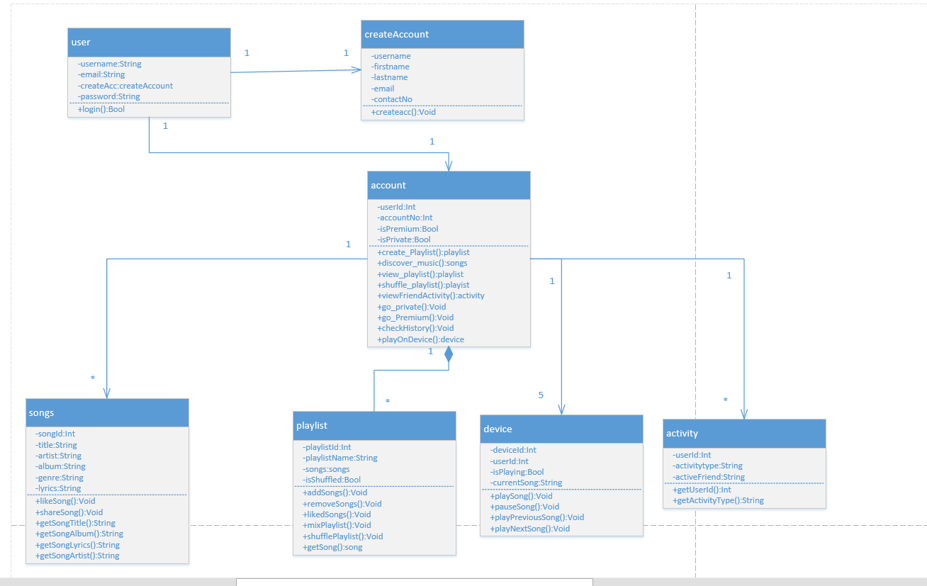

# System sequence diagram:

## Create account

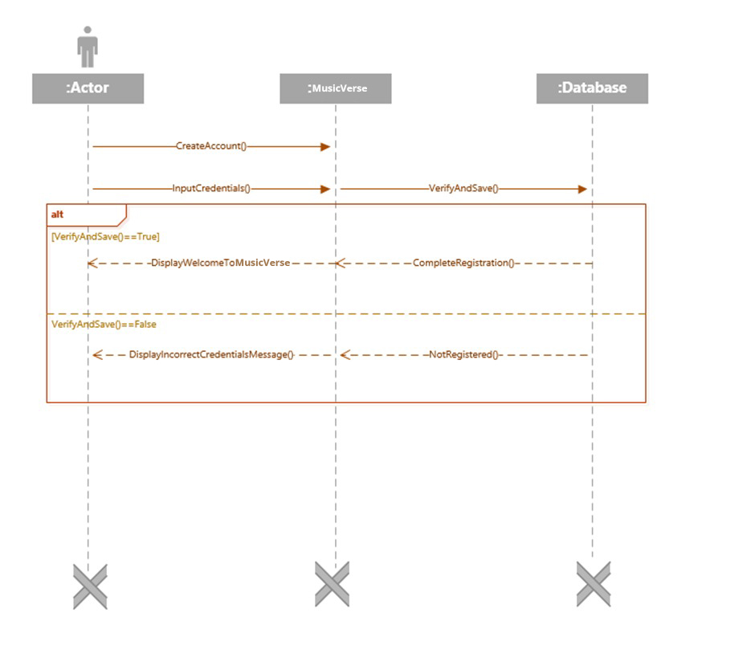

## Login

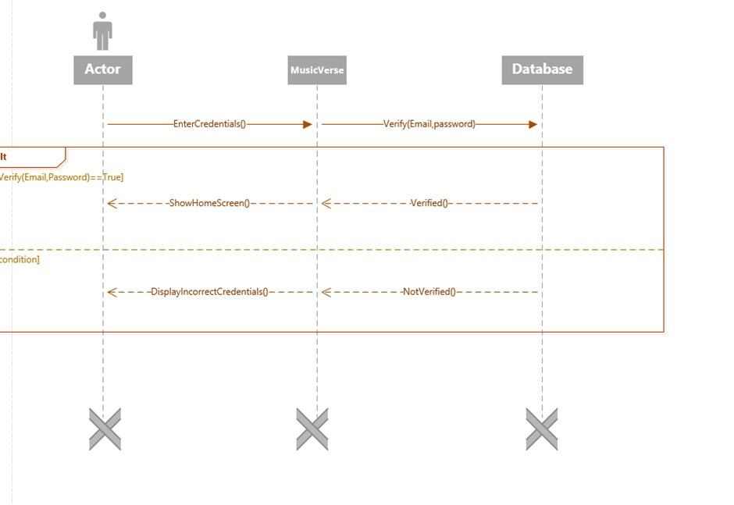

## Discover music:

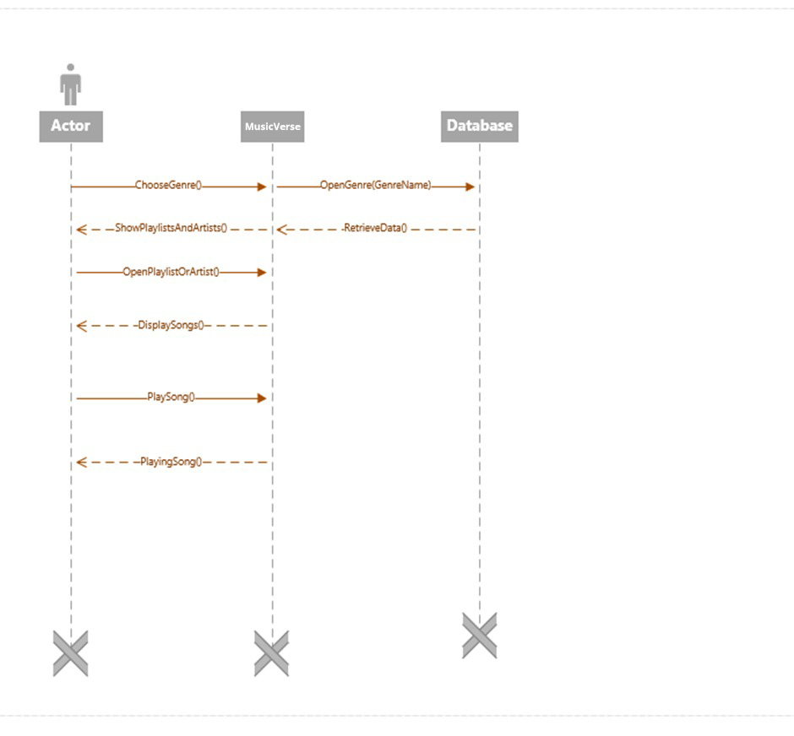

## Create edit playlist:

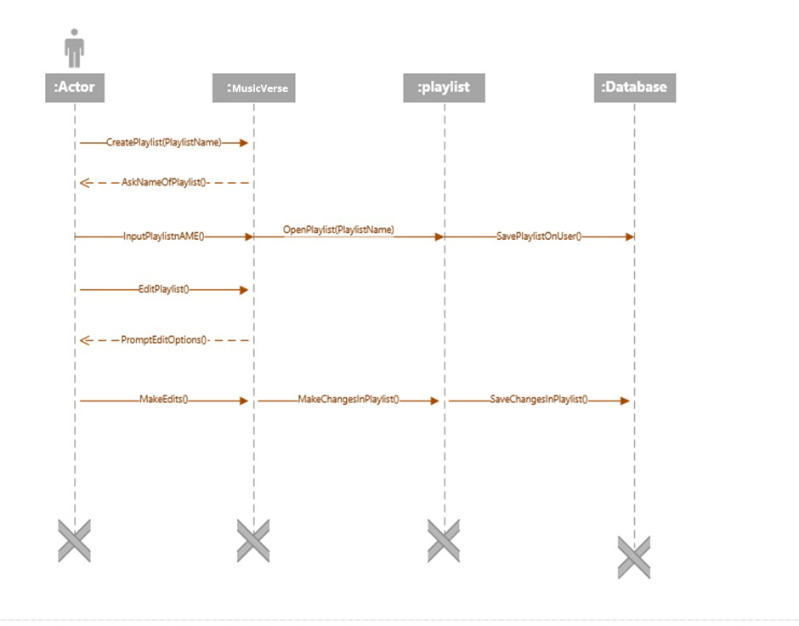

## Check history:

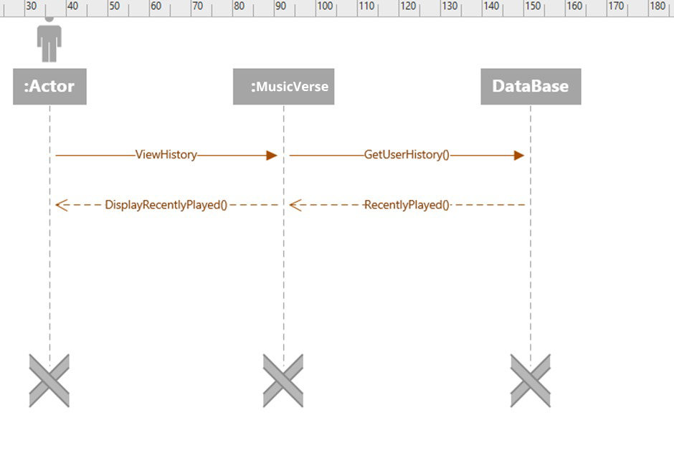

## Play on different devices:

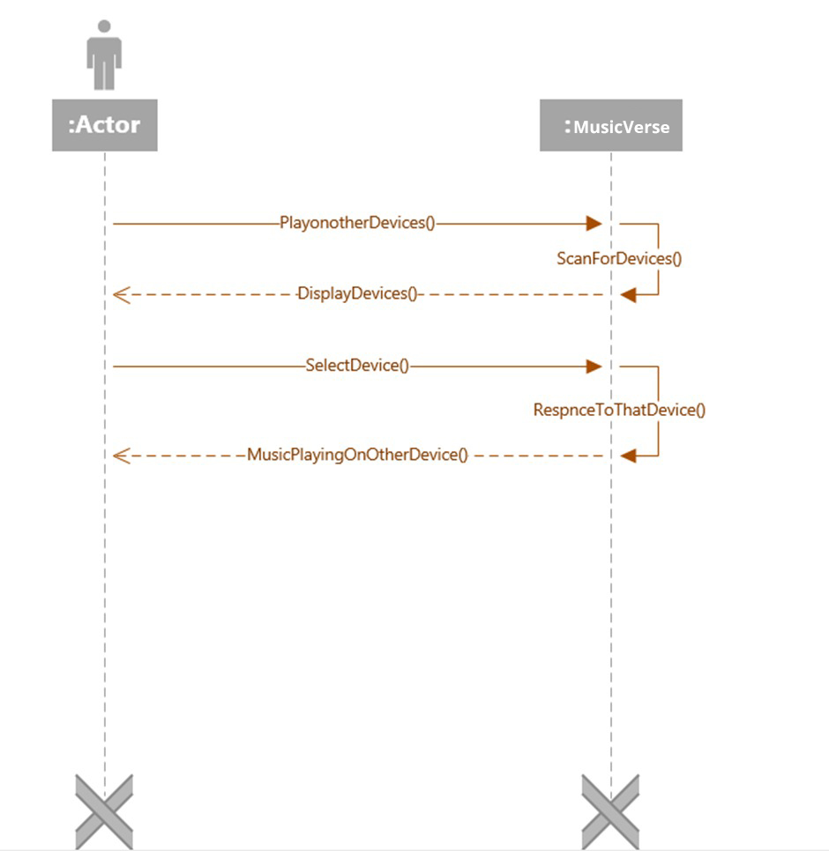

## Friends activity:

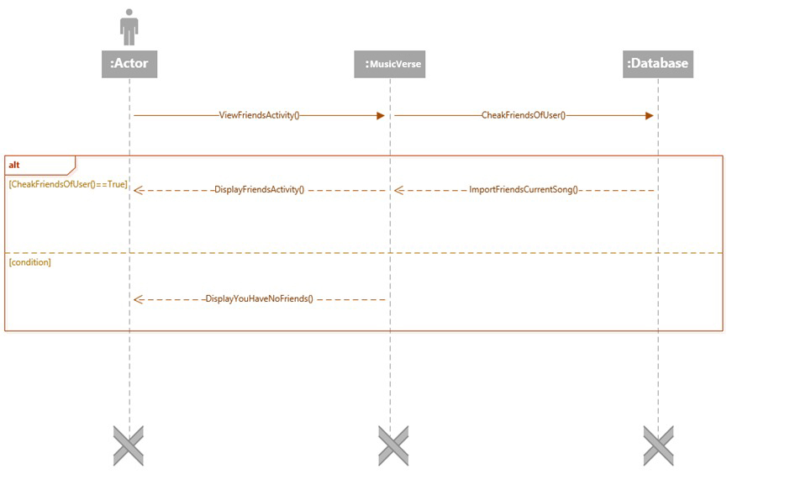

## Shuffle playlist:

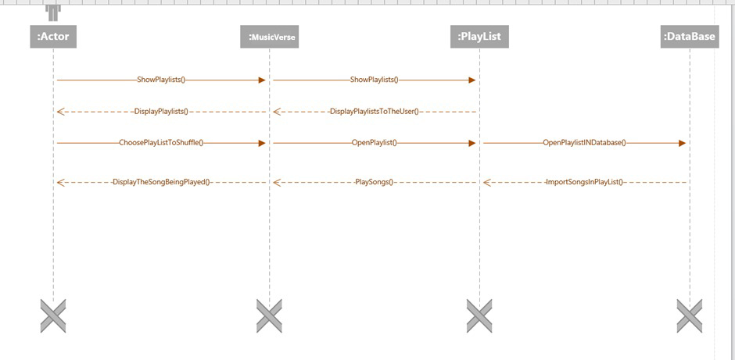

## Search songs:

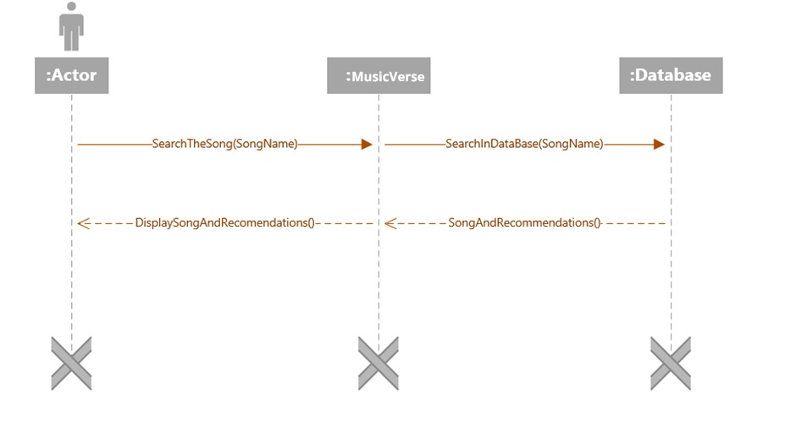

## Premium:

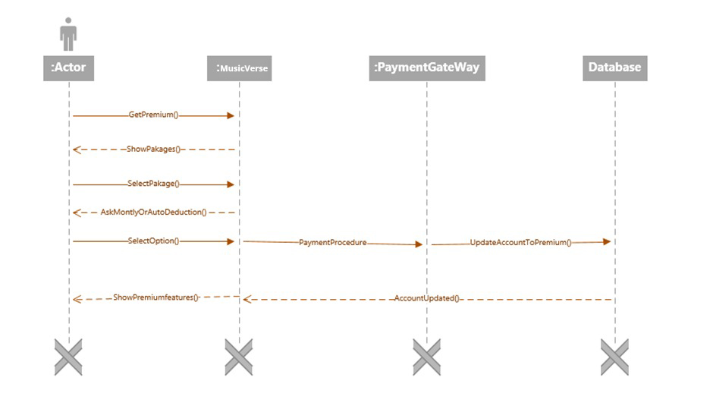

## Display lyrics:

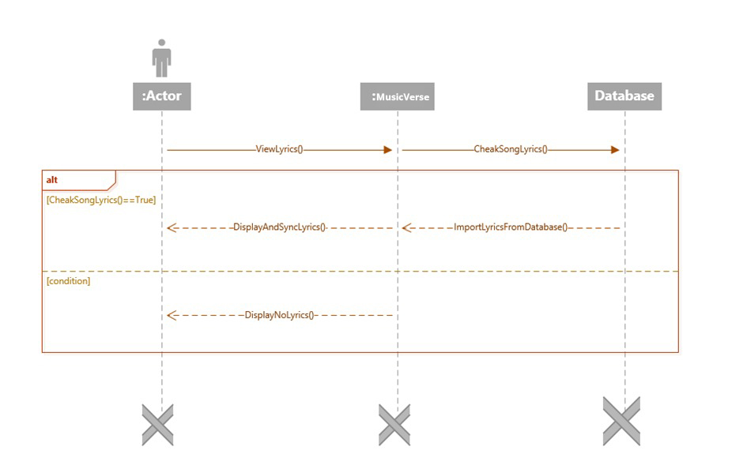

## Private mode:

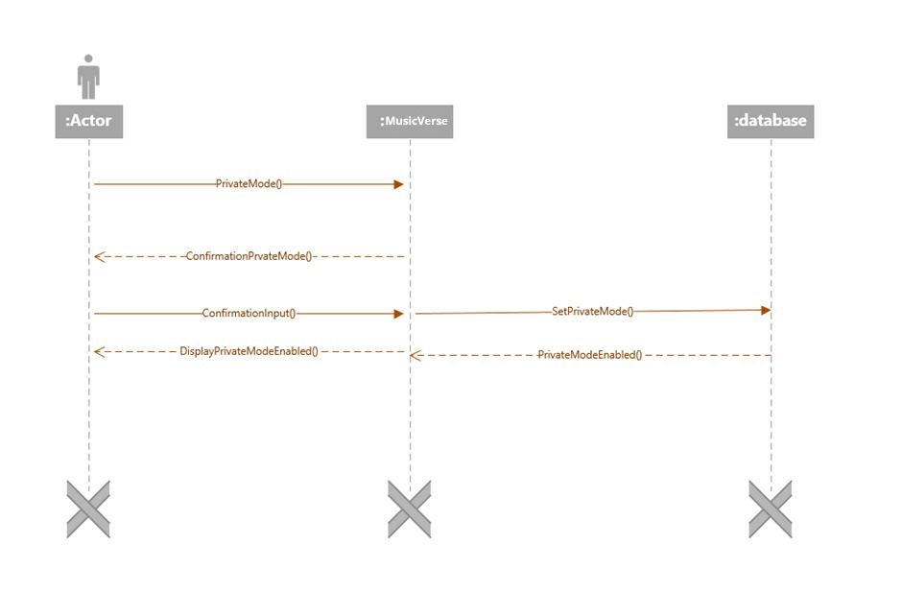

# Sequence diagram:

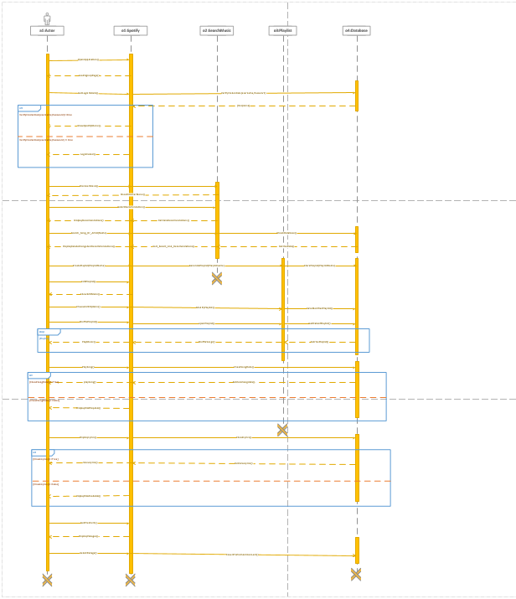

# Activity diagram:

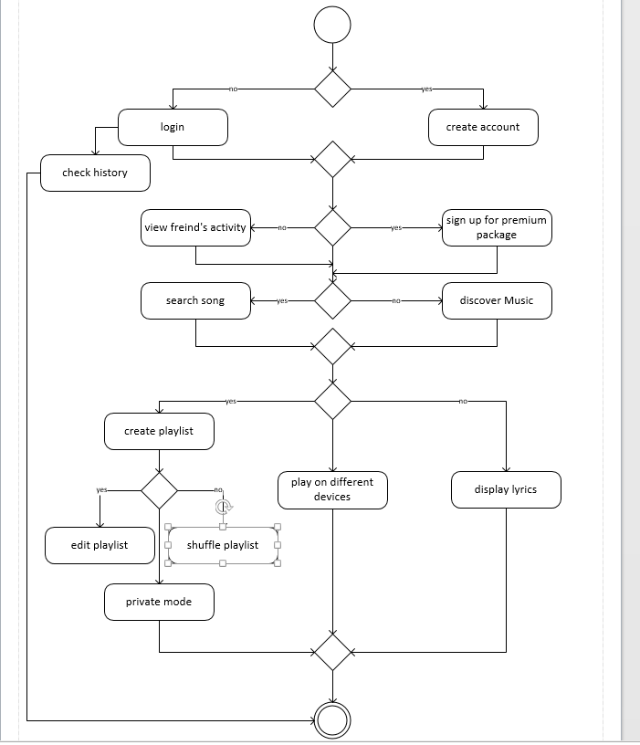

# State machine:

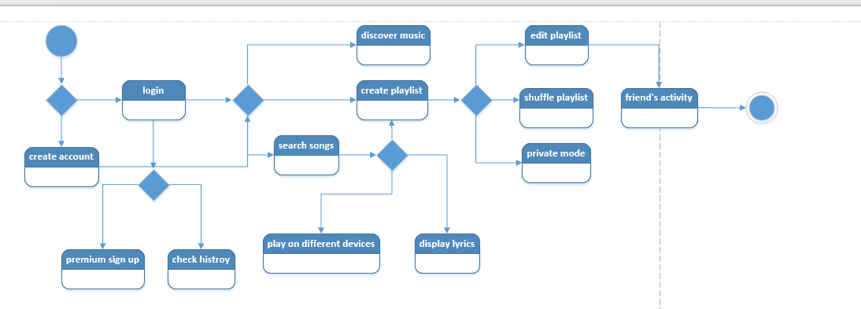

# Data Flow Diagram:

# Level 0:

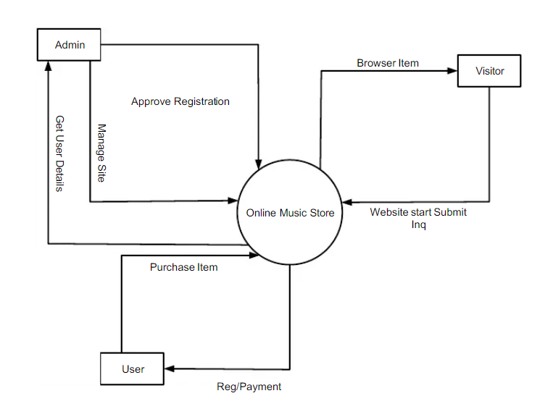

# Level 1:

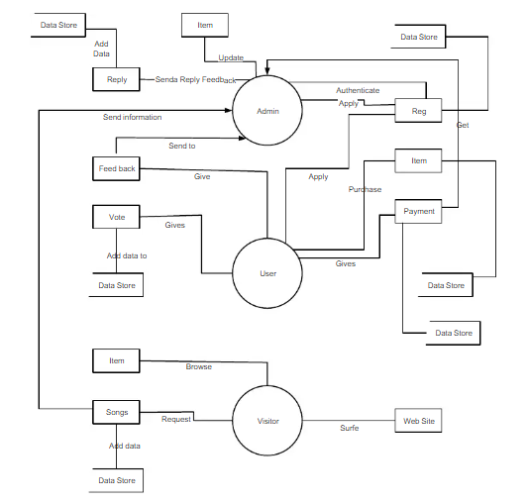

# For User:

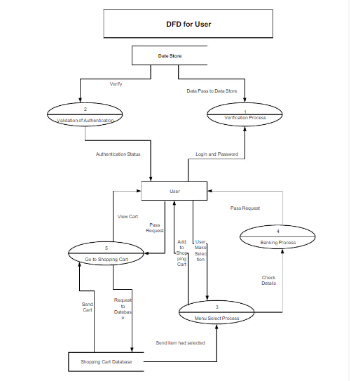

# Component diagram:

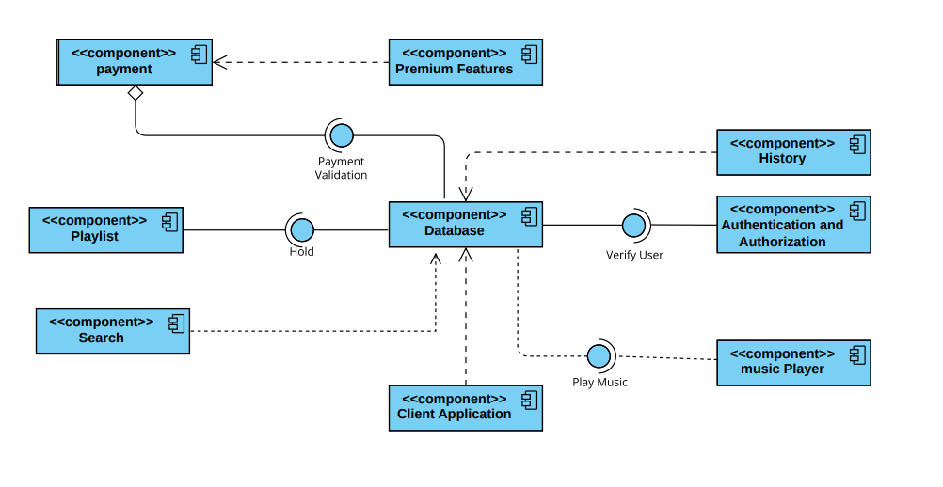

# Package diagram:

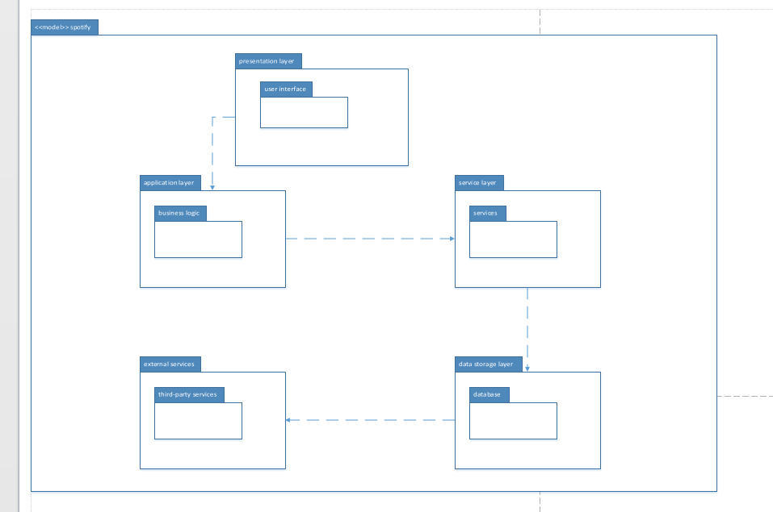

* **Presentation model:** This model represents the user interfaces package, such as web or mobile apps, and is responsible for displaying the music content, handling user interactions, and providing a smooth user experience.
* **Application model:** This model contains the business logic package and handles functionalities such as user authentication, playlist creation, music recommendation algorithms, and social features like viewing friends' activities.
* **Services model:** This model includes services package that provide specific functionalities, such as a music recommendation service, a playlist management service, a user profile service, and a payment service for premium subscriptions.
* **Data Storage model:** This model consists of databases package that store music metadata, user profiles, playlists, listening history, and other relevant data.
* **External Services model:** MusicVerse may also interact with external services, such as music licensing providers, payment gateways, social media platforms (for friend activities), and other third-party services for additional functionalities.

# Deployment diagram:

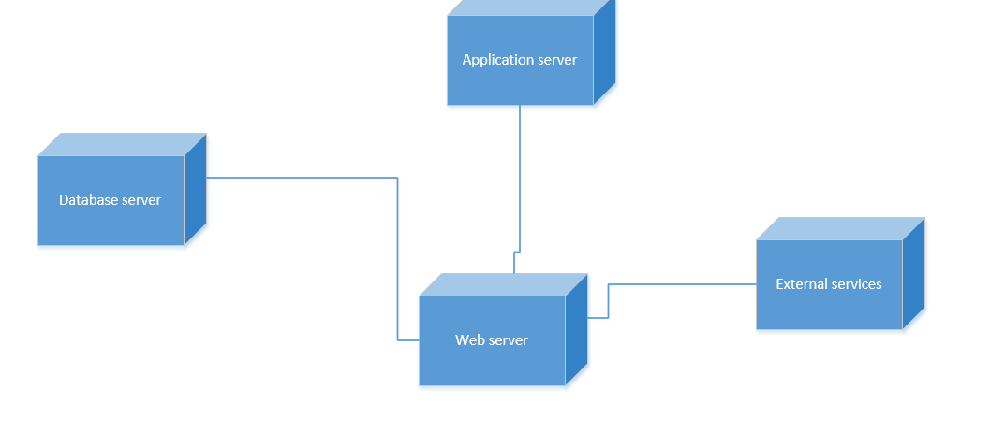

* **Web server:**
* Serves user interface
* Implements Application Layer
* **Application server:**
* Implements Application Layer
* Provides access to Services Layer
* **Database server:**
* Stores user data and music data
* Implements Data Storage Layer
* **External services:**
* Payment Gateways
* Social Media Platforms
* Third-party Services