|  |  |  |
| --- | --- | --- |
|  | National University  of Computer and Emerging Sciences  Chiniot-Faisalabad Campus |  |

**Database Lab**

**Final Project**

**Spring 2023**

|  |
| --- |
|  |

**Murad Hameed**

**Submitted To**

“Ms. Saba Naseem”

# Schema

CREATE TABLE users (

id INT PRIMARY KEY IDENTITY(1,1),

fullname VARCHAR(255) NOT NULL,

email VARCHAR(255) NOT NULL UNIQUE,

role VARCHAR(100),

password VARCHAR(255) NOT NULL,

image VARCHAR(255),

is_deleted BIT DEFAULT 0

);

CREATE TABLE products (

id INT PRIMARY KEY IDENTITY(1,1),

name VARCHAR(255) NOT NULL,

category VARCHAR(255) NOT NULL,

price DECIMAL(10,2) NOT NULL,

is_available BIT DEFAULT 1,

image VARCHAR(255) NULL,

is_deleted BIT DEFAULT 0

);

CREATE TABLE transactions (

id INT PRIMARY KEY IDENTITY(1,1),

user_id INT NOT NULL,

cash DECIMAL(10,2) NOT NULL,

date_created DATETIME DEFAULT GETDATE() NOT NULL,

FOREIGN KEY (user_id) REFERENCES users(id)

);

CREATE TABLE logs (

id INT PRIMARY KEY IDENTITY(1,1),

user_id INT NOT NULL,

activity VARCHAR(255) NOT NULL,

date_created DATETIME DEFAULT GETDATE(),

FOREIGN KEY (user_id) REFERENCES users(id)

);

CREATE TABLE orders (

id INT PRIMARY KEY IDENTITY(1,1),

product_id INT NOT NULL,

transaction_id INT NOT NULL,

quantity INT NOT NULL,

price DECIMAL(10,2) NOT NULL,

FOREIGN KEY (product_id) REFERENCES products(id),

FOREIGN KEY (transaction_id) REFERENCES transactions(id)

);

CREATE VIEW OrderTotal AS

SELECT transaction_id, SUM(price*quantity) AS total, Sum(quantity) AS orders

FROM orders

GROUP BY transaction_id;

CREATE VIEW TransactionsView AS

SELECT transactions.*, OrderTotal.total, OrderTotal.orders

FROM transactions INNER JOIN OrderTotal ON transactions.id=OrderTotal.transaction_id;

CREATE VIEW SalesView AS

SELECT

Sum(TransactionsView.total) AS Sale,

CAST(TransactionsView.date_created AS DATE) AS day,

Sum(TransactionsView.orders) AS total_order,

Count(TransactionsView.id) AS total_customer

FROM

TransactionsView

GROUP BY

CAST(TransactionsView.date_created AS DATE);

# All Tables

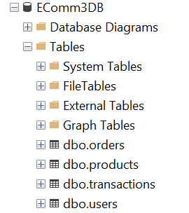

# Orders Table

# 

# Products Table

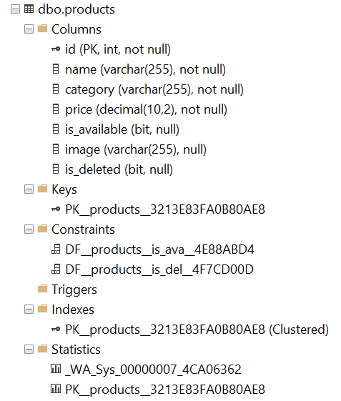

# Transactions Table

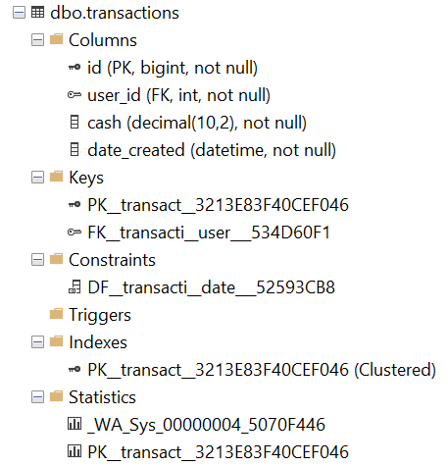

# Users Table

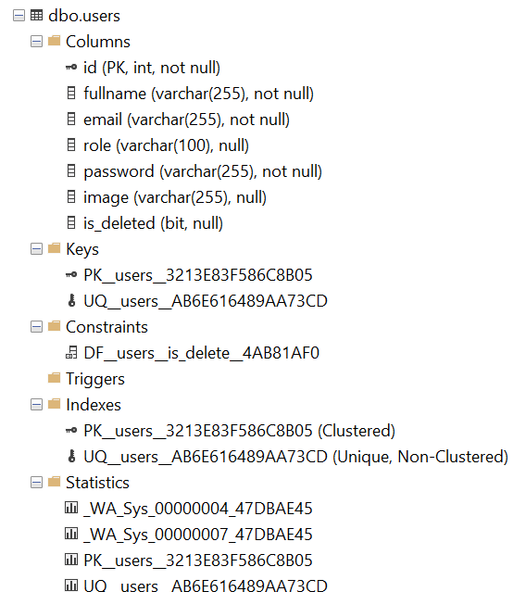

# All Views

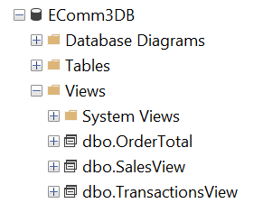

# OrderTotal

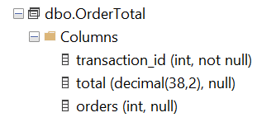

# SalesView

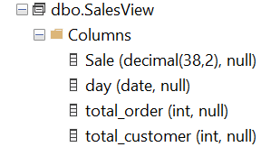

# TransactionsView

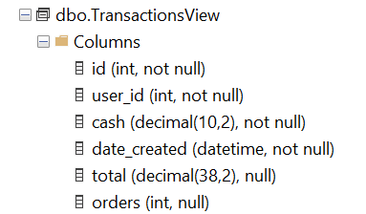

# Schema Diagram

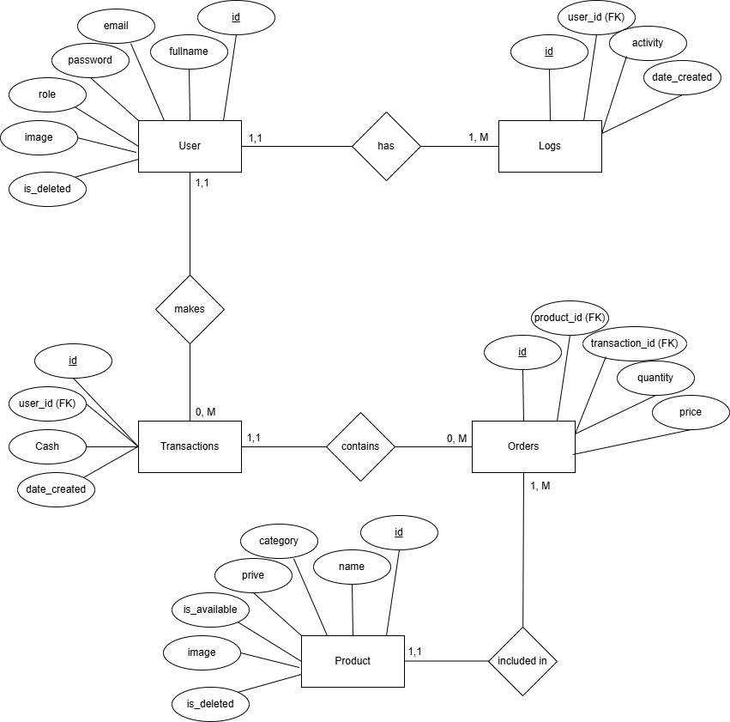

# Application Demo

# Role as Admin

# Loading Screen



# Login Screen

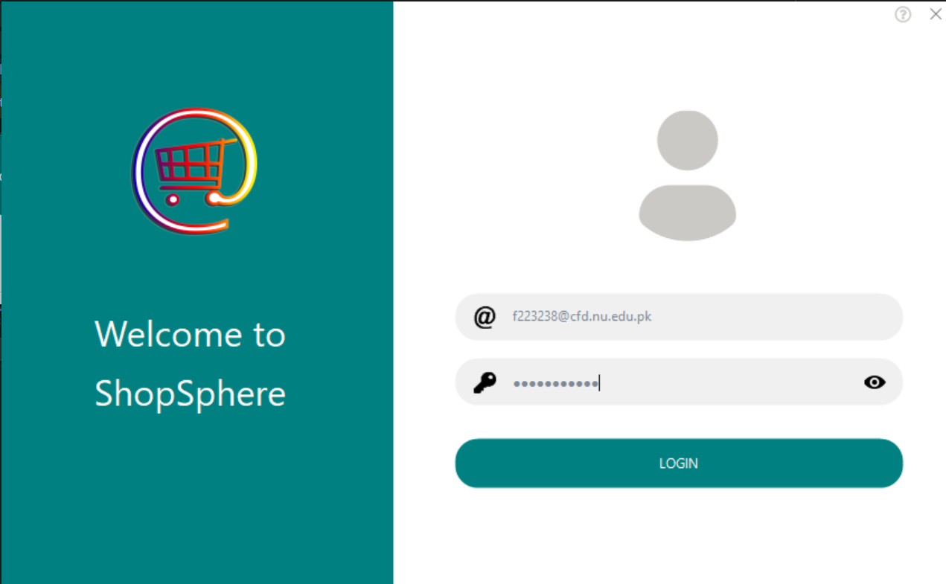

# Toggling the eye button

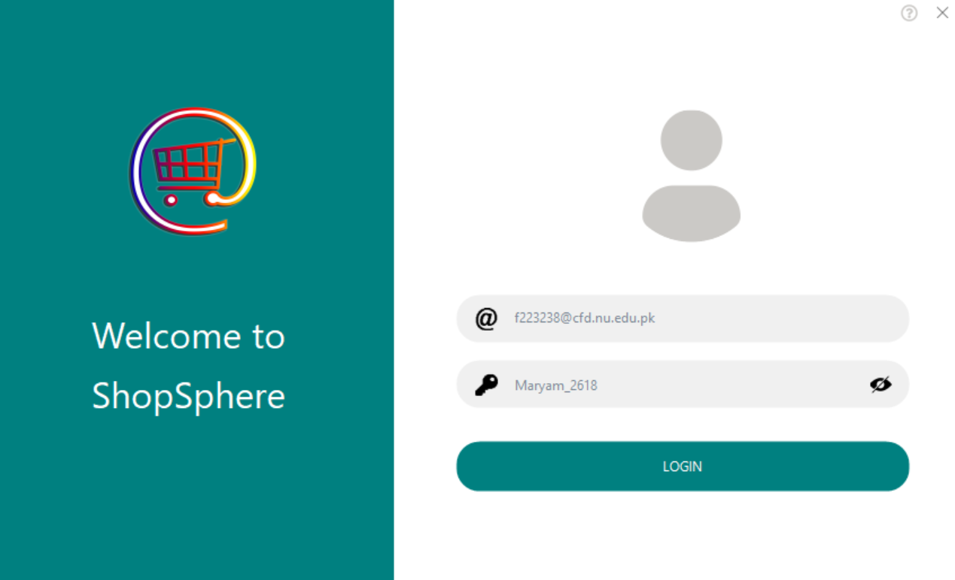

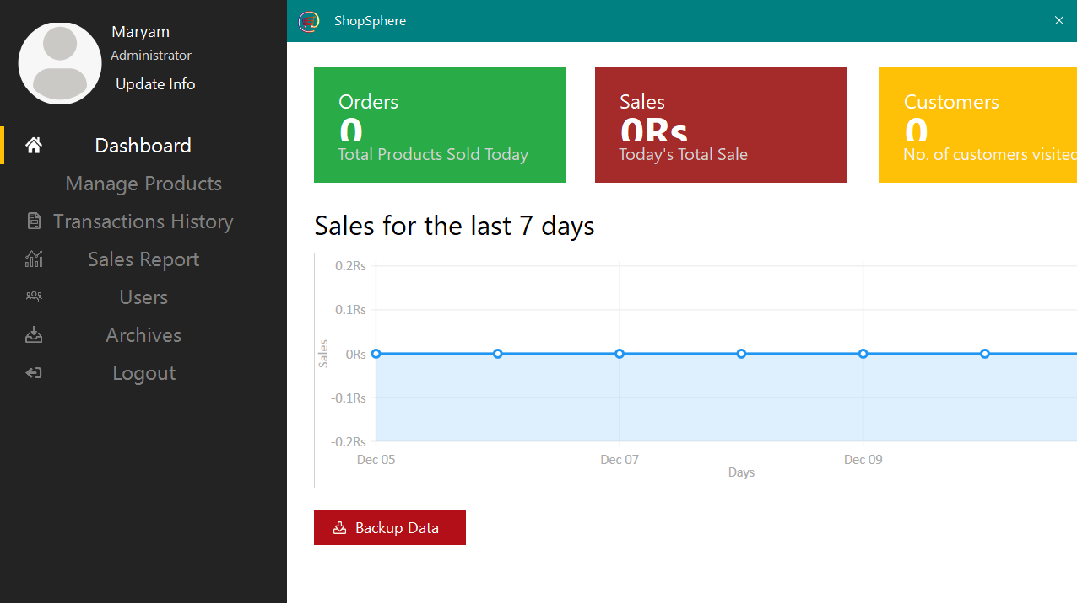

As no products are sold and hence no order or customers are made, these statistics as well as the graph is showing Zero

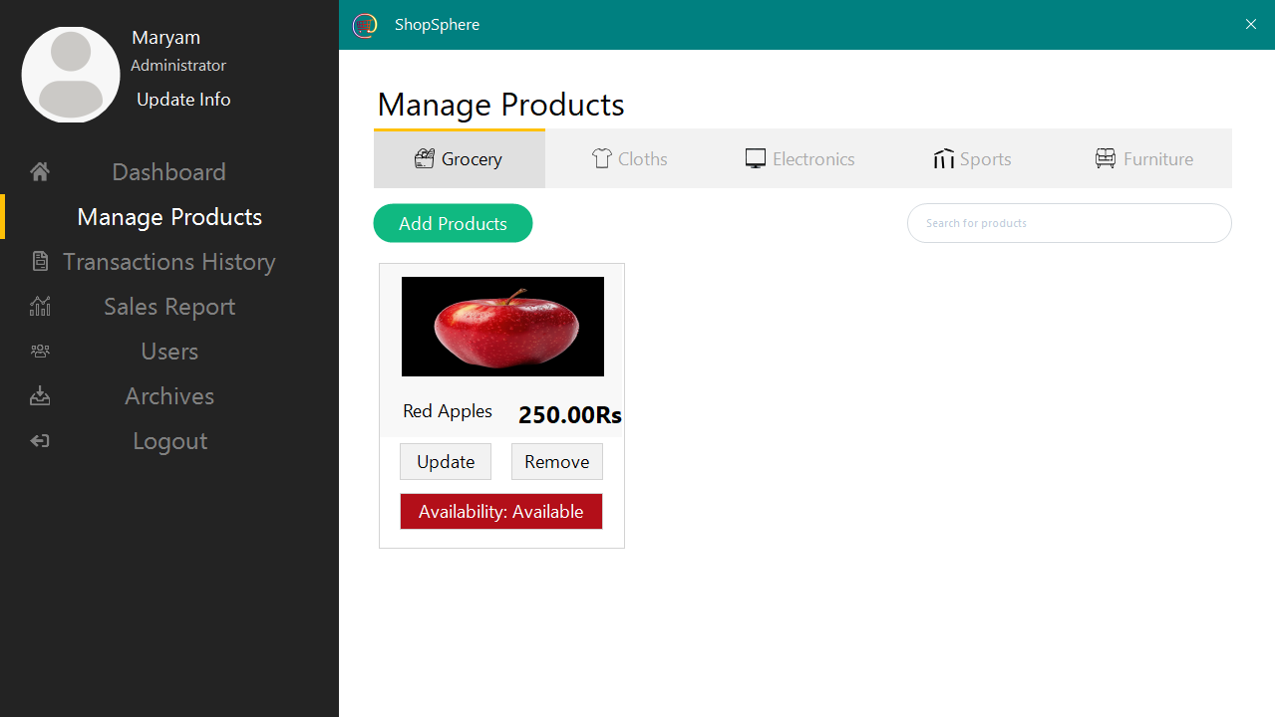

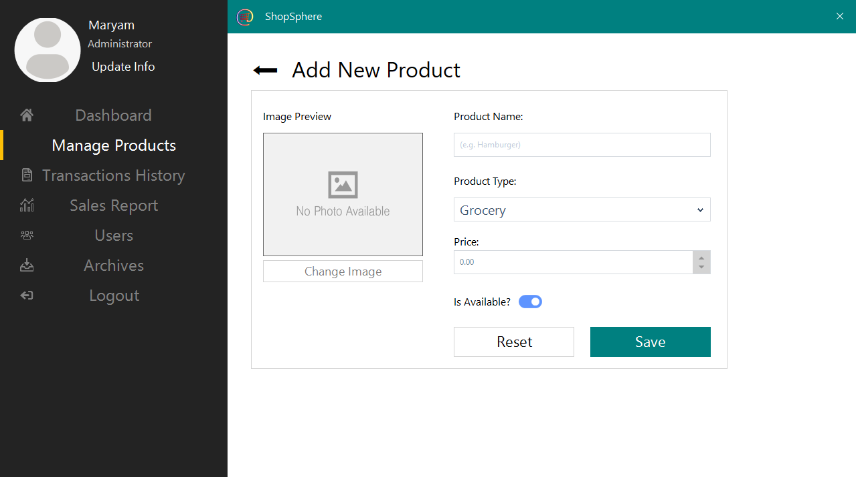

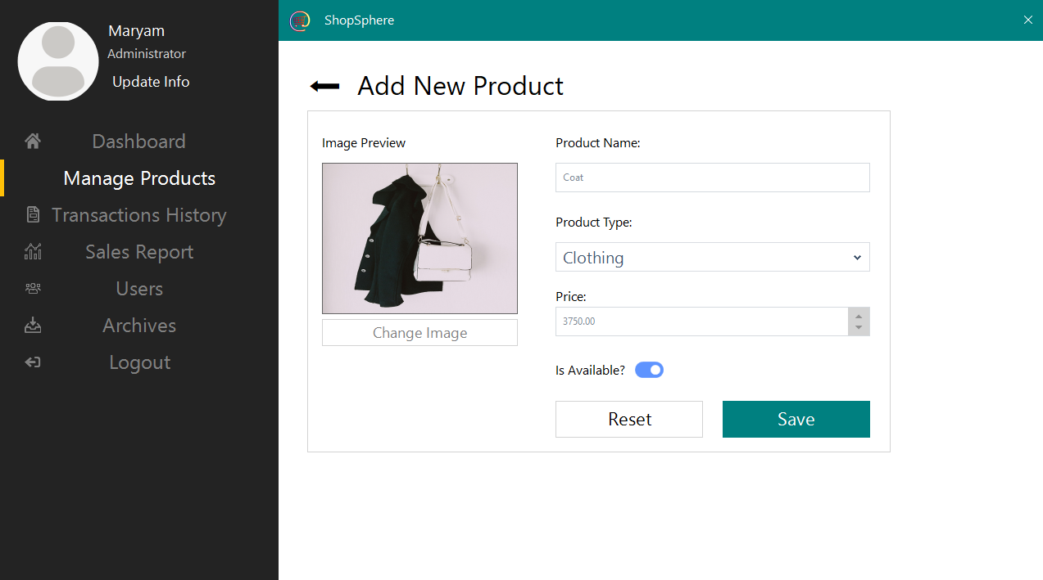

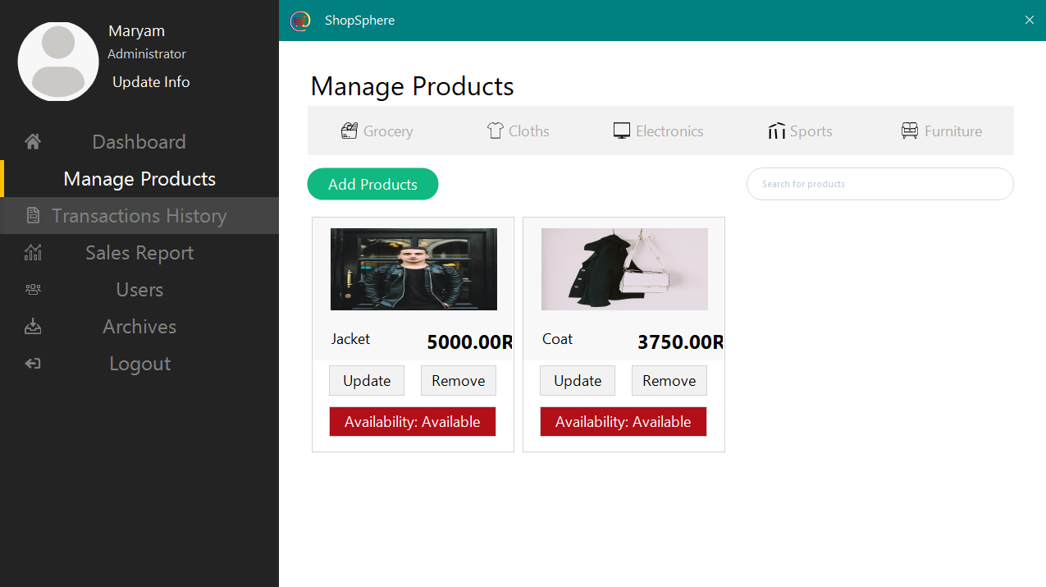

# Categories

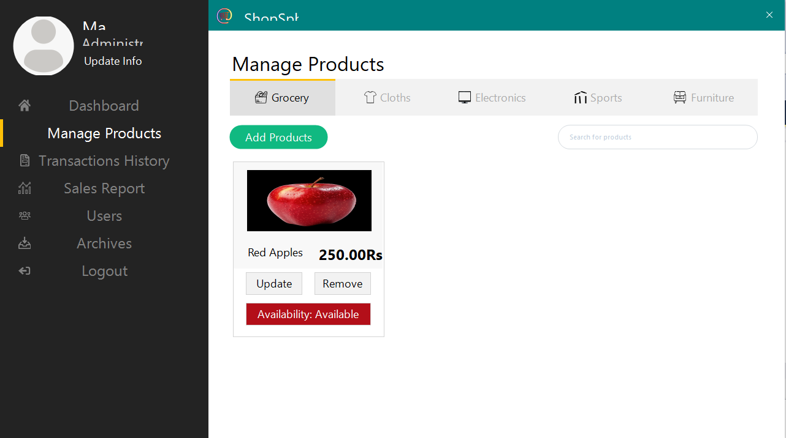

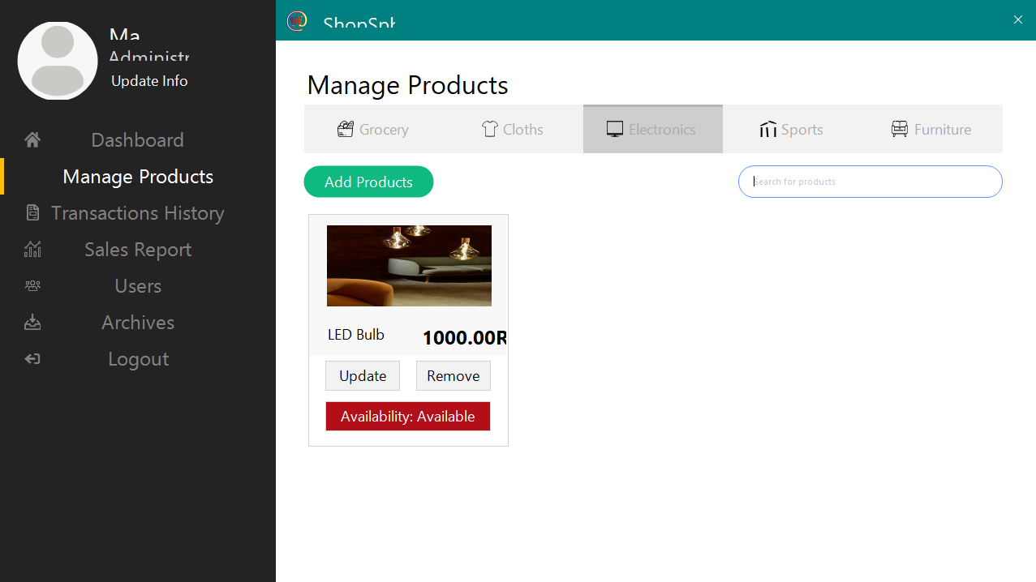

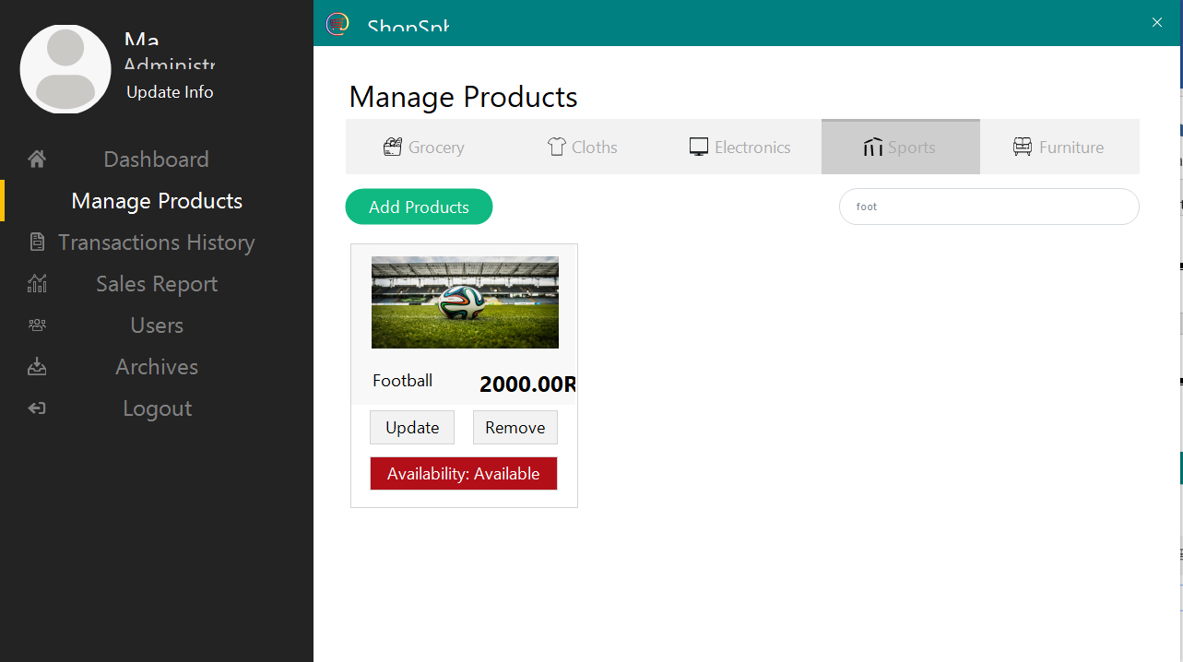

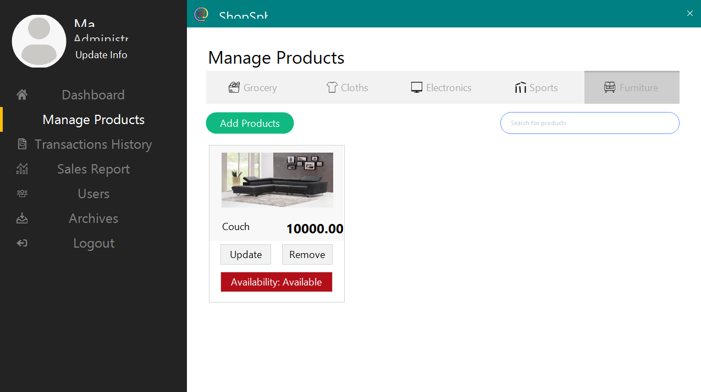

# In database

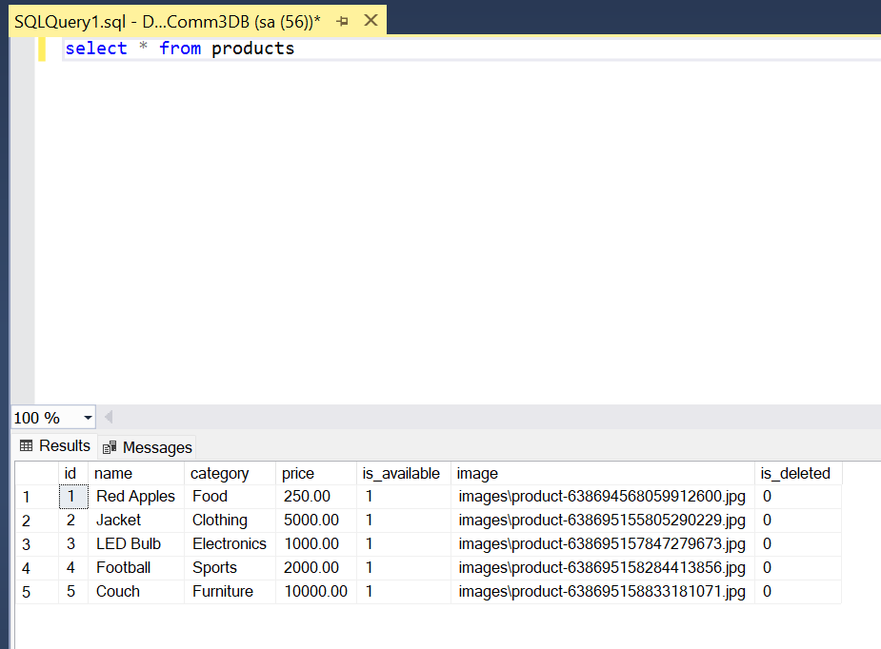

# Searching

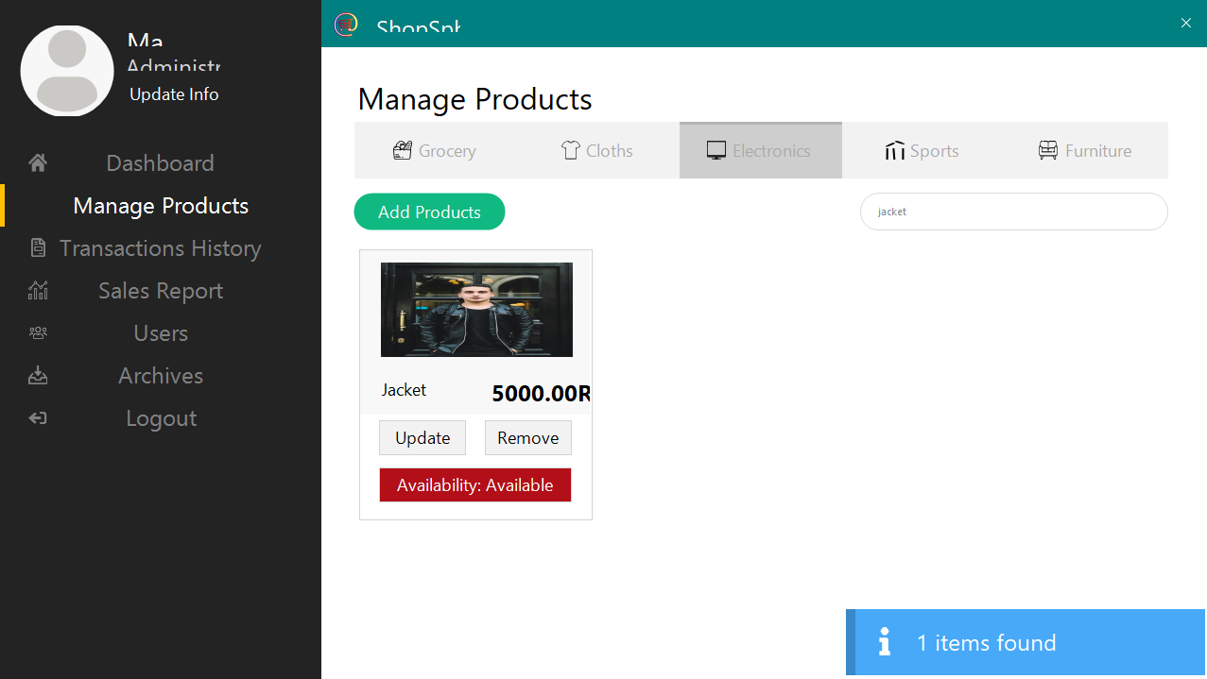

# Setting the availability to false

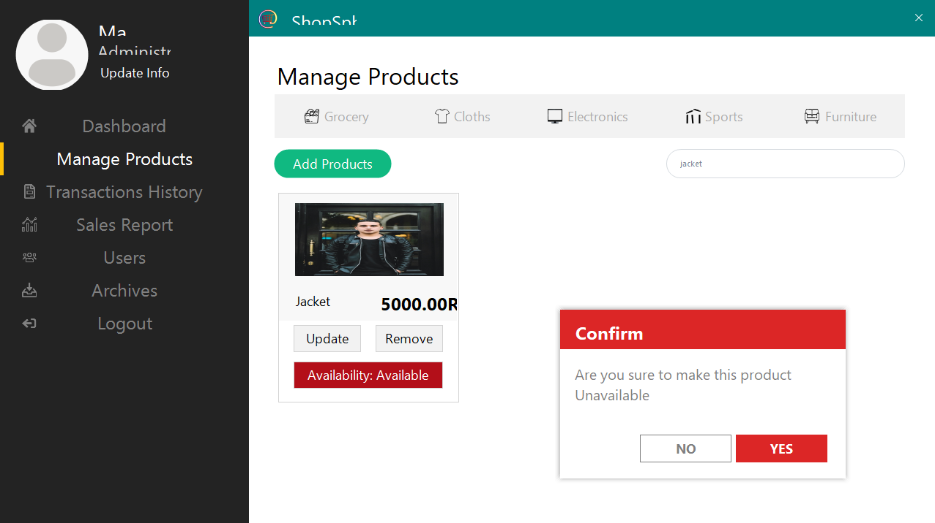

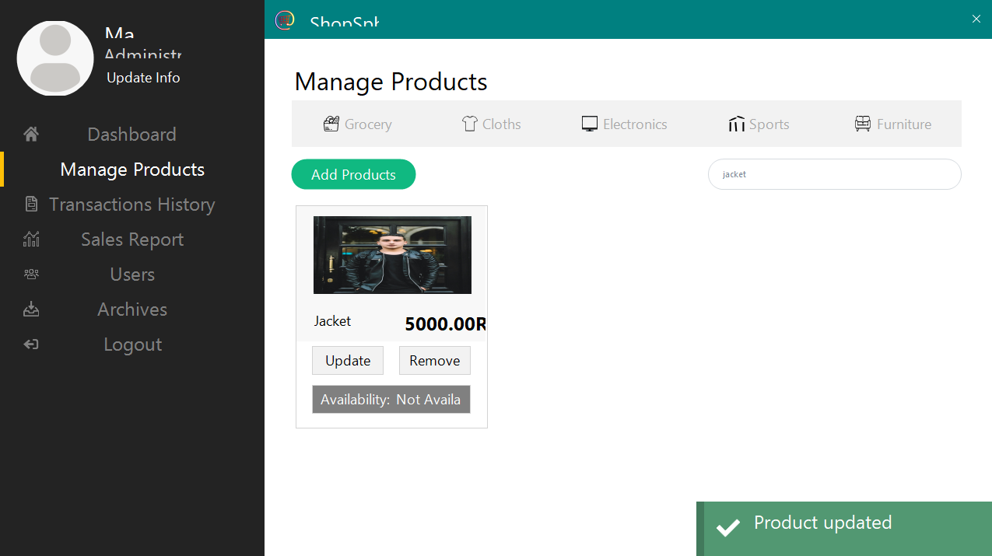

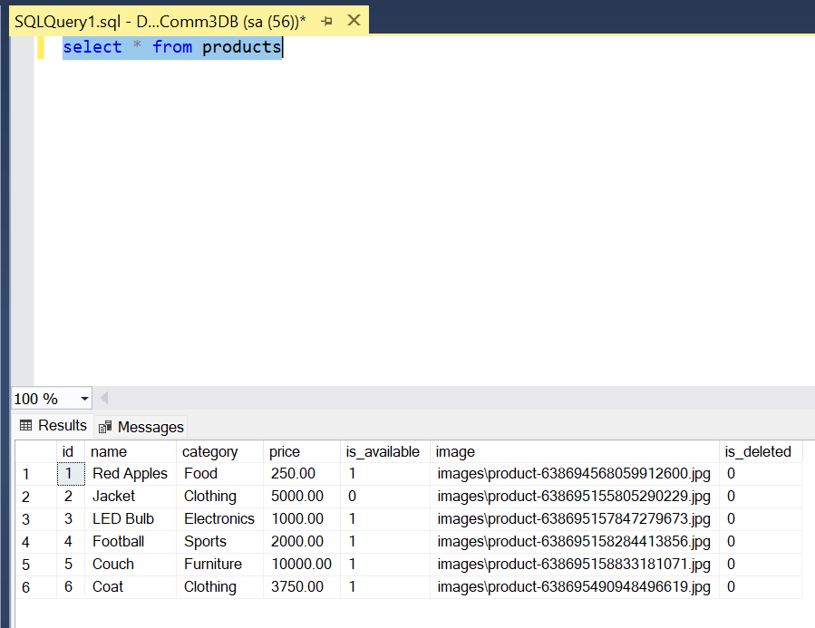

# Updating the Product

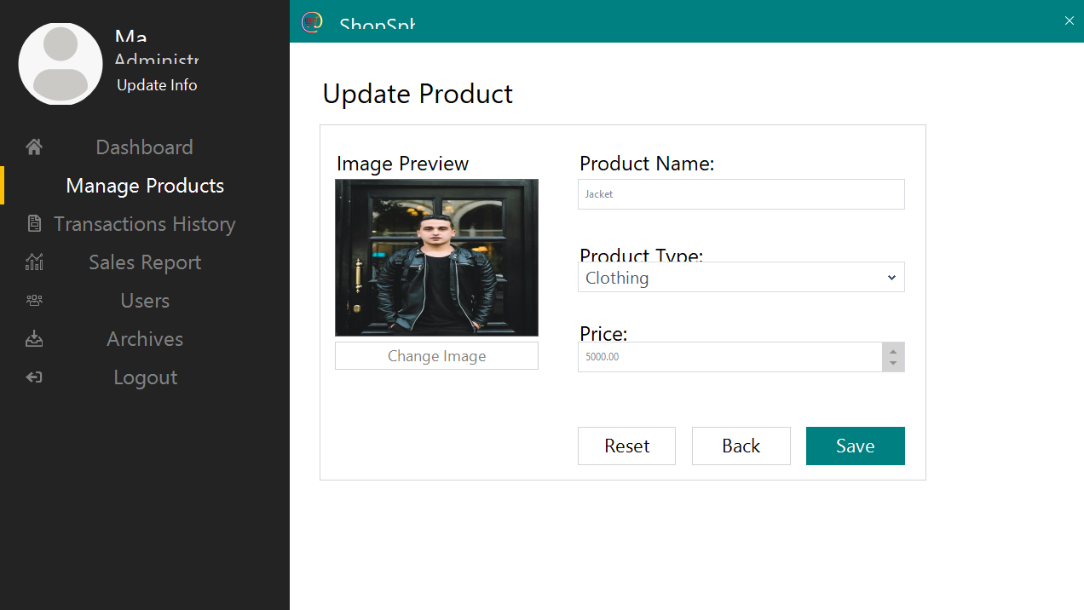

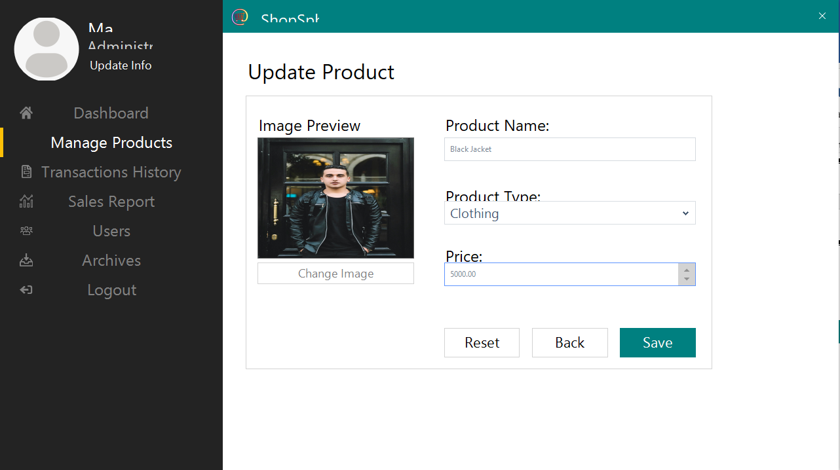

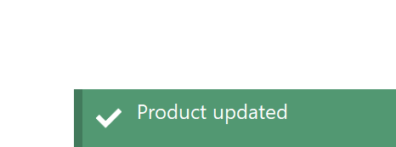

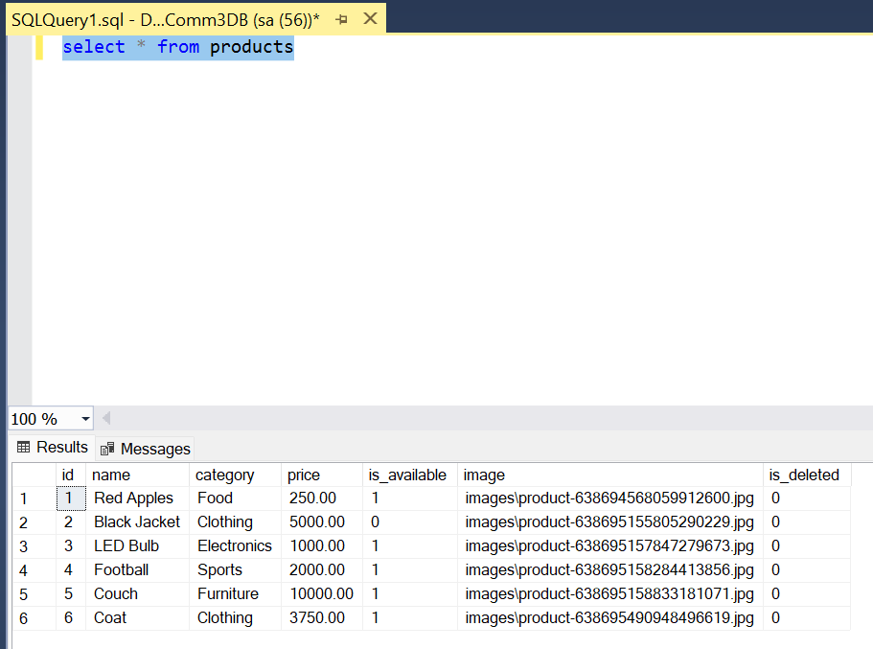

# Sales Report of the Week

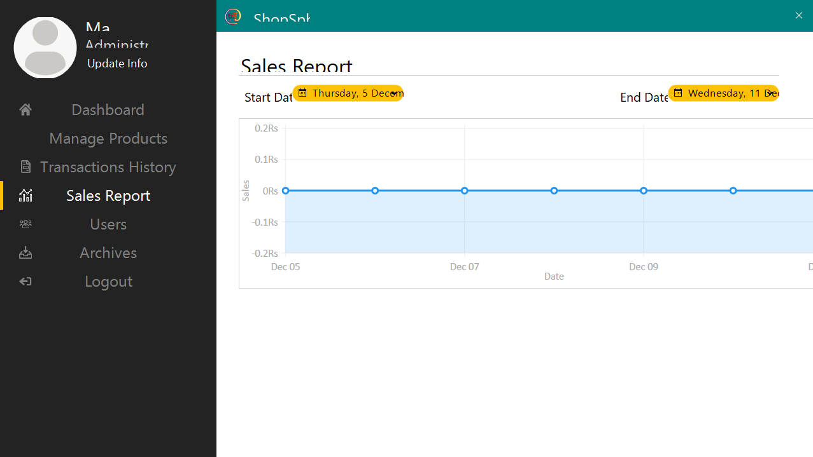

# We can set the calendar as well

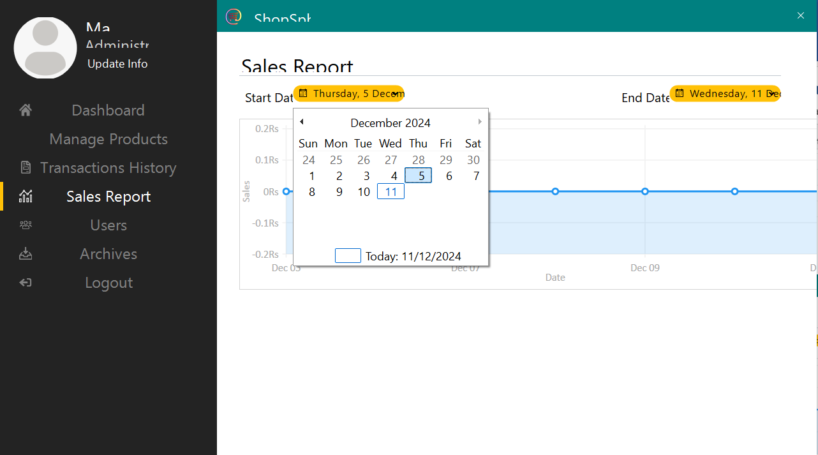

It will now show the sales of that modified timeperiod

# Users

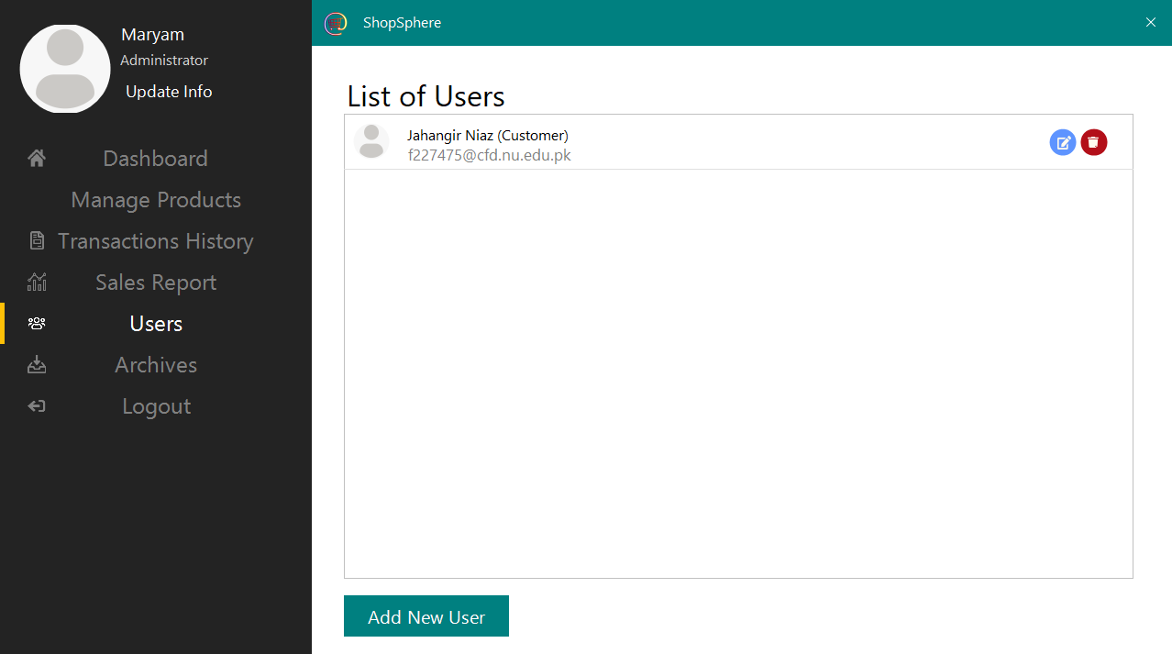

It shows the users of the application that are registered, currently we have 1 customer

# Updating User

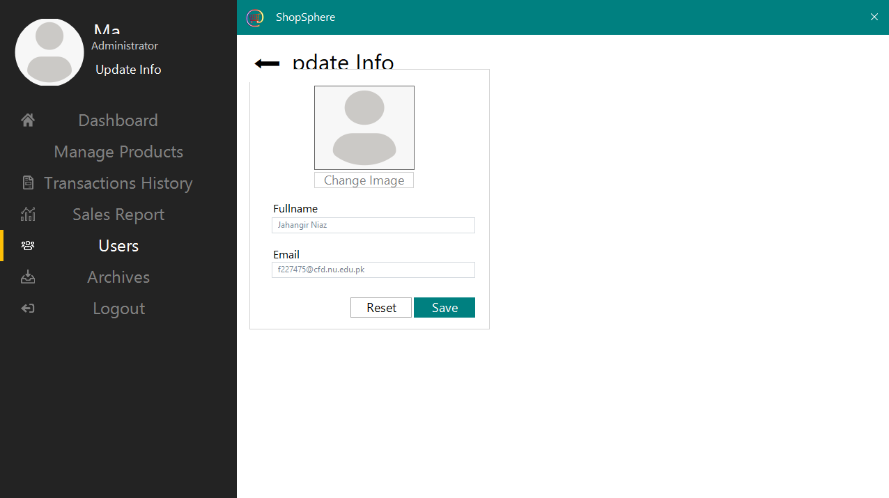

We can edit the customer that we added

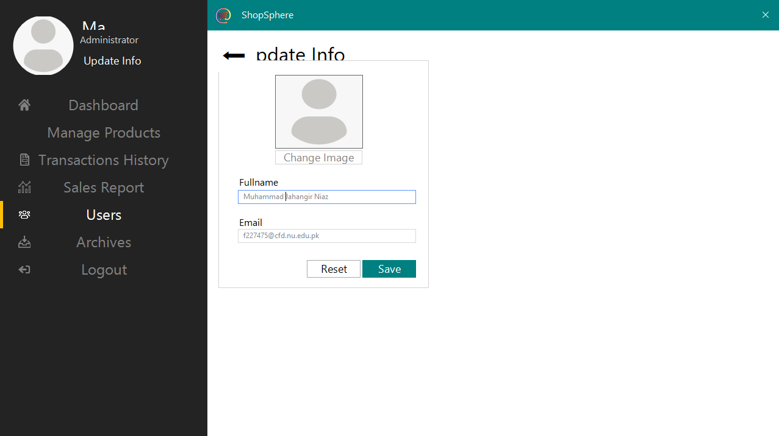

# Adding new user

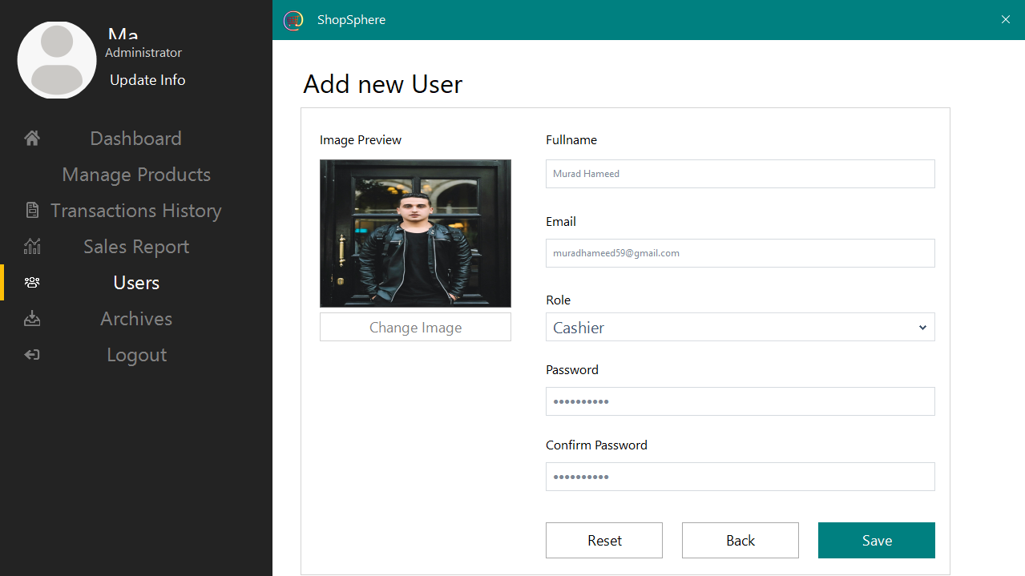

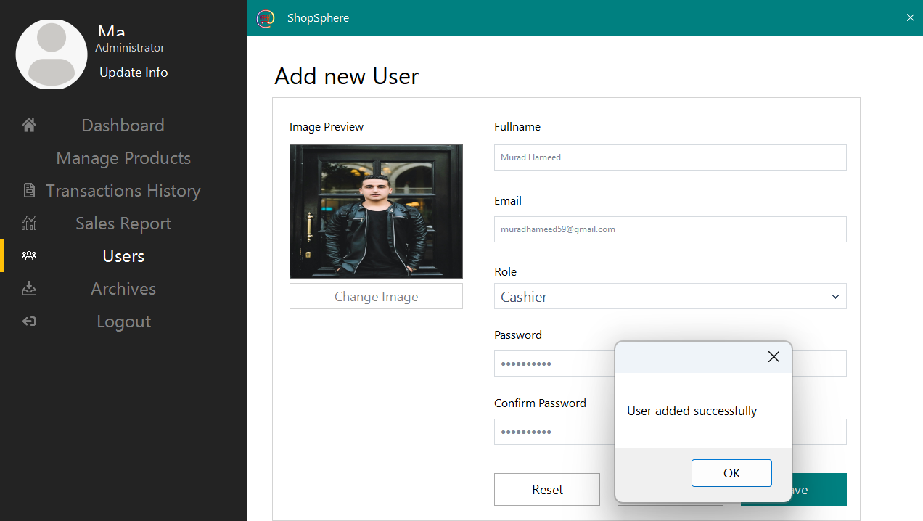

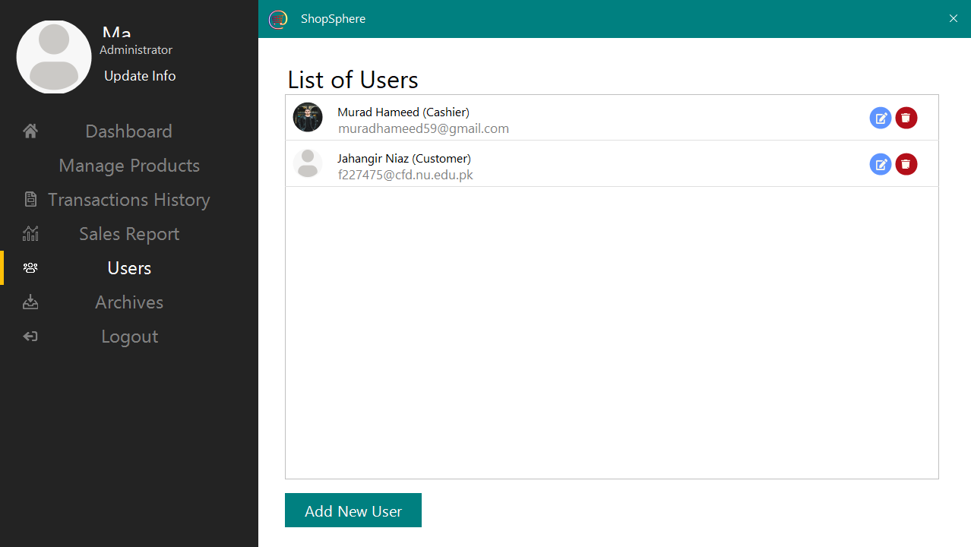

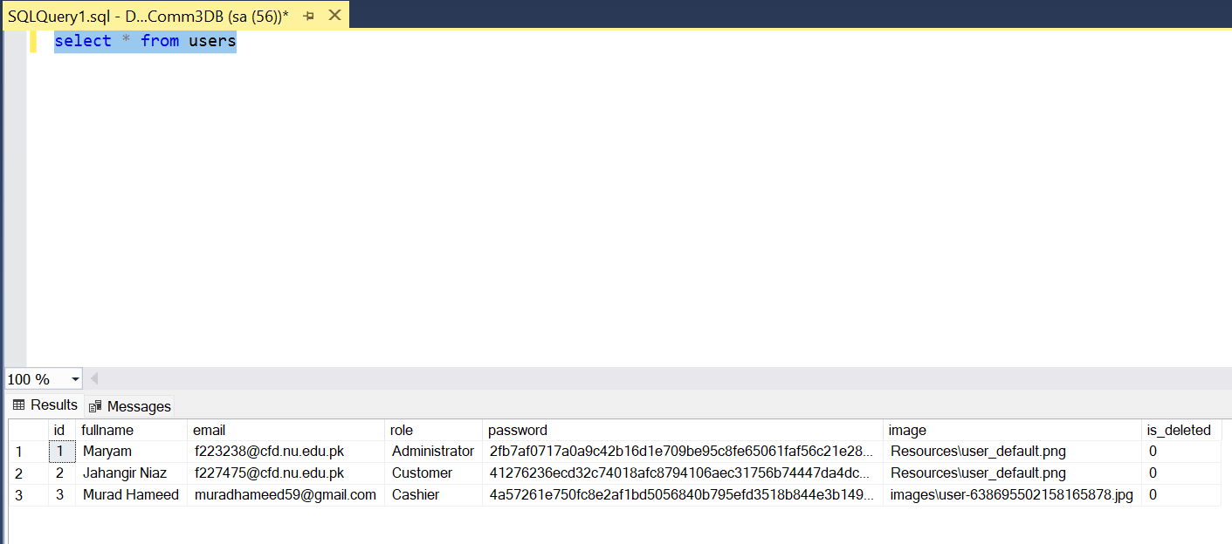

# You can see that the password is stored in the form of HASH in database for security purposes

# Deleting the User

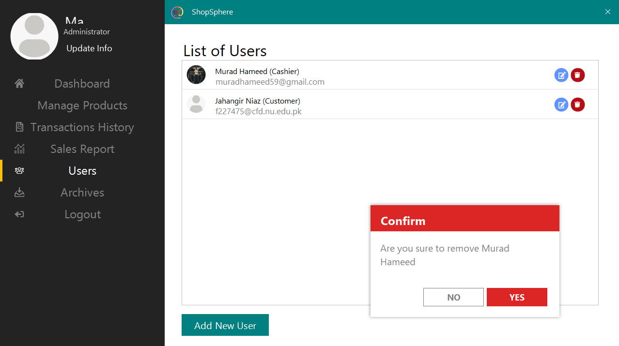

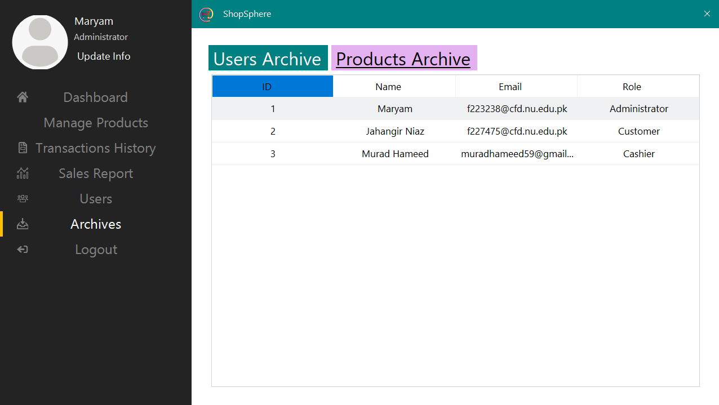

# Product Archive

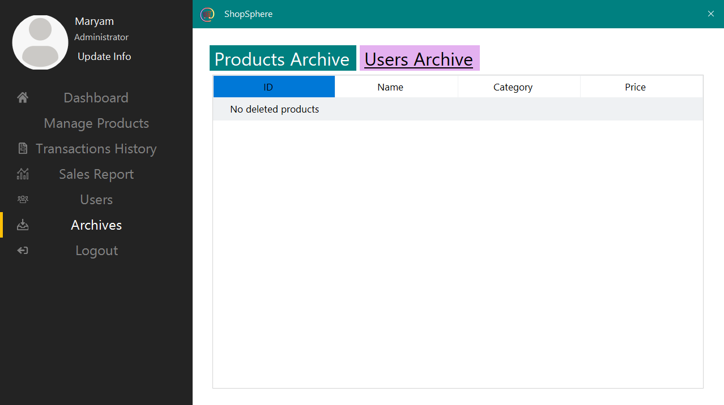

It shows the products that are deleted

# Updating your own info

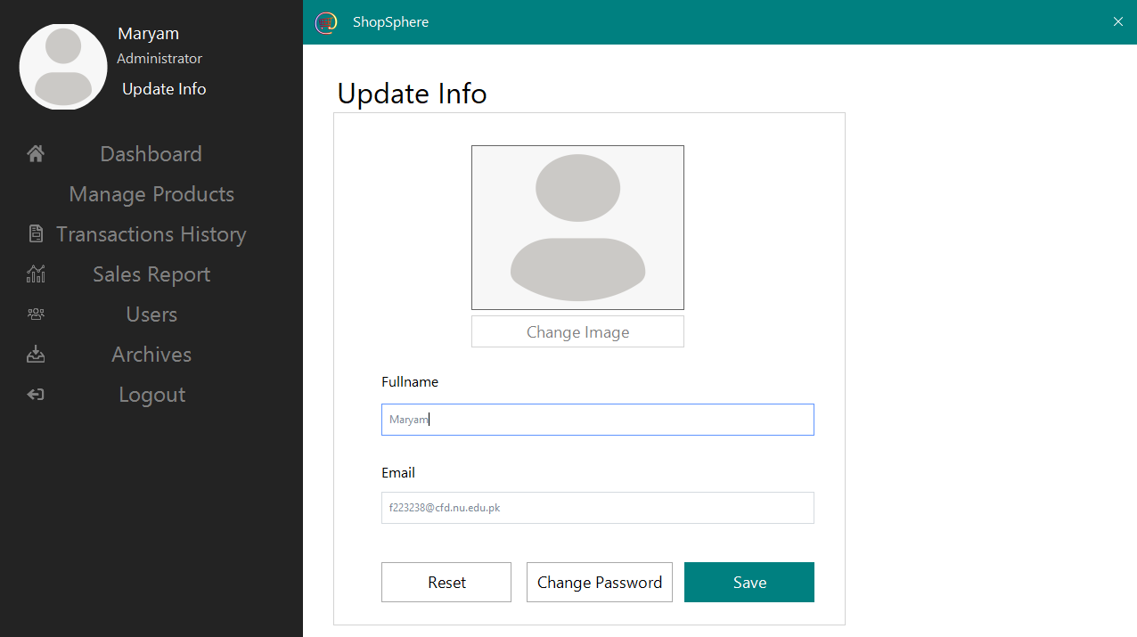

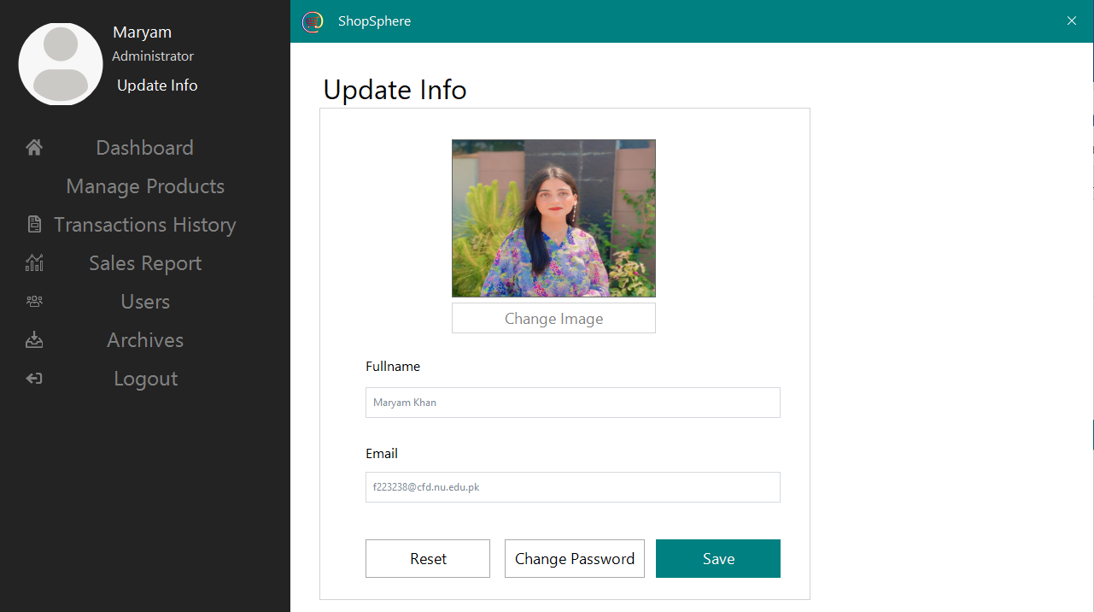

# Log out

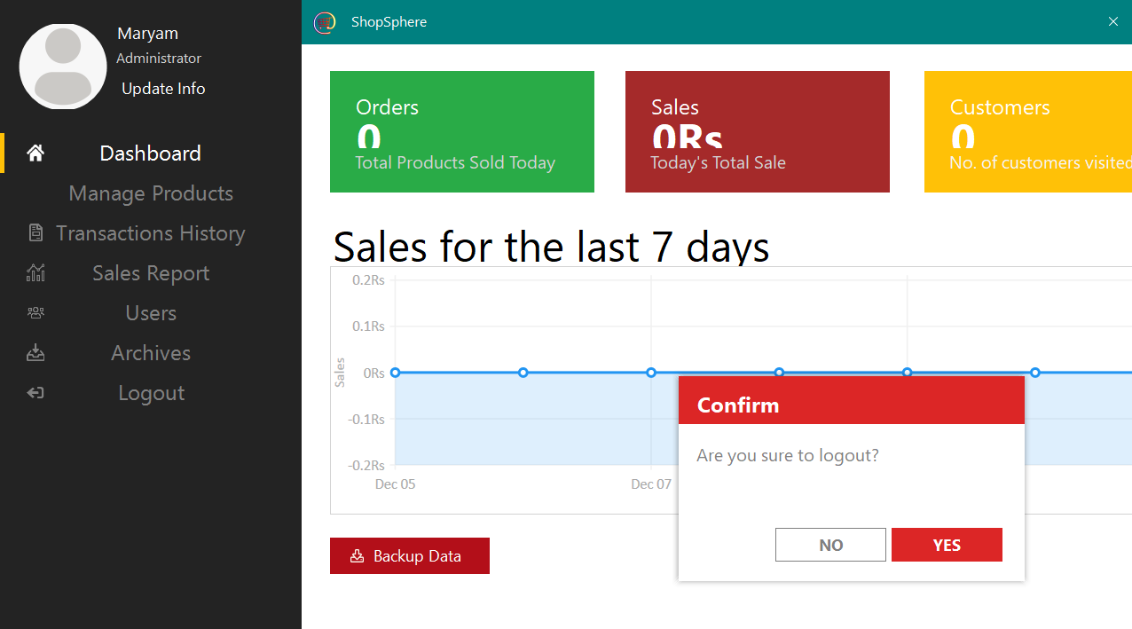

# Role as Cashier

# Login

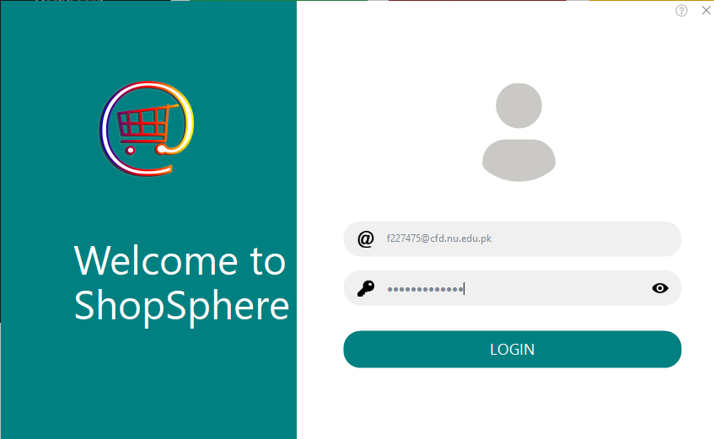

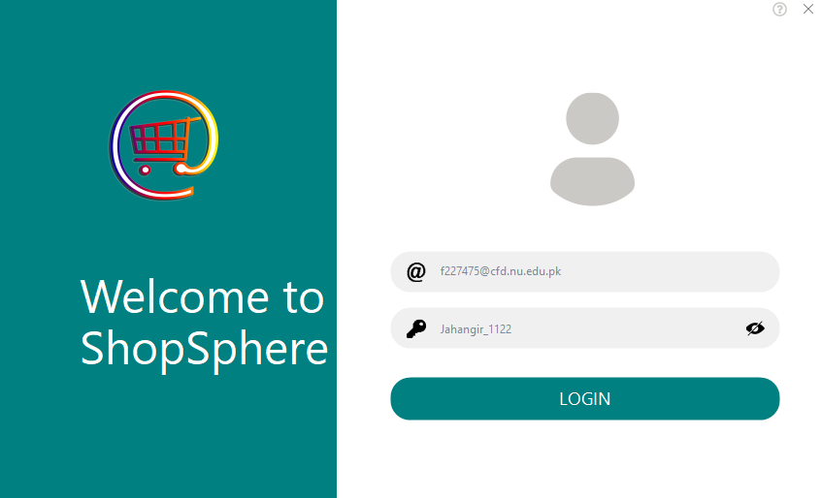

# Browse by Category

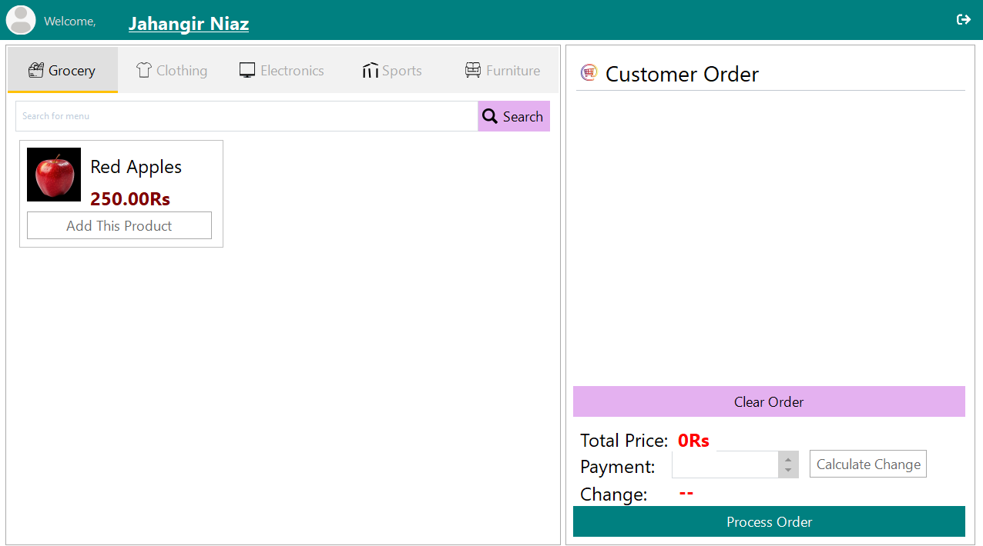

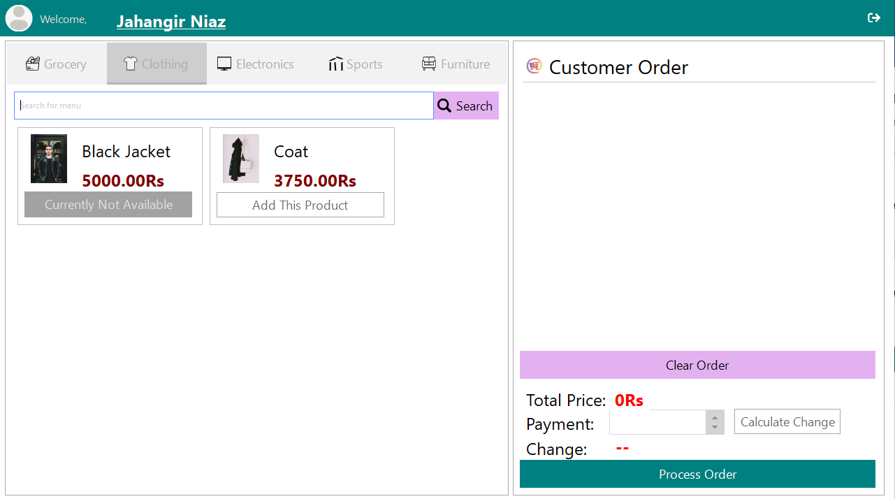

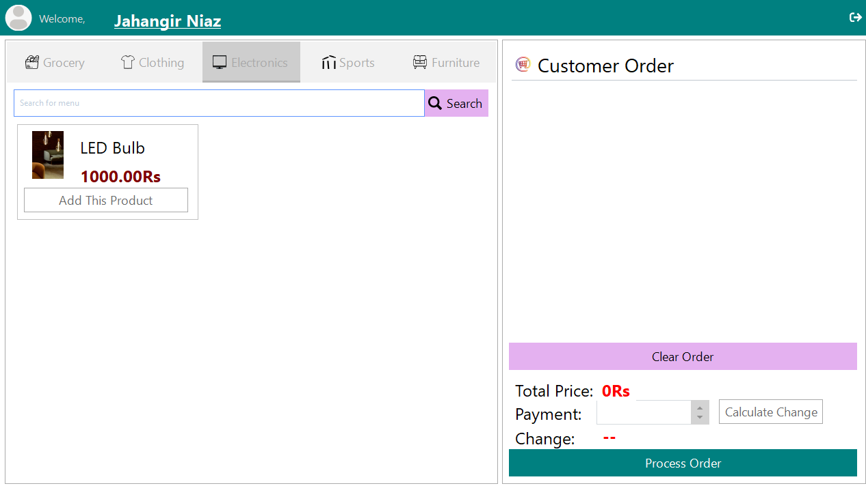

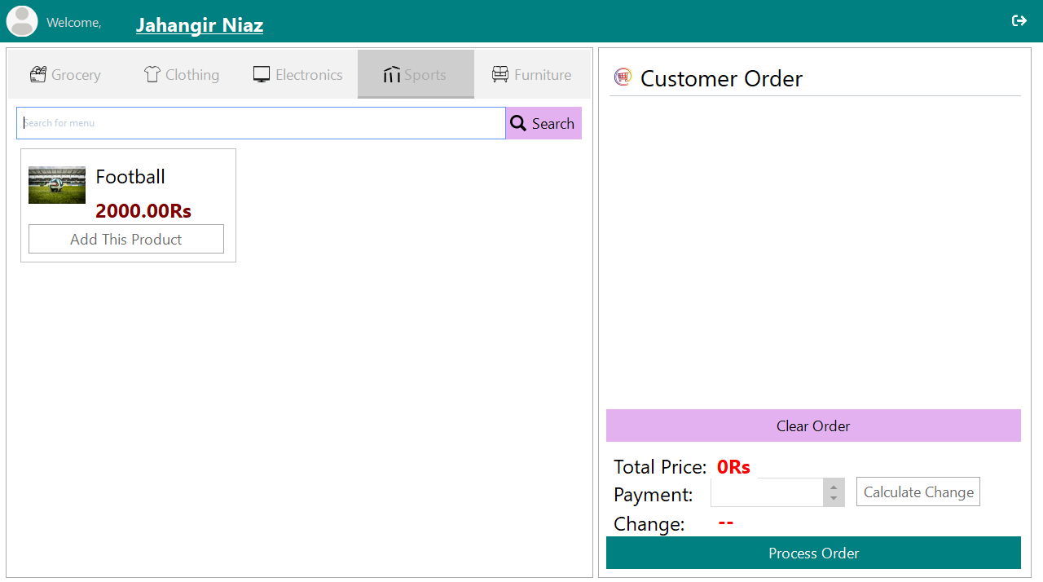

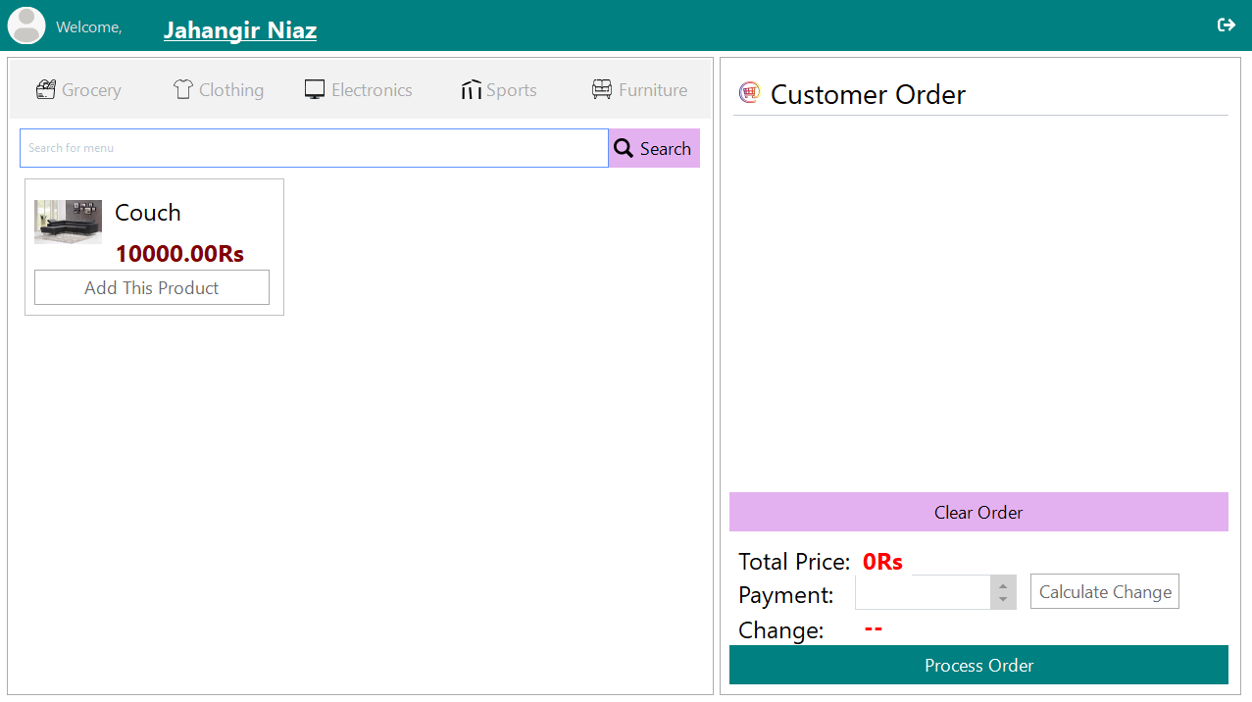

# Add to Cart

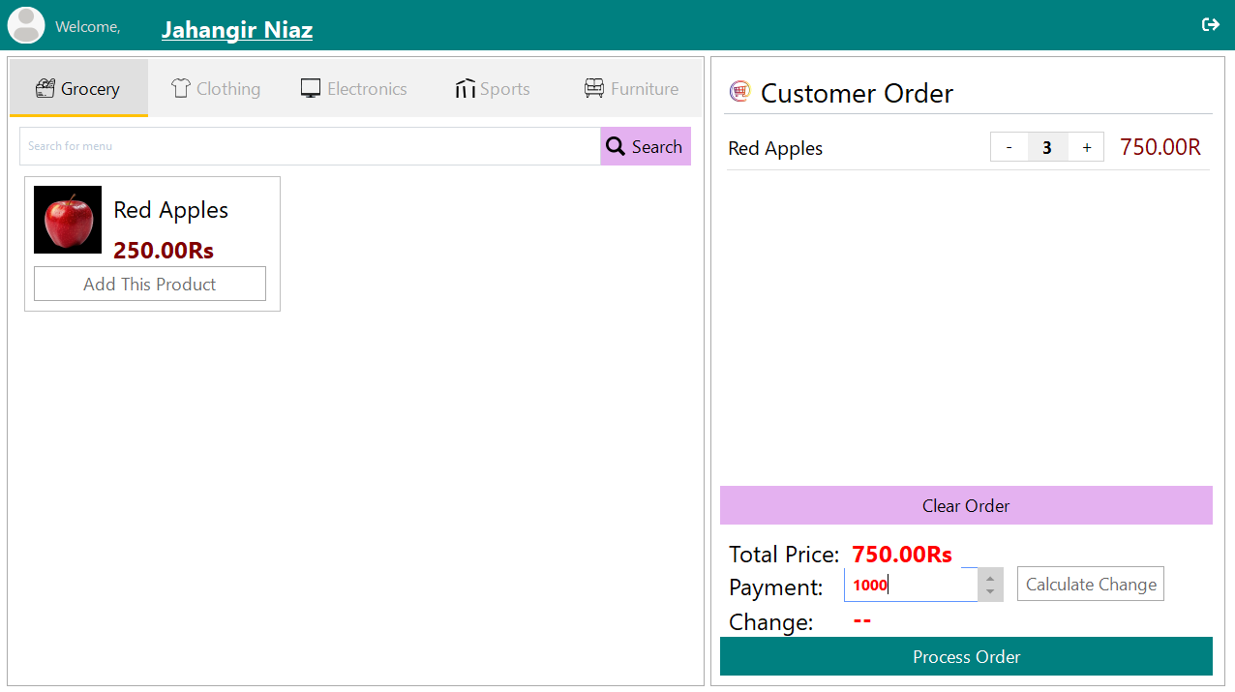

Customer can click “Add This Product” multiple times or can use +, - buttons to increase the quantity of selected products.

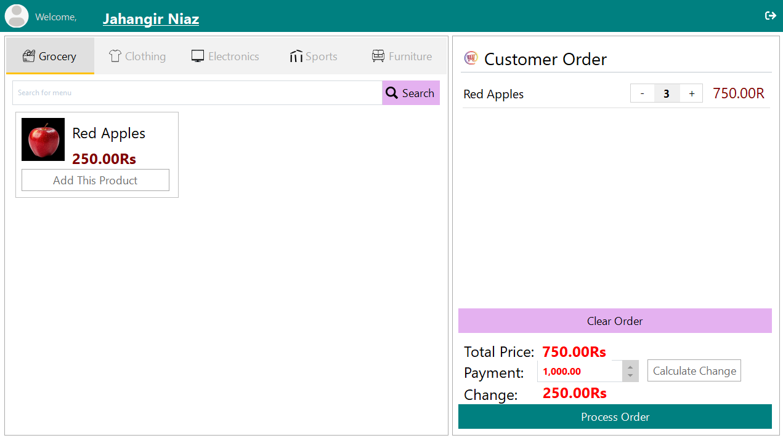

Calculate Change will calculate the remaining amount

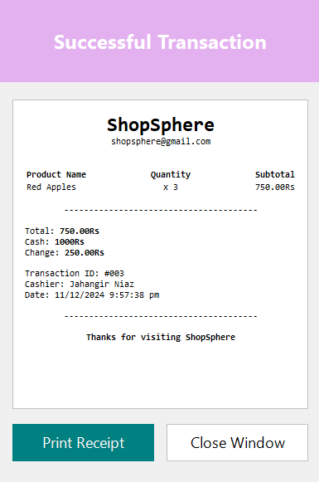

Process Order will generate a receipt which you can print

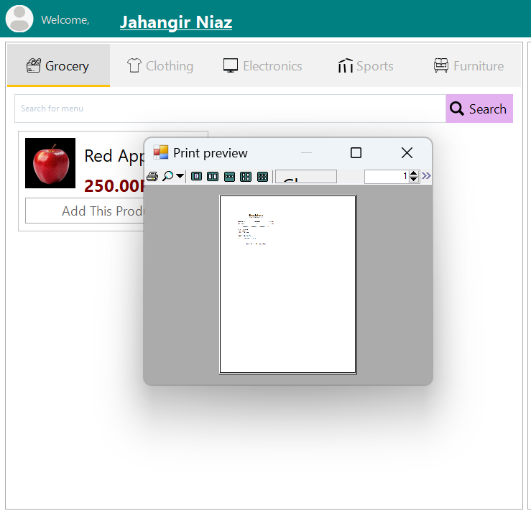

# Searching

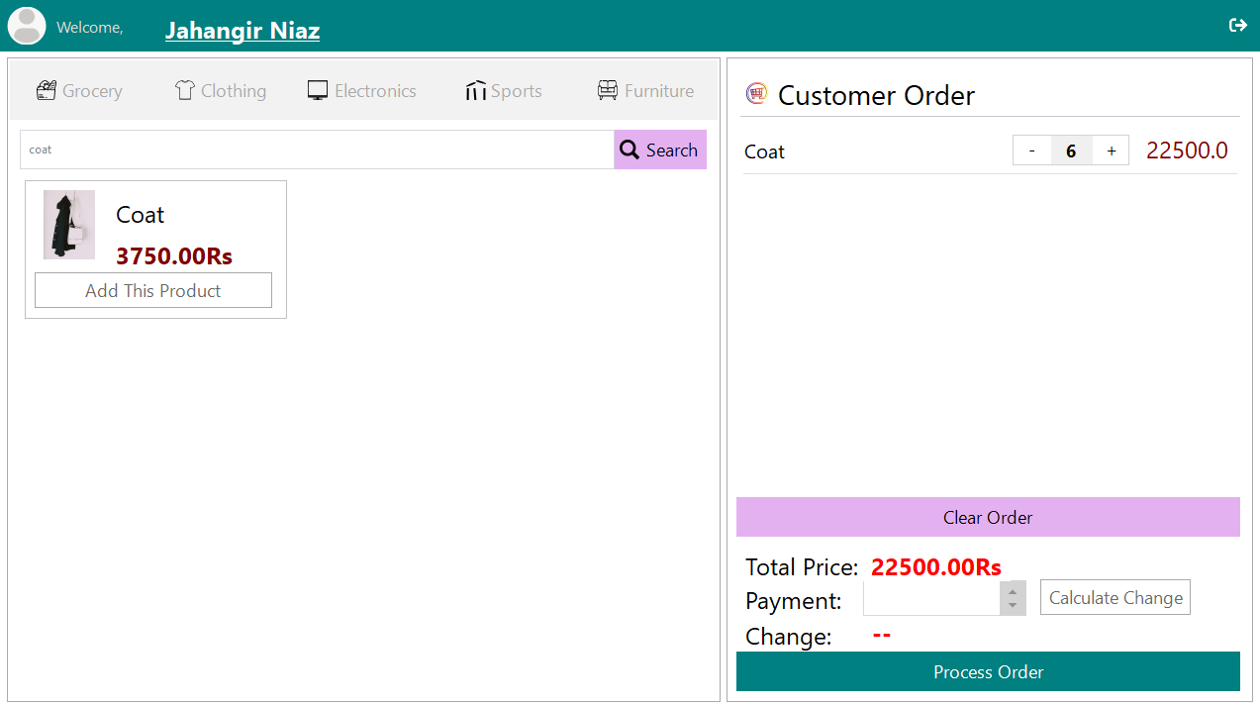

# Clear the order

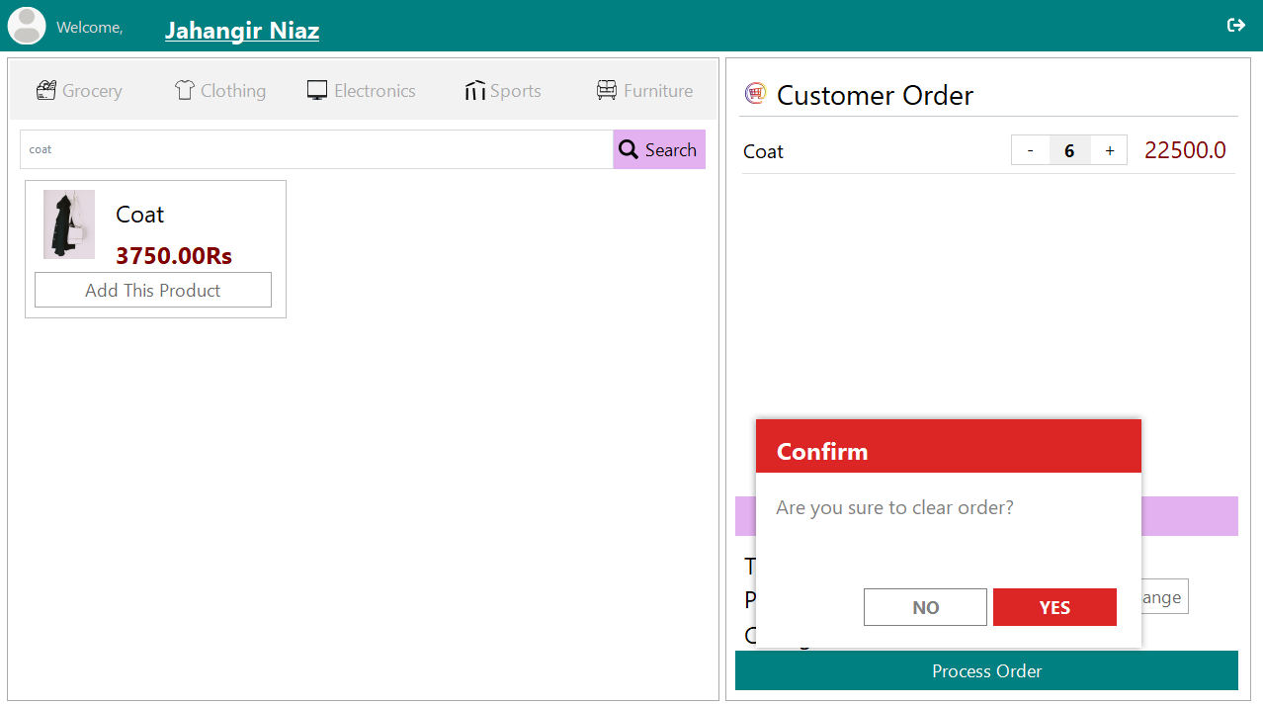

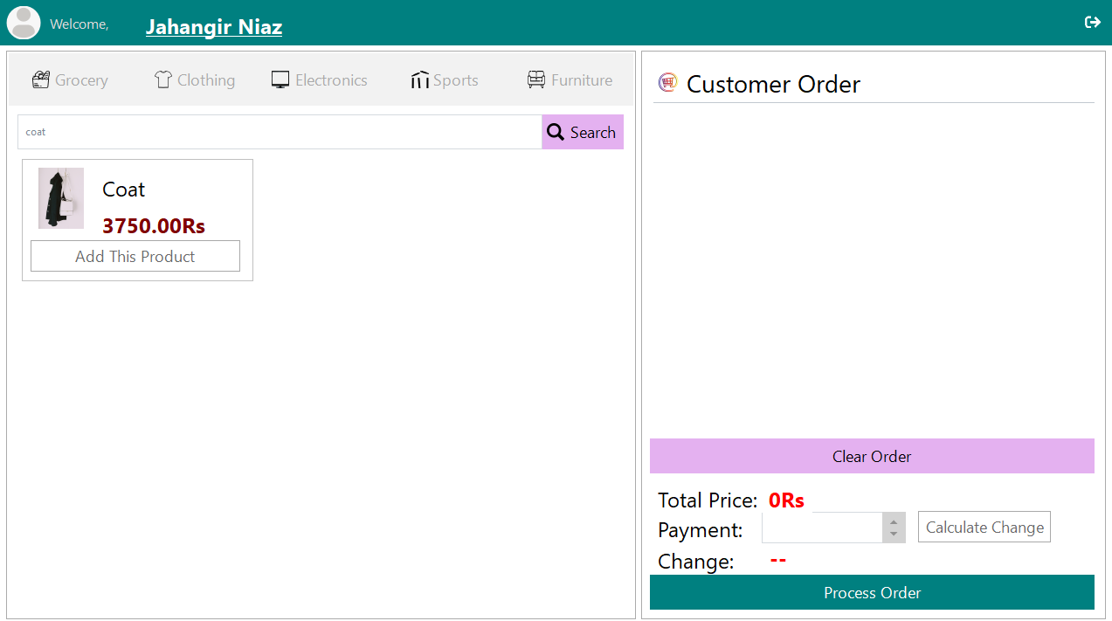

# Editing own info

