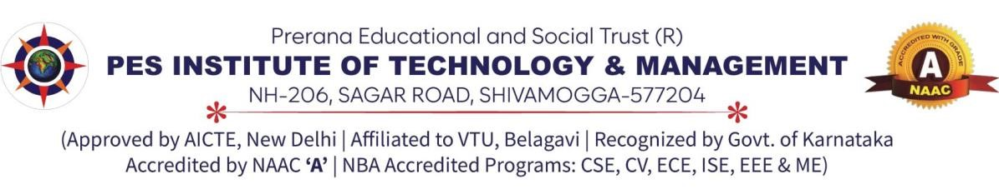

DEPARTMENT OF COMPUTER SCIENCE AND DATA SCIENCE
DBMS MINI Project Report (BCS403)
On

Hostel Management System

Submitted by

Prajwal M P

4PM22CD032
Submitted To
Dr. Sunitha B S
HOD -CSDS Department

MARKS AWARDED
Presentation(5M) | Report (5M) | Total (10M) | Faculty Sign with Date

COORDINATER HOD

Mrs.Sheethal Lobo Dr.Sunitha B S

…………………………… …......……………………

TABLE OF CONTENTS
Cover Page (i)
Certificate (ii)
Abstract (iii)
Chapter No. Chapter Description Page No.

CHAPTER-1 INTRODUCTION ¹
1.1 OVERVIEW OF HOSTEL MANAGEMENT SYSTEM 1
1.2 OBJECTIVES 2
1.3 About Dbms 3
1.4 About Rdbms 3

CHAPTER-2 SYSTEM REQUIREMENTS SPECIFICATION 4
2.1 Software Requirements 4
2.2 Hardware Requirements 4
2.3 Technologies used 4
2.4. About tool used 5

2.5 About Programming Language 5

CHAPTER 3 System Design 6
3.1 Schema Diagram for Hostel Management 6
3.2 E-R diagram For Hostel Management 7

CHAPTER 4 SYSTEM IMPLEMENTATION 8
4.1 Modules 9
CHAPTER 5 SNAPSHOTS AND RESULTS 12
5.1 Login Page 12
5.2 Dashboard 12
5.3 Courses 13
5.4 Rooms 13
Chapter 6 Conclusion 14

HOSTEL MANAGEMENT SYSTEM

ABSTRACT
A Hostel Management System (HMS) is crucial for efficiently managing the operations of a hostel, ensuring smooth functioning and enhanced service delivery. This abstract outlines the key components and benefits of an HMS.

Firstly, an HMS facilitates comprehensive student management, including admission, room allocation, and attendance tracking. It streamlines the process of allocating rooms based on preferences and availability, thereby minimizing manual errors and optimizing resource utilization.

Secondly, the system automates fee management, allowing for transparent and timely transactions. It generates invoices, tracks payments, and sends automated reminders, ensuring financial operations are efficient and organized.

Moreover, an HMS enhances security through features like biometric access and CCTV monitoring, thereby ensuring the safety of residents and their belongings.

Furthermore, the system provides administrative efficiency by centralizing records, simplifying communication with stakeholders, and generating insightful reports for informed decision-making.

In conclusion, a well-implemented Hostel Management System significantly improves operational efficiency, enhances security measures, and provides a seamless experience for both students and administrators. Its integration with modern technologies ensures that hostel management evolves to meet the growing demands of educational institutions effectively.

CHAPTER-1
INTRODUCTION

1.1 OVERVIEW OF HOSTEL MANAGEMENT SYSTEM
A Hostel Management System (HMS) is a comprehensive software solution designed to automate and streamline the management of hostels or dormitories in educational institutions, universities, or any residential facilities. It integrates various functionalities to facilitate efficient administration, enhance security, and improve overall operational effectiveness.
Key Features of Hostel Management System:
1. Room Allocation and Management: HMS automates the process of room allocation based on student preferences, availability of rooms, and specific rules set by the institution. It manages room occupancy, transfers, and ensures optimal utilization of hostel resources.
2. Student Admission and Profile Management: The system maintains detailed records of students residing in the hostel, including admission details, personal information, contact details, and room assignments. It facilitates easy retrieval and updating of student information as needed.
3. Fee Management: HMS simplifies fee collection processes by generating invoices, tracking payments, and managing financial transactions related to hostel accommodation. It sends automated reminders for due payments, reducing administrative workload and ensuring timely collections.
4. Attendance Tracking: It monitors student attendance within the hostel premises, ensuring compliance with rules and regulations. This feature helps in maintaining discipline and accountability among residents.
5. Security and Access Control: The system enhances security through features such as biometric access control, CCTV surveillance, and visitor management. It helps in preventing unauthorized access and ensuring the safety of residents and their belongings.
6. Communication Tools: HMS facilitates seamless communication between hostel management, students, and parents through integrated messaging systems. It enables quick dissemination of important announcements, notifications, and updates regarding hostel activities.
7. Reports and Analytics: The system generates comprehensive reports and analytics on various aspects such as room occupancy rates, financial transactions, attendance records, and maintenance schedules. These insights aid administrators in making informed decisions, improving resource allocation, and planning future hostel operations.

In conclusion, a well-implemented Hostel Management System plays a pivotal role in optimizing hostel operations, enhancing administrative efficiency, and providing a conducive living environment for students. It modernizes hostel management practices, fosters transparency, and contributes to the overall academic experience by ensuring smooth and well-managed residential facilities.

1.2 OBJECTIVES:

The objectives of a Hostel Management System (HMS), with a focus on specific entities like booking hostels, room details management, complaint registration, and handling registered complaints, are as follows:

1. Booking Hostels: Enable students or applicants to easily book hostel accommodations through an online portal or administrative interface. This process includes checking availability, selecting preferences, and confirming bookings, all while ensuring transparency and adherence to institutional policies.

2. Room Details Management: Maintain comprehensive records of room allocations, configurations, and occupancy status. This includes managing room types (e.g., single, double, shared), amenities, and any special requests or accommodations needed by residents.

3. Complaint Register: Provide a platform for residents to register complaints regarding facilities, services, or other hostel-related issues. The system should categorize and prioritize complaints based on urgency and severity, ensuring timely resolution.

4. Handling Registered Complaints: Efficiently manage registered complaints through a structured workflow. This involves assigning complaints to relevant personnel or departments, tracking progress, and ensuring resolution within stipulated timeframes. The system should also facilitate communication between complainants and administrators for updates and feedback.

Overall Objectives:

- Enhanced User Experience: Simplify the process of booking hostels and managing room details to provide a user-friendly experience for students and administrators alike.

- Improved Service Delivery: Streamline complaint registration and handling processes to ensure quick responses and resolutions, thereby enhancing resident satisfaction and overall hostel experience.

- Operational Efficiency: Centralize hostel management operations related to booking, room details, and complaints in a single platform to optimize administrative processes and resource allocation.

- Transparency and Accountability: Maintain transparent communication channels and workflows for complaint management, fostering accountability among hostel staff and administrators.

- Data Integrity and Security: Ensure the integrity and security of data related to hostel bookings, room details, and complaints through robust data management practices and access controls.

By achieving these objectives, a Hostel Management System aims to facilitate seamless operations, improve resident satisfaction, and uphold the quality of services provided within the hostel environment.

1.3 About DBMS
A Database Management System (DBMS) is a software application that enables users to efficiently organize, manipulate, and retrieve data stored in a database. Acting as an intermediary between the user and the database, DBMS provides tools for creating, modifying, and querying data in a structured manner. It ensures data integrity by enforcing constraints and security measures, allowing only authorized users to access and modify the data., DBMS ensures that multiple users can interact with the database simultaneously without compromising data consistency. Additionally, DBMS offers scalability, performance optimization, and backup/recovery mechanisms to handle large volumes of data and ensure its availability and durability. Overall, DBMS plays a crucial role in modern information systems, serving as a reliable and efficient solution for managing and leveraging data assets across diverse applications and industries. Database Management Systems (DBMS) are software systems used to store, retrieve, and run queries on data.

1.4 About RDBMS
A Relational Database Management System (RDBMS) is a specialized type of Database Management System (DBMS) that is based on the relational model of data organization. In an RDBMS, data is structured into tables, where each table consists of rows and columns, with each row representing a unique record and each column representing a specific attribute of the data. The strength of an RDBMS lies in its ability to establish relationships between different tables through keys, such as primary keys and foreign keys, enabling the creation of complex relational databases. RDBMSs provide mechanisms for enforcing data integrity, ensuring that the relationships between data elements remain consistent and accurate. Popular RDBMSs, such as MySQL, PostgreSQL, Oracle Database, and Microsoft SQL Server, offer robust features including support for transactions, concurrency control, indexing, and query optimization, making them essential tools for managing structured data in a wide range of applications, from enterprise systems to web applications and beyond.

CHAPTER 2

SYSTEM REQUIREMENTS SPECIFICATION

2.1 Software Requirements
- XAMPP
- Windows 11

2.2 Hardware Requirements
- Hard Disk – 2 GB.
- RAM – 1 GB.
- Processor – Dual Core or Above.
- Mouse.
- Keyboard.
- Monitor.
- Printer.
2.3 Technologies used
- HTML
- CSS
- JScript
- PHP
- MySQL
- Bootstrap
2.4. About tool used
2.4.1 XAMPP
XAMPP is an abbreviation where X stands for Cross-Platform, A stands for Apache, M stands for MYSQL, and the Ps stand for PHP and Perl, respectively. It is an open-source package of web solutions that includes Apache distribution for many servers and command- line executables along with modules such as Apache server, MariaDB, PHP, and Perl. XAMPP helps a local host or server to test its website and clients via computers and laptops before releasing it to the main server.

2.5 About Programming Language

2.5.1 PHP

PHP stands for Hypertext Preprocessor. It is an open-source, interpreted, and object-oriented scripting language that can be executed at the server-side. PHP is well suited for web development. Therefore, it is used to develop web applications (an application that executes on the server and generates the dynamic page. PHP was created by Rasmus Lerdorf in 1994 but appeared in the market in 1995.
PHP code may be embedded into HTML code, or it can be used in combination with various web template systems, web content management systems and web frameworks. PHP code is usually processed by a PHP interpreter implemented as a module in the web server or as a Common Gateway (CGI) executable. The web server combines the results of the generated web page.

2.5.2 JavaScript

JavaScript is the most popular scripting language for the Web. It is easy to learn, lightweight, crossplatform, single-threaded, and interpreted compiled language. It is widely used for web development, both on the client side and server side. As a scripting language, it plays an important role in web browsers, allowing real-time modification of web page content and enhancing user experience.

2.5.3 BOOTSTRAP

Bootstrap is a huge collection of reusable pieces of code which can be quite handy to the developers. It is a Frontend-Development Framework, written in HTML, CSS, and JavaScript. Bootstrap enables designers and developers to build completely responsive websites quickly. It can be considered the most popular CSS framework for developing responsive and Mobile- First applications. The main features of Bootstrap may be described as follows:

- Bootstrap provides the users with the ability to easily create responsive designs.
- The responsive CSS of Bootstrap also adjusts to phones, tablets, and desktops easily.
- It is compatible with all modern browsers like Chrome, Firefox, Internet Explorer, Edge, Safari, and Opera

CHAPTER 3

System Design

3.1 Schema Diagram for Expense Management
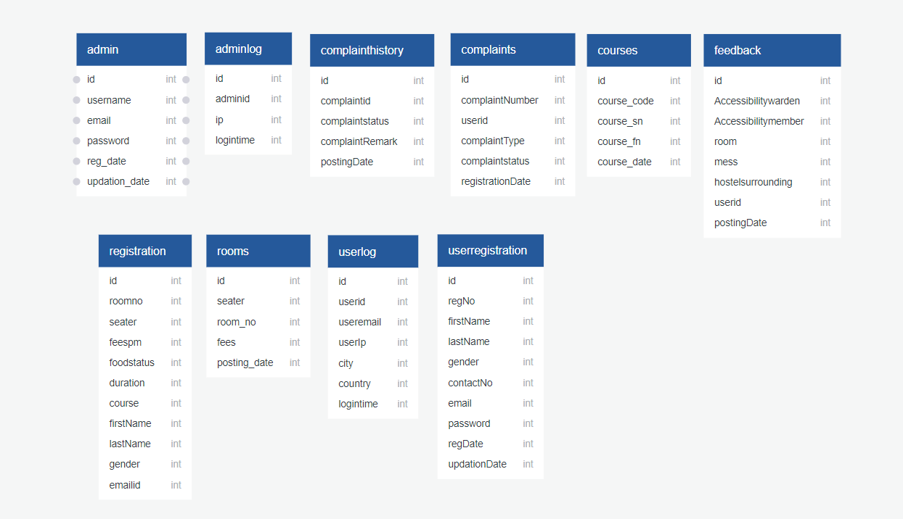

3.2 E-R diagram For Expense Management
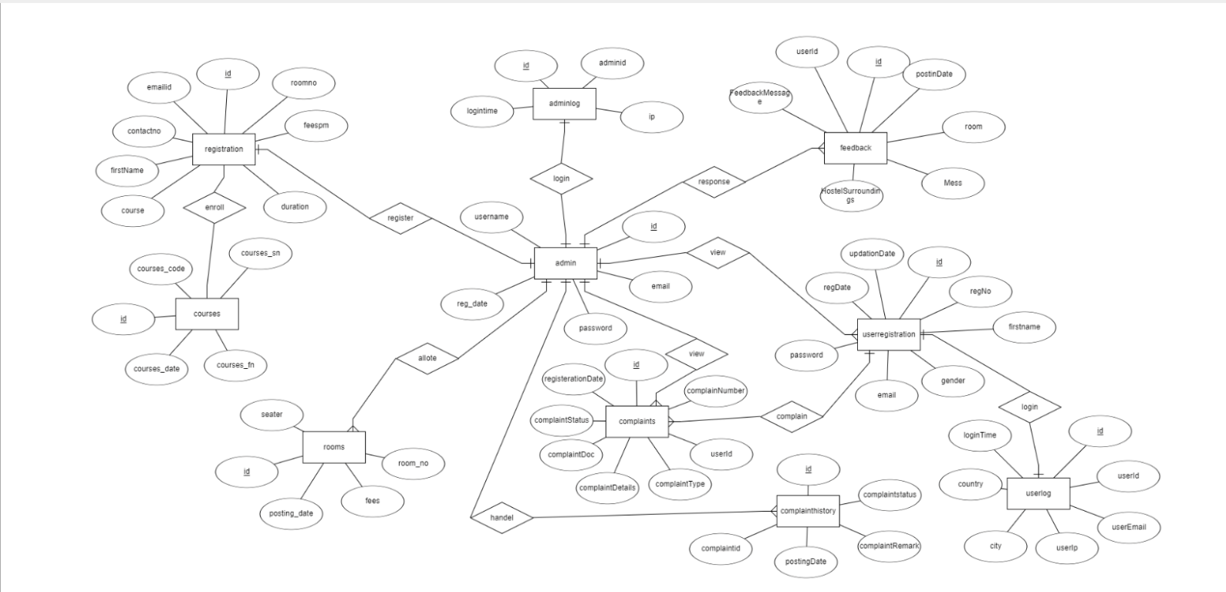

Fig - 3 E R diagram for Expense Management
Dashboard: In this section, user can briefly view expenses on a daily basis, monthly basis, and yearly basis.
Courses: In this section user can manage the courses (add/delete).

Rooms : In this section, user can view rooms select the room no to stay for their purpose.

Profile: In this section, user can update his/her profile.

- Change Password: In this section, user can change his/her passwords
- Logout: Through this button, user can log out.
- Users can also recover his/her password.

CHAPTER 4

SYSTEM IMPLEMENTATION

Implementation is the stage in the project where the theoretical design is turned into the working system and is giving confidence to the new system for the users i.e. it will work effectively. It involves careful planning, investigation of the current system and its constraints on implementation, design of method to achieve the changeover, an evaluation, of change over methods.

- Data Setup: Setting up a database in MySQL involves defining the structure of your data using tables, columns, and relationships. You begin by creating a database where all your data will be stored. Within this database, you define tables to represent different entities or concepts, such as users, products, orders, etc. Each table consists of columns that define the attributes of those entities, like names, IDs, dates, and so on.

- Backend Development: PHP's versatility and ease of integration with databases and web servers make it a popular choice for backend development, particularly in web application development. By mastering PHP fundamentals and best practices, you can create robust and scalable backend solutions to support various web applications.
- Front End Development: Front-end development involves crafting the user interface (UI) and experience (UX) of websites or web applications using HTML, CSS, and JavaScript. HTML forms the structure and content of web pages, using semantic tags to define the meaning of content for better accessibility and SEO. CSS styles these elements, controlling their appearance, layout, and responsiveness across different devices. JavaScript adds interactivity, enabling dynamic behavior like user input handling, DOM manipulation, and asynchronous communication with servers for data fetching and updating content without page reloads. Together, these technologies empower developers to create engaging and functional web experiences that cater to diverse user needs and preferences
- Integration and Testing: integrate your backend and frontend effectively. Utilize
XAMPP to set up a local development environment for testing. This allows you to seamlessly test functionalities like event registration, coordinator assignments, and data updates. Design test cases covering various scenarios and conduct usability testing to ensure a smooth user experience. Throughout development, document your code, database schema, and system architecture for future maintenance. Finally, gather user feedback and iterate on the system to continuously improve functionality and usability. This approach ensures a well-integrated, user-friendly system built for future success.

4.1 Modules:

Sure, let's outline the main modules of a Hostel Management System (HMS) based on the objectives mentioned: booking hostels, room details management, complaint registration, and handling registered complaints. Each module plays a crucial role in ensuring smooth hostel operations and resident satisfaction:

1. Booking Hostels Module

Objective: This module facilitates the process of booking hostel accommodations for students or applicants.

Key Features and Explanation:
- Availability Check: Allows users to check the availability of rooms based on specified criteria such as room type, occupancy, and dates.

- Booking Request: Enables students to submit booking requests through an online portal or administrative interface.

- Preference Selection: Provides options for students to select room preferences (e.g., single, double, shared) and specify any special requirements.

- Confirmation and Payment: Once a booking request is approved, the system generates a confirmation along with payment details (if applicable) for the student.

- Cancellation and Modification: Allows for the cancellation or modification of bookings within specified policies and timelines.

- Reporting: Provides reports on booking trends, occupancy rates, and revenue generated from hostel accommodations.

2. Room Details Management Module

Objective: This module manages and maintains comprehensive information about hostel rooms.

Key Features and Explanation:
- Room Allocation: Automates the allocation of rooms based on booking requests, availability, and
institutional rules.

- Room Configuration: Records details about room types, capacities, amenities, and floor plans.

- Occupancy Tracking: Tracks current occupancy status of rooms and generates occupancy reports.

- Maintenance Scheduling: Manages schedules for room maintenance, repairs, and cleaning tasks.

- Inventory Management: Tracks and manages inventory related to room furnishings, appliances, and other supplies.

- Billing and Invoicing: Integrates with fee management systems to generate invoices related to room charges.

3. Complaint Registration Module

Objective: Provides a platform for residents to register complaints regarding hostel facilities or services.

Key Features and Explanation:
- Complaint Submission: Allows residents to submit complaints online, specifying the nature and details of the issue.

- Categorization: Categorizes complaints based on type (e.g., maintenance, cleanliness, noise) to facilitate prioritization.

- Assignment: Automatically assigns complaints to relevant staff or departments responsible for resolution.

- Tracking and Monitoring: Tracks the status of complaints, from registration to resolution, providing updates to residents.

- Escalation: Facilitates escalation of unresolved complaints according to predefined escalation paths.

- Feedback and Closure: Allows residents to provide feedback on the resolution process and confirms closure of complaints.

4. Handling Registered Complaints Module

Objective: Manages the process of handling and resolving registered complaints effectively.

Key Features and Explanation:
- Workflow Management: Defines workflows for handling complaints, including stages such as investigation, action, and closure.

- Prioritization: Prioritizes complaints based on urgency, impact on residents, and institutional policies.

- Communication: Facilitates communication between complainants and staff handling the complaints, providing updates and notifications.

- Resolution Documentation: Records details of actions taken to resolve complaints and maintains a history of resolutions.

- Performance Analytics: Generates reports on complaint trends, resolution times, and resident satisfaction levels.

- Integration: Integrates with other modules such as room details management and communication tools for seamless operations.

CHAPTER 5

SNAPSHOTS AND RESULTS

5.1 Login Page:
This login page serves as the gateway to your personal expense management system. Enter your registered username and password to access your financial data. We prioritize security, so consider using strong passwords. New users can easily register by following the provided link. The clean and professional design, potentially incorporating your application's branding, ensures a user-friendly experience for managing your finances. 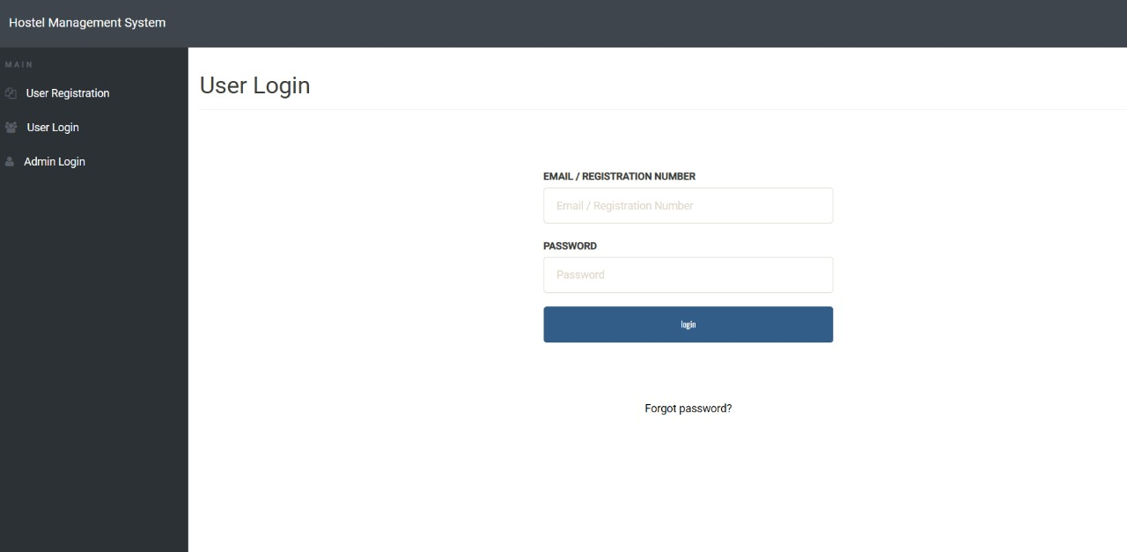
5.2 Dashboard: The Dashboard serves as your Hostel command center. A prominent summary having student details, total rooms, total courses, registered complaints,new complaints, in process complaints, closed complaints,total feedbacks.
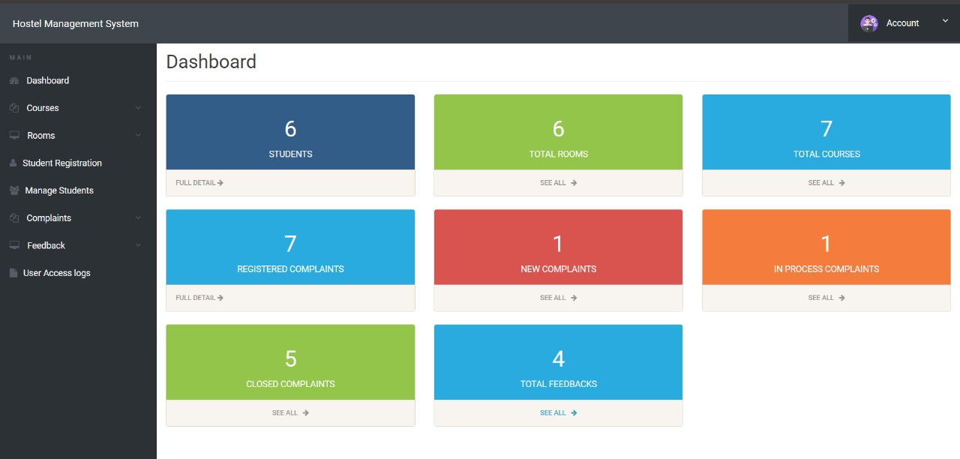

5.3 Courses:
In courses there are two options one is Add courses and another one is Manage courses where admin can add their branch so they can allot the room to same course student.

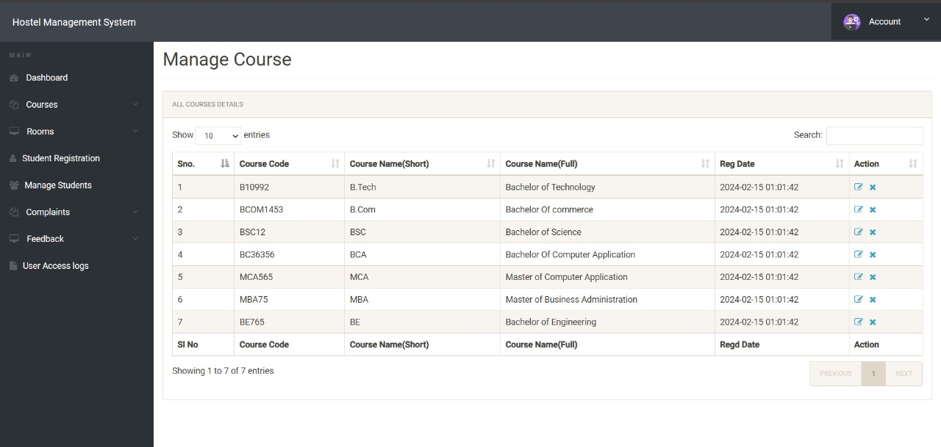

5.4 Rooms:
In rooms column there are Add rooms and Manage rooms where admin can allot room numbers and the number of students sharing rooms and based on the sharing the fees will be given .
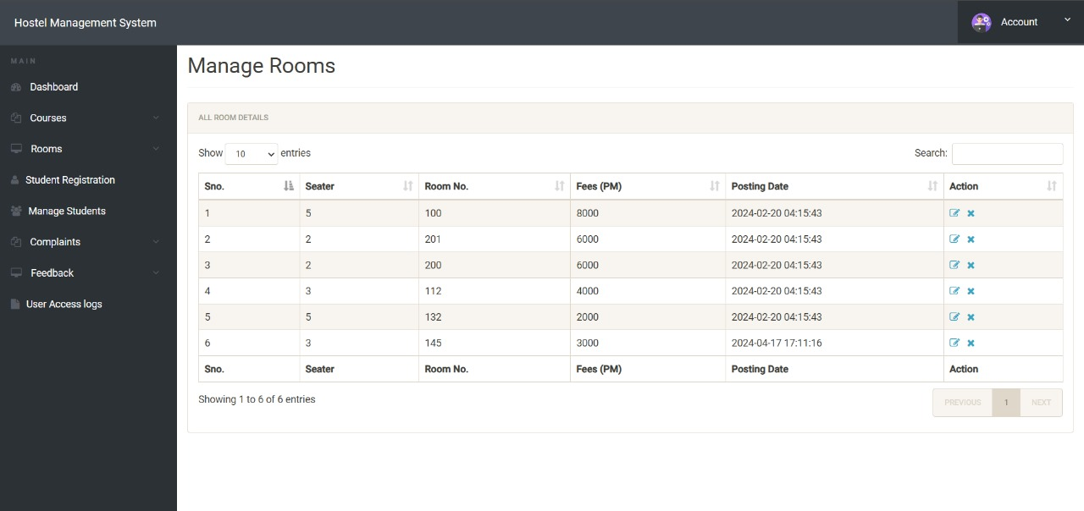

Chapter 6

Conclusion

In conclusion, the Hostel Management System (HMS) presented aims to revolutionize the management of hostel operations by integrating several key modules: booking hostels, room details management, complaint registration, and handling registered complaints. Each module plays a vital role in enhancing efficiency, improving service delivery, and fostering a conducive living environment for hostel residents.

The booking hostels module streamlines the process of reserving accommodations, providing transparency and ease of access for students or applicants. It ensures optimal utilization of hostel resources while accommodating diverse preferences and requirements.

The room details management module maintains comprehensive records of room allocations, configurations, and maintenance schedules. This facilitates efficient management of occupancy, amenities, and upkeep, ensuring that residents have access to well-maintained living spaces.

The complaint registration module offers a platform for residents to voice concerns or issues regarding hostel facilities or services. This module categorizes and prioritizes complaints, ensuring timely resolutions and proactive management of resident feedback.

Handling registered complaints module ensures that all registered issues are addressed promptly and effectively. It provides structured workflows for complaint resolution, tracks progress, and maintains clear communication channels between residents and management.

Collectively, these modules contribute to operational transparency, accountability, and resident satisfaction within the hostel environment. By leveraging technology to automate and streamline administrative tasks, the HMS enhances overall management efficiency and allows administrators to focus on providing a supportive and secure living experience for hostel residents.

In essence, the HMS not only meets the logistical needs of managing hostel operations but also supports the broader goal of fostering a positive residential community conducive to academic and personal growth. Its implementation promises to elevate the standard of hostel management, aligning with the evolving expectations of educational institutions and enhancing the overall experience for residents.

