INTRODUCTION
Portfolio analytics is a critical component of investment management that involves the systematic evaluation of portfolios to optimize returns, manage risk, and align with strategic objectives. It integrates quantitative techniques, financial theories, and technological tools to analyze and improve portfolio performance, providing insights into various aspects such as asset allocation, diversification, risk management, and performance measurement.

Key Aspects of Portfolio Analytics
- Performance Measurement: Metrics like the Sharpe ratio, Jensen’s alpha, and the Information ratio are used to evaluate the efficiency and effectiveness of the portfolio in generating returns relative to the risk taken.
- Risk Analysis: Involves assessing the risk profile of the portfolio using measures such as Value-at-Risk (VaR), beta, and standard deviation. It also examines the exposure to different types of risks, including market, credit, and liquidity risks.
- Asset Allocation: The process of distributing investments across various asset classes, such as equities, bonds, and real estate, to balance risk and return. This is based on the investor’s goals, risk tolerance, and market conditions.
- Diversification: A strategy to reduce risk by investing in a variety of assets. Diversification aims to minimize the impact of any single investment’s poor performance on the overall portfolio.
- Performance Attribution: Analyzes the sources of returns by distinguishing between market effects, asset allocation decisions, and security selection. It helps identify which factors contributed positively or negatively to portfolio performance.
- Scenario Analysis and Stress Testing: Simulates various economic and market scenarios to assess how the portfolio would perform under different conditions. This helps in understanding potential risks and making informed decisions to mitigate them.
Advancements in technology, such as machine learning and big data analytics, have significantly enhanced the capabilities of portfolio analytics. These tools enable more sophisticated modeling, real-time data analysis, and improved decision-making processes, thereby enhancing the ability to achieve better risk-adjusted returns. Portfolio analytics is essential for ensuring that investment portfolios are well-structured, resilient, and aligned with the investor's financial goals.

Schema Diagram
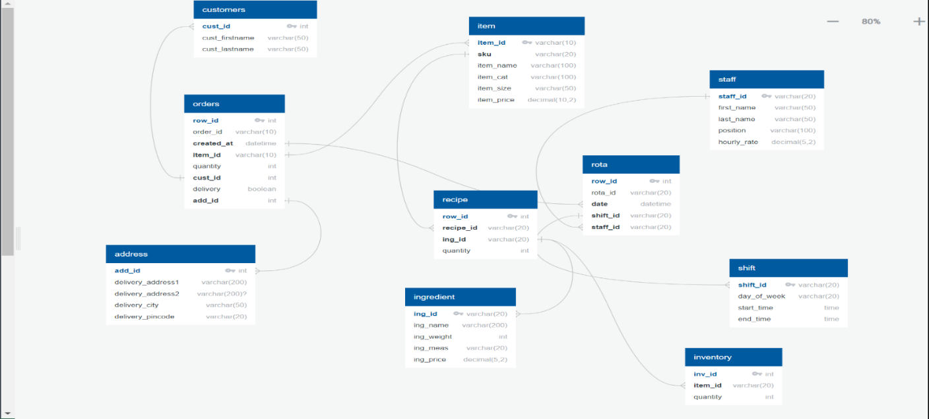
Fig . Schema diagram for Portfolio analytics

ER diagram
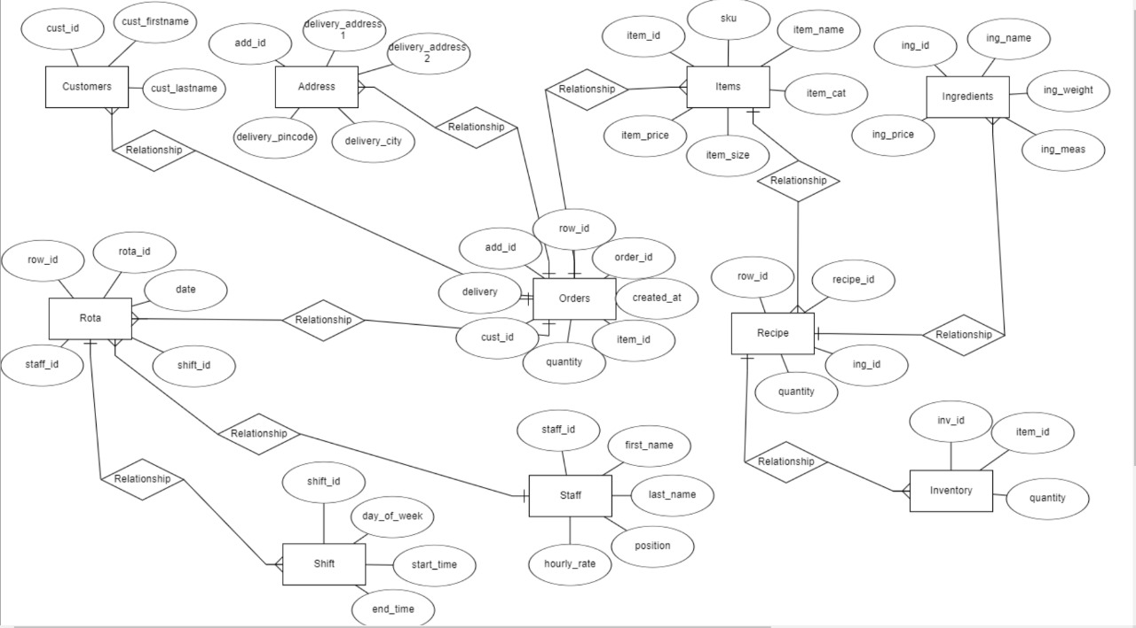
Fig . ER diagram for Portfolio analytics
