Come for an evening of music, dancing and fun as we celebrate Brad’s
40th Birthday!
Join us at Edina’s Braemar Golf Course Clubhouse
Saturday, January 25
7:00 pm

Come ready for fine food, captivating conversation, and wonderful
music, beginning with Rich Jahnke’s coffeehouse set, followed by a
dance set by the Space Heaters. Then help Brad re-live his youth, as
we cap off the evening with a jam session by the Space Heaters and the
All State All Star Band, featuring special guests from four states!

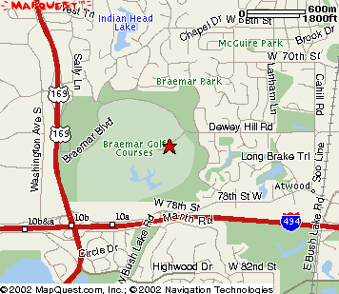

RSVP to Caroline at 952-922-2534. No Gifts, please!

From I-494:

Take East Bush Lake Road Exit, north to 78th St. West (left) on 78th Street to Gleason.
North (right) on Gleason to Dewey Hill Road. Left on Dewey Hill, and immediately left
again into the Golf Course on John Harris Drive, up to the clubhouse.

From Highway 62:

Get off at Gleason, south on Gleason to Dewey Hill Road. West (right) on Dewey Hill,
and immediately left on John Harris Drive, up to the clubhouse.

