Software Engineeering
Lab -05
Name:R Muralidharan
SRN:PES2UG24CS387
Section:G
Music_catalog:
Output screenshots:
Initial reports:
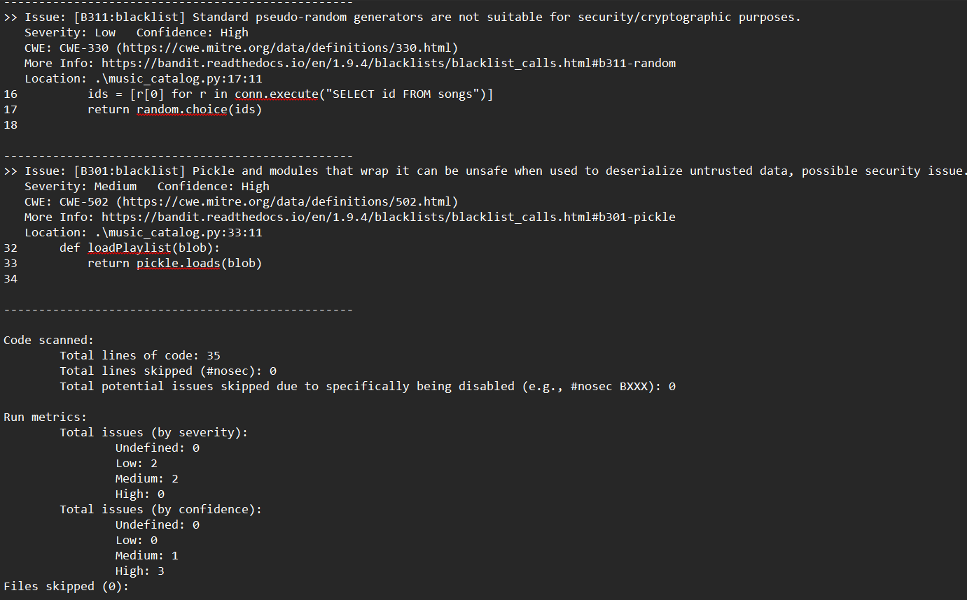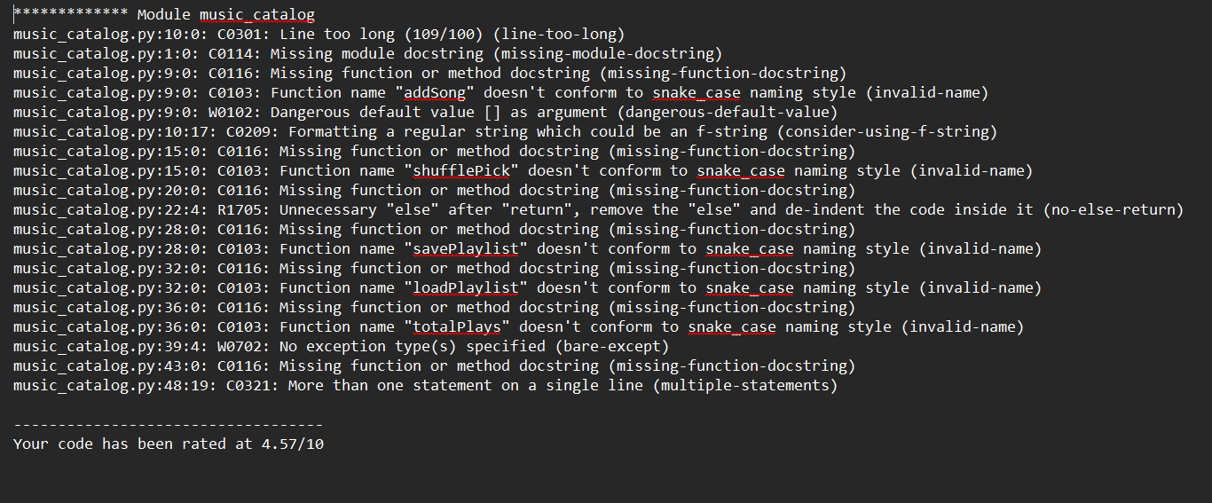
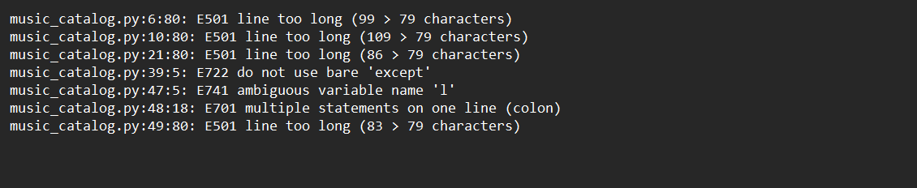
Updated code:
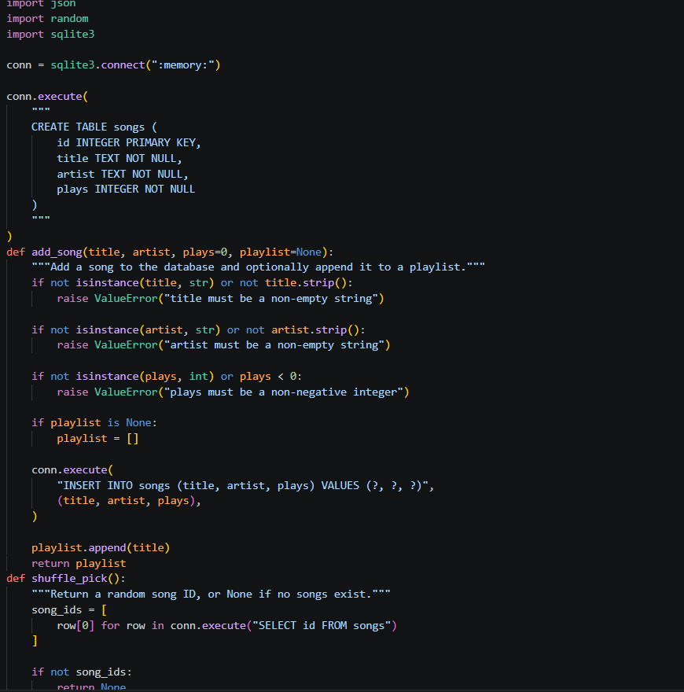
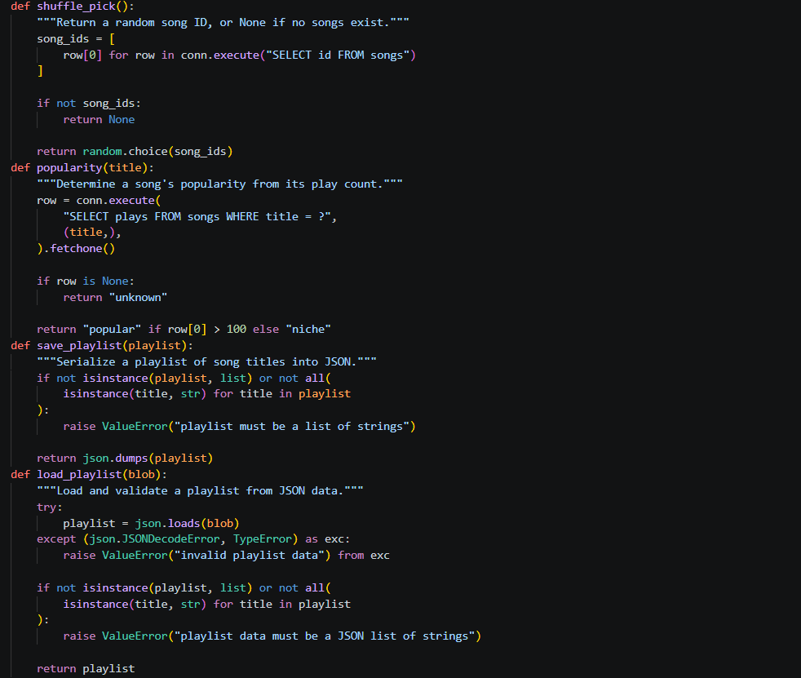
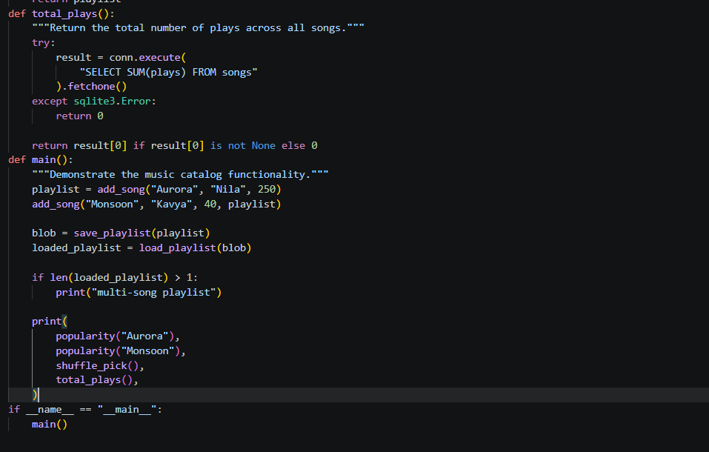
Updated reports:
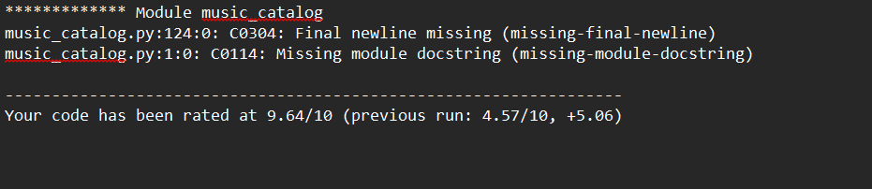

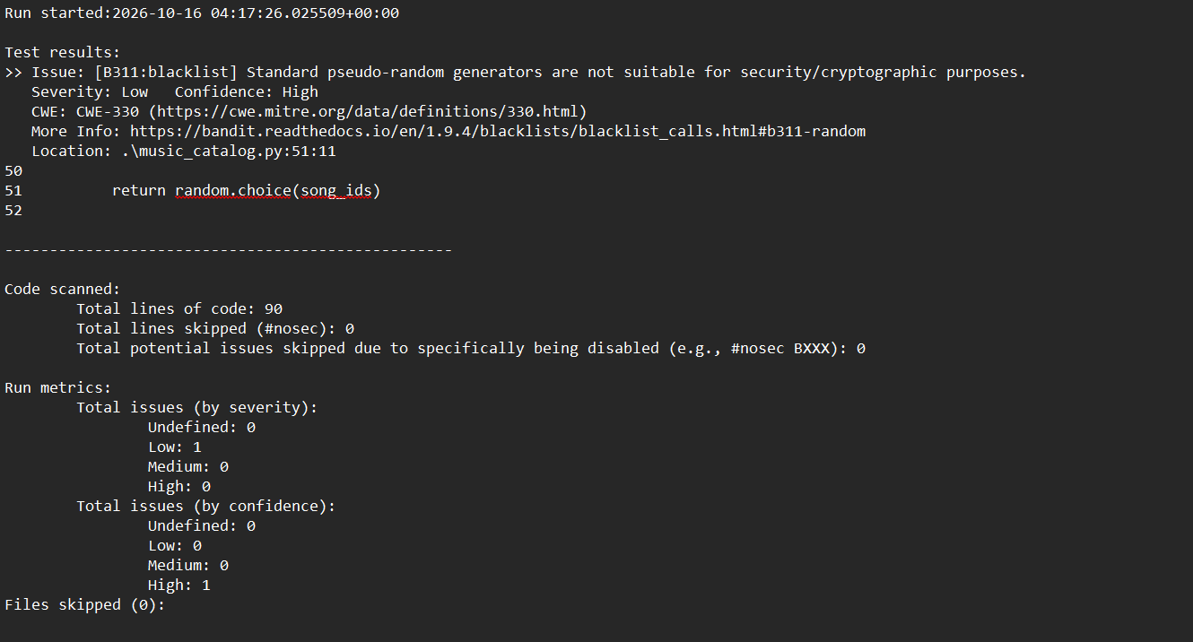

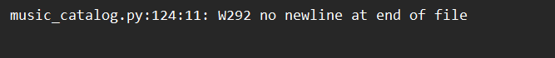

Issue | Type | Line(s) | Description | Fix approach
SQL injection | Security | Original line 10 | SQL query constructed using string formatting | Parameterized SQL query
Unsafe pickle deserialization | Security | Original line 33 | Loading pickle data may execute malicious code | Use JSON for simple playlist data
Mutable default argument | Code quality | Original line 9 | Default list can be shared between calls | Use None and initialize a new list
Bare exception | Code quality | Original line 39 | Catches all exceptions indiscriminately | Catch sqlite3.Error
Long lines | Style | Multiple | Lines exceed configured limits | Split expressions across lines
Ambiguous variable | Style | Original line 47 | Variable l is difficult to understand | Use loaded_playlist

