Software Engineeering
Lab -02
Name:R Muralidharan
SRN:PES2UG24CS387
Section:G
Problem 19: Personalized Meal & Diet Subscription Manager
1)View of all epics and stories
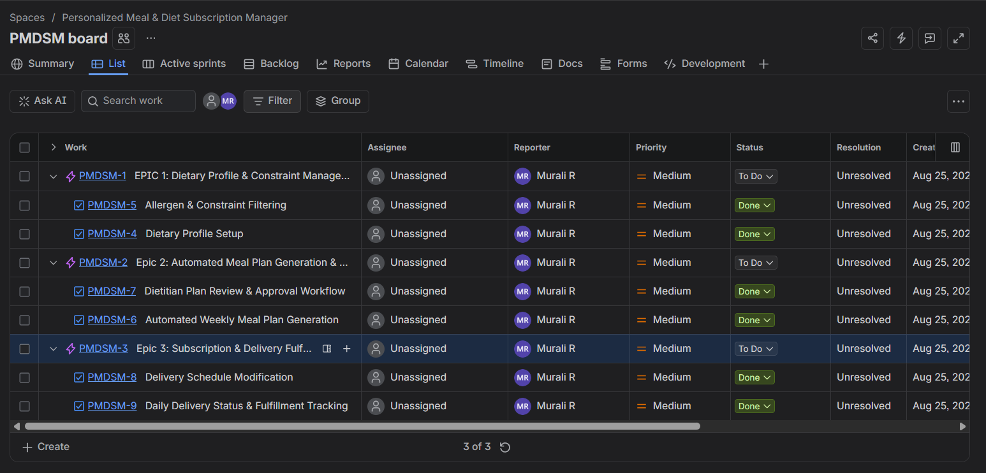

2)Story points(original estimates of time duration)
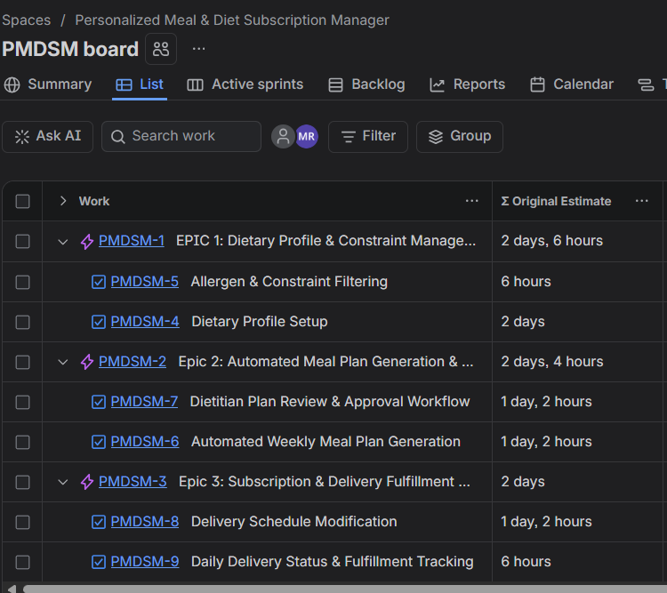

3)Active Sprints
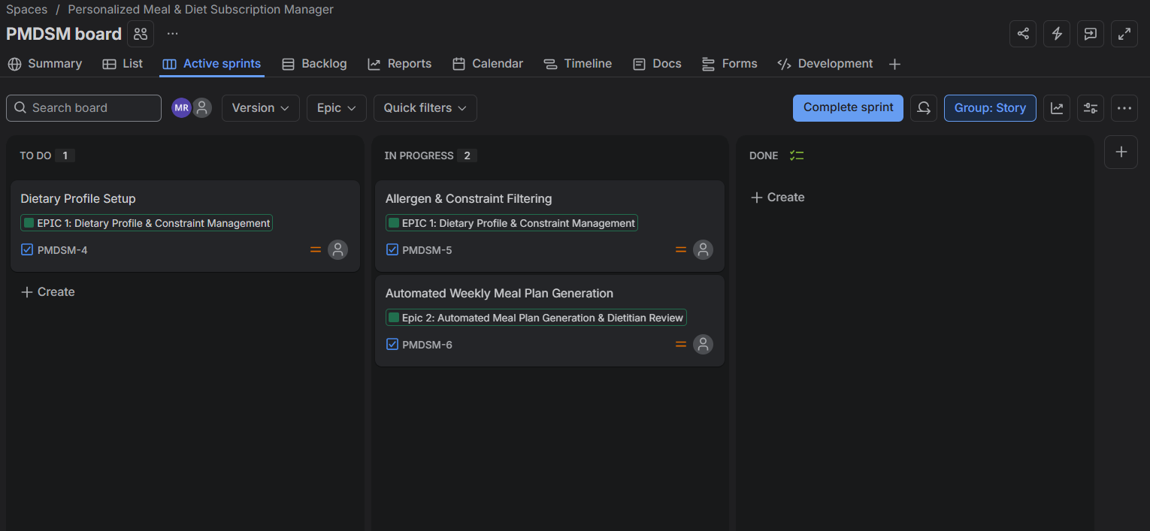
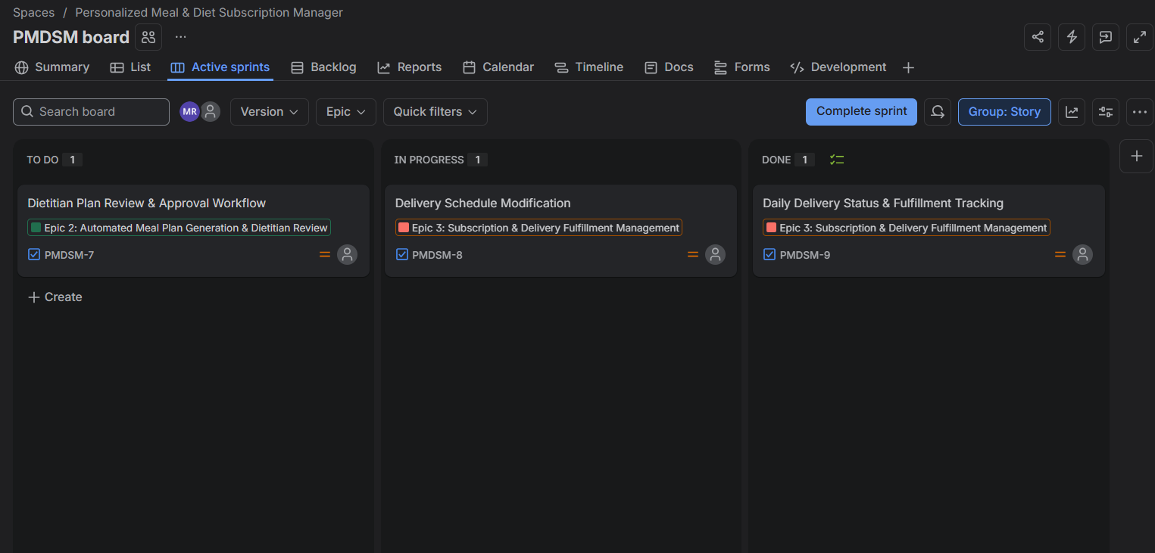

4)Burndown Chart
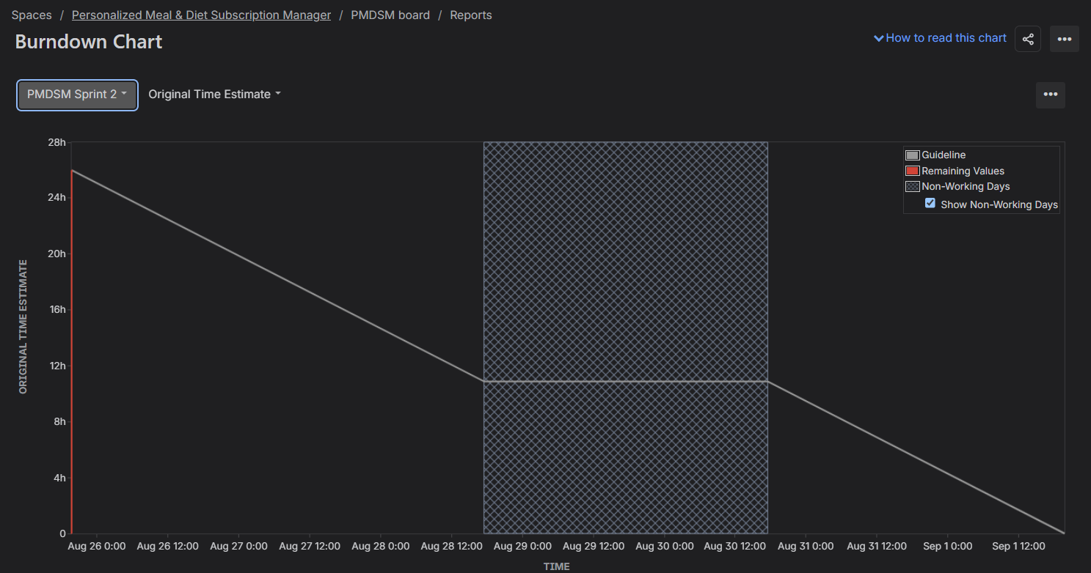

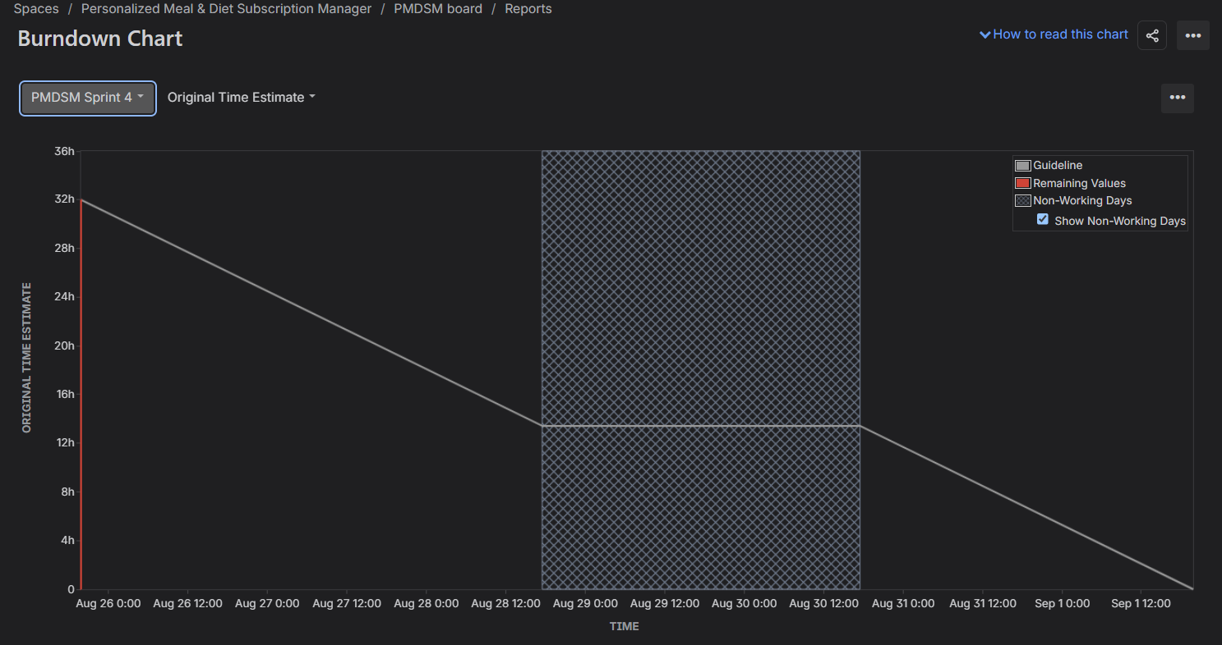

5)Reflection questions
1. Did your estimations reflect the actual effort?
Yes. The estimations mapped accurately to the functional complexity and risks of the requirements. Higher estimates (8 Story Points / 16 hours) were assigned to complex logic like automated meal generation to account for algorithmic constraints and edge cases. Moderate estimates (5 Story Points / 10 hours) were assigned to core user-facing flows like dietary profile setup, dietitian review workflows, and schedule modifications. Simpler operational tracking and constraint validation tasks were assigned lower estimates (3 Story Points / 6 hours)
2. Was your backlog well-prioritized?
Yes. The backlog followed a logical dependency order based on core user requirements:
- Sprint 1 (High Priority Foundation): Focused on subscriber profile creation (FR-002), allergen filtering rules, and core weekly meal plan generation (FR-001).
- Sprint 2 (Operational & Fulfillment): Built upon the core plan generation to introduce dietitian review/approval workflows (FR-003), delivery modification controls (FR-004), and daily fulfillment status tracking (FR-005).
3. How did your simulated sprint align with your plan?
The simulated sprints executed according to the planned scope and time-boxes. All user stories assigned to each 1-week sprint iteration were systematically transitioned from To Do to In Progress and successfully marked as Done without requiring scope deferrals or rollover into subsequent sprints.
4. What insights did the burndown chart give about your team’s capacity?
The burndown chart demonstrated a consistent velocity across iterations, managing approximately 16 hours (Sprint 1) and 26 hours (Sprint 2) per 1-week sprint. The progression tracked against the guideline showed that breaking down epics into clear, estimated tasks prevented bottlenecks and ensured predictable, steady completion of planned work.

