Software Engineeering
Lab -01
Name:R Muralidharan
SRN:PES2UG24CS387
Section:G
Problem 19: Personalized Meal & Diet Subscription Manager

1)Requirements table
Exactly five Functional Requirements (FR-001 to FR-005) and two Non-Functional Requirements (NFR-001 and NFR-002).
Req ID | Type | Description | Priority | Acceptance Criteria | Rationale
FR-001 | Functional | The system shall generate weekly meal plans strictly adhering to user macro-nutrient constraints and allergen exclusion lists. | High | Pass: Generated menu contains zero excluded allergen ingredients. Fail: Any excluded allergen is present. | Ensures generated meal plans are personalized and safe for the subscriber.
FR-002 | Functional | The system shall allow a Subscriber to create and update their dietary profile, including allergies, calorie goals, and diabetic limits. | High | Pass: Updated dietary constraints are correctly stored in the Subscriber's profile. Fail: Any submitted constraint is missing or incorrectly stored. | Provides the dietary information required for personalized meal generation.
FR-003 | Functional | The system shall allow a Dietitian to review and approve a generated weekly meal plan before it is activated for delivery. | High | Pass: Only an approved meal plan can be activated for delivery. Fail: An unapproved meal plan is activated. | Provides professional validation of generated meal plans.
FR-004 | Functional | The system shall allow the Subscriber to view and modify upcoming meal deliveries, including pause, skip, and reschedule operations. | Medium | Pass: A valid modification is reflected in the delivery schedule. Fail: The schedule remains unchanged after a valid modification request. | Provides flexibility for subscribers to manage their upcoming deliveries.
FR-005 | Functional | The system shall record the fulfillment status of each scheduled daily meal delivery. | High | Pass: Each scheduled delivery has a recorded status such as delivered, pending, skipped, or failed. Fail: A scheduled delivery has no fulfillment status. | Enables tracking and monitoring of daily delivery fulfillment.
NFR-001 | Performance & Security | The subscription engine must support schedule modifications (pause, skip, reschedule) up to 12 hours before dispatch. | High | Pass: Valid modification requests submitted at least 12 hours before dispatch are accepted and processed. Fail: A valid request submitted within the permitted time is rejected. | Ensures subscribers can modify deliveries while maintaining operational scheduling constraints.
NFR-002 | Performance | The system shall generate and display a personalized weekly meal plan within 5 seconds of a valid request. | Medium | Pass: At least 95 out of 100 valid requests generate and display the meal plan within 5 seconds. Fail: More than 5 requests exceed 5 seconds. | Ensures responsive meal-plan generation and a good user experience.

2)Actors
Actor | Role / Interaction
Subscriber | Maintains dietary profile, generates/views meal plans, manages subscriptions and delivery modifications, and tracks fulfillment.
Dietitian | Reviews and approves generated weekly meal plans before activation for delivery.
Delivery Service | External service involved in delivery scheduling and reporting daily delivery fulfillment status.

3) Use Cases
UC ID | Use Case | Primary Actor / Role
UC-01 | Manage Dietary Profile | Subscriber
UC-02 | Generate Weekly Meal Plan | Subscriber
UC-03 | Validate Dietary Constraints | System / included behavior
UC-04 | View Meal Plan | Subscriber
UC-05 | Review Meal Plan | Dietitian
UC-06 | Approve Meal Plan | Dietitian
UC-07 | Manage Meal Subscription | Subscriber
UC-08 | Modify Delivery Schedule | Subscriber
UC-09 | Track Delivery Fulfillment | Subscriber / Delivery Service
UC-10 | Apply Meal Substitution | Subscriber / optional behavior
UC-11 | Send Delivery Schedule | Delivery Service
UC-12 | Update Delivery Status | Delivery Service

4)UML Use-case diagram
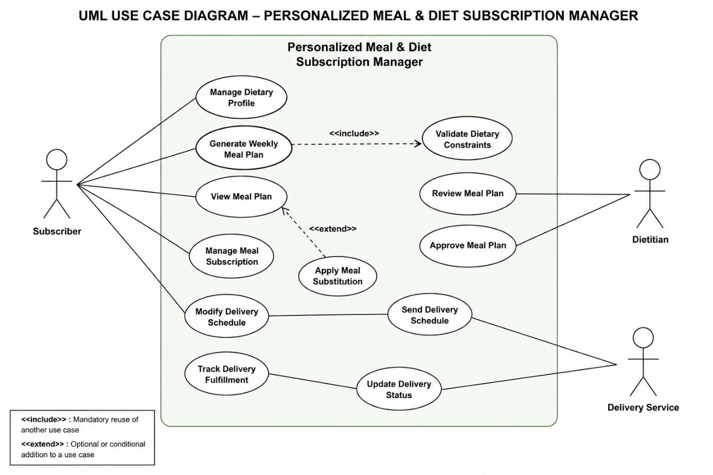

5)Use-case flow specifications
Use Case: UC-02 – Generate Weekly Meal Plan
Primary Actor: Subscriber
Supporting Actor: Dietitian
Goal: Generate a personalized weekly meal plan based on the Subscriber's dietary and metabolic constraints.

Preconditions
- The Subscriber has an active account in the system.
- The Subscriber has provided their dietary profile.
- The Subscriber's allergies, diabetic limits, calorie goals, and macro-nutrient constraints are available in the system.
- The system has access to available meal/food information.
Postconditions
- A personalized weekly meal plan is generated.
- The generated meal plan adheres to the Subscriber's specified dietary constraints.
- The generated meal plan contains no excluded allergens.
- The meal plan is stored in the system.
- The meal plan is made available for Dietitian review and approval.

Main Success Scenario
- Subscriber logs into the Personalized Meal & Diet Subscription Manager.
- Subscriber selects "Generate Weekly Meal Plan."
- System retrieves the Subscriber's dietary profile.
- System retrieves the Subscriber's allergies, diabetic limits, calorie goals, and macro-nutrient constraints.
- System validates the dietary constraints.
- System generates a weekly meal plan according to the validated constraints.
- System checks the generated meals against the Subscriber's allergen exclusion list and nutritional constraints.
- System displays the generated weekly meal plan to the Subscriber.
- System stores the generated meal plan.
- System marks the meal plan as "Pending Dietitian Review."
- Use case ends successfully.

Alternate Flow – Dietary Constraint Violation
A1. Generated meal violates a dietary constraint
- At Step 7, the system detects that a generated meal contains an excluded allergen or violates a specified nutritional constraint.
- The system rejects the affected meal or meal plan.
- The system identifies the violated dietary constraint.
- The system regenerates the affected meal using valid alternatives.
- The system validates the revised meal against the Subscriber's constraints.
- If the revised meal passes validation, the system continues from Step 8 of the Main Success Scenario.
- If the meal cannot be successfully regenerated, the system notifies the Subscriber and marks the meal plan for Dietitian Review.

