NHCX Interoperability Platform

Team Name: CFC [Murali Nidugondi].

Hackathon: NHCX Hackathon 2026.

Date: March 1st, 2026.

https://github.com/Murali-SpringAI/NHCX-Interoperability-Platform

A pluggable, AI-ready healthcare interoperability engine that converts heterogeneous healthcare data (HL7, CSV, legacy formats) into standardized FHIR bundles across multiple workflows — Eligibility and Claims — without rewriting core logic.

🚀 30-Second Pitch

Healthcare integrations today are brittle and expensive because every system speaks a different language.
- Hospitals → HL7 v2
- Insurers → CSV / Flat files
- Government Exchanges → FHIR
Every new connection usually requires a custom integration project.
This creates:
- Integration delays
- Data quality problems
- High operational cost
- Vendor lock-in

Our solution
We built a domain-agnostic interoperability platform core that normalizes any healthcare input into a canonical model, enriches it using semantic intelligence, and produces standards-compliant FHIR.

Our platform:
- Accepts legacy healthcare data.
- Normalizes it into a canonical model.
- Enhances it with semantic intelligence (AI layer).
- Produces standards-compliant FHIR bundles.
This allows one system to integrate with many ecosystems.

🧠 What Makes This Interesting

Not a Converter — A Platform
- Most projects do: HL7 → FHIR conversion.
- We built: Source-agnostic ingestion → Canonical healthcare model → AI semantic enrichment → Multi-workflow FHIR transformation.
- Most projects do: HL7 → FHIR conversion.
- Supports multiple sources without modifying core code.
- All data is first converted into canonical domain objects.

Meaning:
- Add a new source → plug an adapter
- Add a new workflow → plug a builder
- No core rewrite

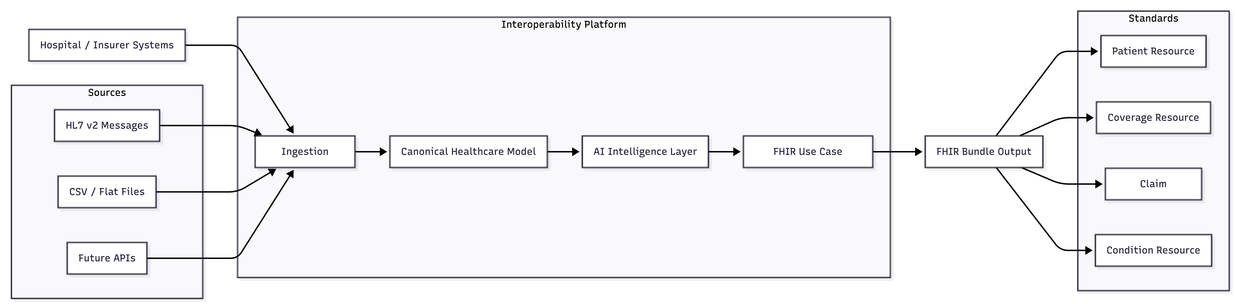

Supported Workflows & Platform Roadmap

🟢 Coverage Eligibility — Implemented
- HL7 ingestion → Canonical normalization → AI enrichment → FHIR Patient & Coverage bundle
🟢 Claims Processing — Implemented
- CSV ingestion → Canonical claim model → AI anomaly detection → FHIR Claim resource
🟡 Prior Authorization — Architecture Ready
- Requires only a new DTO and FHIR builder. No ingestion changes.
🟡 Clinical Exchange — Architecture Ready
- Existing pipeline can generate Encounter, Observation, and Condition resources.

Supported Inputs
- HL7 v2 ADT Messages
- CSV / Flat Files
- (Architected for APIs, Kafka streams, DB dumps)
Standards Produced
- FHIR R4 Bundles
- SNOMED Clinical Coding
- Structured Patient, Coverage, Claim, and Condition Resources

🏗️ Architecture (Simple Explanation)

Pipeline: Source → Adapter → Canonical Model → AI Layer → FHIR Builder → Bundle

Layer Responsibilities:
Ingestion Layer
- Strategy Pattern
- Parses HL7/CSV without business assumptions
Canonical Layer
- Normalizes healthcare meaning
- Decouples message format from semantics
AI Intelligence Layer
- Cleans messy real-world data
- Normalizes demographics
- Detects claim anomalies
FHIR Builder Layer
- Converts canonical meaning into standard FHIR resources
- Workflow-specific (Eligibility vs Claim)

High-Level Architecture Diagram

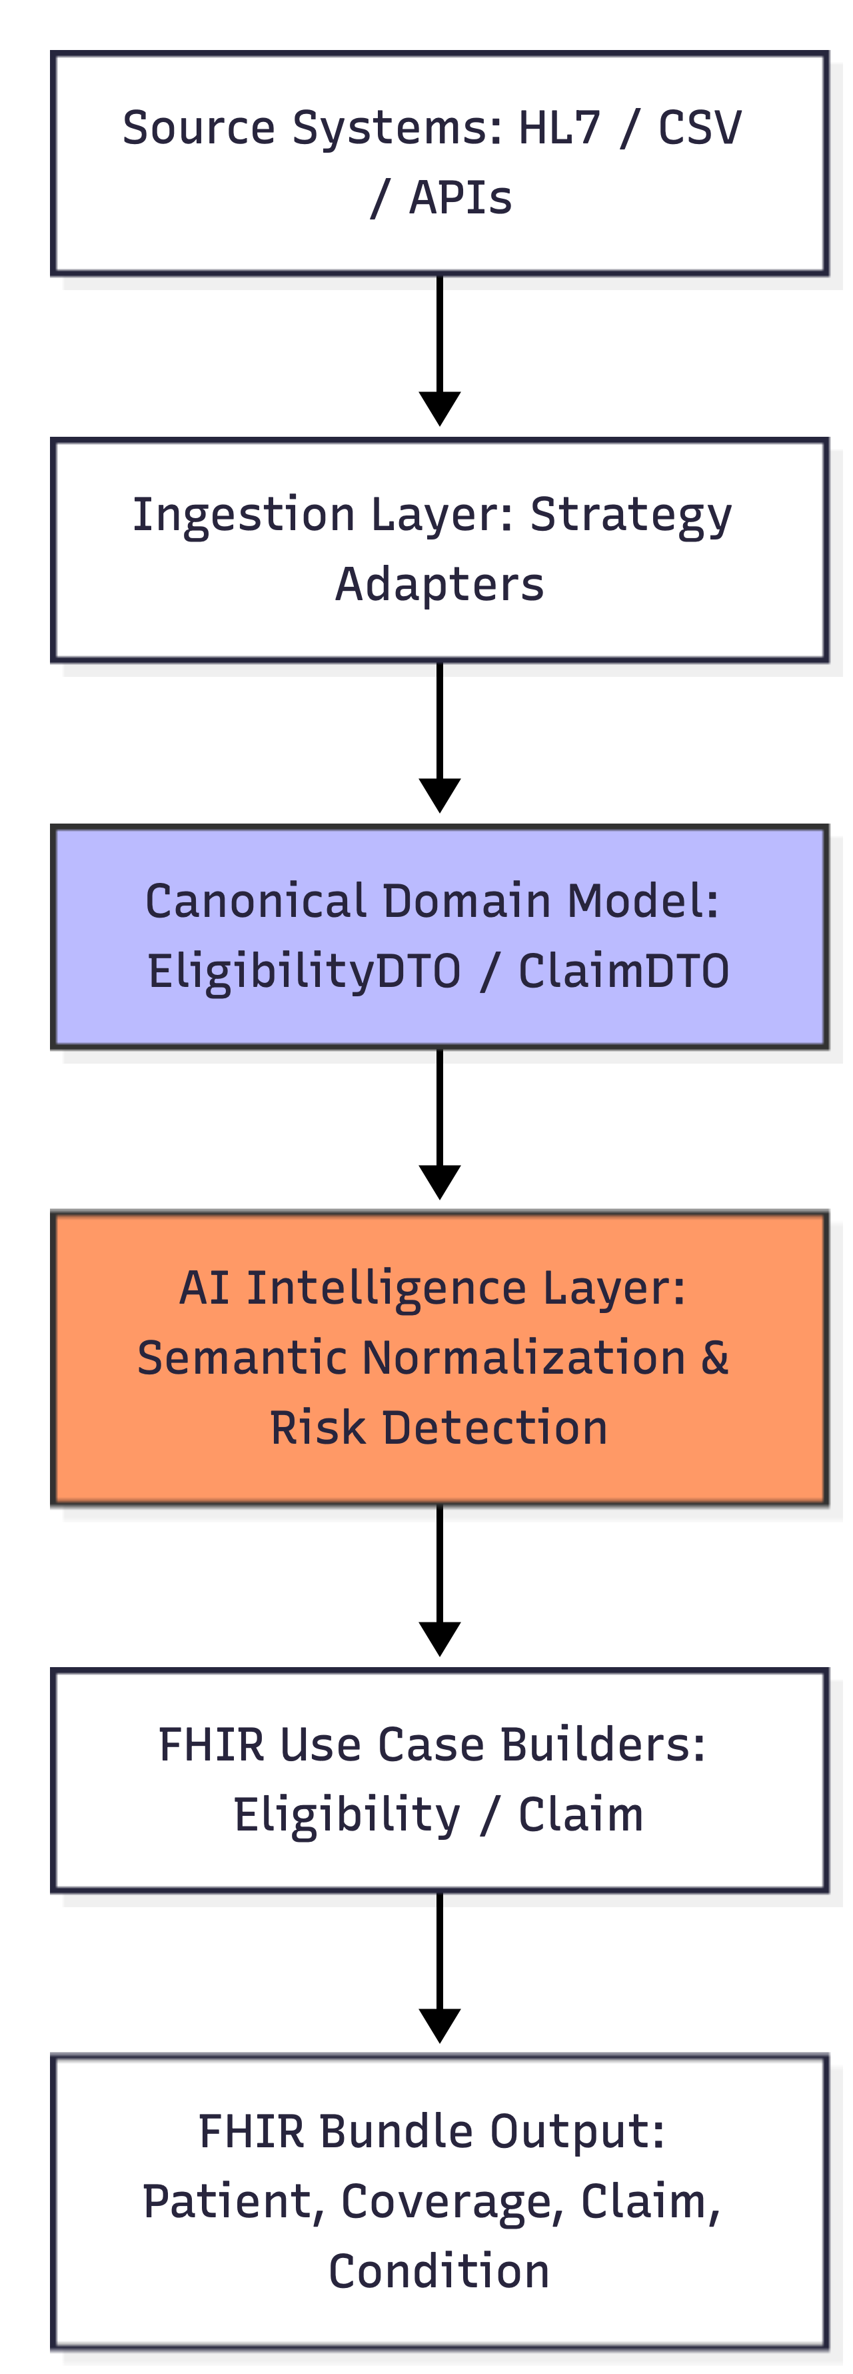

🤖 Where AI Fits

AI is intentionally placed between normalization and FHIR generation. It does not parse HL7 and does not generate FHIR; it enhances healthcare meaning.
- Normalizing inconsistent demographics
- Interpreting free-text diagnosis
- Flagging high-value claims (risk detection)

🧩 Extensibility (Core Design Goal)

Add a New Source: Create a new IngestionAdapter. No controller changes.
Add a New Workflow: Create a new FhirUseCaseBuilder. No ingestion changes.
Add Real AI: Replace MockAiIntelligenceService with LLM/NLP/Terminology services. No FHIR mapping changes.

⚙️ How to Run

Prerequisites: Java 17+, Maven
Start the application: mvn spring-boot:run
Open in browser: http://localhost:8080 (UI for live transformation)

🧪 Demo Scenarios

1) Eligibility (HL7): Paste an HL7 ADT message → Patient + Coverage + Condition FHIR bundle (AI normalization, SNOMED mapping).
2) Claims (CSV): Paste CLM9999,12345,PROV001,HMO123,2024-03-01,E11.9,99213,25000.00 → FHIR Claim resource (AI anomaly detection).

Internal Component Diagram

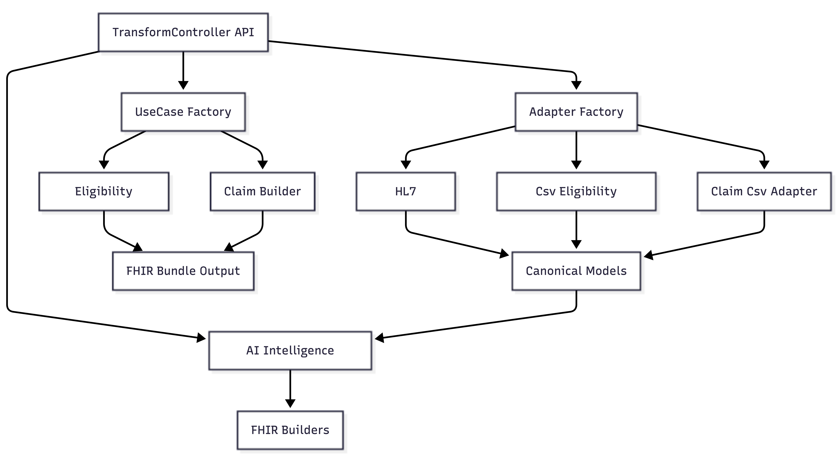

📈 Scalability Vision
- Current: Modular monolith (fast iteration)
- Future: Ingestion Service, AI Intelligence Service, Terminology Service, Workflow Transformation Services
- Stateless processing enables horizontal scaling behind a load balancer

🎯 Why This Matters for NHCX / ABDM

- A national health exchange cannot depend on one message format, vendor, or workflow
- Acts as a universal adapter between legacy hospital systems and modern FHIR ecosystems
- Reduces onboarding effort for providers and insurers

Key Takeaway
We built a foundation layer that allows heterogeneous healthcare systems to participate in standardized digital health ecosystems — the missing middle layer in interoperability.

Architecture Overview – Platform Vision

This section summarizes the architectural philosophy, extensibility strategy, and scalability roadmap of the NHCX Interoperability Platform.
What We Built
- Accepts heterogeneous healthcare data (HL7 v2, CSV today)
- Normalizes into a canonical domain model
- Enriches clinical data using SNOMED terminology
- Transforms into standards-based FHIR R4 bundles
- Supports multiple business use cases (Eligibility today, Claims tomorrow)
This is not a single-purpose transformer. It is an extensible transformation engine.

Architecture Flow Diagram

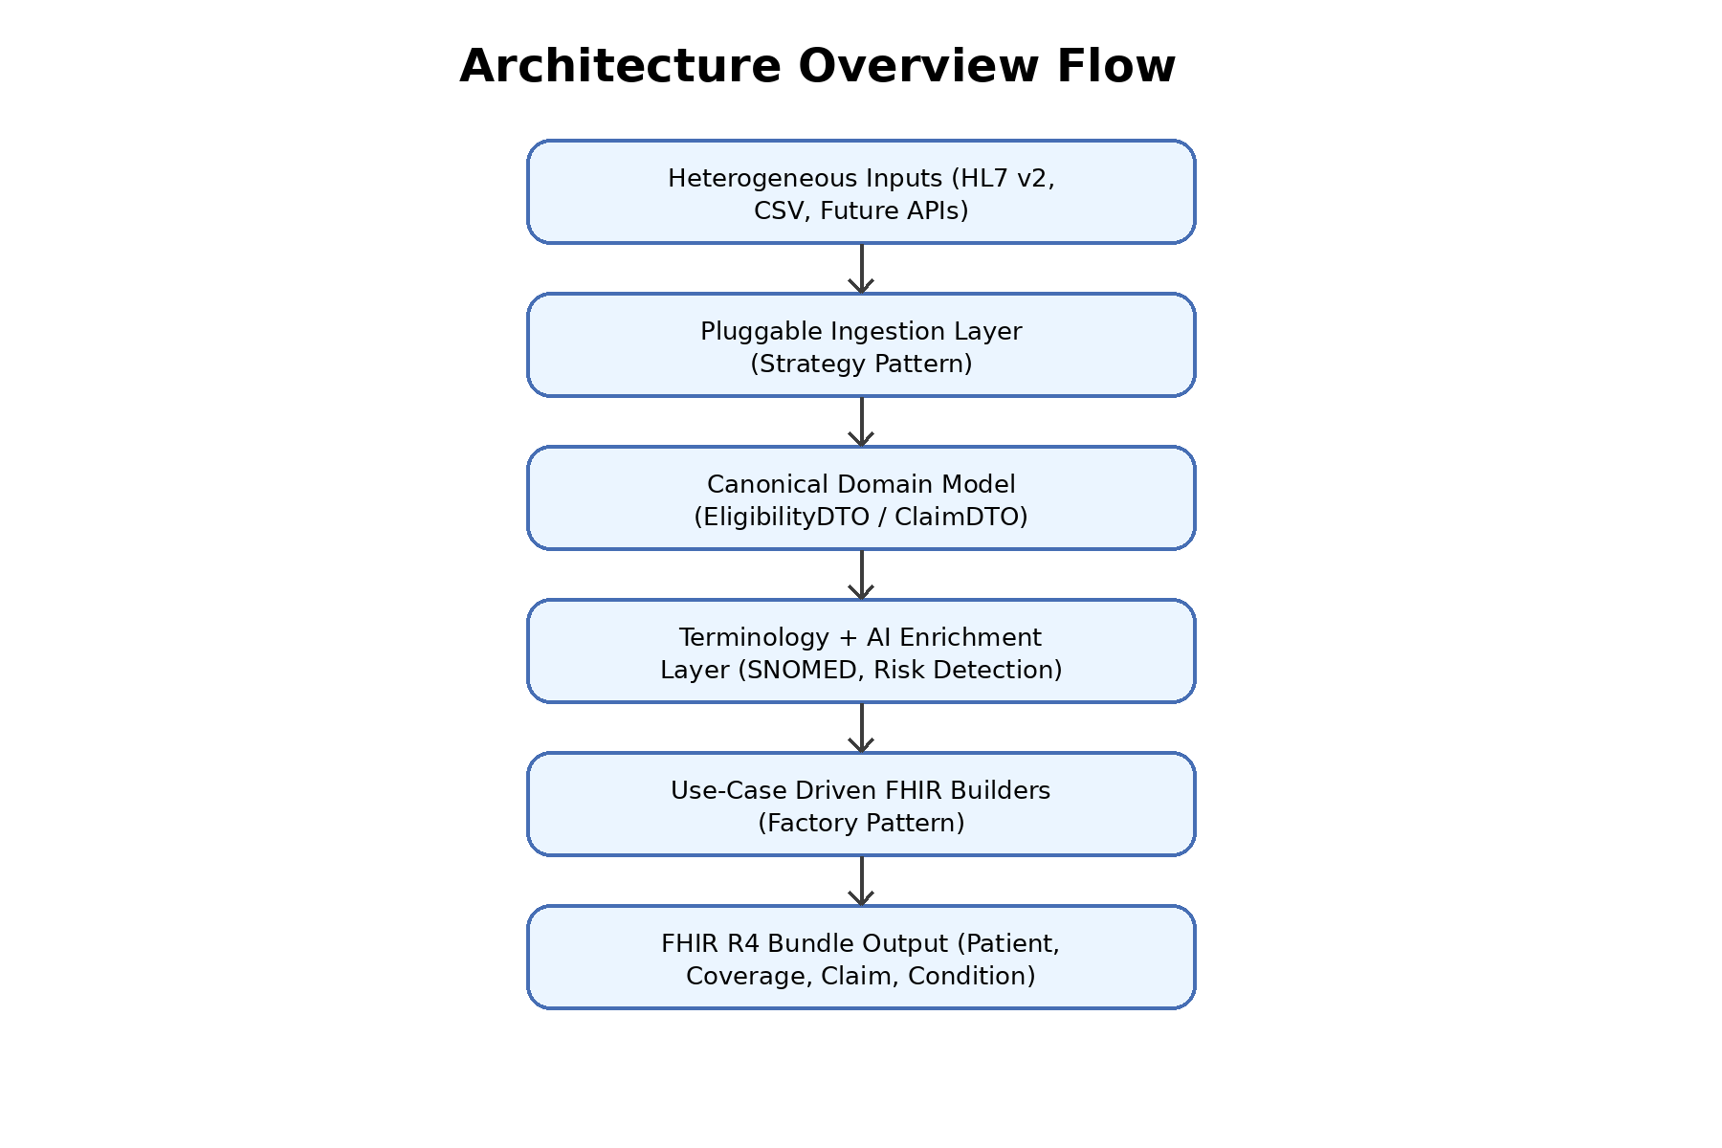

Architectural Patterns Used

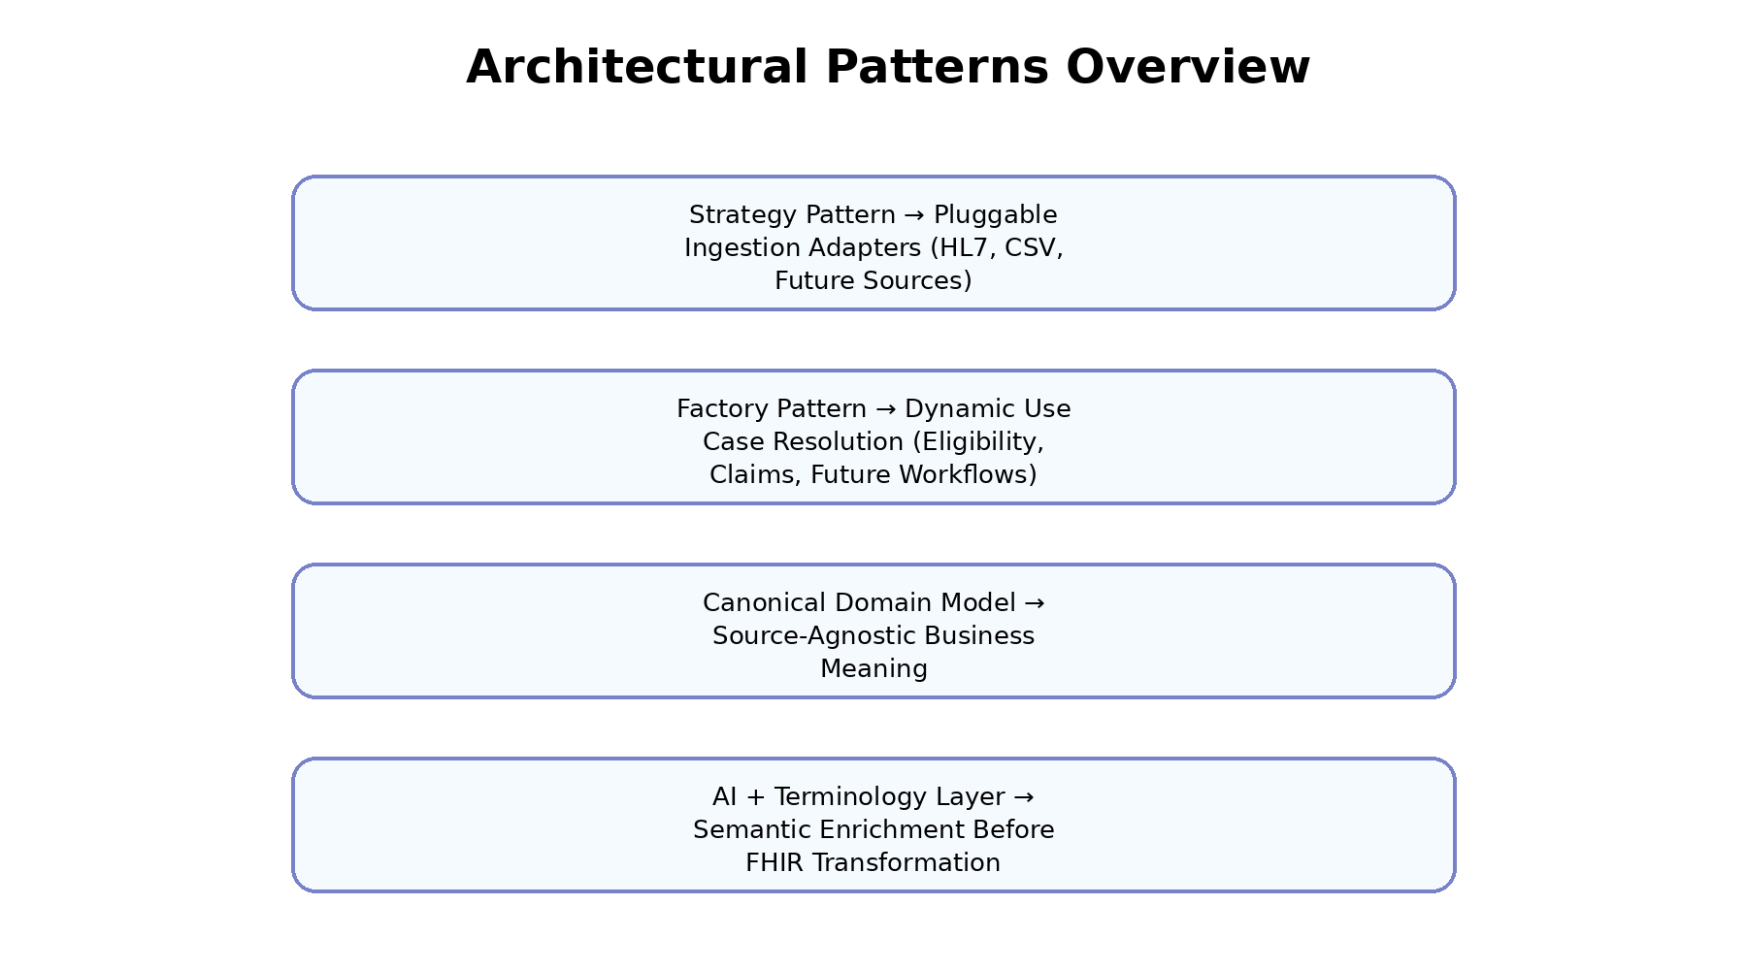

Why This Is a Platform
We decouple source format, domain meaning, terminology enrichment, and output standards. This separation enables extension without rewriting core logic.
Extensibility Strategy
- Phase 1 – Modular Monolith (Current)
- Phase 2 – Domain-Based Services (Ingestion, Terminology, Eligibility, Claims)
- Phase 3 – Event-Driven Architecture (Kafka, async transformation, replay capability)
- Stateless processing enables horizontal scaling behind load balancers and Kubernetes autoscaling.

