Help Section Outline

SECTION 1: Interacting with a graph
    - Viewing a graph
    - Embedded Information
    - Layouts
    - Searching a graph
    - Step-Filtering

SECTION 2: Browsing for Graphs
    - Types of graphs
    - Searching for graphs
    - Tags

SECTION 3: Groups
    - What is a group?
    - Group functionality
      - Owner privileges
      - Member privileges

SECTION 4: Uploading to GraphSpace
- See REST API

SECTION 1: Interacting with a graph

Viewing a graph

Below is a graph that can be found at [link to URL to graph linker-q_0.5-query_CDC55-path_k_50].
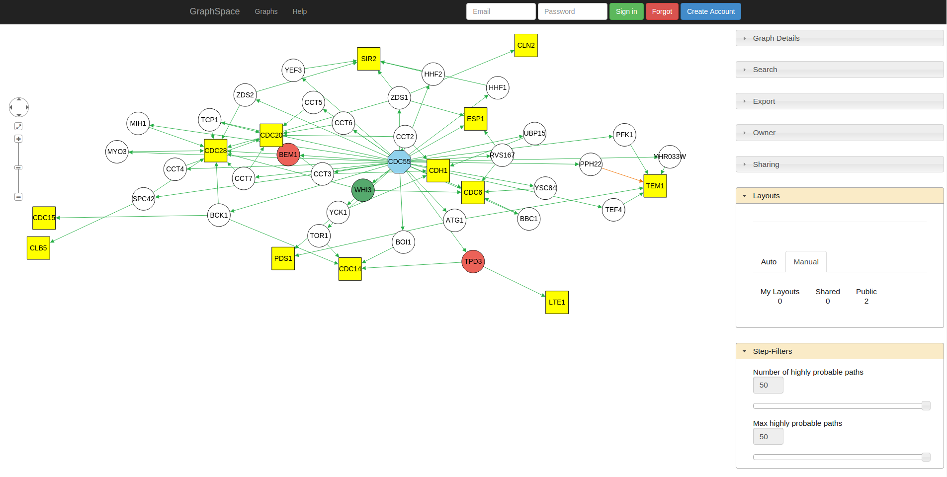
Positions of all the nodes in a graph are mutable. One can click and drag on nodes to change their positions.

Embedded Information

Clicking on a node itself will reveal information about that specific node (such as its description). The image below shows the information that node CCT6 contains.

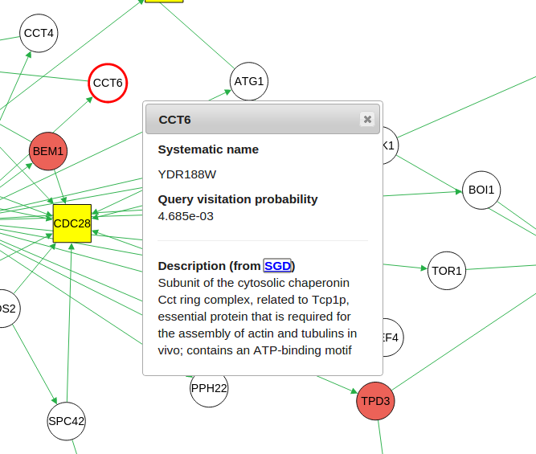

On the right hand side, there are panels with information about the graph. Some of these panels are hidden. Clicking on the panel title will expand the panel.

“Graph Details” shows a legend image for a graph

Searching

“Search” allows one to distinguish a node or an edge. If a user wants to distinguish a node, simply enter the text that the node has inside of it. If a user wants to distinguish an edge, enter in the following format: [tail:head]. For example, if a user searched for the node 'TEM1', TEM1 will look like this:

Before Searching After Searching
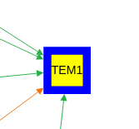
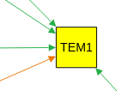

If a user wants to search for edge connection TEF4 to TEM1, they can do so with the following text: TEF4:TEM1. The edge will look like this.

Before Searching After Searching

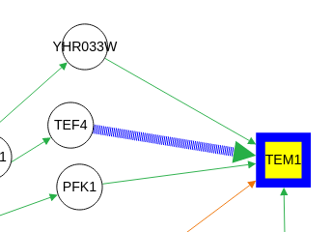
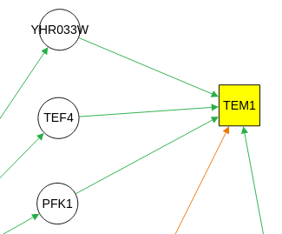

GraphSpace allows users send links which contain elements of the graph which a user wants to distinguish. After searching for a node, a link is generated on top of the search bar. This link points to this graph including all of the elements that are currently distinguished. If a GraphSpace user sends this link to someone else, they can click the link and see all the distinguished elements.

“Export” allows one to export the entire image of the Graph as a PNG.

“Owner” shows the GraphSpace user whom the graph belongs to

“Sharing” Displays all the groups that a graph is shared with [See Groups]

Layouts (GraphSpace account recommended)

“Layouts” GraphSpace provides multiple methods to display or layout a graph. These methods can be found in the 'Layout' container.
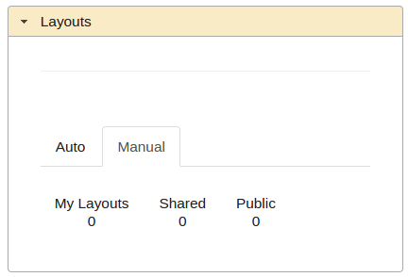
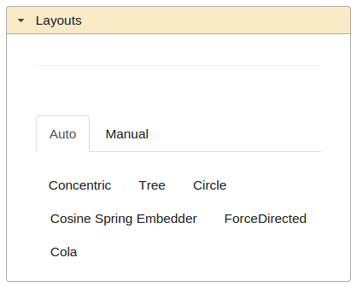

In the 'Auto' section, options are provided to automatically layout a graph using their respective algorithms.

If a person has created an account and logged in, a user will be allowed to save any changes to the positions of elements they manually make to a graph in addition to viewing and sharing layouts with groups they are members of. [LINK TO GROUP].

Step through filtering

There are graphs in GraphSpace which employ the use of Step through filtering. This concept allows one to see subgraphs of the entire graph. In addition, it allows a user to “step” through the connections of a graph in sequential order. The images below show a user stepping through a graph.

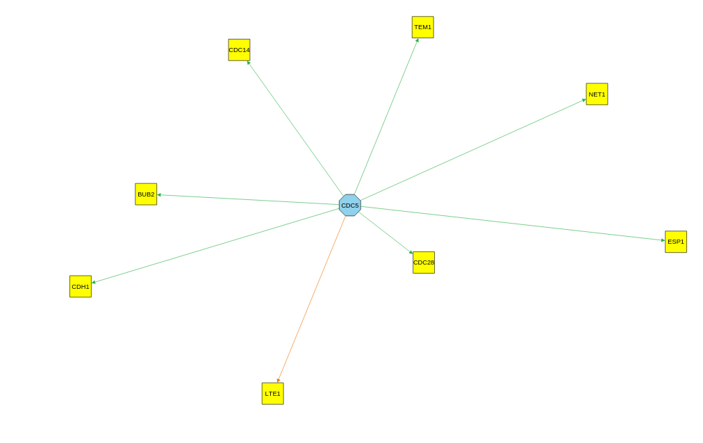
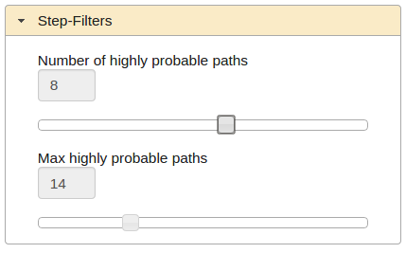

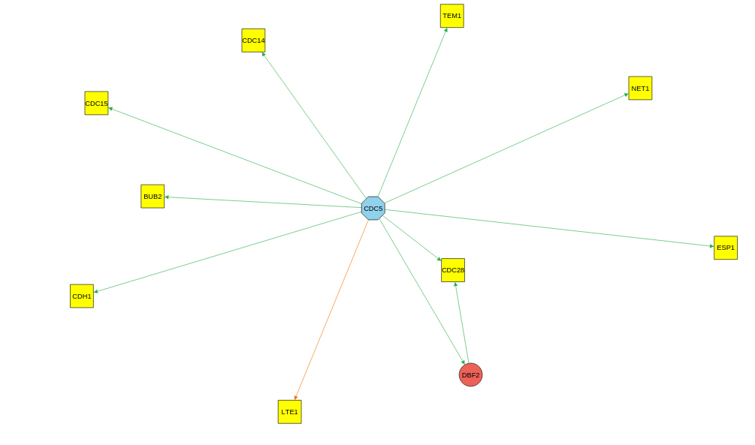
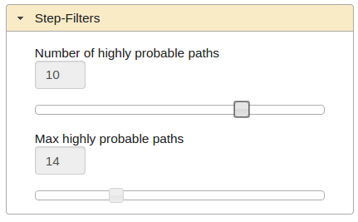

“Max highly probably paths” tells GraphSpace to display a subgraph up to the specified value.

“Number of highly probable paths” reveals interactions (connections) that occur at a certain value
For example, when Number of highly probably paths was 10, a red node was revealed whereas at value = 8, this red node was not present.

SECTION 2: Browsing for Graphs

Types of Graphs

Public Graphs

Public graphs are viewable to everyone. Provided a link to a public graph, any anonymous user may see the contents of the graph. For example, http://graphspace.org/users/ategge@vt.edu/graphs/XTalk-family-MAPK-Wnt.

Shared Graphs (GraphSpace account required)

GraphSpace utilizes a concept of Groups [LINK TO GROUPS SECTION]. All graphs that are shared with any of the groups that a user is in are considered to be shared graphs. A user that has access to a shared graph may view shared layouts of the graph in addition to saving and sharing their own layouts of the graph with the group.

My Graphs

These are the graphs that a user has uploaded to GraphSpace through the REST API [LINK TO REST API]. The only person that can delete these graphs are the owners of the graphs themselves. A graph owner has the exclusive ability to share a graph with a group that they are a part of.

Searching for graphs

While on the graphs page, there are two boxes: Search and Tags [See Tags section]. The Search section allows for any user of GraphSpace to search a graph that matches the criteria of ALL search queries. A user may search for graphs using its name as well as a node or an edge which a graph may contain.

To search for graphs that match a name, simply type the name or a part of the name of the graph

To search for nodes, type the name of the node (text that you want to see inside the node)

To search for edges, search using the following syntax [tail: head] where tail is the name of the node where the arrow is coming from and head is the name of the node that the arrow is point to. For example, to search for the edge that connects YEF3 to SIR2, type YEF3:SIR2. All graphs that contain this edge will be presented to the user.

** Note**

If there are multiple search terms (and/or tag terms), all graphs that are returned WILL match all of these terms.

Tags

Tags are used to categorize graphs. For example, if a user is uploading multiple graphs to GraphSpace for a specific paper, a tag would be used to categorize all the graphs related to the paper. On the graphs page, a user can search for graphs that match a tag. A graph may have any amount of tags that the user sees fit. It is advantageous for users to group all graphs they upload using tags as it allows for clear organization of work on GraphSpace.

SECTION 3: Groups (GraphSpace account required)

Groups contain collections of graphs that are shared by members of the group.

A group owner may invite any GraphSpace user that has an account to be a member of their group. They can also remove any member from their group.

A group owner may unshare any graph that has already been shared by the members of their group.

A group member is a user that is a part of a group that is owned by someone else.

A group member may share their graphs from the group. Unlike the group owner, they may only un-share the graphs that the own from the group

While viewing a graph, if a user saves a layout and they wish to share their layout with other users, the following happens:

If a graph is public, then sharing a layout will cause it to become a public layout – which is viewable by any anonymous user of GraphSpace

If a graph is private and is shared with groups, then sharing a layout will cause that layout to be shared with all the groups that the graph is shared with

