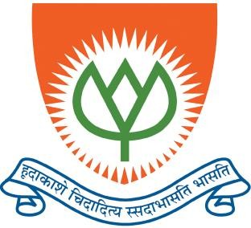

**GEETHANJALI INSTITUTE OF SCIENCE & TECHNOLOGY**

Approved by AICTE, New Delhi & Affiliated to JNTU, Anantapur)(Recognised Under section 2(f) of UGC Act 1956) An ISO 9001: 2015 certified Institution – Unit of USHODAYA EDUCATIONAL SOCIETY

3rd Mile, Bombay Highway, Gangavaram (V), Kovur(M), SPSR Nellore (Dt), Andhra Pradesh, India- 524137

Ph. No. 08622-212779, 212781, Fax: 08622-212778, E-Mail: [principal@gist.edu.in](mailto:principal@gist.edu.in) / [geethanjali@gist.edu.in,](mailto:geethanjali@gist.edu.in) Website: gist.edu.in



CAD/CAM/CIM

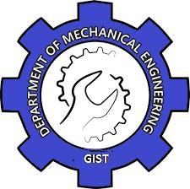**L E C T U R E N O T E S**

**Department of**

**M e c h a n i c a l E n g i n e e r i n g**

|  |  |
| --- | --- |
| Name |  |
| Roll No. |  |
| Class | III B.TECH. I SEM |
| Branch | MECHANICAL ENGINEERING |
| Regulation | RG22 |
| Name of the  Subject | CAD/CAM/CIM (22A0323T) |
| Academic year | 2024-25 |

Geethanjali Institute Of Science And Technology, Nellore 1

# Col Logo GEETHANJALI INSTITUTE OF SCIENCE & TECHNOLOGY

(Approved by AICTE, New Delhi & Affiliated to JNTU, Anantapur)(Recognised Under section 2(f) of UGC Act 1956)

An ISO 9001: 2015 certified Institution – Unit of USHODAYA EDUCATIONAL SOCIETY

3rd Mile, Bombay Highway, Gangavaram (V), Kovur(M), SPSR Nellore (Dt), Andhra Pradesh, India- 524137

Ph. No. 08622-212779, 212781, Fax: 08622-212778, E-Mail: [principal@gist.edu.in](mailto:principal@gist.edu.in) / [geethanjali@gist.edu.in,](mailto:geethanjali@gist.edu.in) Website: gist.edu.in

**VISION**

To sustain as a premier technical Institution with impeccable credentials in imparting quality engineering education, research and consultancy services with a futuristic perspective, blending ethical values and technological advancements in tune with emerging trends.

**MISSION**

* Providing quality instruction in technical education through activity based innovative interactive teaching-learning strategies.
* Empowering the students through demanding and stimulated training in advanced technologies and real-time applications by interaction and interface with leading Industry, Academic and Research institutions.
* Adopting holistic approaches to develop sensitive, socially responsible, professionally competent and motivated technocrats.
* Equipping the students with required skill sets to face the challenges in research, academics, administration, industry and enterprise.

**QUALITY POLICY**

To self-prescribe exacting standards of Academic excellence, continuously strive towards accomplishing quality teaching learning opportunities and providing student associated services.

**Department Of Mechanical Engineering VISION**

To nurture and groom the students into competent Mechanical Engineers by inculcating conceptual learning in design and development, visualization and innovation through value-based and interactive teaching-learning process, projects and research to address industrial and societal needs.

**MISSION**

*The vision of the department is achieved by*

* + Creating a congenial learning environment for students to upgrade their skills in mechanical engineering through interactive teaching-learning process.
  + Developing conceptual learning in design and development, creative learning in visualization and innovation and strengthening the technical base for qualitative research to address societal needs.
  + Imparting advanced knowledge through workshops, seminars, conferences, guest-lectures, industrial visits, in-plant training, internships and projects.
  + Facilitating collaboration among students, faculty, academia and industry to inculcate team work, leadership and professional ethics.

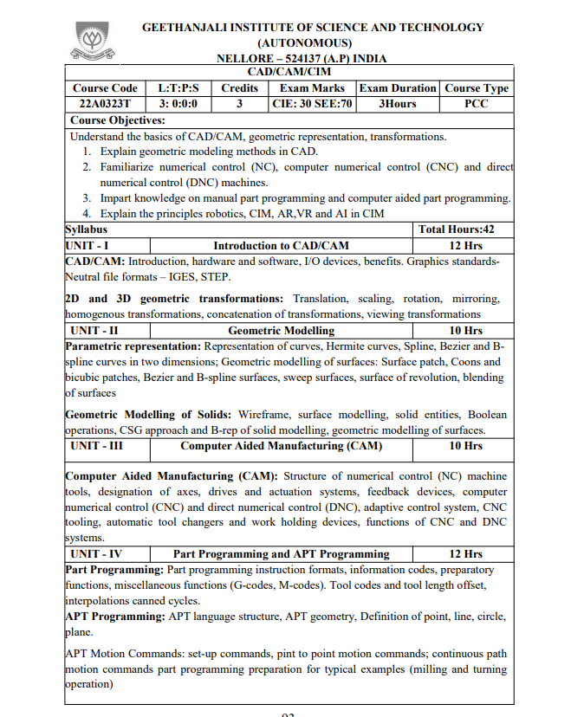

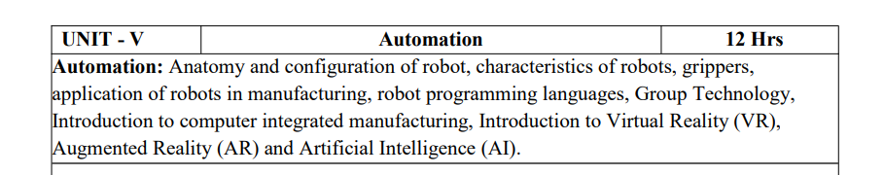

# TWO MARKS QUESTION AND ANSWERS UNIT-I

|  |  |
| --- | --- |
| **1** | **Define the terms CAD and Cam.** |
| **A** | Computer aided design (CAD) can be defined as the use of computer systems to assist in the creation, modification, analysis, or optimization of a design.  Computer aided manufacturing (CAM) can be defined as the use of computer systems to plan, manage, and control the operations of a manufacturing plant through either direct or indirect computer  interface with the plant’s production resource |
| **2** | **Define CAD Tools** |
| **A** | CAD tools can be defined as the intersection of three sets of  geometric modeling, computer graphics and design tools |
| **3** | **Define CAM Tools** |
| **A** | CAM tools can be defined as the intersection of three sets of CAD  tools, networking concepts and the manufacturing tools. |
| **4** | **Define CAD/CAM tools** |
| **A** | CAD/CAM Tools can be defined as the intersection of five sets of  design tools, manufacturing tools, geometric modeling, and computer graphic concepts and networking concepts |
| **5** | **Write any four advantages of CAM.** |
| **A** | 1. Greater Flexibility. 2. Higher Productivity. 3. Reduced scrap and improves the quality of the product. 4. Different sizes of the product can be achieved. |
| **6** | **Name the techniques that are used for improving the design**  **of a product through CAD** |
| **A** | 1. Geometric Modelling and Computer graphics. 2. Design packages. 3. Design testing 4. Drafting 5. Documentation. |

|  |  |
| --- | --- |
| **7** | **What are the various activities of a manufacturing plant**  **which can be carried out through computer control?** |
| **A** | 1. Computer aided process planning. 2. Computer aided quality control. |

|  |  |
| --- | --- |
| **8** | **List out the 2D transformations** |
| **A** | The 2D transformations are given below   1. Scaling 2. Translation 3. Rotation 4. Reflection 5. Shearing |
| **9** | **Define Rendering.** |
| **A** | The representation of 3D object into shaded 2D projection on the  screen in the computer is known as rendering. |
| **10** | **Define Clipping** |
| **A** | It identifies the portions of a picture that as either inside or outside of a specified region is known as clipping.  The region in which the object is to be clipped is called as **“Clipping**  **Window”.** |
| **11** | **What is homogenous transformations** |
| **A** | It is used to combine the rotation and displacement into a single  matrix. |
|  |  |

**UNIT-II**

|  |  |
| --- | --- |
| **1** | **What is wire frame modelling?** |
| **A** | 1. In wire frame modeling the object is represented by its edges. 2. In the initial stages of “CAD” wire frame models. are 2D-model. 3. Later the software has introduced wire frame model of a box and   it is represented as 3D-model |
| **2** | **Define Geometric Modelling.** |
| **A** | Geometric modeling is defined as the representation of the geometry of a component using software is known as “geometric  modeling “. |
| **3** | **List out the types of Geometric modelling?** |
| **A** | Geometric modeling is of three types. They are   1. Wire frame modeling 2. Surface modeling 3. Solid modeling |
| **4** | **Briefly explain CSG model** |
| **A** | In case model physical models are created by combining basic elementary shapes know as primitive like blocks, cylinders, cones, pyramids and spheres. The Boolean operations like union (U),  DIFFERENCE (-) and intersection (n) are used carry out this task. |
| **5** | **What is Spline function and list the characteristics.** |
| **A** | * B-spline curves provide another effective method bezeir of generating curves define by data points * They provide local control of the curve shape as opposed to global control by using blending functions which provide influence.   **Characteristics**   * 1. The local control of the curve can be obtained by changing the position of a control point   2. The B-spline curves do not pass through the first and last   control points except when the linear blending functions are |

|  |  |
| --- | --- |
|  | used. |
| **6** | **Write the advantages of the Bezier curve.** |
| **A** | 1. It is more numerically more robust compared to other splines. 2. It is very good mathematical properties and higher order continuity. 3. The curve is smooth. 4. The shape of the curve is controlled by defining points only. |
| **7** | **State few uses of NURBS** |
| **A** | 1. Evaluation can be done very fastly by using numerical stable and accurate algorithm. 2. They reduce the memory consumption when storing shapes. 3. They provide the flexibility to design large variety of shapes. |
| **8** | **What do you understand the ‘Snap’ feature in CAD?** |
| **A** | Object snaps provide a way to specify precise locations on objects whenever you are prompted for a point within a command.  For example, you can use object snaps to create a line from the center of a circle to the midpoint of another line. |
| **9** | **What are the limitations in utilising the sweep method in**  **geometric construction?** |
| **A** | 1. It consists of limited modeling domain. 2. If sweep direction is not proper, then it may result in invalid solid or irregular shapes. 3. It does not support all wire frame entities in sweep operations. |

# UNIT-III

|  |  |
| --- | --- |
| **1** | **Define Numerical control.** |
| **A** | Numerical control can be defined as a form of programmable automation in which the process is controlled by numbers, letters and special character symbols.  NC technology has been widely used in the operations,  including drafting, assembly, inspection, sheet metal process and spot welding. |
| **2** | **Write the applications of numerical control.** |
| **A** | 1. Milling 2. Drilling 3. Boring 4. Turning 5. Grinding 6. Sawing |
| **3** | **List out NC Machining centres.** |
| **A** | The machining centre’s are of three types. They are   1. Horizontal machining centre 2. Vertical machining centre 3. Universal machining centre |
| **4** | **What is meant by CNC system?** |
| **A** | CNC refers to a computer that is joined to the NC machine to make the machine versatile .information can be stored in a memory bank. The program is read from a storage medium such as the  punched tape and retrieved to the memory of the CNC computer |
| **5** | **Write the applications of CNC machine.** |
| **A** | In addition to metal machining, CNC has been applied to a variety of other applications.   1. Welding machines 6.Plasma arc welding 2. Automatic drafting 7.Laser beam process 3. Assembly machines 8.Cloth cutting 4. Tube bending 9.Riveting |

|  |  |
| --- | --- |
|  | 5. Flame cutting 10.Wire Wrap machines |
| **6** | **Mention any two types of CNC machines** |
| **A** | 1. Hybrid CNC 2. Straight- CNC. |
| **7** | **Explain macro statement in APT programming** |
| **A** | The MACRO feature is similar to the sub routine in FORTRAN and other programming languages. It would be used where certain motion sequences would be repeated for several times within the program.  The purpose in using a MACRO subroutine is to reduce the total number of statements required in the APT program, thus making the job of the part programmer easier and in less time consuming.  The MACRO subroutine is defined by a statement of the following format.  Symbol=MACRO/parameter specification. |

**UNIT-IV**

|  |  |
| --- | --- |
| **1** | **What is APT?** |
| **A** | APT is a programming language used to generate instructions for numerically controlled machine tools. It's a high-level language that helps avoid the complex math of writing tool paths. |
| **2** | **What are the types of statements in APT?** |
| **A** | * Geometry statements: Define the part's shape * Motion statements: Specify the path the tool takes * Post-processor statements: Control the machinery, including feeds, speeds, and coolants * Auxiliary statements: Specify the part and required tools |
| **3** | **What are the components of the APT language?** |
| **A** | The APT language includes letters, numbers, punctuation marks, commas, and equals signs. |
| **4** | **What is the difference between manual and computer-aided part programming?** |
| **A** | The main difference between manual and computer-aided part programming is that manual programming is done without a computer, while computer-aided part programming uses a computer to perform calculations and prepare the tape. |
| **5** | **Write few preparatory codes and miscellaneous functions**  **used in NC systems.** |
| **A** | G-codes (Preparatory codes)   1. G00- Rapid traverse 2. G01- Linear Interpolation 3. G02-Circular Interpolation (C.W) 4. G03-Circular Interpolation (A.C.W) M-Codes (Miscellaneous functions) 5. M00- Program Stop. 6. M03- Spindle ON 7. M05- Spindle OFF   M30- End of program and rewind |
|  |  |

# MULTIPLE CHOICE QUESTIONS CAD/CAM

|  |  |  |  |
| --- | --- | --- | --- |
| 1 | Which of the following NC is used to move the cutting tool to a predefined position | | [ ] |
|  | (a) Point to point NC mode | (b) Straight NC mode | |
| (c) Contouring NC | (d) None of the above | |
| 2 | Which of the following is not an element of data processing unit | | [ ] |
|  | (a) Tape Reader | (b) Rotary encoder | |
| (c) Interpolator | (d) Reading circuit | |
| 3 | is an input medium used in NC system, acts as a temporary storage device | | [ ] |
|  | (a) Punched device | (b) Magnetic tape | |
| (c) Floppy disc | (d) none | |
| 4 | In system, the part program is directly transferred to the MUC without tape reader | | [ ] |
|  | (a) NC | (b) CNC | |
| (c) DNC | (d) NONE | |
| 5 | Performance index( ) of adoptive controlling machine is given by | | [ ] |
|  | (a) Material removal rate x  tool wear rate | (b) Material removal  rate/tool wear rate | |
| (c) Tool wear rate/material removal rate | (d) Tool wear rate x material removal rate | |
| 6 | NC is a form of programmable automation in which the processing machine is | | [ ] |
|  | (a) numbers | (b) symbols | |
| (c) letters | (d) all of these | |
| 7 | The code used in cutter radius compensation, when the cutter is located the left side of the programmer | | [ ] |
|  | (a) G41 | (b) G40 | |
| (c) G42 | (d) G43 | |
| 8 | Which of the following G code is used for circular interpolation anticlockwise | | [ ] |
|  | (a) G01 | (b) G02 | |
| (c) G03 | (d) G04 | |
| 9 | The function of G04 code is | | [ ] |
|  | (a) Linear interpolation | (b) Circular interpolation | |
| (c) dwell | (d) hold | |
| 10 | Which of the following M-code is used for tool change operation | | [ ] |
|  | (a) M05 | (b) M06 | |
| (c) M07 | (d) M08 | |
| 11 | Optiz code comprises of | | [ ] |
|  | (a) Design attributes | (b) Machining attributes | |
| (c) both | (d) a(or)b | |

|  |  |  |  |
| --- | --- | --- | --- |
| 12 | The fourth digit in MICLASS coding system represents | | [ ] |
|  | (a) Main shape | (b) Shape elements | |
| (c) Position of shape elements | (d) None | |
| 13 | In code structure, the interpretation of each symbol is fixed and is independent | | [ ] |
|  | (a) hierarchical structure | (b) chain type structure | |
| (c) hybrid structure | (d) none | |
| 14 | The form code in optiz coding system consists of digits | | [ ] |
|  | (a) 3 | (b) 4 | |
| (c) 5 | (d) 6 | |
| 15 | The code number used to represent dimension ratio in MICLASS system is | | [ ] |
|  | (a) Sixth digit | (b) Seventh digit | |
| (c) First digit | (d) Fourth digit | |
| 16 | CMM stands for | | [ ] |
|  | (a) Computer measuring machine | (b) Coordinate measuring machine | |
| (c) Complex measuring machine | (d) Compact measuring machine | |
| 17 | The cell having the lowest production rate is | | [ ] |
|  | (a) Special manufacturing system | (b) Flexible manufacturing system | |
| (c) Manufacturing system | (d) Both (a) and (b) | |
| 18 | Which of the following files uses machinability data base system | | [ ] |
|  | (a) Tool file | (b) Material file | |
| (c) Machine file | (d) All the above | |
| 19 | transducers are sussed to indicate the presence and distance of the objects from the probe of ferromagnetic substances | | [ ] |
|  | (a) Reluctance | (b) Capacitance | |
| (c) Inductance | (d) None | |
| 20 | In FMS, regulation of the secondary part handling systems at each workstation os controlled | | [ ] |
|  | (a) Traffic control | (b) Shuttle control | |
| (c) Workstation control | (d) Production | |
| 21 | systems are also called as variant systems | | [ ] |
|  | (a) Retrieval CAPP systems | (b) Generative CAPP systems | |
| (c) Both (a) and (b) | (d) None | |
| 22 | The benifits of CAPP includes | | [ ] |
|  | (a) Process rationalisation | (b) Improved legibility | |
| (c) Reduced lead time | (d) All the above | |
| 23 | Part classification and coding together with group technology forms a starting for process planning systems | | [ ] |

|  |  |  |  |
| --- | --- | --- | --- |
|  | (a) Generative type | (b) Retrieval type | |
| (c) Both (a) and (b) | (d) None | |
| 24 | The capacity related to the size of the work piece is | | [ ] |
|  | (a) Fixed capacity | (b) Adjustable capacity | |
| (c) Design capicity | (d) Effective capacity | |
| 25 | The planning that determines the quantity of finished products to be produced in a given time | | [ ] |
|  | (a) Aggregate planning | (b) Master production schedule | |
| (c) Fore casting | (d) Order writing | |
| 26 | Dispatching takes place through the | | [ ] |
|  | (a) Job order | (b) Store issue order | |
| (c) Tool order | (d) All the above | |
| 27 | The inputs to MRP includes | | [ ] |
|  | (a) Master production schedule | (b) Bill of materials | |
| (c) Inventory status file | (d) All the above | |
| 28 | MRP is introduced in the year | | [ ] |
|  | (a) 1950 | (b) 1960 | |
| (c) 1970 | (d) 1980 | |
| 29 | Which of the following data base is more flexible | | [ ] |
|  | (a) Hierarchical database | (b) Network database | |
| (c) Relational database | (d) None of the above | |
| 30 | The techniques used to determine time standards in manufacturing include | | [ ] |
|  | (a) Direct time study | (b) Use of standard data | |
| (c) Work sampling | (d) All the above | |

**ANSWER KEY**

|  |  |  |  |  |  |  |  |  |  |
| --- | --- | --- | --- | --- | --- | --- | --- | --- | --- |
| 1. A | 2.B | 3.A | 4.C | 5.B | 6.D | 7.A | 8.C | 9.C | 10.B |
| 11.C | 12.C | 13.B | 14.C | 15.A | 16.B | 17.C | 18.D | 19.A | 20.B |
| 21.A | 22.D | 23.B | 24.B | 25.B | 26.D | 27.D | 28.B | 29.C | 30.D |

# UNIT-I INTRODUCTION TO CAD/CAM

**Definition of CAD/CAM:**

CAD/CAM is a term which means computer aided design and computer aided manufacturing. It is the technology concerned with the use of digital computers to perform certain functions design and production.

This technology is moving in the direction of greater integration of design and manufacturing, two activities which have traditionally have been treated as distinct and separate functions in a production firm. Ultimately, CAD/CAM will provide the technology base for the computer integrated factory in future.

# Definition of CAD:

Computer aided design (CAD) can be defined as the use of computer systems to assist in the creation, modification, analysis, or optimization of a design.

Examples of the applications of CAD programs may include stress- strain analysis of components, dynamic response of mechanisms, heat- transfer calculations and numerical control part programming.

# Definition of CAM:

Computer aided manufacturing (CAM) can be defined as the use of computer systems to plan, manage, and control the operations of a manufacturing plant through either direct or indirect computer interface with the plant’s production resource. As indicated by the definition, the applications of computer aided manufacturing fall into two broad categories.

1. **Computer monitoring and control.** These are the direct applications in which the computer is connected directly to the manufacturing process for the purpose of monitoring or controlling the process.

ME, III B.TECH-I SEM (R20) COMPUTER AIDED DESIGN & MANUFACTURING



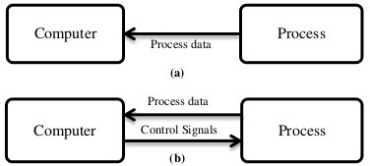

Fig: Computer monitoring and control

1. **Manufacturing support applications.** These are the indirect applications in which the computer is used in support of the production operations in the plant, but there is no direct interface between the computer and the manufacturing process.

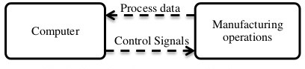

Fig: CAM for manufacturing support

# AUTOMATION AND CAD/CAM

Automation was defined as the technology concerned with the application of complex mechanical, electronic, and computer based systems in the operation and control of production.

Production activity can be divided in to four main categories.

1. Continuous-flow processes.
2. Mass production of discrete products.
3. Batch production.
4. Job shop production.
5. **Continuous-flow processes.** Continuous dedicated production of large amounts of bulk product.

**Ex:** Chemical plants and oil refineries.

1. **Mass production of discrete products.** Dedicated production of large quantities of one product.

**Ex:** Automobile engine block.

1. **Batch production.** Production of medium lot sizes of the same product or component. The lots may be produced once or repeated periodically.

**Ex:** Clothing Industries

1. **Job Shop Production.** Production in low quantities.

**Ex:** Prototypes in aircraft, machine tools etc.,

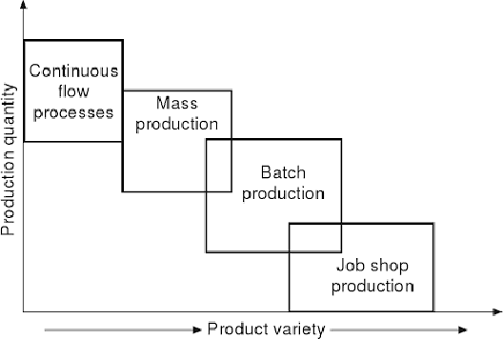

Fig: Four production types

# ADVANTAGES OF CAM

1. Greater Flexibility.
2. Higher Productivity.
3. Reduced scrap and improves the quality of the product.
4. Different sizes of the product can be achieved.
5. Minimum automation and transfer flow lines are used.

# CAD TOOLS:

CAD tools can be defined as the intersection of three sets of geometric modeling, computer graphics and design tools.

or

CAD tools can be defined as the design tools being augmented by computer hardware and software to achieve design goal efficiency completely.

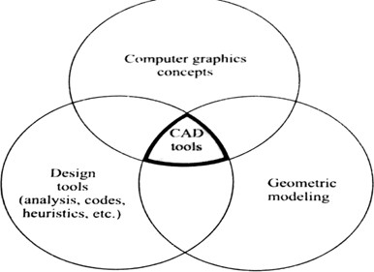

Fig: Definition of CAD Tools

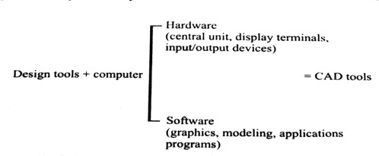

Fig: Definition of CAD Tools and implementation in design environment

# CAM TOOLS

CAM tools can be defined as the intersection of three sets of CAD tools, networking concepts and the manufacturing tools.

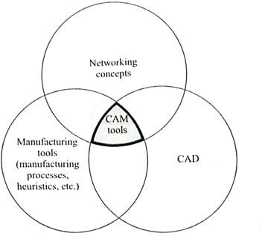

Fig: Definition of CAD Tools

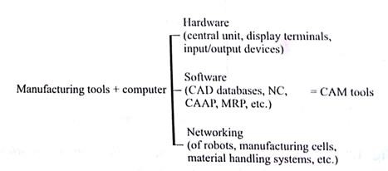

Fig: Definition of CAD Tools and implementation in manufacturing environment

# CAD/CAM TOOLS

CAD/CAM Tools can be defined as the intersection of five sets of design tools, manufacturing tools, geometric modeling, and computer graphic concepts and networking concepts. CAD/CAM can be defined as the subset of the product cycle augmented by computer as shown in figure.

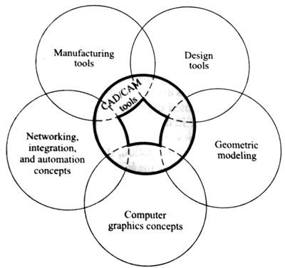

Fig: Definition of CAD/CAM tools

# C:\Users\murali krishna\Downloads\New Doc 2018-10-13 21.16.24_4.jpgULITIZATION OF CAD/CAM IN INDUSTRIAL ENVIRONMENT or MANUFACTURING PROCESSES BY USING CAD/CAM

Fig; Utilization of CAD/CAM in industrial environment

# PRODUCT CYCLE AND CAD/CAM

A Product cycle is used to perform the various activities and functions that must be accomplished in the design and manufacture of a product. A diagram showing the various steps in the product cycle is as shown in figure. The cycle is driven by the customers and markets which demand the product.

It is realistic to think of these as a large collection of diverse industrial and consumer markets rather than the monolithic markets. Depending on the particular customer group, the differences of the product cycle is activated.

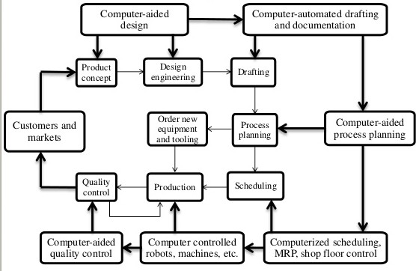

Fig: Product cycle with CAD/CAM

Device Drives

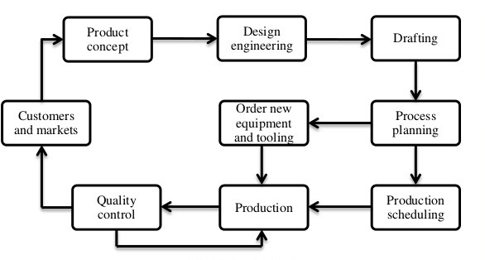

Fig: Product Cycle

# CAD STANDARDS

The following are the graphical input data which is used to improve the ‘CAD standards.

1. GKS-Graphical Kernal System.
2. PHIGS-Programmers Hierarchal Interface for graphic system.
3. IGES-Initial graphics exchange specifications.
4. DXF-Drawing exchange format.
5. STEP-Standard for the exchange of the product model data.
6. DMIS-Dimensional measurement interface specifications.
7. VDI-Virtual device interface.
8. VDM-Virtual device metaface.

# Example:

Graphics database



Graphic Functions

Device Drives

Applications of program

**DATA BASE MANAGEMENT SYSTEMS**

A DBMS is defined as the software that allows the access to use or modify data stored in database. The DBMS forms a layer of software between the physical databases as shown in figure. DBMS protects from the users abuse. It also shields users from having to deal with hardware level details by interpreting their input commands and request from the database.

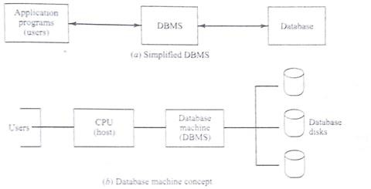

Fig: A typical database

ME, III B.TECH-I SEM (R20) COMPUTER AIDED DESIGN & MANUFACTURING



# COMPUTER GRAPHICS

**Computer Graphics**

Modern computer graphics display simple in construction. It consists of three main components.

1. Monitor.
2. Digital memory.
3. Display Controller.
4. **Monitor.** Computer graphics displays with the help of CRT, which is in the matrix of discrete cells which is in bright color.

On the screen there is a series of points or dots is known as “point plotting device or pixel”.

**Monitor**

**Digital**

**Memory**

**Display**

**Controller**

Fig: Computer graphics system

1. **Digital Memory.** It is also known as frame buffer. A frame buffer (frame buffer, or sometimes frame store) is a portion of RAM containing a bitmap that drives a video display. In computing, a screen buffer is a part of **computer memory** used by a **computer** application for the representation of the content to be shown on the **computer** display.
2. **Display Controller.** The display controller the refresh rate is in the number of complete images of frames scanned per second. The refreshing rate is 1/60 images or frames per second. These display controllers are very expensive when compared to frame buffer and monitor.

# GRAPHIC PRIMITIVES or GRAPHIC ENTITIES

A drawing is created by assembly of points, lines, arcs and circles. In computer graphics drawing are prepared by using CAD software. Each of the tools are called as “Entities”.

The drawing entities are given below.

1. Point
2. Line
3. Construction of line, polyline,
4. Circle
5. Spline
6. Arc
7. Ellipse
8. Polygon
9. Rectangle

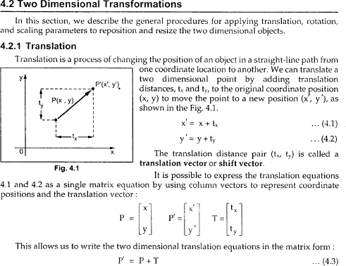

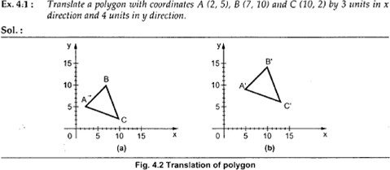

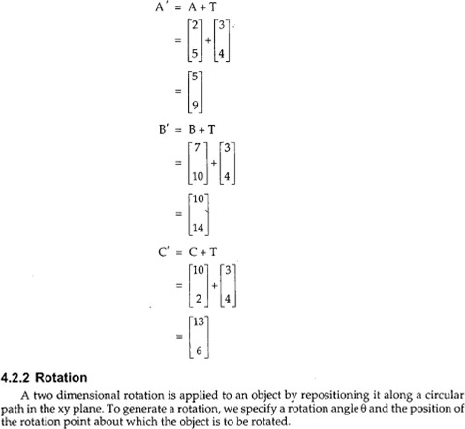

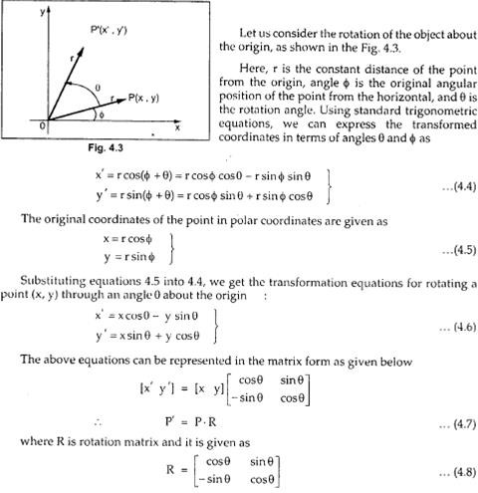

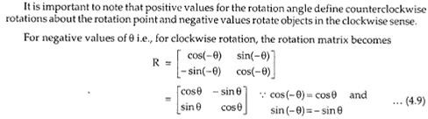

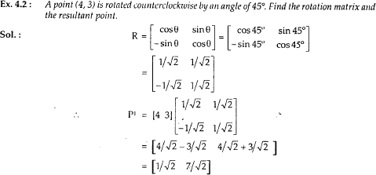

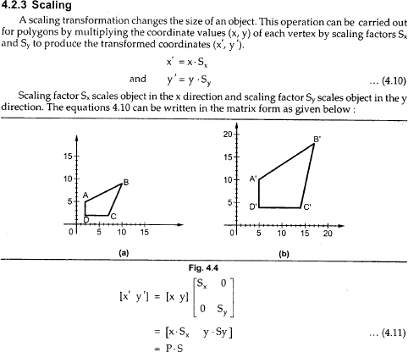

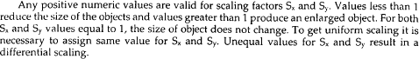

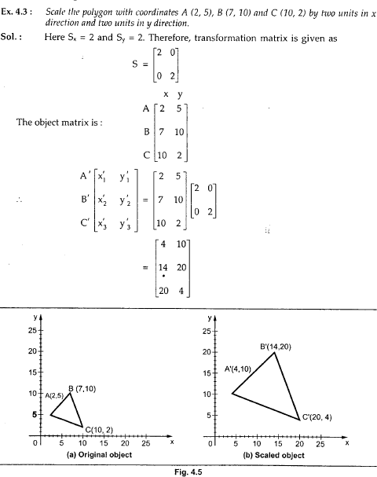



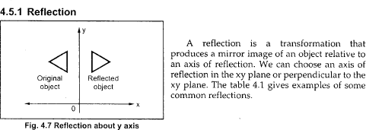

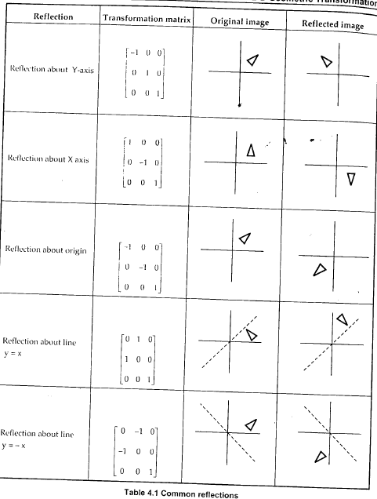

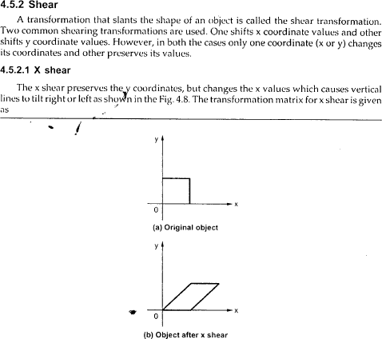

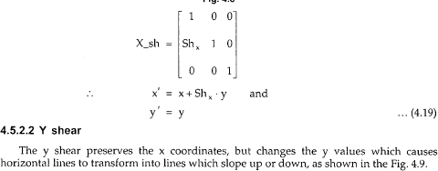

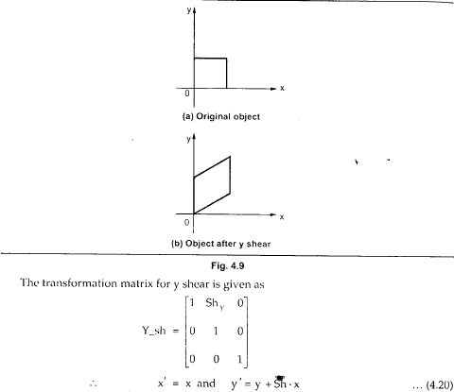

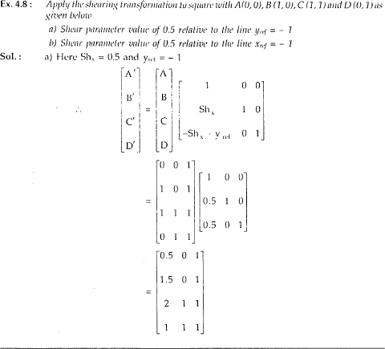

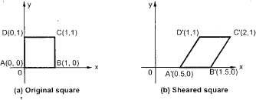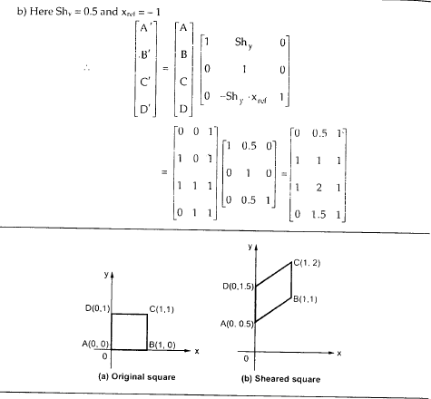

# HOMOGENOUS CO-ORDINATES

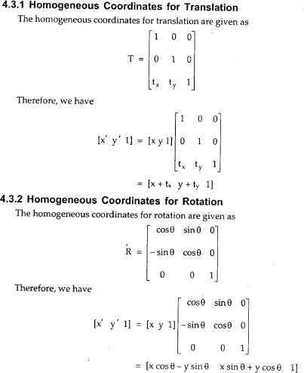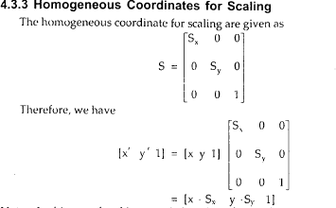

**3D TRANSFORMATIONS**

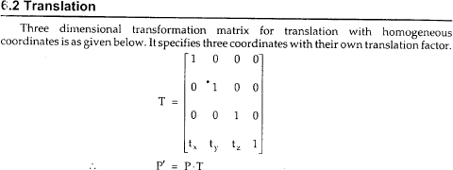

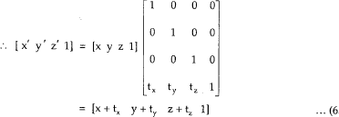

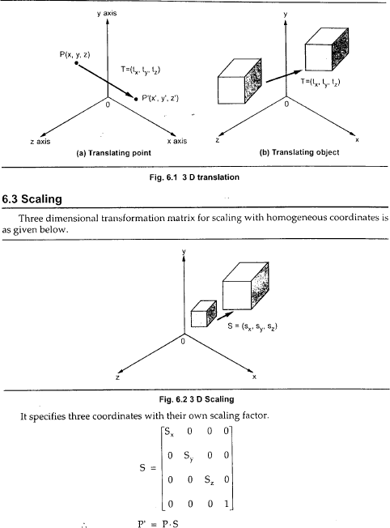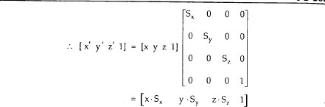

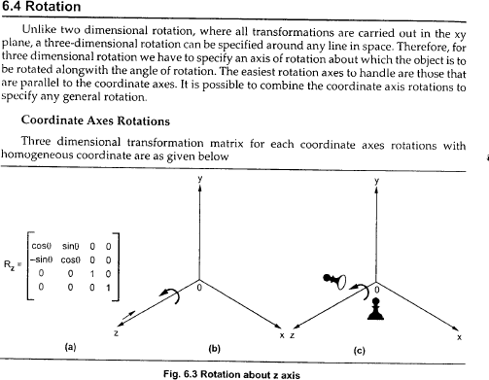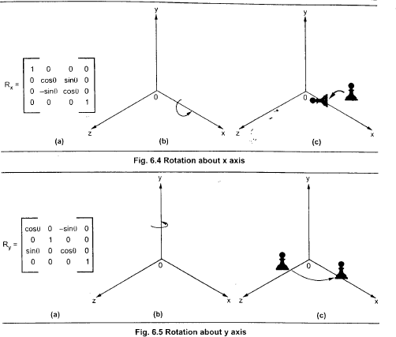

# CLIPPING

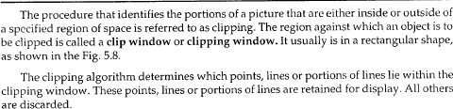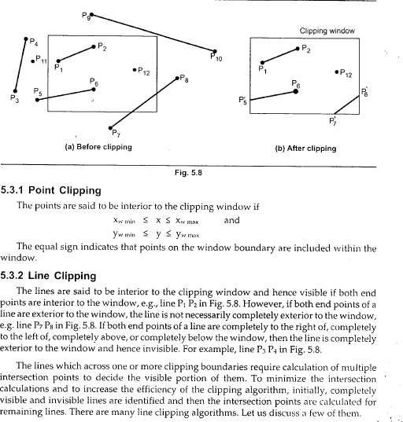

**COHEN-SOUTHERLAND ALGORITHM**

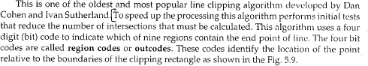

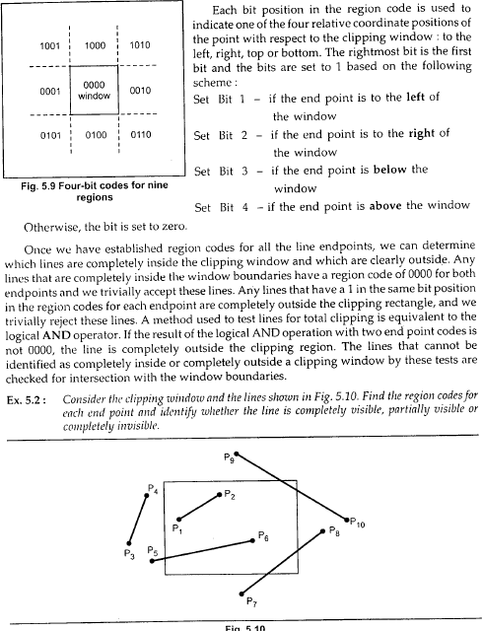

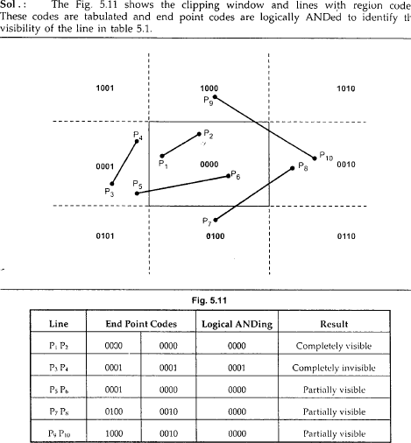

# UNIT-II

**Parametric and Non-Parametric Representation of Curves**

* Parameters can be driven by dimensional values which are called as “geometry “and it is used to change the length, width and height in a 3D co-ordinates system is known as parameter.
* Parametric representation are given below
  1. Line 4. Polyline
  2. Ellipse 5. circle
  3. Are 6. Polygon
* Non – parametric representations are given below

1. Bezier curves
2. B-spline curves
3. Hermit curves
4. Cubic spline curves

The above mentioned curves are known as “synthetic curves”

# Geometric Modelling

Geometric modeling is defined as the representation of the geometry of a component using software is known as “geometric modeling “.

# Types of Geometric Modeling.

Geometric modeling is of three types. They are

1. Wire frame modeling
2. Surface modeling
3. Solid modeling

# WIRE FRAME MODELING

1. In wire frame modeling the object is represented by its edges.
2. In the initial stages of “CAD” wire frame models. are 2D-model.
3. Later the software has introduced wire frame model of a box and it is represented as 3D-model

ME, III B.TECH-I SEM (R20) COMPUTER AIDED DESIGN & MANUFACTURING



1. Complex parts of wire frame model can be identified as visible of a model and invisible edges are eliminated.
2. Wire frame modeling is used to draw the plan, elevation and side view of the object.

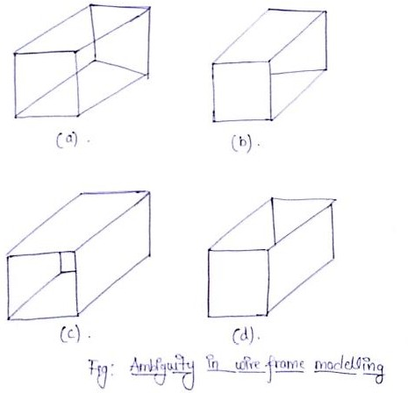

# Advantages Of Wire Frame Modeling :-

1. It is simple to construct.
2. It does not require much computer time and memory as much as surface (or) solid modeling
3. As a natural extension of drafting. it does not require extensive training to users.
4. Most of the surface models require wire frame entire (such as points, linear, and wires).

# Disadvantages:-

1. The input time is substantial and increases rapidly with the complexity of the object.

ME, III B.TECH-I SEM (R20) COMPUTER AIDED DESIGN & MANUFACTURING



1. Both topological and geometrical data is needed in wire frame modeling.

# Surface Modeling:-

* In surface modeling a component is represented by its surface, in which it is represented by its vertices and edges is known as surface modeling.
* For example eight surfaces are kept together to create a box as shown in figure.
* Surface modeling is very popular in aerospace design and automotive design.
* Surface modeling is particularly used in development of automobile panels and complex double curved shapes of aerospace structure used to prepare dies and moulds.
* Ex:-box, pyramid, sphere, cone, torus and mesh.
* Meshing is created by using NURBS technique. (Non- uniform rational B- sp line).

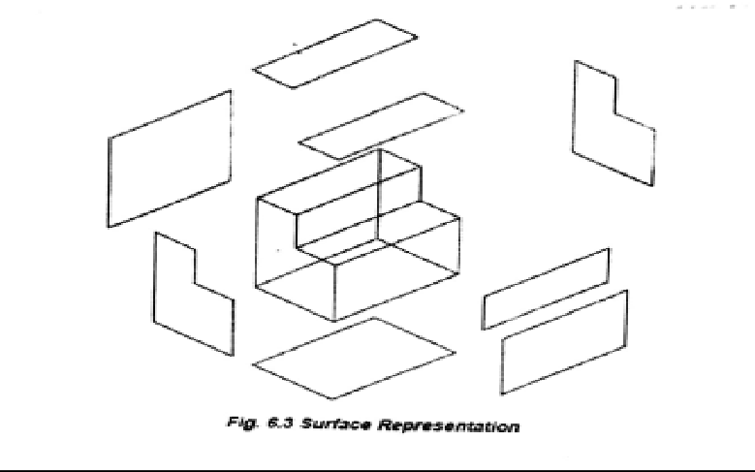

# Advantages:-

1. It is less ambiguous.
2. Complex surface can be easily identified.
3. It improves hidden line and adds realistic.

ME, III B.TECH-I SEM (R20) COMPUTER AIDED DESIGN & MANUFACTURING



# Disadvantages:-

1. Difficult to construct.
2. Difficult to calculate mass property.
3. More time is required for creation.
4. Require high storage space when compared to wire frame modeling.
5. Also requires more time for modifications.

# Solid Modeling :-

It is a modeling that provides a complete representation of an object than a wire frame and surface modeling in this model, the appearance of an object is displayed in solid design.

There are six common representation are used in solid modeling are

## Spatical enumeration :-

It is the simplest form of 3D volumetric raster model, a section of 3D space is described by a matrix of evenly spaced cubic volume elements called as voxels.

## Cell decomposition:-

This is a hierarchical adaptation of spatial enumeration 3D space is sub divided in to cells. Cells could be of different sizes. The simple cells are grouped together to describe a solid object.

## Boundary representation :-

Solid is represented by its boundary which consists of a set of faces, a set of edges and set of vertices.

## Sweeping:-

It Is a technique a plauar shape is moved along a curve. Translational sweep can be used to create prismatic objects and rotational sweep could be used for ax symmetric components.

ME, III B.TECH-I SEM (R20) COMPUTER AIDED DESIGN & MANUFACTURING



## Primitive instances:-

This modeling scheme provides a set of possible objects shapes which are described by a set of parameters. Instances of object shape can be created by varying these parameters.

## Constructive solid geometry(CSG):-

Primitive instances are combined using Boolean set of operations to create complex objects.

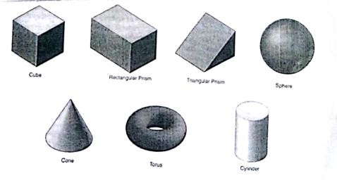

# Fig: Representation of solid modeling

**Advantages :-**

1. Complex modeling can be done easily.
2. Unambiguous.
3. Best suitable for calculating mass properties.
4. Very much suitable for automated applications.
5. Fast creation.
6. Gives huge information.

# Disadvantages :-

* 1. Requires large memory.
  2. Slow manipulation.
  3. Some manipulations can be complex and requires slow procedure.

ME, III B.TECH-I SEM (R20) COMPUTER AIDED DESIGN & MANUFACTURING



# CONSTRUCTIVE SOLID GEOMETRY(CSG) :-

In case model physical models are created by combining basic elementary shapes know as primitive like blocks, cylinders, cones, pyramids and spheres. The Boolean operations like union (U), DIFFERENCE (-) and intersection (n) are used carry out this task.

For example, let us assume two primitives, a black and a cylinder which are located in a space

“A union “operation (AUB) will combine the two to convert tm into a new solid

The difference operation (A-B) will create a block with a hope

An intersection operation (A^B) will yield the portion common to the two primitives.

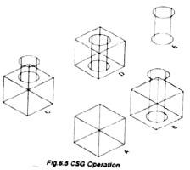

ME, III B.TECH-I SEM (R20) COMPUTER AIDED DESIGN & MANUFACTURING



# Surface Entities

* Analytic entities include:
  + 1. Plane surface ,
    2. Ruled surface
    3. Surface of revolution , and
    4. Tabulated cylinder.
* Synthetic entities include

1. Hermit cubic spline surface.
2. B-spline surface,
3. Bezier surface, and
4. Coons patch.

# Types of Surfaces:

1. **Plane surface***:*

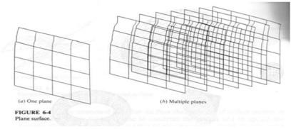This is the simplest surface . it required three non coincident points to define an infinite plane

# Ruled(lofted)surface.

This is a linear surface. It interpolates linearly between two boundary curves that define the surfaces.

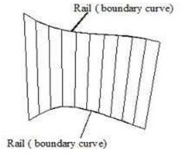

ME, III B.TECH-I SEM (R20) COMPUTER AIDED DESIGN & MANUFACTURING



# Surface of revolution.

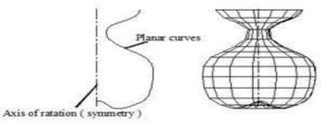This is an axis symmetric surface that can mould axis symmetric objects it is generated by rotating a plane wire frame entity in space about the axis of symmetry a certain angle.

# Tabulated cylinder.

This is a surface generated by translating a plane curve a certain distance along a specified direction (axis of cylinder)

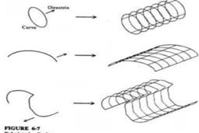

# Bezier curves

Curves used in geometric modeling are obtained through either interpolation techniques or approximation techniques the curves generated by interpolation techniques ,pass through given or specified data points ,whereas ,the curves generated by approximation techniques does not passes through the specified set of date points .

Bezier curves are different from interpolation cubic splines in the following aspects,

1. Specified data points only can control the shape of Bezier curve. In cubic splines 1st order derivative are used to define the Bezier curve, while in Bezier curve they are not used which enables improved relation between data points and curves.

ME, III B.TECH-I SEM (R20) COMPUTER AIDED DESIGN & MANUFACTURING



1. The degree of Bezier curve varies with the number of data points, whereas the degree of cubic spline is always constant
2. Bezier curve is smoother comparatively, due to its higher order derivatives.

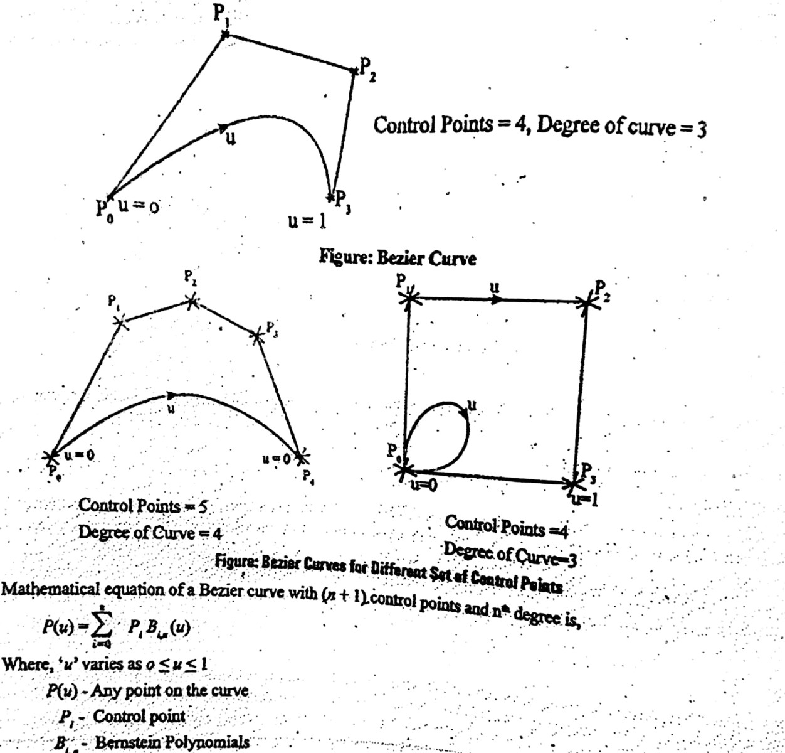

# B-Spline Curves

* + B-spline curves provide another effective method bezeir of generating curves define by data points
  + They provide local control of the curve shape as opposed to global control by using blending functions which provide influence.

ME, III B.TECH-I SEM (R20) COMPUTER AIDED DESIGN & MANUFACTURING



* + Control points sometimes called deboor points.
  + The selected set of sub interval end points u is referred as a knot vector.

This is a surface that can approximate or interpolate given input data. It is a general surface like the Bezier surface but with the advantages of permitting local control of the surface.

# Characteristics of the B-spline curves

* 1. The local control of the curve can be obtained by changing the position of a control point
  2. The B-spline curves do not pass through the first and last control points except when the linear blending functions are used.
  3. B-spline allow us to vary the number of control points used to a design a curve without changing the degree of polynomial.
  4. The B-spline curve becomes a Bezier curve if K equals the number of control points(n+1)
  5. Multiple control points results the region of high curvature of B- spline curve
  6. The number of degree of curve increase the curve tightness if the degree of curve is less the control points will be closer.
  7. As the degree of curve increases, it is more difficult to control and calculate accurately. Thus, a cubic B-spline curve is sufficient for many applications.

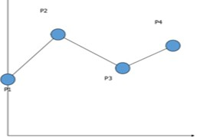

# Fig: Linear Interpolation Spline

ME, III B.TECH-I SEM (R20) COMPUTER AIDED DESIGN & MANUFACTURING



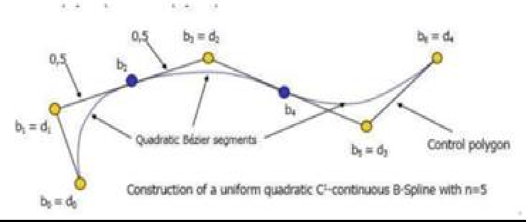

# Fig: Quadratic Interpolation Spline

**Benefits of B-spline curves**

* User define degree
* Independent of the number of controls points
* Produces a single piecewise curve of a particular degree
* No need to stitch together separate curves at junction points
* Continuity comes for free

# Hermite curve

* Hermite curve ia a type of cubic spline described by French mathematician Charles hermite
* Splines are functions which are used to fit a curve through a number of data points
* Hermite cubic spline is the interpolation curve
* Cubic polygon has 4 coefficients and 4 conditions evaluated.
* Hermite cubic splines using two data points at its ends and two tangents vector at these points.

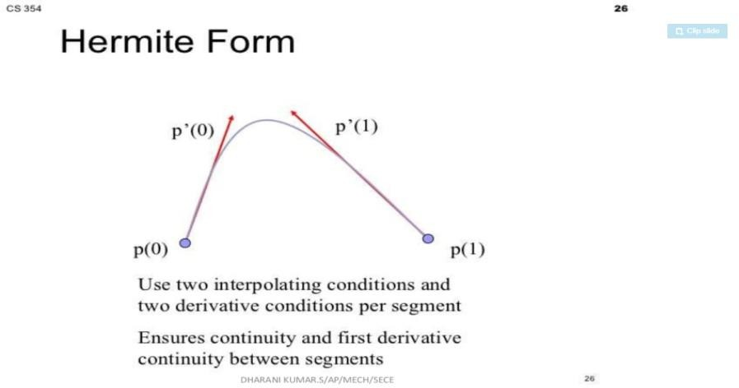

ME, III B.TECH-I SEM (RG22) COMPUTER AIDED DESIGN & MANUFACTURING



# Disadvantages :

* It is not used very popular due to the need for tangent vectors or slopes to define the curve.
* For example changing the position of data points or end slopes change the entire shape of the spline .which does not provide the initiative feel required for design.

# Hermite bi- cubic surface

* + This 3-D surface is generated by interpolation of 4 end points . bi-linear surfaces are very useful in finite element analysis
  + A mechanical structure is discretised into elements which are generated by interpolation 4 nodes points to form a 2-D solid element.
  + It can have C0 and the same direction of the tangent vector C1 continuity across the common edges between the 2 patches.

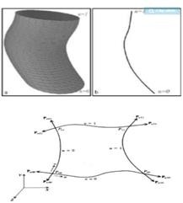

# Fig: Hermit bicubic surface

ME, III B.TECH-I SEM (R20) COMPUTER AIDED DESIGN & MANUFACTURING



# Coons patch

* + Coons patch or surface is generated by the interpolation of 4 edges curves
  + These types of surfaces can be used to form connecting surfaces between two given surfaces, and thus are used in CAD/CAM system to blend two cylinders – from an elbow joints.
  + Interpolation of 4 curves.

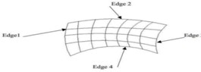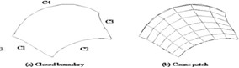

# Advantages and disadvantages:-

* Coon patch is particularly useful in blending four prescribed intersecting curves which form a closed boundary.
* The two ruled surfaces connecting the two pairs of boundary curves might satisfy the boundary curve conditions and products the coons patch.
* Main drawback of the bilinear of the bilinear blinded coons patch’s it only provides c0 continuity between adjacent patches even if there curves from a c1 continuity network.

ME, III B.TECH-I SEM (R20) COMPUTER AIDED DESIGN & MANUFACTURING



# UNIT-III

**NUMERICAL CONTROL (NC):**

Numerical control can be defined as a form of programmable automation in which the process is controlled by numbers, letters and special character symbols.

NC technology has been widely used in the operations, including drafting, assembly, inspection, sheet metal process and spot welding.

# NC MODES (OR) COMPONENTS OF NC SYSTEM:

There are three components of NC system. They are

1. Program of instructions.
2. Controller unit also called as Machine control unit.
3. Machine tool (or) control process.

# Program of Instructions:

The program of instructions is the detailed step by step set of directions which tell the machine to do sequence of operations. It is coded in numerical or symbolic form on some type of input medium that can be performed by the controller unit. The common input for program of instructions is punched in 1 inch wide. This is also known as “Manual data input”.

# Controller Unit

The second basic component of the NC system is the controller unit. It consists of the electronics and hardware that read and interpret the program of instructions and convert into mechanical actions of the machine tool.

The typical elements of conventional NC control unit are

* 1. Tape Reader
  2. Data buffer
  3. Feedback channels from the machine tool.

ME, III B.TECH-I SEM (R20) COMPUTER AIDED DESIGN & MANUFACTURING



* 1. Sequence control to coordinate the overall operation.
  2. Sequence controls to coordinate the overall operation
     + Tape Reader is an electromechanical device for winding and reading the punched tape containing the programs of instructions. The data contained on the tape are read into the data buffer. The purpose of this device is to store the input instructions in logical blocks of information.
     + The signal output channels are connected to the servo motors and other controls in the machine tool. The instructions are sent to the machine from the controller unit.
     + Sequence controls coordinate the activities of the other elements of the controller unit. The tape reader is actuated to read the data into the buffer from the tape, signals are sent to and from the machine tool.

# Machine Tool:

The third basic component of an NC system is the machine tool (or) other controlled process. It is the part of the NC system which performs useful work. It is used to perform the operations; the machine tool consists of the spindles as well as the motors and controls necessary to drive them.

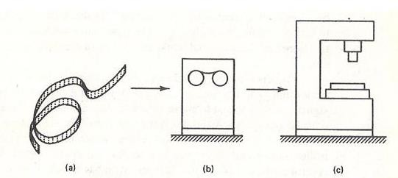

(a)Program of Instructions (b) Controller unit (c) Machine Tool

ME, III B.TECH-I SEM (R20) COMPUTER AIDED DESIGN & MANUFACTURING



# NC PROCEDURE

The NC procedure is given below

* 1. Process planning
  2. Part programming
  3. Tape preparation
  4. Tape verification
  5. Production

# Process planning

The engineering drawing of the work part must be interpreted in terms of manufacturing process to be used. Thus the process pans are prepared in different forms of route sheets. The route sheet is a listing the sequence of operations which must be performed on the one or more NC machines.

# Part programming

The part programmer plans the process for the portions of the job to be accomplished by NC part programmers must have knowledge on the machine process and they have been trained to program for numerical control.

There are two ways to program for NC

* 1. Manual programming.
  2. Computer assisted part programming:
     + In Manual Part programming, the machining instructions are prepared on a form called as Part program manuscript.
     + In computer assisted part programming, the computational work is converted into the computer. This is to machine the computer work piece geometries and jobs with many machining steps.

# Tape preparation

* + - A punched tape is prepared directly from the part programmer NC process plan.
    - In Manual part programming, the punched tape is prepared directly from the part program manuscript on a typewriter like device equipped with tape punching capability.
    - In computer assisted part programming, necessary calculations to convert this into a detailed set of machine tool motion commands, and then controls a tape punch device to prepare the tape for the specific NC machine.

# Tape verification:

After the punched tape has been prepared, a method is usually prepared for checking the accuracy of the tape. Sometimes the tape is checked by running it through a computer program which plots the various tool movements on a paper.

# Production:

The final step in the NC procedure to use the NC tape in production. This involves ordering the raw work parts specifying and preparing the tooling and any way fixturing may be required and setting up. The machine tool operates function during the production is to load the raw material is to be cutting relative to the work piece.

# NC COORDINATE SYSTEMS

Two axes x and y, are defined in the plane of the table, as shown in figure. The z-axis is perpendicular to this plane and movement in the z- direction is controlled by the vertical motion of the spindle. The positive and negative direction of motion of tool relative to the table along these axes as shown in figure.

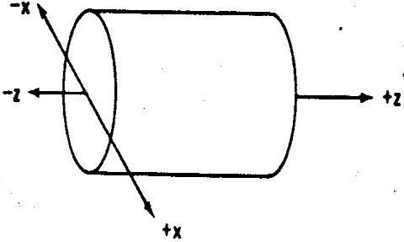

# Fig: Machine tool axes for turning

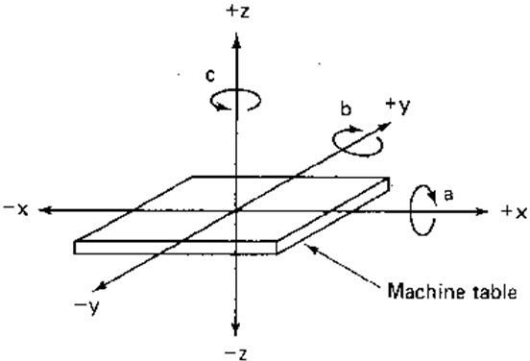

**Fig: Machine tool axes for milling**

For turning operations, two axes all that are required to command the movement of the tool relative to the rotating work piece. The z-axis is the axis of rotation of the work part and x-axis define the radial location of the cutting tool.

# Fixed zero and floating zero

The programmer must determine the position of the tool relative to the origin(zero point) of the coordinate system NC machine have either of two methods specifying the zero point. The first possibility of the machine as fixed zero.

The second and most common feature on NC machine allows the machine operates to set the zero point at any position on the machine table. This feature is known as floating zero.

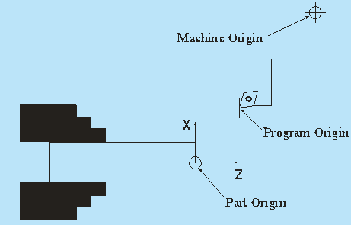

# Fig: Fixed zero & Floating zero

The location of zero point is communicated to the machine operator. At the beginning of the job, the operator moves the tool under manual control to some target point on the table. The target point is some convenient place on the work piece (or) table for the operator to position the tool.

# Absolute Positioning and Incremental Position

The part programmer is to use either an absolute system of tool positioning is known as incremental system.

Absolute positioning means that the tool locations are always defined in relation to the zero point.

# Example:

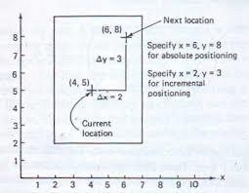

If the hole is drilled at a spot is to 8 inches above the axis and 6 inches to the right of the y-axis, the coordinate location of the hole would be specified as X=+6.000 and y=+8.000.

The incremental position of the next tool must be defined with reference to the previous location. The position of x=+4.000 and y==5.000.

# NC MOTOIN CONTROL SYSTEMS:

In NC, there are three basic types of motion constant system. They

are

1. Point to point
2. Straight cut
3. Contouring

# Point to point

Point to point (PTP) is also called a positioning system. In PTP, the objective of the machine tool control system is to move the cutting tool to a predefined location. The speed or path by which this movement is accomplished not import in point to point NC. Once the tool reaches the desired location, the machining operation is performed at that position.

NC drill presser is good example of PTP systems. The spindle must first be positioned at a particular location on the work piece. This is done under PTP control. Then drilling of a hole is performed at the location, since no cutting is performed between hole, there is no need for controlling the relative motion of the tool and work piece between hole locations.

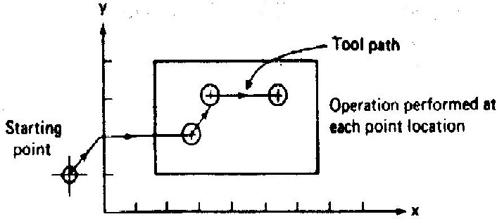

# Fig: Point to Point NC System

1. **Straight Cut NC**

Straight cut NC systems are capable of moving the cutting tool parallel to one of the major axes at a controlled rate suitable for machining. It is therefore appropriate for performing milling operations to fabricate work pieces of rectangular configurations. With this type of NC system it is not possible to combine movements in more than a single axis direction. In NC machine capable of PTP movements.

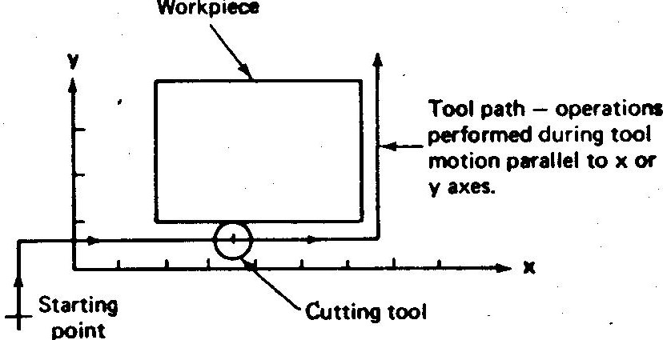

Fig: Straight Cut NC System

# Contouring NC

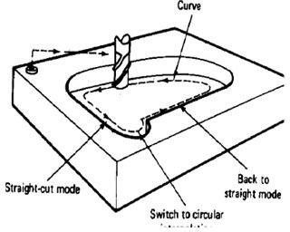Contouring is the most complex, the most flexible and most expensive type of machine tool control. It is capable of performing both PTP and straight cut operation. The contouring systems are also called contouring path NC systems.

Fig: Contouring NC System

# Applications of Numerical Control

NC equipment has been built to perform virtually the entire range of material removal process. They are

1. Milling
2. Drilling
3. Boring
4. Turning
5. Grinding
6. Sawing

In addition to metal machining, NC has been applied to a variety of other applications.

1. Welding machines 6.Plasma arc welding
2. Automatic drafting 7.Laser beam process
3. Assembly machines 8.Cloth cutting
4. Tube bending 9.Riveting
5. Flame cutting 10.Wire Wrap machines

# NC Machining Centre’s

The machining centre’s are of three types. They are

* 1. Horizontal machining centre
  2. Vertical machining centre
  3. Universal machining centre

# Horizontal machining centre

It is machining centre with its spindle in a horizontal orientation. This machining centre design favors uninterrupted production work. It encourages the chips to fall away from the NC machine. So we do not clear from the table.

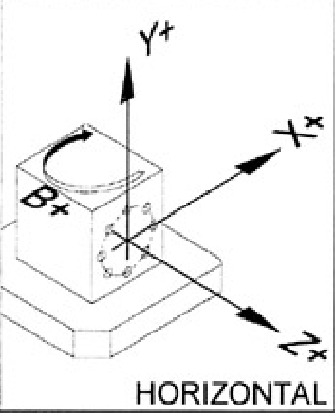

Fig: Horizontal machining centre

ME, III B.TECH-I SEM (R20) COMPUTER AIDED DESIGN & MANUFACTURING



# Vertical machining centre

It is also known as milling, relief on rotary cutters to remove metal from a work piece. It occurs on vertical machining centre which employs the spindle in vertical orientation.

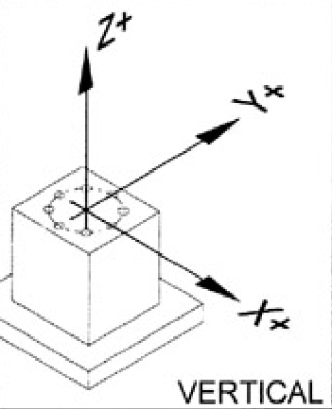

Fig: Vertical machining centre

# Universal machining centre

These are similar to the horizontal machining centres but the spindle axis capable of tilting from the horizontal position to the vertical position continuously under computer control.

The machine centre consists of 5 or more axis. Such machines facilitates access at the top surface on work piece mounted on a horizontal machining centre so that all the five sides of a component can be machined in a single setup.

# ADVANTAGES OF NC:

1. **Reduced nonproductive time**

It accomplishes by means of fewer steps, less time, reduced work handling time, automatic tool changer on some machines

# Reduced fixturing

NC requires fixture which are simpler and less costly to fabricate because the positioning is done by NC tape rather than the figure or fixture.

ME, III B.TECH-I SEM (R20) COMPUTER AIDED DESIGN & MANUFACTURING



# Reduced manufacturing lead time

The jobs can be set up more quickly with NC and fewer steps are generally required with NC, the lead time to deliver a job to the customer is reduced.

# Greater manufacturing flexibility

With NC it is less difficult to adopt the design changer alternations of the production schedule, changeovers in jobs for rush orders.

# Improved quality control

NC is deal for complicated work parts where the chance of human mistakes is high. NC producer parts with greater accuracy, reduced scrap.

# Reduced Inventory

The shorter lead time with NC, the amount of inventory carried by the company is reduced. Reduced floor space requirements.

# DEFINITION AND FEATURE OF CNC

**Computer Numerical Control (CNC)**

CNC refers to a computer that is joined to the NC machine to make the machine versatile .information can be stored in a memory bank. The program is read from a storage medium such as the punched tape and retrieved to the memory of the CNC computer. Some CNC machines have a magnetic medium for storing program. This gives more flexibility for editing or saving CNC programs.

# Advantages of CNC

* 1. Increased productivity.
  2. High accuracy and repeatability.
  3. Reduced production costs.
  4. Reduced indirect operating cost.
  5. Facilitation of complex machining operation.
  6. Greater flexibility.
  7. Improved production planning and control.
  8. Lower operator skill requirement.
  9. Facilitation of flexible automation.

ME, III B.TECH-I SEM (R20) COMPUTER AIDED DESIGN & MANUFACTURING



**Machine tool**

# Limitations of CNC

1. High initial investment.
2. High maintenance requirement.
3. Non cost-effect for low production cost.

**Magnetic Tape**

**Or disk tape or**

**Tape reader**

**Miscellaneous controls**

Fig: Computer Numerical Control

**Paper tape punch**

**CNC**

**Controller**

**Axis and Spindle Speed**

# Features of CNC

Computer NC systems include additional features beyond what is feasible with conventional hard-wired NC. These features, many of which are standard on most CNC control units (MCU), include the following;- ***1.Storage of more than one part program***

With improvements in computer storage technology, newer CNC controllers have sufficient capacity to store multiple programs. Controller manufacturers generally offer one more memory expansions as options to the MCU.

## Various forms of program input

Whereas conventional (hard-wired) MCUs are limited to punched tape as the input medium for entering part programs, CNC controllers generally possess multiple data entry capabilities such as punched tape,

ME, III B.TECH-I SEM (R20) COMPUTER AIDED DESIGN & MANUFACTURING



magnetic tape, floppy diskettes, RS232 communication with external computers, and manual data input.

1. ***Program editing at the machine tool***

CNC permits a part program to be edited while it resides in the MCU computer memory. Hence, a part program can be tested and corrected entirely at the machine site, rather than being returned to the programming office for corrections.

# Fixed cycles and programming subroutines

The increased memory capacity and the ability to program the control computer provide the opportunity to store frequently used machining cycles as macros that can be called by the part program.

# Interpolation

Some of the interpolation schemes are normally executed only on a CNC system because of computational requirements. Linear and circular interpolations are sometimes hard-wired into the control unit, but helical parabolic and cubic interpolations are usually executed by a stored program algorithm

# Cutter length and size compensation

In older style controls, cutter dimensions had to be set precisely to agree with the tool path defined in the part program. Alternative methods for ensuring accurate tool path definition have been incorporated into the CNC controls. One method involves manually entering the actual tool dimensions into the MCU. These actual dimensions may differ from those originally programmed.

# Acceleration and deceleration calculations

This feature is applicable, when the cutter moves at high feed rates. It is designed to avoid tool marks on the work surface that would be generated due to machine tool dynamics when the cutter path changes are the feed rate is smoothly decelerated in anticipation of a tool path change and then accelerated back up to the programmed feed rate after the direction change.

ME, III B.TECH-I SEM (R20) COMPUTER AIDED DESIGN & MANUFACTURING



# Communications interface

This is useful for various applications, such as

1. Downloading part programs from a central data file;
2. Collecting operational data such as work piece counts, cycle times, and machine utilization.
3. Interfacing with peripheral equipment, such as robots that unload and load parts.

# Diagnostics

Many modern CNC systems possess a diagnostics capability that monitors certain aspects of the machine tool to detect malfunctions or signs of impending malfunctions or to diagnose system breakdowns.

# TYPES OF CNC

1 Hybrid CNC

2. Straight- CNC.

# 1 Hybrid CNC

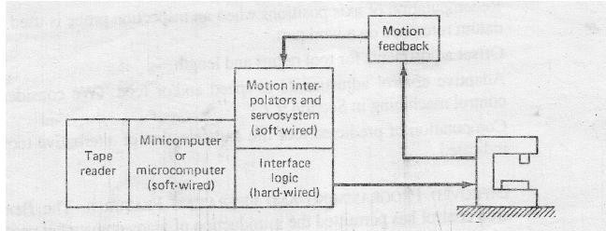The controller consents of soft wired computer and hard wired logical circuits. The hard wired components are used to perform the functions like feed rate and circular interpolation.

Fig: Hybrid CNC

# 2. Straight- CNC.

The straight CNC systems user a computer to perform all the NC functions. The only hard –wired elements are those required to Interface the computer with the M/C tool it performs the interpolation, tool position feedback and other functions by software.

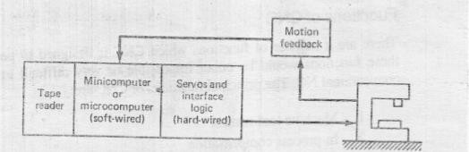

Fig: Straight CNC

# DIRECT NUMERICAL CONTROL (DNC)

It can be defined as a manufacturing system in which a number of machines are controlled by a computer through direct connection and real time. In the place of tape recorder the telecommunication lines are used to send input medium to machine tool. The part program is transmitted to the machine directly to the computer memory.

# COMPONENTS OF A DNC SYSTEM

It consists of four main components.

1. Central computer
2. Bulk memory which stores the NC part programming
3. Telecommunication lines
4. Direct numerical control machine is as shown in figure.

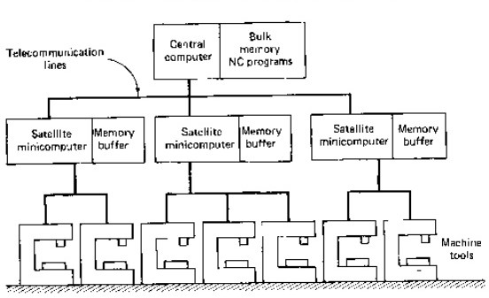

Fig: DNC with satellite minicomputer

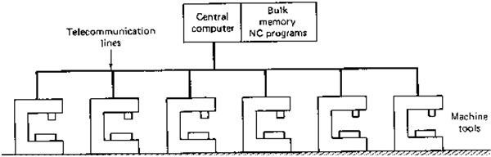

Fig: Direct numerical control without satellite computer

# TYPES OF DNC SYSTEMS

There are two types of DNC systems. They are

1. Behind the Tape Recorder (BTR) System
2. Special Machine Control Unit (MCU)

# BEHIND THE TAPE RECORDER (BTR) SYSTEM:

The computer is directly linked to the regular NC controller unit. The tape recorder is replaced with telecommunication lines to the DNC computer. The connection with the computer is made between the tape reader and controller unit.

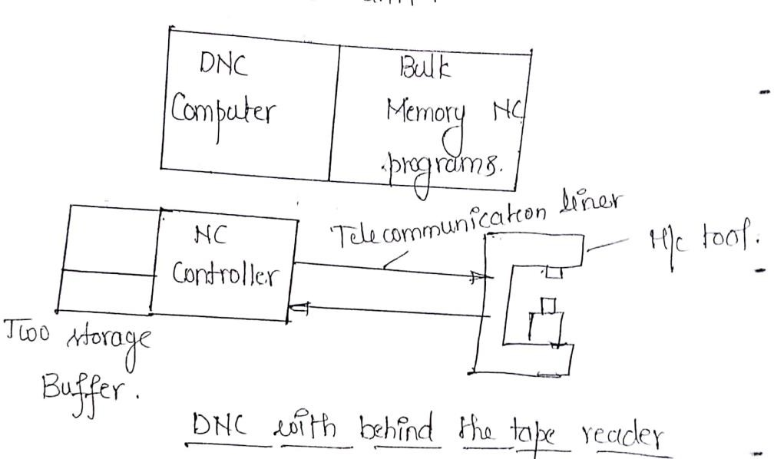

# SPECIAL MACHINE CONTROL UNIT (MCU):

In DNC, to eliminate the regular NC controller altogether and it replace by a special machine control unit. It a device is used to make communication between the machine to and computer.

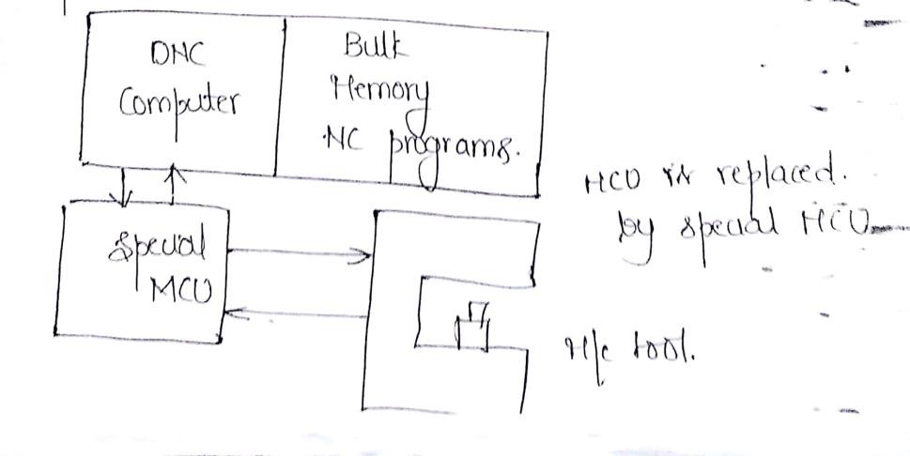

Fig: Special Machine Control unit

# ADVANTAGES OF DNC

* 1. Elimination of punched taper and tape recorders.
  2. Greater computational capability and flexibility.
  3. Convenient storage of NC part programs in file location
  4. Programs stored as CLFILE.
  5. Reporting of shop performance.
  6. Establisher the frame work for the evolution of future computer.

# ADAPTIVE CONTROL MACHING SYSTEMS

By using numerical (including DNC and CNC) is that NC reducer the non-productive time is machining operation. By using adaptive control, the following can be achieved work piece handling time, setup the job tool changer, machine delay etc.,

Where as in numerical control guides the sequence of operations (or) path of the machine tool during machining adaptive control determines the proper speeds and feeds during machining or a function of variation such as work material hardness, depth of cut, air gaps in part geometry etc;

# TWO TYPES OF ADAPTIVE CONTROL

1. Adaptive control optimization (ACU)
2. Adaptive control constraint (ACC).

# ADAPTIVE CONTROL OPTIMIZATION

In this form of adaptive control, an index of performance is specified for the system. Performance index is a measure of overall process performance, such as production rate (or) cost per volume of metal removed. The objective of adaptive control is to optimize the inde of performance by manipulating the speed and feed of operation.

Index of performance IP = a function MRR/TWR MRR= Material removal rate.

TWR= Tool wear rate.

# ADAPTIVE CONTROL CONSTRAINTS

The systems developed for actual production were somewhat less sophisticated (and less expansive) than the research systems. The production of AC systems utilize the constraints limits imposed on certain measured process is known as adaptive control constraints (ACC) systems. The operation of ACC system by using APT is given below.

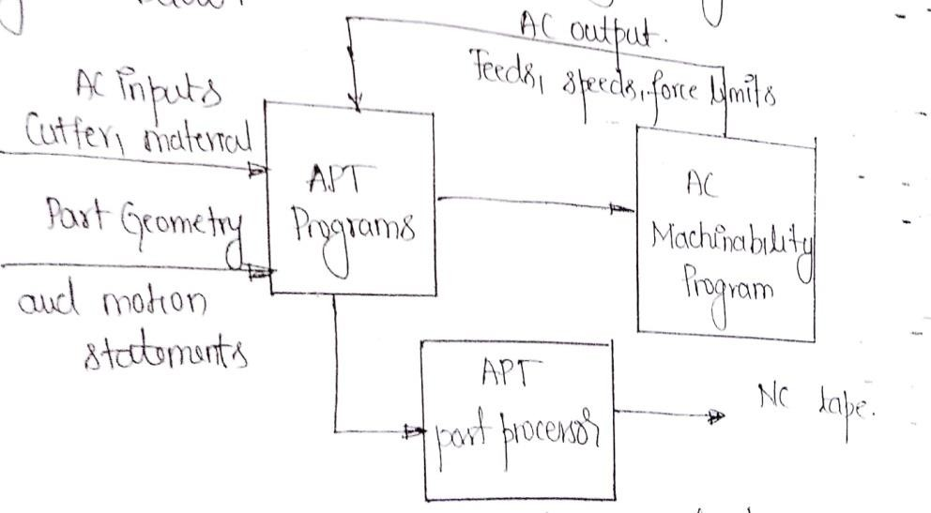

Fig: Adaptive control constraints

ME, III B.TECH-I SEM (R20) COMPUTER AIDED DESIGN & MANUFACTURING



# UNIT - IV

**CNC PART PROGRAMMING**

# NC WORDS

**Sequence Numbers :( N-Words (Or) Codes)**

This is used to identify the block.

# Preparatory Words :( G-Words (Or) Codes)

It is used to prepare the controller for instructions that are to follow. For example:

G02 is used to prepare the control unit for circular interpolation along an arc in the clock wise direction.

# COORDINATES(X, Y and Z Words)

It gives the coordinates positions of the tool. In a two axis system, only two of the words would be used. In a four (or) five axis machine, a words and v (or) b-words would specify the angular position.

# Feed Rate (F-Word)

This specifies the feed in a machining operation. Units are inch/min (or) mm/min.

# Cutting Speed(S-Word)

This specifies the cutting speed of the process, the rate at which spindle rotates.

# Tool Selection (T-Words)

It is needed only for machines with a tool turret (or) automatic tool changer. The T-words specifies the tool is to be used in the operation.

For example:

T05 drill bit in turret position 5 on a NC turret drill.

# Miscellaneous Function (M- Words)

The M-words is used to specify certain miscellaneous (or) auxiliary function which may be available on the machine tool

For example:

M03- Spindle starts rotation

ME, III B.TECH-I SEM (R20) COMPUTER AIDED DESIGN & MANUFACTURING



M05- Spindle stop M30- End of program

# PART PROGRAMING

There are two part programming are used in NC machines. They are

* 1. Manual part programming
  2. Computer assisted part programming

# MANUAL PART PROGRAMMING

To prepare a part program using manual method, the programmer writes the machining instruction on a special form called part programming manuscript. The manuscript is the hand written data driven by typist plotted in NC tape.

# For example:

The manuscript form will have two axis point-to-point drilling machine would be different that one for a three-axis contouring machine. The manuscript is a listening of the relative tool and work piece locations. It includes other data, such as preparatory coder, miscellaneous codes and speed/feed specifications, which are needed to prepare the machine under tape control.

Example:

|  |  |  |  |  |  |  |
| --- | --- | --- | --- | --- | --- | --- |
| Recommended speeds operation. | and | feeds | as | follows | as | for a given drilling |
| Speed (rpm) |  |  |  |  |  | Feed inch/min |
| 0.484 in-diameter drill 3.55 |  |  |  |  |  | 592 |
| 0.500 in-diameter drill 3.82 |  |  |  |  |  | 382 |

ME, III B.TECH-I SEM (R20) COMPUTER AIDED DESIGN & MANUFACTURING



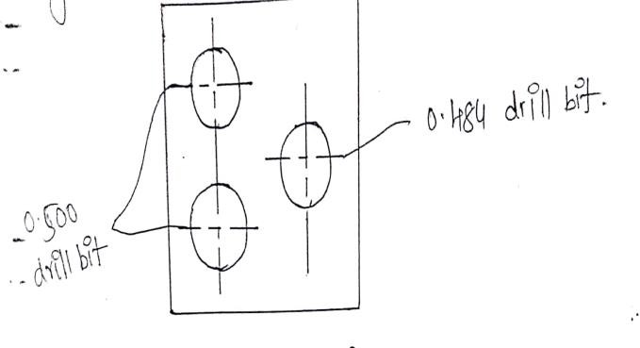

Fig: NC drill press

# COMPUTER ASSISTED PART PROGRAMMING

In computer-assisted part programming, the computational work is converted in to the computer. This is used to machine the complex work piece geometries and jobs with many machining steps. The results are more accurate and more efficient part program. In this programming, the part program given in magnetic tape, disc (or) floppy and pap tape to read the data and operator the machine tool.

The part programmer’s responsibility is two basic steps

* 1. Defining the work part geometry
  2. Specifying the sequence of operations and tool path.

# CUTTER RADIUS COMPENSATION

The actual tool path is different from the part outline because the tool path is defined as the path taken by the centre of thee cutter (or) machine tool. The purpose of cutter offset is to offset the tool path from desired part surface by the radius of cutter. This is known as **cutter radius compensation.**

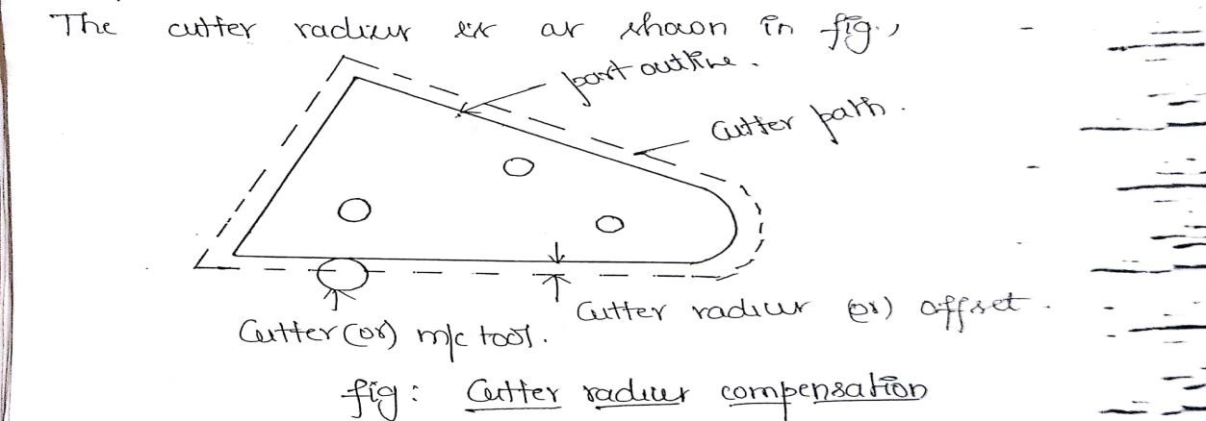

ME, III B.TECH-I SEM (R20) COMPUTER AIDED DESIGN & MANUFACTURING



# PART PROGRAMMING LANGUAGE

NC part programming language consists of a software package plus special rules, conventions and words. It purposes is to communicate the part geometry and tool motion information to the computer so the desired part program can be prepared. The NC part programming languages is given below.

1. APT (Automatically programmed tools)
2. ADAPT (Adaption of APT)
3. EXAPT (Extended subset of APT)
4. UNIAPT
5. SPILT (Sundstrand processing language internally translated)
6. PROMPT
7. CINTURN 2

The most commonly used NC part programming language is APT including its derivatives (ADAPT, EXAPT, UNIAPT etc ;).

# APT LANGUAGE

In APT language for computer assisted part programming. The APT is not only an NC language; it is also the computer program that performs the calculations to generate cutter positions based on APT statement.

APT is a 3D system that can be used to control up to five axes. We will limit three axes, x, y and z and rotational coordinates. APT can be used to control a variety of different machining operations, it cover only milling and drilling operations.

The four types of statements in APT language.

* 1. Geometry statements.
  2. Motion statements.
  3. Postprocessor statements.
  4. Auxiliary statements.

## GEOMETRY STATEMENTS:

It is used to define the geometric elements that comprise the work part. It is also known as definition statements.

ME, III B.TECH-I SEM (R20) COMPUTER AIDED DESIGN & MANUFACTURING



The general form of APT statement is P1=POINT /5.0,4.0,0.0

It is also used to define the LINE, PLANE and CIRCLE. L1= LINE/P1, P2

PL1= PLANE/P1, P4, P5 PL2=PLANE/P2, P1

C1= CIRCLE/ CENTER, P1, RADIUS, 5.0.

EXAMPLE: For the above given work is as shown in figure write an APT program to define the geometry.

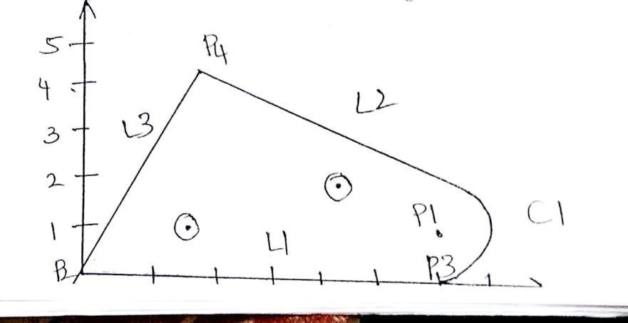

# PROGRAM USING APT:

P0= POINT/0,-1.0, 0

P1=POINT/6.0, 1.125, 0

P2=POINT/0, 0, 0

P3=POINT/6.0, 0, 0

P4=POINT/1.75, 4.5, 0 L1=LINE/P2, P3

C1=CIRCLE/CENTER, P1, RADIUS, 1.125 L2=LINE/P4, C1

L3=LINE/P2, P4 PL1=PLANE/P2, P3, P4

# MOTION STATEMENT:

It is used to describe the path by the cutting tool. The following commonly used to motion statements are:

GOTO/P1: Go to point p1

ME, III B.TECH-I SEM (R20) COMPUTER AIDED DESIGN & MANUFACTURING



FROM/TARG: From target point GOTO/P2: Go to point p2

GODLTA: It specifies the incremental move of the tool. Ex: GODLTA/2.0, 7.0, 0.0

Instructs the tool to move position 2 in x-direction 7 in y-direction and 0 in z-direction.

This command is used in drilling and related operations. If tool bar to change they use the command GOTO.

The contouring motions are given below.

# DRIVING SURFACE

This is the surface that guides the side of the cutter.

## PART SURFACE:

This is the surface on bottom cutter rider.

## 2. CHECK SURFACE

This is the surface that stops the movement of the tool in its current direction and its checks the forward movement of the tool.

The following are the motion commands are

1. GOLFT 4. GOBACK
2. GOFWD 5. GOUP
3. GORGT 6. GODOWN

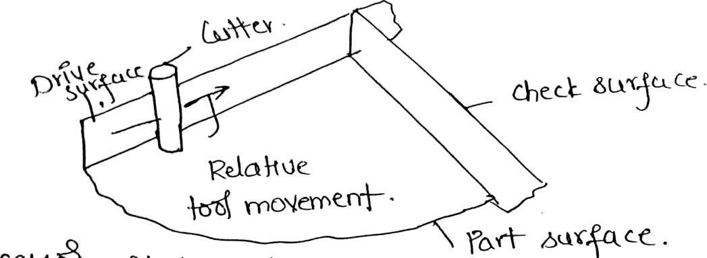

# POSTPROCESSOR STATEMENT:

The following are the post processor statements given below.

|  |  |  |
| --- | --- | --- |
| 1. COOLNT/ | 4.MACHIN/ | 7. TURRE/ |
| 2. RAPID | 5. END |  |
| 3. FEDRANT | 6. SPINDL |  |

ME, III B.TECH-I SEM (R20) COMPUTER AIDED DESIGN & MANUFACTURING



## AUXILARY STATEMENTS:

The following are the auxiliary statements given

below.

1. CLPRNT
2. CUTTER
3. FNI
4. INTOL/
5. OUTOL/
6. PARTNO/

# MACRO STATEMENT IN APT

The MACRO feature is similar to the sub routine in FORTRAN and other programming languages. It would be used where certain motion sequences would be repeated for several times within the program.

The purpose in using a MACRO subroutine is to reduce the total number of statements required in the APT program, thus making the job of the part programmer easier and in less time consuming.

The MACRO subroutine is defined by a statement of the following format.

Symbol=MACRO/parameter specification.

# M-CODES (MISCELLANEOUS FUNCTIONS)

|  |  |
| --- | --- |
| **M CODES** | **DESCRIPTION** |
| M00 | Program Stop |
| M01 | Original Stop |
| M02 | Program End |
| M03 | Spindle Rotation (C.W) |
| M04 | Spindle Rotation (A.C.W) |
| M05 | Spindle Stop |
| M06 | Tool change |
| M08 | Coolant ON |
| M09 | Coolant OFF |
| M10&M11 | Chuck Open & Close |
| M30 | Program Stop & rewind |

ME, III B.TECH-I SEM (R20) COMPUTER AIDED DESIGN & MANUFACTURING



# G-CODES (PREPARATORY CODES)

|  |  |
| --- | --- |
| **G-Codes** | **Functions** |
| G00 | Rapid Traverse (Positioning) |
| G01 | Linear Interpolation (Cutting Feed) |
| G02 | Circular Interpolation (C.W) |
| G03 | Circular Interpolation (A.C.W) |
| G04 | Dwell |
| G20 | Input in inch |
| G21 | Input in mm |
| G28 | Return to reference point |
| G40 | Tool Nose Radius compensation cancel |
| G41 | Tool Nose Radius compensation left |
| G42 | Tool Nose Radius compensation right |
| G70 | Finishing Cycle |
| G71 | Multiple turning cycle |
| G72 | Multiple facing cycle |
| G73 | Pattern repeating cycle |
| G74 | Drilling Cycle |
| G75 | Grooving Cycle |
| G76 | Multiple threading cycle |
| G90 | Turning Cycle |
| G92 | Threading cycle |
| G94 | Facing cycle |
| G96 | Constant Surface Speed Control |
| G97 | Constant Surface Speed Control cancel |
| G98 | Feed per minute |
| G99 | Feed per revolution |

ME, III B.TECH-I SEM (R20) COMPUTER AIDED DESIGN & MANUFACTURING



# Write a manual part program manuscript using the word address and absolute positioning to drill the holes in the part as shown in figure.

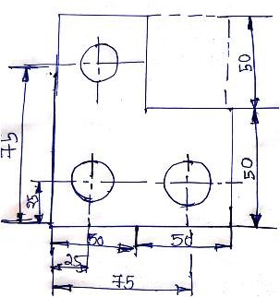

G21 G98 G28 U0 W0 M06 T01 M03 S1500

G00 X0 Y0 Z11 G00 X100 Y50 G01 X50 Y50 G01 Z-10

G01 X50 Y100 G01 Z-10

G00 Z11

G00 X0 Y0 Z11 G28 U0 W0 M05

M06 T02 M03 S1500

G00 X0 Y0 Z11 G90 F75

ME, III B.TECH-I SEM (R20) COMPUTER AIDED DESIGN & MANUFACTURING



G01 X25 Y25 G01 Z-10 G00 X75 Y25 G01 Z-10 G00 Z11 G00 X25 Y75 G01 Z-10 G00 Z11 G28 U0 W0 M05

M30

# Write a part program manuscript of step turning operation by using G90 code given diagram

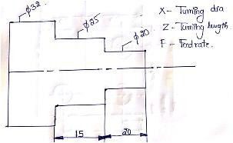

G21 G98 G28 U0 W0 M06 T01 M03 S1500 G00 X33 Z5

G90 X32 Z-35 F100 X31

X30 X29 X28 X27 X26

ME, III B.TECH-I SEM (R20) COMPUTER AIDED DESIGN & MANUFACTURING



X25

G90 X24 Z-20 X23

X22 X21 X20 G00 Z5

G28 U0 W0 M05

M30.

# Write a part program manuscript of taper turning operation by using G90 code given diagram

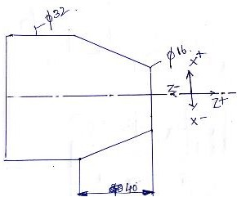

G21 G98 G28 U0 W0 M06 T01 M03 S1500 G00 X16 Z5

G90 X32 Z-40 R-1 F100 R-2

R-3

R-4

R-5

R-6

ME, III B.TECH-I SEM (R20) COMPUTER AIDED DESIGN & MANUFACTURING



R-7

R-8

G28 U0 W0 M05

M30.

# Write a part program manuscript of multiple turning operation by using G71 code given diagram

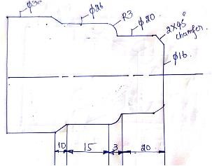

G71 Format G71 U R

G71 P Q U W F- Roughing Cycle. G70 P Q F S--- Finishing Cycle. U=Each depth of cut in X-axis.

R= Tool Retract

P-Program starting point in mension ‘N’ Block

Q-Program ending point in mension ‘N’ Block U- Finishing allowance in X-axis.

W- Finishing allowance in Z-axis. F- Feed rate.

S-Spindle speed in rpm. G21 G98

G28 U0 W0 M06 T01

ME, III B.TECH-I SEM (R20) COMPUTER AIDED DESIGN & MANUFACTURING



M03 S1500 G00 X32 Z2 G71 U0.5 R0.5

G71 P5 Q10 U0.2 W0.2 F100 N5 G00 X16 Z0

G01 X20 Z-2 G01 X20 Z-20 G03 X26 Z-38

N10 G01 X32 Z-48 G70 P5 Q10 S1800 F70 G28 U0 W0

M05 M30

# Write a part program manuscript of facing operation by using given diagram.

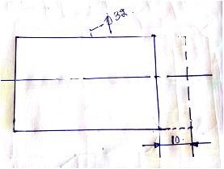

G21 G98 G28 U0 W0 M06 T01 M03 S1500 G00 X33 Z5 G00 X32 G01 Z-2

Z-4

Z-6

Z-8 Z-10

G00 Z5

ME, III B.TECH-I SEM (R20) COMPUTER AIDED DESIGN & MANUFACTURING



G28 U0 W0 M05

M30