Engineering Drawing
Exercise Book



Prepared by
Department Of Mechanical Engineering
Geethanjali Institute of Science & Technology
Gangavaram Village, Kovur Mandal, SPSR Nellore (Dt), AP-524137

Sheet No: 1 Lettering & Dimensioning & Types of Lines

Specifications for the dimensions of letters and numerals:

- The height of capital letters is taken as the base of dimensioning.
- The two standard ratios for d/h, 1/14 and 1/10 are the most economical
- The lettering may be inclined at 15° to the right, or may be vertical.
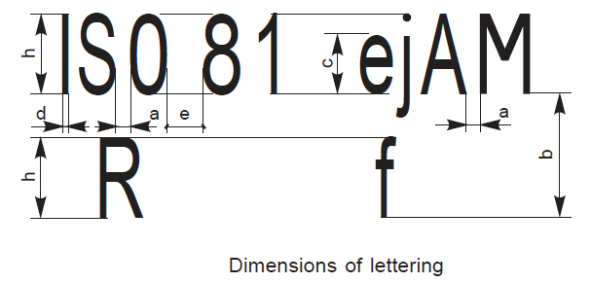
- Lettering height (Height of capitals) h
- Height of lower-case letters c (7/10)h
- Spacing between characters a (2/10)h
- Minimum spacing of base lines b (14/10)h
- Minimum spacing between words e (6/14)h
- Thickness of lines d (1/10)h

- STATE BOARD OF TECHNICAL EDUCATION AND TRAINING
- DEOARTMENT OF TECHNICAL EDUCATION
- ENGINEERING IS THE UNIVERSAL LANGUAGE OF ENGINEERS
- GEETHANJALI INSTITUTE OF SCIENCE AND TECHNOLOGY
- PIN NUMBER
- POLYTECHNIC DIPLOMA IN ENGINEERING C20 CURRICULUM
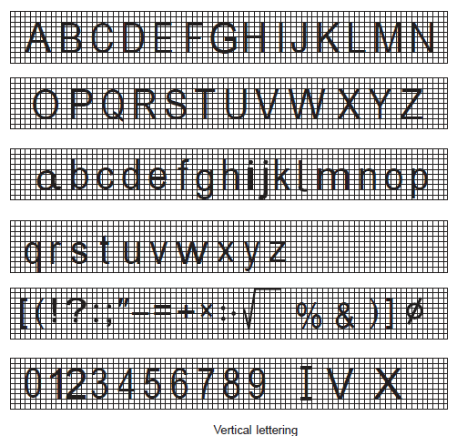
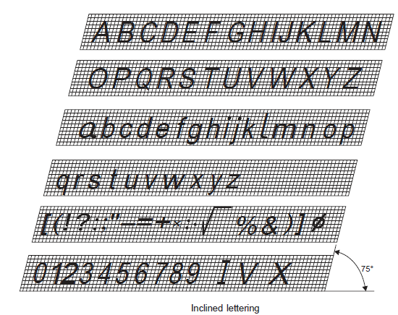

Sheet No:2 Geometrical Constructions
- Bisecting a line
- Bisecting an arc
- Bisection of an angle
- Division of a line into equal parts
- An arc through three points
- Determination of centre of an arc
Sheet No:3 Polygons
- Method – I
- Method – II
- Method – III

Sheet No:4 Polygons – Special Methods
- Construction of a square – given the diagonal
- Construction of a pentagon – given the side
- Construction of a hexagon
    - given the side
    - given the distance between the corners
    - given the distance between the flats
- Construction of a octagon with a square
- Construction of a inscribed polygon of N – sides
Sheet No:5 Conic sections – Eccentricity Method
      - Trace a conic section when the distance of the focus from the directrix is 50 mm and eccentricity equal to 2/3. Name the curve. Draw a tangent and normal to the curve from a point on it, which is at a distance of 35 mm from the directrix.

      - Trace a conic section when the distance of the focus from the directrix is equal to 50mm and eccentricity equal to one, Name the curve. Draw a tangent and normal to the curve from a point on it, this is at a distance of 45mm from the focus
- Trace a conic section when the distance of the focus from the directrix is 50 mm and eccentricity is equal to 3/2. Name the curve. Draw a tangent and normal to the curve from a point on it. This is at a distance of 30 mm from the focus.

Sheet No:6 PARABOLA– Special Methods
- Rectangle method

- Parallelogram method
- Tangent method

Sheet No:7 ELLIPSE – Special Methods
      - The Major and minor axes of an ellipse are 120 mm and 80mm respectively. Draw the curve by
i). Foci/Arcs of circles method
ii). Concentric circles method.
iii). Oblong method
iv). Four centre method

Sheet No:8 HYPERBOLA – Special Methods
- Two points A and B are 80 mm apart. Draw the curve traced by a point P moving in such a way that the difference between its distances from A and B is always constant and is equal to 50mm. (Foci/Arcs of circles method )
- Draw a pair of hyperbolas with the distance between the foci as 80 mm and the length of the transverse axis 60mm. Draw a tangent to the curve from a point 10 mm from the axis and 30 mm from one of the foci and draw the asymptotes.
- Draw a hyperbola when half of the transverse axis is 50 mm, abscissa 40 mm and double ordinate 120 mm.
- Draw a rectangular hyperbola, given a point P on it at a distance of 40mm and 80mm from two asymptotes.

Sheet No:9 Conics – miscellaneous problems
- A stone is thrown from a building 5m height at its highest point of flight; it just crosses a palm tree 10m height. Trace the path of the projectile if the distance between the building and the palm tree is 6 m. (scale I: 100).
- A shot is discharged from the ground level at an inclination of 55° to the ground, which is assumed to be horizontal. The shot returns to the ground at a point 125m. distance from the point of discharge. Trace the path of the shot. Determine its direction at a height of 5 m from the ground (scale 1: 1000).
- Draw a parabola passing through three vertices of a triangle of sides 30mm, 45mm and 60 mm. The corner of the triangle common to 45mm and 60mm sides lies on the axis of the parabola. Draw a tangent and normal at a point on the curve 20mm from the axis.
- Two fixed points A and B are 80 mm apart. Trace the complete paths of point P moving in such a way that the sum of its distance from A and B is always the same and equal to100 mm. Draw tangent and normal to the curve through a point. (Use arcs of circles method).
- Two points A and B are 100 mm apart. Point C is 75mm from A and 60 mm from B. Draw an ellipse passing through A, B and C
- Construct an ellipse such that the distance between the directrices is 200 mm. and the distance between the vertices is 150 mm. Also calculate the eccentricity and minor axis.
Sheet No:10 cycloids
- A Circle of 60 mm diameter rolls along a straight line without slipping. Draw the curve traced out by a point P on the circumference for one complete revolution of the circle. Name the curve. Draw a tangent to the curve at a point 50 mm from the Directing line.
- A circle of 50 mm diameter rolls on the circumference of another circle of 120 mm diameter with an external contact. Trace the locus of a point on the circumference of the rolling circle for one complete revolution. Name the curve. Draw tangent and normal to the curve at a point, 90 mm from the center of the directing circle.
- Circle of 40 mm diameter rolls inside the circumference of another circle of 80 mm diameter. Draw the locus of any point on the rolling circle for one complete revolution of the rolling circle. Name the curve

Sheet No:11 cycloids - miscellaneous problems

- ABC is an equilateral triangle of side 70 mm. Trace the loci of vertices A, B and C. When the circle circumscribing ABC rolls without slipping along a fixed straight line, for one complete revolution.
- A circle of 40 mm diameter rolls on a horizontal line for half revolution and then on a 60⁰ inclined line for another half. Draw the curve traced out by a point P on the circumference of the circle, taking the top most point on the rolling circle as the initial position of the generating point
- A circus man rides a motorcycle inside a globe of diameter 4 m. The motorcycle wheel is 0.8 m in diameter. Draw the locus of a point on the circumference of the motorcycle wheel for its one complete rotation. Name the curve.
- Circle of 40 mm diameter rolls over another circle of 40 mm diameter. Trace the locus of a point on the rolling circle for one complete revolution. Name the curve.

Sheet No:12 INVOLUTES

- Draw an involute of a hexagon of 25 mm side for one convolution. Draw tangent and normal to the curve at a distance 100 mm from the centre of the hexagon.
- An in elastic string of length has its one end attached to the circumference of circle of 50 mm diameter. Draw the curve traced by the other end of the string when it is tightly wound round the circle when L = 200 mm. Draw a tangent and normal to curve at any convenient point on the curve.
- Trace the paths of the ends of a straight line AP, 100 mm long, when it rolls, without slipping, on a semi-circle having its diameter AB, 75 mm long. (Assume the line AP to be tangent to the Semi-circle in the starting position.)
- AB is a rope 1.6 meters long, tied to a peg at B. keeping it always tight; the rope is wound round the pole O. Draw the curve traced out by the end A. scale 1/10 full size.

Sheet No:13 HELICES

- Draw a helix for one convolution with a pitch of 50mm upon a cylinder of 75mm diameter. also develop the surface of a cylinder showing the helix on it.
      - Draw a helix for one convolution upon a cone, diameter of base is 75mm, height 100mm, and pitch 75mm. also develop the surface of the cone showing the helix on it.
      - Draw the helical spring of circular and square cross section
      - Draw the screw thread of square cross section

Sheet No:14 PROJECTIONS OF POINTS

- Draw the projections of the following points by keeping 30mm. as the distance between the projectors.
(a) A is 20 mm in front of VP and 30 mm above HP.
(b) B is 30 mm in front of VP and in HP.
(c) C is 40 mm behind VP and 20 mm below HP.
(d) D is 30 mm behind VP and 10 mm above HP.
(e) E is 40 mm in front of VP and 30 mm below HP.
(f) F touches both HP and VP
- Draw the projections of a point lying 20 mm below HP and in third quadrant if its shortest distance from the line of intersection of planes is 40 mm. Also, find the distance of the point VP.

Sheet No:15 PROJECTIONS OF LINES - I
- A line AB 60 mm long is parallel to both the planes. The line is 20 mm above H.P. and 25 mm in front of V.P. draw the projections of the line.
- Draw the projections of a line 80 mm long when it is parallel to both HP and VP. One of the end points is 40 mm above HP, 60 mm in front of VP and 20 mm from anyone of the profile planes.
- A line AB 60 mm long is parallel to V.P and perpendicular to H.P. Point A is 35 mm above H.P and the line is 20 mm in front of V.P. Draw the projections of the line AB.
- A line AB 60 mm long is perpendicular to V.P and parallel to H.P. Its end A is 10 mm in front of V.P and the line is 20 mm above H.P. Draw the projections of the line.
Sheet No:16 PROJECTIONS OF LINES - II

- A line AB 60 mm long is parallel to V.P. and inclined at angle of 30° to H.P. The end A is 15 mm in front of H.P and 20 mm in front of V.P. Draw the projections of the line.
- Draw the projections of a straight-line EF 60 mm long parallel to H.P. and inclined at an angle of 35° to V.P. The end E is 20 mm above H.P and 15 mm in front of V.P.
- A line AB 60 mm long is in V.P and inclined at an angle of 35° to H.P. The end A is 10 mm above H.P. draw the projections.
- A line RS 60 mm long is in H.P and inclined at an angle of 45° to V.P. The end A is 10 mm above V.P. draw the projections.
- A 100 mm long line is parallel 40 mm above the HP. Its two ends are 25 mm and 50 mm in front of the VP respectively. Draw its projections and find its inclination with the VP.
Sheet No:17 PROJECTIONS OF LINES – III

- A line AB 60 mm long has one of its extremities 20 mm in front of VP and 15 mm above HP. The line is Inclined at 25° to HP and 40° VP, Draw its top and front views.
- A line AB measuring 70 mm has its end A 15 mm in front of VP and 20 mm above HP, and the other end B is 60 mm in front of VP and 50 mm above HP. Draw the projections of the line and find the inclinations of the line with both the reference planes of projection.
- A line PQ has its end P, 15 mm above HP and 10 mm in front of VP. The end Q is 55 mm above HP, and the line is inclined at 30° to HP. The, distance between the ends projectors of 40 mm. draw the projections of the line and find its inclination with VP.
- A point A is 50 mm below HP and 12 mm behind the VP. A point B is 10 mm above the HP. and 25 mm in front of the VP. The distance between the projectors of A and B is 40 mm. Determine the traces, true length and true inclinations of the line joining A & B.
- The end projectors of a line AB are 75 mm apart. A is 20 mm in front of VP. And 30 mm above HP. B is 25 mm behind VP and 25 mm below HP. Draw its projections and determine the true length, the inclinations to the co-ordinate planes and the traces of the line.
Sheet No:18 PROJECTIONS OF LINES - IV

- The projections of a line measures 80 mm in the view from above and 70 mm in the view from front. The midpoint of the line is 40 mm in front of VP and 30 mm above HP. One end is 10 mm in front of V.P and nearer to it. Other end nearer to HP. Draw the projections of the line. Find true length, true inclinations and locate traces.
- The end projectors a straight line AB are 80 mm apart. The HT and VT of the line coincide with each other on XY, at a point 25 mm from the projector of the end A and situated in between the end projectors of the line. The end A is 20 mm above HP and the end B is 65 mm behind V.P.Draw the projections of the line and determine the true length of the line AB and its inclinations with V.P. and H.P.
- The front view of a line AB 125 mm long measures 85 mm and its top view measures 100 mm. Its end B and the mid point are in the third quadrants. The mid point M being 65 mm from both the planes. Draw the projection of the line AB and find the inclinations of the line with VP & HP.
- A line PQ has its end P and Q is 20 mm and 40 mm in front of VP. The projectors of the line PQ when measured parallel to the line of in the section of HP and VP are 50 mm apart. The HT of the line is 10 mm in front of VP. The line PQ is inclined at 35° to HP. Draw the projections of the line PQ and locate the VT. Find the distance of VT of the line from the HP and the inclination line with the VP.
- The projections of the line are perpendicular to the XY lines. One of the ends is nearer to both HP and VP and 20 mm from both HP and VP. The other end is 40 mm from HP and 55 mm from VP. Both the ends points of the line lie in first quadrant. Determine its traces and inclinations of the lie with HP and VP.
- A room is 6 m x 5 m x 3.5 m height. An object is placed 1.2 m above the ground and in the center of the room. Determine graphically its distance from one of the comers between the roof and adjacent walls select a scale 1:50.
- A room is 6m x 5m x 3.5 m height. An electric bracket light is above the center of the longer wall and 1m below the ceiling. The bulb is O.3m away from the wall. The switch for the light is on an adjacent wall, 1.5 m above the floor and 1 m away from the other longer wall. Find graphically its shortest distance between the bulb and switch.

Sheet No:19 PROJECTIONS OF PLANES - I
- If an edge is in the HP or on the ground, in the initial position, the plane is assumed to be lying in the H.P or on the ground, with the edge perpendicular to the V.P. If a comer is in the H.P or on the ground, the line joining that comer with the center of the plane is kept parallel to the VP.
- If an edge is in the VP, in the initial position, the plane is assumed to be lying in the V.P. with an edge perpendicular to the HP. If a comer is in the VP, the line joining that comer with center of the plane is kept parallel to the H.P.
- An equilateral triangle of 50 side, has its plane parallel to HP and 30 away from it. Draw the projections when one of its sides is
  - perpendicular to VP
  - parallel to VP
  - Inclined to VP at an angle of 45⁰. Locate its traces.
- A rectangle ABCD, 40 X 60 has a corner on the HP and 20mm away from the VP. All the sides of the rectangle are equally inclined to the HP and parallel to the VP. Draw its projections and obtain its traces.
- A regular pentagon ABCDE of 25 mm side has its corner A in HP and the side CD parallel to HP. Draw its projections when its top view is parallel to and 20 mm away from VP. Also show its traces.
- A regular pentagonal plate of side 28 mm is placed with one side on HP such that the surface is inclined at 45⁰ to HP and perpendicular to VP. Draw its projections and traces.
- A thin circular metal plate of 50 mm diameter, having its plane vertical and inclined 30⁰ to VP. Its centre is 30 mm above HP and 20 mm in front of the VP. Draw its projections and locate its traces.
Sheet No:20 PROJECTIONS OF PLANES - II

- Draw an equilateral triangle of 75 mm side and inscribe a circle in it. Draw the projections of the figure , when its plane is inclined at 30⁰ to the VP and one of the sides of the triangle is inclined at 45⁰ to the HP
- A thin rectangular plate of sides 70mm X 25 mm has its shorter side is inclined at45⁰ to the VP project its front view if its surface is inclined at 30⁰ to the HP.
- A thin rectangular plate of sides 60mm X 30 mm has its shorter side in the VP and inclined at30⁰ to the HP. project its top view if its front view is a square of 30 mm long sides
- A pentagonal plate of 45 mm side has a circular hole of 40mm diameter in its centre. The plane stands on one of its sides on the HP with its plane perpendicular to VP and 45⁰ inclined to the HP. Draw the projection.
- Draw the projections of a regular hexagon of 25 mm side having one of its sides in HP and inclined at 60⁰ to the VP and its surface making an angle of 45⁰ with the HP.
Sheet No:21 PROJECTIONS OF PLANES - III

- A circular plate of negligible thickness and 50 mm diameter appears as an ellipse in the front view having its major axis 50 mm long and minor axis 30 mm long draw its top view when the major axis of the ellipse is horizontal.
- Draw the projections of a rhombus having diagonals 125 mm and 50 mm long the smaller diagonal of which is parallel to both the principal planes while the other is inclined at 30⁰ to the HP.
- Draw the projections of the circle of 75mm diameter having the end A of the diameter AB in the HP. The end B in the VP and the surface is inclined 30⁰ to the HP. And 60⁰ to the VP.
- A semi circular plate of 80 mm diameter has its straight edge in the VP and inclined at 45⁰ to the HP. The surface of the plate makes an angle of 30⁰ to the VP. Draw its projections.
- Draw a rhombus of diagonal 100 mm and 60mm long , with the longer diagonal horizontal. The figure is the top view of a square of 100 mm long diagonals with a corner on the ground. Draw its front view and determine the angle which its surface makes with the ground.

Sheet No:22 PROJECTIONS OF PLANES - IV

- draw the projections of a circle of 50mm diameter resting in the HP on a point A on the circumference, its plane inclined at 45⁰ to the HP and
  - The top view of the diameter AB making 30⁰ angle with the VP.
  - The Diameter AB making 30⁰ angle with the VP
- a regular hexagonal plane of 45 side has a corner on HP and its surface is inclined at45⁰ to HP. Draw the projections , when the diagonal through the corner, which is on HP makes 30⁰ with the HP.
- a circle of 40 mm diameter , is resting on HP on a point, with its surface inclined at 30⁰ to HP. Draw the projections of the circle, when
  - the top view of the diameter, through the resting point , makes an angle of 45⁰ with the XY
  - the diameter passing through the resting point makes an angle of 45⁰ with VP

Sheet No:23 AUXIALIARY PLANE PROJECTIONS

- A point A is 25 above HP and 15 infront of VP. Draw the front and top view of the point. Also obtain
(a). auxiliary front view of the point on a plane which makes an angle 60 º with VP and perpendicular to HP
(b). auxiliary top view of the point on a plane which makes an angle 45 º with HP and perpendicular to VP
- The end projectors of a line AB are 75 mm apart. A is 20 mm in front of VP. And 30 mm above HP. B is 50 mm infront of VP and 55 mm above HP. Draw its projections and determine the true length, the inclinations to the co-ordinate planes using auxiliary projections.
- A line AB 60 mm long has one of its extremities 20 mm in front of VP and 15 mm above HP. The line is Inclined at 25° to HP and 40° VP, Draw the projections by auxiliary plane method and show the point or edge view of the line.
- The straight line AB of 50 length, is inclined at 30 to HP and its top view makes an angle of 60 with xy. The end A of the line is 20 above HP and 15 infront of VP. Draw the projections of line by auxialiary plane method.
- The top view of the line AB, inclined at 45 º to xy, measures 85, while the length of the front view is 65. its end A is on the HP and 15 infront of VP. Draw the projections of AB and determine its true length and true inclinations with HP and VP. Find the distance of the mid point of AB from xy and also the shortest distance of the line from xy.

Sheet No:24 PROJECTIONS OF SOLIDS - I

- If the solid axis is inclined to H.P or inclined to ground. In the initial position, The solid axis is assumed to be as perpendicular to H.P. Similarly, if the solid axis is inclined to V.P., then in the initial position the solid axis is inclined assumed to be as perpendicular to V.P.

- If the solid is resting on one of its base edges or sides on the H.P. or on the ground or on a plane parallel to the H.P or on the ground or on a plane parallel to the H.P. or to the ground. Then the initial position that edge or side of the base should taken perpendicular to V.P.

- If the solid is resting on one of its base edges or sides on the V.P or on a plane parallel to the V.P. Then in the initial position that edge or side of the base should be taken perpendicular to H.P.

- If the solid is resting on one of its base edges or sides on the V.P. or on a plane parallel to the V.P. Then in the initial position that edge or side of the base should be taken perpendicular to H.P.

- If the solid is resting on one of the comers of the base on the H.P. or to the ground, or on plane parallel to the H.P. or to the ground, then in the initial position the base edges or sides forming that comer should be taken as equally inclined to V.P. and that line joining the center of the base to that comer should be taken as parallel to V.P (i.e. the line joining the center of the base and that comer should be taken as parallel to x, y line)

- If the solids resting on one of the comers of the base on V.P. or on a plane parallel to the V.P. then in the initial position the edges or sides forming that comer should be taken as equally inclined to H.P. and that line joining the center of the base so that comer should be taken as parallel to H.P (i.e. the line joining the center of the base and that comer should be taken as parallel to x, y line).
- A pentagonal prism side of base 30 mm and axis 50 mm long is resting on one its longer edges in the H.P. Such that the axis is perpendicular to V.P., base nearer to the V.P. is 15 mm from it, and rectangular face opposite to the longer edge on which it is resting is parallel to H.P. Draw its projections.
- Draw the projection of a hexagonal prism side of base 30 mm and axis 60 mm long resting on its base on the H.P. such that pair of rectangular face are perpendicular to V.P.
- Draw the projection of a hexagonal prism side of base 30 mm and axis 60 mm long resting on one of its rectangular faces in the H.P. such that the axis of the prism is perpendicular to V.P. and base nearer to the V.P. is 20 mm from it.

Sheet No:25 PROJECTIONS OF SOLIDS - II

- Draw the projection of a cylinder of base 30 mm diameter and axis 60 mm long resting with its bases on H.P. and axis is 25 mm from the V.P.
- A cone of diameter of base 30 mm height of the axis is 60 mm is resting on its base on the H.P. draw its projections.
- A hexagonal pyramid side of base 30 mm and height 60 mm resting with its base on H.P. Such that one of the edges of the base is inclined at 20° to V.P. draw its projections.
- A Tetrahedron of side 50 mm rests with its base on H.P. Draw its projections
    - When one of its edges is perpendicular to V.P. and
    - When one of its edges is parallel to and 15 mm from V.P.
- A pentagonal prism side of base 30 mm axis 60 mm long lies on H.P. Such that its axis is parallel to both H.P. and V.P. Draw its projections when
    - The prism lies with one of its rectangular faces on H.P.
    - The prism lies with one of the longer edges on H.P. such that the rectangular faces forming the longer edge on which the prism lies makes equal inclinations with H.P.

Sheet No:26 PROJECTIONS OF SOLIDS - III

- A pentagonal prism, side of base 30 mm and axis 60 mm long, rests on one of its base edges on H.P. Such that the base containing that base edges makes an angle of 30° to H.P. and axis is parallel to V.P. Draw its projection.
- A pentagonal prism, side of base 30 mm and axis 60 mm long, rests on one of the comers of the base on the H.P. In such a way that the base edges forming the comer on which it is resting makes equal inclinations with H.P. and axis of the prism makes an angle 40° to H.P. and parallel to V.P. Draw its projection.
- A hexagonal prism of 30 mm sides of base and axis are 60 mm long is resting on one of the rectangular faces on H.P. and the axis is inclined at 40° to V.P. Draw the projections.
- A cylinder base diameter 50 mm and length of axis is 70mm resting on a point of the base in the H.P. with the axis is inclined at 40° to H.P. and parallel to V.P. draw its projection.
- A cone of diameter of base 50 mm and axis 70 mm long is lying on one its generator in the H.P. and axis is parallel to V.P. Draw its projection.

Sheet No:27 PROJECTIONS OF SOLIDS - IV

- A hexagonal pyramid side of the base 30 mm and axis 70 mm long is resting on one of its base edges on H.P. and its axis is inclined at 30° to H.P.and parallel to V.P.Draw its projections.
- A pentagonal pyramid side of base 30 mm and height of the axis is 60 mm is resting on one of the slant edges in the H.P. and the axis is parallel to V.P.
- Draw the projections of a cube of side 50mm is resting on one of the comers of the H.P. Such that all the vertical faces of the cube are equally inclined to V.P. and the one of the body diagonal is parallel to both H.P and V.P.
- A Hexagonal Pyramid of side of base 30 mm and axis 60 mm long is resting on one edge of the rectangular faces on H.P. Draw the projections of the solid. When the axis makes an angle 45ºwith V.P. and the base of the solid is nearer to VP. Follow the change of position method.
- A pentagonal prism side of base 30 mm and height of the axis is 60 mm, is resting on one of the base edges on the H.P. such that the axis of the prism is inclined at 40° to H.P and base edge on which it is resting is inclined at 50° to V.P. Draw its projections.

Sheet No:28 PROJECTIONS OF SOLIDS - V

- A pentagonal prism side of base 30 mm and height of the axis is 60 mm is resting on one of the comers of the base on H.P. such that the axis of the prism is inclined at 40° to V.P. and the side opposite to the comer on which it is resting is inclined at 45° H.P. draw its projections.
- A hexagonal prism side of base 30 mm axis is 70 mm long is resting on one of the comer of the base in the V.P. and longer edge passing through that comer is inclined at 40° to V.P and the axis is inclined at 30º to H.P. Draw its projections.(β to be calculated)
- A cylinder base diameter of 60 mm, length of the axis is 80 mm is resting on a point of the base in the H.P.with the axis is inclined at 50º to H.P. and the top view . The axis is inclined at 40º to V.P. Draw its projections.(β is given)
- A hexagonal prism side of base 30 mm axis is 70 mm long is resting on one of base edges, such that the axis of the prism is inclined at 35° to H.P. and 50º to V.P. Draw its projections. (β to be calculated)
- .Draw the projections of a cylinder base diameter 60 mm and length of the axis is 80 mm , whose axis is inclined at 40º to H.P. and 50ºto to V.P. (β to be calculated)
Sheet No:29 PROJECTIONS OF SOLIDS - VI

- A right pentagonal prism is suspended from one of its corners of its base. Draw its projections when the edge of the base makes an angel of 30º to V.P. Take base 30 mm side and length of the axis is 60 mm.
- A cube of 40 mm edge resting one of its corners in the H.P. such that one of the solid diagonal is perpendicular to V.P. Draw its projections.
- A tetrahedron of 40 mm edges rest with one of its edges on H.P. and inclined at 45° to V.P. the triangular face containing that edge is inclined at 30º to H.P. Draw the top and front views of the solid.
- A pentagonal pyramid edge of base 30 mm and height 60 mm is resting on a comer of its base in such that the slant edge containing the comer makes an angle of 60° with H.P. and 30° with V.P. obtain the projections.
- Draw the projection of a cone-base diameter 40 mm length of axis 50 mm when it is resting on a generator in the H.P with that generator making an angle of 40° with XY and the vertex touching the V.P.

Sheet No:30 PROJECTIONS OF SOLIDS - VII

- Draw the projection of a cone, base 30 mm and axis 50 mm long, resting on H.P. on a point or its base circle with
        - The axis making an angle of 45° with H.P. and its top view making an angle of 30° with V.P.
        - The axis making 45° with H.P and 45° with V.P.
- A square base pyramid base 35 mm side and axis 70 mm long has a triangular of face on the H.P. and the vertical plane containing the axis makes an angle of 45° with the V.P. Draw its projections.
- The frustum of a hexagonal pyramid side of base 30 mm side of top face 20 mm and height 60 mm in standing on the ground on one of its base edges which makes an angle of 30° to V.P.The axis if the frustum is inclined to H.P at an angle of 60°. Draw the projections.
- A cone of base 50 mm diameter and axis 30 mm long has one of its generators in the V.P. and inclined at 30° to H.P. Its apex is in the H.P. Draw its projections. ,
- A hexagonal pyramid side of base 30 mm height of the axis is 65 mm long lying on one of the slant edges in the H.P. such that the plane containing that slant edge and the axis making an angle of 35° to V.P. Draw the projections.
- A hexagonal pyramid side of base 30 mm and axis is 60 mm long is freely suspended from one of the comers of its base. Draw its projections, when the axis as a vertical plane makes angle of 45° with the V.P.

Sheet No:31 DEVELOPMENTS OF SOLIDS - I

- Draw the complete developments of the following solids
- A pentagonal prism side of base 30 mm and height of the axis is 50 mm.
- A hexagonal prism side of base 30mm and height of the axis is 50mm.
- Cylinder of diameter of base 40 mm and height 50 mm.
- A tetrahedron of side 40 mm.
- A square pyramid of side 30 mm and height of the axis is 50 mm.
- A pentagonal pyramid of side 30 mm and height of the axis is 50 mm.
- A cone of diameter of the base 40 mm height of the axis is 50 mm.

Sheet No:32 SECTIONS - DEVELOPMENTS OF SOLIDS - I

- A cube of 40 mm side has a vertical face inclined at 30° to V.P. It is cut by a plane making an angle of 30° to H.P. and passing through a point 30 mm above H.P. Draw the development of the lower part of the cube.
- A pentagonal prism 30 mm side of base and 50 mm height stands vertically on its base with two of its rectangular faces equally inclined to V.P. One rectangular face nearer to V.P. The vertical trace of a cutting plane inclined at 45° to axis of the prism passes through the left corner top face of the prism. Develop the lateral surface of the prism for the lower portion.
- A vertical hexagonal prism of 25 mm side of the base and axis 50 mm has one of its rectangular face parallel to V.P. A circular hole of 40 mm diameter is drilled through the prism such that the axis of the hole bisects the axis of the prism at right angle and is perpendicular to V.P. Draw the development of the prism showing the true shape of the hole in it.
- A vertical cylinder of 60 mm diameter and 80 mm high is cut by a section plane perpendicular to V.P. and inclined at 45º to the axis and passes through the left of the horizontal diameter of the top faces. Draw the development of the lateral surface of the truncated cylinder.
- A thin sheet metal pentagonal pyramid 30 mm edge of the base and 55 mm high rests vertically with two of its base edges making equal inclination with V.P and nearer to it. A cutting plane perpendicular to V.P. cuts the axis of the pyramid at a point 20 mm above the base, is horizontal towards the left of the axis, is inclined at 45º to the right of the axis, and leans upwards. Draw the development of the lateral surface of the lower portion of the pyramid.
- A vertical cone of 40 mm diameter of base and height 50 mm is cut by a cutting plane perpendicular to V.P. and inclined at 30° to H.P. So as to bisect the axis of the cone. Draw the development of the lateral surface of the bisected portion of the cone.
- Draw the projections of a cone resting on H.P. on its base and show on them, the shortest path by which a point P, starting from a point on the circumference of the base and moving around the cone will return to the same point. Take base of the cone 60 mm diameter and axis is 75 mm long.
- Develop the lateral surface of the three piece pipe elbow. Take the diameter of the pipe as 40 mm. and the axis length of each piece 40 mm.

Sheet No:32 SECTIONS - DEVELOPMENTS OF SOLIDS - II

- A cylinder 60 mm diameter and 80 mm long, has its axis parallel to the H.P. and inclined at 40° to the V.P. A vertical section plane in such a way that the true shape of the section is an ellipse having the major axis 75 mm long cuts it. Draw its sectional front view and true shape of the section.
- A cube of 50 mm edge rests on one face on the H.P. with Its vertical faces equally Inclined to the V.P.a section plane, perpendicular to the V.P. producing a largest rhombus, cuts it. Draw the projections, true shape of the section and determine the inclination of the plane with the H.P.
- A cube of edge 60 mm stands vertically on the H.P. such that its vertical faces are equally inclined to the V.P. A section plane perpendicular to the V.P. and inclined to the H.P. cuts the solid in such away that the true shape of the section is an equilateral triangle. Draw the projections and the true shape of the section and determine the inclination of the section plane with the H.P.
- A Cube of 65 mm long edges has its vertical faces equally inclined to the V.P. A section plane, perpendicular to the V.P., so that the true shape of the section is a regular hexagon, cuts it. Determine the inclination of the cutting plane with the H.P. and draw the sectional top view and true shape of the section
- A tetrahedron of 65 mm long edges is lying on the ground on one of its faces, with an edge perpendicular to the V.P. It is cut by a section plane which is perpendicular to the V.P: so that the true shape of the section is an isosceles triangle of base 50 mm long an altitude 50 mm. Find the inclination of the section plane with the H.P. and draw the front view, sectional top view and the true shape of the section.

Sheet No:33 SECTIONS - DEVELOPMENTS OF SOLIDS - III

- A cone of base 60 mm diameter and 75 mm high stands vertically on the H.P. A section plane, perpendicular to the V.P. and inclined to the H.P. cuts the cone is such a way that the true shape of the section is an ellipse of major axis 45 mm long. Find the inclination of the cutting plane with the H.P. and draw the view from the front, sectional view from above and true shape of the section.
- A sphere of 75 mm diameter is cut by a section plane, perpendicular to the V.P. and inclined at 30° to the H.P. in such a way that the true shape of the section is a circle of 50 mm diameter. Draw its front view, sectional top view and sectional side view.
- A pentagonal prism side of base is 25 mm and the axis 70 mm long is resting on its base on the ground such that one of the sides of the base is Inclined at 45° to the V.P. It is cut by a section plane perpendicular to V.P. and inclined to H.P. at 40° passing through the point on the axis 40 mm above the base. Draw the view from the front showing the section plane, sectional view from the above and true shape of the section.
- A cube of 50 mm edge is resting on one its square faces on the H.P. with a vertical face inclined at 30⁰ to the V.P. it is cut by a section plane inclined to H.P. to 50° and passing through a point on the axis 30 mm above the H.P. Draw the view from the front sectional view from the above and an auxiliary view from the above showing true shape of the section.
- A hexagonal prism side of base 40 mm and the axis 60 mm long rests with its base on the H.P. such that one of its rectangular faces is inclined at 20° to V.P. It is cut by a section plane perpendicular to H.P. and Inclined at 60° to V.P. passing through a point 15 mm away from the axis. Draw the view from the above, sectional view from the front and true shape of the section.

Sheet No:34 SECTIONS - DEVELOPMENTS OF SOLIDS - IV

- A hexagonal pyramid side of base 30 mm and the axis is 60 mm long rests with its base on the ground, such that one of the edges of the base Is Inclined at 40° to V.P. It is cut by a section plane perpendicular V.P. and inclined to H.P. at 50° passing through a point on the axis 30mm above the base. Draw the view from the front, sectional view from the above and auxiliary view from the above showing the true shape of the section in it.
- A pentagonal pyramid of side of base 30 mm height 60 mm rests on a triangular face on the H.P. with Its axis parallel to the V.P It is cut by a horizontal section, plane bisecting the axis. Draw the projections of the solid showing the section' plane.
- A pentagonal pyramid side of base 35 mm and axis 60 mm rests on the H.P. such that one of the base edges is parallel, to V.P. and away from it. It is cut by a section plane whose V.T. is inclined at 45° to H.P. passing through the point on the axis 35 mm above the base. Draw the front view, Sectional top view and true shape of the section
- A cylinder of diameter 50 mm and axis is 70 mm long is resting on its base in the H.P. It is cut by a section plane perpendicular to V.P. and inclined at 60° to H.P. passing. Through a point on the axis 20 mm from the top face. Draw front view, sectional top view and true shape of the section.
- A cylinder of diameter 50 mm and axis is 70 mm is resting on its base in the H.P. A section perpendicular to V.P. and 45° to H.P. cuts the solids passing through a mid point on the axis. Draw its projections and true shape of the section.

Sheet No:35 INTERPENETRATION OF SOLIDS - I
- A vertical square prism, base 50mm. side is completely penetrated by a horizontal square prism, base 35mm. side. The axis of the horizontal prism is parallel to VP., while the faces of the two prisms are equally inclined to the VP. Draw the projections of the solids, showing the lines of intersection (assume suitable lengths for the prisms )., when their
a. intersect at right angles b. offset by 5mm
- A vertical square prism, base 50mm side and height 90 mm has a face inclined at 30_{o} to VP. It is completely penetrated by a another square prism, base 40mm side and axis 100mm. long, faces of which are equally inclined to to the VP. And bisect each other at right angles. Draw the projections showing the lines of intersection.
- A vertical cylinder of 60 diameter, is penetrated by another cylinder of 45 diameter. The axes of two cylinders are intersecting at right angle. Draw the projections of cylinders, showing the lines of intersection.
- a right cylinder of 60 mm diameter and 90mm long resting on its base on HP, is penetrated by a square prism of 36 mm base edge and 90 mm long such that the axes of the solids bisect each other at right angles. The faces of the prism are equally inclined to the VP. Draw the projections of the solid showing the curves of intersection.

Sheet No:36 INTERPENETRATION OF SOLIDS - II

- A vertical cone with diameter of base 90 and axis 100 long, is penetrated by a horizontal cylinder of 50 diameter. Draw the projections of the solids, showing the lines of intersection. When
a. The axis of the cylinder intersects the axis of cone at a point 30 from the base.
b. The axis of the cylinder is parallel to VP., 30 from the base and 5 mm in front of the axis of the cone.
- a horizontal cylindrical pipe 40 mm diameter is joined with vertical cylindrical pipe of same diameter. The axes of the pipes are parallel to VP. Neglecting the thickness of the pipe, draw the projections showing the curves of intersection when their axes intersect each other at right angles.
- A funnel is made of a cylindrical pipe and a conical part, both enveloping a common sphere of 40 diameter, with their axes intersecting at right angle. The diameter at the mouth of the funnel is 90. draw the projections of the funnel, showing the lines of inter section, when it is placed with its mouth on the HP.

Sheet No:37 Ortho graphic Projections –I
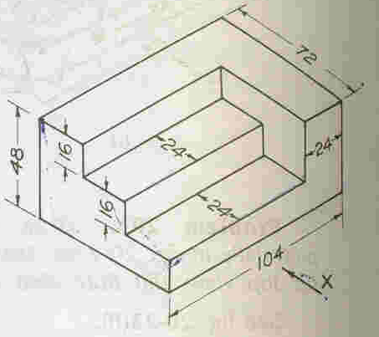
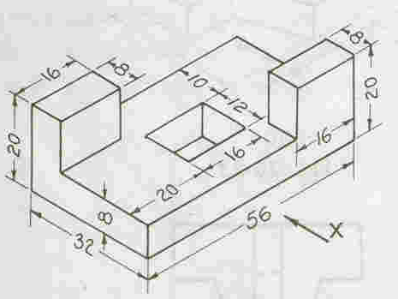

Sheet No:38 Ortho graphic Projections –I I

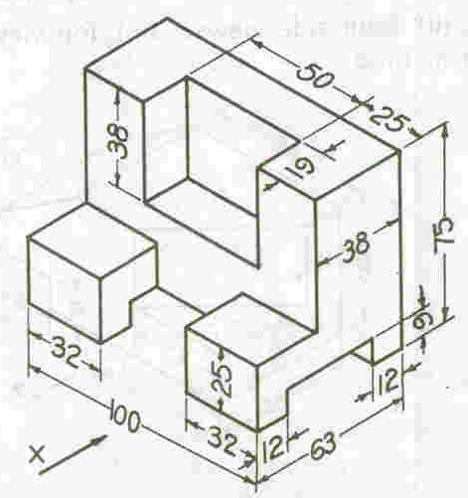

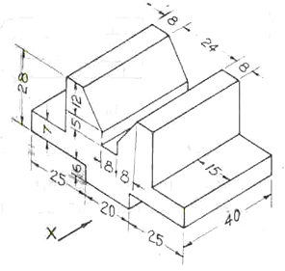

Sheet No:39 Ortho graphic Projections –I II
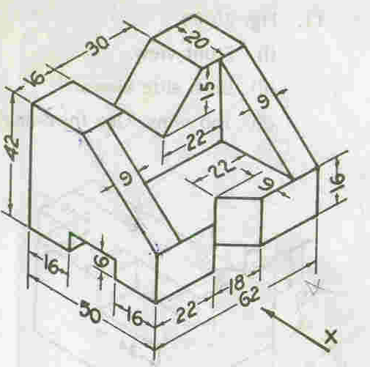

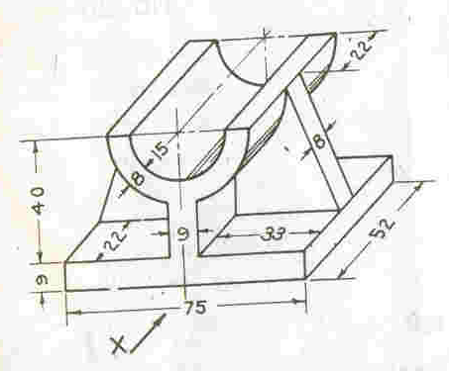

Sheet No: 40 Ortho graphic Projections –I V

Sheet No:41 Isometric Projections –I

1. Draw an isometric projections and isometric view of the following
        - A rectangle of 75 mm and 50 mm sides, is plane being
(i)vertical (ii) horizontal
        - A regular pentagon of side 40 mm, its plane being
(i) Vertical (ii) horizontal
        - A circular lamina of diameter 80 mm when its plane surface is
(i) Vertical (ii) Horizontal
- Draw an isometric drawing of hexagonal prism side of base 35 mm and axis is70 mm long when its axis is
(a)Vertical (b) horizontal.

Sheet No:42 Isometric Projections –II
- Draw an isometric view of a cylinder of diameter 60 mm and the length of the axis is 80 mm. (a) Vertical (b) horizontal.
- Draw an isometric view of a cone of diameter of base 50 mm and length of the axis 70 mm when its axis is (a)Vertical (b) horizontal.
- A pentagonal pyramid base side 40 mm and axis is 70 mm long rests with its base is parallel to V.P.and nearer to it. A horizontal section plane cuts the pyramid and Passes through a point on the axis at a distance of 30 mm from the apex. Draw the isometric view of the frustum of the pyramid.
- Draw an isometric view of the frustum of cone when it is resting on its base on the ground. The diameter of the base is 60 mm and the height of the axis is 50 mm
- Draw an isometric projection of sphere of diameter 60 mm when it is resting on H.P.

Sheet No:43 Isometric Projections –III
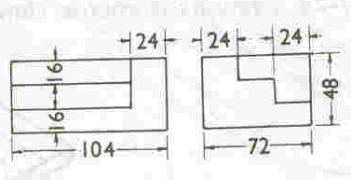
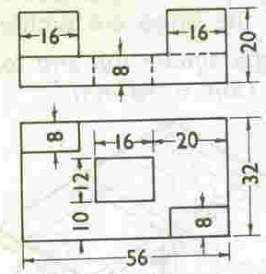

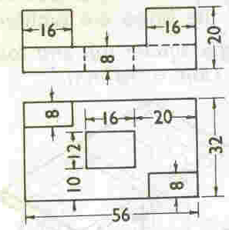

Sheet No:44 Isometric Projections –IV
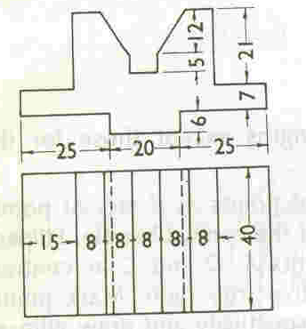

Sheet No:44 Isometric Projections –IV
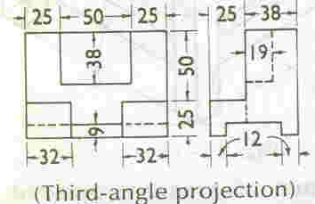

Sheet No:44 Isometric Projections –V
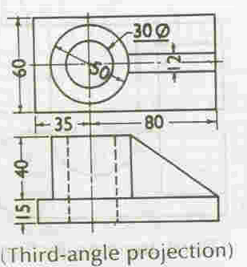

Sheet No:45 PERSPECTIVE PROJECTIONS -I

Perspective Projection : Representation of object on a plane surface, called the Picture Plane, as it would appear to the eye, when viewed from the fixed position.
- Ground plane (GP)
- Picture plane (PP)
- Horizontal plane (HP)
- Central plane(CP)
- Auxiliary ground plane (AGP)
- Ground line (GL)
- Horizon line (HL)
- Perpendicular axis (PA)
- Station point (S)
- Centre of vision (C)

- Draw the perspective view of a point A situated 20 mm behind the picture plane and 15 mm above the ground plane. The station point is 30 mm in front of the picture plane, 40 mm above the ground plane and lies in a central plane, which is 35 mm to the right of the given point.
- Draw the perspective view of a straight line AB, 60 mm long is parallel to and 10 mm above the ground plane and inclined at 45º to PP. The end A is 20 mm behind the picture plane. The station point is 35 mm in front of the picture plane and 45 mm above the ground plane and lies in a central plane passing through the mid-point of AB.
- A square lamina of 40 mm side lies on the ground plane. One of its corners is touching the PP and an edge is inclined at 60º to PP. the station point is 40 mm in front of PP, 60 mm above GP and lies in a central plane which is at a distance of 35mm to the right of the corner touching the PP. draw the perspective view of the lamina.
- A pentagonal lamina of 40 mm side lies on the ground. The corner which is nearest to PP is 15 mm behind it and an edge containing the corner is making 45º with PP. the station point is 40 mm in front of PP, 50mm above GP and lies in a central plane which is at a distance of 70 mm to the left of the corner nearest to the PP. Draw the perspective view of the lamina.

Sheet No:46 PERSPECTIVE PROJECTIONS -II

- A circular lamina of 45 mm diameter lies on the ground plane and touches the picture plane. The centre plane passes touches the centre of the circle. Station point is 70 mm in front of the picture plane and 60 mm above the ground plane. Draw the prospective view.
- A square prism, side of base 40 mm and height 60 mm rests with its base on the ground such that one of its rectangular faces is parallel to and 10 mm behind the picture plane. .the station point is 30 mm in front of PP, 80 mm above the ground plane and lies in a central plane 45 mm to the right of the center of the prism. Draw the perspective view.
- Draw the perspective view of a hexagonal prism lying on the ground plane on one of its longer edges such that one of its rectangular faces is perpendicular to the ground plane. The axis inclined at 30º to the picture plane and an edge of the base is touching the picture plane. The station point is 110 mm in front of the PP, 95 mm above the ground plane and lies in a central plane, which bisects the axis. For the prism, side of base is 25 mm and height 75 mm.
- Draw the perspective view of a square pyramid of base 50 mm side and 60 mm height. And edge of base is parallel to and 10 mm behind PP., the station point is situated at a distance of 60 mm in front of PP, 40 mm above the ground plane and 40 mm to the right of the apex.

