**HELP INFORMATION -- LOGGING INTO THE MCTR PROGRAM**

**Prerequisites: Browser and JAVA “desktop” software**

Please check with the Enterprise Help Desk (EHD) desktop team if support using the prerequisite software is needed.

**Troubleshooting Steps:**

The steps listed below may help you if you are have a problem starting up the MCTR application program.

**STEP 1: Please Use "Control Panel" to make sure latest JAVA Runtime Environment (JRE) Version 7 or 8 is installed.**

**It is strongly recommended having the Enterprise Help Desk (EHD) team help with installing JAVA JRE software.**

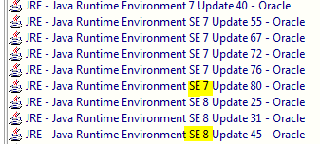

**Note: *Please do not install JAVA JRE 8 Update 60.*** Reason is that JRE 8u60, available through Software Express and certified by Oracle for use with Oracle Forms, has a known performance issue (intermittent long wait times) when Oracle Forms 11 programs are launched. If you encountered performance issues using JRE 8 Update 60 or are in the process of upgrading to Java 8, it is advisable that you use an earlier JRE 8 update such as JRE 8u31 where this performance issue is not present. The performance issue appears to be solved in forthcoming JRE 8 updates not yet released by Oracle as of November 2015.

**STEP 2**: Please close all browsers (IE and Mozilla) and close down "ALL Open Windows".

**STEP 3**: Please "Open IE browser" and log on to MCTR using WSSO.

If program does not work using Microsoft IE browser, then please **try the** **Mozilla Firefox** browser.

**STEP 4:** If you get the following certificate message when starting up the MCTR program, please *check the box* “**always trust content**” and click the “**Run**” button. Your message box may look different when running JAVA TM 7 software.

