**MISCELLANEOUS COST TRANSFER REQUEST (MCTR)**

***Program User Guide***

Revision 6

2 Sep 2014

**Table of Contents**

Introduction 4

PROCESS FLOW 5

WORK FLOW AND ROLE ACCESS Overview 6

MAPPINGS FIELD TO FIELD 7

The URL and Login 9

**WSSO Authentication** **10**

**Help Resources** (EHD) 10

MCTR Main Menu 11

**Actions** 12

**Create / View MCTR** 12

**Line Item Search** 12

**Refresh List > >** 12

**Collapse List > >** 12

**Reports** 12

**User List** 12

**Exit** 12

**IP Address** 12

Create / View MCTR 13

**Creating a MCTR** 13

**Finishing the Header Information** 15

**Justification / Corrective Actions** 15

**Attachments** 16

**Comments** 18

**Reason Code** 18

**Line Item Assignment** 18

**Appl Jrnl Id/Jv Item Cd & Accounting Related Approvals** 18

**Line Item Entry (From Side)** 20

**Activity ID** 20

**> BUGL** 21

**Account** 22

**> Tran Type** 22

**Home Dept** 23

**Home Loc** 24

**Work Dept** 24

**RSC** 24

**Class Code (requirement based on BU profile)** 24

**WPD (requirement based on current year)** 25

**Bulk Alctn (requirement based on BU profile)** 26

**Material Fields** 26

**CPY** 27

**Line Item Entry (To Side)** 27

**Hours** 28

**Amount** 28

**Adj (adjustment)** 28

**GLPC Backup** 28

**Inquire** 28

**Related Overhead Amount** 30

**Line Item Approvals** 31

**Assignment** 31

**Approval / Disapproval** 32

**Header Action Buttons** 32

**Print MCTR** 32

**History** 33

**Just / Correct Action** - Previously explained 33

**Attachments** - previously explained 33

**Comments** – previously explained 33

**Submit MCTR** 33

**Reset Approvals** 33

**Recall** 33

**Cancel** 33

**Reopen** 33

**Journal** 33

**Unjournal** 34

Line Item Search 34

Report Menu 35

User List 36

Appendix A - Using the Command Bar 37

**Introduction**

The MCTR application program was designed with the help and support from various members of the business community and took into concern their need in designing a system that is easy to use and is comprehensive enough for all functional organizations under Business Management. The MCTR program creates cost transfers, has the capability to store, track, and status cost transfers and eliminates the need to access various business systems to provide back-up data to support the transfer of cost.

The windows in MCTR are designed to be displayed on a monitor with a display setting of 1024 x 768 or greater. If the entire window can not be displayed, an additional set of horizontal and or vertical scroll bars will automatically be added to the window.

This program user guide is broken into several sections and follows the order by which a MCTR in the new system should be created and processed. Please make sure you follow each step correctly because any deviations in the process order might result in the loss of data and having to start over again.

Always remember the Golden Rule – ***“Take Cost Out How it Was Put In !”***

**Process Flow**

Users enter inputs using MCTR program

PDBS

Employee Tables

EASRPTG

EAS Data

Access Server

EASPROD

Sends Journals

to EAS

* End user inputs data into MCTR application.
* MCTR reads data from the People Database system.
* MCTR reads data from the EAS Reporting Data Access Server
* MCTR sends journals to EAS

MCTR System Process Flow

The system is considered a source system that stages data into the EAS (Enterprise Accounting System) weekly. Transfers in IP or Journals in Process by close of business each Thursday will be staged to the EAS system. See Status Flow document on login page.

**Work Flow and Role Access Overview**

1. See the Status Flow document on web site to learn about the cost transfer workflow process. The roles are listed in screen image below and are discussed within the user guide and overview write-ups.

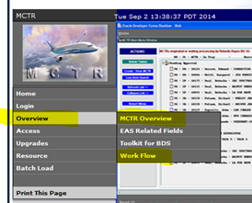 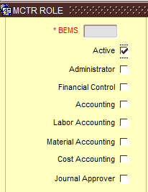 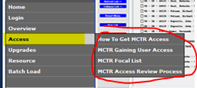

2. See the Access information on web site to learn how to sign-up in order to use the MCTR program.

In order to gain access to the MCTR, you need to fill out the MCTR ACCESS REQUEST form, get your manager to approve the form and send the approved form to the MCTR BU FOCAL for processing.

In order to locate the MCTR Access Request form using the MCTR Web Page, click the Access link and then click the How to Get MCTR Access sub-link. The Boeing Forms Library Window will pop up with the form. You may need to click the yellow box to download the form. Complete the form and route to your manager for approval who must route to the MCTR BU FOCAL. The MCTR web page link labeled MCTR Focal List (located as a sub-link to the Access Link just mentioned) that provides the name of focals by ABU. The MCTR BU FOCAL is responsible for providing requestors with access to the program and maintaining MCTR ROLE based on processed MCTR approved request forms.

Note 1: If you will get the following message: “You are not an active MCTR user, you will need to obtain access.

Note 2: The MCTR system will automatically email you after 75 business days of not logging into the program to remind you to renew your access. After 90 days you will lose your access. The system will send you another email when your access is inactivated. If you are not a registered MCTR user or your access has been inactivated, you are required to fill out the MCTR ACCESS REQUEST form if access to the program is needed.

**Mappings (MCTR to EAS Field to Field)**

|  |  |  |
| --- | --- | --- |
| **MCTR** | **EAS** | **Data Dictionary** |
| BU/GRP | bus_unit_gl_from | BU performing work on contract. |
| OH Base Year | ovrhd_base_yr_cd7 | Identifies current year for rates applied in MCTR |
| Activity_Id | Activity_Id | The Activity ID is an identifier which defines the lowest level of cost segregation related to a task as required by the contractual framework. The Activity ID will segregate actual cost expended, consistent with the program management performance measurement system. This field must be common across components, unique by product. |
| BUGL | business_unit_gl | BU who owns the contract |
| Project ID | project_id | An identifier which defines a method to aggregate and segregate cost, provides information necessary for revenue recognition, and provides visibility to bill for contract work as it progresses and is completed. Additionally, Project ID, in combination with hierarchical tree functionality, can be used to define rollups of Project Resource row information in levels as defined by the user. This field must be unique across components. S&E project id is located on level 3 of project main tree. |
| Account | Account | The Account is an identifier which is used to label an aggregation of values designed to track and collect costs and revenues across the corporation in order to capture, measure and report financial information. |
| Trn Type | proj_trans_type | Indicates the type of record; Labor, Material, Other, etc. |
| Trn Code | proj_trans_code | A further distinction of record type from the PROJ_TRANS_TYPE. Ex. 'STR' = straight labor, 'PRM' = premium labor. |
| UOM | unit_of_measure | A code which denotes a physical measurement or count of an item. |
| Home Dept | deptid_from | Department ID From is the home department. The home department identifies the assigned department of the employee who performed work and charged to the activity identified. Home department is a responsibility unit to which people and assets are uniquely assigned for management and custodial purposes. |
| Home LOC | home_location_cd7 | Home location is a unique geographical site where people and/or assets reside. |
| BU Fr | bus_unit_gl_from | BU performing work on contract. |
| Hm OH | ovrhd_alctn_cd_from | Code used to group overhead base and/or indirect expense information for use in the Overhead Allocation Process. Assignment is based on who performed the work. |
| Lbr Cd | labor_rate_cd7 | Identifies labor rate grouping and used to calculate labor averaging. The labor rate code groups departments of like skills and is ABU unique. |
| Cls Cd | class_cd7 | Class code is used to segregate labor and various types of compensation into multiple buckets. |
| Work Dept | deptid | Department ID identifies the work department. The work department is responsible for the actual work performed. Work department is an organizational unit to which people are uniquely assigned for management and budgetary purposes. |
| Work Loc | work_location_cd7 | Work location is a unique geographical site where work is performed. |
| Work OH | ovrhd_alctn_cd | Code used to group overhead base and/or indirect expense information for use in the Overhead Allocation Process. Assignment is based on work location. |
| RSC Cd | resource_sub_cat | The Resource SubCategory is used to segregate types of cost within work-in-process, some construction-in-process, and certain expense accounts (Factory Orders). It will be used for cost estimates, forecasts, cost analysis, calculation of overhead applications, value-added bases and Sales and Earnings. |
| WPD(BTU) | wpd_id7 | This field was not filled at the time of GL/PC implementation. It will be reserved for future use as a cost chargining mechanism to support Financial Controls and Program Business Management. It is intended that this field will become Activity ID after final source system conversions. The field will be common across components and unique by product. |
| Bulk Alctn | bulk_alctn_cd7 | A code assigned to control the allocation of pool labor over a specified base. This is component unique and assigned. Bulk allocation code is received from the A12+4 process. Currtently A12+4 creates this code and passes it to GL/PC.. |
| Casual ID | casual_id7 | Used for Material (4 characters) |
| EP/CEC Code | estmg_pricg_cd7 | Used for Material EAS edited field (4 characters) |
| PO# | PO# | Used for Material (16 characters) |
| Part# | res_user1 | Used for Material (23 characters) |
| Shop Order | res_user10 | Used for Material (10 characters) |
| PO Line | res_user11 | Used for Material (10 characters) |
| EPACS/CTT | res_user8 | Used for Material (10 characters) |
| Hours | resource_quantity | This field displays statistical values for data. May be used for data expressed as hours, headcount, square feet, etc. |
| Amount | resource_amount | Holds data values expressed in base currency. |
| **For Audit Trail Purposes Below:** |  |  |
| **All Sites excluding CG** |  |  |
| res_user2 | MCTR# |  |
| res_user3 | MCTR' |  |
| res_user4 | Line # |  |
| **CG = Long Beach** |  |  |
| res_user5 | MCTR# |  |
| res_user6 | MCTR' |  |
| res_user7 | Line # |  |

**The URL to production MCTR Web Page and MCTR Program Login Option**

The URL for MCTR is: https://mctr.web.boeing.com/home.htm

Microsoft Internet Explorer is the preferred browser.

Below is a screen print of the home page:

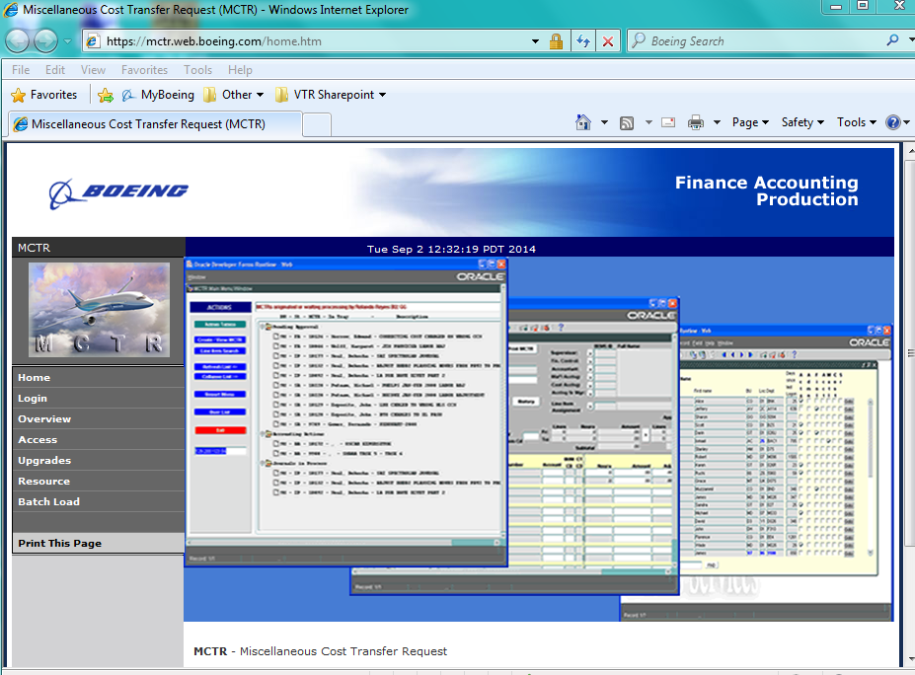

You can begin to use MCTR by clicking on the Login link>sub-link.

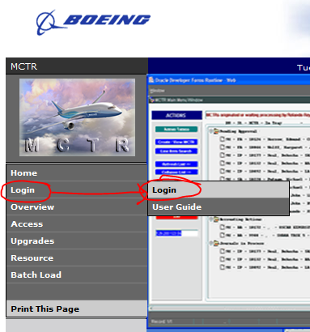 **WSSO Authentication**

As you can see from the screen print below, the system uses Web Single Sign On (WSSO) for user authentication. WSSO is a Boeing standard used by many common systems which eliminates the need for system unique ID/passwords. There are several choices you can use to authenticate yourself. The most common is Windows / Stable E-mail. This is how you most likely logged onto your PC.

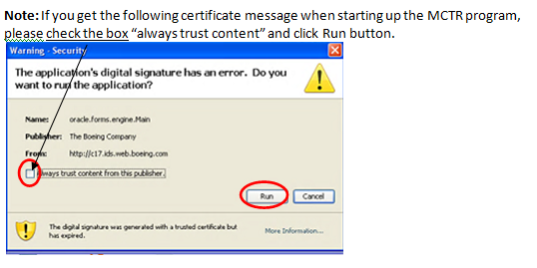

**Help Resources** (EHD)

1. It is best to have **Enterprise Help Desk (EHD) "Desktop**" Group if you are unable to log into the program. Desktop Prerequisites is to have Desktop Browser and **JAVA** software installed.

2. MCTR Web Page also is a good source for documentation including troubleshooting resources

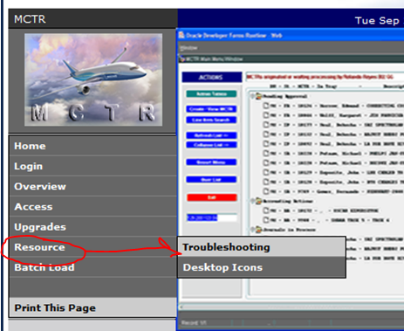

.

**MCTR Main Menu**

Once you have successfully completed the WSSO login, you will be presented with the MCTR Main Menu. There are 2 sections: Actions with buttons that will take you to additional screens, and a large display area that shows all of the MCTR entries that are applicable to you as the creator, approver, and/or processor of that MCTR.

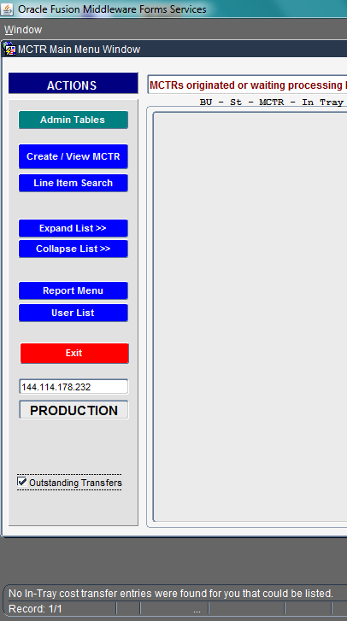

**Actions**

**Create / View MCTR**

You will primarily work under this section. It is here where all MCTRs will be created and viewed. We will go into more detail in the next section.

**Line Item Search**

This screen allows you to query line items directly bypassing MCTR header fields.

Example: Useful for finding what MCTRs were created for a specific Activity or department.

**Refresh List > >**

This button will refresh the listing of MCTRs on the right

**Collapse List > >**

This button will collapse the listing of MCTRs on the right to the Status level.

**Reports**

This button takes you to a report menu.

**User List**

Listing of all active and inactive MCTR users and profiles

**Exit**

This button exits you from the MCTR Oracle application and back to the home html page.

**IP Address**

Shows the IP address of your computing device this is connnected to Boeing’s network. This IP address is used in validation your access at time you selected to log into the MCTR program.

**Create / View MCTR**

The MCTR Oracle based application consists of various field and pull-down menus to help guide the user through the process of entering and editing a MCTR. It is recommended that you use the Tab Key to move through the fields and pull-downs. This will force you to enter the data in an order that is edit and validation friendly.

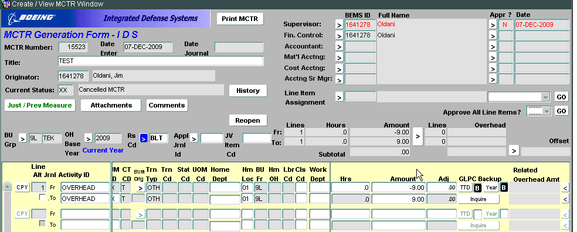

As of May 8th, 2009 additional fields were added to the Create/View MCTR screen, see picture below, to accommodate Material related transfers.





**Creating a MCTR**

From the MCTR Main Menu select the Create / View MCTR button. Before a MCTR can be saved in the system, three key fields have to be entered. They are Title, BU/GRP and OH Base Year. In addition, the Justification, Prevent Measure, Supervisor and Fin. Control approvers are required to submit the MCTR. Begin creating the MCTR by entering a title then press the <Tab> key. The cursor will now be on the BU/Grp button. Click on the button and select the value for the Business Unit GL From that you will be moving cost for. Only Business Units you have access to will be displayed.

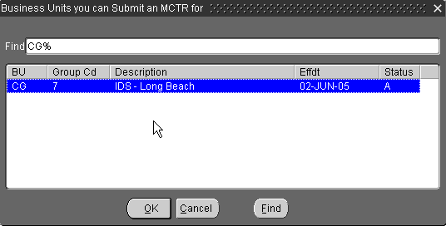

Press the <Tab> key. The cursor will now be on the OH Base Year list button >. Click on the button with your mouse or press the Enter key. The OH Base Year you will be moving cost from will be compared to this value. **(Note: Backup reports should select data using the OH Base Year, not the Fiscal Year. Hint: You can use the MCTR Backup report in the reports section of MCTR to analyze your transactions.)** The OH Base Year is also a factor in the labor and overhead rates used for calculating additional fields and rows of data. The values depend on the Business Unit selected and the Prior Year Overhead entries setup by your Accounting group. Contact accounting for the proper procedure for moving cost before the current year.

Select the year and click on OK.

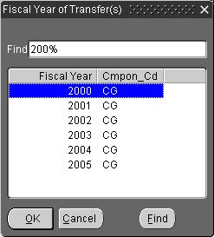

You have now filled out the three required fields and can save the entry. In the upper left hand corner is the save icon  . Click on it. You have now saved the MCTR in the Database. You will notice that additional information has been supplied in some fields. Fields in gray are supplied by the application. Fields in white are supplied by the user.

At this point you could exit the MCTR Create / view screen by clicking on the exit icon  . You can come back to this MCTR by double clicking on the document in the Main Menu.



**Finishing the Header Information**

***Required Approvals***

Press the Tab key. The cursor should now be on the > button next to Supervisor. Click on the button. A listing of all MCTR users will appear.

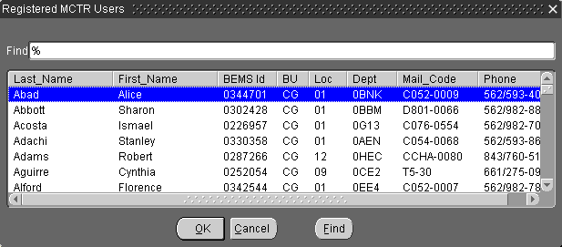

Start typing in the last name of your supervisor who should approve this MCTR. Double click on the name or single click and select OK to select the name into the Supervisor field. If your supervisor is not in the list then you or your supervisor willneed to obtain access see the MCTR home page Access Link. In addition, you can also contact your MCTR BU FOCAL for further guidance.

Tab to the Fin. Control > button. Repeat the selection process described above. This is a short list of MCTR user with the Financial Control role. If your Financial Control person is not listed than you probably do not know who your Financial Control person is. Contact your Financial Control person or the Accounting MCTR administrator to verify.

***Justification / Preventative Measure***

Underneath the Current Status fields, there are three buttons: Justification/Preventative Measure, Attachments and Comments.

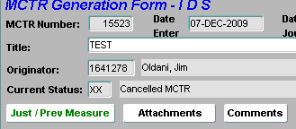

Let’s look at the **Justification/Preventative Measure Action** field. If the title on the button is red, that means that nothing has been written for this MCTR. If the color is green, then something has been written. Click on the button. The following window should appear.

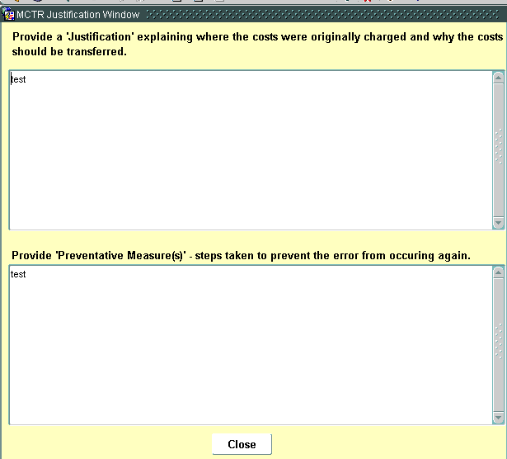

In this window you are to write a detailed explanation of why the cost transfer is taking place *and* the preventative measure action that will now take place as a result of it. Remember, Accounting is subject to random audits by our customer. It is mandatory that cost transfers include reasons that are justified and corrective actions that will ensure the transfers are not required again. You can use the standard Windows features of copy <Ctrl C> and paste <Ctrl V> to copy text from another document into this window. Once you have completed your write up, click on the **Close** button. You will be sent back to the MCTR Create / View screen. In fact, you will not be able to submit a MCTR for approval unless both boxes above are filled out with text.

***Attachments***

This is an area where additional documentation can be stored electronically in the database with the MCTR. Click on the **Attachments** button. The following window will appear:

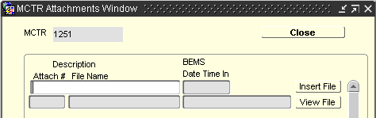

…

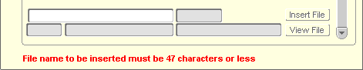

Type in a description on the first available entry. If no entries are available then press the insert record button  on the command bar. This will create a blank entry and push existing entries down (viewable using the vertical scroll bar). Next press the **Insert File** button. The following window showing your desktop and drive mappings will show up.

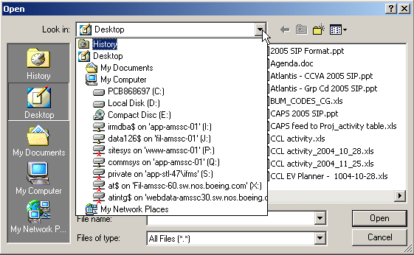

Find the drive and file to be uploaded. Double click or highlight and click the Open button. You will have to click through a few windows. You will now be taken back to the Attachment screen. The file name is system generated. This does not replace the name on your local drive or server. Also populated is the BEMS id of the person who made the insert and a date time stamp. If you do not see a file name, then the file did not get loaded. Check to see that the original file name is not longer than 47 characters. The **View File** button will display the attached document in a new browser window. If your browser or Windows Explorer does not recognize the extension of the file, you may be forced to save the document instead of opening the document. There is a known bug with the current combination of software where the new browser window comes up blank. Use the refresh button  or  to repaint the window. You can close the Browser window displaying the attachment when you are finished. Use the **Close** button on the attachment screen to return to the MCTR Create / View screen.

Deleting or Replacing a File

To remove a line item, click on the description field of the item to be removed. In the command bar click on the delete record  button. The Line will be blanked out. Click on the save  button.

To replace a file click on the **Insert File** button. The following window will appear:

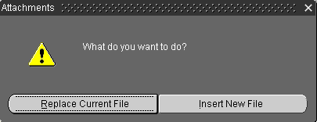

Select **Replace Current File** and repeat the steps for entering a new attachment. If you select **Insert New File**, you will be asked if you want to insert a new row.

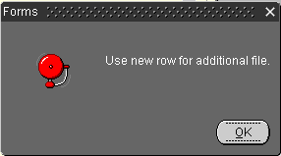

Click OK and you will be returned to the Attachment screen. Again, repeat the steps for entering a new attachment. On the MCTR Create / View screen, if no attachment exists, the title on the button is red. If an attachment exists the color is green.

***Comments***

Since the system will electronically route the MCTR for approval and processing, a comments section has been provided to keep track of any comments related to the life cycle of the MCTR. These comments will provide an electronic audit trail for future reference and audits. Click on the **Comments** button. The following will appear.

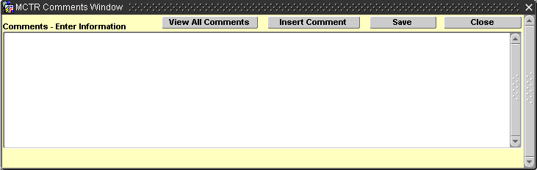

You can view all the comments related to this MCTR by clicking on the **View All Comments** button. To insert a comment, click on the **Insert Comment** button. After you have typed in your comments, click on the **Save** button. Once the comments are inserted, they can not be revised. Comments are visible to everyone who has access to MCTR. Be careful of the comments that are written. The comments will be date-time stamped and include the creator’s BEMS id and name.



Click on the **Close** button to return to the MCTR Create / View screen. On the MCTR Create / View screen, if no comments exists, the title on the button is black. If a comment exists the color is green. An example of when comments would be used is for an approver that rejects the transfer and needs to communicate to the originator.

**Reason Code**

The Business Unit the transfer is being done for may require you to select a Reason Code for Labor Transfers and if so the applicable code should be selected. Check with your MCTR BU FOCAL or business group to determine if you are required to populate this field.

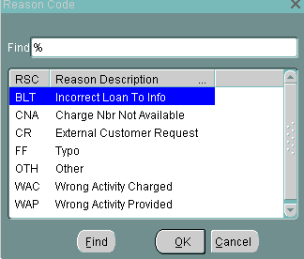

**Line Item Assignment**

An additional optional approver can be selected if desired. The approver must be an active user in the system. Line Item approver occurs after the Supervisor and before the Financial Control approver.

You can select 1 Line Item approver in the header portion of the MCTR or you can select at the individual detail line.



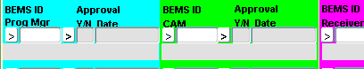

**Appl Jrnl Id/ Jv Item Cd & Accounting Related Approvals**

The Accounting organization is solely responsible for completing these fields on the header.



**Line Item Entry (From Side)**

In this section it will be important for a user friendly entry and validation sequence that you use the <Tab**>** key to move to the next field.

***Activity ID***

Type in the 8 digit Activity ID (CCN) in the first available line next to the right of the Fr label and under the Activity ID column heading. If no available line exists, then press the insert record button  on the command bar. This will create a blank entry and push existing entries down (viewable using the vertical scroll bar).

***> BUGL***

<Tab> to the > button to the left of the BUGL From field. Click on the button or press <Enter>. The application will verify that the activity is a valid value on the EAS Proj_Activity_7 table. If valid, a listing of all Project IDs and attributes that activity belongs to will be displayed. Typically there will only be 1 choice.

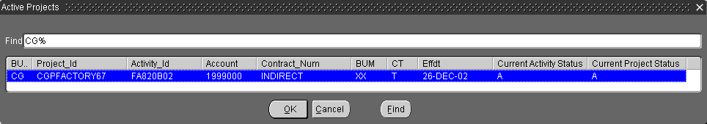

The majority of the time transfers are performed with active values. Some Business Units, with the proper approvals, will allow for an inactive value to be selected. Inactive values are represented by the “I” in either the Act Status and/or Proj Status field in the Active Projects pop up window. Once selected, the field is colored ‘Orange’ so that all downstream approvers know the selected value is inactive. Contact your MCTR BU FOCAL if an inactive value should be transferred.

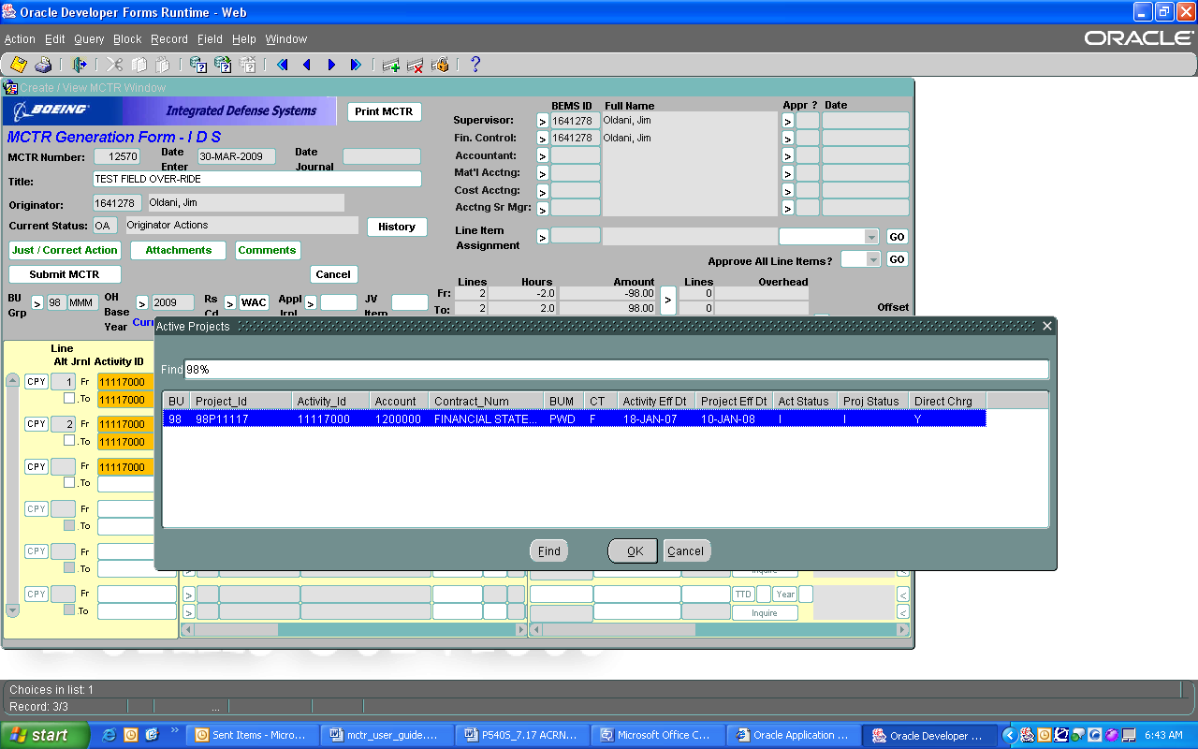

Double click or single click on the appropriate choice in the list and click on OK. The BUGL, Project ID, Account, Business Unit Management Code, and Customer Type will be populated on the line item.

When charging to an Overhead Project, you will type the 8 digit Activity Id. <Tab> to the > button to the left of the BUGL From field. Click on the button or press <Enter>. You will get a slightly different pop up window. Click Get List and single click on the appropriate choice in the list and click on OK. The BUGL, Project ID, Account, Business Unit Management Code, and Customer Type will be populated on the line item.

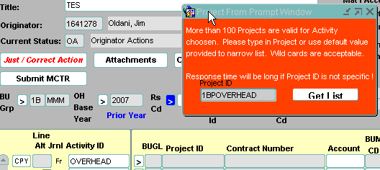

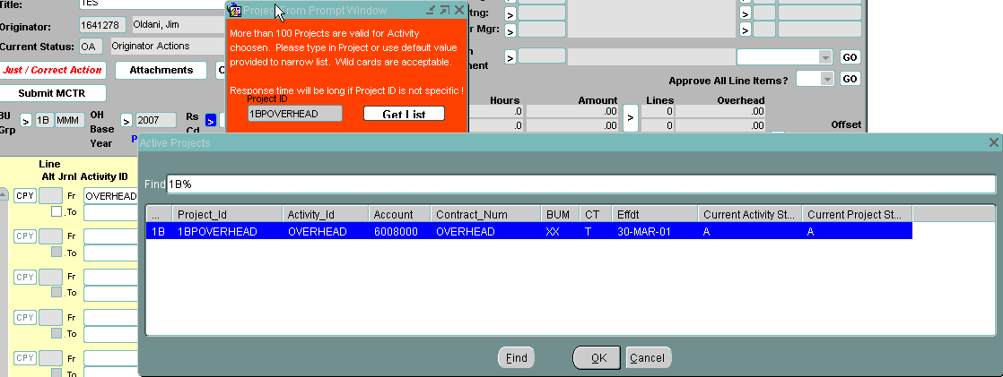

***Account***

<Tab> to the Account field. If the value is 1999000 or blank, you will need to provide the appropriate account for the activity you have selected.

**> Tran Type**

<Tab> to the **>** button before the Transaction Type field. Click on the button or press <Enter>. The following will appear:

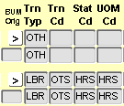 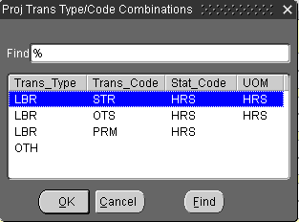

Select from the 8 choices {note some Business Units have additional Tran Types the MCTR BU FOCAL can assist you if other types should be chosen}:

LBR STR HRS HRS } Boeing Labor (0xx RSCs) – Straight Time

LBR OTS HRS HRS } Boeing Labor (0xx RSCs) – Overtime

LBR PRM HRS } Boeing Labor (0xx RSCs) – Premium

OTH } Other – Material, Outside supplier, etc. (non 0xx RSCs)

CNT } Contractor related (non 0xx RSCs)

MTL } Material (5xx RSCs)

TVL } Travel (6xx RSCs)

PYB } Accounts Payable related (non 0xx RSCs)

***Home Dept***

<Tab> to the Home Dept field. This field is necessary for Labor transactions. Some Other transactions do not have department values in GLPC. Enter the Home Dept value. After you <Tab> or leave this field, you will get a list of BU/Loc/Dept combinations for the department. Select the appropriate combo. No choice indicates the department is not valid. The Home Loc through RSC Cd fields will be populated based on your choice for Labor transactions.

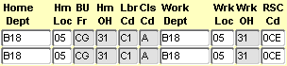

The majority of the time transfers are performed with active values. Some Business Units, with the proper approvals, will allow for an inactive value to be selected. Inactive values are represented by the “I” in the Current Status field in the Home Department Listing pop up window. Once selected, the field is colored ‘Orange’ so that all downstream approvers know the selected value is inactive. Contact your MCTR BU FOCAL if an inactive value should be transferred.

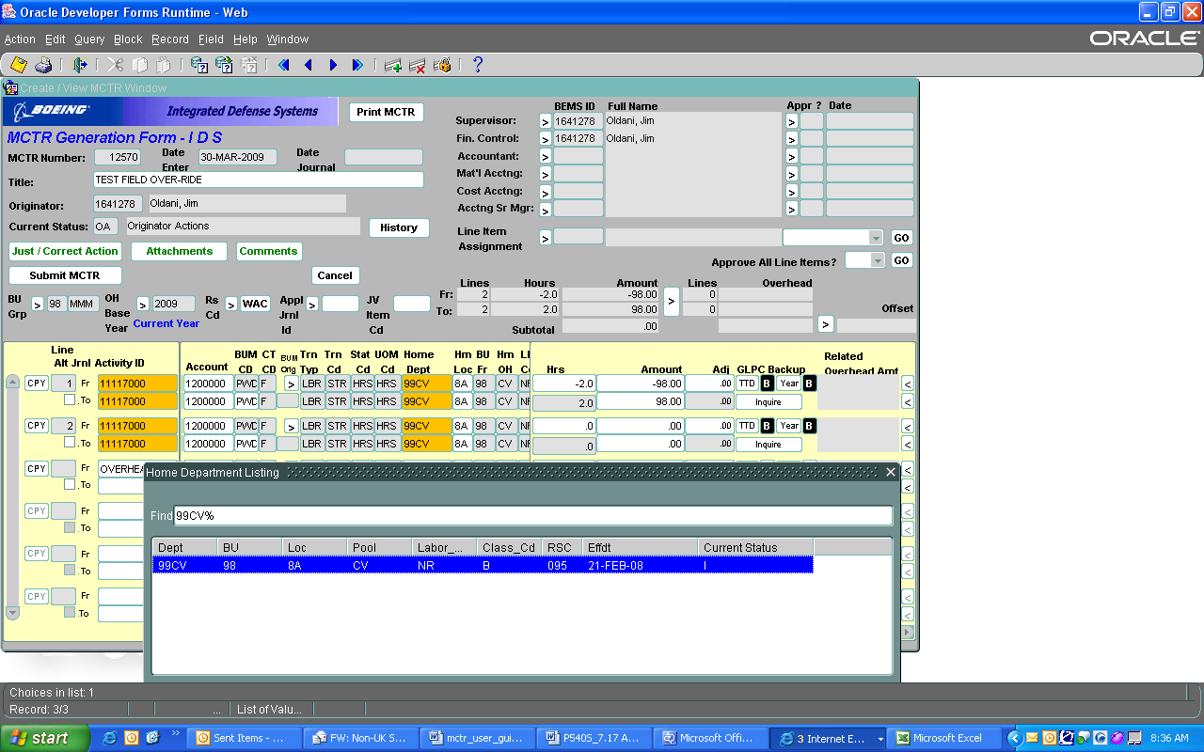

***Home Loc***

<Tab> to the Home Loc field. You may need to bypass the Home Dept field if you are transferring Other cost. Enter the Home Loc value. After you <Tab> or leave this field, you will get a list to validate your entry.

***Work Dept***

<Tab> to the Work Dept field. This field is necessary for Labor transactions. Some Other transactions do not have department values in GLPC. Enter the Work Dept value. After you <Tab> or leave this field, you will get a list of BU/Loc/Dept combinations for the department. Select the appropriate combo. No choice indicates the department is not valid. The Work Loc and Work OH fields will be populated.

***RSC***

<Tab> to the RSC field. This field should be populated on labor transactions after you select the Home or Work department. In some cases you may need to change this from a 0xx to a 6xx value. (eg. Travel Expense). Material transactions (OTH trans type) will require you to enter in a RSC value. After entry of this field you will given the description of the RSC value as confirmation that the correct RSC was choosen.

***Class Code (requirement based on BU profile)***

The Class Code is automatically populated based on the Home Dept and Home Loc selected which are required for LBR transfers. The system will either populate a value of ‘A’ or ‘B’ based on the RSC value selected. Check with your MCTR BU FOCAL to determine if the Business Unit you are transferring costs for should validate class code. If you are not required to validate class code please skip the remainder of this section it will not apply. If you are required to validate class code, you must know what the correct class code value is when entering the transfer. If the system default of ‘A’ or ‘B’ is not correct, tab to the class code field which is colored white and enter the appropriate value.

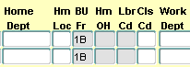

Class code is included in the validation of the data if the Business Unit you are transferring costs for requires it. This means that the GLPC Backup will take the field into consideration.

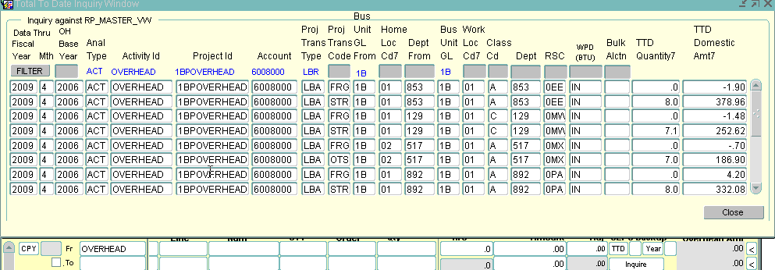

***WPD (requirement based on current year)***

The Work Package Detail (Basic Task Unit) field is only required for Current Year Direct Labor transactions. Optional for Prior Year Direct Labor. Non-Labor transactions will be left blank. The application will supply a value of ‘IN’ for Indirect Labor. On the From line enter the WPD value as entered into GLPC. On the To line you will need to select a value from a list. Click on the > button in front of the field. The following window will appear:

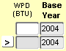 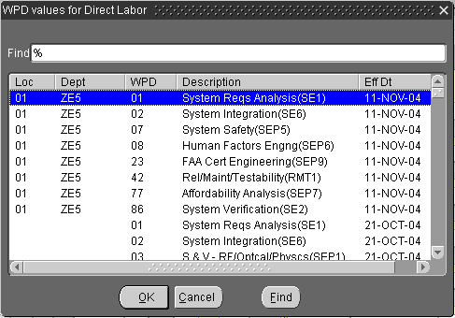

WPDs associated with the Home Loc/ Home Dept will be displayed at the top followed by all of the valid WPDs for direct labor. Double click or single click on the appropriate choice in the list and click on OK.

***Bulk Alctn (requirement based on BU profile)***

The Bulk Allocation code is only used when the Business Unit’s profile specifies that Bulk Allocation detail is required. The From code is not edited. The backup reports will indicate if the value exists with the other values in the line of accounting. The To code should be in the drop down list. On the From line enter the Bulk value as entered into GLPC. On the To line you will need to select a value from a list. Click on the > button in front of the field. The following window will appear:

 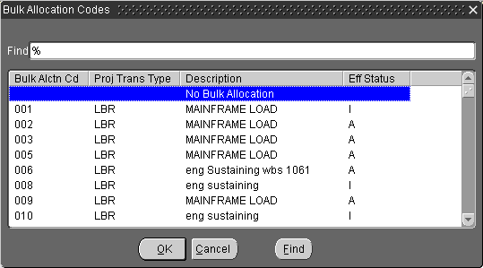

***Material Fields***

The following material fields may be required for material related transfers: Casual Code, CEC Code or Estimating & Pricing Code, PO Number, PO Line, Part Number, EPACS CTT, Shop Order, Material Quantity. To save keying time, you can CPY or Save (insert icon) to populate the values from these fields to the TO line. In addition, the Material Quantity if entered as -2.0 will automatically populate on the TO line as the inverse of 2.0. All fields entered do not require edits with the exception of the CEC Code or also known as the Estimating & Pricing Code. When you enter the 3 digit code and tab if a valid active value is keyed, the Estimating Pricing Code window will appear. Double click or single click on the appropriate choice in the list and click on OK.

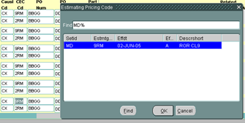

***CPY***

The **CPY** (Copy) button serves two purposes:

1. Copy an existing line item to a blank one.
2. Copy the From side of a line item to the To side
3. To copy an entire line item you must first be a blank line item below the line to be copied. If a blank line item is not available then place you cursor on the line # of the line item to be copied. Click on the Insert Record  button. This will insert a blank line item below the line item to be copied. Use the vertical scroll bar too view items that are not displayed in the window. Next click on the **CPY** button in the blank line item below the line item to be copied. All data except the hours and amounts will be copied. This is a good method if you have both Straight and Overtime hours that need to be moved. Enter Straight on one line item; use the copy button on the next line item; change the Proj Type to OTS and enter in the hours.
4. If you press the CPY button when data is already on the From side of the line item, the data on the from side will be copied to the To side. You will be given a second chance/backout window if data is already on the To side. This might be useful if little is changing between the From and To. Be sure to change something on the To side, otherwise you will be transferring cost to the same Line of Accounting resulting in a net zero change.

**Line Item Entry (To Side)**

<Tab> through the To side before you enter the Hours and Amount. The To side of the line items have similar functionality as the From side. Some values may be preset based on the From entries. For help, see the (From Side).

***Hours***

For labor transactions, enter the number of hours. If you are moving hours out of a Line of Accounting then you must put a negative sign (-) before the hours. Enter hours to the nearest tenth or one decimal position and <Tab>. The To side will automatically be assigned the credit amount.

***Amount***

MCTR will use current and year end labor rates to calculate the amount field for you on Labor transactions based on the Hours entry. For material (OTH) transactions you will need to enter the From amount. If you are moving cost out of a Line of Accounting then you must put a negative sign (-) before the amount. In some cases labor transactions using a 6xx RSC will not have hours to move and therefore you are allowed to enter the amount.

***Adj (adjustment)***

This field is for Accounting use only. Sometimes rounding and summation in GLPC can cause small discrepancies to the amounts MCTR calculates. This field allows the MCTR Accountant Approver to zero out these differences. You would enter comments in the MCTR Header asking the MCTR Accounting Approvers to Adjust.

**GLPC Backup**

MCTR will validate that the From side of your transaction exists in GLPC. 

The hours and amount will be compared to both the Total To Date (TTD) balance and the Year balance based of the Overhead Base Year you selected. Backup indicators will be recalculated when you save  the data. The following is the legend for the validation and is accessible by clicking on the TTD or Per indicator :

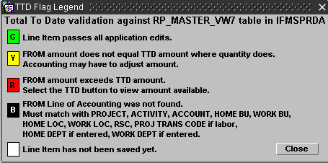

You should not submit a MCTR with a  or  indicator without advanced approval from accounting. MCTRs with these indicators will be rejected. A  will be adjusted by Accounting.

MCTR also provides the backup records from GLPC that were used for the validation. Click on the TTD  and/or Year  buttons to see the backup. The following windows will appear:



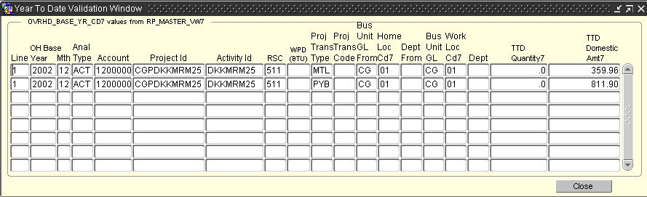

These backup rows of data are saved in the database with the MCTR. The backup data is captured at the time of entry and may update when changes are made to the transfer in a following month. When no more changes are made to the transfer and the resulting Journals are sent to GLPC, the backup data is frozen. Looking at the backup data for a previously created MCTR is representative of that time period, not the current period.

Use the **Close** button to return to the MCTR Create / View screen.

**Inquire**

 Press the Inquire button if you want to see all of the GLPC records that match the From line of accounting using the following columns in the selection criteria:

Analysis Type

Activity_id

Project_id

Account

Proj_Trans_Type

Bus_Unit_GL_From

Business_Unit_GL

You will get the following window:



You can then enter in additional values and use the Filter button to further limit the rows returned. This window is very useful if you get a  indicator for the TTD or Period backup. This window can help determine if you are using the wrong OH Base Year, Work Dept, WPD, Bulk, etc.

**Related Overhead Amount**

MCTR will calculate the Related Overhead Amount on all prior year entries.

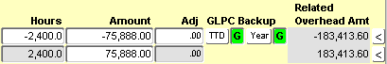

Users with Accounting roles can click on the < button to the right of the amount to see the actual records created to be sent toGLPC for the From and To sides of the transaction. The following window will appear (limited to Accounting roles):

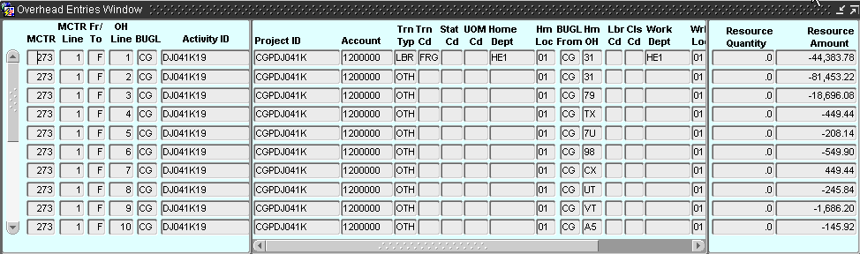

Click on the exit  button to return to the MCTR Create / View screen.

Overhead records created can also viewed from the Header section by clicking on the > button showed below.

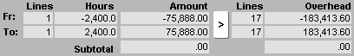

**Line Item Approvals**

It may be necessary to assign approvers to individual line items. There are 3 additional approval areas for each line item: Program Manager, Control Account Manager, and Receiving Manager.

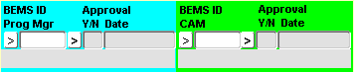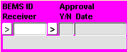

***Assignment***

To assign a person click on the > button under the BEMS ID title. A listing of all MCTR users will appear.



Start typing in the last name of who should approve this MCTR line item. Double click on the name or single click and select OK to select the name. If the person is not in the list then you or that person will need to send an E-mail request to your Financial control focal requesting MCTR access.

You can also use the Line Item Assignment in the Header section to assign a person to all line items.



Click on the first > button to select a person. Click on the  list box to select the approval area. Clicking on the **GO** button will make the assignment.

***Approval / Disapproval***

Click on the > button below the Approval title to approve or disapprove the individual line item.

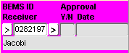

You may also approve/disapprove all line items that you have been assigned by using the Approve All Line Items in the Header section. Use the drop down list to select Yes or No. Click on **GO** to make the assignment.



**Header Action Buttons**

**Print MCTR**

Creates an Adobe .pdf file of your MCTR. The following window will appear for you to select what should be included. Notice that the Justification & Preventative Measure boxes are checked to default print both boxes. User has the option to uncheck both or one of them before printing, therefore, excluding from the print out.

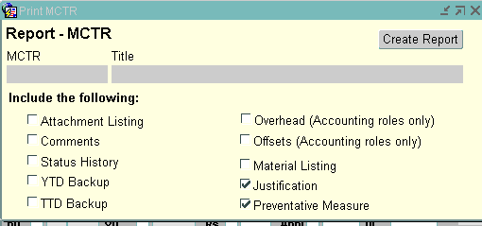

click on the exit  button to return to the MCTR Create / View screen.

**History**

This button shows the status history. The following window will appear:

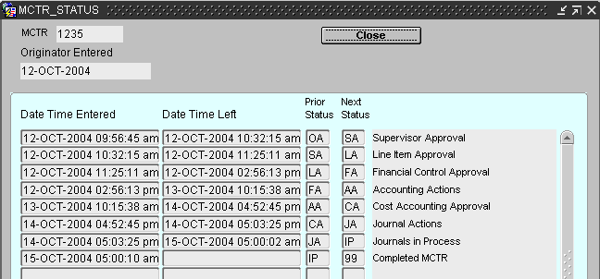

**Just / Correct Action** - Previously explained

**Attachments** - previously explained

**Comments** – previously explained

**Submit MCTR**

Originator can send MCTR from the OA or OR status to the next Status that requires approval. See Status Flow document on login page.

**Reset Approvals**

Originator can reset all Yes and No approvals to null and moves the MCTR from OR to OA status. See Status Flow document on login page.

**Recall**

Originator can move the MCTR from the SA, LA, or FA status to the OR status. The Accountant role can move the MCTR from the MA, CA, SR, or JA status to the AA status. See Status Flow document on login page.

**Cancel**

Originator can move the MCTR from the OA or OR status to the XX status. See Status Flow document on login page.

**Reopen**

Originator can move the MCTR from the XX to the OR status. See Status Flow document on login page.

**Journal**

Accountant role can move the MCTR from the JA to IP status and create the journal records to be sent to GLPC. See Status Flow document on login page.

**Unjournal**

Accountant role can move the MCTR from the IP to JA status and delete the journal records to be sent to GLPC. See Status Flow document on login page.

**Line Item Search**

You can query line item information using this screen without having to know header information.

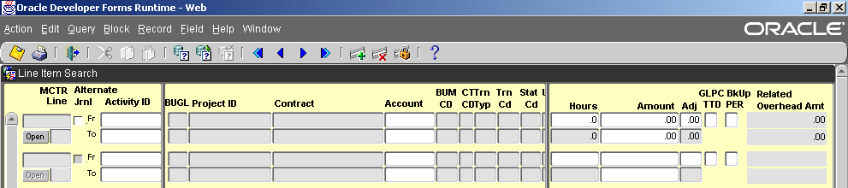

Use the query buttons  to initiate and execute a query. After records have been retrieved, you can go to the MCTR by clicking on the  button.

**Report Menu**

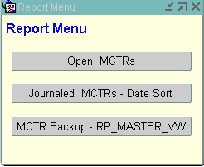

Click on the report you want to run. Results will be returned to your PC in the form of an Adobe Acrobat .pdf file. The results can be saved, E-mailed, and are printable. Unless you have the full Adobe product suite, they can not be modified.

The Open MCTRs reports will allow you to select a single bugl_from and run all open MCTRs at the time the report is run.

The Journaled MCTRs – Date Sort report will ask for a date range and optional Financial Control or Originator.

The MCTR Backup – RP_MASTER_VW report is provided so you can query the RP_MASTER_VW in GLPC. This is the same table used for the MCTR backup and status. Use the wildcard % for values you are uncertain.

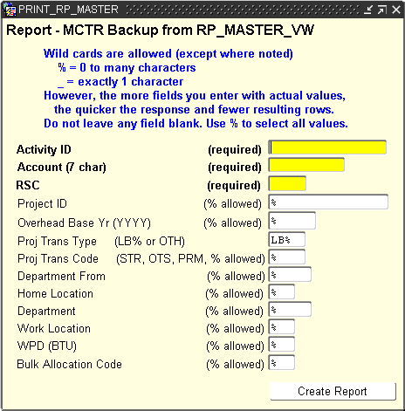

**User List**

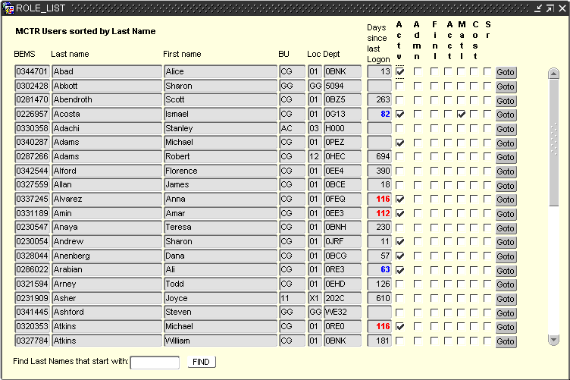

Use the field at the bottom of the window and Find button to find an MCTR user by last name. Use the Goto button at the end of the user’s record to get the user’s profile.

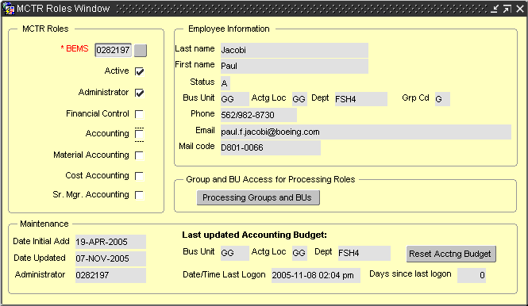

Click on the Processing Groups and Bus button to see what Business Units this MCTR user can process. You will get the following window:

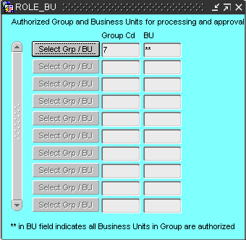

Only a user with the Administrator role  can insert or update records in the ‘Role’ tables.

**Appendix A - Using the Command Bar**



Save – Commits changes made on the screen to the Database

 or Action / Save

Print – Prints contents of window to local/NT printer

 or Action / Print

Exit – closes active window

 or Action / Exit

Enter Query – Puts you into a mode to enter search values for retrieving data. See *Enter Query Examples* document for examples and how to use wildcards and operators.

 or Query / Enter

Execute Query – Uses the values entered in Enter Query mode to retrieve records from database sequentially. Execute Query without Enter Query search values will retrieve all records sequentially.

 or Query / Execute

Cancel Query – Cancels the Enter Query mode

 or Query / Cancel

Previous Record – Retrieves previous record in the set of records Query retrieved

 or Record / Previous

Next Record – Retrieves next record in the set of records Query retrieved

 or Record / Next

Insert Record – Presents you with an empty screen to populate for a new entry into the database

 or Record / Insert

Delete Record – Removes data from current record displayed on screen

 or Record / Delete