1. Explain differences – Virtual Machine vs Docker Containers

-> Docker is container based technology and containers are just user space of the operating system
A Virtual Machine, on the other hand, is not based on container technology. They are made up of user space plus kernel space of an operating system

A Virtual Machine, on the other hand, is not based on container technology. They are made up of user space plus kernel space of an operating system
Ms, server hardware is virtualized. Each VM has Operating system (OS) & apps. It shares hardware resource from the host.

-> Under a VM environment, each workload needs a complete OS.
But with a container environment, multiple workloads can run with 1 OS.

-> Docker to isolate individual applications, and use Virtual Machines to isolate entire systems.

-> A Dockerized application is just a process that runs on your system. It doesn’t require running a Hypervisor (such as VMWare or VirtualBox), which means there’s no guest operating system to lug around. I do think there are reasons to use Virtual Machines nowadays, but they solve a different set of problems than Docker

-> Starting a virtual machine is more expensive in terms of time than starting a container.

-> containers are typically much smaller and faster, which makes them a much better fit for fast development cycles and microservices.
->Docker is basically using the OS-level virtualization, Linux namespaces and control groups, for example. Its overhead is very thin compared to a virtualization technique, like Hypervisor used by virtual machines.

->Containers and Docker are not in conflict with virtual machines; they are complementary technologies for distinct usages. VMs allow users to manage hosts by APIs and offer infrastructure elasticity. Docker allows users to define software as small lego blocks to assemble, so they embrace modern architectures: immutable infrastructures, microservices, distributed software, and more.

->VM’s are built for applications that are usually more static and don’t change very often. Whereas containers are more flexible and make it possible to easily and frequently update your containers. The line between VM’s and containers comes down to use case. But in the same breath I also mention that we run all of our apps in containers and VM’s so they actually complement each other very well.

2. Describe the Docker Workflow – [Docker File, Image, Container, Registry, Docker Engine etc.]

Docker workflow evolves, you will eventually collapse all of those steps into a single fluid workflow

- Orchestrate the deployment of images and creation of containers on production servers.
We talked about some of those steps already, but it is worthwhile to look at them again to see where deployment fits into the life cycle of getting Docker up and running.

At the most basic level, a deployment story must encompass two things:
- It must be a repeatable process. Each time you invoke it, it needs to do the same thing.
- It needs to handle container configuration for you. You must be able to define your application’s configuration in a particular environment and then guarantee that it will ship that configuration for each container on each deployment.
The Docker client itself can only talk to one server, so you need some kind of orchestration tool to support deployment at any scale. Docker’s Swarm tool, which we talk about in not available, solves the problem of talking to multiple servers, but you would still need additional tools to support items one and two above. You could script that behavior with shell scripting or your favorite dynamic language. As we mentioned earlier, you could also talk directly to the Docker Remote API, which is the API exposed by the docker daemon. If you have complicated needs, the Remote API might be the right solution since it exposes much of the power of the docker command line in a programmatically accessible way.

- Tools that treat this as an orchestration or deployment problem, replacing things like Capistrano, Fabric, and shell scripts.
- Tools that treat your network like a larger computer, implementing automatic scheduling and/or fleet management policies, typically replacing manual processes.
These tools generally provide the simplest way to get into production with Docker.
In this category are tools like:
- New Relic’s Centurion
- Spotify’s Helios
- Ansible’s Docker tooling
This class of tools in many cases requires the least infrastructure or modification to your existing system. Setup time is pretty minimal and the standardized nature of the Docker interface means that a lot of functionality is already packed into the tooling. You can get important processes like zero-down-time deployment right out of the box.
The second set of tools looks at Docker as a way to turn your network into a single computer by using a distributed scheduler. The idea here is that you define some policies about how you want your application to run and you let the system figure out where to run it and how many instances of it to run. If something goes wrong on a server or with the application, you let the scheduler start it up again on resources that are healthy.

Deployment Wrap-Up
Many people will start by using simple Docker orchestration tools. However, as the number of containers and frequency with which you deploy containers grow, the appeal of distributed schedulers will quickly become apparent. Tools like Mesos allow you to abstract individual servers and whole data centers into large pools of resources in which to run container-based tasks.
There are undoubtedly many other worthy projects out there in the deployment space. But these are the most commonly cited and have the most publicly available information at the time of this writing. It’s a fast-evolving space, so it’s worth taking a look around to see what new tools are being shipped.

Testing Containers
One of the key promises of Docker is the ability to test your application and all of its dependencies in exactly the operating environment it would have in production. It can’t guarantee that you have properly tested external dependencies like databases, nor does it provide any magical test framework, but it can make sure that your libraries and other code dependencies are all tested together.
shows what a common workflow looks like for testing Dockerized applications, including the following steps:
- A build is triggered by some outside means.
- The build server kicks off a Docker build.
- The image is created on the local docker.
- The image is tagged with a build number or commit hash.
- A container is configured to run the test suite based on the newly built image.
- The test suite is run against the container and the result is captured by the build server.
- The build is marked as passing or failing.
- Passed builds are shipped to an image store (registry, etc.).

3. What are the various states of Docker Container?

- created A container that has been created (e.g. with docker create) but not started
- restarting A container that is in the process of being restarted
- running A currently running container
- paused A container whose processes have been paused
- exited A container that ran and completed ("stopped" in other contexts, although a created container is technically also "stopped")
- dead A container that the daemon tried and failed to stop (usually due to a busy device or resource used by the container)

4. How Networking in Docker works?
->
There are three common Docker network types – bridge networks, used within a single host, overlay networks, for multi-host communication, and macvlan networks which are used to connect Docker containers directly to host network interfaces.

  - When you install Docker Engine it creates a bridge network automatically. This network corresponds to the docker0 bridge that Engine has traditionally relied on. When you launch a new container with docker run it automatically connects to this bridge network.
$ docker network ls

NETWORK ID NAME DRIVER SCOPE
17e324f45964 bridge bridge local
6ed54d316334 host host local
7092879f2cc8 none null local

Container Networking is an emerging application sandboxing mechanism used in home desktops and web-scale enterprise networking solutions similar in concept to a virtual machine. ... All applications inside the container are permitted to access or modify files or resources available inside the container only.

-> Container networks run on software platforms, such as Docker, that can be run on the cloud. ... They use the bare minimum of software and resources to run and use a router to direct traffic instead of a switch. Applications in a container are built out of microservices, which communicate through a virtualized network.

Use user-defined bridge networks
In this example, we again start two alpine containers, but attach them to a user-defined network called alpine-net which we have already created. These containers are not connected to the default bridge network at all. We then start a third alpine container which is connected to the bridge network but not connected to alpine-net, and a fourth alpine container which is connected to both networks.
- Create the alpine-net network. You do not need the --driver bridge flag since it’s the default, but this example shows how to specify it.
- $ docker network create --driver bridge alpine-net
- List Docker’s networks:
- $ docker network ls

- NETWORK ID NAME DRIVER SCOPE
- e9261a8c9a19 alpine-net bridge local
- 17e324f45964 bridge bridge local
- 6ed54d316334 host host local
- 7092879f2cc8 none null local
Inspect the alpine-net network. This shows you its IP address and the fact that no containers are connected to it:
$ docker network inspect alpine-net
Create your four containers. Notice the --network flags. You can only connect to one network during the docker run command, so you need to use docker network connect afterward to connect alpine4 to the bridge network as well.
$ docker run -dit --name alpine1 --network alpine-net alpine ash

$ docker run -dit --name alpine2 --network alpine-net alpine ash

$ docker run -dit --name alpine3 alpine ash

$ docker run -dit --name alpine4 --network alpine-net alpine ash

$ docker network connect bridge alpine4
Verify that all containers are running:
$ docker container ls
Containers alpine1, alpine2, and alpine4 are connected to the alpine-net network.

5. How Security is handled in Dockers?

- Docker work bench
- Use Seccomp (Secure Computing Mode) to restrict host syscall access
- Use SELinux to isolate containers
Use AppArmor security profile which protects an operating system and its applications from security threats

  - Docker Bench for Security is Docker's own script for checking code against dozens of best practices, including those for security. There are two main ways to use Docker Bench for Security, first to verify that the installation of Docker is following best practices,
  - second to confirm that each container running in the host is following best practices.

Create dockerBench.sh add following code

docker run -it --net host --pid host --userns host --cap-add audit_control \
-e DOCKER_CONTENT_TRUST=$DOCKER_CONTENT_TRUST \
-v /var/lib:/var/lib \

-v /var/run/docker.sock:/var/run/docker.sock \
-v /usr/lib/systemd:/usr/lib/systemd \
-v /etc:/etc --label docker_bench_security \
docker/docker-bench-security

$bash name_of_script.sh

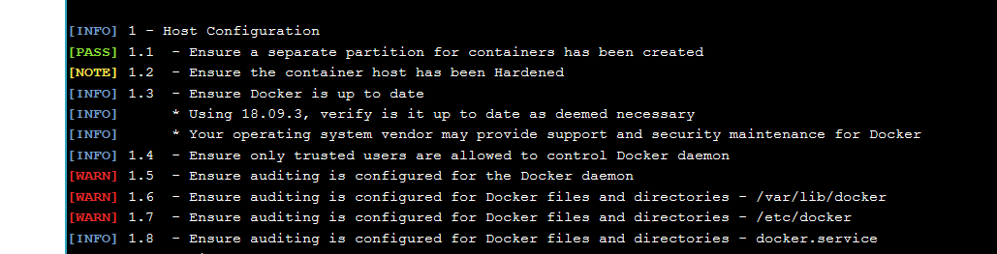

To address this, install audit . Audit is a Linux access monitoring and accounting subsystem that logs system operations at the kernel level. (If you are familiar with the Ubuntu flavor of Linux, then it is the same as auditd. Both enable the auditing of Docker's files, directories, and sockets.)
Using Alpine's package manager, add Audit.
$ apk add audit && apk update
Now, it's time to add the audit.rules
vim /etc/audit/audit.rules
It will be a blank file, so go ahead and add the following:
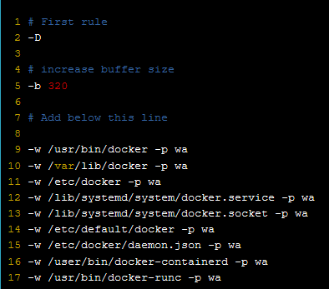
$ apk add openrc –update

Again run bash dockerbenh.sh

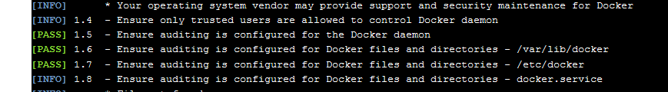

Apparomor:
Docker automatically generates and loads a default profile for containers named docker-default. The Docker binary generates this profile in tmpfs and then loads it into the kernel.

The docker-default profile is the default for running containers. It is moderately protective while providing wide application compatibility. The profile is generated from the following template.
When you run a container, it uses the docker-default policy unless you override it with the security-opt option. For example, the following explicitly specifies the default policy:
$ docker run --rm -it --security-opt apparmor=docker-default hello-world

To load a new profile into AppArmor for use with containers:
$ apparmor_parser -r -W /path/to/your_profile

Then, run the custom profile with --security-opt like so:
$ docker run --rm -it --security-opt apparmor=your_profile hello-world

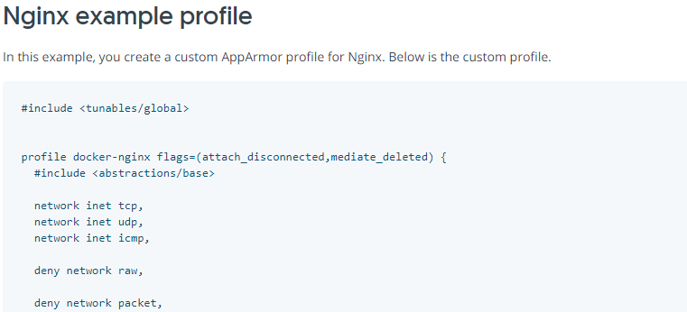

$ sudo apparmor_parser -r -W /etc/apparmor.d/containers/docker-nginx
docker run --security-opt "apparmor=docker-nginx" \
-p 80:80 -d --name apparmor-nginx nginx
docker container exec -it apparmor-nginx bash
root@6da5a2a930b9:~# ping 8.8.8.8
ping: Lacking privilege for raw socket.

root@6da5a2a930b9:/# top
bash: /usr/bin/top: Permission denied

root@6da5a2a930b9:~# touch ~/thing
touch: cannot touch 'thing': Permission denied

root@6da5a2a930b9:/# sh
bash: /bin/sh: Permission denied

root@6da5a2a930b9:/# dash
bash: /bin/dash: Permission denied

Docker seccomp

Secure computing mode (seccomp) is a Linux kernel feature. You can use it to restrict the actions available within the container. The seccomp() system call operates on the seccomp state of the calling process. You can use this feature to restrict your application’s access.
This feature is available only if Docker has been built with seccomp and the kernel is configured with CONFIG_SECCOMP enabled. To check if your kernel supports seccomp

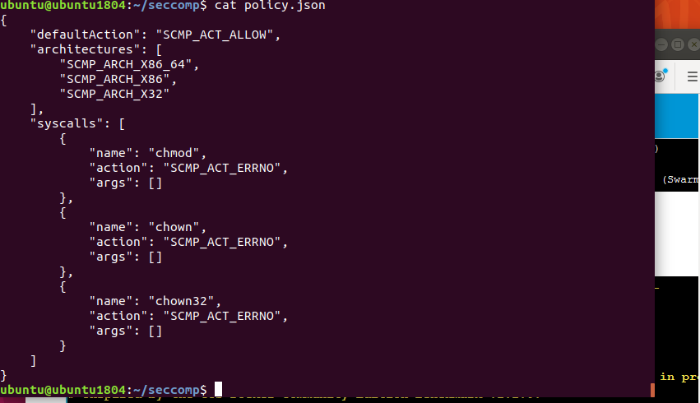

Sudo docker run –it –security-opt seccomp:policy.json alpine sh

Then try to do chmod, chown it will give error

Try strace ls for all the system calls related to ls, those can controled with seccomp

6. What is Docker Save and Load Commands?

Load

Extended description. Load an image or repository from a tar archive (even if compressed with gzip, bzip2, or xz) from a file or STDIN. It restores both images and tags. For example uses of this command, refer to the examples section below.

Save

Docker save Produces a tar file repo which contains all parent layers, and all tags + versions, or specified repo:tag, for each argument provided from image. Docker export Produces specified file(can be tar or tgz) with flat contents without contents of specified volumes from Container.

7. What is RUN vs CMD vs Entry point in Dockers?

RUN and CMD are both Dockerfile instructions. RUN lets you execute commands inside of your Docker image. These commands get executed once at build time and get written into your Docker image as a new layer. ... CMD lets you define a default command to run when your container starts.

RUN lets you execute commands inside of your Docker image. These commands get executed once at build time and get written into your Docker image as a new layer.
For example if you wanted to install a package or create a directory inside of your Docker image then RUN will be what you’ll want to use. For example, RUN mkdir -p /path/to/folder.
CMD lets you define a default command to run when your container starts.
This is a run-time operation, but you still need to re-build your Docker image to change what your CMD does. A running image is called a container btw.
For example, if you were creating a Dockerfile for your own web application, a reasonable CMD to have would be to start your web application’s app server.

- What is Docker Pull and Push?
Extended description. Use docker image push to share your images to the Docker Hub registry or to a self-hosted one. Refer to the docker image tag reference for more information about valid image and tag names. ... Progress bars are shown during docker push, which show the uncompressed size.

Docker enables you to pull an image by its digest. When pulling an image by digest, you specify exactly which version of an image to pull. Doing so, allows you to “pin” an image to that version, and guarantee that the image you're using is always the same. To know the digest of an image, pull the image first.

- What is Docker Commit?

Docker's commit command allows users to take a running container and save its current state as an image. ... The docker exec command is used to execute a command against a running Docker container.

- Develop Hello World Container for Java/Python/Node Js based simple application

Java example

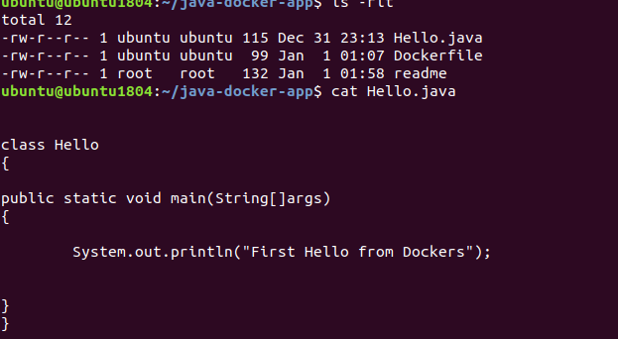

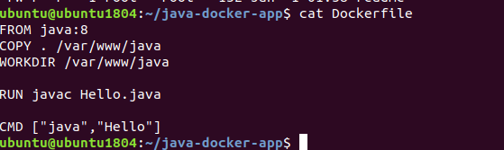

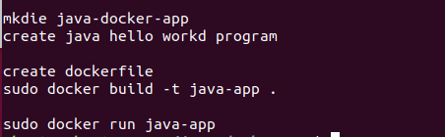

11. Spin a Container with Centos, Nginx and ensure Nginx running with a Hello World page

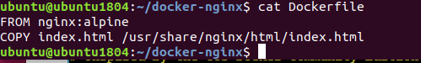

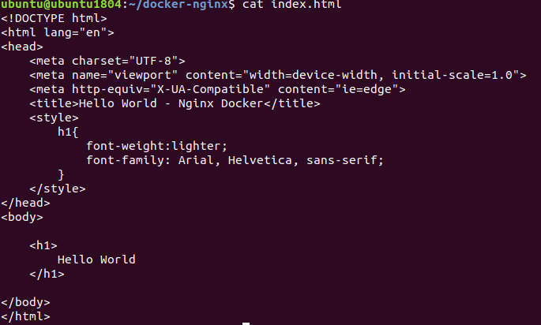

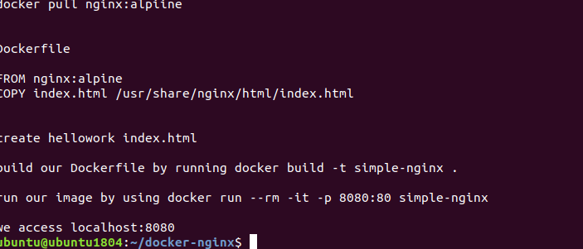

12. Spin an Ubuntu Container with Apache Web Server running and display Hello World page

curl -fsSL https://get.docker.com | sh

check docker service status
# systemctl start docker
# systemctl status docker
sudo docker run -dit --name tecmint-web -p 8080:80 -v /home/user/website/:/usr/local/apache2/htdocs/ httpd:2.4
sudo docker ps
# vi /home/user/website/docker.html
<!DOCTYPE html>
<html lang="en">
<head>
<meta charset="UTF-8">
<title>Learn Docker at Tecmint.com</title>
</head>
<body>
<h1>Learn Docker With Us</h1>
</body>
</html>
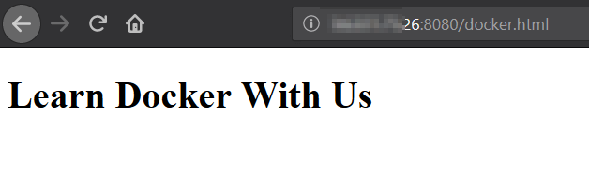

- Show an end-to-end example using Docker Compose with at least two Containers [Frontend and Backend]

