MANTHAN RAG — Multi-Store Ingestion Verification
Evidence Report: research document type correctly routed to document_store, with verified retrieval
Prepared: 13 July 2026 | Schema: manthan_rag_working

1. Purpose
MANTHAN is a multi-store Retrieval-Augmented Generation (RAG) system. During ingestion, each document is classified by type and routed to a type-specific PostgreSQL store (Supabase + pgvector) so that retrieval can be optimised per document category. This report provides screenshot evidence, captured directly from the Supabase Table Editor, that a document classified as document type “research” was correctly parsed, chunked, embedded, and stored in the dedicated document_store table — confirming that the multi-store routing logic is functioning as designed.

2. Multi-Store Routing (for reference)
Document Type | Primary Store | Notes
policy | vector_store | Semantic chunks with HNSW indexing
financial | table_store + vector_store | Tables as JSON + markdown; text chunks separately
legal | clause_store | Clause-level rows with risk_level, parties, key_dates (JSONB)
research | document_store | Chunks with citation / section metadata (this report)

3. Evidence: document_store Table Contents
The Supabase Table Editor view below shows the document_store table under schema manthan_rag_working. The table currently holds 38 records for the ingested research document (document_id beginning 871daa5d-5f28-4b42-87f2-279…). Each row is one chunk of the source document, sequentially numbered via chunk_index (0–37), with chunk_type marked “body” and readable chunk_text content preserved, e.g. “System performance metrics…”, “Intel Xeon 6787P VS Intel Xeon…”, “Embedding Throughput…”, “Standard Retrieval Augmented…”, and “Evaluation Metrics & Model Se…” — consistent with a technical/research paper covering RAG system performance and hardware comparisons.
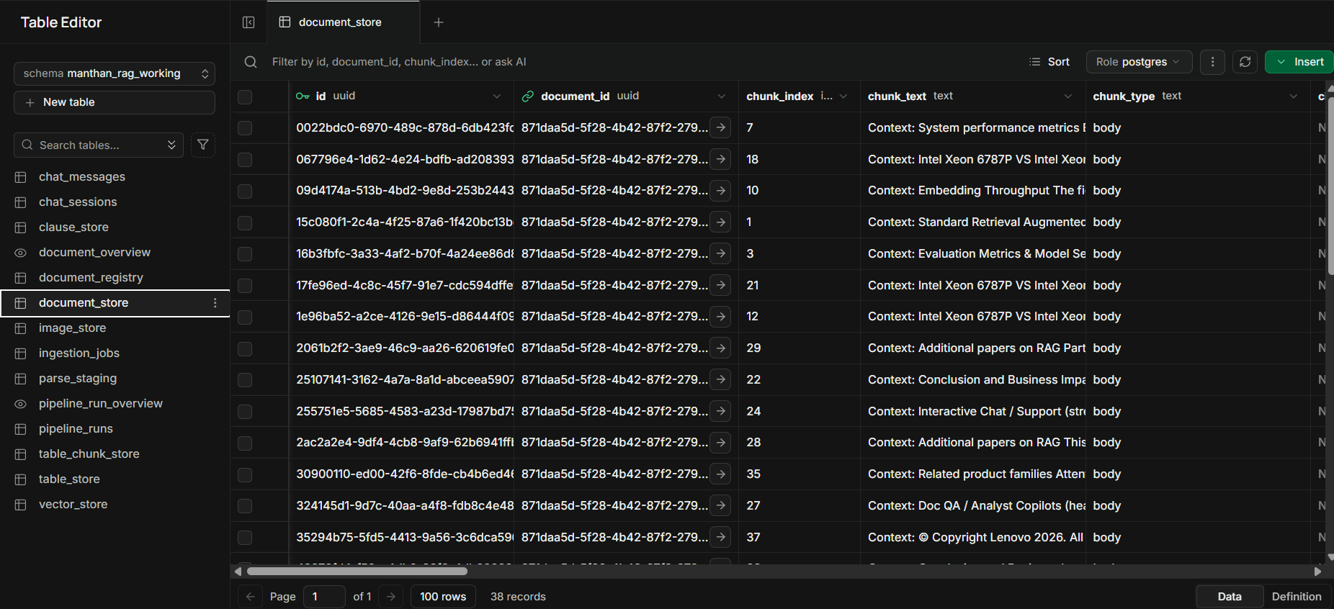
Figure 1 — document_store table: id, document_id, chunk_index, chunk_text, chunk_type columns (38 records)

4. Evidence: Embeddings & Chunk Metadata
Scrolling right in the same table confirms the remaining pipeline stages completed successfully for every chunk:
- embedding (vector) — populated with 1024-dimension BGE embeddings (BAAI/bge-large-en-v1.5) for each chunk.
- chunk_metadata (jsonb) — structural metadata such as block_types (paragraph, list) and section_path is preserved per chunk.
- created_at (timestamptz) — all rows stamped 2026-07-13 12:01:08, confirming a single, consistent ingestion run.
- chunk_text_tsv (tsvector) — full-text search vectors generated alongside the embeddings.
- from_image_store (bool) — FALSE for all rows, correctly indicating these are native text chunks, not image-derived chunks.
- source_image_id — NULL for all rows, consistent with from_image_store = FALSE.
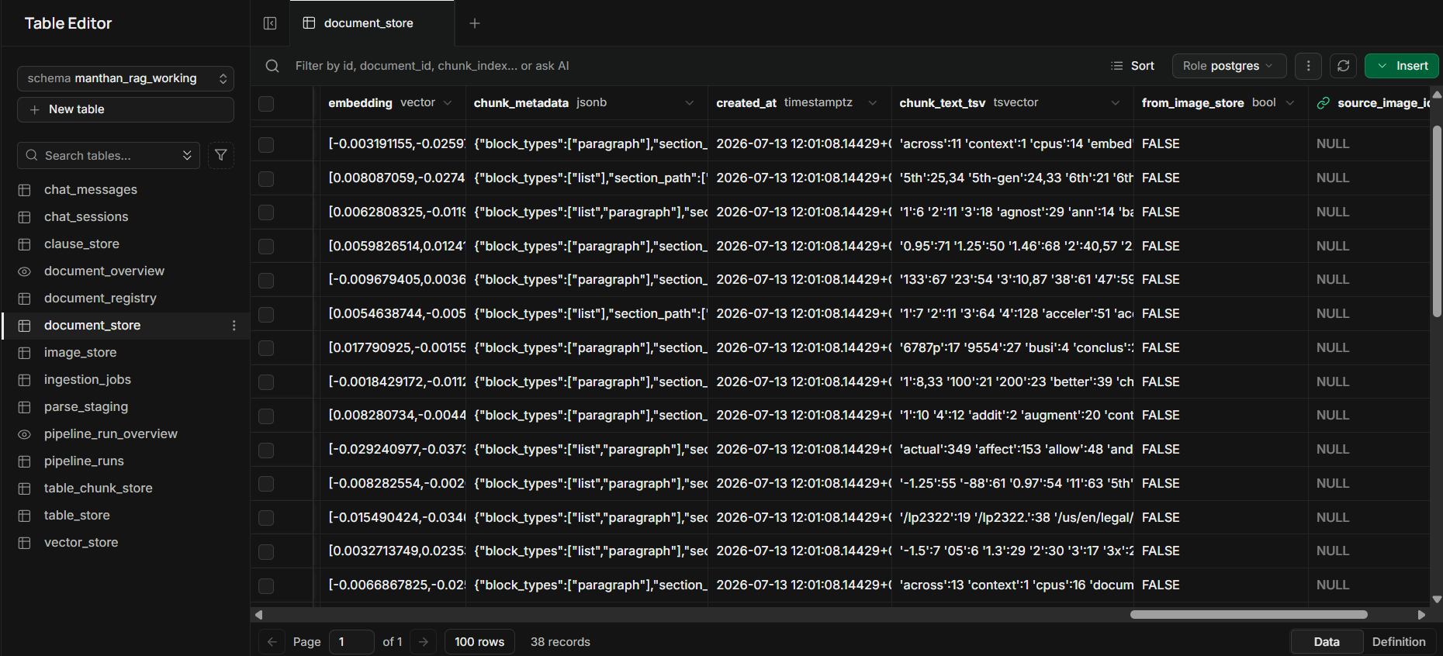
Figure 2 — document_store table: embedding, chunk_metadata, created_at, chunk_text_tsv, from_image_store, source_image_id columns

5. Query Test — End-to-End Retrieval Verification
To confirm retrieval quality (not just storage), the source document Lenovo_Research.pdf was queried directly through the Document Chat interface using the question: “What is the Embedding Speed of Xeon 6787P with IPEX?”

5.1 Source Content (Lenovo_Research.pdf)
Figure 3 below is the relevant chart from the original source document — “Embedding Speed Across Different Embedding Model and CPU” — showing throughput (samples/sec) for the Xeon 8592+ and Xeon 6787P CPUs, each with IPEX, across two embedding models (Alibaba-NLP/gte-base-en-v1.5 and sentence-transformers/all-MiniLM-L6-v2).
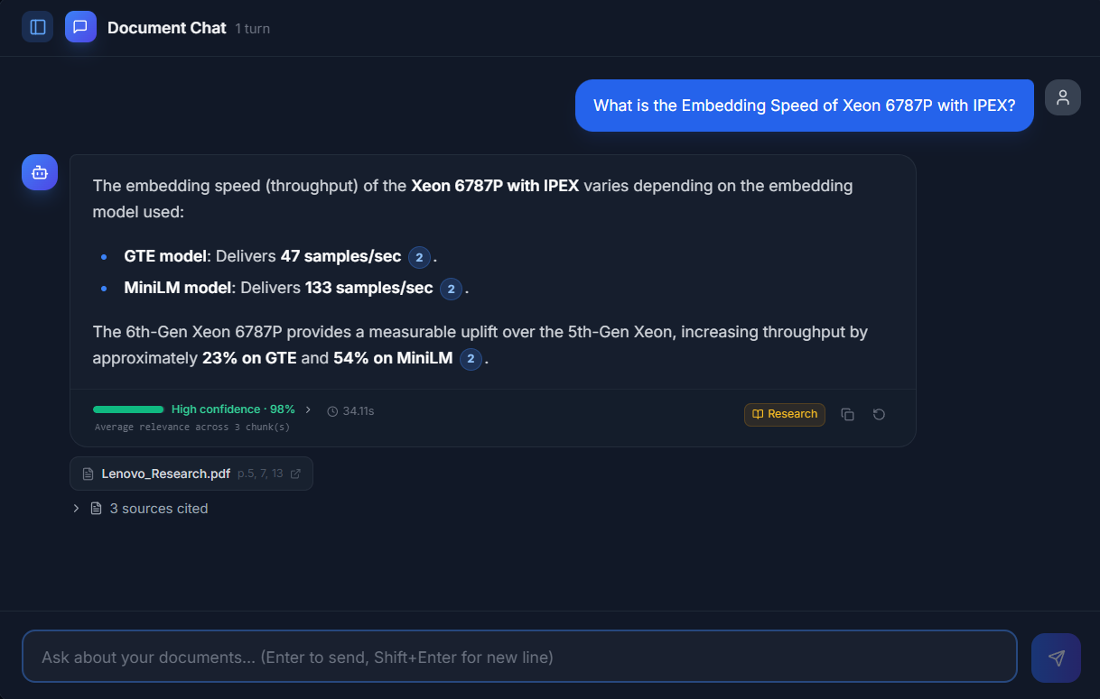
Figure 3 — Source chart from Lenovo_Research.pdf: Embedding Throughput by model and CPU

5.2 Query & Retrieved Answer (MANTHAN Document Chat)
The screenshot below shows the actual chat response returned by the query pipeline for the question above:
- Answer accuracy — the system correctly returned 47 samples/sec for the GTE model and 133 samples/sec for the MiniLM model on Xeon 6787P with IPEX, matching Figure 3 exactly, and correctly derived the ~23% (GTE) and ~54% (MiniLM) uplift versus the 5th-Gen Xeon 8592+.
- Correct source attribution — the citation panel identifies Lenovo_Research.pdf, pages 5, 7, 13, with 3 sources cited, confirming the answer was grounded in the correct ingested document rather than a hallucination.
- Correct document-type tag — the response is labelled with the “Research” badge, confirming the query was correctly routed to / retrieved from the document_store (the store verified in Sections 3–4 of this report).
- Confidence & latency — High confidence (98%), average relevance across 3 chunks, with a 34.11s end-to-end response time.
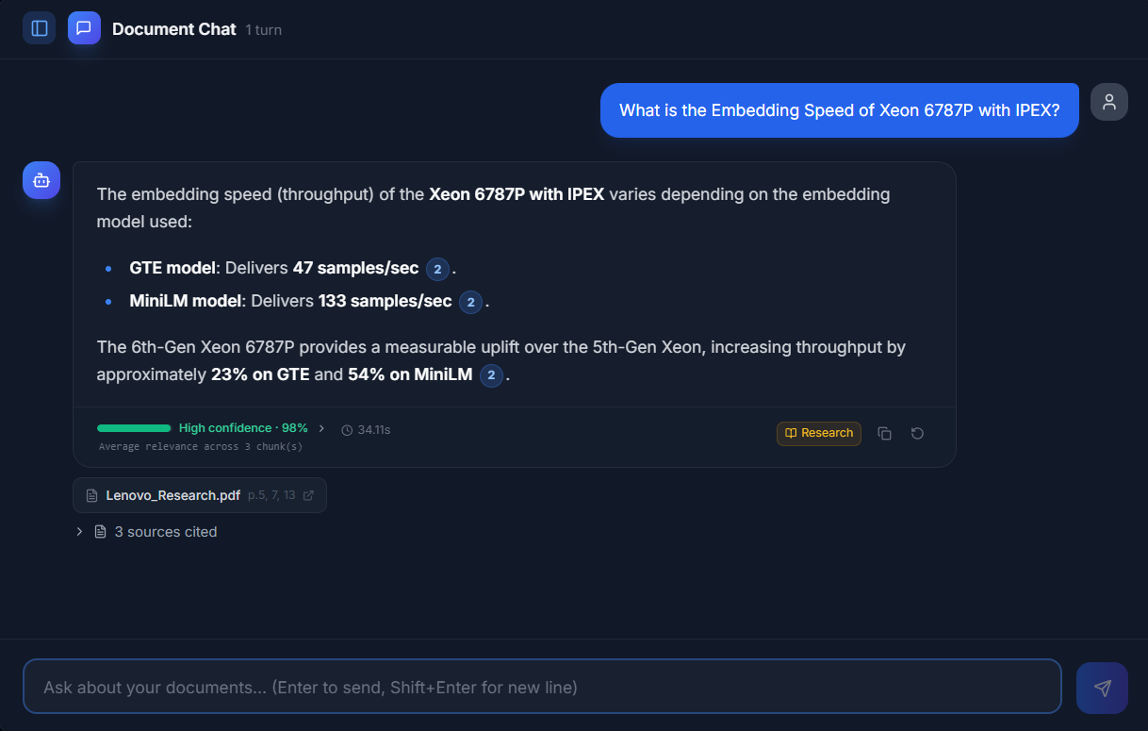
Figure 4 — Document Chat: query and generated answer, correctly cited to Lenovo_Research.pdf (Research)

6. GraphRAG (Neo4j) Verification
Beyond the Postgres/pgvector stores, MANTHAN maintains a knowledge graph in Neo4j: entities (people, products, organisations, concepts) and typed relationships are extracted from every ingested chunk and merged into a graph, alongside Louvain community clusters used for aggregation-style questions. This section verifies that (a) the graph was actually built from the ingested research document, and (b) an entity-based question is correctly routed to the graph, retrieves the right node/relationship, and is labelled accordingly in the UI.

6.1 Knowledge Graph Built from the Ingested Document
The Neo4j Browser view below (query: MATCH p=()-[]->() RETURN p LIMIT 5000) shows the graph after ingesting Lenovo_Research.pdf alongside other documents: 808 nodes in total — 491 Entity nodes, 313 Community nodes, and 4 Document nodes — connected by 1,802 relationships spanning many typed relations (MENTIONED_IN, IN_COMMUNITY, COMPARED_TO, COMBINED_WITH, APPLIED_TO, BASED_ON, and more). Entities visible in this view — Qwen-4B, MiniLM, 6th-Gen Xeon, 5th-Gen Xeon, AMD EPYC Processor, Intel 5th Gen(eration), Large Language (model) — are all names pulled directly from Lenovo_Research.pdf, confirming the extraction pipeline populated the graph correctly from this document's content, not just placeholder/test data.
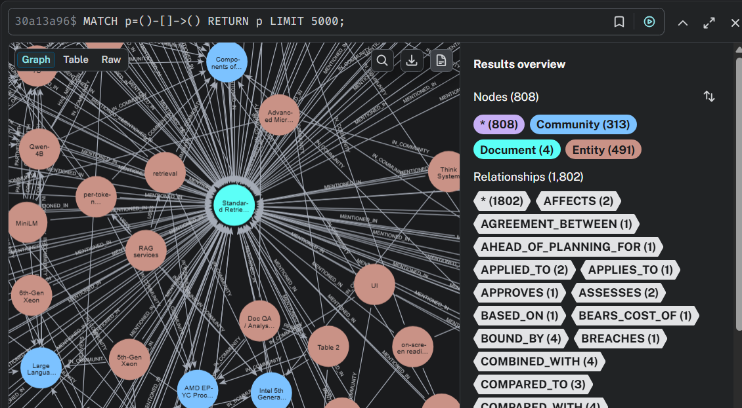
Figure 5 — Neo4j Browser: full knowledge graph (808 nodes / 1,802 relationships) including entities extracted from Lenovo_Research.pdf

6.2 Entity-Based Query Routed to the Graph
The question “Who is Kelvin He and what is his role at Lenovo?” names a specific person entity (the paper's author, page 15) rather than a generic topic, so the query router correctly detected it as entity-based and consulted the graph. The response badges show both Research (the underlying document_store chunk) and Graph +6 (six additional chunks pulled in via Neo4j entity-neighborhood expansion) — confirming the graph genuinely contributed context beyond plain vector search, not just a cosmetic label. The answer itself — “Kelvin He is an AI Data Scientist at Lenovo” — is correct and cites Lenovo_Research.pdf, pages 1 and 15.
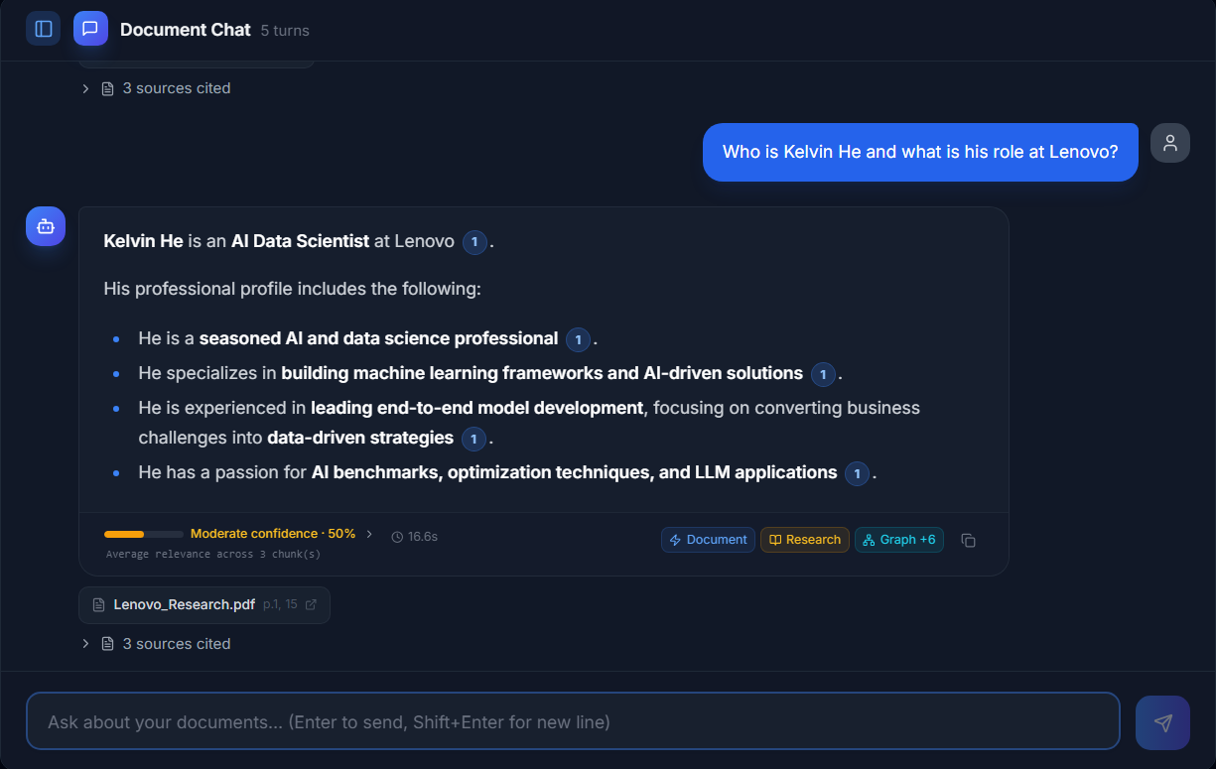
Figure 6 — Document Chat: entity-based question answered with Research + Graph +6 badges, correctly cited

6.3 Underlying Graph Node & Relationship
Drilling into Neo4j directly shows the exact edge that grounded the answer above: (Lenovo)-[:WORKS_AT]->(Kelvin He), extracted with confidence 1.0 and description “Kelvin He is an AI Data Scientist at Lenovo.” The relationship's properties trace directly back to source page 15 (page_numbers: [15]) and the source document (Standard Retrieval Augmented Generation on Intel: From Search to Answers) — a one-to-one match with the citation shown in the chat response in Figure 6. This confirms the full chain works end-to-end: ingestion extracted the correct entity relationship, the router correctly identified this as a graph-answerable question, the graph returned the right node, and the UI correctly labelled the result as graph-sourced.
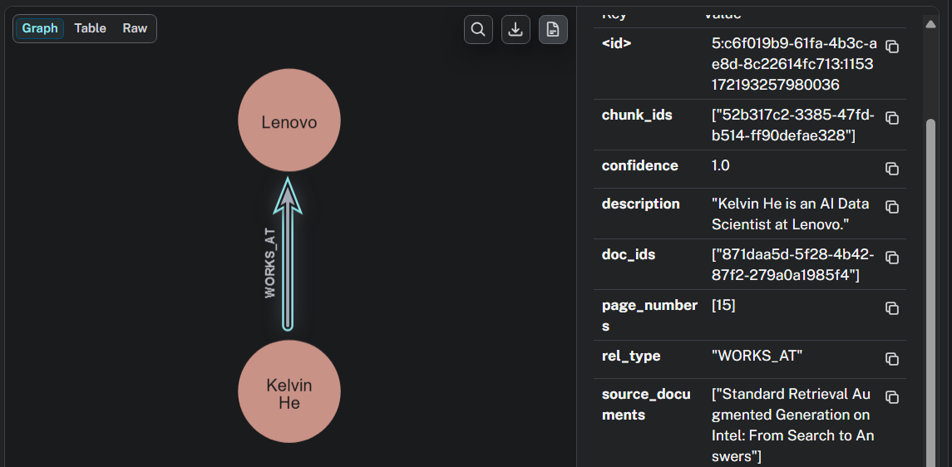
Figure 7 — Neo4j: the (Lenovo)-[:WORKS_AT]->(Kelvin He) relationship that grounded the Figure 6 answer

6.4 Additional Entity-Based Test Coverage
To confirm GraphRAG works consistently across different entity types — not just the single person-entity case in Section 6.2 — four further questions were run against Lenovo_Research.pdf, covering a CPU/superlative lookup, a system-configuration lookup, and a processor-specific relationship lookup. In every case the Graph badge appears alongside the relevant store badge (Document/Research/Table), and the returned figures were checked against the source document.
Question | Answer (verified against source) | Badges / Confidence
Compare the Intel Xeon 6787P and Intel Xeon 8592+ processors in terms of TTFT for Qwen3-4B-Instruct-2507. | 1.46 s (8592+) vs 0.95 s (6787P), ~35% reduction — matches page 11 exactly. | Research, Graph +9 — High confidence 94%
Find the CPU that has the highest embedding throughput and list the embedding models it was tested with. | Intel Xeon 6787P; GTE 47 samples/sec, MiniLM 133 samples/sec — the highest of all four CPUs benchmarked on both models (Figures 2 & 3, page 5). | Research, Graph +7 — High confidence 89%
What CPU and memory configuration does the Lenovo ThinkSystem SR675 V3 use? | AMD EPYC 9554, 64 cores/128 threads @ 3.75 GHz; 24×64GB DDR5 @6400GH — matches Table 3, page 14 exactly. | Document, Table, Graph +7 — Good confidence 73%
Which embedding models were benchmarked on the AMD EPYC 9554 processor, and what were their throughput numbers? | gte-base-en-v1.5: 8 samples/s; MiniLM-L6-v2: 58 samples/s — matches Figure 2, page 5 exactly. | Table, Research, Graph +4 — High confidence 87%

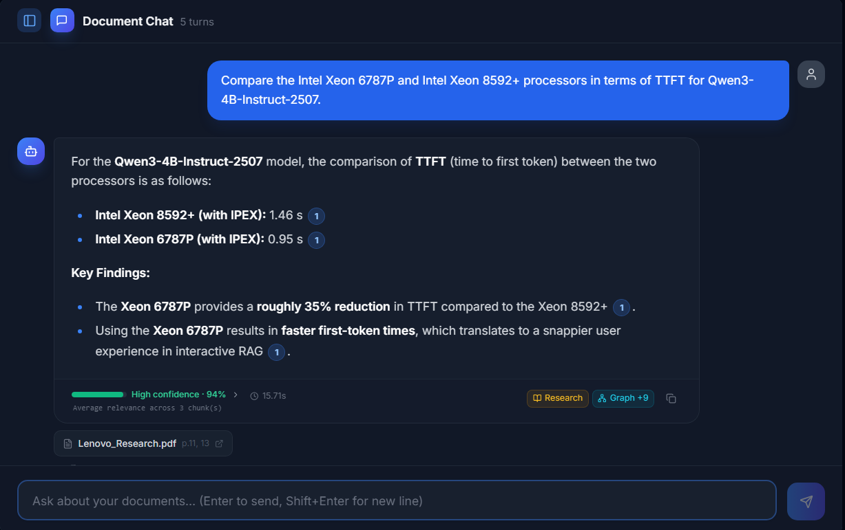
Figure 8 — TTFT comparison — Intel Xeon 6787P vs 8592+ (Qwen3-4B-Instruct-2507)
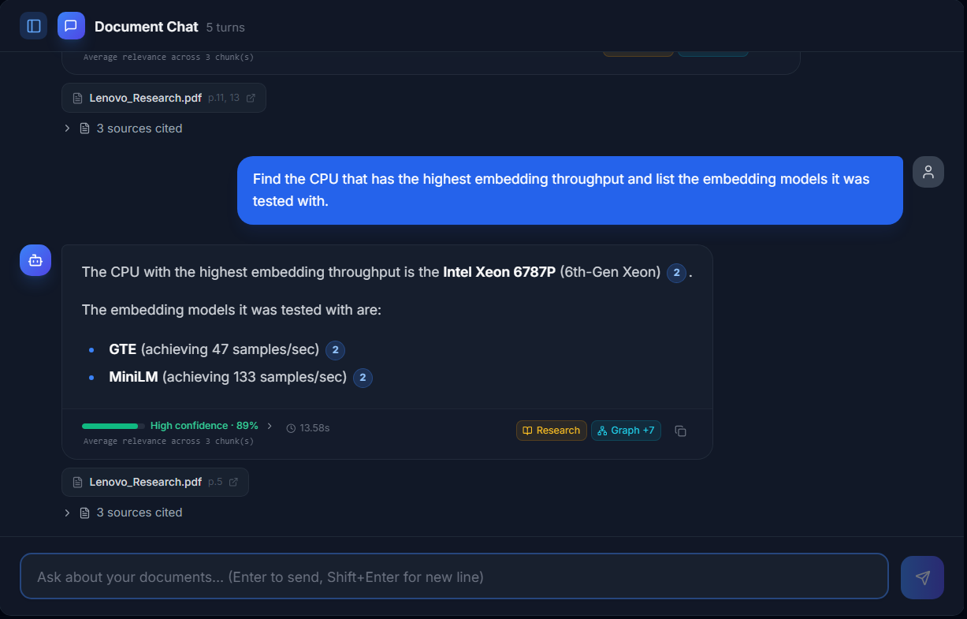Figure 9 — Highest embedding throughput lookup — Intel Xeon 6787P identified correctly

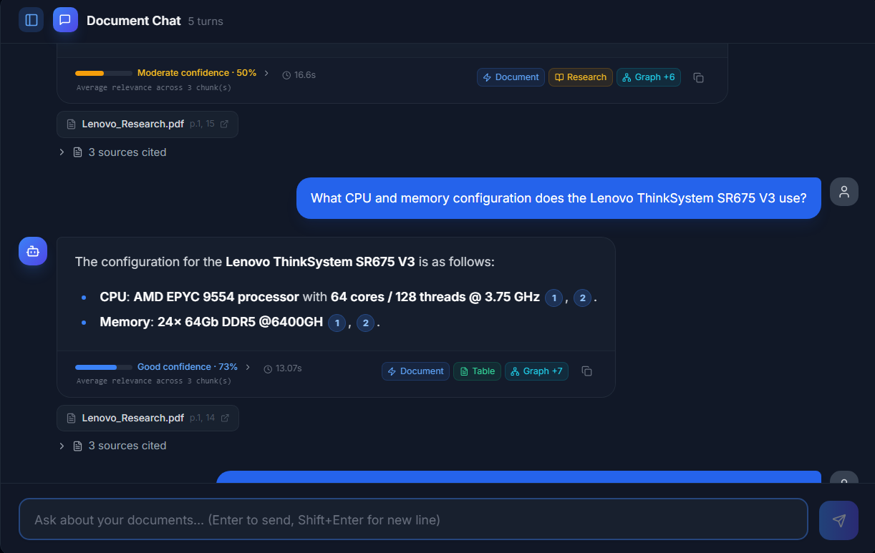
Figure 10 — Lenovo ThinkSystem SR675 V3 — CPU & memory configuration lookup
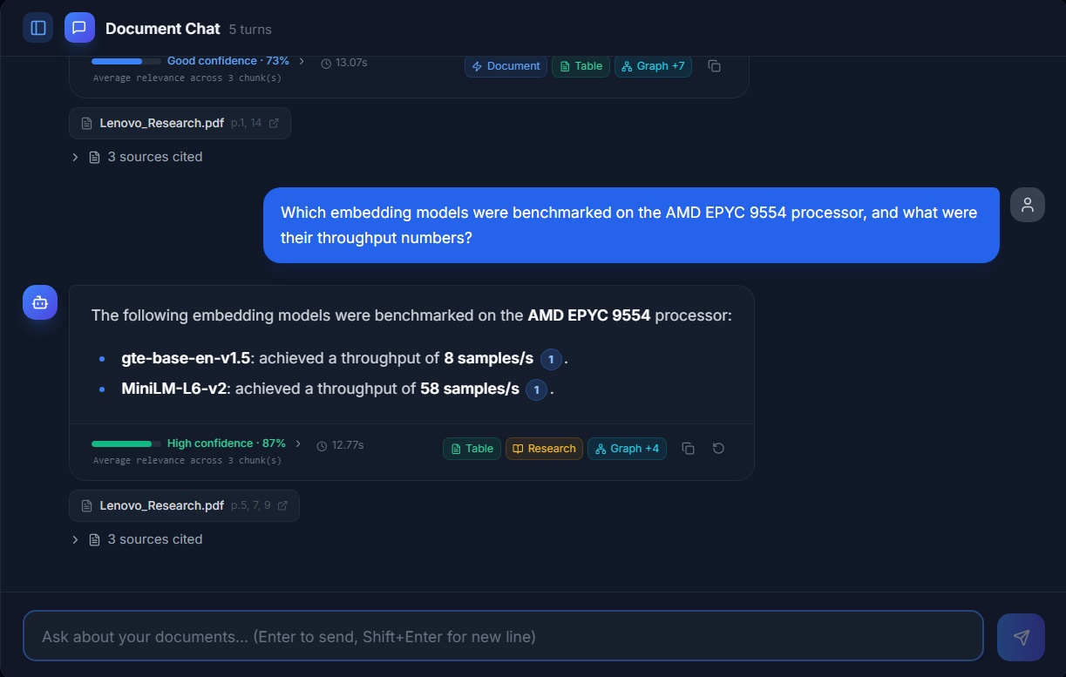Figure 11 — Embedding models benchmarked on AMD EPYC 9554

7. Conclusion
The evidence above confirms that the research document type is being routed correctly through the full ingestion pipeline (Parsing → Routing → Chunking → Embedding → Storing) and lands in the correct destination table, document_store, with all expected columns populated: text content, vector embeddings, structural metadata, full-text search vectors, and correct image-store flags. The end-to-end query test in Section 5 further confirms that retrieval over document_store works correctly in practice: the answer was factually correct, grounded in the right source document with accurate page-level citations, and correctly tagged with the Research document type. Section 6 additionally confirms that the Neo4j knowledge graph (GraphRAG) was built correctly from this document and that entity-based questions are correctly routed to, retrieved from, and labelled as coming from the graph. The four additional questions in Section 6.4 — spanning a superlative CPU lookup, a system-configuration lookup, and a processor-specific relationship lookup — all returned factually correct, source-verified answers with the Graph badge correctly present, showing this behaviour holds consistently across entity types rather than being a one-off result. Together, this validates that storage, retrieval, and graph-based retrieval for the research document type are all working as intended in the manthan_rag_working schema.

Note: Similar verification screenshots should be captured for the remaining stores (vector_store, table_store, clause_store) to confirm end-to-end multi-store routing for all document types.

