Clause Store Testing Report
MANTHAN AI-RAG — Legal Clause Extraction & Retrieval Validation
Test Document: NovaTech_MSA_Compliance_Report_FY2025-26

1. Objective
This report documents the functional testing of the clause_store component within the MANTHAN AI-RAG ingestion and retrieval pipeline. The objective of this test was to verify that legal clauses extracted from the source document "NovaTech_MSA_Compliance_Report_FY2025-26" — a Master Service Agreement (MSA) between NovaTech Solutions Pvt. Ltd. and Meridian — are correctly parsed into clause-level records and stored in the clause_store table (Supabase / PostgreSQL, schema manthan_rag_working), and that the stored clause data can be accurately retrieved and synthesised into correct, cited answers during query time.

2. Test Methodology
The following verification steps were performed end-to-end for the legal clause extraction and retrieval pipeline:
- Step 1 — Storage verification: Inspect the clause_store table in Supabase Table Editor and confirm each clause is stored as an individual record with clause_number, clause_title, clause_text and clause_word_count populated correctly.
- Step 2 — Source verification: Cross-check the stored clause_text against a screenshot of the corresponding clause as it appears in the source MSA document, confirming wording, terms, and figures are captured verbatim.
- Step 3 — Retrieval verification: Query the system with natural-language legal questions targeting specific clauses and confirm the returned answer, confidence score, and cited clause/page match the stored clause content.

3. Test Case — Clause-Level Extraction and Retrieval
This test case validates clause-level parsing of the NovaTech-Meridian MSA, which contains an Executive Summary followed by numbered clauses (Definitions, Scope of Services, Payment Terms, Intellectual Property, Confidentiality, Limitation of Liability, Indemnification, Governing Law, Uptime Guarantee, Incident Response, Data Privacy / DPDP Act 2023 Compliance, Change Management, Force Majeure, and Key Dates).

3.1 Supabase Storage — clause_store
The screenshots below show the clause_store table in Supabase, confirming each clause of the MSA is stored as a distinct row with its clause number, title, full clause text, and computed word count.
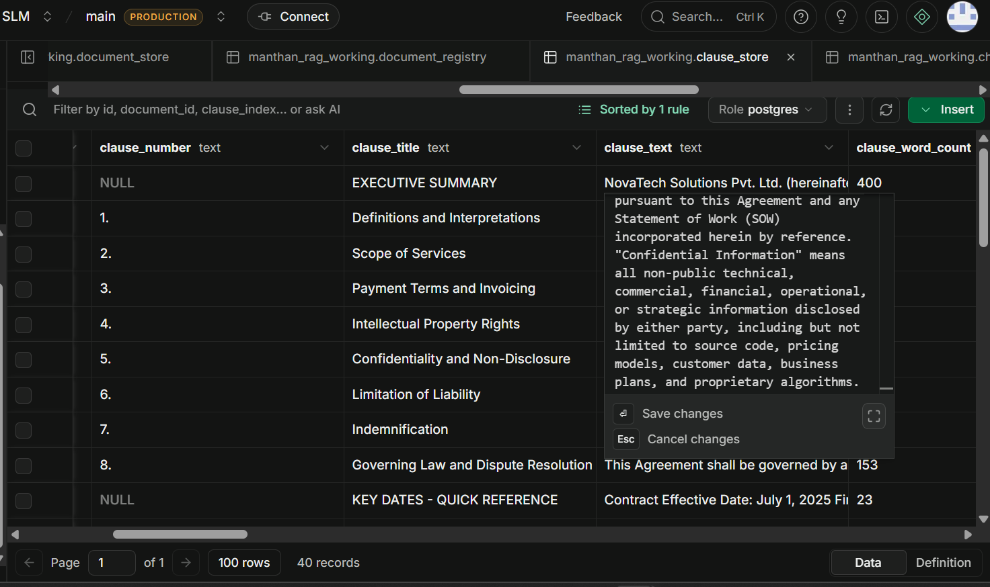
Figure 1 — clause_store: Executive Summary and clauses 1-8 (Definitions through Governing Law and Dispute Resolution).
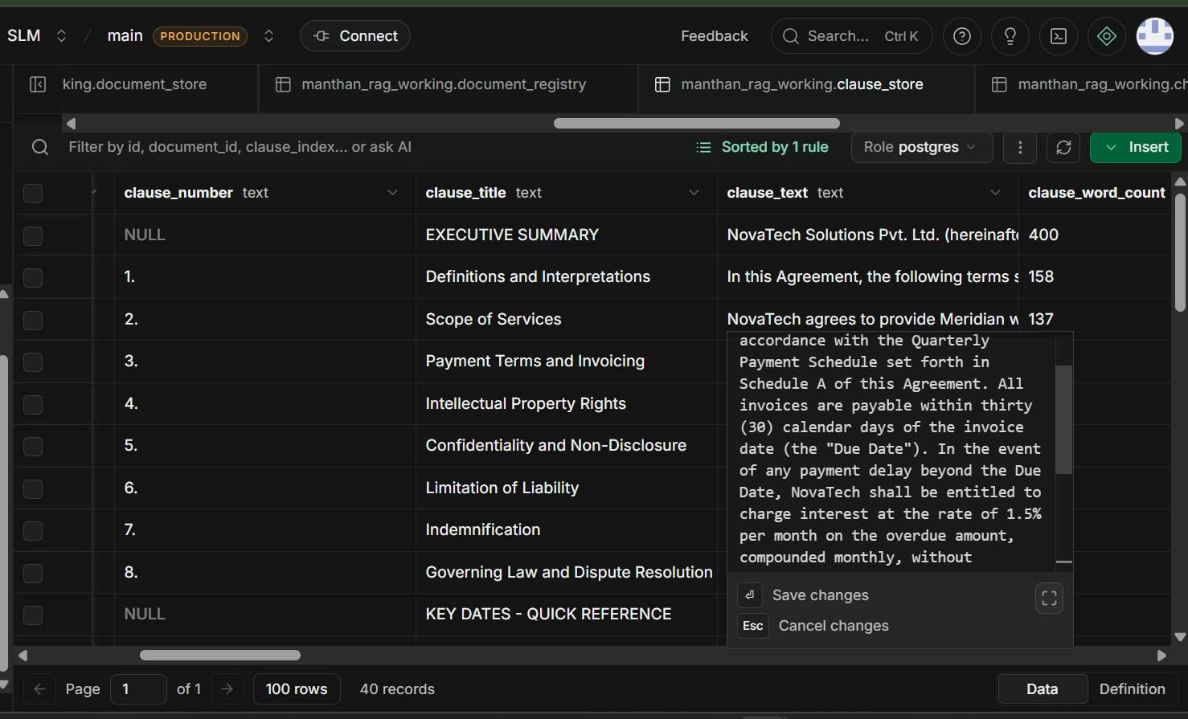
Figure 2 — clause_store: clause_text detail for Clause 2, Scope of Services (137 words), showing the Quarterly Payment Schedule and 30-day invoicing terms carried over into Clause 3.
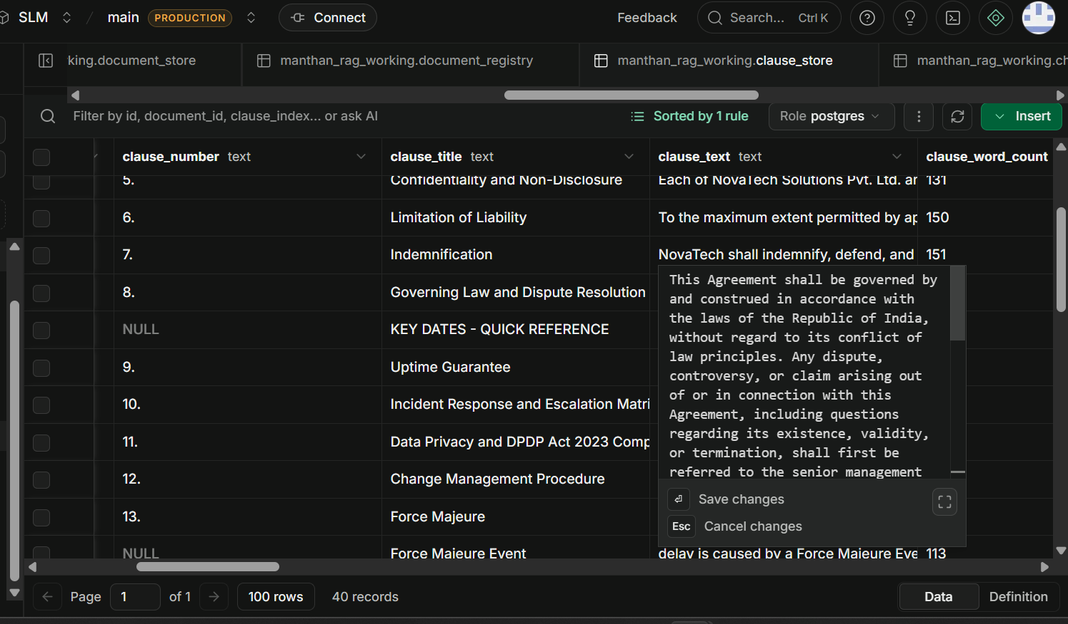
Figure 3 — clause_store: clauses 5-13 (Confidentiality, Limitation of Liability, Indemnification, Governing Law, Uptime Guarantee, Incident Response, Data Privacy / DPDP Act 2023 Compliance, Change Management, Force Majeure) with clause_text detail for Clause 8, Governing Law and Dispute Resolution.

3.2 Source Verification — Actual PDF Clauses
The following screenshots are the corresponding clauses as rendered in the original source document (NovaTech_MSA_Compliance_Report_FY2025-26), used to confirm the stored clause_text is an accurate, verbatim representation of the source agreement.
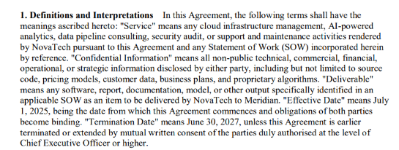
Figure 4 — Source document: Clause 1, Definitions and Interpretations, defining "Effective Date" as July 1, 2025 and "Termination Date" as June 30, 2030.
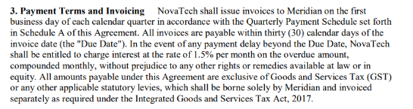
Figure 5 — Source document: Clause 3, Payment Terms and Invoicing, specifying invoices are payable within thirty (30) calendar days of the invoice date.
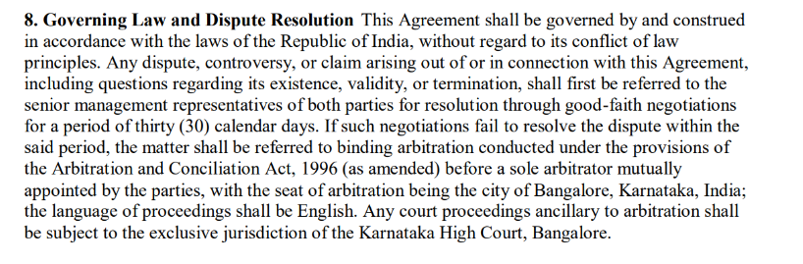
Figure 6 — Source document: Clause 8, Governing Law and Dispute Resolution, specifying the Agreement is governed by the laws of the Republic of India with arbitration seated in Bangalore, Karnataka.

3.3 Query & Answer Verification
Natural-language legal queries were issued against the system to confirm correct retrieval and synthesis of clause-level data, with each query mapped directly to one of the source clauses verified in Section 3.2.
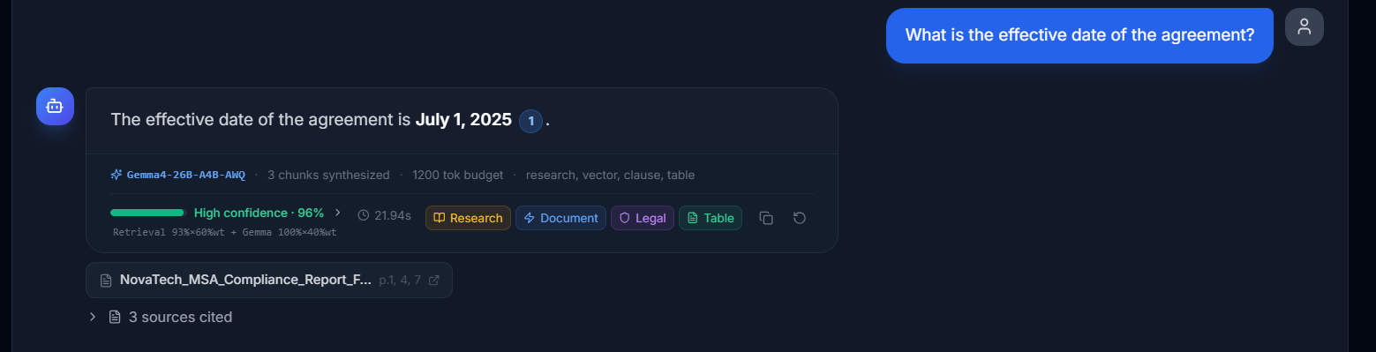
Figure 7 — Query: "What is the effective date of the agreement?" — Answer: July 1, 2025, High confidence 96%, citing Clause 1 (Definitions), source NovaTech_MSA_Compliance_Report p.1, 4, 7.
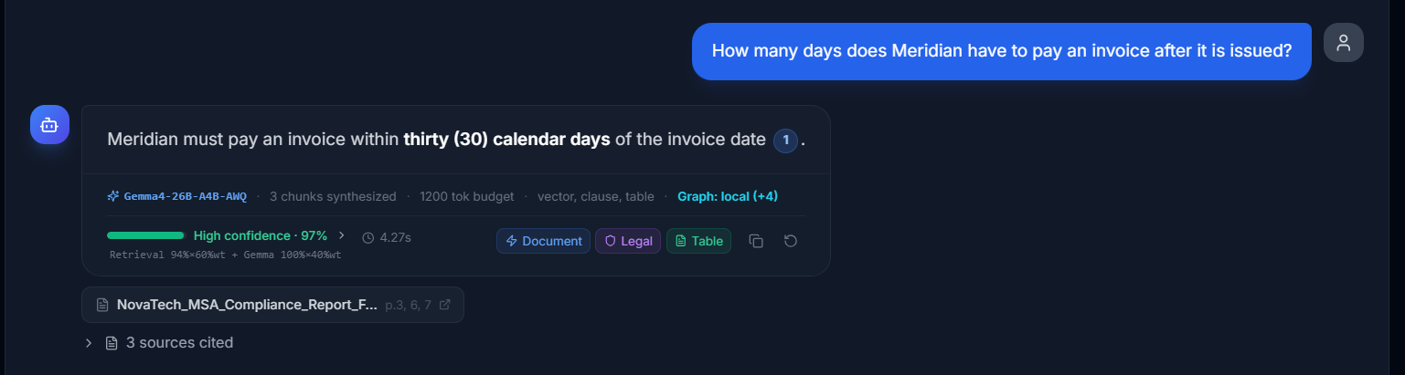
Figure 8 — Query: "How many days does Meridian have to pay an invoice after it is issued?" — Answer: thirty (30) calendar days, High confidence 97%, citing Clause 3 (Payment Terms and Invoicing), p.3, 6, 7.
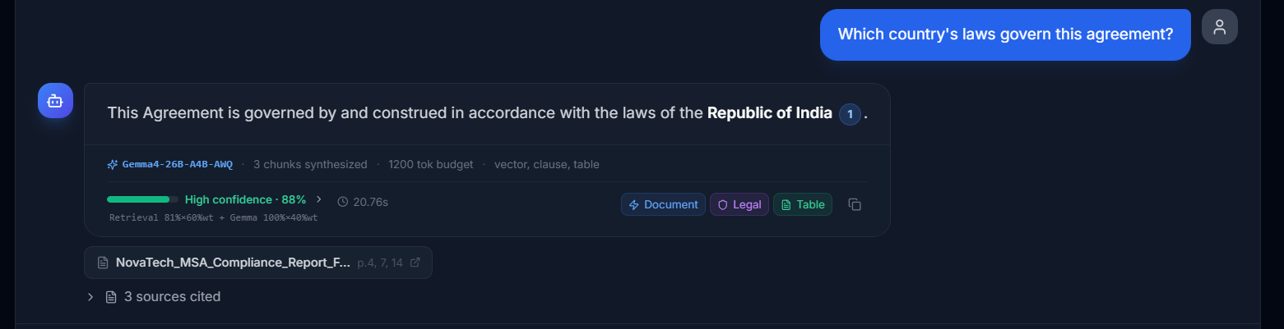
Figure 9 — Query: "Which country's laws govern this agreement?" — Answer: Republic of India, High confidence 88%, citing Clause 8 (Governing Law and Dispute Resolution), p.4, 7, 14.

3.4 Result
PASS — All three queries returned answers that exactly match the corresponding clause_text stored in clause_store and the original source clauses in the MSA, with High confidence scores (88-97%) and correctly cited clause references and page numbers.

4. Observations
- Clause-level segmentation correctly identifies numbered clauses (1-13) as well as unnumbered structural sections (Executive Summary, Key Dates - Quick Reference), preserving clause_number as NULL where the source has no explicit numbering.
- Clause boundaries align with the source document's own section headings, and clause_text is captured verbatim, including monetary terms, interest rates, and statutory references (e.g. Integrated Goods and Services Tax Act, 2017; Arbitration and Conciliation Act, 1996).
- Retrieval consistently tagged results with the "Legal" and "clause" source badges alongside vector/table stores, and correctly cited multiple page numbers per answer, reflecting cross-references between clauses (e.g. Clause 3's payment terms echoed in Clause 8's dispute-resolution context).
- Confidence scores for direct factual clause lookups (effective date, payment days, governing law) ranged from Good-to-High (88-97%), indicating reliable retrieval for clause-grounded legal questions.

5. Conclusion
Testing confirms that the clause_store component of the MANTHAN AI-RAG pipeline correctly extracts, segments, and stores legal clauses from the Master Service Agreement "NovaTech_MSA_Compliance_Report_FY2025-26" at clause-level granularity, preserving clause numbers, titles, and verbatim text. Retrieved answers matched the underlying clause_store records and the original source clauses in every test case, with confidence scores ranging from Good (88%) to High (97%). The clause_store is functioning as intended for legal document ingestion and clause-grounded question answering.

