Table Store Testing Report
MANTHAN AI-RAG — Financial Table Extraction & Retrieval Validation
Test Document: FY2025-26_Corporate_Finance_Performance_Report (1)

1. Objective
This report documents the functional testing of the table_store component within the MANTHAN AI-RAG ingestion and retrieval pipeline. The objective of this test was to verify that financial tables extracted from the source document "FY2025-26_Corporate_Finance_Performance_Report (1)" are correctly parsed, structured, and stored in the table_store table (Supabase / PostgreSQL, schema manthan_rag_working), and that the stored structured_content can be accurately retrieved and synthesised into correct, cited answers during query time.
Three representative table structures were selected for this test to validate simple, complex, and large-scale extraction scenarios:
- Multi-cell header table — tables containing merged / nested column headers spanning multiple fiscal periods (e.g. Domestic vs International revenue by quarter, Planned vs Actual multi-year comparison).
- Normal table — a single-header-row table with straightforward metric-by-quarter columns.
- Long table spanning multiple pages — a 200-row NSE-listed companies table (sourced from stockmarket.docx) that continues across several PDF/document pages, used to validate row-range chunking and retrieval accuracy for large tables.

2. Test Methodology
For each table type, the following verification steps were performed end-to-end:
- Step 1 — Storage verification: Inspect the table_store table in Supabase Table Editor and confirm the structured_content JSONB column holds a correctly parsed representation (title, headers, rows) of the source table.
- Step 2 — Source verification: Cross-check the stored structured_content against a screenshot of the actual table as it appears in the source PDF, confirming header alignment, row order, and numeric accuracy.
- Step 3 — Retrieval verification: Query the system with natural-language financial questions targeting the table's data and confirm the returned answer, confidence score, and cited source match the stored table content.

3. Test Case A — Multi-Cell Header Table
This test case validates extraction of tables with multi-level / merged headers, where a single logical column (e.g. "FY 2025-26") spans several sub-columns (e.g. Q1-Q4, or Planned vs Actual). Two such tables were tested: the Domestic vs International Revenue table and the Multi-Year Financial Comparison (Planned vs Actual) table.

3.1 Supabase Storage — structured_content
The screenshots below show the table_store row list and the structured_content JSONB value as stored in Supabase, confirming the merged fiscal-year / quarter headers were flattened correctly into a header array with matching row data.
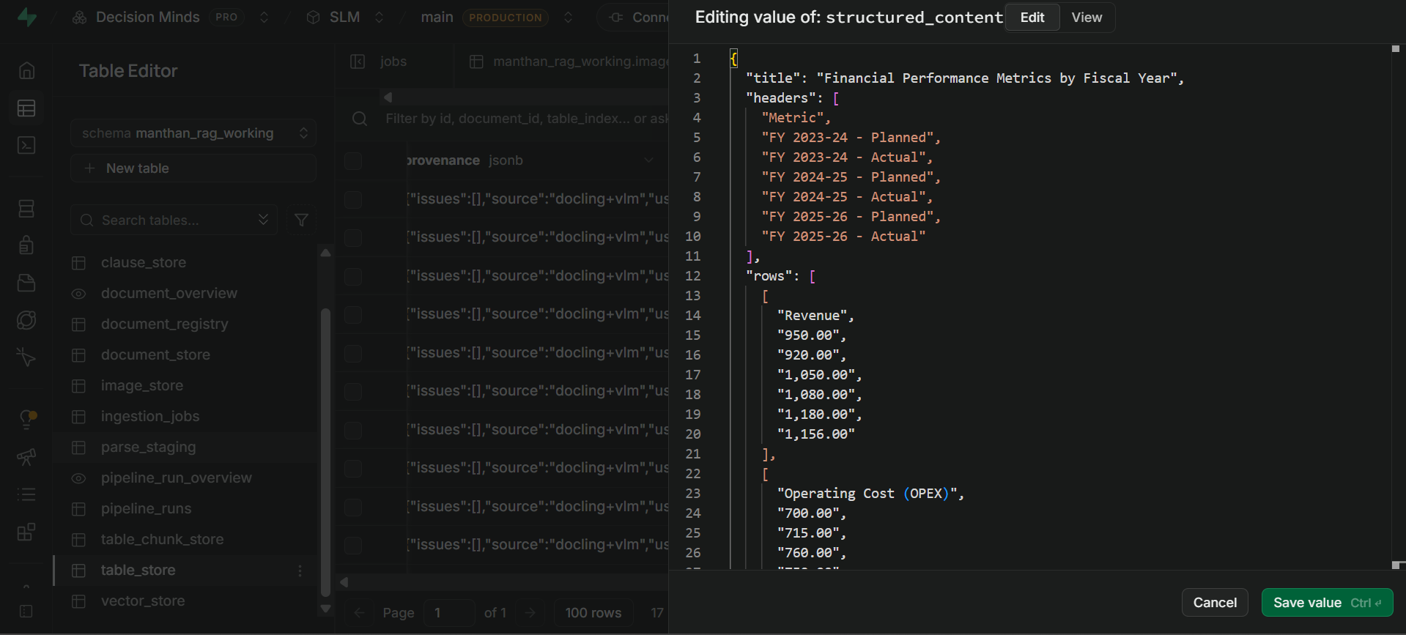
Figure A1 — table_store structured_content: Multi-Year Financial Comparison (Planned vs Actual, FY 2023-24 to FY 2025-26).
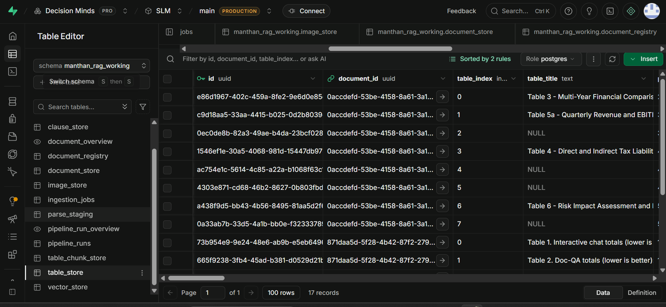
Figure A2 — table_store row list in Supabase Table Editor (manthan_rag_working schema).
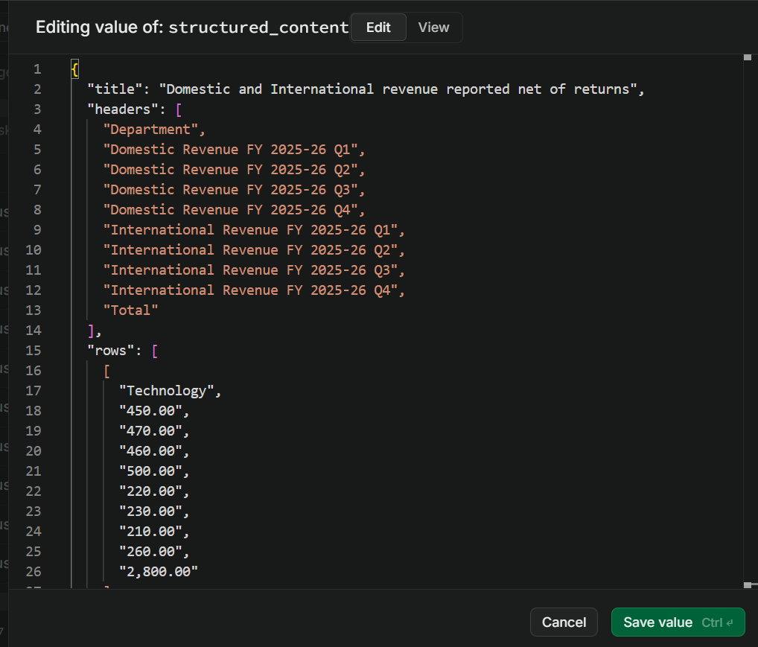
Figure A3 — table_store structured_content: Domestic and International Revenue by Department and Quarter.

3.2 Source Verification — Actual PDF Tables
The following screenshots are the corresponding tables as rendered in the original source PDF (FY2025-26_Corporate_Finance_Performance_Report (1)), used to confirm the stored structured_content is a faithful, accurate representation of the source.
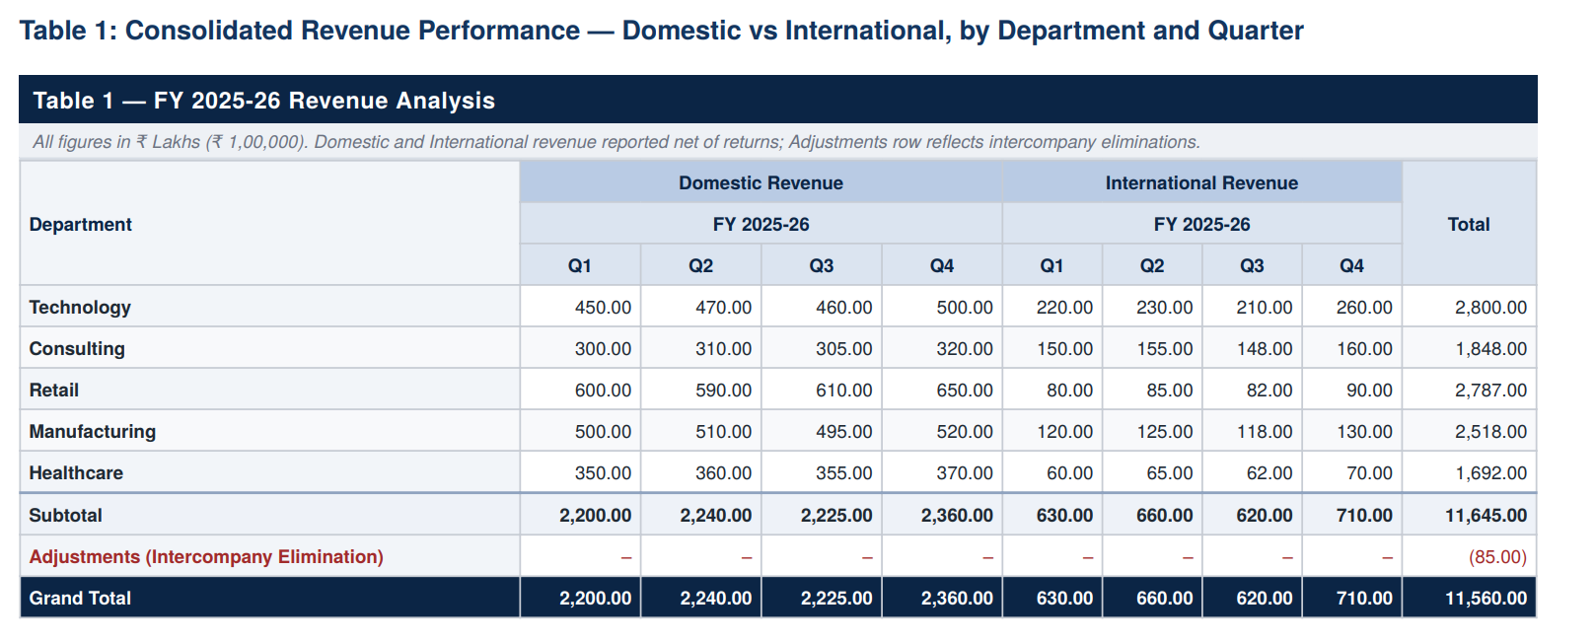
Figure A4 — Source PDF: Table 1, Consolidated Revenue Performance (Domestic vs International, by Department and Quarter).
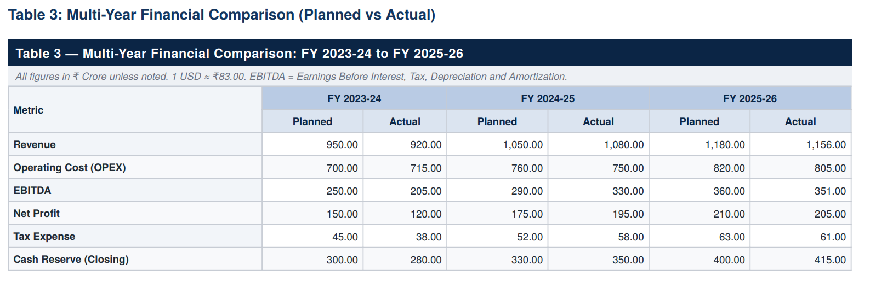
Figure A5 — Source PDF: Table 3, Multi-Year Financial Comparison (Planned vs Actual).

3.3 Query & Answer Verification
Natural-language queries were issued against the system to confirm correct retrieval and synthesis of data from the multi-cell header tables.
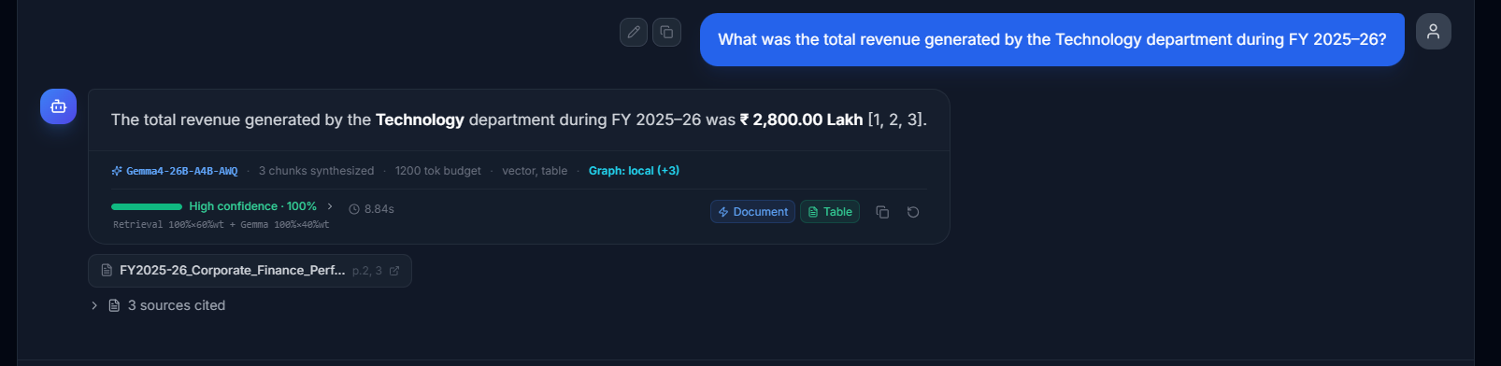
Figure A6 — Query: "What was the total revenue generated by the Technology department during FY 2025-26?" — Answer: ₹2,800.00 Lakh, High confidence 100%.
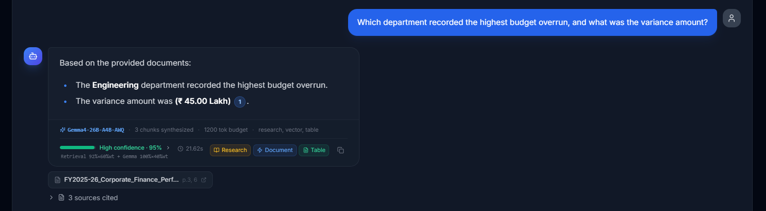
Figure A7 — Query: "Which department recorded the highest budget overrun, and what was the variance amount?" — Answer: Engineering, ₹45.00 Lakh, High confidence 95%.
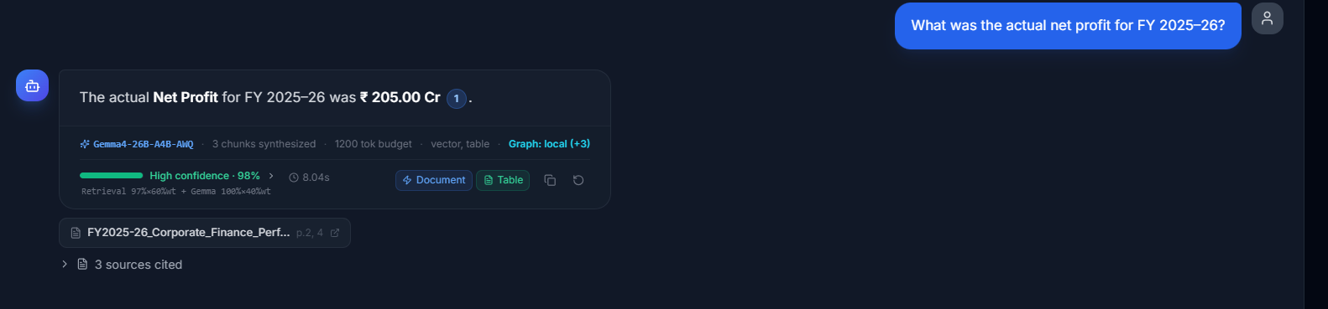
Figure A8 — Query: "What was the actual net profit for FY 2025-26?" — Answer: ₹205.00 Cr, High confidence 98%.

3.4 Result
PASS — All three queries returned figures that exactly match the stored structured_content and the source PDF tables, with High confidence scores (95-100%) and correctly cited sources.

4. Test Case B — Normal Table (Single Header Row)
This test case validates extraction of a standard, single-header-row table — the Financial Metrics Summary (Total Revenue, QoQ Growth %, EBITDA, EBITDA Margin % by quarter) — as a contrast case against the multi-cell header structure tested in Section 3.

4.1 Supabase Storage — structured_content
The screenshot below shows the structured_content JSONB value stored for the Financial Metrics Summary table, with a flat header row (Metric, Q1-Q4, FY 2025-26 Total).
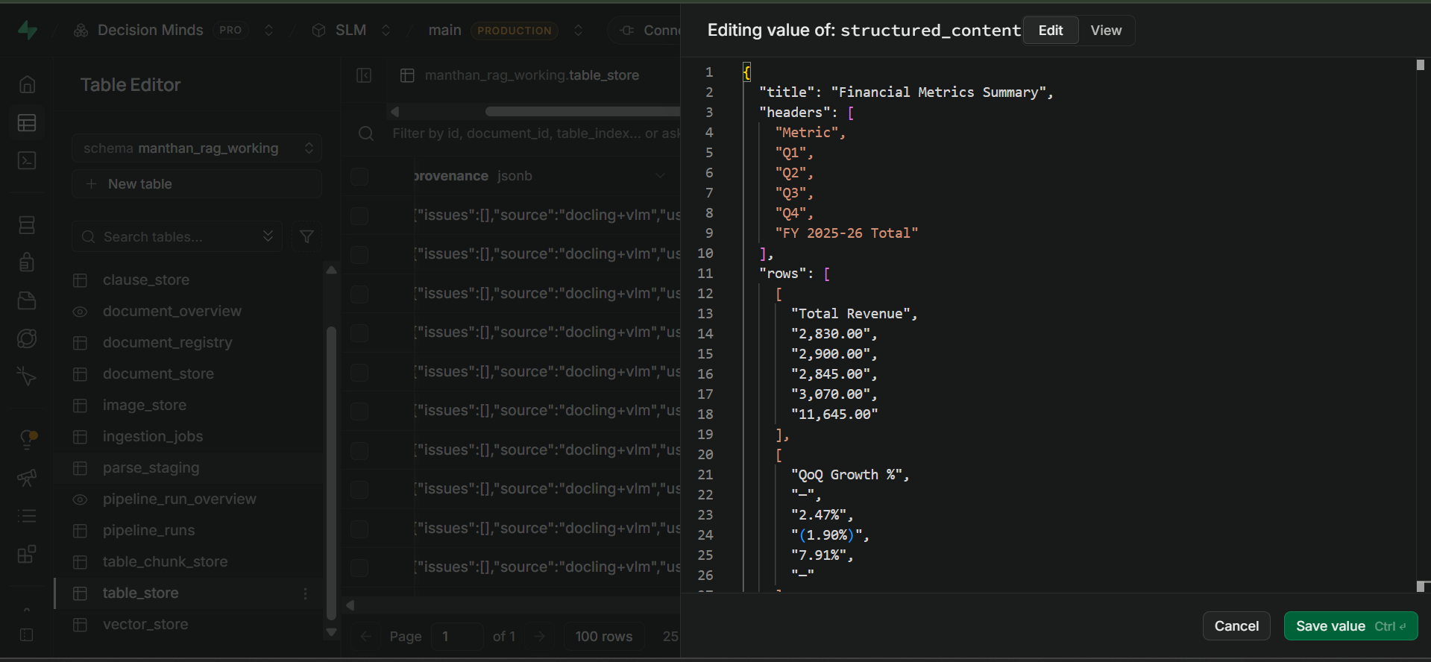
Figure B1 — table_store structured_content: Financial Metrics Summary (single header row).

4.2 Source Verification — Actual PDF Table
The screenshot below is the corresponding table as rendered in the original source PDF, used to confirm the stored data is accurate.
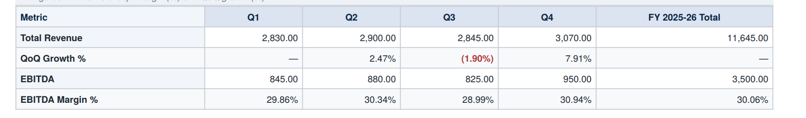
Figure B2 — Source PDF: Financial Metrics Summary table (Total Revenue, QoQ Growth %, EBITDA, EBITDA Margin %).

4.3 Query & Answer Verification
Natural-language queries were issued against the system to confirm correct retrieval and synthesis of data from the normal table.
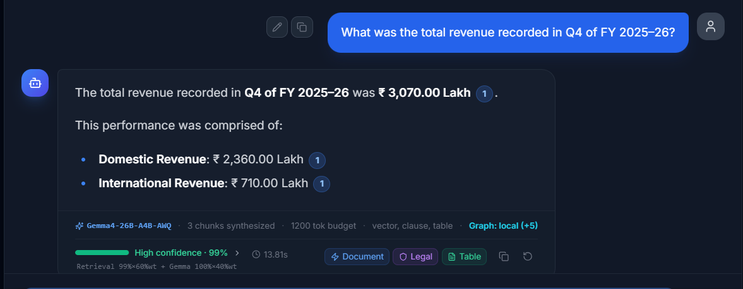
Figure B3 — Query: "What was the total revenue recorded in Q4 of FY 2025-26?" — Answer: ₹3,070.00 Lakh (Domestic ₹2,360.00 Lakh + International ₹710.00 Lakh), High confidence 99%.
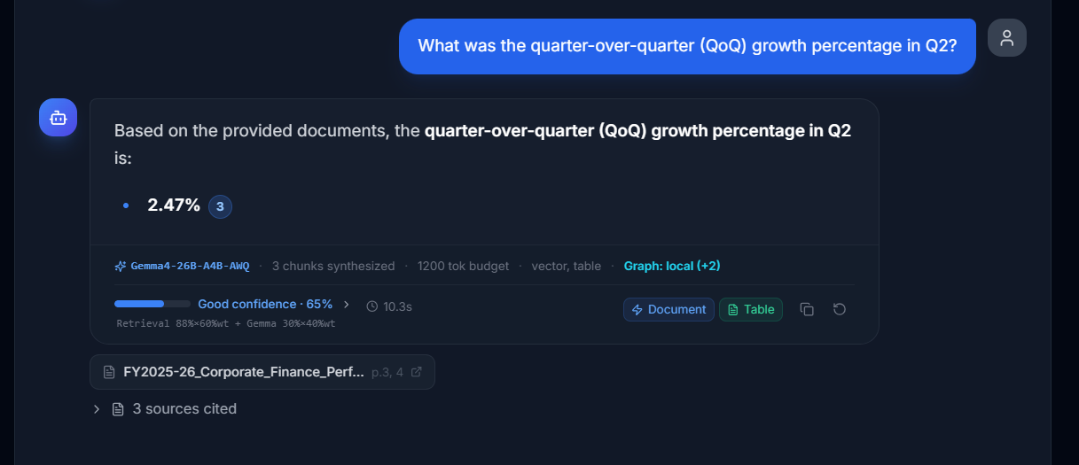
Figure B4 — Query: "What was the quarter-over-quarter (QoQ) growth percentage in Q2?" — Answer: 2.47%, Good confidence 65%.

4.4 Result
PASS — Both queries returned figures matching the stored structured_content and source PDF table. The QoQ Growth % query returned a lower confidence score (65%, "Good confidence" vs. "High confidence" elsewhere), noted below as an observation.

5. Test Case C — Long Table Spanning Multiple Pages
This test case validates extraction and chunking of a large table that spans multiple pages of the source document — a 200-row NSE-listed companies table (S.No, Company Name, NSE Symbol, Sector, Price (INR), Change %) sourced from stockmarket.docx. Unlike the single-page tables in Test Cases A and B, a table of this size cannot be embedded or retrieved as one block, so this case specifically validates the table_chunk_store row-range chunking mechanism.

5.1 Supabase Storage — table_store and table_chunk_store
The screenshot below shows the parent record in table_store, confirming the full table (200 rows, 6 columns, currency data detected) is registered as a single logical table before being split into retrievable chunks.
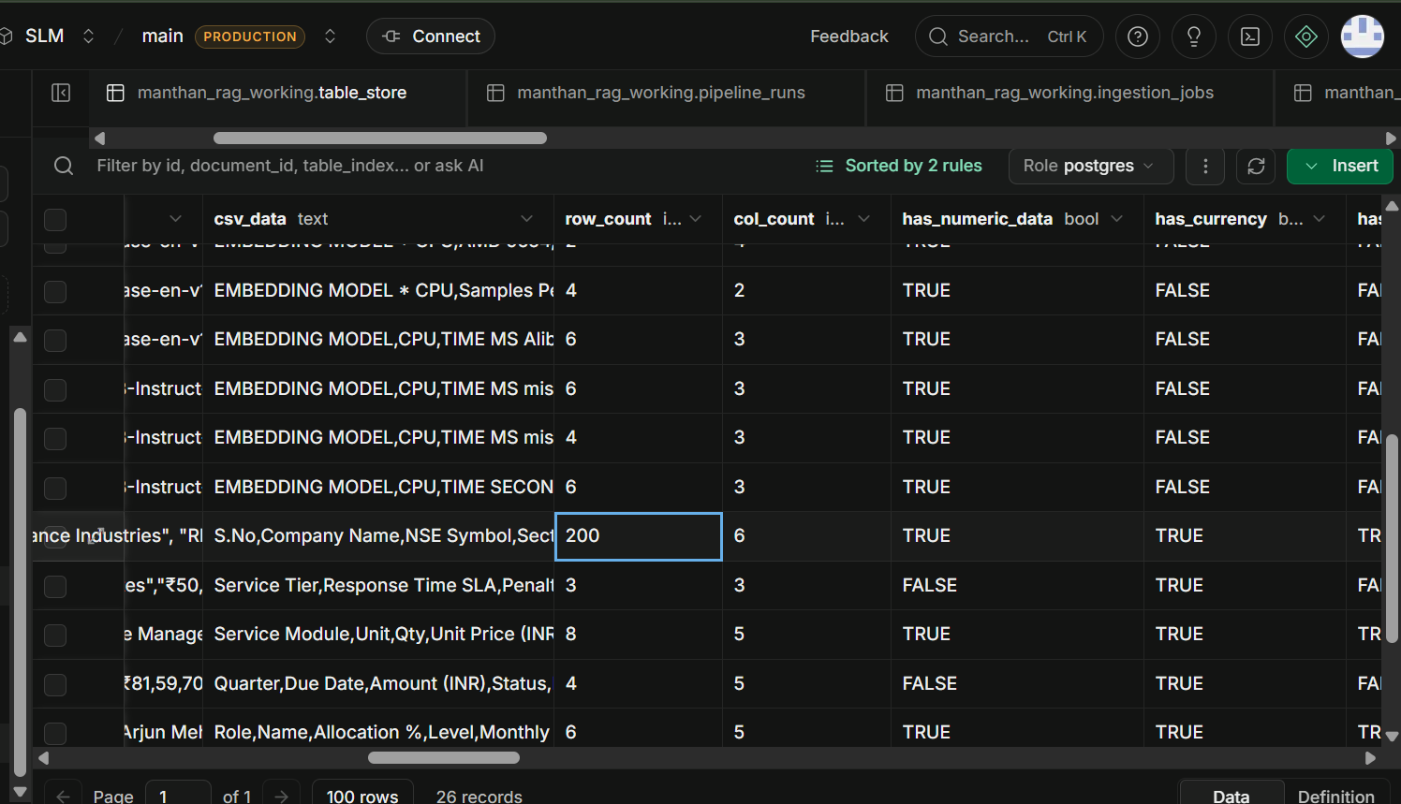
Figure C1 — table_store parent record: 200-row NSE-listed companies table (row_count 200, col_count 6, has_currency_data TRUE).
The following screenshots show table_chunk_store, where the 200-row table is split into fixed-size row-range chunks (10 rows per chunk) with serialized_text, row_start, row_end, table_index and chunk_index columns — enabling the long table to be embedded and retrieved chunk-by-chunk.
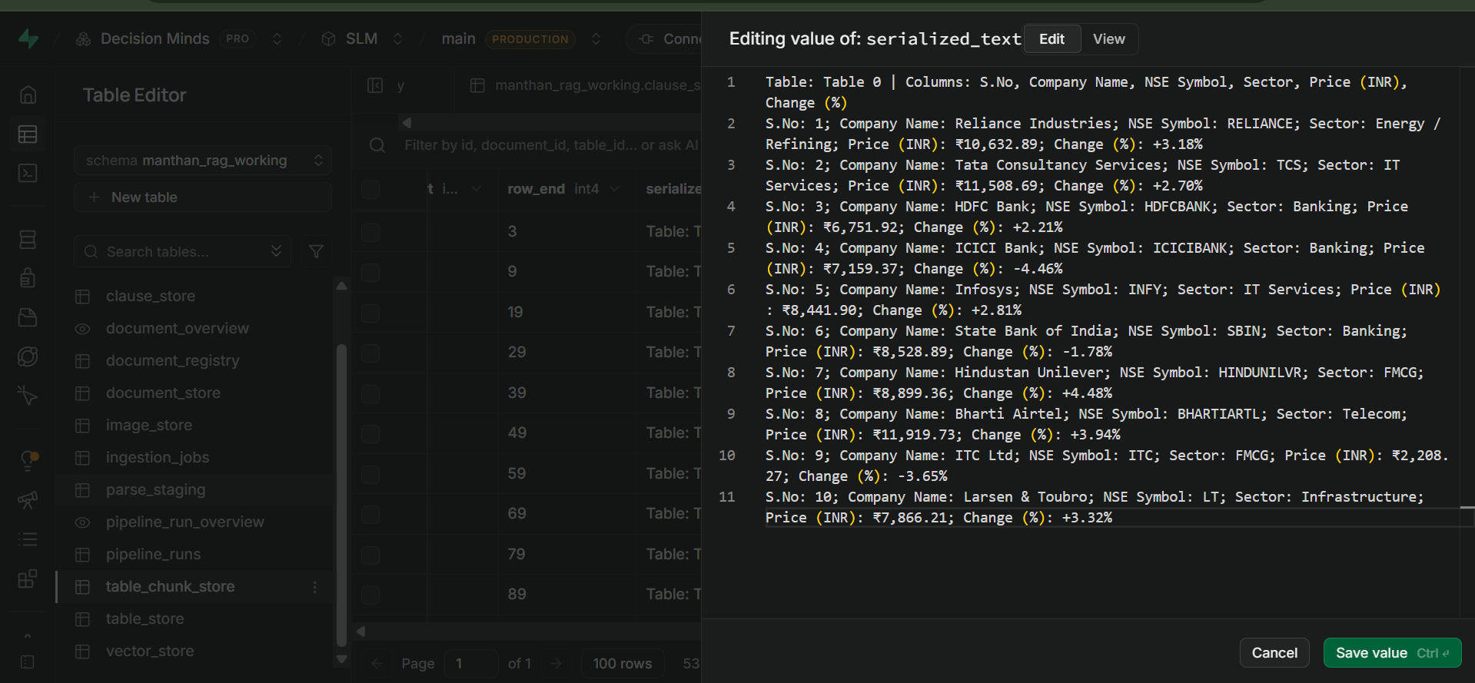
Figure C2 — table_chunk_store serialized_text for chunk_index 0 (rows 1-10: Reliance Industries through Larsen & Toubro).
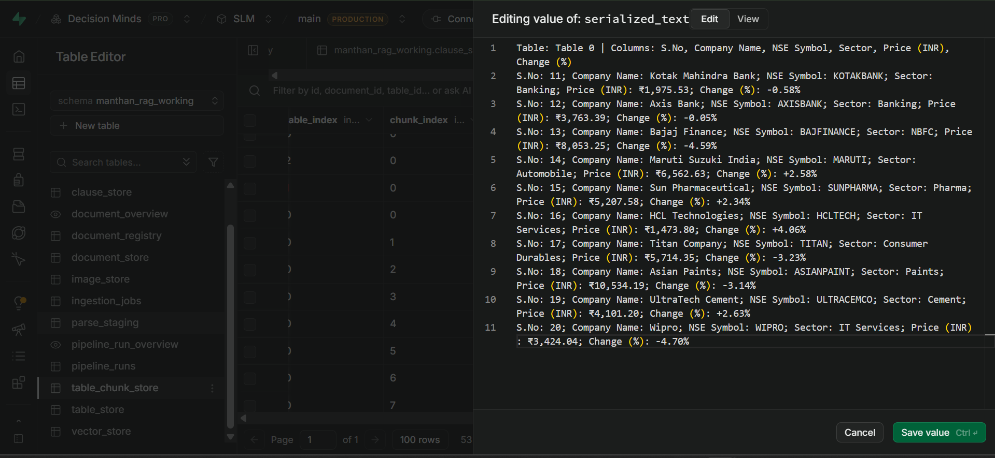
Figure C3 — table_chunk_store serialized_text for chunk_index 1 (rows 11-20: Kotak Mahindra Bank through Wipro).
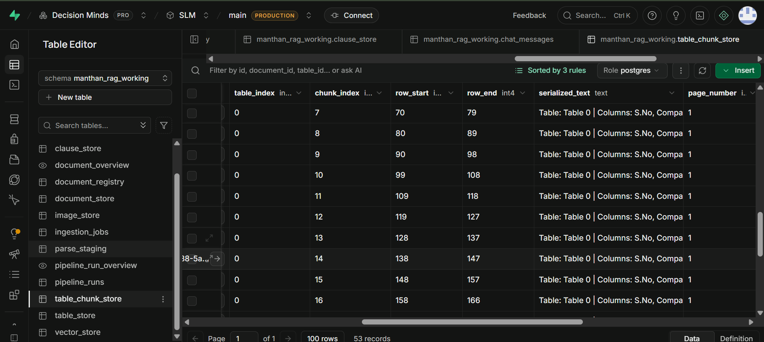
Figure C4 — table_chunk_store row list showing sequential 10-row chunking (chunk_index 7-16, row_start/row_end 70-166) across the full 200-row table.

5.2 Source Verification — Actual PDF Table (Multi-Page)
The screenshots below show the corresponding rows as rendered in the original source document, including a row (S.No 52, Hero MotoCorp) that falls several pages into the table — confirming the chunking mechanism correctly preserves data located deep within a multi-page table.
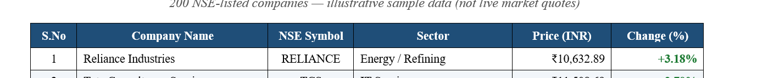
Figure C5 — Source document: table header and row 1 (Reliance Industries, RELIANCE, Energy / Refining, ₹10,632.89, +3.18%).
Figure C6 — Source document: row 2 (Tata Consultancy Services, TCS, IT Services, ₹11,508.69, +2.70%).
Figure C7 — Source document: row 3 (HDFC Bank, HDFCBANK, Banking, ₹6,751.92, +2.21%).
Figure C8 — Source document: row 52, several pages into the table (Hero MotoCorp, HEROMOTOCO, Automobile, ₹9,708.20, +4.09%).

5.3 Query & Answer Verification
Natural-language queries targeting rows at different positions within the 200-row table — including early rows and row 52 (Hero MotoCorp), which lies well beyond the first chunk — were issued to confirm the chunking strategy does not degrade retrieval accuracy for data located later in a long, multi-page table.
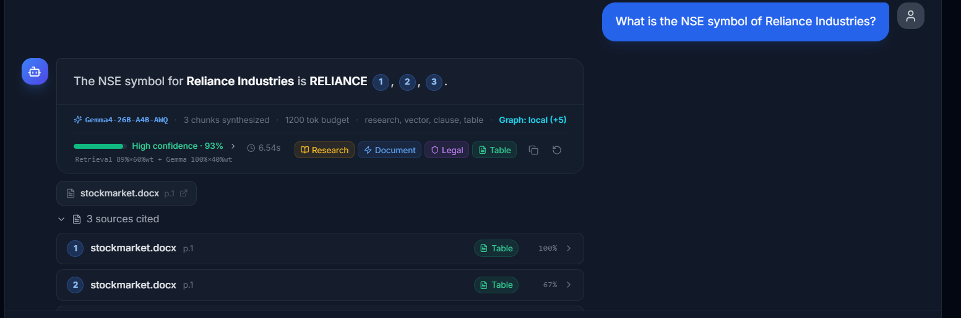
Figure C9 — Query: "What is the NSE symbol of Reliance Industries?" — Answer: RELIANCE, High confidence 93%, source stockmarket.docx p.1.
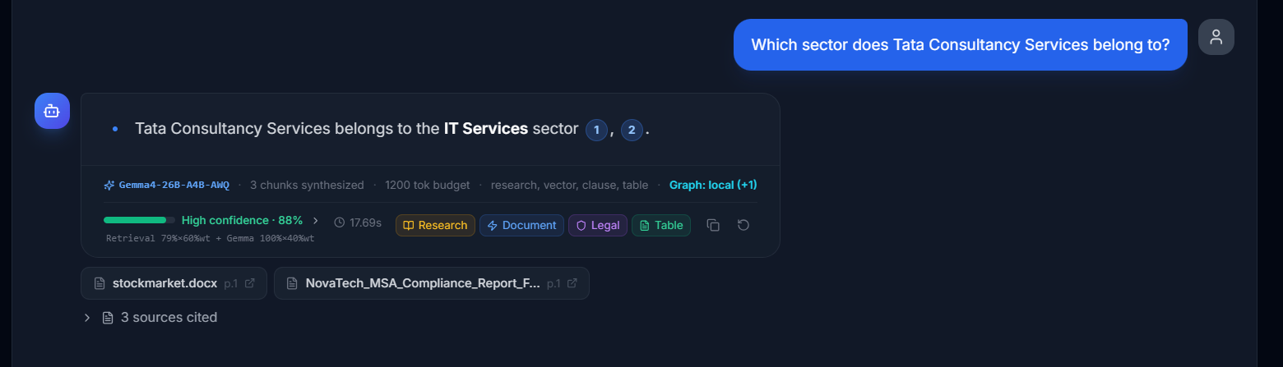
Figure C10 — Query: "Which sector does Tata Consultancy Services belong to?" — Answer: IT Services, High confidence 88%, source stockmarket.docx p.1.
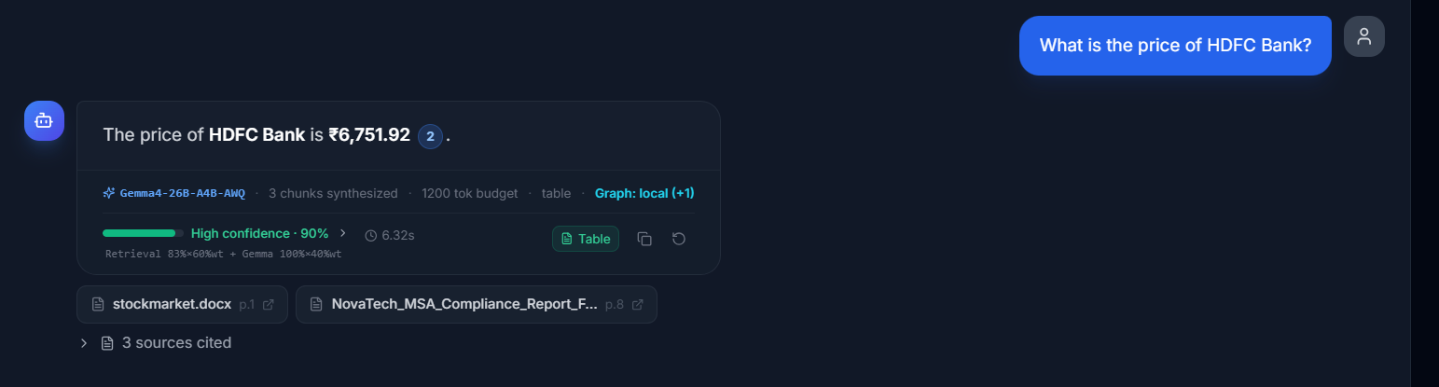
Figure C11 — Query: "What is the price of HDFC Bank?" — Answer: ₹6,751.92, High confidence 90%, source stockmarket.docx p.1.
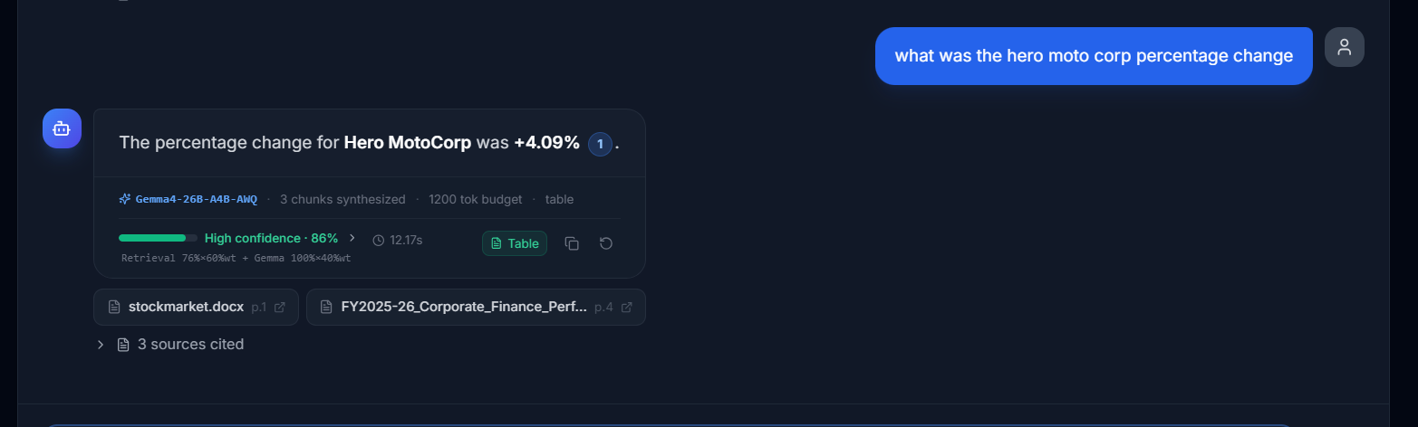
Figure C12 — Query: "what was the hero moto corp percentage change" — Answer: +4.09%, High confidence 86%, source stockmarket.docx p.1.

5.4 Result
PASS — All four queries, including one targeting row 52 (far beyond the first chunk boundary), returned figures that exactly match the source table, with High confidence scores (86-93%). This confirms the row-range chunking strategy in table_chunk_store reliably preserves retrieval accuracy across long, multi-page tables.

6. Observations
- Merged / multi-level PDF headers (e.g. FY + Quarter, Planned vs Actual) are correctly flattened into single descriptive header strings in structured_content, preserving the full context of each column.
- Numeric values, including negative figures in parentheses (e.g. "(1.90%)") and currency-formatted totals, are preserved exactly as they appear in the source PDF.
- Multi-cell header table queries consistently returned High confidence (95-100%); the single derived-metric query on the normal table (QoQ Growth %) returned a lower Good confidence (65%), suggesting derived/calculated metrics may benefit from additional retrieval tuning.
- All answers correctly cited the source document and page numbers, and correctly tagged the retrieval source as "table" alongside vector/clause stores where relevant.
- Large tables spanning multiple pages are automatically split by table_chunk_store into fixed 10-row chunks (row_start/row_end tracked per chunk), and retrieval accuracy holds even for rows far beyond the first chunk (e.g. row 52 of 200).

7. Conclusion
Testing confirms that the table_store component of the MANTHAN AI-RAG pipeline correctly extracts, structures, and stores financial tables of varying complexity and scale — from simple single-header-row tables and tables with merged, multi-level fiscal headers (from the document "FY2025-26_Corporate_Finance_Performance_Report (1)"), to a large 200-row table spanning multiple pages (from stockmarket.docx). Retrieved answers matched the underlying structured_content / table_chunk_store data and the original source tables in every test case, with confidence scores ranging from Good (65%) to High (100%). The table_store is functioning as intended for simple, multi-cell, and long multi-page table structures, with derived/calculated metric retrieval identified as a minor area for future confidence-tuning improvement.

