ROUTER 0:

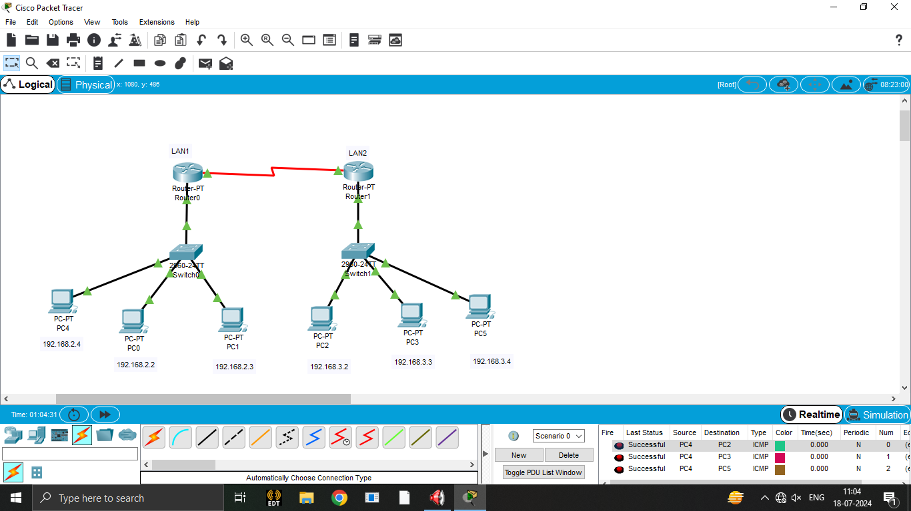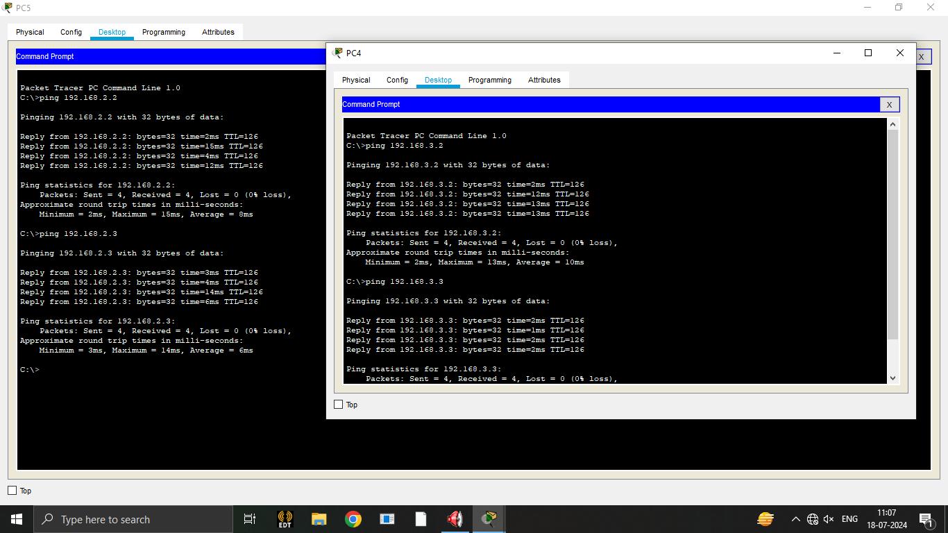

--- System Configuration Dialog ---

Would you like to enter the initial configuration dialog? [yes/no]: n

Press RETURN to get started!

Router>enable

Router#

Router#configure terminal

Enter configuration commands, one per line. End with CNTL/Z.

Router(config)#interface FastEthernet0/0

Router(config-if)#ip address 192.168.2.1 255.255.255.0

Router(config-if)#ip address 192.168.2.1 255.255.255.0

Router(config-if)#no shutdown

Router(config-if)#

%LINK-5-CHANGED: Interface FastEthernet0/0, changed state to up

%LINEPROTO-5-UPDOWN: Line protocol on Interface FastEthernet0/0, changed state to up

Router(config-if)#

Router(config-if)#exit

Router(config)#interface FastEthernet0/0

Router(config-if)#

Router(config-if)#exit

Router(config)#interface Serial2/0

Router(config-if)#ip address 192.168.4.1 255.255.255.0

Router(config-if)#ip address 192.168.4.1 255.255.255.0

Router(config-if)#no shut

%LINK-5-CHANGED: Interface Serial2/0, changed state to down

Router(config-if)#

%LINK-5-CHANGED: Interface Serial2/0, changed state to up

%LINEPROTO-5-UPDOWN: Line protocol on Interface Serial2/0, changed state to up

Router(config-if)#exit

Router(config)#interface Serial2/0

Router(config-if)#ip address 192.168.4.2 255.255.255.0

Router(config-if)#ip address 192.168.4.2 255.255.255.0

Router(config-if)#ip address 192.168.4.1 255.255.255.0

Router(config-if)#ip address 192.168.4.1 255.255.255.0

Router(config-if)#ipi

Router(config-if)#exit

Router(config)#router rip

Router(config-router)#network 192.168.2.0

Router(config-router)#network 192.168.4.0

Router(config-router)#exit

Router(config)#rirouter rip

Router(config-router)#cocexit

Router(config)#copy run

^

% Invalid input detected at '^' marker.

Router(config)#exit

Router#

%SYS-5-CONFIG_I: Configured from console by console

Router#copy run

% Incomplete command.

Router#

Router#configure terminal

Enter configuration commands, one per line. End with CNTL/Z.

Router(config)#router rip

Router(config-router)#

Router(config-router)#end

Router#configure terminal

Enter configuration commands, one per line. End with CNTL/Z.

Router(config)#router rip

Router(config-router)#

%SYS-5-CONFIG_I: Configured from console by console

Router(config-router)#end

Router#copy running-config startup-config

Destination filename [startup-config]?

Building configuration...

[OK]

Router#

%SYS-5-CONFIG_I: Configured from console by console

Router#

Router con0 is now available

Press RETURN to get started.

Router>enable

Router#

Router#configure terminal

Enter configuration commands, one per line. End with CNTL/Z.

Router(config)#interface FastEthernet0/0

Router(config-if)#ip address 192.168.2.1 255.255.255.0

Router(config-if)#ip address 192.168.2.1 255.255.255.0

Router(config-if)#no shut

Router(config-if)#

ROUTER 1:

--- System Configuration Dialog ---

Would you like to enter the initial configuration dialog? [yes/no]: n

Press RETURN to get started!

Router>enable

Router#

Router#configure terminal

Enter configuration commands, one per line. End with CNTL/Z.

Router(config)#interface FastEthernet0/0

Router(config-if)#ip address 192.168.3.1 255.255.255.0

Router(config-if)#ip address 192.168.3.1 255.255.255.0

Router(config-if)#no shutdown

Router(config-if)#

%LINK-5-CHANGED: Interface FastEthernet0/0, changed state to up

%LINEPROTO-5-UPDOWN: Line protocol on Interface FastEthernet0/0, changed state to up

Router(config-if)#

Router(config-if)#exit

Router(config)#interface FastEthernet0/0

Router(config-if)#

Router(config-if)#exit

Router(config)#interface Serial2/0

Router(config-if)#ip address 192.168.4.2 255.255.255.0

Router(config-if)#ip address 192.168.4.2 255.255.255.0

Router(config-if)#no shut

Router(config-if)#

%LINK-5-CHANGED: Interface Serial2/0, changed state to up

Router(config-if)#

%LINEPROTO-5-UPDOWN: Line protocol on Interface Serial2/0, changed state to up

Router(config-if)#exit

Router(config)#interface Serial2/0

Router(config-if)#

Router(config-if)#exit

Router(config)#router rip

Router(config-router)#network 192.168.3.0

Router(config-router)#network 192.168.4.0

Router(config-router)#

Router(config-router)#end

Router#copy running-config startup-config

Destination filename [startup-config]?

Building configuration...

[OK]

Router#

%SYS-5-CONFIG_I: Configured from console by console

Router#

Router con0 is now available

Press RETURN to get started.

Router>enable

Router#

Router#configure terminal

Enter configuration commands, one per line. End with CNTL/Z.

Router(config)#

Router(config)#

Router(config)#router rip

Router(config-router)#

Router(config-router)#end

Router#configure terminal

Enter configuration commands, one per line. End with CNTL/Z.

Router(config)#interface FastEthernet0/0

Router(config-if)#

%SYS-5-CONFIG_I: Configured from console by console

Router(config-if)#no shut

Router(config-if)#

Router con0 is now available

Press RETURN to get started.

%Inconsistent address and mask

Router(config)#

Router(config)#

Router(config)#

Router(config)#router rip

Router(config-router)#

Router(config-router)#end

Router#configure terminal

Enter configuration commands, one per line. End with CNTL/Z.

Router(config)#

Router(config)#

%SYS-5-CONFIG_I: Configured from console by console

Router(config)#interface Serial2/0

Router(config-if)#

Router(config-if)#exit

Router(config)#interface Serial3/0

Router(config-if)#

Router(config-if)#exit

Router(config)#

Router(config)#ip route 192.168.4.2 255.255.255.0 192.168.2.0

%Inconsistent address and mask

Router(config)#ip route 192.168.4.1 255.255.255.0 192.168.4.2

%Inconsistent address and mask

Router(config)#interface Serial2/0

Router(config-if)#

Router(config-if)#exit

Router(config)#interface Serial3/0

Router(config-if)#!

Router#

%SYS-5-CONFIG_I: Configured from console by console

Router#

Router#configure terminal

Enter configuration commands, one per line. End with CNTL/Z.

Router(config)#

Router(config)#ip route 192.168.2.0 255.255.255.0 192.168.4.2

Router(config)#

Router(config)#

Router(config)#

Router(config)#

Router(config)#

Router(config)#interface Serial3/0

Router(config-if)#

Router(config-if)#exit

Router(config)#

Router(config)#ip route 192.168.2.0 255.255.255.0 192.168.4.2

Router(config)#

Router(config)#interface FastEthernet0/0

Router(config-if)#

Router(config-if)#exit

Router(config)#interface Serial2/0

Router(config-if)#

Router(config-if)#exit

Router(config)#interface Serial3/0

Router(config-if)#

Router(config-if)#exit

Router(config)#interface Serial2/0

Router(config-if)#shutdown

Router(config-if)#

%LINK-5-CHANGED: Interface Serial2/0, changed state to administratively down

%LINEPROTO-5-UPDOWN: Line protocol on Interface Serial2/0, changed state to down

Router(config-if)#exit

Router(config)#interface Serial3/0

Router(config-if)#

Router(config-if)#exit

Router(config)#

Router(config)#

Router(config)#

Router(config)#

Router(config)#

Router(config)#

Router(config)#interface Serial3/0

Router(config-if)#

Router(config-if)#exit

Router(config)#

Router(config)#

Router(config)#end

Router#copy running-config startup-config

Destination filename [startup-config]?

Building configuration...

[OK]

Router#

%SYS-5-CONFIG_I: Configured from console by console

Router#configure terminal

Enter configuration commands, one per line. End with CNTL/Z.

Router(config)#

Router(config)#

Router(config)#

Router(config)#

Router(config)#interface Serial3/0

Router(config-if)#

Router(config-if)#exit

Router(config)#

Router(config)#ip route 192.168.2.0 255.255.255.0 192.168.4.2

Router(config)#

Router(config)#end

Router#copy running-config startup-config

Destination filename [startup-config]?

Building configuration...

[OK]

Router#

%SYS-5-CONFIG_I: Configured from console by console

Router#no shut

^

% Invalid input detected at '^' marker.

Router#

Router#configure terminal

Enter configuration commands, one per line. End with CNTL/Z.

Router(config)#

Router(config)#

Router(config)#interface Serial2/0

Router(config-if)#

Router(config-if)#exit

Router(config)#interface Serial3/0

Router(config-if)#

Router(config-if)#exit

Router(config)#interface Serial2/0

Router(config-if)#

Router(config-if)#exit

Router(config)#interface Serial3/0

Router(config-if)#

Router(config-if)#exit

Router(config)#interface Serial3/0

Router(config-if)#

Router(config-if)#exit

Router(config)#

Router(config)#

Router(config)#

Router(config)#ip route 192.168.3.0 255.255.255.0 192.168.4.2

Router(config)#no ip route 192.168.2.0 255.255.255.0 192.168.4.2

Router(config)#

Router(config)#end

Router#copy running-config startup-config

Destination filename [startup-config]?

Building configuration...

[OK]

Router#

%SYS-5-CONFIG_I: Configured from console by console

Router#configure terminal

Enter configuration commands, one per line. End with CNTL/Z.

Router(config)#router rip

Router(config-router)#

Router(config-router)#end

Router#configure terminal

Enter configuration commands, one per line. End with CNTL/Z.

Router(config)#

Router(config)#

%SYS-5-CONFIG_I: Configured from console by console

Router(config)#end

Router#copy running-config startup-config

Destination filename [startup-config]?

Building configuration...

[OK]

Router#

%SYS-5-CONFIG_I: Configured from console by console

Router#copy running-config startup-config

Destination filename [startup-config]?

Building configuration...

[OK]

Router#

Router#configure terminal

Enter configuration commands, one per line. End with CNTL/Z.

Router(config)#interface Serial2/0

Router(config-if)#

Router(config-if)#exit

Router(config)#interface Serial3/0

Router(config-if)#

Router(config-if)#exit

Router(config)#interface Serial3/0

Router(config-if)#

Router(config-if)#exit

Router(config)#interface Serial2/0

Router(config-if)#

Router(config-if)#exit

Router(config)#interface Serial3/0

Router(config-if)#shutdown

Router(config-if)#

Router(config-if)#exit

Router(config)#interface Serial2/0

Router(config-if)#

Router(config-if)#exit

Router(config)#interface Serial3/0

Router(config-if)#no shutdown

Router(config-if)#

%LINK-5-CHANGED: Interface Serial3/0, changed state to up

%LINEPROTO-5-UPDOWN: Line protocol on Interface Serial3/0, changed state to up

Router(config-if)#exit

Router(config)#

Router(config)#

Router 1:

Router#configure terminal

Enter configuration commands, one per line. End with CNTL/Z.

Router(config)#

Router(config)#

%SYS-5-CONFIG_I: Configured from console by console

ip route 192.168.4.1 255.255.255.0 192.168.3.0

%Inconsistent address and mask

Router(config)#ip route 192.168.4.1 255.255.255.0 192.168.2.0

%Inconsistent address and mask

Router(config)#no shut

^

% Invalid input detected at '^' marker.

Router(config)#

Router(config)#interface Serial2/0

Router(config-if)#

Router(config-if)#exit

Router(config)#interface Serial3/0

Router(config-if)#

Router(config-if)#exit

Router(config)#interface Serial2/0

Router(config-if)#

Router(config-if)#exit

Router(config)#interface FastEthernet0/0

Router(config-if)#

Router(config-if)#exit

Router(config)#interface Serial2/0

Router(config-if)#

Router(config-if)#exit

Router(config)#interface Serial3/0

Router(config-if)#

Router(config-if)#exit

Router(config)#

Router(config)#

Router(config)#interface Serial3/0

Router(config-if)#

Router(config-if)#exit

Router(config)#interface Serial2/0

Router(config-if)#

Router(config-if)#exit

Router(config)#interface Serial3/0

Router(config-if)#

Router(config-if)#exit

Router(config)#interface Serial2/0

Router(config-if)#ip address 192.168.4.2 255.255.255.0

Router(config-if)#

Router(config-if)#exit

Router(config)#interface Serial3/0

Router(config-if)#no ip address

Router(config-if)#ip address

% Incomplete command.

Router(config-if)#

Router(config-if)#exit

Router(config)#interface Serial2/0

Router(config-if)#ip address 192.168.4.2

% Incomplete command.

Router(config-if)#ip address

% Incomplete command.

Router(config-if)#

Router(config-if)#exit

Router(config)#interface Serial3/0

Router(config-if)#ip address 192.168.4.2 255.255.255.0

Router(config-if)#ip address 192.168.4.2 255.255.255.0

Router(config-if)#no shut

%LINK-5-CHANGED: Interface Serial3/0, changed state to down

Router(config-if)#

Router(config-if)#exit

Router(config)#interface Serial3/0

Router(config-if)#

Router(config-if)#exit

Router(config)#interface Serial2/0

Router(config-if)#ip route 192.168.4.1 255.255.255.0 192.168.2.0

%Inconsistent address and mask

Router(config)#

Router(config)#

Router(config)#

Router(config)#router rip

Router(config-router)#

Router(config-router)#end

Router#configure terminal

Enter configuration commands, one per line. End with CNTL/Z.

Router(config)#

Router(config)#

%SYS-5-CONFIG_I: Configured from console by console

Router(config)#

Router(config)#ip route 192.168.4.1 255.255.255.0 192.168.3.0

%Inconsistent address and mask

Router(config)#

Router(config)#ip route 192.168.4.1 255.255.255.0 192.168.4.2

%Inconsistent address and mask

Router(config)#

Router(config)#

Router(config)#ip route 192.168.3.0 255.255.255.0 192.168.4.1

Router(config)#

Router(config)#interface Serial3/0

Router(config-if)#

Router(config-if)#exit

Router(config)#

Router(config)#

Router(config)#interface Serial3/0

Router(config-if)#

Router(config-if)#exit

Router(config)#

Router(config)#

Router(config)#

Router(config)#

Router(config)#interface Serial3/0

Router(config-if)#

Router(config-if)#exit

Router(config)#

Router(config)#ip route 192.168.3.0 255.255.255.0 192.168.4.1

Router(config)#

%LINK-3-UPDOWN: Interface Serial2/0, changed state to down

%LINEPROTO-5-UPDOWN: Line protocol on Interface Serial2/0, changed state to down

Router(config)#interface Serial2/0

Router(config-if)#shutdown

Router(config-if)#

Router(config-if)#exit

Router(config)#interface Serial3/0

Router(config-if)#

Router(config-if)#exit

Router(config)#interface FastEthernet0/0

Router(config-if)#

Router(config-if)#exit

Router(config)#

Router(config)#

Router(config)#interface FastEthernet0/0

Router(config-if)#

Router(config-if)#exit

Router(config)#interface Serial2/0

Router(config-if)#

Router(config-if)#exit

Router(config)#interface Serial3/0

Router(config-if)#

Router(config-if)#end

Router#copy running-config startup-config

Destination filename [startup-config]?

Building configuration...

[OK]

Router#

%SYS-5-CONFIG_I: Configured from console by console

Router#configure terminal

Enter configuration commands, one per line. End with CNTL/Z.

Router(config)#

Router(config)#no shutdown

^

% Invalid input detected at '^' marker.

Router(config)#

Router(config)#

Router(config)#ip route 192.168.3.0 255.255.255.0 192.168.4.1

Router(config)#

Router(config)#end

Router#copy running-config startup-config

Destination filename [startup-config]?

Building configuration...

[OK]

Router#

%SYS-5-CONFIG_I: Configured from console by console

Router#configure terminal

Enter configuration commands, one per line. End with CNTL/Z.

Router(config)#

Router(config)#no shut

^

% Invalid input detected at '^' marker.

Router(config)#

Router(config)#interface Serial3/0

Router(config-if)#

Router(config-if)#exit

Router(config)#interface Serial2/0

Router(config-if)#

Router(config-if)#exit

Router(config)#interface Serial3/0

Router(config-if)#

Router(config-if)#exit

Router(config)#

Router(config)#ip route 192.168.2.0 255.255.255.0 192.168.4.1

Router(config)#no ip route 192.168.3.0 255.255.255.0 192.168.4.1

Router(config)#

Router(config)#

Router(config)#

Router(config)#interface Serial2/0

Router(config-if)#

Router(config-if)#exit

Router(config)#interface Serial3/0

Router(config-if)#

Router(config-if)#exit

Router(config)#interface Serial3/0

Router(config-if)#

%LINK-5-CHANGED: Interface Serial3/0, changed state to up

%LINEPROTO-5-UPDOWN: Line protocol on Interface Serial3/0, changed state to up